Mathematics Conversation Guide

Introduction

Effective mathematical discourse is an important component of benchmarks-aligned, high-quality mathematics instruction. It goes beyond simply answering questions; and it engages students in explaining their thinking, justifying their reasoning and considering the ideas of others. Through purposeful dialogue, students develop a deeper conceptual understanding of mathematics, refine their problem-solving skills and become active participants in their own learning.

When educators create opportunities for students to discuss, reason and critique mathematical ideas, they foster an environment where learning is collaborative and thinking is made visible. This process not only supports students in constructing their own understanding but also helps them learn how to mathematically communicate using precise language and logical reasoning.
Mathematical discourse also plays a vital role in developing a resilient student in mathematics. As students share strategies, analyze errors and engage in productive struggle, they learn that mathematics is not about memorizing procedures but about making sense of problems and exploring multiple pathways to solutions. Teachers who prioritize mathematical discourse are equipping students with the communication skills, critical thinking and confidence necessary for success both within the classroom and beyond.

Incorporating effective discourse strategies such as structured questioning, partner talk and collaborative problem-solving ensures that all learners have access to rigorous mathematical thinking. This approach transforms the classroom into a community of mathematicians who value reasoning, precision and the exchange of ideas.

Mathematics Conversation Guide

Introduction 1
Purpose of the Mathematics Conversation Guide 4
Florida’s Formula for Success 4
Mathematical Conversations and Florida’s Formula for Success 6
Examples of Mathematical Discourse Within Benchmarks-Aligned, High-Quality Instruction 6
Examples of Mathematical Discourse Within Assessment Types 6
Examples of Mathematical Discourse Within Tiered Instruction 6
Using Questioning to Increase Achievement and Support Instruction and Intervention 7
Connection to Mathematical Thinking and Reasoning Standards (MTRs) 8
Mathematical Conversation Categories 9
Sample Activities for Engaging Students in Mathematical Conversations 122

Purpose of the Mathematics Conversation Guide

The purpose of this Mathematics Conversation Guide is to support educators in creating rich, student-centered mathematical discussions that deepen understanding and promote critical thinking. This guide provides a collection of intentional question stems and sentence starters that encourage students to articulate their reasoning, justify their thinking and engage in meaningful dialogue with peers.
These tools are designed to be flexible and applicable at every stage of the problem-solving process from making sense of the problem to developing strategies, evaluating solutions and extending thinking. By embedding these prompts into daily instruction, educators can shift the focus from simply getting the right answer to fostering a deeper understanding of mathematical concepts and processes.
Additionally, the Mathematics Conversation Guide supports students in developing academic language, precision in communication and confidence in expressing mathematical ideas. It encourages learners to reflect on their strategies, consider alternative approaches and make connections between classroom mathematics and real-life situations. Ultimately, this guide equips teachers with practical strategies to cultivate a learning environment where mathematical discourse is valued, thinking is visible and every student is an active participant in constructing mathematical knowledge.

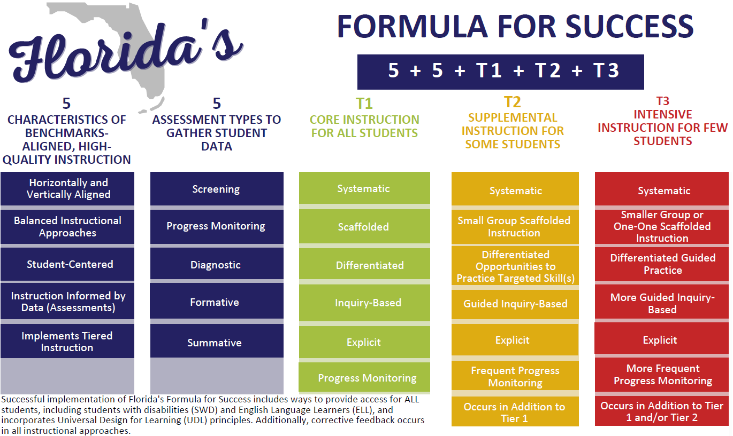

*The Formula for Success supports benchmarks-aligned, high-quality instruction in Mathematics, Civics, Science, Computer Science, Social Studies, Health and Physical Education.

Mathematical Conversations and Florida’s Formula for Success

Mathematical discourse is a foundational instructional strategy that directly supports Florida’s Formula for Success. When students engage in meaningful mathematics conversations, they participate in high-quality instruction reflecting each component of the formula.
Mathematical Conversation Supports the Five Characteristics of Benchmarks-Aligned, High-Quality Instruction
- Horizontally and Vertically Aligned: Discourse allows students to connect concepts within and across grade levels.
- Balanced Instructional Approaches: Supports Universal Design for Learning (UDL) principles and builds language and reasoning skills.
- Student-Centered: Elevates student voice and positions students as thinkers and problem solvers.
- Instruction Informed by Data: Listening to student reasoning provides formative data for adjusting instruction.
- Implements Tiered Instruction: Adapts discourse to support Tiers 1, 2 and 3 of instruction and intervention.

Examples of Mathematical Discourse Within Assessment Types
- Screening: Quick checks of verbal responses indicate understanding.
- Progress Monitoring: Ongoing conversations reveal whether students are improving in targeted skills.
- Diagnostic: Deep questioning uncovers misconceptions.
- Formative: Real-time discussions help teachers immediately adjust lessons.
- Summative: Oral presentations and mathematical arguments serve as evidence, alongside written assessments.

Examples of Mathematical Discourse Within Tiered Instruction
Tier 1
Open-ended questions, collaborative discussions and problem-solving discourse accessible to all students.
Tier 2
Scaffolded conversations around specific skill gaps with clarifying questions, error analysis and guided peer dialogue.
Tier 3
Highly structured, teacher-led discourse focusing on precise questioning and step-by-step verbal reasoning.

Using Questioning to Increase Achievement and Support Instruction and Intervention
Strategic questioning not only promotes mathematical discourse but also plays an important role in accelerating student achievement. When used intentionally, questions guide student thinking, uncover misconceptions and support deeper understanding. This is especially important during interventions, where individualized support and targeted questioning can help students bridge gaps and build confidence.

Structured Collaborative Thinking
During small group instruction and intervention, present a carefully chosen problem aligned to a specific skill gap. Ask each student to think silently, then discuss with a peer using provided sentence starters and questions like:
• What makes this problem challenging?
• How could you approach this another way?
Finish with a group share and reflective questions like:
• What was one thing you learned from your partner?

Error Analysis Conversations
Provide an incorrect sample solution and ask students to identify and explain the error. Use prompts such as:
• Where does this example go wrong?
• How would you revise this?
• Can you explain why this strategy does not work here?

Strategy Share Circle
Have each student solve the same problem using manipulatives, drawings or other various methods. Then, in a circle, each student explains their thinking using sentence starters. Encourage peer questions using:
• What do you agree with in their approach?
• Would your strategy work for a different problem?

Exit Interview with a Question Focus
Use a quick, one-on-one student conference at the end of a session to ask:
• What was the most confusing part of today’s lesson?
• How would you explain this to a classmate?

Record student responses to inform follow-up support.

Connection to Mathematical Thinking and Reasoning Standards (MTRs)

This guide aligns with Florida’s Mathematical Thinking and Reasoning standards (MTRs), which emphasize the importance of productive struggle, collaboration, reasoning and mathematical communication. The categories of questions and activities included throughout this guide are designed to naturally support students’ development of these competencies. Below are specific MTRs that are reinforced by the use of this guide:
- MTR.1.1: Actively participate in effortful learning both individually and collectively. Students use prompts to stay engaged, collaborate and persist through challenging tasks by sharing ideas, listening to peers and refining their thinking.
- MTR.2.1: Demonstrate understanding by representing problems in multiple ways. Questions encourage students to use objects, drawings, expressions, equations, graphs and models to make sense of mathematics and communicate solutions
- MTR.3.1: Complete tasks with mathematical fluency.
  - Students are prompted to choose efficient strategies, use precise procedures and communicate accurate answers with clarity.
- MTR.4.1: Engage in discussions that reflect on mathematical thinking of self and others. Sentence frames and discussion prompts foster meaningful conversations where students listen, question, explain and refine their mathematical ideas.
- MTR.5.1: Use patterns and structure to help understand and connect mathematical concepts.
  - Prompts guide students to look for relationships, use structure, generalize patterns and connect new concepts to prior knowledge.
- MTR.6.1: Assess the reasonableness of solutions.
  - Students are encouraged to evaluate their answers by asking if they make sense, revising when needed and justifying their thinking.
- MTR.7.1: Apply mathematics to real-world contexts.
  - This guide promotes prompts and discussions that help students connect mathematical concepts to real-life situations, solve authentic problems and see the relevance of mathematics beyond the classroom.

Mathematical Conversation Categories

- Understanding and Problem-Solving
These questions help students engage with the problem, understand the information provided and explore different methods for solving the problem. Encourage students to think critically and make connections to previous learning.
- What is the focus of this problem? What information can you gather from it?
- Can you clarify what the problem is asking you to do?
- What does the problem reveal to you?
- Which words or concepts are the most significant in this problem? Why?
- Is there anything in the problem that can be disregarded or something that is missing?
- What methods or approaches did you use to solve this problem?
- Have you attempted to make an estimate? What other approaches have you explored?
- Would another approach work as well or better?
- Is there a simple or quick way to solve this problem?

- Reasoning and Explanation
These questions guide students in justifying their reasoning, explaining their methods and evaluating their solutions.
- How did you come to this answer?
- Can you explain your method to someone else?
- How would you demonstrate that your answer is reasonable to your partner or the class?
- What question do you want to ask your partner or the class about this problem?
- What was your thought process when starting to work on this problem?
- Are there other possible methods to solve this problem?
- How does your method compare to someone else’s approach?
- Can you think of a situation where this strategy would not work?
- How did you organize your thinking during this problem-solving process?
- Was your group’s contribution effective and constructive?

- Making Connections and Reflecting
These questions encourage students to connect mathematical concepts to prior knowledge, explore patterns, and reflect on their problem-solving strategies.
- How does this problem relate to ones we have worked on in the past? What makes it different?
- In what ways are your strategy and your partner’s strategy alike or different?
- What new ideas or concepts did you apply in solving this problem?
- Have you noticed any patterns while solving this problem?
- Where else might you use this strategy or approach?
- How does this problem relate to other topics or to real-world situations?
- Can you find a general principle or rule from this problem?
- Can you think of a real-life scenario where this solution would apply?
- How could your method be adapted to work with other types of problems?
- What other questions or ideas have emerged from this topic?

- Sentence Starters for Discussion
Sentence starters help students structure their responses and promote deeper reflection during discussions.
- One thing I appreciate about my approach is ___.
- One thing I like about my partner’s method is ___.
- Something new I learned in today’s lesson is ___.
- I am still unsure about ___.
- I noticed a connection between ___.
- Something important to keep in mind is ___.
- I was surprised when ___.
- This problem is similar to ___.
- I agree with ___ because ___.
- I disagree with ___ because ___.
- I started solving the problem by… .
- The strategy that made the most sense to me was… .
- I would like to revise my answer because… .
- Something new I learned was… .
- I noticed a pattern between ___ and ___.

- Collaborating and Critiquing with Peers
These questions are designed to encourage students to listen to, respond to and build upon the ideas of their peers. They help foster a community of learners who can articulate their thinking while respectfully challenging and supporting others.
- Can you restate your partner’s strategy in your own words?
- What do you agree or disagree with in your partner’s solution?
- What would you add to your group’s discussion?
- How did your group work together?
- What question do you have for your partner or the class?
- How does your thinking compare with others in your group?
- Did everyone get a chance to participate?
- What did you learn from your partner’s method?

- Revising and Persevering
These prompts support students in refining their approaches and persisting through challenges. They guide learners to reflect on their process, adapt strategies and embrace productive struggle in solving problems.
- What did you try first? What did not work?
- Would another method or model work better?
- Do you want to revise your answer or strategy?
- What was challenging and how did you respond?
- How confident are you in your answer?
- What is one thing you would do differently if you tried again?
- What part of the problem can you work on next?
- What helped you keep going when it got difficult?

Sample Activities for Engaging Students in Mathematical Conversations

These activities are designed to promote collaboration, critical thinking and mathematical discourse among students. Each activity is aligned with Florida’s B.E.S.T. Standards for Mathematics and encourages students to work together, reason mathematically and communicate their ideas effectively.

Activity 1: Problem-Solving Partners
In this activity, students work in pairs to solve a challenging problem. One student is the “explainer,” who must describe their thought process and explain their strategy to their partner. The other student is the “questioner” who asks clarifying questions and provides feedback.

Steps:
- Present a challenging mathematics problem aligned with the current topic.
- Assign one student in each pair to be the “explainer,” and the other the “questioner.”
- The “explainer” explains their solution strategy while the questioner asks clarifying questions.
- After the explanation, the roles reverse. The “questioner” becomes the “explainer,” and the “explainer” becomes the “questioner.”
- After both students have had a chance to explain their reasoning, they reflect on the strategies and decide which one is more effective.

Activity 2: Group Problem-Solving Discussion
In this activity, students work in small groups to solve a complex problem. They use the provided discourse questions and sentence starters to guide their conversation and deepen their understanding.

Steps:
- Present a problem-solving group activity where students must collaborate to find a solution.
- Provide each student with a list of the discourse questions and sentence starters from this guide.
- Students work together in small groups, using the questions to guide their discussion and problem-solving process.
- After the activity, have each group present their solution and reasoning to the class.
- Encourage the class to critique each group’s approach using additional discourse questions.
- “Peer Critique” round: one student from another group offers feedback using sentence starters.

Activity 3: Real-World Application Discussion
This activity helps students connect mathematics to real-world situations. Students will discuss how the mathematics concepts they have learned apply to everyday life.

Steps:
- Present a real-world scenario or problem that requires students to apply the mathematical concepts they’ve learned.
- Have students work individually or in pairs to discuss how they would approach the problem and which mathematical methods they would use.
- Use the discourse questions to guide the conversation and deepen students’ understanding of how mathematics is used in the real world.
- Have students present their solutions and reasoning to the class.

