**These standards were written to:**

Provide clarity on the grade-level expectations for educators, parents and students.

Allow students flexibility to solve problems using a method/strategy of their choice.

Allow for student discovery (i.e., exploration) of strategies rather than the teaching, naming and assessing of each strategy individually.

ShapeThe Benchmarks for Excellent Student Thinking (B.E.S.T.) Standards for Mathematics are the state’s mathematical standards that pave the way for Florida students to receive a world-class education and prepare them for a successful future.

Education leaders from across the state came together to develop Florida’s B.E.S.T. Standards for Mathematics. These standards and benchmarks are goals that students are expected to achieve by the end of the school year. A standard is an overarching criterion for a grade level or grade band. A benchmark is a specific expectation or skill for the grade level or grade band that falls within a standard. The B.E.S.T. Standards are designed to ensure that ALL students reach their greatest potential.

**Preparing your student for success begins in Kindergarten and continues as your child progresses through each mathematics course. This guide will support parents, guardians and families with students in Mathematics for Data and Financial Literacy Honors by helping them:**

* **Learn about the B.E.S.T. Standards for Mathematics and why they matter for your student.**
* **Understand important educational (academic) words that you will see in your student’s grade-level standards and benchmarks.**
* **Talk with your student’s teacher about what they will be learning in the classroom.**
* **Locate activities and resources to support your student’s learning in practical ways at home.**

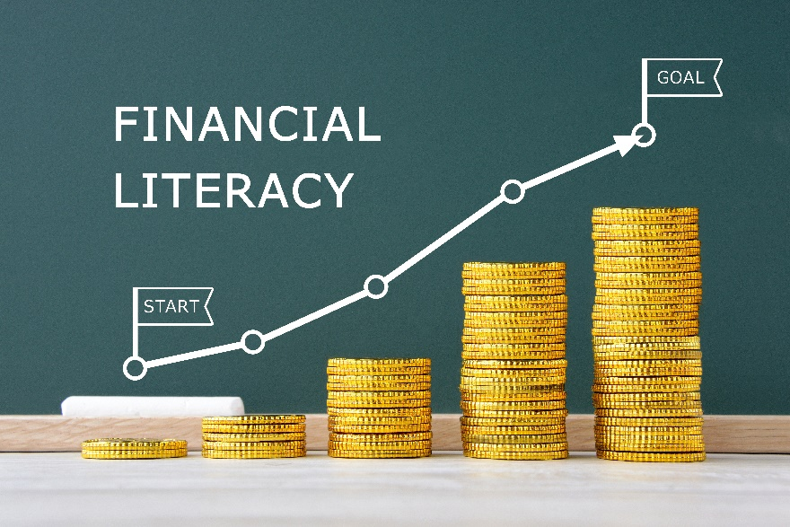

**Learn About the Mathematics for Data and Financial Literacy Honors Standards**

This table describes the areas of emphasis within Mathematics for Data and Financial Literacy Honors and provides examples of specific expectations within each area of emphasis. The purpose of the areas of emphasis is not to provide detailed guidance for specific units of learning and instruction, but rather provide insight on major mathematical topics that will be covered within the mathematics course.

| **Area of Emphasis** | **Examples** |
| --- | --- |
| Extending knowledge of ratios, proportions and functions to data and financial contexts. | * Add, subtract, multiply and divide polynomial expressions. * Add, subtract, multiply and divide radical expressions. * Convert between expressions with rational exponents and radical expressions. * Apply the Laws of Exponents to exponents in the form $\frac{a}{b}$. * Solve real-world problems involving money and business. |
| Developing an understanding of basic economic and accounting principles. | * Write, solve and graph linear equations and functions. * Write and solve quadratic equations and graph functions in one and two variables. * Write and solve exponential equations and graph exponential functions in one and two variables. * Fit an exponential or quadratic function to bivariate numerical data. * Develop budgets that fit within various incomes. |
| Determining advantages and disadvantages of credit accounts and short- and long-term loans. | * Write and solve a system of two-variable equations and inequalities that describes quantities or relationships. * Given a mathematical or real-world context, write and solve a system of two-variable linear equations algebraically or graphically. * Calculate the finance charges and the total amount due on a bill using various forms of credit. * Establish a plan to pay off debt. |
| Developing understanding of planning for the future through investments, insurance and retirement plans. | * Use inequality and set builder notations when representing domain and range. * Compare the advantages and disadvantages for adding on a one-time warranty to a purchase. * Compare the advantages and disadvantages of various retirement savings plans. |
| Extending knowledge of data analysis to create and evaluate reports and to make predictions. | * Classify data as categorical or numerical, and univariate or bivariate. * Plot and analyze residuals given a scatterplot that represents bivariate numerical data. * Given a relative frequency table, construct and interpret a segmented bar graph. * Evaluate data-based arguments. |

**B.E.S.T. Instructional Guide for Mathematics**

The B.E.S.T. Instructional Guide for Mathematics (B1G-M) is intended to assist educators with planning for student learning and instruction aligned to Florida’s Benchmarks for Excellent Student Thinking (B.E.S.T.) Standards. This guide is designed to aid high-quality instruction through the identification of components that support the learning and teaching of the B.E.S.T. Mathematics Standards and Benchmarks. The B1G-M can be utilized by parents, guardians and families to support learning at home through the Instructional Strategies section.

This document is posted on the B.E.S.T. Standards for Mathematics webpage (<https://www.fldoe.org/academics/standards/subject-areas/math-science/mathematics/bestmath.stml>) of the Florida Department of Education’s website and will continue to undergo edits as needed.

**Mathematical Words to Know and Use in Mathematics for Data and Financial Literacy Honors**

|  |  |  |  |  |  |
| --- | --- | --- | --- | --- | --- |
| Arithmetic sequence | Coordinate plane | Function | Measures of center | Quadratic expression | Simple interest |
| Base | Data | Function notation | Measures of variability | Quadratic function | Slope |
| Bivariate data | Domain | Geometric sequence | Percent error | Random sampling | x-intercept |
| Categorical data | Equation | Inverse function | Percent of change | Range | y-intercept |
| Cluster | Exponent | Joint frequency | Piecewise function | Rate |  |
| Coefficient | Exponential function | Joint relative frequency | Polynomial | Rate of change |  |
| Conditional relative frequency | Expression | Line of fit | Population | Scatterplot |  |
| Coordinate | Frequency table | Linear function | Proportional relationships | Set-builder notation |  |

*Definitions for these terms can be found in the glossary of the standards book, which can be accessed at* [6-12 Mathematics Glossary.](https://cpalmsmediaprod.blob.core.windows.net/uploads/docs/standards/best/ma/mathbeststandardsfinal.pdf#page=208)

**Support Learning at Home**

You can encourage learning mathematics at home in ways that are fun for you and your student. Try these ideas after school, on weekends and during the summer:

* Have your student develop a budget spreadsheet for their home that includes typical expenses such as rent, electric bill, water bill, cable and internet, groceries, gas and miscellaneous expenses. Have them add categories for savings toward their own financial goals, and determine the monthly income needed, before taxes, to meet the requirements of their budget.
* Have your student research two of their favorite stores’ credit cards. Your student should make note of the annual percentage rate for each credit card. Using a starting balance of their choice and a minimum balance to pay off each month, have them calculate the time it will take to pay off the balance. Compare the starting balance to the total amount paid with interest. Discuss credit card usage.
* Help your student choose the best option for saving money. Research the different types of savings accounts and ways to save money. Discuss the best time for your student to withdraw the money from their account.
* Using an online stock simulator, have your student simulate the purchase of a stock portfolio with a set amount of money, and evaluate its worth over time considering gains, losses and selling, taking into account any associated fees.
* At a family gathering, provide a list of entrées and sides. Survey the family members on their choice of entrée and side and record the data in an appropriate data display. Determine if there seems to be a correlation between the entrée and side chosen.
* Have your student choose two events that they believe are related, for example, drinking a lot of water and hot weather. Help them determine if there is a correlation and causation between the two events.

**Talk with Your Student’s Teacher**

Remember, you are your student’s first teacher. Think about a parent-teacher conference as a “team meeting” in which you will discover the special contributions each of you bring to your student’s success. Here are some questions you could ask to prompt discussions:

Which skills or topics is my student working on? Which have they mastered? How can I support them at home?

In the area of mathematics, what are my student’s strengths? How are those strengths supported during instruction? Where is my student struggling and how can I help?

Can my student show you that they understand what they are learning about through manipulatives, drawing, talking and writing? If not, what challenges are they facing?

What topics in connection to science and social studies is my student learning about through math?

What behaviors should I see when my student is doing math? Can I see an example of the type of problems my student is given? How can I support them at home?

**Mathematical Thinking and Reasoning Standards (MTRs)**

Florida students are expected to engage with mathematics through the Mathematical Thinking and Reasoning Standards (MTRs). These standards are written in clear language so all stakeholders can understand them and teachers can assist students to use them as self-monitoring tools. The MTRs promote deeper learning and understanding of mathematics. By understanding the MTRs, parents, guardians and families can support the development of these skills at home.

MA.K12.MTR.1.1 Actively participate in effortful learning both individually and collectively.
MA.K12.MTR.2.1 Demonstrate understanding by representing problems in multiple ways.
MA.K12.MTR.3.1 Complete tasks with mathematical fluency. MA.K12.MTR.4.1 Engage in discussions that reflect on the mathematical thinking of self and others. MA.K12.MTR.5.1 Use patterns and structure to connect mathematical concepts. MA.K12.MTR.6.1 Assess the reasonableness of solutions. MA.K12.MTR.7.1 Apply mathematics to real-world contexts.

Your student will develop the above skills (MTRs) throughout their education and during their life. These skills will help maintain positive relationships through effective communication, collaboration, conflict resolution and problem solving.

Below are some ways you can help develop mathematical thinking and reasoning skills for your mathematics student:

* Encourage your student to ask questions when they do not understand what is being asked of them.
* Ask your student to estimate before determining a solution to the task at hand.
* Identify a problem and create a plan to tackle it in smaller steps that are more manageable.
* Try activities like a scavenger hunt or a puzzle.

By helping to develop your student’s mathematical thinking and reasoning skills, you will prepare them to become a confident, independent and successful individual.