ShapeThe Benchmarks for Excellent Student Thinking (B.E.S.T.) Standards for Mathematics are the state’s mathematical standards that pave the way for Florida students to receive a world-class education and prepare them for a successful future.

**These standards were written to:**

Provide clarity on the grade-level expectations for educators, parents and students.

Allow students flexibility to solve problems using a method/strategy of their choice.

Allow for student discovery (i.e., exploration) of strategies rather than the teaching, naming and assessing of each strategy individually.

Education leaders from across the state came together to develop Florida’s B.E.S.T. Standards for Mathematics. These standards and benchmarks are goals that students are expected to achieve by the end of the school year. A standard is an overarching criterion for a grade level or grade band. A benchmark is a specific expectation or skill for the grade level or grade band that falls within a standard. The B.E.S.T. Standards are designed to ensure that ALL students reach their greatest potential.

**Preparing your student for success begins in Kindergarten and continues as your child progresses through each mathematics course. This guide will support parents, guardians and families with students in Geometry by helping them:**

* **Learn about the B.E.S.T. Standards for Mathematics and why they matter for your student.**
* **Understand important educational (academic) words that you will see in your student’s grade-level standards and benchmarks.**
* **Talk with your student’s teacher about what they will be learning in the classroom.**
* **Locate activities and resources to support your student’s learning in practical ways at home.**

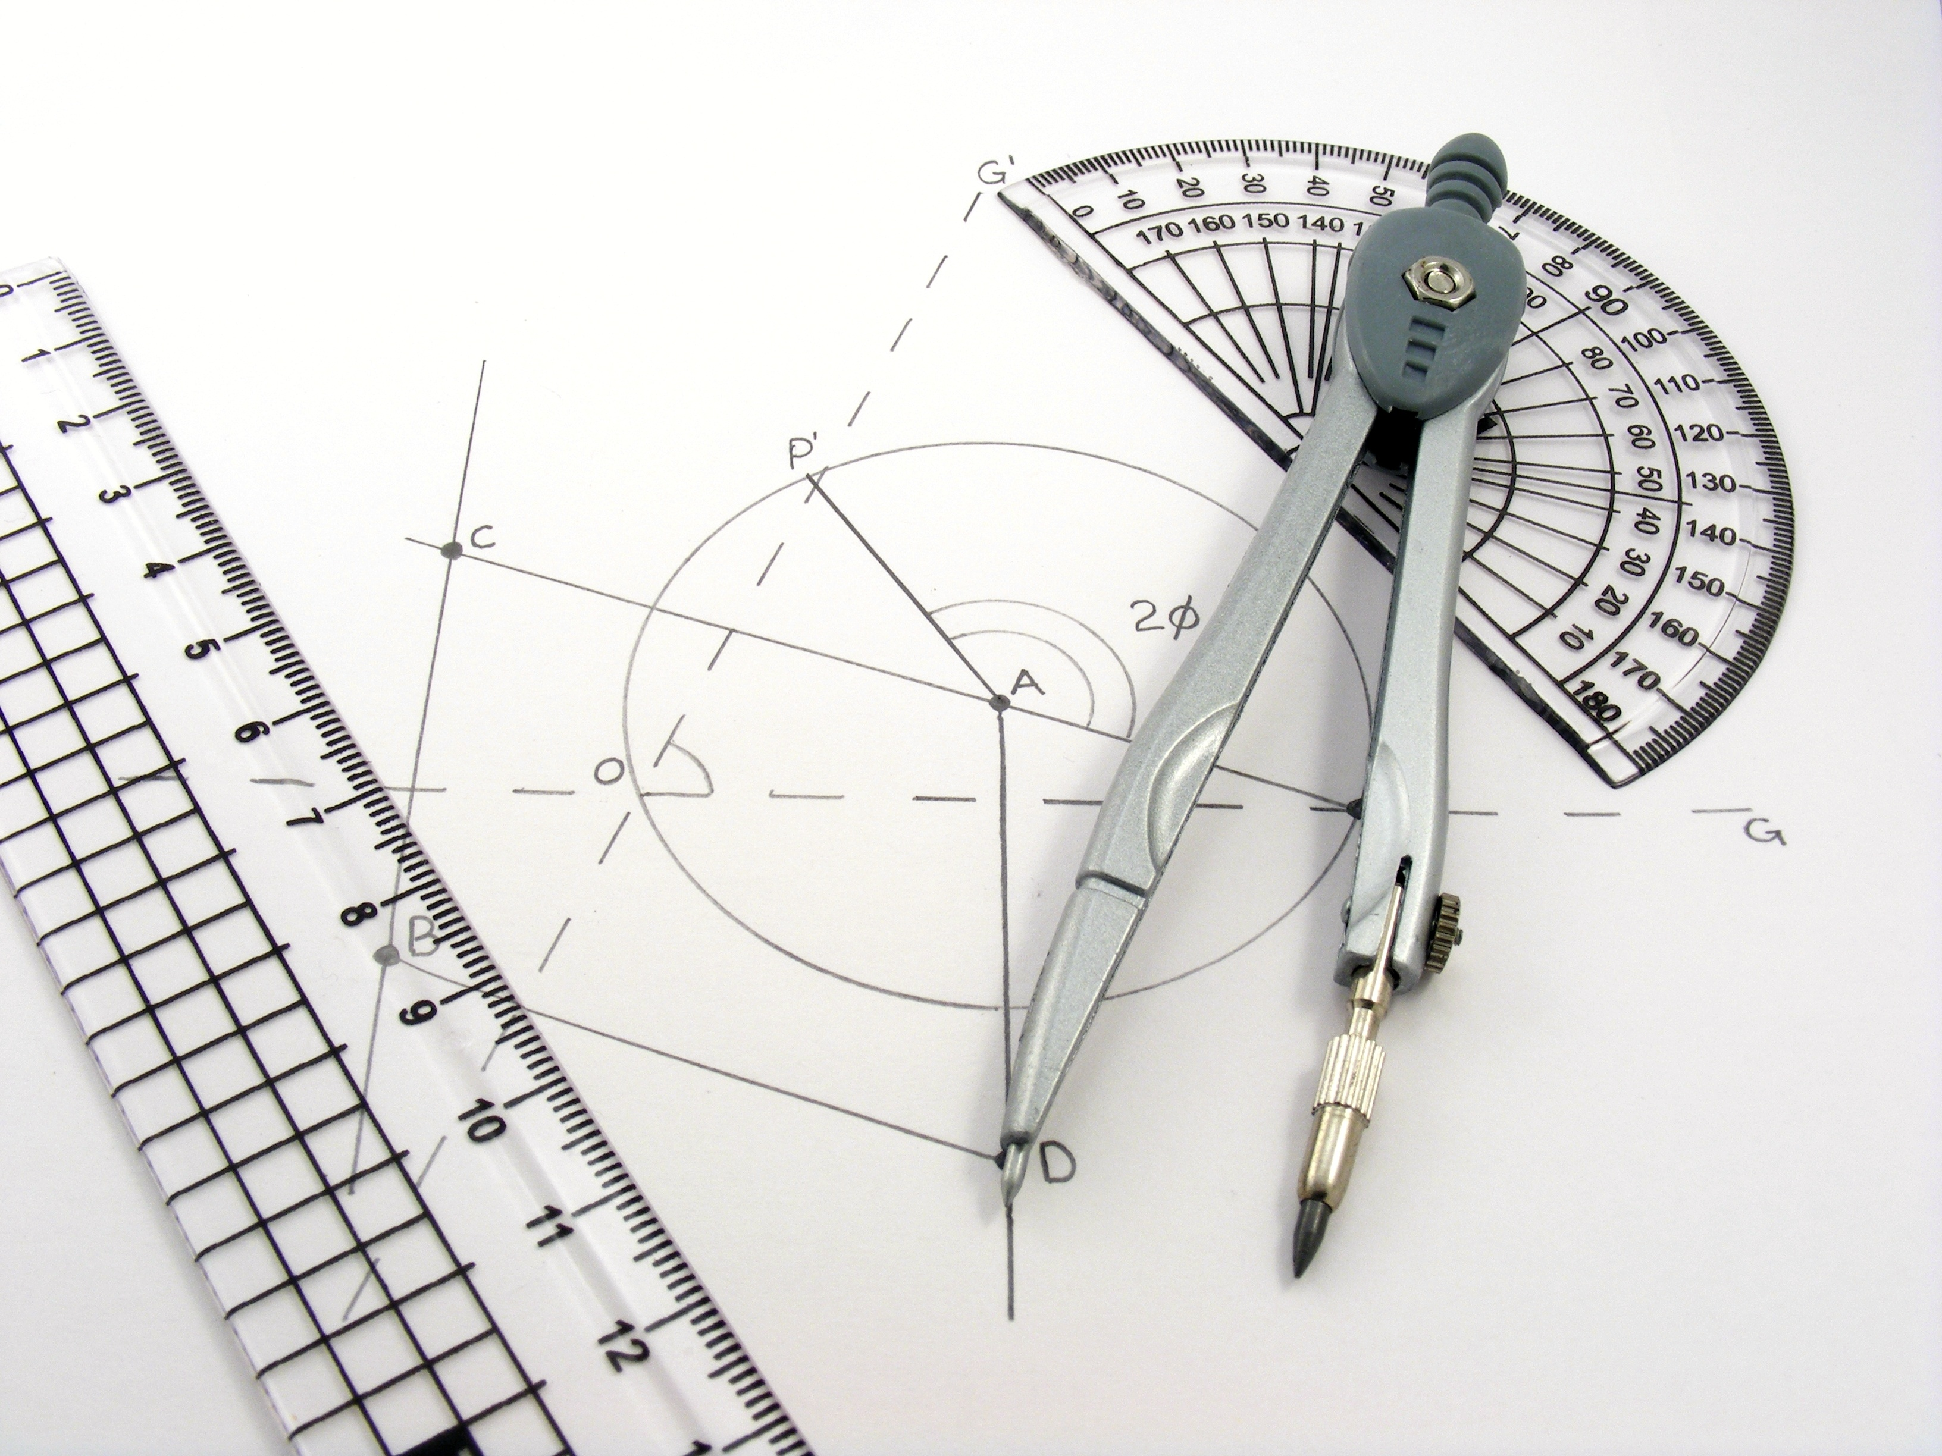

**Learn About the Geometry Standards**

The table describes the areas of emphasis within Geometry Honors and provides examples of specific expectations within each area of emphasis. The purpose of the areas of emphasis is not to provide detailed guidance for specific units of learning and instruction, but rather provide insight on major mathematical topics that will be covered within the mathematics course.

| **Area of Emphasis** | **Examples** |
| --- | --- |
| Proving and applying relationships and theorems involving two-dimensional figures using Euclidean geometry and coordinate geometry. | * Prove two-dimensional figures are congruent or similar using postulates. * Construct various types of proofs, such as two-column, pictorial, paragraph or narrative, flow chart, or informal proofs. * Identify relationships between angles. * Find the midpoint and distance between two points using formulas. * Develop an understanding of logic. * Perform constructions of lines, angles, and figures. |
| Establishing congruence and similarity using criteria from Euclidean geometry and using rigid transformations. | * Perform transformations such as translations, reflections, rotations, and dilations and sequences of these on figures in the coordinate plane. * Apply properties of transformations to describe congruence or similarity. * Distinguish the difference between rigid and non-rigid transformations. |
| Extending knowledge of geometric measurement to two-dimensional figures and three-dimensional figures. | * Apply formulas to find the area of two-dimensional figures in real-world situations. * Apply formulas to find the volume and surface area of three-dimensional figures in real-world situations. |
| Creating and applying equations of circles in the coordinate plane. | * Make connections between the equation of a circle to the distance formula and Pythagorean Theorem. * Use the equation of circle to identify the radius and center. * Graph circles in a coordinate plane. |
| Developing an understanding of right triangle trigonometry. | * Use the special right triangle side and angle relationships to solve problems. * Use trigonometric ratios (sine, cosine, tangent) to identify missing sides or angles in triangles. |

*For specific examples and an inclusive list of skills, visit the B1G-M using the link below.*

**B.E.S.T. Instructional Guide for Mathematics**

The B.E.S.T. Instructional Guide for Mathematics (B1G-M) is intended to assist educators with planning for student learning and instruction aligned to Florida’s Benchmarks for Excellent Student Thinking (B.E.S.T.) Standards. This guide is designed to aid high-quality instruction through the identification of components that support the learning and teaching of the B.E.S.T. Mathematics Standards and Benchmarks. The B1G-M can be utilized by parents, guardians and families to support learning at home through the Instructional Strategies section.

This document is posted on the B.E.S.T. Standards for Mathematics webpage (<https://www.fldoe.org/academics/standards/subject-areas/math-science/mathematics/bestmath.stml>) of the Florida Department of Education’s website and will continue to undergo edits as needed.

**Mathematical Words to Know and Use in Geometry Honors**

|  |  |  |  |  |  |
| --- | --- | --- | --- | --- | --- |
| Angle | Corresponding Angles | Inscribed Polygon in a Circle | Prism | Right Triangle | Square |
| Area | Cylinder | Isosceles Triangle | Pyramid | Rigid Transformation | Supplementary Angles |
| Central Angle | Diameter | Line of Symmetry | Quadrilateral | Rotation | Translation |
| Circle | Dilation | Number Line | Radius | Scale Factor | Transversal |
| Circumscribed Circle | Domain | Origin | Range of a Relation or Function | Scale Model | Trapezoid |
| Cone | Hypotenuse | Parallelogram | Rectangle | Similarity | Triangle |
| Congruent | Inscribed Angle | Perimeter | Reflection | Slope | Vertical Angles |

*Definitions for these terms can be found in the glossary of the standards book which can be accessed using the following link:* [6-12 Mathematics Glossary](https://cpalmsmediaprod.blob.core.windows.net/uploads/docs/standards/best/ma/mathbeststandardsfinal.pdf#page=208).

**Helpful Formulas for Geometry Honors**

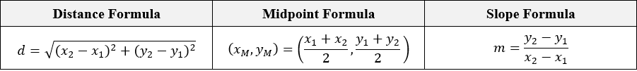

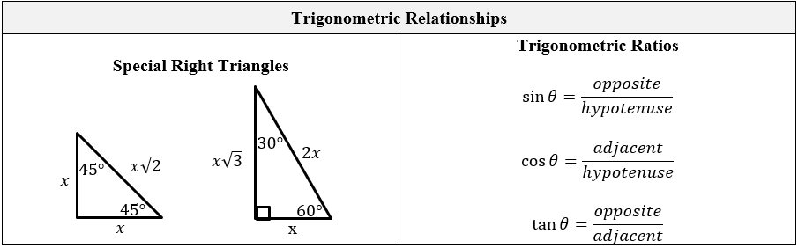

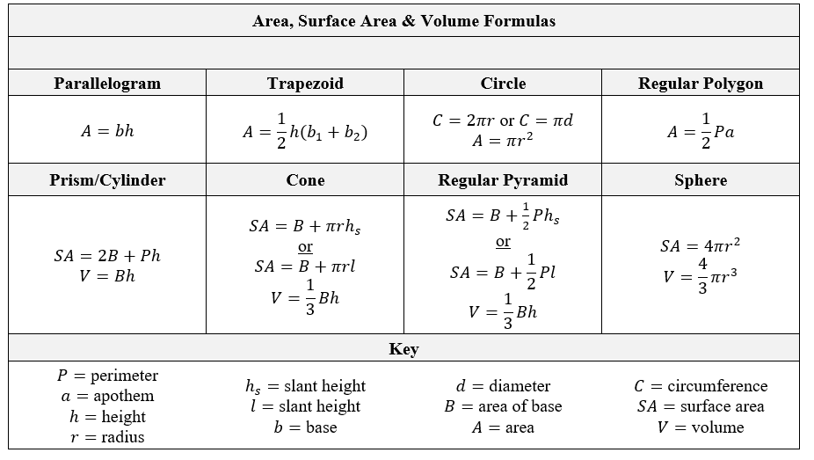

**Support Learning at Home**

You can encourage learning mathematics at home in ways that are fun for you and your student. Try these ideas after school, on weekends and during the summer:

* Choose a room in your home. Using a tool other than a ruler or measuring tape, measure the distance from one side of the room to the other side. Have your student discuss how they found the distance. Then, have them explain how to find the midpoint of that distance.
* Take a walk around the neighborhood and locate as many two- and three-dimensional shapes.
* Choose a room in your house and create a scale drawing.
* Have your student stand in front of a mirror. Discuss what they see and notice about the reflected image. They may notice that their right hand is their left hand in the reflection. They may notice that their distance from the mirror is the same distance their reflection is in the mirror.
* Ask your local meat market for patty paper. Have your student find an image of a brand’s logo online. Use the patty paper to trace the image. Discuss that the images are congruent. This could also be a good time to mention that the traced image is a translation of the online image. Next, have your student fold the paper to locate any lines of symmetry. Also, have your student turn the paper over and discuss the effect on the images.
* Discuss with your student an airplane's location, height, and angle as it takes off and lands at an airport. Bring in the idea of angles of elevation and depression to the discussion.
* Find between 3-4 different size circular, household items. Discuss with your student whether or these circles are similar and why. Use string to simulate and talk about the different parts of a circle (e.g. radius, diameter, chord, etc).
* Using the concept of surface area, have your student determine the number of gallons of paint needed to cover one of the rooms in your house.

**Talk with Your Student’s Teacher**

Remember, you are your student’s first teacher. Think about a parent-teacher conference as a “team meeting” in which you will discover the special contributions each of you bring to your student’s success. Here are some questions you could ask to prompt discussions:

Which skills or topics is my student working on? Which have they mastered? How can I support them at home?

In the area of mathematics, what are my student’s strengths? How are those strengths supported during instruction? Where is my student struggling and how can I help?

Can my student show you that they understand what they are learning about through manipulatives, drawing, talking and writing? If not, what challenges are they facing?

What topics in connection to science and social studies is my student learning about through math?

What behaviors should I see when my student is doing math? Can I see an example of the type of problems my student is given? How can I support them at home?

**Mathematical Thinking and Reasoning Standards (MTRs)**

Florida students are expected to engage with mathematics through the Mathematical Thinking and Reasoning Standards (MTRs). These standards are written in clear language so all stakeholders can understand them and teachers can assist students to use them as self-monitoring tools. The MTRs promote deeper learning and understanding of mathematics. By understanding the MTRs, parents, guardians and families can support the development of these skills at home.

MA.K12.MTR.1.1 Actively participate in effortful learning both individually and collectively. MA.K12.MTR.2.1 Demonstrate understanding by representing problems in multiple ways. MA.K12.MTR.3.1 Complete tasks with mathematical fluency. MA.K12.MTR.4.1 Engage in discussions that reflect on the mathematical thinking of self and others.
MA.K12.MTR.5.1
Use patterns and structure to connect mathematical concepts.
MA.K12.MTR.6.1
Assess the reasonableness of solutions.
MA.K12.MTR.7.1
Apply mathematics to real-world contexts.

Your student will develop the above skills (MTRs) throughout their education and during their life. These skills will help maintain positive relationships through effective communication, collaboration, conflict resolution and problem solving.

Below are some ways you can help develop mathematical thinking and reasoning skills for your mathematics student:

* Encourage your student to ask questions when they do not understand what is being asked of them.
* Ask your student to estimate before determining a solution to the task at hand.
* Identify a problem and create a plan to tackle it in smaller steps that are more manageable.
* Try activities like a scavenger hunt or a puzzle.

By helping to develop your student’s mathematical thinking and reasoning skills, you will prepare them to become a confident, independent and successful individual.