ShapeThe Benchmarks for Excellent Student Thinking (B.E.S.T.) Standards for Mathematics are the state’s mathematical standards that pave the way for Florida students to receive a world-class education and prepare them for a successful future.

**These standards were written to:**

Provide clarity on the grade-level expectations for educators, parents and students.

Allow students flexibility to solve problems using a method/strategy of their choice.

Allow for student discovery (i.e., exploration) of strategies rather than the teaching, naming and assessing of each strategy individually.

Education leaders from across the state came together to develop Florida’s B.E.S.T. Standards for Mathematics. These standards and benchmarks are goals that students are expected to achieve by the end of the school year. A standard is an overarching criterion for a grade level or grade band. A benchmark is a specific expectation or skill for the grade level or grade band that falls within a standard. The B.E.S.T. Standards are designed to ensure that ALL students reach their greatest potential.

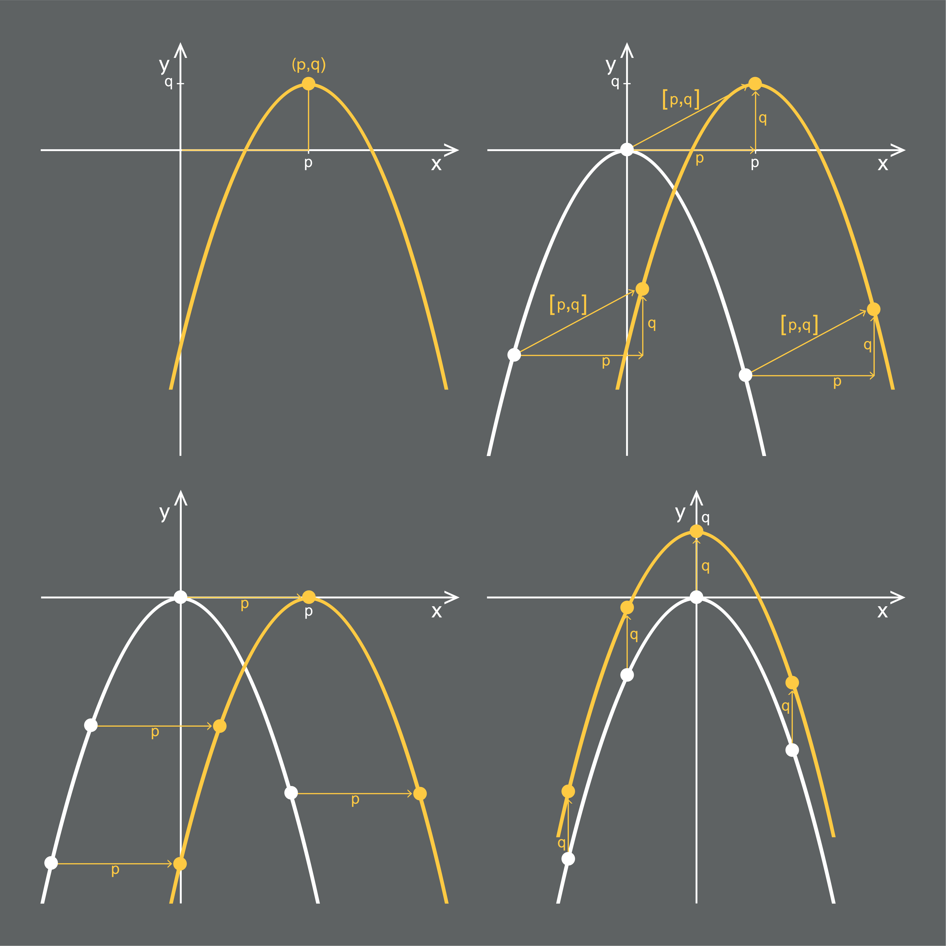

**Preparing your student for success begins in Kindergarten and continues as your child progresses through each mathematics course. This guide will support parents, guardians and families with students in Algebra 2 by helping them:**

* **Learn about the B.E.S.T. Standards for Mathematics and why they matter for your student.**
* **Understand important educational (academic) words that you will see in your student’s grade-level standards and benchmarks.**
* **Talk with your student’s teacher about what they will be learning in the classroom.**
* **Locate activities and resources to support your student’s learning in practical ways at home.**

**Learn About the Algebra 2 Standards**

This table describes the areas of emphasis within Algebra 2 and provides examples of specific expectations within each area of emphasis. The purpose of the areas of emphasis is not to provide detailed guidance for specific units of learning and instruction, but rather provide insight on major mathematical topics that will be covered within the mathematics course.

| **Area of Emphasis** | **Examples** |
| --- | --- |
| Developing understanding of the complex number system, including complex numbers as roots of polynomial equations. | * Add, subtract, multiply, and divide complex numbers. * Understand the elements that make up the complex number system, including the imaginary number, *i.* * Determine the complex roots of a polynomial equation. |
| Extending arithmetic operations with algebraic expressions to include polynomial division, radical and rational expressions. | * Add, subtract, multiply, and divide radical expressions. * Convert between expressions with rational exponents and radical expressions. * Given a mathematical or real-world context, add, subtract, multiply, and divide polynomial expressions. |
| Graphing and analyzing functions including polynomials, absolute value, radical, rational, exponential and logarithmic. | * Identify key features of functions such as domain; range; intercepts; intervals where the function is increasing, decreasing, positive or negative; end behavior and asymptotes. * Determine the roots of functions. * Given written descriptions, equations, graphs, and tables of values, recognize the function being represented and then represent the function in a different way. * Use inequality, interval, or set builder notations when representing domain and range. |
| Extending systems of equations and inequalities to include non-linear expressions. | * Given a mathematical or real-world context, write and solve a system of two-variable or three-variable linear equations and inequalities algebraically or graphically. * Given a mathematical or real-world context, solve a system consisting of two-variable quadratic equations. |
| Building functions using compositions, inverses and transformations. | * Determine the domain and range of a composite function. * Solve mathematical or real-world problems involving composite functions and inverse functions. * Represent the inverse of a function algebraically, graphically or in a table. * Given an exponential function, write its inverse as a logarithmic function. |
| Developing understanding of probability concepts. | * Calculate the conditional probability of one event given another event and interpret the result in terms of its context. * Determine independence of events. * Describe events as unions, intersections, or compliments of other events. * Given a mathematical or real-world situation, calculate the appropriate permutation or combination. |

*For specific examples and an inclusive list of skills, visit the B1G-M using the link below.*

**B.E.S.T. Instructional Guide for Mathematics**

The B.E.S.T. Instructional Guide for Mathematics (B1G-M) is intended to assist educators with planning for student learning and instruction aligned to Florida’s Benchmarks for Excellent Student Thinking (B.E.S.T.) Standards. This guide is designed to aid high-quality instruction through the identification of components that support the learning and teaching of the B.E.S.T. Mathematics Standards and Benchmarks. The B1G-M can be utilized by parents, guardians and families to support learning at home through the Instructional Strategies section.

This document is posted on the B.E.S.T. Standards for Mathematics webpage (<https://www.fldoe.org/academics/standards/subject-areas/math-science/mathematics/bestmath.stml>) of the Florida Department of Education’s website and will continue to undergo edits as needed.

**Educational Words to Know and Use in Algebra 2**

|  |  |  |  |  |  |
| --- | --- | --- | --- | --- | --- |
| Absolute Value | Domain | Inequality | Numerical Data | Rate of Change | Simulation |
| Base | Exponent | Intercept | Piecewise Function | Rational Number | Slope |
| Categorical Data | Exponential | Line of Fit | Polynomial | Real Numbers | Transformation |
| Coefficient | Exponential Function | Linear Equation | Quadratic Function | Rotation | Translation |
| Compound Inequality | Function | Linear Expression | Random Sampling | Scatter Plot | x-intercept |
| Coordinate Plane | Function Notation | Monomial | Range | Simple Interest | y-intercept |

*Definitions for these terms can be found in the glossary of the standards book which can be accessed using the following link:*

**Support Learning at Home**

You can encourage learning mathematics at home in ways that are fun for you and your student. Try these ideas after school, on weekends and during the summer:

* Have your child help you sort the laundry into different groups. For example, put all the pants in one pile, shirts in another pile and socks in a third pile. Talk about what the items in each pile have in common.
* Plan a trip to the movies with a specific budget. Before going, research the price for each adult and child ticket. Figure out the possible number of adults and children that could go.
* At a family gathering, provide a list of entrees and sides. Survey the family members on their choice of entrée and side and record the data in an appropriate data display. Determine if there is a correlation between the entrée and side chosen.
* Have your child practice inputting the functions below in a graphing utility, handheld or online. Create a chart for each function to include the name, function notation, and visual of the graph.

|  |  |  |
| --- | --- | --- |
| Linear $f(x) = x$ | Square root $f(x) = \sqrt{x}$ | Exponential (growth) $f(x) = 2^{x}$ |
| Quadratic $f(x) = x^{2}$ | Cube root $f(x) = \sqrt[3]{x}$ | Exponential (decay) $f(x) = {\left(\frac{1}{2}\right)}^{x}$ |
| Cubic $f(x) = x^{3}$ | Absolute value |  |

* Have your student select a recipe where there is an ingredient that can be replaced with another recipe. Every time they see that ingredient in the selected recipe, have them replace it with a recipe for that ingredient. Discuss with your student how the substituted recipe may change the original recipe. Make connections between this discussion and the composition of functions.
* Be on the lookout for parabolic shapes. When at a park/playground, discuss how shooting a basketball or hitting a golf ball creates a parabola.
* Using a deck of cards, determine the probability that two cards drawn at random from the deck will both be aces. Discuss with your student how drawing an ace the first time will affect the probability of drawing an ace the second time.

**Talk with Your Student’s Teacher**

Remember, you are your student’s first teacher. Think about a parent-teacher conference as a “team meeting” in which you will discover the special contributions each of you bring to your student’s success. Here are some questions you could ask to prompt discussions:

Which skills or topics is my student working on? Which have they mastered? How can I support them at home?

In the area of mathematics, what are my student’s strengths? How are those strengths supported during instruction? Where is my student struggling and how can I help?

Can my student show you that they understand what they are learning about through manipulatives, drawing, talking and writing? If not, what challenges are they facing?

What topics in connection to science and social studies is my student learning about through math?

What behaviors should I see when my student is doing math? Can I see an example of the type of problems my student is given? How can I support them at home?

**Mathematical Thinking and Reasoning Standards (MTRs)**

Florida students are expected to engage with mathematics through the Mathematical Thinking and Reasoning Standards (MTRs). These standards are written in clear language so all stakeholders can understand them and teachers can assist students to use them as self-monitoring tools. The MTRs promote deeper learning and understanding of mathematics. By understanding the MTRs, parents, guardians and families can support the development of these skills at home.

MA.K12.MTR.1.1 Actively participate in effortful learning both individually and collectively. MA.K12.MTR.2.1 Demonstrate understanding by representing problems in multiple ways. MA.K12.MTR.3.1 Complete tasks with mathematical fluency. MA.K12.MTR.4.1 Engage in discussions that reflect on the mathematical thinking of self and others.
MA.K12.MTR.5.1
Use patterns and structure to connect mathematical concepts.
MA.K12.MTR.6.1
Assess the reasonableness of solutions.
MA.K12.MTR.7.1
Apply mathematics to real-world contexts.

Your student will develop the above skills (MTRs) throughout their education and during their life. These skills will help maintain positive relationships through effective communication, collaboration, conflict resolution and problem solving.

Below are some ways you can help develop mathematical thinking and reasoning skills for your mathematics student:

* Encourage your student to ask questions when they do not understand what is being asked of them.
* Ask your student to estimate before determining a solution to the task at hand.
* Identify a problem and create a plan to tackle it in smaller steps that are more manageable.
* Try activities like a scavenger hunt or a puzzle.

By helping to develop your student’s mathematical thinking and reasoning skills, you will prepare them to become a confident, independent and successful individual.