The Benchmarks for Excellent Student Thinking (B.E.S.T.) Standards for Mathematics are the state’s mathematical standards that pave the way for Florida students to receive a world-class education and prepare them for a successful future.
These standards were written to:
Provide clarity on the grade-level expectations for educators, parents and students.

Allow students flexibility to solve problems using a method/strategy of their choice.

Allow for student discovery (i.e., exploration) of strategies rather than the teaching, naming and assessing of each strategy individually.

Education leaders from across the state came together to develop Florida’s B.E.S.T. Standards for Mathematics. These standards and benchmarks are goals that students are expected to achieve by the end of the school year. A standard is an overarching criterion for a grade level or grade band. A benchmark is a specific expectation or skill for the grade level or grade band that falls within a standard. The B.E.S.T. Standards are designed to ensure that ALL students reach their greatest potential.

Preparing your student for success begins in Kindergarten and continues as your child progresses through each grade. This guide will support parents, guardians and families with students in Kindergarten by helping them:

- Learn about the B.E.S.T. Standards for Mathematics and why they matter for your student.
- Understand important educational (academic) words that you will see in your student’s grade-level standards and benchmarks.
- Talk with your student’s teacher about what they will be learning in the classroom.
- Locate activities and resources to support your student’s learning in practical ways at home.

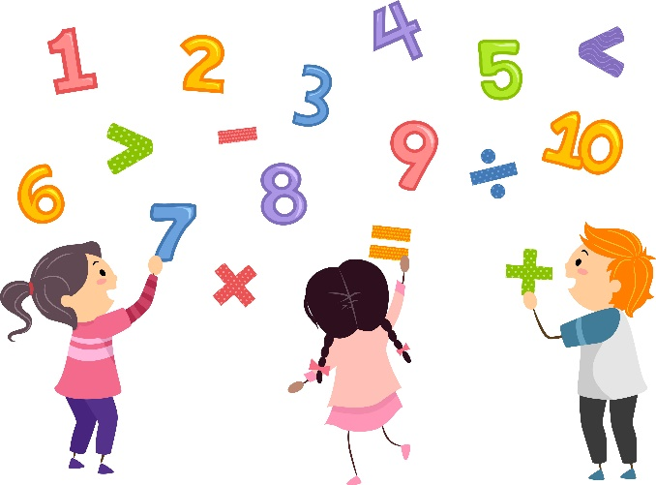

Learn About the Kindergarten Mathematics Standards
The table describes the areas of emphasis within Kindergarten and provides examples of specific expectations within each area of emphasis. The purpose of the areas of emphasis is not to guide specific units of learning and instruction, but rather provide insight on major mathematical topics that will be covered within the grade level. The table below is not in any set order in which areas should be taught. Areas of emphasis may be taught in any order, combined with others and taught throughout the year.
Area of Emphasis | Examples
Developing an understanding of counting to represent the total number of objects in a set and to order the objects within a set. | - Counting up to 20 objects.  - Reciting numbers up to 100 by ones and by tens.  - Identifying the position of an object using the words “first,” “second,” “third,” “fourth” or “fifth.”
Developing an understanding of addition and subtraction and the relationship of these operations to counting. | - Adding two whole numbers with sums up to 20 (e.g., $4+7=11$ or $3+1=4$).  - Subtracting with the related facts (e.g., $11-7=4$ or $4-3=1$).  - Solving real-world problems involving addition and subtraction.
Measuring, comparing and categorizing objects according to various attributes, including their two- and three-dimensional figures. | - Understanding that an object has length, volume and weight.  - Knowing the names of various two- and three-dimensional figures, including circles, triangles, rectangles, squares, spheres, cubes, cones and cylinders.

B.E.S.T. Instructional Guide for Mathematics
The B.E.S.T. Instructional Guide for Mathematics (B1G-M) is intended to assist educators with planning for student learning and instruction aligned to Florida’s Benchmarks for Excellent Student Thinking (B.E.S.T.) Standards. This guide is designed to aid high-quality instruction through the identification of components that support the learning and teaching of the B.E.S.T. Mathematics Standards and Benchmarks. The B1G-M can be utilized by parents, guardians and families to support learning at home through the Instructional Strategies section.

This document is posted on the B.E.S.T. Standards for Mathematics webpage (https://www.fldoe.org/academics/standards/subject-areas/math-science/mathematics/bestmath.stml) of the Florida Department of Education’s website and will continue to undergo edits as needed.

Mathematical Words to Know and Use in Kindergarten
Addition | Empty | First | Less than | Recite | Subtraction
Circle | Equal | Fourth | Lighter | Rectangle | Taller
Compare | Equal sign | Full | Longer | Second | Third
Cone | Equation | Greater than | More | Shorter | Triangle
Cube | Expression | Heavier | More than | Sphere | Whole number
Cylinder | Fifth | Less | Number line | Square
*Note: Within Kindergarten, it is not the expectation that students be able to spell each of these words.
* This is not a comprehensive list – please access the K-5 Glossary.
https://cpalmsmediaprod.blob.core.windows.net/uploads/docs/standards/best/ma/appendixc.pdf

Support Learning at Home
You can encourage learning mathematics at home in ways that are fun for you and your student. Try these ideas after school, on weekends and during the summer:
- Counting with everyday activities. Count the number of steps when walking from one place to another or count the number of items you unload from a backpack or bag of groceries.
- Have your child help you sort the laundry into different groups. For example, put all the pants in one pile, shirts in another pile and socks in a third pile. Talk about how one item can belong to different categories. Talk about which groups include more, less or an equal number of items.
- Talk about and create lists that include drawings of items. Label them by writing numbers 1 to 20. Practice reading the numbers together.
- Practice addition and subtraction. Say, “You have 3 crackers. If I give you 2 more, how many will you have?” By the end of Kindergarten, your child should be comfortable adding with sums between 0 and 10 and subtracting with related facts.
- The concept of “one hundred” is important for Kindergarteners. Think of ways to incorporate “100” into real-life, meaningful activities. For instance, make a chart and log 10 “bend and stretch” exercise moves every day for 10 days.
- Be on the lookout for geometric shapes. The park/playground or the grocery store are good places to search and name circles, cones, squares and rectangles.
- Observe relationships such as more/less, above/below and taller/shorter.

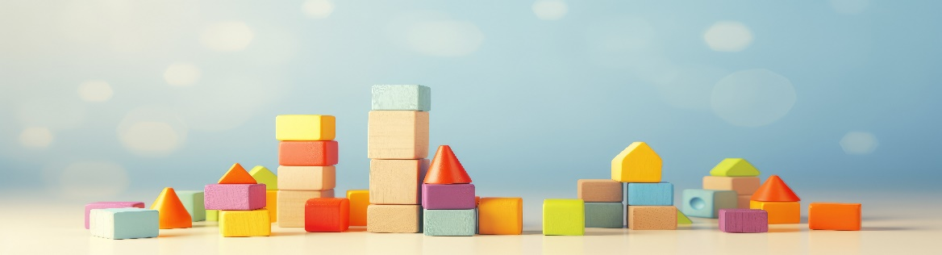

Talk with Your Student’s Teacher
Remember, you are your student’s first teacher. Think about a parent-teacher conference as a “team meeting” in which you will discover the special contributions each of you bring to your student’s success. Here are some questions you could ask to prompt discussions:

Which numbers or figures is my student working on? Which have they mastered? How can I support them at home?

In the area of mathematics, what are my student’s strengths? How are those strengths supported during instruction? Where is my student struggling and how can I help?

Can my student show you that they understand what they are learning about through manipulatives, drawing, talking and writing? If not, what challenges are they facing?

What topics in connection to science and social studies is my student learning about through math?

What behaviors should I see when my student is doing math? Can I see an example of the type of problems my student is given? How can I support them at home?

Mathematical Thinking and Reasoning Standards (MTRs)
Florida students are expected to engage with mathematics through the Mathematical Thinking and Reasoning Standards (MTRs). These standards are written in clear language so all stakeholders can understand them and teachers can assist students to use them as self-monitoring tools. The MTRs promote deeper learning and understanding of mathematics. By understanding the MTRs, parents, guardians and families can support the development of these skills at home.
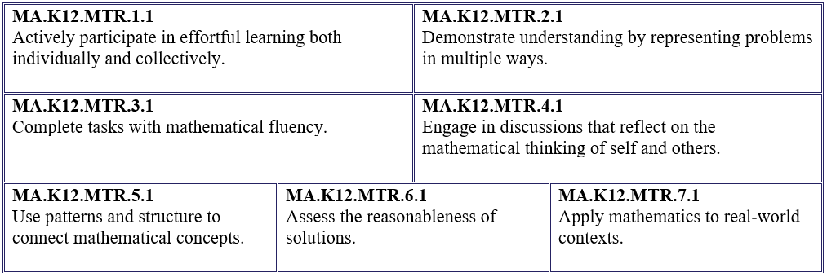

Your student will develop the above skills (MTRs) throughout their education and during their life. These skills will help maintain positive relationships through effective communication, collaboration, conflict resolution and problem solving.

Below are some ways you can help develop mathematical thinking and reasoning skills for your Kindergartener:
- Encourage your student to ask questions when they do not understand what is being asked of them.
- Ask your student to estimate before determining a solution to the task at hand.
- Identify a problem and create a plan to tackle it in smaller steps that are more manageable.
- Try activities like a scavenger hunt or a puzzle.

By helping to develop your student’s mathematical thinking and reasoning skills, you will prepare them to become a confident, independent and successful individual.

Fluency
Building a strong numeracy foundation is critical to every child’s mathematical success. The B.E.S.T. Standards for Mathematics were developed to allow skills to build upon one another within a grade level as well as from one grade to the next. Benchmark expectations have been developed with a hierarchy in mind consisting of three stages: exploration, procedural reliability and procedural fluency. The three stages illustrated below show the stages students may work through when learning new skills and concepts.
Exploration
The expectation is to develop understanding through the use of manipulatives, visual models, discussions, estimation and drawings.
Procedural Reliability
The expectation is to utilize skills from the exploration stage to develop an accurate, reliable method that aligns with the student’s understanding and learning style. Students may need the teacher’s help to choose a method, and they will learn how to use a method without help.
Procedural Fluency
The expectation is to utilize skills from the procedural reliability stage to become fluent with an efficient, generalizable and accurate procedure, including a standard algorithm.
Automaticity
The expectation is to directly recall basic arithmetic facts from memory. Automaticity is the ability to act according to an automatic response which is easily retrieved from long-term memory. It usually results from repetition and practice.

In Kindergarten, students are expected to explore the addition of two whole numbers, with sums up to 20, and their related subtraction facts.

For example, determine the sum of 6 and 5. Students can add together a bunch of 6 bananas and a bunch of 5 bananas to determine that there are 11 total bananas. Therefore, the sum of 6 and 5 is 11.

For example, determine the difference between 18 and 5. Students can start with 18 blocks and take away 5 to determine that there are 13 left. Therefore, the difference between 18 and 5 is 13.

Within these facts, students are also expected to become procedurally reliable with the addition of two one-digit numbers, with sums up to 10, and their related subtraction facts.

For example, determine the sum of 8 and 2. Students can use a number line to start at 8 and count two whole number “jumps” until they land at 10. Therefore, $8+2=10$.

For example, determine the difference between 6 and 4. Students can use their number facts to state that they know $2+4=6$, so $6-4$ must be equal to $2$.

