The Benchmarks for Excellent Student Thinking (B.E.S.T.) Standards for Mathematics are the state’s mathematical standards that pave the way for Florida students to receive a world-class education and prepare them for a successful future.
These standards were written to:
Provide clarity on the grade-level expectations for educators, parents and students.

Allow students flexibility to solve problems using a method/strategy of their choice.

Allow for student discovery (i.e., exploration) of strategies rather than the teaching, naming and assessing of each strategy individually.

Education leaders from across the state came together to develop Florida’s B.E.S.T. Standards for Mathematics. These standards and benchmarks are goals that students are expected to achieve by the end of the school year. A standard is an overarching criterion for a grade level or grade band. A benchmark is a specific expectation or skill for the grade level or grade band that falls within a standard. The B.E.S.T. Standards are designed to ensure that ALL students reach their greatest potential.

Preparing your student for success begins in Kindergarten and continues as your child progresses through each grade. This guide will support parents, guardians and families with students in Grade 7 by helping them:

- Learn about the B.E.S.T. Standards for Mathematics and why they matter for your student.
- Understand important educational (academic) words that you will see in your student’s grade-level standards and benchmarks.
- Talk with your student’s teacher about what they will be learning in the classroom.
- Locate activities and resources to support your student’s learning in practical ways at home.

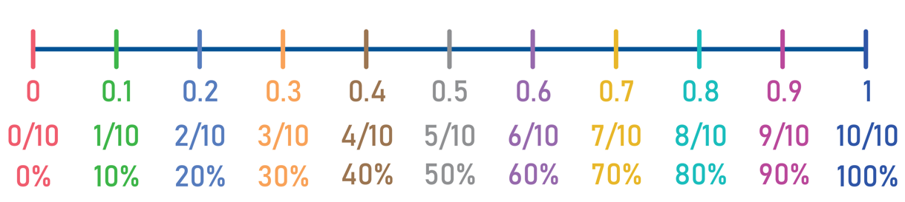

Learn About the Grade 7 Mathematics Standards
This table describes the areas of emphasis within Grade 7 and provides examples of specific expectations within each area of emphasis. The purpose of the areas of emphasis is not to guide specific units of learning and instruction but rather provide insight on major mathematical topics that will be covered within the grade level. The table below is not in any set order in which areas should be taught. Areas of emphasis may be taught in any order, combined with others and taught throughout the year.

Area of Emphasis | Examples
Recognize that fractions, decimals and percentages are different representations of rational numbers and perform all four operations with rational numbers with procedural fluency. | - Rewrite numbers in different but equivalent forms (fractions, decimals and percents).  - Add, subtract, multiply and divide with positive and negative rational numbers.
Create equivalent expressions and solve equations and inequalities. | - Add and subtract linear expressions with rational coefficients.  - Determine whether two linear expressions are equivalent.  - Write and solve one-step inequalities.  - Write and solve two-step equations with rational numbers.  - Apply the Laws of Exponents.
Develop an understanding of and apply proportional relationships in two variables. | - Apply percents and ratios to solve percent problems (tax, tip, markup, markdown, discount, simple interest and percent error).  - Determine whether two quantities have a proportional relationship, using a table, graph or written description.  - Given a mathematical or real-world situation, find the constant of proportionality.  - Solve conversions between the metric and customary systems.
Extend analysis of two- and three-dimensional figures to include circles and cylinders. | - Find the circumference and area of a circle.  - Find the area of a trapezoid, parallelogram and rhombus.  - Find the area of polygons by decomposing them into triangles or quadrilaterals.  - Solve problems involving scale drawings and scale factor.  - Find the surface area and volume of a right circular cylinder.
Represent and compare categorical and numerical data and develop an understanding of probability. | - Use the measure(s) of center and measure(s) of variation to make comparisons.  - Interpret data in circle graphs and create circle graphs from data.  - Compare the probabilities of chance events.  - Find the theoretical and experimental probability of an event related to a simple experiment.

B.E.S.T. Instructional Guide for Mathematics
The B.E.S.T. Instructional Guide for Mathematics (B1G-M) is intended to assist educators with planning for student learning and instruction aligned to Florida’s Benchmarks for Excellent Student Thinking (B.E.S.T.) Standards. This guide is designed to aid high-quality instruction through the identification of components that support the learning and teaching of the B.E.S.T. Mathematics Standards and Benchmarks. The B1G-M can be utilized by parents, guardians and families to support learning at home through the Instructional Strategies section.

This document is posted on the B.E.S.T. Standards for Mathematics webpage (https://www.fldoe.org/academics/standards/subject-areas/math-science/mathematics/bestmath.stml) of the Florida Department of Education’s website and will continue to undergo edits as needed.

Mathematical Words to Know and Use in Grade 7
Absolute Value | Constant of Proportionality | Line Plot | Percent of Change | Rate | Surface Area
Area | Customary Units | Linear Expression | Pi (π) | Rational Number | Theoretical Probability
Box Plot | Cylinder | Measures of Center (mean, median, and mode) | Polygon | Rectangle | Trapezoid
Capacity (e.g., ounces and liters) | Data | Measures of Variation (range, interquartile range [IQR]) | Population (in data analysis) | Rhombus | Triangle
Categorical Data | Diameter | Metric Units | Proportional Relationships | Sample Space | Unit Rates
Circle | Equation | Origin | Quadrilateral | Scale Factor | Volume
Circumference | Experimental Probability | Outlier | Quartiles | Simple Interest
Coefficient | Exponent | Parallelogram | Radius | Simulation
Composite Figure | Histogram | Percent Error | Random Sampling | Stem-and-Leaf Plot
This is not a comprehensive list – please access the 6-12 Glossary.
To access the full K-12 Mathematics Glossary, visit https://cpalmsmediaprod.blob.core.windows.net/uploads/docs/standards/best/ma/appendixc.pdf.

Support Learning at Home
You can encourage learning mathematics at home in ways that are fun for you and your student. Try these ideas after school, on weekends and during the summer:
- Practice vocabulary utilized within the Grade 7 course. Encourage math discourse within your family.
- Use everyday items. For example, have your child look at the battery life on their cell phone. If their battery is at 60% have them convert that percent to a fraction of $\frac{60}{100}$ and then a decimal of 0.60.
- Create a scavenger hunt using exponents within the clues. For example, the first clue can be found at $5^{1}\left(5^{0}+5^{0}\right)$ Main Street. [Answer = 10 Main Street]
- Take a trip to the store. Have them calculate the sale price of an item. For example, a jacket originally priced at $120 is on sale for 20% off, calculate the sale price. [Answer = $96]
- When out at a restaurant, have them calculate the sales tax and tip for the restaurant bill. For example, if you have a restaurant bill of $50 with a sales tax of 8% and you leave a 15% tip. [Answer = $62.10]
- Give your child a map and have them measure the distance from your home to school on the map versus the actual distance when driven. Here is another example, a map has a scale of 1:50, meaning 1 inch on the map represents 50 miles in reality. If the distance between two towns on the map is 6.5 inches, what is the actual distance between them? [Answer = 325 miles]
- Sit down as a family with your monthly budget and visualize how your money is spent. Use a circle graph (pie chart) to represent the different categories of your expenses. For example, Housing: $1,200, Food: $600, Utilities: $300, Transportation: $400, Entertainment: $200, and Savings: $300. Have them calculate the percentages for each category and then take those percentages and multiply by 360 degrees to find the angles for the sectors of the pie chart.
- Plan an outside activity and have your child check the weather forecast for both Saturday and Sunday. Have them compare the probability of rain for both days. For example, on Saturday there is a 30% chance of rain and on Sunday there is a 50% chance. There is a higher chance of rain on Sunday than on Saturday.

Talk with Your Student’s Teacher
Think about a parent-teacher conference as a “team meeting” in which you will discover the special contributions each of you bring to your student’s success. Here are some questions you could ask to prompt discussions:

What topic is my student currently working on? Which have they mastered? How can I support them at home?

In the area of mathematics, what are my student’s strengths? How are those strengths supported during instruction? Where is my student struggling and how can I help?

Can my student show you that they understand what they are learning about through manipulatives, drawing, talking and writing? If not, what challenges are they facing?

What additional resources can I use at home to support my student’s mathematical learning?

What behaviors should I see when my student is doing math? Can I see an example of the type of problems my student is given? How can I support them at home?

Mathematical Thinking and Reasoning Standards (MTRs)
Florida students are expected to engage with mathematics through the Mathematical Thinking and Reasoning Standards (MTRs). These standards are written in clear language so all stakeholders can understand them and teachers can assist students to use them as self-monitoring tools. The MTRs promote deeper learning and understanding of mathematics. By understanding the MTRs, parents, guardians and families can support the development of these skills at home.

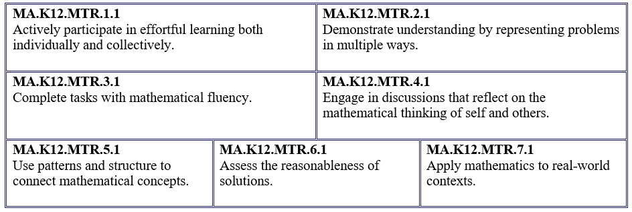

Your student will develop the above skills (MTRs) throughout their education and during their life. These skills will help maintain positive relationships through effective communication, collaboration, conflict resolution and problem solving.

Below are some ways you can help develop mathematical thinking and reasoning skills for your Grade 7 student:
- Encourage your student to ask questions when they do not understand what is being asked of them.
- Ask your student to estimate before determining a solution to the task at hand.
- Identify a problem and create a plan to tackle it in smaller steps that are more manageable.
- Try activities like a scavenger hunt or a puzzle.

By helping to develop your student’s mathematical thinking and reasoning skills, you will prepare them to become a confident, independent and successful individual.

Fluency
Building a strong numeracy foundation is critical to every child’s mathematical success. The B.E.S.T. Standards for Mathematics were developed to allow skills to build upon one another within a grade level as well as from one grade to the next. Benchmark expectations have been developed with a hierarchy in mind consisting of three stages: exploration, procedural reliability and procedural fluency. The three stages illustrated below show the stages students may work through when learning new skills and concepts.
Exploration
The expectation is to develop understanding through the use of manipulatives, visual models, discussions, estimation and drawings.
Procedural Reliability
The expectation is to utilize skills from the exploration stage to develop an accurate, reliable method that aligns with the student’s understanding and learning style. Students may need the teacher’s help to choose a method, and they will learn how to use a method without help.
Procedural Fluency
The expectation is to utilize skills from the procedural reliability stage to become fluent with an efficient, generalizable and accurate procedure, including a standard algorithm.
Automaticity
The expectation is to directly recall the rules for the Laws of Exponents and basic arithmetic facts and geometric formulas from memory. Automaticity is the ability to act according to an automatic response which is easily retrieved from long-term memory. It usually results from repetition and practice.

In Grade 7, students are expected to explore the circumference and area of a circle.
For example, have your student measure the diameter of any circle and then have them cut the length of the diameter out using a piece of string. Next, have your student count how many times the string can be wrapped around the outside of the circle. (This represents circumference.) Your student will discover that the diameter can be wrapped around the outside of the circle 3 times with a little bit left over. This represents π ($≈3.14$) which is the ratio of circumference to diameter.

For example, have your student determine which scenario would get you more pizza, 2 small personal pizzas with a radius of 5 inches or one large pizza with a radius of 10 inches. To find the area, have your student multiply 3.14 by the radius squared. After solving they will see the area of the small pizza is 78.5 ${inches}^{2}$, so two of them together would be 157 ${inches}^{2}$ while the area of the large pizza is 314 ${inches}^{2}$, so the large pizza would get you the most food.

In Grade 7, students are expected to be PROCEDURALLY FLUENT when adding, subtracting, multiplying and dividing rational numbers (fractions, decimals, negatives, etc.).
For example, $-\frac{5}{8}+ 2\frac{2}{3}$. [Answer: $2\frac{1}{24}$ or an approximate answer of 2.04167]

