The Benchmarks for Excellent Student Thinking (B.E.S.T.) Standards for Mathematics are the state’s mathematical standards that pave the way for Florida students to receive a world-class education and prepare them for a successful future.
These standards were written to:
Provide clarity on the grade-level expectations for educators, parents and students.

Allow students flexibility to solve problems using a method/strategy of their choice.

Allow for student discovery (i.e., exploration) of strategies rather than the teaching, naming and assessing of each strategy individually.

Education leaders from across the state came together to develop Florida’s B.E.S.T. Standards for Mathematics. These standards and benchmarks are goals that students are expected to achieve by the end of the school year. A standard is an overarching criterion for a grade level or grade band. A benchmark is a specific expectation or skill for the grade level or grade band that falls within a standard. The B.E.S.T. Standards are designed to ensure that ALL students reach their greatest potential.

Preparing your student for success begins in Kindergarten and continues as your child progresses through each grade. This guide will support parents, guardians and families with students in Grade 6 by helping them:

- Learn about the B.E.S.T. Standards for Mathematics and why they matter for your student.
- Understand important educational (academic) words that you will see in your student’s grade-level standards and benchmarks.
- Talk with your student’s teacher about what they will be learning in the classroom.
- Locate activities and resources to support your student’s learning in practical ways at home.

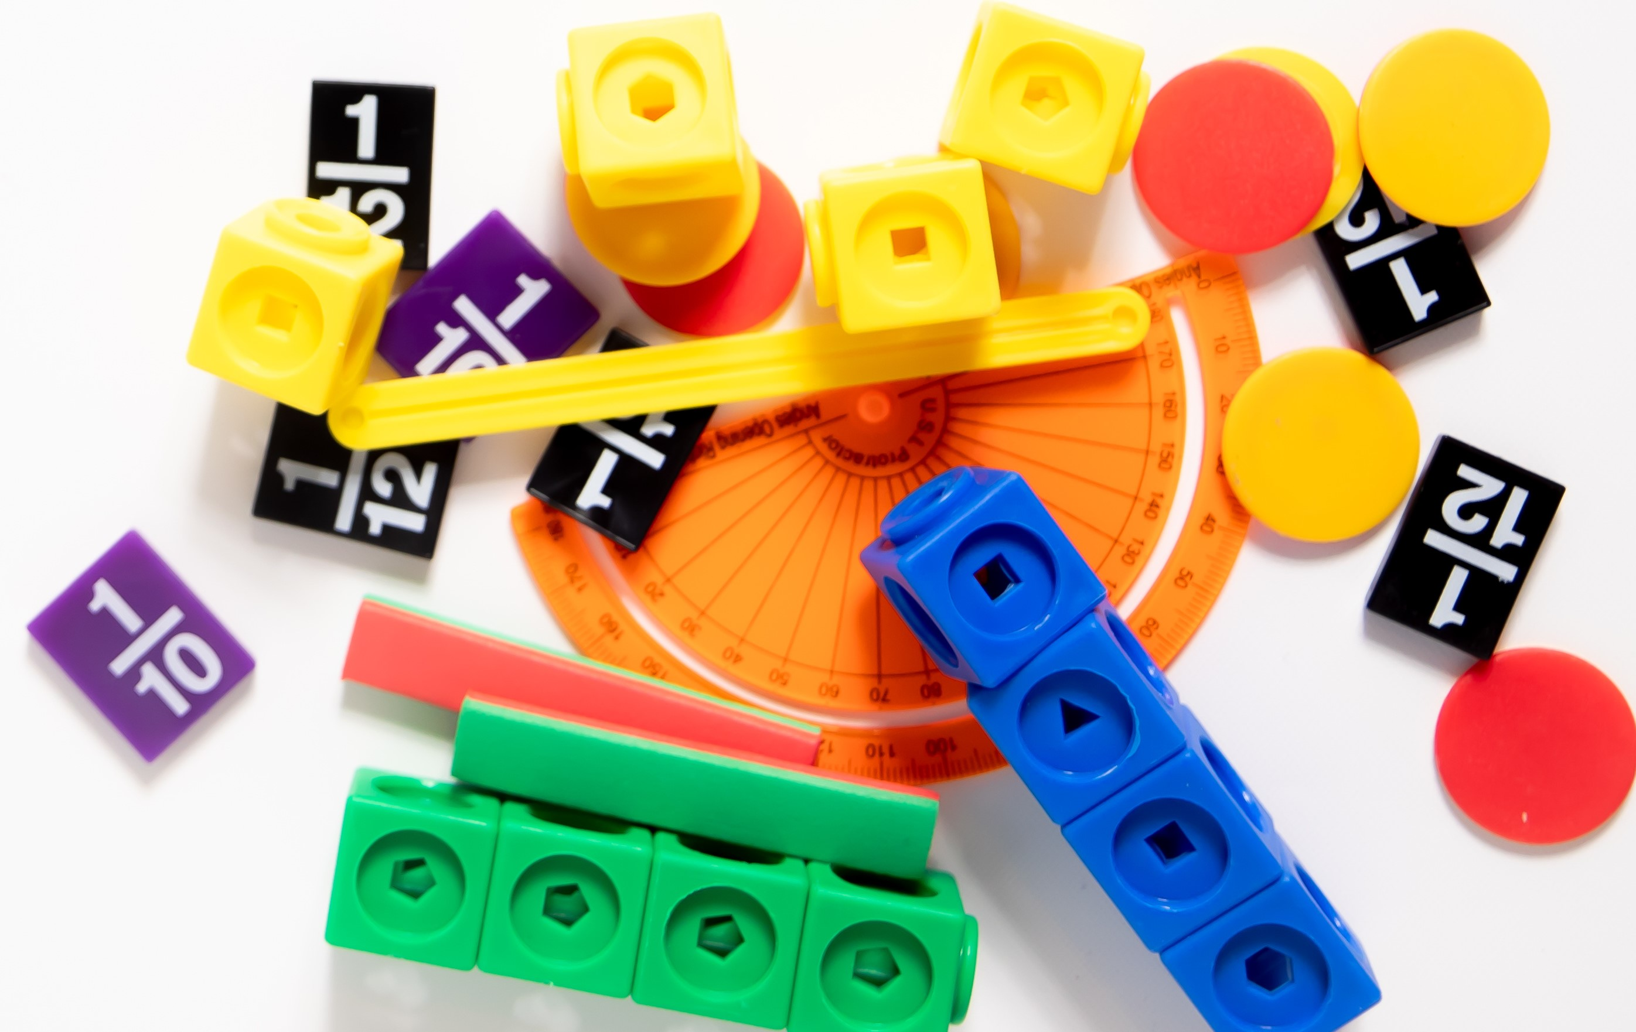

Learn About the Grade 6 Mathematics Standards
This table describes the areas of emphasis within Grade 6 and provides examples of specific expectations within each area of emphasis. The purpose of the areas of emphasis is not to guide specific units of learning and instruction but rather provide insight on major mathematical topics that will be covered within the grade level. The table below is not in any set order in which areas should be taught. Areas of emphasis may be taught in any order, combined with others and taught throughout the year.

Area of Emphasis | Examples
Perform all four operations with integers, positive decimals and positive fractions with procedural fluency. | - Understand the meaning of negative numbers.  - Plot, order and compare rational numbers (fractions, decimals, integers).  - Interpret the absolute value of a number as the distance from zero on a number line.  - Add, subtract, multiply and divide positive rational numbers.  - Rewrite positive numbers in different but equivalent forms (fractions, decimals and percents).
Explore and apply concepts of ratios, rates and percent to solve problems. | - Write and interpret ratios $\left(\frac{a}{b}, a:b, a to b\right)$.  - Calculate and interpret unit rate.  - Use ratios to solve problems involving percents (e.g., What is 20% of 50?).  - Solve conversions within the same measurement system.
Creates, interprets and uses expressions and equations. | - Translate written descriptions into algebraic expressions and translate algebraic expressions into written descriptions.  - Write and solve one-step equations.  - Write an inequality that represents a real-world situation.
Extend geometric reasoning to plotting points on the coordinate plane, area and volume of geometric figures. | - Plot positive and negative numbers in all four quadrants and on both axes.  - Find the area of a triangle.  - Find the area of quadrilaterals and composite figures by decomposing them into triangles and rectangles.  - Find the surface area and volume of right rectangular prisms.
Extend understanding of statistical thinking. | - Recognize and create a statistical question that would generate numerical data.  - Find and interpret mean, median, mode and range.  - Interpret numerical and categorical data; create graphical representations (box plots and histograms).

B.E.S.T. Instructional Guide for Mathematics
The B.E.S.T. Instructional Guide for Mathematics (B1G-M) is intended to assist educators with planning for student learning and instruction aligned to Florida’s Benchmarks for Excellent Student Thinking (B.E.S.T.) Standards. This guide is designed to aid high-quality instruction through the identification of components that support the learning and teaching of the B.E.S.T. Mathematics Standards and Benchmarks. The B1G-M can be utilized by parents, guardians and families to support learning at home through the Instructional Strategies section.

This document is posted on the B.E.S.T. Standards for Mathematics webpage (https://www.fldoe.org/academics/standards/subject-areas/math-science/mathematics/bestmath.stml) of the Florida Department of Education’s website and will continue to undergo edits as needed.

Mathematical Words to Know and Use in Grade 6
Base (of an exponent) | Customary Units | Integers | Number Line | Rate | Triangle
Box Plot | Data | Least Common Multiple (LCM) | Origin | Rational Number | Unit Rate
Cluster | Equation | Line Plot | Outlier | Reciprocal | Whole Number
Coefficient | Expression | Measures of Center (mean, median, mode) | Prime Factorization | Rectangle | X-Axis
Composite Number | Factor | Measures of Variability (range, interquartile range [IQR]) | Prime Number | Rectangular Prism | Y-Axis
Coordinate Plane | Greatest Common Factor (GCF) | Metric Units | Quadrant | Rectangular Pyramid
Cube | Histogram | Net | Quadrilateral | Statistical Question
This is not a comprehensive list – please access the 6-12 Glossary.
To access the full K-12 Mathematics Glossary, visit https://cpalmsmediaprod.blob.core.windows.net/uploads/docs/standards/best/ma/appendixc.pdf.

Support Learning at Home
You can encourage learning mathematics at home in ways that are fun for you and your student. Try these ideas after school, on weekends and during the summer:
- Practice vocabulary utilized within the Grade 6 course. Encourage math discourse within your family.
- Discuss the use of positive and negative numbers used in everyday life. For example, temperature falling below zero, banking deposits and debts, or gains and losses in football.
- Find the unit rate of an item while grocery shopping. For example, if you buy 5 pounds of apples for $10, the unit rate is calculated as $10 $÷$5 pounds = $2 per pound. So, each pound of apples costs $2.
- Solve for unit rate of real-world scenarios such as miles per hour, hourly job wage, internet speed, etc.
- Explore using inequalities through discussions utilizing the terms at least, no more than, less, maximum, etc. For example, if a classroom can hold a maximum of 30 students and n is the number of students enrolled, the inequality is: $n≤30$.
- Decomposing composite figures is an important skill throughout all math courses. Have students decompose a figure by determining what smaller shapes they can create. For example, draw an L-shaped figure. You can decompose the figure into two rectangles and find the area of each rectangle. After finding the area, add them together for the total area of the composite figure.
- Practice finding the volume of rectangular prisms (e.g., cereal box) in your home. First measure the length, width and height of the box. The volume ($V$) of the rectangular prism is calculated using the formula $V=l× w×h$.
- Explore finding the surface area (SA) of the rectangular prism. Unfold the cereal box to create a two-dimensional net of the rectangular prism, then find the area of all rectangles and add them together.
- As a family, track the number of minutes doing an activity (e.g., watching TV, playing a sport) for a week. Create a histogram and discuss the data.

Talk with Your Student’s Teacher
Think about a parent-teacher conference as a “team meeting” in which you will discover the special contributions each of you bring to your student’s success. Here are some questions you could ask to prompt discussions:

What topic is my student currently working on? Which have they mastered? How can I support them at home?

In the area of mathematics, what are my student’s strengths? How are those strengths supported during instruction? Where is my student struggling and how can I help?

Can my student show you that they understand what they are learning about through manipulatives, drawing, talking and writing? If not, what challenges are they facing?

What additional resources can I use at home to support my student’s mathematical learning?

What behaviors should I see when my student is doing math? Can I see an example of the type of problems my student is given? How can I support them at home?

Mathematical Thinking and Reasoning Standards (MTRs)
Florida students are expected to engage with mathematics through the Mathematical Thinking and Reasoning Standards (MTRs). These standards are written in clear language so all stakeholders can understand them and teachers can assist students to use them as self-monitoring tools. The MTRs promote deeper learning and understanding of mathematics. By understanding the MTRs, parents, guardians and families can support the development of these skills at home.

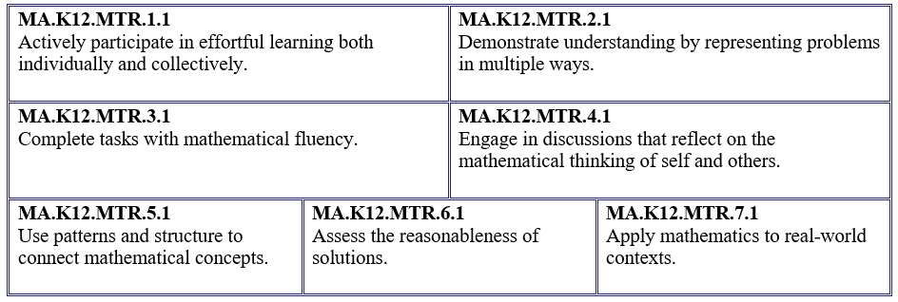

Your student will develop the above skills (MTRs) throughout their education and during their life. These skills will help maintain positive relationships through effective communication, collaboration, conflict resolution and problem solving.

Below are some ways you can help develop mathematical thinking and reasoning skills for your Grade 6 student:
- Encourage your student to ask questions when they do not understand what is being asked of them.
- Ask your student to estimate before determining a solution to the task at hand.
- Identify a problem and create a plan to tackle it in smaller steps that are more manageable.
- Try activities like a scavenger hunt or a puzzle.

By helping to develop your student’s mathematical thinking and reasoning skills, you will prepare them to become a confident, independent and successful individual.

Fluency
Building a strong numeracy foundation is critical to every child’s mathematical success. The B.E.S.T. Standards for Mathematics were developed to allow skills to build upon one another within a grade level as well as from one grade to the next. Benchmark expectations have been developed with a hierarchy in mind consisting of three stages: exploration, procedural reliability and procedural fluency. The three stages illustrated below show the stages students may work through when learning new skills and concepts.
Exploration
The expectation is to develop understanding through the use of manipulatives, visual models, discussions, estimation and drawings.
Procedural Reliability
The expectation is to utilize skills from the exploration stage to develop an accurate, reliable method that aligns with the student’s understanding and learning style. Students may need the teacher’s help to choose a method, and they will learn how to use a method without help.
Procedural Fluency
The expectation is to utilize skills from the procedural reliability stage to become fluent with an efficient, generalizable and accurate procedure, including a standard algorithm.
Automaticity
The expectation is to directly recall basic arithmetic facts and geometric formulas from memory. Automaticity is the ability to act according to an automatic response which is easily retrieved from long-term memory. It usually results from repetition and practice.

In Grade 6, students are expected to be PROCEDURALLY FLUENT when:

- Multiplying and dividing positive fractions by positive fractions, including mixed numbers.
For example, determine the product of $\frac{3}{5}$ and $\frac{4}{9}$ . [Answer: $\frac{12}{45}$ or an equivalent answer such as $\frac{4}{15}$ or the approximate answer of 0.267]

- Adding and subtracting integers.
For example, -8 + 2. [Answer: -6]

- Multiplying and dividing integers.
For example, find the quotient of -42 and -6. [Answer: 7]

