The Benchmarks for Excellent Student Thinking (B.E.S.T.) Standards for Mathematics are the state’s mathematical standards that pave the way for Florida students to receive a world-class education and prepare them for a successful future.

**These standards were written to:**

Provide clarity on the grade-level expectations for educators, parents and students.

Allow students flexibility to solve problems using a method/strategy of their choice.

Allow for student discovery (i.e., exploration) of strategies rather than the teaching, naming and assessing of each strategy individually.

Education leaders from across the state came together to develop Florida’s B.E.S.T. Standards for Mathematics. These standards and benchmarks are goals that students are expected to achieve by the end of the school year. A standard is an overarching criterion for a grade level or grade band. A benchmark is a specific expectation or skill for the grade level or grade band that falls within a standard. The B.E.S.T. Standards are designed to ensure that ALL students reach their greatest potential.

**Preparing your student for success begins in Kindergarten and continues as your child progresses through each grade. This guide will support parents, guardians and families with students in Grade 5 by helping them:**

* **Learn about the B.E.S.T. Standards for Mathematics and why they matter for your student.**
* **Understand important educational (academic) words that you will see in your student’s grade-level standards and benchmarks.**
* **Talk with your student’s teacher about what they will be learning in the classroom.**
* **Locate activities and resources to support your student’s learning in practical ways at home.**

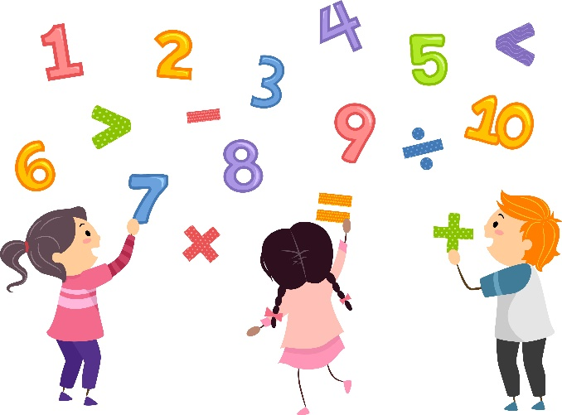

**Learn About the Grade 5 Mathematics Standards**

This table describes the areas of emphasis within Grade 5 and provides examples of specific expectations within each area of emphasis. The purpose of the areas of emphasis is not to guide specific units of learning and instruction, but rather provide insight on major mathematical topics that will be covered within the grade level. The table below is not in any set order in which areas should be taught. Areas of emphasis may be taught in any order, combined with others and taught throughout the year.

|  |  |
| --- | --- |
| **Area of Emphasis** | **Examples** |
| Multiply and divide multi-digit whole numbers, including using a standard algorithm. | * To demonstrate procedural fluency, students may choose a standard algorithm that works best for them and demonstrates their procedural fluency. * Divide multi-digit whole numbers, up to five digits by two digits, including using a standard algorithm with procedural fluency. Represent remainders as fractions. * A standard algorithm is a method that is efficient, accurate and always works. |
| Add and subtract fractions and decimals with procedural fluency, and develop an understanding of multiplication and division of fractions and decimals. | * Express how the value of a digit in a multi-digit number with decimals to the thousandths value changes depending on its place in the number. * Read and write multi-digit numbers with decimals to the thousandths using standard form, word form and expanded form. * Add and subtract multi-digit numbers with decimals to the thousandths, including using a standard algorithm with procedural fluency. * Plot, order and compare multi-digit numbers with decimals up to the thousandths. * Round multi-digit numbers with decimals to the thousandths to the nearest hundredth, tenth or whole number. * Explore the multiplication and division of multi-digit numbers with decimals to the hundredths using estimation, rounding and place value. * Multiply and divide a multi-digit number with decimals to the tenths by one-tenth and one-hundredth with procedural reliability. * Add and subtract fractions with unlike denominators, including mixed numbers and fractions greater than 1, with procedural reliability. * Multiply a fraction by a fraction, including mixed numbers and fractions greater than 1, with procedural reliability. * Explore the division of a unit fraction by a whole number and a whole number by a unit fraction. |
| Develop an understanding of the coordinate plane and plot pairs of numbers in the first quadrant. | * Identify the origin and axis in the coordinate system. * Plot and label ordered pairs in the first quadrant of the coordinate plane. * Plot points in the first quadrant of the coordinate plane and interpret coordinate values of points in the context of the situation. |

|  |  |
| --- | --- |
| **Area of Emphasis** | **Examples** |
| Extend geometric reasoning to include volume. | * Classify triangles or quadrilaterals into different categories based on shared defining attributes. * Explain why a triangle or quadrilateral would or would not belong to a category. * Identify and classify three-dimensional figures into categories based on their defining attributes. * Find the perimeter and area of a rectangle with fraction or decimal side lengths using visual models and formulas. * Explore volume as an attribute of three-dimensional figures by packing them with unit cubes without gaps. * Find the volume of a right rectangular prism with whole-number side lengths by counting unit cubes. * Find the volume of a right rectangular prism using a formula. |
| Extend understanding of data to include the mean. | * Collect and represent numerical data, including fractional and decimal values, using tables, line graphs or line plots. * Interpret numerical data, with whole-number values, represented with tables or line plots by determining the mean, mode, median or range. |

**B.E.S.T. Instructional Guide for Mathematics**

The B.E.S.T. Instructional Guide for Mathematics (B1G-M) is intended to assist educators with planning for student learning and instruction aligned to Florida’s Benchmarks for Excellent Student Thinking (B.E.S.T.) Standards. This guide is designed to aid high-quality instruction through the identification of components that support the learning and teaching of the B.E.S.T. Mathematics Standards and Benchmarks. The B1G-M can be utilized by parents, guardians and families to support learning at home through the Instructional Strategies section.

This document is posted on the B.E.S.T. Standards for Mathematics webpage (<https://www.fldoe.org/academics/standards/subject-areas/math-science/mathematics/bestmath.stml>) of the Florida Department of Education’s website and will continue to undergo edits as needed.

**Mathematical Words to Know and Use in Grade 5**

|  |  |  |  |  |  |
| --- | --- | --- | --- | --- | --- |
| Area | Difference | Formula | Number line | Quadrilateral | Vertex |
| Attribute | Dividend | Fraction greater than 1 | Numerator | Quotient | Vertical |
| Classify | Divisor | Horizontal | Numerical pattern | Range | Volume |
| Cone | Edge | Line graph | Order of operations | Rectangular prism | Whole number |
| Conversions | Equal sign | Line plot | Origin | Remainder | $x$-axis |
| Coordinate plane | Equation | Mean | Perimeter | Rounding | $y$-axis |
| Cube | Equivalent | Median | Place value | Sphere |  |
| Cylinder | Estimate | Mixed number | Plot | Sum |  |
| Decimal | Expression | Mode | Product | Triangle |  |
| Denominator | Factors | Multiples | Quadrant | Unit fraction |  |

*Note: This is not a comprehensive list – please access the K-5 Glossary at* [*https://cpalmsmediaprod.blob.core.windows.net/uploads/docs/standards/best/ma/appendixc.pdf*](https://cpalmsmediaprod.blob.core.windows.net/uploads/docs/standards/best/ma/appendixc.pdf)*.*

**Support Learning at Home**

You can encourage learning mathematics at home in ways that are fun for you and your student. Try these ideas after school, on weekends and during the summer:

* When buying cases of water at the store, have your child help calculate the total ounces being purchased for several cases.
* Sort various household items that match geometric shapes into categories such as “opposite sides are parallel” or “at least 1 right angle.”
* Choose a race car driver to calculate the average lap speed. Compare these average speeds to other tracks that the race car driver has raced.
* When you send something in the mail that is in a box, let your child assist in measuring the box’s dimensions and calculating its volume.
* Have your child come up with an expression to match the scenario you provide. For instance, you might say, “Your favorite football team gets 14 points in the first half and doubles that amount in the second half. What expression shows the total points the team has?” Then, let your child say or write down the expression (e.g., 14 + 2 x 14).

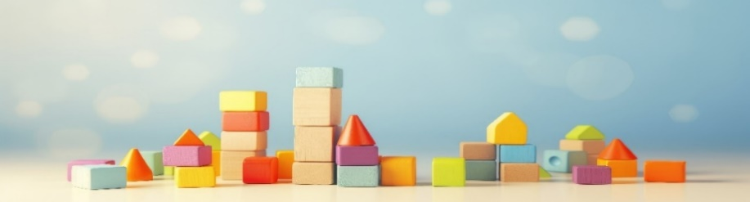

**Talk with Your Student’s Teacher**

Remember, you are your student’s first teacher. Think about a parent-teacher conference as a “team meeting” in which you will discover the special contributions each of you bring to your student’s success. Here are some questions you could ask to prompt discussions:

What multiplication and/or division strategies is my student working on? Which have they mastered? How can I support them at home?

In the area of mathematics, what are my student’s strengths? How are those strengths supported during instruction? Where is my student struggling and how can I help?

Can my student show you that they understand what they are learning about through manipulatives, drawing, talking and writing? If not, what challenges are they facing?

What topics in connection to science and social studies is my student learning about through math?

What behaviors should I see when my student is doing math? Can I see an example of the type of problems my student is given? How can I support them at home?

**Mathematical Thinking and Reasoning Standards (MTRs)**

Florida students are expected to engage with mathematics through the Mathematical Thinking and Reasoning Standards (MTRs). These standards are written in clear language so all stakeholders can understand them, and teachers can assist students to use them as self-monitoring tools. The MTRs promote deeper learning and understanding of mathematics. By understanding the MTRs, parents, guardians and families can support the development of these skills at home.

**MA.K12.MTR.1.1 Actively participate in effortful learning both individually and collectively. MA.K12.MTR.2.1 Demonstrate understanding by representing problems in multiple ways. MA.K12.MTR.3.1 Complete tasks with mathematical fluency. MA.K12.MTR.4.1 Engage in discussions that reflect on the mathematical thinking of self and others.
MA.K12.MTR.5.1
Use patterns and structure to connect mathematical concepts.
MA.K12.MTR.6.1
Assess the reasonableness of solutions.
MA.K12.MTR.7.1
Apply mathematics to real-world contexts.**

Your student will develop the above skills (MTRs) throughout their education and during their life. These skills will help maintain positive relationships through effective communication, collaboration, conflict resolution and problem solving.

Below are some ways you can help develop mathematical thinking and reasoning skills for your Grade 5 student:

* Encourage your student to ask questions when they do not understand what is being asked of them.
* Ask your student to estimate before determining a solution to the task at hand.
* Identify a problem and create a plan to tackle it in smaller steps that are more manageable.
* Try activities like a scavenger hunt or a puzzle.

By helping to develop your student’s mathematical thinking and reasoning skills, you will prepare them to become a confident, independent and successful individual.

**Fluency**

Building a strong numeracy foundation is critical to every child’s mathematical success. The B.E.S.T. Standards for Mathematics were developed to allow skills to build upon one another within a grade level as well as from one grade to the next. Benchmark expectations have been developed with a hierarchy in mind consisting of three stages: exploration, procedural reliability and procedural fluency. The three stages illustrated below show the stages students may work through when learning new skills and concepts.

**Exploration**

The expectation is to develop understanding through the use of manipulatives, visual models, discussions, estimation and drawings.

**Procedural Reliability**

The expectation is to utilize skills from the exploration stage to develop an accurate, reliable method that aligns with the student’s understanding and learning style. Students may need the teacher’s help to choose a method, and they will learn how to use a method without help.

**Procedural Fluency**

The expectation is to utilize skills from the procedural reliability stage to become fluent with an efficient, generalizable and accurate procedure, including a standard algorithm.

**Automaticity**

The expectation is to directly recall basic arithmetic facts or geometric formulas from memory. Automaticity is the ability to act according to an automatic response which is easily retrieved from long-term memory. It usually results from repetition and practice.

In Grade 5, students are expected to demonstrate procedural fluency while multiplying multi-digit whole numbers. To do that, students may choose a standard algorithm that works best for them and demonstrates their procedural fluency. There is no limit on the number of digits for multiplication in grade 5.

For example, determine the product of 245 and 136 using a method that is efficient, generalizable (it works correctly no matter how many digits are involved) and accurate using skills learned from the procedural reliability stage of fluency.

Within these concepts, students are also expected to become procedurally reliable with adding and subtracting fractions with unlike denominators, including mixed numbers and fractions greater than 1.

For example, when adding or subtracting fractions with unlike denominators, equivalent fractions are generated to rewrite the fractions with like denominators.

Grade 5 students are also exploring multiplication and division of multi-digit numbers with decimals using estimation, rounding, place value and exploring the relationship between multiplication and division.

For example, if students know the product of 8 × 7 and the quotient of 56 ÷ 4, then they can reason through 0.08 × 7 or 5.6 ÷ 0.4 through place value relationships. Allow children to explore these patterns and use them to estimate products and quotients.