ShapeThe Benchmarks for Excellent Student Thinking (B.E.S.T.) Standards for Mathematics are the state’s mathematical standards that pave the way for Florida students to receive a world-class education and prepare them for a successful future.

**These standards were written to:**

Provide clarity on the grade-level expectations for educators, parents and students.

Allow students flexibility to solve problems using a method/strategy of their choice.

Allow for student discovery (i.e., exploration) of strategies rather than the teaching, naming and assessing of each strategy individually.

Education leaders from across the state came together to develop Florida’s B.E.S.T. Standards for Mathematics. These standards and benchmarks are goals that students are expected to achieve by the end of the school year. A standard is an overarching criterion for a grade level or grade band. A benchmark is a specific expectation or skill for the grade level or grade band that falls within a standard. The B.E.S.T. Standards are designed to ensure that ALL students reach their greatest potential.

**Preparing your student for success begins in Kindergarten and continues as your child progresses through each grade. This guide will support parents, guardians and families with students in Grade 3 Accelerated by helping them:**

* **Learn about the B.E.S.T. Standards for Mathematics and why they matter for your student.**
* **Understand important educational (academic) words that you will see in your student’s grade-level standards and benchmarks.**
* **Talk with your student’s teacher about what they will be learning in the classroom.**
* **Locate activities and resources to support your student’s learning in practical ways at home.**

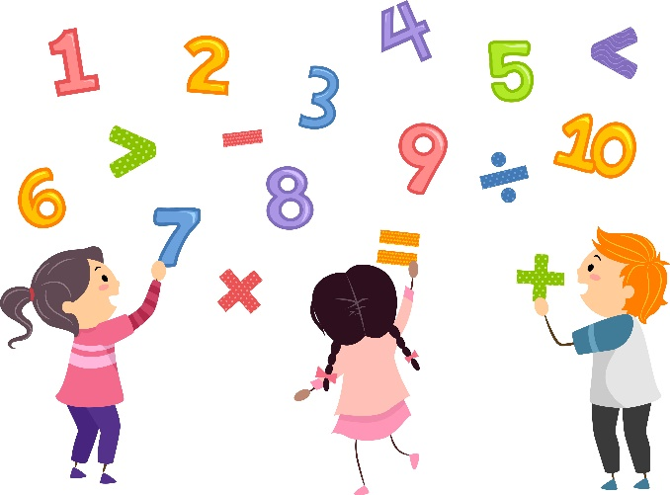

**Learn About the Grade 3 Accelerated Mathematics Standards**

This table describes the areas of emphasis within Grade 3 Accelerated and provides examples of specific expectations within each area of emphasis. The purpose of the areas of emphasis is not to guide specific units of learning and instruction, but rather provide insight on major mathematical topics that will be covered within the grade level. The table below is not in any set order in which areas should be taught. Areas of emphasis may be taught in any order, combined with others and taught many times throughout the year.

|  |  |
| --- | --- |
| **Area of Emphasis** | **Examples** |
| Extending understanding of place value in multi-digit whole numbers. | * Read and write multi-digit whole numbers from 0 to 1,000,000 using standard form (e.g., 54,278), expanded form (e.g., 50,000 + 4,000 + 200 + 70 + 8) and word form (e.g., fifty-four thousand two hundred seventy-eight). * Plot, order and compare multi-digit whole numbers up to 1,000,000 (e.g., the numbers 75,421; 74,241 and 74,521 can be arranged in ascending order as 74,241; 74,521 and 75,421). * Round whole numbers from 0 to 10,000 to the nearest 10, 100 or 1,000 (e.g., the number 6,325 is rounded to 6,300 when rounded to the nearest 100; 6330 when rounded to the nearest 10 and 6,000 when rounded to the nearest 1,000). |
| Adding and subtracting multi-digit whole numbers, including using a standard algorithm. | * Recognize and examine place value up to the thousands place. * Explain when regrouping happens and identify the place value that is regrouped. * Solve multi-digit addition and subtraction with accuracy and efficiency. * Compose and decompose four-digit numbers in multiple ways using thousands, hundreds, tens and ones (e.g., the number 5,783 can be expressed as 5 thousands + 7 hundreds + 8 tens + 3 ones or as 56 hundreds + 183 ones). * Check calculations when solving problems using the inverse operation. |
| Building an understanding of multiplication and division, the relationship between them and the connection to area of rectangles. | * Multiply two whole numbers, up to three digits by up to two digits, with procedural reliability. * Connect area to arrays and equal groups. * Develop a formula for area and perimeter based on understanding of multiplication and attributes of shapes. * Find the area of a rectangle with whole-number side lengths using a visual model and a multiplication formula. * Solve mathematical and real-world problems involving the perimeter and area of composite figures composed of non-overlapping rectangles with whole-number side lengths. * Recall multiplication facts with factors up to 12 and related division facts with automaticity. |

|  |  |
| --- | --- |
| **Area of Emphasis** | **Examples** |
| Developing an understanding of fractions. | * Recognize the difference between the meaning of numerators and denominators in fractions. * Recognize that as the denominator decreases, each part becomes larger, and as the denominator increases, each part becomes smaller. * Represent fractions using manipulatives (e.g., fraction strips and circles), visual area models (e.g., partitioned shapes) and on a number line. * Count by unit fractions. * Explain how fractions are equivalent or not equivalent using models or an explanation. * Add and subtract fractions with like denominators, including mixed numbers and fractions greater than one, with procedural reliability. * Solve real-world problems involving addition and subtraction of fractions with like denominators, including mixed numbers and fractions greater than one. |
| Extending geometric reasoning to lines and attributes of quadrilaterals. | * Identify evidence of these geometric characteristics in real-life images (e.g., aerial views of city maps, photos of objects). * Use math vocabulary when identifying geometric lines and figures. * Fold paper in various shapes, images, letters, etc. to determine if there are lines of symmetry or not. * Draw lines of symmetry and identify line-symmetric figures. * Understand angles and how they can be identified in lines and shapes (e.g., right angle, straight angle, etc.). * Understand that angles can be precisely measured. |

**B.E.S.T. Instructional Guide for Mathematics**

The B.E.S.T. Instructional Guide for Mathematics (B1G-M) is intended to assist educators with planning for student learning and instruction aligned to Florida’s Benchmarks for Excellent Student Thinking (B.E.S.T.) Standards. This guide is designed to aid high-quality instruction through the identification of components that support the learning and teaching of the B.E.S.T. Mathematics Standards and Benchmarks. The B1G-M can be utilized by parents, guardians and families to support learning at home through the Instructional Strategies section.

This document is posted on the B.E.S.T. Standards for Mathematics webpage (<https://www.fldoe.org/academics/standards/subject-areas/math-science/mathematics/bestmath.stml>) of the Florida Department of Education’s website and will continue to undergo edits as needed.

**Mathematical Words to Know and Use in Grade 3 Accelerated**

|  |  |  |  |  |  |
| --- | --- | --- | --- | --- | --- |
| Acute angle | Commutative property of multiplication | Equal Sign | Line | Perimeter | Standard form |
| Angle | Composite Figure | Equation | Line plot | Perpendicular | Straight angle |
| Area | Denominator | Equivalent | Line Segments | Place Value | Stem-and-leaf plot |
| Area model | Descending | Estimate | Liquid Volume | Polygon | Whole number |
| Ascending | Difference | Expanded form | Multiplication | Points |  |
| Attribute | Digit | Expression | Number Line | Prime number |  |
| Associative property of multiplication | Distributive Property | Factors | Numerator | Product |  |
| Bar graph | Dividend | Intersecting | Numerical data | Quotient |  |
| Categorical data | Division | Inverse | Obtuse angle | Reflex angle |  |
| Circle | Divisor | Labels | Parallel | Right angle |  |

*Note: This is not a comprehensive list – please access the K-5 Glossary at* [*https://cpalmsmediaprod.blob.core.windows.net/uploads/docs/standards/best/ma/appendixc.pdf*](https://cpalmsmediaprod.blob.core.windows.net/uploads/docs/standards/best/ma/appendixc.pdf)*.*

**Support Learning at Home**

You can encourage learning mathematics at home in ways that are fun for you and your student. Try these ideas after school, on weekends and during the summer:

* Create a shopping list with your child and determine how much money will be needed before going to the store by adding the costs of each item.
* Using a set of dominoes, each player selects two and multiplies the numbers to find their total. Players can compare their totals (products) and the player with the greater total wins the dominoes.
* Find numbers in or out of the home. Ask if it has any factors (two numbers that can be multiplied together to make that number), and if it’s prime or composite (e.g., A speed limit sign indicates 40 mph. What two numbers could we multiply together to make 40? If two numbers or factors can be found, then 40 is a composite number.)
* Use measuring cups (including teaspoons) when cooking or baking to show how different measurements compare to each other (e.g., ⅛ tsp. is smaller than ¼ tsp. or ½ cup is larger than ¼ cup).
* Use a chocolate candy bar to show how smaller pieces of the same size can be put together to make a whole.
* Look at a picture in a book, magazine or online and have your child identify the different types of angles they see.
* Using a digital or analog clock, tell time to the minute using a.m. and p.m. appropriately.
* Determine how much time has passed (elapsed time) between two events. For example, a bus picks up Kimberly at 6:45 a.m. and arrives at school at 8:15 a.m. How long was her bus ride?
* Point out intersecting lines, perpendicular lines and parallel lines on signs, in stores and when out in nature.
* Have your child assist you with solving problems involving sharing or dividing quantities. For example, you may have to cut a 60-inch piece of fabric into 12 equal pieces. Therefore, each piece is 5 inches long.
* Get your child to help you find equivalent fractions and compare fractions during everyday activities. For instance, if someone mentions, “The grocery store is about 1/2 of a mile from the school,” you could respond, “Our house is about 6/8 of a mile from the school. Which is farther away?”
* Pay attention to angles at home or when you’re out, like angles in furniture, buildings or patterns in fabric. Get your child to identify the type of angle and estimate its measure.

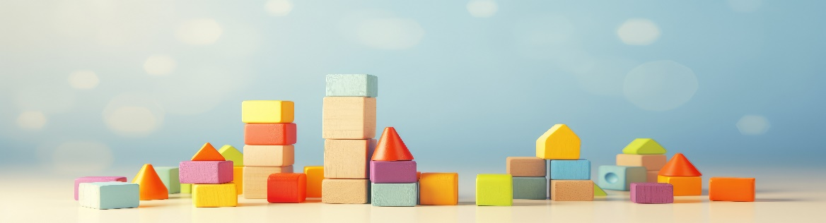

**Talk with Your Student’s Teacher**

Remember, you are your student’s first teacher. Think about a parent-teacher conference as a “team meeting” in which you will discover the special contributions each of you bring to your student’s success. Here are some questions you could ask to prompt discussions:

Which facts or figures are my student working on? Which have they mastered? How can I support them at home?

In the area of mathematics, what are my student’s strengths? How are those strengths supported during instruction? Where is my student struggling and how can I help?

Can my student show you that they understand what they are learning about through manipulatives, drawing, talking and writing? If not, what challenges are they facing?

What topics in connection to science and social studies is my student learning about through math?

What behaviors should I see when my student is doing math? Can I see an example of the type of problems my student is given? How can I support them at home?

**Mathematical Thinking and Reasoning Standards (MTRs)**

Florida students are expected to engage with mathematics through the Mathematical Thinking and Reasoning Standards (MTRs). These standards are written in clear language so all stakeholders can understand them and teachers can assist students to use them as self-monitoring tools. The MTRs promote deeper learning and understanding of mathematics. By understanding the MTRs, parents, guardians and families can support the development of these skills at home.

Your student will develop the above skills (MTRs) throughout their education and during their life. These skills will help maintain positive relationships through effective communication, collaboration, conflict resolution and problem solving.

**MA.K12.MTR.1.1 Actively participate in effortful learning both individually and collectively. MA.K12.MTR.2.1 Demonstrate understanding by representing problems in multiple ways. MA.K12.MTR.3.1 Complete tasks with mathematical fluency. MA.K12.MTR.4.1 Engage in discussions that reflect on the mathematical thinking of self and others.
MA.K12.MTR.5.1
Use patterns and structure to connect mathematical concepts.
MA.K12.MTR.6.1
Assess the reasonableness of solutions.
MA.K12.MTR.7.1
Apply mathematics to real-world contexts.**Below are some ways you can help develop mathematical thinking and reasoning skills for your Grade 3 Accelerated student:

* Encourage your student to ask questions when they do not understand what is being asked of them.
* Ask your student to estimate before determining a solution to the task at hand.
* Identify a problem and create a plan to tackle it in smaller steps that are more manageable.
* Try activities like a scavenger hunt or a puzzle.

By helping to develop your student’s mathematical thinking and reasoning skills, you will prepare them to become a confident, independent and successful individual.

**Fluency**

Building a strong numeracy foundation is critical to every child’s mathematical success. The B.E.S.T. Standards for Mathematics were developed to allow skills to build upon one another within a grade level as well as from one grade to the next. Benchmark expectations have been developed with a hierarchy in mind consisting of three stages: exploration, procedural reliability and procedural fluency. The three stages illustrated below show the stages students may work through when learning new skills and concepts.

**Exploration**

The expectation is to develop understanding through the use of manipulatives, visual models, discussions, estimation and drawings.

**Procedural Reliability**

The expectation is to utilize skills from the exploration stage to develop an accurate, reliable method that aligns with the student’s understanding and learning style. Students may need the teacher’s help to choose a method, and they will learn how to use a method without help.

**Procedural Fluency**

The expectation is to utilize skills from the procedural reliability stage to become fluent with an efficient, generalizable and accurate procedure, including a standard algorithm.

**Automaticity**

The expectation is to directly recall basic arithmetic facts and/or geometric formulas from memory. Automaticity is the ability to act according to an automatic response which is easily retrieved from long-term memory. It usually results from repetition and practice.

In Grade 3 Accelerated, students are expected to add and subtract multi-digit whole numbers up to the ten-thousands place with procedural fluency.

For example, determine the sum of 5,267 and 2,412. Students may use a standard algorithm or a strategy that is reliable and accurate for them. Therefore, 5,267 + 2,412 = 7,679.

For example, determine the difference between 5,267 and 2412. Students may use a standard algorithm or a strategy that is reliable and accurate for them. Therefore, 5,267 – 2,412 = 2,855.

Students are also expected to become procedurally reliable with the addition and subtraction of fractions with like denominators.

For example, students may add by rewriting the expression 1 $\frac{4}{5}$ + 4 $\frac{3}{5}$ as 1 + 4 + $\frac{4}{5}$ + $\frac{3}{5}$ using the associative property of addition. Therefore, 1 $\frac{4}{5}$ + 4 $\frac{3}{5}$ = 6 $\frac{2}{5}$.

In addition, students are expected to recall multiplication of whole numbers with products from 0 to 144 and division with related facts with automaticity.

For example, explain how the 2s facts, 4s facts and 8s facts for multiplication are related. Explaining

doubles (2s facts), double and double again (4s), and doubling three times (8s) demonstrates repetition and practice needed to build automaticity. It is not recommended to use timed fact fluency activities to learn and practice facts.