The Benchmarks for Excellent Student Thinking (B.E.S.T.) Standards for Mathematics are the state’s mathematical standards that pave the way for Florida students to receive a world-class education and prepare them for a successful future.

**These standards were written to:**

Provide clarity on the grade-level expectations for educators, parents and students.

Allow students flexibility to solve problems using a method/strategy of their choice.

Allow for student discovery (i.e., exploration) of strategies rather than the teaching, naming and assessing of each strategy individually.

Education leaders from across the state came together to develop Florida’s B.E.S.T. Standards for Mathematics. These standards and benchmarks are goals that students are expected to achieve by the end of the school year. A standard is an overarching criterion for a grade level or grade band. A benchmark is a specific expectation or skill for the grade level or grade band that falls within a standard. The B.E.S.T. Standards are designed to ensure that ALL students reach their greatest potential.

**Preparing your student for success begins in Kindergarten and continues as your child progresses through each grade. This guide will support parents, guardians and families with students in Grade 1 by helping them:**

* **Learn about the B.E.S.T. Standards for Mathematics and why they matter for your student.**
* **Understand important educational (academic) words that you will see in your student’s grade-level standards and benchmarks.**
* **Talk with your student’s teacher about what they will be learning in the classroom.**
* **Locate activities and resources to support your student’s learning in practical ways at home.**

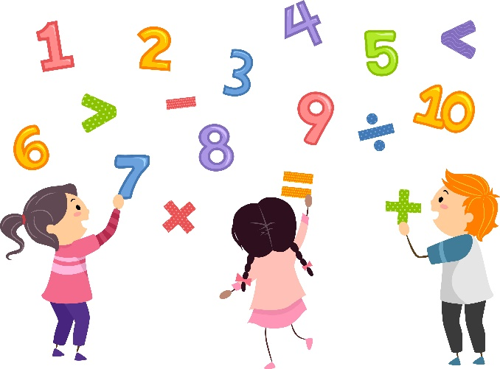

**Learn About the Grade 1 Mathematics Standards**

This table describes the areas of emphasis within Grade 1 and provides examples of specific expectations within each area of emphasis. The purpose of the areas of emphasis is not to guide specific units of learning and instruction, but rather provide insight on major mathematical topics that will be covered within the grade level. The table below is not in any set order in which areas should be taught. Areas of emphasis may be taught in any order, combined with others and taught throughout the year.

|  |  |
| --- | --- |
| **Area of Emphasis** | **Examples** |
| Understand the place value of tens and ones within two-digit whole numbers. | * Starting at a given number, count forward and backward within 120 by ones. * Skip count by 2s to 20 and by 5s to 100. * Read and write numbers from 0 to 100 in standard form, expanded form and word form (e.g., standard form: 52; expanded form: 50 + 2; word form: fifty-two). Emphasis is not on spelling. * Compose and decompose two-digit numbers in multiple ways using tens and ones (e.g., composing: building the number 48 from tens and ones: 4 tens & 8 ones; then decomposing 48 into tens and ones: 4 tens & 8 ones.). |
| Extend understanding of addition and subtraction and the relationship between them. | * Recall addition facts with sums to 10 and related subtraction facts with automaticity. **Automaticity is usually the result of repetition and practice. The focus should not be placed on speed.** * Add two whole numbers with sums from 0 to 20. * Identify the number that is one more, one less, ten more and ten less than a given two-digit number. * Explore the addition and subtraction of a two-digit number and a one-digit number with sums to 100 and differences from 99. |
| Develop an understanding of measurement of physical objects, money and time. | * Estimate the length of an object to the nearest inch. Measure the length of an object to the nearest inch or centimeter. * Using analog and digital clocks, tell and write time in hours and half hours. * Identify pennies, nickels, dimes and quarters, and express their values using the ¢ symbol. State how many of each coin equals a dollar. * Find the value of combinations of coins listed above up to one dollar and bills up to $100. Use the ¢ and $ symbols appropriately. |
| Categorize, compose and decompose geometric figures. | * Identify, compare, sort, compose and decompose two- and three-dimensional figures based on their characteristics. Figures are limited to circles, semi-circles, triangles, rectangles, squares, trapezoids, hexagons, spheres, cubes, rectangular prisms, cones and cylinders. * Sketch triangles, rectangles, squares and hexagons when given characteristics. * Identify shapes in real-world situations. |

**B.E.S.T. Instructional Guide for Mathematics**

The B.E.S.T. Instructional Guide for Mathematics (B1G-M) is intended to assist educators with planning for student learning and instruction aligned to Florida’s Benchmarks for Excellent Student Thinking (B.E.S.T.) Standards. This guide is designed to aid high-quality instruction through the identification of components that support the learning and teaching of the B.E.S.T. Mathematics Standards and Benchmarks. The B1G-M can be utilized by parents, guardians and families to support learning at home through the Instructional Strategies section.

This document is posted on the B.E.S.T. Standards for Mathematics webpage (<https://www.fldoe.org/academics/standards/subject-areas/math-science/mathematics/bestmath.stml>) of the Florida Department of Education’s website and will continue to undergo edits as needed.

**Mathematical Words to Know and Use in Grade 1**

|  |  |  |  |  |  |
| --- | --- | --- | --- | --- | --- |
| Addition | Cylinder | Equal sign | Length | Quarter | Subtraction |
| Cent | Data | Equation | Nickel | Recall | Sum |
| Centimeter | Decompose | Expression | Number line | Rectangle | Tally marks |
| Circle | Difference | Fourths | Partition | Rectangular prism | Trapezoid |
| Compose | Dime | Hexagon | Penny | Skip counting | Triangle |
| Cone | Dollar | Halves | Pictograph | Sphere | Vertex |
| Cube | Edge | Inch | Place value | Square |  |

*Note: Within Grade 1, it is not the expectation that students be able to spell each of these words.*

*This is not a comprehensive list – please access the K-5 Glossary at* [*https://cpalmsmediaprod.blob.core.windows.net/uploads/docs/standards/best/ma/appendixc.pdf*](https://cpalmsmediaprod.blob.core.windows.net/uploads/docs/standards/best/ma/appendixc.pdf)*.*

**Support Learning at Home**

You can encourage learning mathematics at home in ways that are fun for you and your student. Try these ideas after school, on weekends and during the summer:

* Practice counting with everyday activities beginning at a given number. When walking into a store, count the number of steps from the car to the store and when leaving the store count the steps from the store back to the car, picking up from the number of steps to get to the store from the car.
* Skip count by 2s or 5s when counting coins, snacks or toys. Use nickels to skip count by fives.
* Talk about the total number of objects. Ask, “What is 1 more or 1 less? What is 10 more or 10 less?” Use pennies and dimes to practice 1 more or 1 less and 10 more or 10 less.
* Practice addition and subtraction facts to 10. Say, “You have 5 toy cars. Shelby gives you 2 more toy cars. How many will you have?” By the end of Grade 1, your child should be comfortable adding with sums between 0 and 20 and subtracting with related facts.
* Be on the lookout for geometric shapes. The park/playground or the grocery store are good places to search for and name circles, semi-circles, triangles, rectangles, squares, trapezoids, hexagons, spheres, cubes, rectangular prisms, cones and cylinders.
* When at the store, ask for your children to help count coins and bills for items.
* Have your child help tell time to the hour and half-hour when planning out the day.

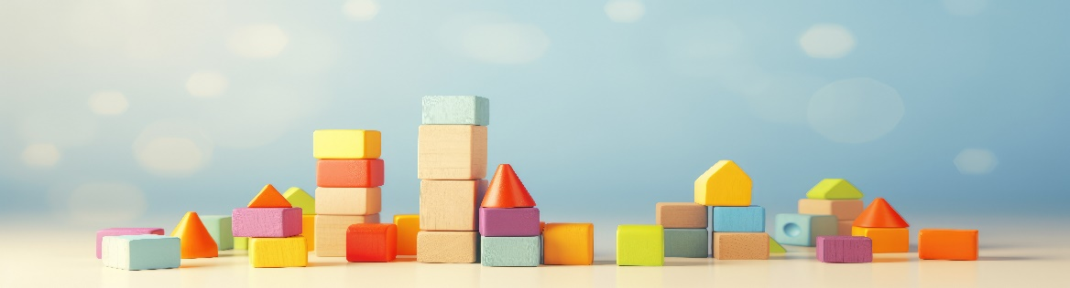

**Talk with Your Student’s Teacher**

Remember, you are your student’s first teacher. Think about a parent-teacher conference as a “team meeting” in which you will discover the special contributions each of you bring to your student’s success. Here are some questions you could ask to prompt discussions:

Which numbers or shapes is my student working on? Which have they mastered? How can I support them at home?

In the area of mathematics, what are my student’s strengths? How are those strengths supported during instruction? Where is my student struggling and how can I help?

Can my student show you that they understand what they are learning about through manipulatives, drawing, talking and writing? If not, what challenges are they facing?

What topics in connection to science and social studies is my student learning about through math?

What behaviors should I see when my student is doing math? Can I see an example of the type of problems my student is given? How can I support them at home?

**Mathematical Thinking and Reasoning Standards (MTRs)**

Florida students are expected to engage with mathematics through the Mathematical Thinking and Reasoning Standards (MTRs). These standards are written in clear language so all stakeholders can understand them and teachers can assist students to use them as self-monitoring tools. The MTRs promote deeper learning and understanding of mathematics. By understanding the MTRs, parents, guardians and families can support the development of these skills at home.

**MA.K12.MTR.1.1 Actively participate in effortful learning both individually and collectively. MA.K12.MTR.2.1 Demonstrate understanding by representing problems in multiple ways. MA.K12.MTR.3.1 Complete tasks with mathematical fluency. MA.K12.MTR.4.1 Engage in discussions that reflect on the mathematical thinking of self and others.
MA.K12.MTR.5.1
Use patterns and structure to connect mathematical concepts.
MA.K12.MTR.6.1
Assess the reasonableness of solutions.
MA.K12.MTR.7.1
Apply mathematics to real-world contexts.**Your student will develop the above skills (MTRs) throughout their education and during their life. These skills will help maintain positive relationships through effective communication, collaboration, conflict resolution and problem solving.

Below are some ways you can help develop mathematical thinking and reasoning skills for your Grade 1 student:

* Encourage your student to ask questions when they do not understand what is being asked of them.
* Ask your student to estimate before determining a solution to the task at hand.
* Identify a problem and create a plan to tackle it in smaller steps that are more manageable.
* Try activities like a scavenger hunt or a puzzle.

By helping to develop your student’s mathematical thinking and reasoning skills, you will prepare them to become a confident, independent and successful individual.

**Fluency**

Building a strong numeracy foundation is critical to every child’s mathematical success. The B.E.S.T. Standards for Mathematics were developed to allow skills to build upon one another within a grade level as well as from one grade to the next. Benchmark expectations have been developed with a hierarchy in mind consisting of three stages: exploration, procedural reliability and procedural fluency. The three stages illustrated below show the stages students may work through when learning new skills and concepts.

**Exploration**

The expectation is to develop understanding through the use of manipulatives, visual models, discussions, estimation and drawings.

**Procedural Reliability**

The expectation is to utilize skills from the exploration stage to develop an accurate, reliable method that aligns with the student’s understanding and learning style. Students may need the teacher’s help to choose a method, and they will learn how to use a method without help.

**Procedural Fluency**

The expectation is to utilize skills from the procedural reliability stage to become fluent with an efficient, generalizable and accurate procedure, including a standard algorithm.

**Automaticity**

The expectation is to directly recall basic arithmetic facts and/or geometric formulas from memory. Automaticity is the ability to act according to an automatic response which is easily retrieved from long-term memory. It usually results from repetition and practice.

In Grade 1, students are expected to recall addition facts with sums to 10 and related subtraction facts with automaticity. The purpose of this expectation is for students to continue through exploration and reliability towards efficiency and eventually automaticity by the end of Grade 1.

For example, when recalling the sum of 4 and 5, students may add together 4 and 5 using a method they find reliable with the end goal of automaticity.

By the end of the year, students are also expected to add two whole numbers with sums from 0 to 20 and subtract using related facts with procedural reliability.

For example, determine the difference between 16 and 2. Students may use their familiarity with the sums to state that they know 2 + 14 = 16 so 16 – 14 must be equal to 2.

Grade 1 students should also be exploring addition of whole numbers up to 100 and their related subtraction facts.

For example, Jasmine is adding 56 and 6 using manipulatives or drawings. She realizes she now has 5 tens and 12 ones. What might be Jasmine’s next step to find the sum of 56 + 6?