# Kindergarten B.E.S.T. Instructional Guide for Mathematics

The B.E.S.T. Instructional Guide for Mathematics (B1G-M) is intended to assist educators with planning for student learning and instruction aligned to Florida’s Benchmarks for Excellent Student Thinking (B.E.S.T.) Standards. This guide is designed to aid high-quality instruction through the identification of components that support the learning and teaching of the B.E.S.T. Mathematics Standards and Benchmarks. The B1G-M includes an analysis of information related to the B.E.S.T. Standards for Mathematics within this specific mathematics course, the instructional emphasis and aligned resources. This document is posted on the [B.E.S.T. Standards for Mathematics webpage](https://www.fldoe.org/academics/standards/subject-areas/math-science/mathematics/bestmath.stml) of the Florida Department of Education’s website and will continue to undergo edits as needed.

## Structural Framework and Intentional Design of the B.E.S.T. Standards for Mathematics

Florida’s B.E.S.T. Standards for Mathematics were built on the following.

* The coding scheme for the standards and benchmarks was changed to be consistent with other content areas. The new coding scheme is structured as follows:

Content.GradeLevel.Strand.Standard.Benchmark.

* Strands were streamlined to be more consistent throughout.
* The standards and benchmarks were written to be clear and concise to ensure that they are easily understood by all stakeholders.
* The benchmarks were written to allow teachers to meet students’ individual skills, knowledge and ability.
* The benchmarks were written to allow students the flexibility to solve problems using a method or strategy that is accurate, generalizable and efficient depending on the content (i.e., the numbers, expressions or equations).
* The benchmarks were written to allow for student discovery (i.e., exploring) of strategies rather than the teaching, naming and assessing of each strategy individually.
* The benchmarks were written to support multiple pathways for success in career and college for students.
* The benchmarks should not be taught in isolation but should be combined purposefully.
* The benchmarks may be addressed at multiple points throughout the year, with the intention of gaining mastery by the end of the year.
* Appropriate progression of content within and across strands was developed for each grade level and across grade levels.
* There is an intentional balance of conceptual understanding and procedural fluency with the application of accurate real-world context intertwined within mathematical concepts for relevance.
* The use of other content areas, like science and the arts, within real-world problems should be accurate, relevant, authentic and reflect grade-level appropriateness.

## Components of the B.E.S.T. Instructional Guide for Mathematics

The following table is an example of the layout for each benchmark and includes the defining attributes for each component. It is important to note that instruction should not be limited to the possible connecting benchmarks, related terms, strategies or examples provided. To do so would strip the intention of an educator meeting students’ individual skills, knowledge and abilities.

Benchmark

focal point for instruction within lesson or task

This section includes the benchmark as identified in the [B.E.S.T. Standards for Mathematics](https://www.cpalms.org/uploads/docs/standards/BEST/MA/MathBESTStandardsFinal.pdf). The benchmark, also referred to as the Benchmark of Focus, is the focal point for student learning and instruction. The benchmark, and its related example(s) and clarification(s), can also be found in the course description. The 9-12 benchmarks may be included in multiple courses; select the example(s) or clarification(s) as appropriate for the identified course.

Connecting Benchmarks/Horizontal Alignment

in other standards within the grade level or course

This section includes a list of connecting benchmarks that relate horizontally to the Benchmark of Focus. Horizontal alignment is the intentional progression of content within a grade level or course linking skills within and across strands. Connecting benchmarks are benchmarks that either make a mathematical connection or include prerequisite skills. The information included in this section is not a comprehensive list, and educators are encouraged to find other connecting benchmarks. Additionally, this list will not include benchmarks from the same standard since benchmarks within the same standard already have an inherent connection.

Terms from the K-12 Glossary

This section includes terms from Appendix C: K-12 Glossary, found within the B.E.S.T. Standards for Mathematics document, which are relevant to the identified Benchmark of Focus. The terms included in this section should not be viewed as a comprehensive vocabulary list, but instead should be considered during instruction or act as a reference for educators.

Vertical Alignment

across grade levels or courses

This section includes a list of related benchmarks that connect vertically to the Benchmark of Focus. Vertical alignment is the intentional progression of content from one year to the next, spanning across multiple grade levels. Benchmarks listed in this section make mathematical connections from prior grade levels or courses in future grade levels or courses within and across strands. If the Benchmark of Focus is a new concept or skill, it may not have any previous benchmarks listed. Likewise, if the Benchmark of Focus is a mathematical skill or concept that is finalized in learning and does not have any direct connection to future grade levels or courses, it may not have any future benchmarks listed. The information included in this section is not a comprehensive list, and educators are encouraged to find other benchmarks within a vertical progression.

Purpose and Instructional Strategies

This section includes further narrative for instruction of the benchmark and vertical alignment. Additionally, this section may also include the following:

* explanations and details for the benchmark;
* vocabulary not provided within Appendix C;
* possible instructional strategies and teaching methods; and
* strategies to embed potentially related Mathematical Thinking and Reasoning Standards (MTRs).

Common Misconceptions or Errors

This section will include common student misconceptions or errors and may include strategies to address the identified misconception or error. Recognition of these misconceptions and errors enables educators to identify them in the classroom and make efforts to correct the misconception or error. This corrective effort in the classroom can also be a form of formative assessment within instruction.

**Strategies** to Support Tiered Instruction

The instructional strategies in this section address the common misconceptions and errors listed within the above section that can be a barrier to successfully learning the benchmark. All instruction and intervention at Tiers 2 and 3 are intended to support students to be successful with Tier 1 instruction. Strategies that support tiered instruction are intended to assist teachers in planning across any tier of support and should not be considered exclusive or inclusive of other instructional strategies that may support student learning with the B.E.S.T. Mathematics Standards. For more information about tiered instruction, please see the Effective Tiered Instruction for Mathematics: ALL Means ALL document.

Instructional Tasks

demonstrate the depth of the benchmark and the connection to the related benchmarks

This section will include example instructional tasks, which may be open-ended and are intended to demonstrate the depth of the benchmark. Some instructional tasks include integration of the Mathematical Thinking and Reasoning Standards (MTRs) and related benchmark(s). Enrichment tasks may be included to make connections to benchmarks in later grade levels or courses. Tasks may require extended time, additional materials and collaboration.

Instructional Items

demonstrate the focus of the benchmark

This section will include example instructional items which may be used as evidence to demonstrate the students’ understanding of the benchmark. Items may highlight one or more parts of the benchmark.

*The strategies, tasks and items included in the B1G-M are examples and should not be considered comprehensive.

# Mathematical Thinking and Reasoning Standards

MTRs: Because Math Matters

Florida students are expected to engage with mathematics through the Mathematical Thinking and Reasoning Standards (MTRs) by utilizing their language as a self-monitoring tool in the classroom, promoting deeper learning and understanding of mathematics. The MTRs are standards which should be used as a lens when planning for student learning and instruction of the B.E.S.T. Standards for Mathematics.

## Structural Framework and Intentional Design of the Mathematical Thinking and Reasoning Standards

The Mathematical Thinking and Reasoning Standards (MTRs) are built on the following.

* The MTRs have the same coding scheme as the standards and benchmarks; however, they are written at the standard level because there are no benchmarks.
* In order to fulfill Florida’s unique coding scheme, the 5th place (benchmark) will always be a “1” for the MTRs.
* The B.E.S.T. Standards for Mathematics should be taught through the lens of the MTRs.
* At least one of the MTRs should be authentically and appropriately embedded throughout every lesson based on the expectation of the benchmark(s).
* The bulleted language of the MTRs were written for students to use as self-monitoring tools during daily instruction.
* The clarifications of the MTRs were written for teachers to use as a guide to inform their instructional practices.
* The MTRs ensure that students stay engaged, persevere in tasks, share their thinking, balance conceptual understanding and procedures, assess their solutions, make connections to previous learning and extended knowledge, and apply mathematical concepts to real-world applications.
* The MTRs should not stand alone as a separate focus for instruction but should be combined purposefully.
* The MTRs will be addressed at multiple points throughout the year, with the intention of gaining mastery of mathematical skills by the end of the year and building upon these skills as they continue in their K-12 education.

MA.K12.MTR.1.1 Actively participate in effortful learning both individually and collectively.

Mathematicians who participate in effortful learning both individually and with others:

* Analyze the problem in a way that makes sense given the task.
* Ask questions that will help with solving the task.
* Build perseverance by modifying methods as needed while solving a challenging task.
* Stay engaged and maintain a positive mindset when working to solve tasks.
* Help and support each other when attempting a new method or approach.

Clarifications:

Teachers who encourage students to participate actively in effortful learning both individually and with others:

* Cultivate a community of growth mindset learners.
* Foster perseverance in students by choosing tasks that are challenging.
* Develop students’ ability to analyze and problem solve.
* Recognize students’ effort when solving challenging problems.

MA.K12.MTR.2.1 Demonstrate understanding by representing problems in multiple ways.

Mathematicians who demonstrate understanding by representing problems in multiple ways:

* Build understanding through modeling and using manipulatives.
* Represent solutions to problems in multiple ways using objects, drawings, tables, graphs and equations.
* Progress from modeling problems with objects and drawings to using algorithms and equations.
* Express connections between concepts and representations.
* Choose a representation based on the given context or purpose.

Clarifications:

Teachers who encourage students to demonstrate understanding by representing problems in multiple ways:

* Help students make connections between concepts and representations.
* Provide opportunities for students to use manipulatives when investigating concepts.
* Guide students from concrete to pictorial to abstract representations as understanding progresses.
* Show students that various representations can have different purposes and can be useful in different situations.

MA.K12.MTR. 3.1 Complete tasks with mathematical fluency.

Mathematicians who complete tasks with mathematical fluency:

* Select efficient and appropriate methods for solving problems within the given context.
* Maintain flexibility and accuracy while performing procedures and mental calculations.
* Complete tasks accurately and with confidence.
* Adapt procedures to apply them to a new context.
* Use feedback to improve efficiency when performing calculations.

Clarifications:

Teachers who encourage students to complete tasks with mathematical fluency:

* Provide students with the flexibility to solve problems by selecting a procedure that allows them to solve efficiently and accurately.
* Offer multiple opportunities for students to practice efficient and generalizable methods.
* Provide opportunities for students to reflect on the method they used and determine if a more efficient method could have been used.

MA.K12.MTR.4.1 Engage in discussions that reflect on the mathematical thinking of self and others.

Mathematicians who engage in discussions that reflect on the mathematical thinking of self and others:

* Communicate mathematical ideas, vocabulary and methods effectively.
* Analyze the mathematical thinking of others.
* Compare the efficiency of a method to those expressed by others.
* Recognize errors and suggest how to correctly solve the task.
* Justify results by explaining methods and processes.
* Construct possible arguments based on evidence.

Clarifications:

Teachers who encourage students to engage in discussions that reflect on the mathematical thinking of self and others:

* Establish a culture in which students ask questions of the teacher and their peers, and error is an opportunity for learning.
* Create opportunities for students to discuss their thinking with peers.
* Select, sequence and present student work to advance and deepen understanding of correct and increasingly efficient methods.
* Develop students’ ability to justify methods and compare their responses to the responses of their peers.

MA.K12.MTR.5.1 Use patterns and structure to help understand and connect mathematical concepts.

Mathematicians who use patterns and structure to help understand and connect mathematical concepts:

* Focus on relevant details within a problem.
* Create plans and procedures to logically order events, steps or ideas to solve problems.
* Decompose a complex problem into manageable parts.
* Relate previously learned concepts to new concepts.
* Look for similarities among problems.
* Connect solutions of problems to more complicated large-scale situations.

Clarifications:

Teachers who encourage students to use patterns and structure to help understand and connect mathematical concepts:

* Help students recognize the patterns in the world around them and connect these patterns to mathematical concepts.
* Support students to develop generalizations based on the similarities found among problems.
* Provide opportunities for students to create plans and procedures to solve problems.
* Develop students’ ability to construct relationships between their current understanding and more sophisticated ways of thinking.

MA.K12.MTR.6.1 Assess the reasonableness of solutions.

Mathematicians who assess the reasonableness of solutions:

* Estimate to discover possible solutions.
* Use benchmark quantities to determine if a solution makes sense.
* Check calculations when solving problems.
* Verify possible solutions by explaining the methods used.
* Evaluate results based on the given context.

Clarifications:

Teachers who encourage students to assess the reasonableness of solutions:

* Have students estimate or predict solutions prior to solving.
* Prompt students to continually ask, “Does this solution make sense? How do you know?”
* Reinforce that students check their work as they progress within and after a task.
* Strengthen students’ ability to verify solutions through justifications.

MA.K12.MTR.7.1 Apply mathematics to real-world contexts.

Mathematicians who apply mathematics to real-world contexts:

* Connect mathematical concepts to everyday experiences.
* Use models and methods to understand, represent and solve problems.
* Perform investigations to gather data or determine if a method is appropriate.
* Redesign models and methods to improve accuracy or efficiency.

Clarifications:

Teachers who encourage students to apply mathematics to real-world contexts:

* Provide opportunities for students to create models, both concrete and abstract, and perform investigations.
* Challenge students to question the accuracy of their models and methods.
* Support students as they validate conclusions by comparing them to the given situation.
* Indicate how various concepts can be applied to other disciplines.

## Examples of Teacher and Student Moves for the MTRs

Below are examples that demonstrate the embedding of the MTRs within the mathematics classroom. The provided teacher and student moves are examples of how some MTRs could be incorporated into student learning and instruction. The information included in this table is not a comprehensive list, and educators are encouraged to incorporate other teacher and student moves that support the MTRs.

| **MTR** | **Student Moves** | **Teacher Moves** |
| --- | --- | --- |
| MA.K12.MTR.1.1  *Actively participate in effortful learning both individually and collectively.* | * Students engage in the task through individual analysis, student-to-teacher interaction and student-to-student interaction. * Students ask task-appropriate questions to self, the teacher and to other students. *(MTR.4.1)* * Students have a positive productive struggle exhibiting growth mindset, even when making a mistake. * Students stay engaged in the task to a purposeful conclusion while modifying methods, when necessary, in solving a problem through self-analysis and perseverance. | * Teacher provides flexible options (i.e., differentiated, challenging tasks that allow students to actively pursue a solution both individually and in groups) so that all students have the opportunity to access and engage with instruction, as well as demonstrate their learning. * Teacher creates a physical environment that supports a growth mindset and will ensure positive student engagement and collaboration. * Teacher provides constructive, encouraging feedback to students that recognizes their efforts and the value of analysis and revision. * Teacher provides appropriate time for student processing, productive struggle and reflection. * Teacher uses data and questions to focus students on their thinking; help students determine their sources of struggle and to build understanding. * Teacher encourages students to ask appropriate questions of other students and of the teacher including questions that examine accuracy. *(MTR.4.1)*. |
| MA.K12.MTR.2.1  *Demonstrate understanding by representing problems in multiple ways.* | * Students represent problems concretely using objects, models and manipulatives. * Students represent problems pictorially using drawings, models, tables and graphs. * Students represent problems abstractly using numerical or algebraic expressions and equations. * Students make connections and select among different representations and methods for the same problem, as appropriate to different situations or context. *(MTR.3.1)* | * Teacher provides students with objects, models, manipulatives, appropriate technology and real-world situations. *(MTR.7.1)* * Teacher encourages students to use drawings, models, tables, expressions, equations and graphs to represent problems and solutions. * Teacher questions students about making connections between different representations and methods and challenges students to choose one that is most appropriate to the context. *(MTR.3.1)* * Teacher encourages students to explain their different representations and methods to each other. *(MTR.4.1)* * Teacher provides opportunities for students to choose appropriate methods and to use mathematical technology). |
| MA.K12.MTR.3.1  *Complete tasks with mathematical fluency.* | * Students complete tasks with flexibility, efficiency and accuracy. * Students use feedback from peers and teachers to reflect on and revise methods used. * Students build confidence through practice in a variety of contexts and problems. | * Teacher provides tasks and opportunities to explore and share different methods to solve problems. *(MTR.1.1)* * Teacher provides opportunities for students to choose methods and reflect (i.e., through error analysis, revision, summarizing methods or writing) on the efficiency and accuracy of the method(s) chosen. * Teacher asks questions and gives feedback to focus student thinking to build efficiency of accurate methods. * Teacher offers multiple opportunities to practice generalizable methods. |
| MA.K12.MTR.4.1  *Engage in discussions that reflect on the mathematical thinking of self and others.* | * Students use content specific language to communicate and justify mathematical ideas and chosen methods. * Students use discussions and reflections to recognize errors and revise their thinking. * Students use discussions to analyze the mathematical thinking of others. * Students identify errors within their own work and then determine possible reasons and potential corrections. * When working in small groups, students recognize errors of their peers and offers suggestions. | * Teacher provides students with opportunities (through open-ended tasks, questions and class structure) to make sense of their thinking. *(MTR.1.1)* * Teacher uses precise mathematical language, both written and abstract, and encourages students to revise their language through discussion. * Teacher creates opportunities for students to discuss and reflect on their choice of methods, their errors and revisions and their justifications. * Teachers select, sequence and present student work to elicit discussion about different methods and representations. *(MTR.2.1, MTR.3.1)* |
| MA.K12.MTR.5.1 *Use patterns and structure to help understand and connect mathematical concepts.* | * Students identify relevant details in a problem in order to create plans and decompose problems into manageable parts. * Students find similarities and common structures, or patterns, between problems in order to solve related and more complex problems using prior knowledge. | * Teacher asks questions to help students construct relationships between familiar and unfamiliar problems and to transfer this relationship to solve other problems. *(MTR.1.1)* * Teacher provides students opportunities to connect prior and current understanding to new concepts. * Teacher provides opportunities for students to discuss and develop generalizations about a mathematical concept. *(MTR.3.1, MTR.4.1)* * Teacher allows students to develop an appropriate sequence of steps in solving problems. * Teacher provides opportunities for students to reflect during problem solving to make connections to problems in other contexts, noticing structure and making improvements to their process. |
| MA.K12.MTR.6.1 *Assess the reasonableness of solutions.* | * Students estimate a solution, including using benchmark quantities in place of the original numbers in a problem. * Students monitor calculations, procedures and intermediate results during the process of solving problems. * Students verify and check if solutions are viable, or reasonable, within the context or situation. *(MTR.7.1)* * Students reflect on the accuracy of their estimations and their solutions. | * Teacher provides opportunities for students to estimate or predict solutions prior to solving. * Teacher encourages students to compare results to estimations and revise if necessary for future situations. *(MTR.5.1)* * Teacher prompts students to self-monitor by continually asking, “Does this solution or intermediate result make sense? How do you know?” * Teacher encourages students to provide explanations and justifications for results to self and others. *(MTR.4.1)* |
| MA.K12.MTR.7.1 *Apply mathematics to real-world contexts.* | * Students connect mathematical concepts to everyday experiences. * Students use mathematical models and methods to understand, represent and solve real-world problems. * Students investigate, research and gather data to determine if a mathematical model is appropriate for a given situation from the world around them. * Students re-design models and methods to improve accuracy or efficiency. | * Teacher provides real-world context to help students build understanding of abstract mathematical ideas. * Teacher encourages students to assess the validity and accuracy of mathematical models and situations in real-world context, and to revise those models if necessary. * Teacher provides opportunities for students to investigate, research and gather data to determine if a mathematical model is appropriate for a given situation from the world around them. * Teacher provides opportunities for students to apply concepts to other content areas. |

# Kindergarten Areas of Emphasis

In Kindergarten, instructional time will emphasize three areas:

(1) developing an understanding of counting to represent the total number of objects in a set and to order the objects within a set;

(2) developing an understanding of addition and subtraction and the relationship of these operations to counting; and

(3) measuring, comparing and categorizing objects according to various attributes, including their two- and three-dimensional shapes.

The purpose of the areas of emphasis is not to guide specific units of learning and instruction, but rather provide insight on major mathematical topics that will be covered within this mathematics course. In addition to its purpose, the areas of emphasis are built on the following.

* Supports the intentional horizontal progression within the strands and across the strands in this grade level or course.
* Student learning and instruction should not focus on the stated areas of emphasis as individual units.
* Areas of emphasis are addressed within standards and benchmarks throughout the course so that students are making connections throughout the school year.
* Some benchmarks can be organized within more than one area.
* Supports the communication of the major mathematical topics to all stakeholders.
* Benchmarks within the areas of emphasis should not be taught within the order in which they appear. To do so would strip the progression of mathematical ideas and miss the opportunity to enhance horizontal progressions within the grade level or course.

The table below shows how the benchmarks within this mathematics course are embedded within the areas of emphasis.

| **Number Sense and Operations** | Understanding counting to represent the total number of objects in a set and order objects within a set. | Understanding addition and subtraction and their relationship to counting. | Measuring, comparing and categorizing objects including two- and three-dimensional figures. |
| --- | --- | --- | --- |
| MA.K.NSO.1.1 | X |  |  |
| MA.K.NSO.1.2 | X |  |  |
| MA.K.NSO.1.3 | X |  |  |
| MA.K.NSO.1.4 | X | X |  |
| MA.K.NSO.2.1 | X | X |  |
| MA.K.NSO.2.2 | X | X |  |
| MA.K.NSO.2.3 | X | X |  |
| MA.K.NSO.3.1 | X | X |  |
| MA.K.NSO.3.2 | X | X |  |

|  |  |  |  |
| --- | --- | --- | --- |
| **Algebraic Reasoning** | Understanding counting to represent the total number of objects in a set and order objects within a set. | Understanding addition and subtraction and their relationship to counting. | Measuring, comparing and categorizing objects including two- and three-dimensional figures. |
| MA.K.AR.1.1 | X | X |  |
| MA.K.AR.1.2 | X | X |  |
| MA.K.AR.1.3 | X | X |  |
| MA.K.AR.2.1 | X | X |  |

|  |  |  |  |
| --- | --- | --- | --- |
| **Measurement** | Understanding counting to represent the total number of objects in a set and order objects within a set. | Understanding addition and subtraction and their relationship to counting. | Measuring, comparing and categorizing objects including two- and three-dimensional figures. |
| MA.K.M.1.1 |  |  | X |
| MA.K.M.1.2 |  |  | X |
| MA.K.M.1.3 | X |  | X |

|  |  |  |  |
| --- | --- | --- | --- |
| **Geometric Reasoning** | Understanding counting to represent the total number of objects in a set and order objects within a set. | Understanding addition and subtraction and their relationship to counting. | Measuring, comparing and categorizing objects including two- and three-dimensional figures. |
| MA.K.GR.1.1 |  |  | X |
| MA.K.GR.1.2 | X |  | X |
| MA.K.GR.1.3 |  |  | X |
| MA.K.GR.1.4 |  |  | X |
| MA.K.GR.1.5 |  |  | X |

|  |  |  |  |
| --- | --- | --- | --- |
| **Data Analysis & Probability** | Understanding counting to represent the total number of objects in a set and order objects within a set. | Understanding addition and subtraction and their relationship to counting. | Measuring, comparing and categorizing objects including two- and three-dimensional figures. |
| MA.K.DP.1.1 | X |  | X |

# Number Sense and Operations

**MA.K.NSO.1** *Develop an understanding for counting using objects in a set.*

### MA.K.NSO.1.1

Benchmark

MA.K.NSO.1.1 Given a group of up to 20 objects, count the number of objects in that group and represent the number of objects with a written numeral. State the number of objects in a rearrangement of that group without recounting.

Benchmark Clarifications:

*Clarification 1:* Instruction focuses on developing an understanding of cardinality and one-to-one correspondence.

*Clarification 2:* Instruction includes counting objects and pictures presented in a line, rectangular array, circle, or scattered arrangement. Objects presented in a scattered arrangement are limited to 10.

*Clarification 3*: Within this benchmark, the expectation is not to write the number in word form.

Connecting Benchmarks/Horizontal Alignment

* MA.K.NSO.2.1, MA.K.NSO.2.2
* MA.K.NSO.3.1, MA.K.NSO.3.2
* MA.K.AR.1.1, MA.K.AR.1.2
* MA.K.M.1.3
* MA.K.DP.1.1

Terms from the K-12 Glossary

* Cardinality Principle
* Natural Number

Vertical Alignment

|  |  |
| --- | --- |
| **Previous Benchmarks**   * [VPK](http://flbt5.floridaearlylearning.com/standards.html#d%3DV%26a%3Dbirth_to_eight-months%2C18-24_months%2Ceight_to_eighteen-months%2Cthree_year_olds%2Ctwo_year_olds%2Cfour_year_olds) | **Next Benchmarks**  MA.1.NSO.1.1 |

Purpose and Instructional Strategies

The purpose of this benchmark is to help students develop an understanding of cardinality: the principle that the last number when counted in a set represents the total number within the set, and that the number of objects in a set remains the same regardless of the arrangement of the set. Additionally, this benchmark allows students to begin recognizing and writing numerals.

* Instruction includes the use of manipulatives, pictorial representations, and real-world contexts to provide a purpose for counting *(MTR.2.1, MTR.7.1)*.
* Instruction includes symbolic representation of numbers 0 – 20 *(MTR.7.1)*.
* Instruction includes the opportunity to demonstrate a consistent one-to-one correspondence when counting a row of objects. The teacher provides an opportunity to observe counters from the same set to be rearranged into a circle (and later, a rectangular array) and asks to determine how many there are *(MTR.3.1).*
* Instruction encourages students to attend to precision by counting the array systematically, for example, starting from top to bottom and left to right..

Common Misconceptions or Errors

* Students may inaccurately report the number of objects in a set that has been rearranged even though the number was accurately counted before the set was rearranged (i.e., conservation of cardinality).
* Students may recount the number of objects in a set that has been rearranged even though the number was accurately counted before the set was rearranged.
* Students may recount a group of objects when asked “how many,” rather than reporting the last number counted.
* Students may not be systematic in their counting.
* For example, a student may double count or skip numbers.

Strategies to Support Tiered Instruction

* Instruction includes modeling how to count objects in a set using identical counters presented in a horizontal row. Students must demonstrate how to count all the objects in the sequence and understand that the last number they state tells how many there are in the group.
  + For example, teacher questions and think-aloud statements can include the following:
    - *“How many counters are there? What do we have to do to find out how many are in this group/set?”*
    - *“I will have to count to find out how many there are. Each time I touch a counter, I will say a number. I know that I can only touch each counter one time. The last number I say will tell me how many counters there are in the whole group/set.”*
    - *“Will you count with me to find out how many there are?”“Since _____ is the last number I said, that tells me how many are in this set. So, if I rearrange them in a different way, I will still have the same number.”*
* Students may represent counting the set by drawing counters and labeling with numbers. Have students count aloud to ensure no numbers were skipped or duplicated. After students finish, they can mark the last number stated and complete the sentence frame: “*There are ____ counters*.”

:A row of red circles with black numbers 1 through 9 under


Student: “There are 8 counters.”

* Teacher provides students with a labeled number path/ten frame to allow students to place counters on top of numbers as they count aloud. Emphasize that the number where the last counter is laid indicates how many counters are in the whole set.
* Instruction includes removing the verbal counting sequence to isolate the concept of one- to-one correspondence. The teacher provides a model with a set of red and yellow counters, red side up, arranged in a horizontal row and then students place a yellow counter below each red counter. Students must demonstrate the understanding that each red counter is matched with only one yellow counter if there are the same number. Students can also represent their model using drawings.
  + Example:

9 red circles with 9 ye;llow circles underneath. 3 red circle with 3 yellow circles underneath.

Instructional Tasks

*Instructional Task 1 (MTR.2.1, MTR.3.1)*

Teacher gives students a set of objects to count (between 0 and 20).

Part A. Observe as students count, mapping each number to one object. Ask the student, “*How many in all?”* Students should report the last number counted without having to recount the set.

Part B. Once the student has reported the numbers of objects, rearrange the orientation of the set and ask the student again, “*How many in all?”*. Students should report the number without recounting. Ask the student why they needed or did not need to count the set again after the set was rearranged..

Instructional Items

*Instructional Item 1*

Part A: Count and tell the total number of stars.

A group of stars in a circle


Part B: The stars have been rearranged. How many stars are there now?

A group of yellow stars



*Instructional Item 2 (image of a calendar provided)*

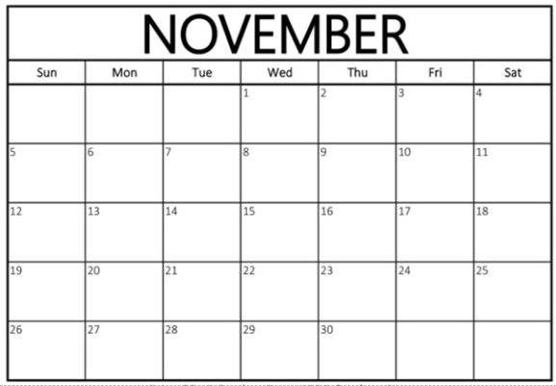

How many days are in a week?

How many Mondays are in this month?

How many Saturdays and Sundays are in the month?

*The strategies, tasks and items included in the B1G-M are examples and should not be considered comprehensive.

### MA.K.NSO.1.2

Benchmark

MA.K.NSO.1.2 Given a number from 0 to 20, count out that many objects.

Benchmark Clarifications:

*Clarification 1:* Instruction includes giving a number verbally or with a written numeral.

Connecting Benchmarks/Horizontal Alignment

* MA.K.NSO.2.1
* MA.K.NSO.3.1/3.2
* MA.K.AR.1.1
* MA.K.M.1.3

Terms from the K-12 Glossary

* Cardinality Principle
* Whole Number

Vertical Alignment

|  |  |
| --- | --- |
| **Previous Benchmarks**   * [VPK](http://flbt5.floridaearlylearning.com/standards.html#d%3DV%26a%3Dbirth_to_eight-months%2C18-24_months%2Ceight_to_eighteen-months%2Cthree_year_olds%2Ctwo_year_olds%2Cfour_year_olds). | **Next Benchmarks**   * MA.1.NSO.1.1 |

Purpose and Instructional Strategies

The purpose of this benchmark is to help students further develop the concept that counting gives the number of objects in a set and to reinforce the counting sequence. Students should count out a given number of objects, and if the counted set is rearranged or moved, students should restate the number of objects without recounting.

* Instruction includes the use of manipulatives and pictorial representations *(MTR 2.1)*.
* Instruction may use ten-frames or similar organizers to help students organize their counting *(MTR.5.1)*.

Instruction includes context to provide a purpose for counting *(MTR.7.1)*.

Common Misconceptions or Errors

* Students may skip or repeat numbers when counting out objects.
  + For example, a student may say “*14, 15, 17.*”
* Students may lose track of which objects have been counted.

Strategies to Support Tiered Instruction

* Instruction includes modeling a given target number to produce a set of objects beginning with quantities 0-5. The container holding the objects should contain a quantity greater than the target number so that students can demonstrate producing an exact set without going over the target number. Students must be able to identify the target number, what quantity that number represents, and where the target number is in relation to other numbers.
  + Examples may include the following statements and questions to elicit student understanding:
    - *“What number is this?”*
    - *“When you are counting, how will you know when to stop?”*
    - *“Can you show me how many counters make this number?”*
    - *“How can you keep track of how many you counted?”*
* Instruction includes presenting students with number cards to 5 for matching quantities of counters to each number card.
  + Example:

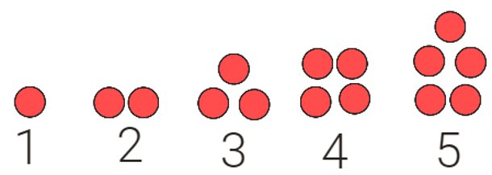

* Teacher provides a number line to allow students to lay out objects until the target number is met. Students should count aloud to practice numbers and ensure no duplicates are said and no omissions are made.
* Teacher includes tasks for students exploring various containers to find which one contains the quantity of the target number card and match the remaining cards to their containers. Use five or ten frames to keep track of each quantity being counted.
  + Example:

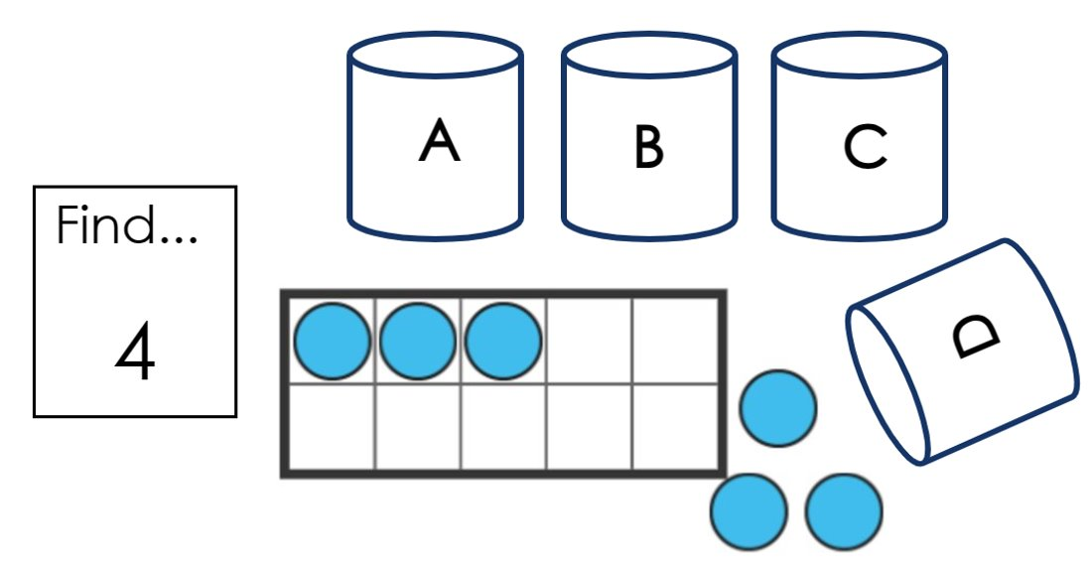

Instructional Tasks

*Instructional Task 1 (MTR 2.1)*

Students can work together in a teacher center or this task could be completed in a center independently. Students are given various containers of objects to count (counters, bears, beans, paperclips, etc.), and bags/containers labeled with various numbers 1-20. Choosing from the objects, students will count out the number and place each set in the bag/container with the matching total. The teacher can scaffold by pairing students or strategically assigning certain numbers to students.

*Instructional Task 2 (MTR.7.1)*

There are 14 people sitting around a table. Everyone at the table needs to have one piece of paper and you want to make sure each person gets one. From a pack of paper, count out enough sheets to make sure everyone gets one.

Instructional Items

*Instructional Item 1*

Count out and circle 15 flowers.

A group of pink flowers.



*Instructional Item 2*

Which picture has 17 frogs?

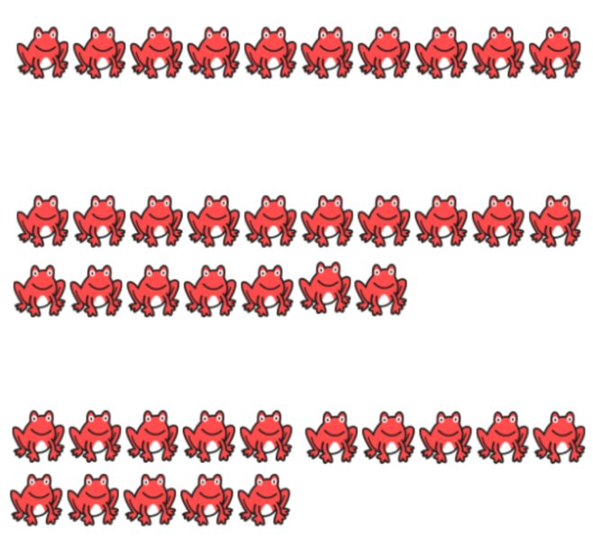

*The strategies, tasks and items included in the B1G-M are examples and should not be considered comprehensive.

### MA.K.NSO.1.3

Benchmark

MA.K.NSO.1.3 Identify positions of objects within a sequence using the words “first,” “second,” “third,” “fourth” or “fifth.”

Benchmark Clarifications:

*Clarification 1:* Instruction includes the understanding that rearranging a group of objects does not change the total number of objects but may change the order of an object in that group.

Connecting Benchmarks/Horizontal Alignment

MA.K.NSO.2.3

Terms from the K-12 Glossary

Vertical Alignment

|  |  |
| --- | --- |
| **Previous Benchmarks**   * [VPK](http://flbt5.floridaearlylearning.com/standards.html#d%3DV%26a%3Dbirth_to_eight-months%2C18-24_months%2Ceight_to_eighteen-months%2Cthree_year_olds%2Ctwo_year_olds%2Cfour_year_olds). | **Next Benchmarks**   * MA.1.NSO.1.4 * MA.1.M.1.2 |

Purpose and Instructional Strategies

The purpose of this benchmark is to develop students’ vocabulary for describing the position of objects in a set (i.e., ordinality). This benchmark reinforces further development of cardinality – even though objects in a set may switch positions, the total number of objects in the set remains the same.

* For mastery of this benchmark, instruction does not need to include students writing the positional word names.
* Instruction includes specificity of sequence relative to the starting position and direction (first from the left, second from the bottom, third from the right, etc.) (*MTR.5.1)*
* Instruction may include sets larger than five as students identify the positions first through fifth. (Many students may be comfortable with using the words sixth through twentieth.)
* Instruction includes the use of manipulatives and pictorial representations (*MTR.2.1)*.

Common Misconceptions or Errors

* Students may not be able to connect the positional terms (first, second, etc.) to the object’s position after rearrangement.
  + For example, a set from left to right shows an elephant, pig, and dolphin. When rearranged the student still identifies the dolphin as “third” regardless of sequence.
* Students may give similar objects the same order number especially if they are next to each other in the sequence?

Strategies to Support Tiered Instruction

* Instruction includes opportunities to build “stairs” using connecting cubes or square tiles in which attention is directed to noting that the third step is number 3, the fourth step is number 4, and so on.
  + Example:

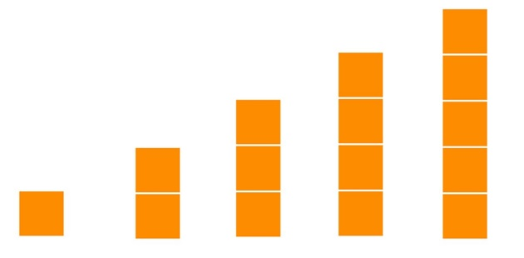

* Instruction includes relating ordinal language to everyday events.
  + For example, using index cards in which an event from the students’ day can be drawn and labeled on each card. Student then arranges the cards in order and tells when the event takes place while incorporating use of the words “first,” “second,” “third,” “fourth,” and “fifth.”

Instructional Tasks

*Instructional Task 1 (MTR.1.1, MTR.5.1)*

In a group, provide students with various objects, and ask them to count out and organize a given amount (no more than 20) into a line. Students’ sets should contain a mixture of objects, but all students should have the same total. Once students have counted their sets, ask the students to identify various positions. It can be appropriate in the classroom to discuss positions beyond the fifth position. The group should discuss how their sets contain the same total, but the sets have different arrangements, and different objects at different positions. Rearrange the set and ask the students how many objects are in the set

and which objects are now in various positions. Repeat the task as needed.

Instructional Items

*Instructional Item 1*

Which animal is in the fourth position starting from the left?

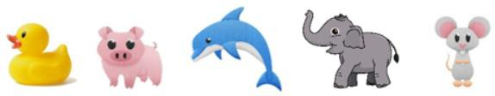

Which animal is in the fourth position from the left now?



*Instructional Item 2*

Point at the carrot that is in the second position starting from the right.

A picture of four carrots.

*The strategies, tasks and items included in the B1G-M are examples and should not be considered

### MA.K.NSO.1.4

Benchmark

MA.K.NSO.1.4 Compare the number of objects from 0 to 20 in two groups using the terms less than, equal to or greater than.

Benchmark Clarifications:

*Clarification 1:* Instruction focuses on matching, counting and the connection to addition and subtraction.

*Clarification 2:* Within this benchmark, the expectation is not to use the relational symbols =, > or <.

Connecting Benchmarks/Horizontal Alignment

* MA.K.NSO.2.3
* MA.K.AR.2.1
* MA.K.M.1.2
* MA.K.DP.1.1

Terms from the K-12 Glossary

Vertical Alignment

|  |  |
| --- | --- |
| **Previous Benchmarks**   * [VPK](http://flbt5.floridaearlylearning.com/standards.html#d%3DV%26a%3Dbirth_to_eight-months%2C18-24_months%2Ceight_to_eighteen-months%2Cthree_year_olds%2Ctwo_year_olds%2Cfour_year_olds) | **Next Benchmarks**   * MA.1.NSO.1.4 * MA.1.AR.2.2 |

Purpose and Instructional Strategies

The purpose of this benchmark is to develop student understanding of comparing numbers and values relative to others. This benchmark may be used to connect to the counting sequence, forwards and backwards, and to addition and subtraction as strategies to compare numbers.

* Instructions encourage students to explain “how they know” a number is greater than, less than or equal to *(MTR.6.1)*.
  + For example, a student could explain that 5 is after 3 so 5 is greater than 3. A student could also pair objects one-to-one to determine that 5 is greater than 3.
* Instruction allows for students to compare sets and demonstrate their thinking using various strategies, such as addition and subtraction, counting on or back, and manipulatives *(MTR.2.1)*.
  + For example, 7 is greater than 5 because 5 + 2 = 7 and because it is like starting at 5 and counting “5, 6, 7.”
* Instruction includes pairing objects in two sets one-to-one, students may observe that a set has more objects when there are no more to pair with *(MTR.5.1)*.
* Instruction includes the language “which is greater,” “which is less,” and “are they equal,” to help students develop vocabulary.
* Instruction includes comparing sets of objects as well as numbers in numeral form.

Common Misconceptions or Errors

* Students may confuse the size of objects with the number of objects when comparing*.*

Strategies to Support Tiered Instruction

* Instruction includes presenting students with two sets of objects to compare in which modeling of a matching strategy is used to determine precisely which set has more.
  + For example, the teacher may use questions that can elicit student thinking about the relationship between quantity and size including:
    - *“Do you think they have the same amount? How do you know?”*
    - *“When we want to see if one group has more, less or the same, we will compare the groups by matching one from each group.”*

Students may record the numbers or drawings of their comparisons and describe how they determined which group was more, or less.

A group of red circles and blue squares with green circle.

 A black and white rectangle with black text. 3+2=5. 5 is 2 more greater than 3.  
5-3=2. 3 is 2 less than 5.


* Instruction includes a focus on “equal” by presenting students with two sets of objects with equal quantities in which the objects in one set are at least twice as large as the objects in the other set.
  + For example, students will need to be introduced to the idea that larger items don’t necessarily mean there are “more”/”greater” or that smaller items mean there are “less.”

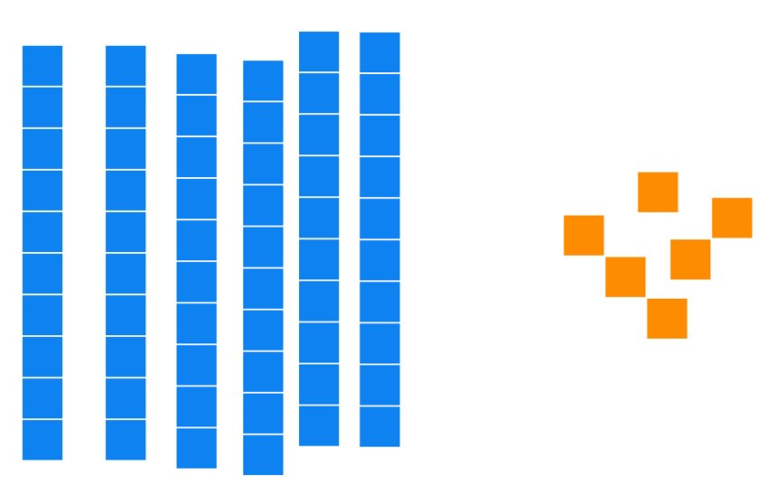

* Student can match a larger item from one group to a smaller item from the other group. When all objects have a match, teachers can state that *“Each group has the same amount. Another word for same is ‘equal.’”*

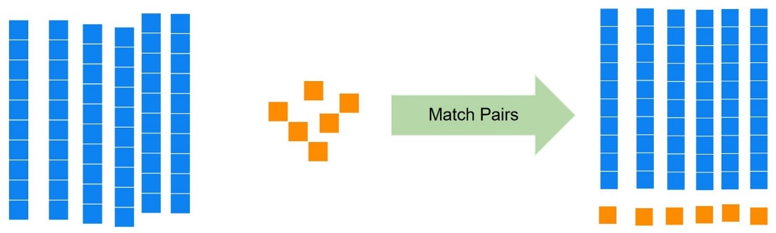

* Teacher may provide ten frames or math racks to do the following activities with students:
  + Teacher shows students two numbers to build and compare.
  + Teacher then can elicit student thinking by asking guiding questions such as:
    - *“What do you notice about each ten frame/row?*
    - *"Are they equal?”,*
    - *“Which one is greater?”,*
* *“Which one is less?“How far from 10 is each number?*

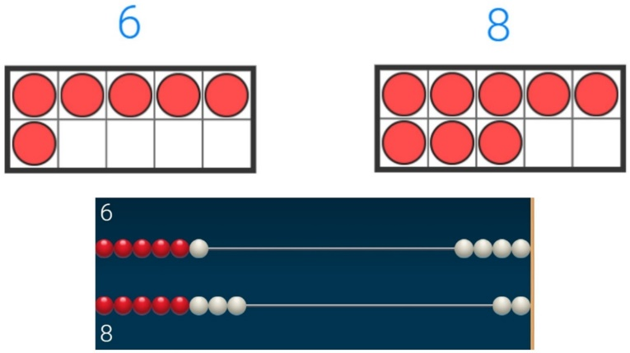

Instructional Tasks

*Instructional Task 1 (MTR 2.1, MTR5.1, MTR 6.1)*

Given two sets of various sized objects (pictorial or concrete objects), students will count and record the number of objects in each set. Give time for students to discuss in groups and ask the following:

* Which number is greater?
* How do you know?
* Which number is less?
* How do you know?
* What’s the total number of objects?
* How many more is in one group than the other?
* How far away from ten is each number?
* How far away from twenty is each number?

*Instructional Task 2 (MTR.6.1)*

Teacher provides students with two sets of objects. Group A has 8 objects and Group B has 6 objects. Teacher asks student, “*Is group A greater than, less than, or equal to group B?”* Teacher then asks, “*How do you know; what would you do to make the groups equal?”*

Instructional Items

*Instructional Item 1*

Who has more shirts? How do you know?

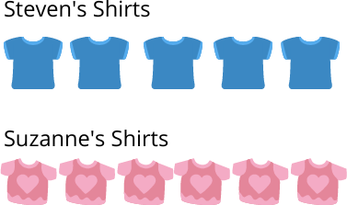

*The strategies, tasks and items included in the B1G-M are examples and should not be considered comprehensive.

**MA.K.NSO.2** *Recite number names sequentially within 100 and develop an understanding for place value.*

### MA.K.NSO.2.1

Benchmark

MA.K.NSO.2.1 Recite the number names to 100 by ones and by tens. Starting at a given number, count forward within 100 and backward within 20.

Benchmark Clarifications:

*Clarification 1:* When counting forward by ones, students are to say the number names in the standard order and understand that each successive number refers to a quantity that is one larger. When counting backward, students are to understand that each succeeding number in the count sequence refers to a quantity that is one less.

*Clarification 2:* Within this benchmark, the expectation is to recognize and count to 100 by the end of Kindergarten.

Connecting Benchmarks/Horizontal Alignment

* MA.K.NSO.1.1/1.2/1.3
* MA.K.NSO.3.1/3.2
* MA.K.AR.1.1/1.2/1.3

Terms from the K-12 Glossary

Vertical Alignment

|  |  |
| --- | --- |
| **Previous Benchmarks**   * [VPK](http://flbt5.floridaearlylearning.com/standards.html#d%3DV%26a%3Dbirth_to_eight-months%2C18-24_months%2Ceight_to_eighteen-months%2Cthree_year_olds%2Ctwo_year_olds%2Cfour_year_olds) | **Next Benchmarks**   * MA.1.NSO.1.1 * MA.1.NSO.2.3 * MA.1.NSO.2.4 * MA.1.NSO.2.5 |

Purpose and Instructional Strategies

The purpose of this benchmark is to deepen student understanding of the counting sequence by 1s and 10s, both forwards and backwards, and to connect the counting sequence to place value. This benchmark will be a foundation as students begin to explore strategies for adding and subtracting. Developing fluency in counting *(MTR.3.1)* will allow students to use strategies to count on and count back, and fluency counting by 10s will be a foundation in building place value and related addition and subtraction strategies. In grade 1, students will count by 2’s and 5’s and identify numbers ten more or ten less than a two-digit number.

* Instruction focuses on building understanding of numbers, not just their conventional names and sequence.
  + For example, 11 can be described as 10 and 1; 20 as 2 tens and 80 as 8 tens

*(MTR.5.1)*.

* Instruction builds the foundation for students to develop the strategy of counting on and counting back to add and subtract *(MTR.5.1)*.
* Students will learn to recognize written numerals from 0 to 100.

Common Misconceptions or Errors

* Students may have difficulty moving from one group of tens to the next.
  + For example, knowing that 30 comes after 29. Students may have to recount by tens to determine the next ten when counting through to 100.
* Students may be confused by the different pattern of word names for the “teens.”

Strategies to Support Tiered Instruction

* Instruction includes an emphasis on connecting verbal counting with objects. Also counting to give purpose, meaning and to recite the number sequence while attending to the strategies used to count objects.
  + For example, the teacher provides number cards to reinforce the idea that the numbers we say can be represented with symbols and that numbers can be read to express a quantity.
* For example, counting collections of objects and using ten frames to group by tens can help students “see” and give meaning to the patterns found in counting by ones and by tens.

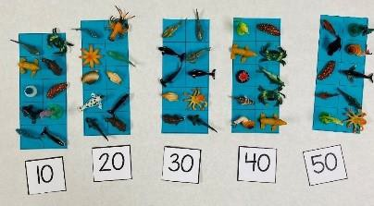

Instructional Tasks

*Instructional Task 1 (MTR.2.1)*

Cut a hundred chart up into irregular shapes along the lines of the rows and columns and have students put it back together in pairs using what they know about place value, patterns, and the concept of one more and one less.

*Enrichment Task 1 (MTR.7.1)*

Have students count pennies, both forwards and backwards, as they receive them or give them away.

*Enrichment Task 2 (MTR.7.1)*

Looking ahead to grade 1, have students explore counting by tens with dimes.

Instructional Items

*Instructional Item 1*

Fill in the missing number or numbers below.

48, 49,

73, 74, , , , 78

19, 18, ,

, , 18, 19

40, 50, _____

*Instructional Item 2*

Start with 12 counters, then give them away one by one, stating each time how many you have left?

*The strategies, tasks and items included in the B1G-M are examples and should not be considered comprehensive.

### MA.K.NSO.2.2

Benchmark

MA.K.NSO.2.2 Represent whole numbers from 10 to 20, using a unit of ten and a group of ones, with objects, drawings and expressions or equations.

*Example:* The number 13 can be represented as the verbal expression “ten ones and three ones” or as “1 ten and 3 ones.”.

Connecting Benchmarks/Horizontal Alignment

* MA.K.NSO.1.1
* MA.K.NSO.3.1

Terms from the K-12 Glossary

* Equation
* Expression

Vertical Alignment

|  |  |
| --- | --- |
| **Previous Benchmarks**   * [VPK](http://flbt5.floridaearlylearning.com/standards.html#d%3DV%26a%3Dbirth_to_eight-months%2C18-24_months%2Ceight_to_eighteen-months%2Cthree_year_olds%2Ctwo_year_olds%2Cfour_year_olds) | **Next Benchmarks**  MA.1.NSO.1.3 |

Purpose and Instructional Strategies

The purpose of this benchmark is to help students build the foundation of place value. By decomposing and viewing a number as its 10s and 1s students can begin to use strategies for adding and subtracting in later benchmarks and grade levels as the scale increases. In grade 1, students will compose and decompose numbers to 100.

Instruction helps students develop the meaning of numbers beyond the conventional names.

* Instruction focuses on multiple ways to represent numbers *(MTR.2.1)*.
* Instructions build the foundation for expanded form and decomposing numbers, which can be used as a strategy for operations later *(MTR.5.1)*..

Common Misconceptions or Errors

* Students may attach too much meaning to certain number names. Example: sixteen linguistically makes sense as six and teen, or six and ten; while eleven and twelve do not have linguistic cues.
* Students may think there is only one way to represent numbers with tens and ones.

Strategies to Support Tiered Instruction

* Teacher provides opportunities to count collections of objects that contain sets with quantities between 11 and 20, using one ten frame to isolate the idea that the quantity contains “ten and some more.”
* For example, students can count the objects that are placed in the ten frame with a “count on” strategy, “10…11, 12, 13, 14.” Using a ten frame reinforces the idea that 10 is a benchmark number and that “10 and more” can be counted additively (10+1+1+1+1) rather than by single units. Students can communicate their thinking by drawing representations of their counts and explaining each drawing. Instruction should emphasize that the “1” in teen numbers means “10,” and language support can include students rephrasing teen number words, for example, “16 is the same as 10 and 6.”

Instructional Tasks

*Instructional Task 1(MTR.1.1, MTR.4.1)*

Materials: Counters and ten frames

Task: Give students two ten frames and a number of counters between 11 and 19. Students will fill a 10 frame and fill the second with the left-over counters. Have students record the number of tens and ones like the example below. This task can be done in a small group, providing opportunities for discussion and collaboration.

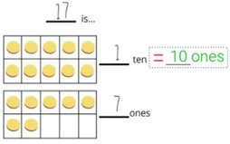

The purpose of this task is to provide students with the opportunity to discover rather than to provide them with a system or rule. Allow explorations with various addends and sums, drawing comparisons and conclusions through discussion.

Instructional Items

*Instructional Item 1*

Given the following, fill in the blanks. For the first two, have students provide a different way to fill in the blanks. Students should give more than one answer when possible.

16 is the same as 𝑡𝑒𝑛(𝑠) 𝑎𝑛𝑑 𝑜𝑛𝑒𝑠.

12 is the same is 𝑜𝑛𝑒𝑠 𝑎𝑛𝑑 𝑡𝑒𝑛(𝑠).

is the same as 1 𝑡𝑒𝑛 𝑎𝑛𝑑 5 𝑜𝑛𝑒𝑠.

is the same as 9 𝑜𝑛𝑒𝑠 𝑎𝑛𝑑 1 𝑡𝑒𝑛.

5 is the same as 𝑡𝑒𝑛(𝑠) 𝑎𝑛𝑑 𝑜𝑛e

*The strategies, tasks and items included in the B1G-M are examples and should not be considered comprehensive

### 

### MA.K.NSO.2.3

Benchmark

MA.K.NSO.2.3 Locate, order and compare numbers from 0 to 20 using the number line and terms less than, equal to or greater than.

Benchmark Clarifications:

*Clarification 1:* Within this benchmark, the expectation is not to use the relational symbols =, > or <. *Clarification 2:* When comparing numbers from 0 to 20, both numbers are plotted on the same number line.

*Clarification 3:* When locating numbers on the number line, the expectation includes filling in a missing number by counting from left to right on the number line.

Connecting Benchmarks/Horizontal Alignment

* MA.K.NSO.1.3/1.4
* MA.K.NSO.3.1/3.2
* MA.K.AR.1.1
* MA.K.AR.2.1
* MA.K.M.1.2

Terms from the K-12 Glossary

* Equal Sign
* Number Line

Vertical Alignment

|  |  |
| --- | --- |
| **Previous Benchmarks**   * [VPK](http://flbt5.floridaearlylearning.com/standards.html#d%3DV%26a%3Dbirth_to_eight-months%2C18-24_months%2Ceight_to_eighteen-months%2Cthree_year_olds%2Ctwo_year_olds%2Cfour_year_olds) | **Next Benchmarks**  MA.1.NSO.1.4 |

Purpose and Instructional Strategies

The purpose of this benchmark is to build on knowledge from comparing in MA.K.NSO.1.4 and to introduce the number line. This benchmark will deepen student understanding of the relationship between numbers, as well as provide the foundation for the number line as a strategy for operations later on. In grade 1, students will plot, order and compare numbers to 100.

* Instruction includes varied orientations and ranges of the number line.
  + For example, given number lines can be horizontal, vertical, starting at 0, starting at another number, and include blanks. (*MTR.5.1)*.
* Instruction includes making a connection to measurement when comparing numbers on a number line, which will help prepare students for using rulers in later grades.

Common Misconceptions or Errors

* Students may assume that all number lines start at 0 or 1.
* When looking at number lines with tick marks, students may number the spaces between the tick marks instead of the tick marks.

Strategies to Support Tiered Instruction

* Instruction includes completing a number line by plotting number cards. Students will benefit from experiences in which large number cards are used and placed on the floor so that students construct relationships about numbers and how far away or close they are to other numbers.
  + - Scaffolds for a number line with missing values can include providing the student with a completed number line to reference.

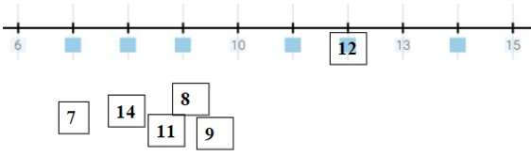

* Instruction focuses on building language for thinking about numbers and describing the location on the number line.
  + For example, questions or statements that can be shared to elicit student thinking about numbers and their positions are:
    - *“Can you find the number 12?”*
    - *“Where is 10? How far away is it to 12? How do you know?”*
    - *“Is 11 greater than, or less than 13? How do you know?”*
    - *“Here is the number 12. It comes before 13 and after 11.”*
    - *“Ten is two away from 12.”*
    - *“Eleven is less than 13 because it is two less than 13.”*

Instructional Tasks

*Instructional Task 1 (MTR 5.1)*

In a small group, provide students with number lines and objects to count, like paperclips

or bears. Ask students to represent two numbers, such as 7 and 9, using objects organized

over the number line. Ask students which number is greater? How do they know? Allow

students to share strategies and thinking with the group. Students should begin to

understand that if there is more of one object, the count will extend further to the right.

*Instructional Task 2 (MTR.5.1)*

Provide students a number line to answer the questions below.

Part A. What’s the third number following 6?

Part B. What’s the fifth number before 14?

Instructional Items

*Instructional Item 1*

Find 12 and 15 on the number line. Show how you know.

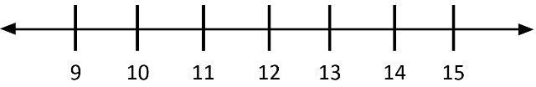

*Instructional Item 2*

Use a number line to show your thinking. Is 19 more than 17? Why or why not?

*Instructional Item 3*

What numbers are missing from the number line?

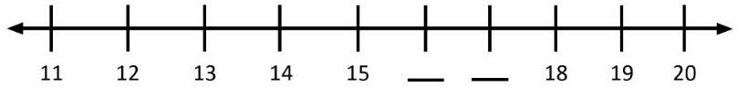

*The strategies, tasks and items included in the B1G-M are examples and should not be considered comprehensive.

**MA.K.NSO.3** *Develop an understanding of addition and subtraction operations with one-digit whole numbers.*

### MA.K.NSO.3.1

Benchmark

MA.K.NSO.3.1 Explore addition of two whole numbers from 0 to 10, and related subtraction facts.

Benchmark Clarifications:

*Clarification 1:* Instruction includes objects, fingers, drawings, number lines and equations. *Clarification 2:* Instruction focuses on the connection that addition is “putting together” or “counting on” and that subtraction is “taking apart” or “taking from.” Refer to Situations Involving Operations with Numbers (Appendix A).

*Clarification 3:* Within this benchmark, it is the expectation that one problem can be represented in multiple ways and understanding how the different representations are related to each other.

Connecting Benchmarks/Horizontal Alignment

* MA.K.NSO.1.1/1.2
* MA.K.NSO.2.1/2.2/2.3
* MA.K.AR.1.1/1.2/1.3
* MA.K.AR.2.1

Terms from the K-12 Glossary

* Equation
* Expression
* Number Line

Vertical Alignment

|  |  |
| --- | --- |
| **Previous Benchmarks**   * [VPK](http://flbt5.floridaearlylearning.com/standards.html#d%3DV%26a%3Dbirth_to_eight-months%2C18-24_months%2Ceight_to_eighteen-months%2Cthree_year_olds%2Ctwo_year_olds%2Cfour_year_olds) | **Next Benchmarks**   * MA.1.NSO.2.1/2.2/2.5 |

Purpose and Instructional Strategies

The purpose of this benchmark is to begin building strategies for addition and subtraction using skills developed through previous benchmarks; such as counting forwards and backwards, counting objects and using number lines. Procedural reliability with addition and subtraction facts within 10 is expected in MA.K.NSO.3.2, and automaticity is to be achieved in grade 1.

* Instruction encourages students to use and explore various strategies as they begin to discover which strategies are best for them and best for given situations *(MTR.5.1, MTR.2.1)*.
  + Strategies include the use of manipulatives; the use of fingers, counting both sets separately and combining or removing, counting on and counting back, and using the relationship between addition and subtraction.
* Instruction includes the use of manipulatives and pictorial representations.
* Instruction includes multiple representations of expressions and equations *(MTR.2.1)*.
* For example, 6 + 7 = and = 6 + 7 and making the connections to the related subtraction of 13 – 6 =____ and __= 13-6. Instruction includes examples of all four situations for addition and subtraction as described in Appendix A*.*
* Instruction includes the use of context to provide a purpose for adding or subtracting, and to develop conceptual understanding for addition and subtraction *(MTR.7.1)*..

Common Misconceptions or Errors

* Students may confuse addition situations with subtraction situations based on “cue” or “key” words.
  + For example, in the word problem “Steve has 7 crayons. Steve has 3 more crayons than Joane. How many crayons does Joane have?” the word “more” may make students think to add, though the context is actually subtraction.
* Students may think there is only one correct way of solving a problem. Many problems can be solved by using addition or subtraction.
* After mastering one addition or subtraction situation students may feel that there are no others to learn.

Strategies to Support Tiered Instruction

* Instruction includes opportunities to use various manipulatives to model addition and subtraction situations and record the equations being modeled. Instruction can include physically breaking apart a whole to model subtraction equations.
* For example, teachers include an emphasis on discovering the commutative property, or that numbers can be added in any order and that the sum will remain the same

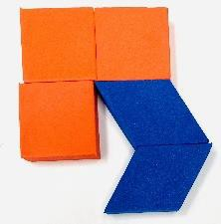

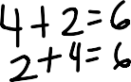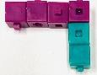

* 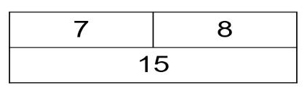Instruction includes removing the equation symbols to both isolate and focus on the concept that two parts combine to make a whole. To support language development of equation representations, describe the concepts of adding to and taking away as “8 and 7 make 15” or, “15 take away 8 is 7.” Students could also use counters inside the part-part-whole organizer to model the situation.
* Teacher provides opportunities for subitizing tasks in which cards with dot patterns can be used to visualize the pattern and describe the way it is seen. Teacher records the combinations of numbers that students use to help make their thinking visual.
* For example, subitize cards can include dots with two different colors to enhance distinction between quantities within a total.
* For example, students may use counters to match the dot patterns on the cards and record an equation that matches.

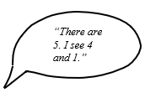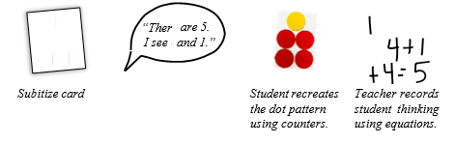

4+1

1+4 = 5

Instructional Tasks

*Instructional Task 1 (MTR.4.1)*

In a small group, provide students with various tools for adding and subtracting (i.e., number lines, counters, bears, paperclips, paper and crayons). Present an expression, both verbally and in written form, and instruct students to find the sum or difference using any tool or strategy they feel comfortable with. Once everyone is comfortable with their solutions, allow students the opportunities to share their solutions and methods. Use the sharing as an opportunity to discuss various methods and strategies, being sure to validate each. Efficiency is not the goal here, so any accurate strategy is valid, especially when it deepens understanding.

Instructional Items

*Instructional Item 1*

To count the flowers shown to the right, James recognized that there are 4 orange flowers and 2 pink. He started at 4, then he counted on, “5, 6,” to find that there are 6 total flowers.

How could you use James’s strategy to find 6 + 3? How many orange flowers are there?

How many pink flowers are there? How many flowers are there in all?

*Instructional Item 2*

Ashley and Larry are coloring a picture. Ashley has 9 crayons and Larry has 4 crayons. How many crayons do they have?

What is a related subtraction equation you could write?

*The strategies, tasks and items included in the B1G-M are examples and should not be considered comprehensive.

### MA.K.NSO.3.2

Benchmark

MA.K.NSO.3.2 Add two one-digit whole numbers with sums from 0 to 10 and subtract using related facts with procedural reliability.

*Example:* The sum 2 + 7 can be found by counting on, using fingers or by “jumps” on the number line.

*Example:* The numbers 3, 5 and 8 make a fact family (number bonds). It can be represented as 5 and 3 make 8; 3 and 5 make 8; 8 take away 5 is 3; and 8 take away 3 is 5.

Benchmark Clarifications:

*Clarification 1:* Instruction focuses on helping a student choose a method they can use reliably.

Connecting Benchmarks/Horizontal Alignment

* MA.K.NSO.1.1/1.2
* MA.K.NSO.2.1/2.3
* MA.K.AR.1.1/1.2/1.3
* MA.K.AR.2.1

Terms from the K-12 Glossary

* Equation
* Expression
* Number Line

Vertical Alignment

|  |  |
| --- | --- |
| **Previous Benchmarks**   * [VPK](http://flbt5.floridaearlylearning.com/standards.html#d%3DV%26a%3Dbirth_to_eight-months%2C18-24_months%2Ceight_to_eighteen-months%2Cthree_year_olds%2Ctwo_year_olds%2Cfour_year_olds) | **Next Benchmarks**  MA.1.NSO.2.1/2.2 |

Purpose and Instructional Strategies

The purpose of this benchmark is to build upon the exploration of MA.K.NSO.3.1 and provide students with opportunities to become more efficient in their selection and use of strategies. The goal is not to be fluent with addition and subtraction, but rather to build the foundation for fluency in later grades *(MTR.3.1).*

* Instruction includes the use of manipulatives and pictorial representations.
* Instruction allows students to continue exploring various strategies for addition and subtraction, discovering strategies that allow them to become more efficient *(MTR.2.1)*.
* Instruction includes the use of discussions where students share strategies with one another *(MTR.4.1)*.
* Though the first expectation for procedural fluency with addition and subtraction is not until Grade 2, instruction allows students to become more efficient through choosing appropriate strategies *(MTR.3.1)*.
  + For example, students moving from combining then counting sets to counting on.
* Instruction includes the use of the commutative property (not by name) as a strategy for adding. This is connected to the Cardinality Principle – the total number remains the same after rearrangement *(MTR.5.1)*.
  + For example, allow students to discover that 7 + 2 = 9 and 2 + 7 = 9 to help develop the understanding of the commutative property.
* Instruction includes the use of context to provide a purpose for adding or subtracting, and to develop conceptual understanding for addition and subtraction *(MTR.7.1)*.
* The goal of this benchmark is not to get to automaticity; however, students should begin to experience strategies that move them toward more efficiency.
* Allowing students to discover the commutative property will allow them to continue exploring and developing understanding, while becoming more efficient with their strategies *(MTR.3.1)*.
  + For example, to find 2 + 7 by counting on, it is more efficient to begin with 7 and count on 2*.*

Common Misconceptions or Errors

* Students may not see the value in counting on (and becoming more efficient) when determining the number of objects in two sets that have been combined.
* When using the count on strategy, students may always start with the first number rather than the larger number.

Strategies to Support Tiered Instruction

* Instruction includes using numbered cards 4 − 10 and dot cards with 1, 2, or 3 dots, which can be combined to model an equation. Students say the number, touch each dot as they count forward (or backward), and record the equation which can be solved by using either counting on or counting back strategy, depending on the students need. Students can move toward identifying both addition and subtraction equations.

“Five…6, 7, 8. Five and 3 more is 8.”

5 2

* Instruction includes using the same activity above. Replace the dot cards with cards numbered 1, 2, or 3. If the student chooses to start counting on the 1, 2, or 3 card instead of the card with the larger number, ask the student to model their count using a number line. Have the student draw the jumps on each model and compare which makes the most sense. Note that both ways get the same answer, yet one is more efficient than the other.
  + For example, to find 2 + 7 by counting on, it is more efficient to begin with 7 and count on 2.”
  + For example, the teacher can use questions and statements that can help elicit student thinking about starting on the bigger number can include:
    - *“How did you know to start on 7 instead of 2?”*
    - *“Let’s see what happens if we start on the lower number. Then, let’s try starting on the higher number. Which way was more efficient?”*.

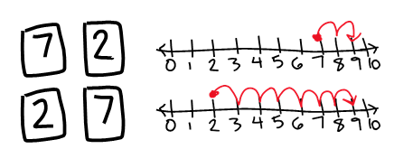

Instructional Tasks

*Instructional Task 1 (MTR.3.1)*

Provide students with white boards and markers and counters, linking cubes, ten frames, number lines and other various tools for adding and subtracting.

Present students with an addition or subtraction problem, such as 4 + 3.

Encourage students to solve the problem using a strategy of their choice, but do not allow them to answer to the group.

The teacher reveals the sum or difference, then have students brainstorm and discuss all the strategies they used to find the answer.

The teacher collects all of the strategies and facilitates a conversation around various strategies, and ways to choose reliable methods. This task focuses on sharing strategies.

*Instructional Task 2 (MTR.5.1)*

Give students two groups of objects. One group has 3 objects and the other group has 4 objects. Ask for the total combined number of objects. Once students find the combined total, collect the objects and redistribute by giving students the group of 4 objects first, and then the group of 3 objects. See if students recognize that the combined total is the same. This task illustrates the commutative property and also the cardinality principle because changing the order of groups can be seen as rearranging the items of the combined group. Now that the students have the combined group of 7 objects, ask them to remove any of the 3 objects and determine how many are left. Discuss the connection.

Instructional Items

*Instructional Item 1*

Stan found 3 + 5 by making 5 jumps forward from 3, as shown on the number line. Is Stan’s solution correct? Is there a more efficient method with the number line Stan could have used?

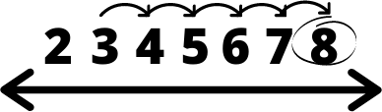

*Instructional Item 2*

Using the numbers 4, 6 and 10 make a fact family (number bonds).

*The strategies, tasks and items included in the B1G-M are examples and should not be considered comprehensive.

# Algebraic Reasoning

**MA.K.AR.1** *Represent and solve addition problems with sums between 0 and 10 and subtraction problems using related facts.*

### MA.K.AR.1.1

Benchmark

MA.K.AR.1.1 For any number from 1 to 9, find the number that makes 10 when added to the given number.

Benchmark Clarifications:

*Clarification 1:* Instruction includes creating a ten using manipulatives, number lines, models and drawings.

Connecting Benchmarks/Horizontal Alignment

* MA.K.NSO.1.1
* MA.K.NSO.2.1/2.3
* MA.K.NSO.3.1/3.2
* MA.K.AR.2.1

Terms from the K-12 Glossary

* Commutative property of addition
* Equation
* Expression
* Number Line

Vertical Alignment

|  |  |
| --- | --- |
| **Previous Benchmarks**   * [VPK](http://flbt5.floridaearlylearning.com/standards.html#d%3DV%26a%3Dbirth_to_eight-months%2C18-24_months%2Ceight_to_eighteen-months%2Cthree_year_olds%2Ctwo_year_olds%2Cfour_year_olds) | **Next Benchmarks**  MA.1.AR.1.1 |

Purpose and Instructional Strategies

The purpose of this benchmark is to explore addition and lay a foundation for fluency in later grades. This benchmark provides the foundation for the strategy of making a 10 that can be used as the scale of addition increases in later grades *(MTR.5.1)*.

* Instruction allows students to flexibly discover addends that make 10 using strategies and manipulatives. Strategies and manipulatives include addition and subtraction facts, counting with fingers, ten frames, number lines, models and drawings *(MTR.2.1)*.
* Instruction includes the use of the commutative property (not by name) as a strategy for adding.
  + For example, allow students to discover that 7 + 3 = 10 and 3 + 7 = 10 to build their understanding and extending it to find new sums. If a student knows 4 + 6 they now also know 6 + 4 *(MTR.5.1)*.
* Instruction allows for students to develop verbal explanations as they learn to justify and explain their thinking *(MTR.4.1)*.
* Instruction includes making a connection to related subtraction facts.
  + For example, saying that the number you add to 3 to find 10 is 7 is the same as

10 − 3 = 7.

* Though there is no expectation that students name the commutative property, they should begin to discover the connections and patterns and recognize that if 𝑎 + 𝑏 = 10, then

𝑏 + 𝑎 = 10.

Common Misconceptions or Errors

* Students may not connect pairs of addends through the commutative property.

Strategies to Support Tiered Instruction

* Instruction includes opportunities to build sets of ten using snap cubes to represent the commutative property.
  + For example, students build 8 + 2 and 2 + 8, 7 + 3 and 3 + 7, and 4 + 6 and 6 + 4. Students should write an expression to represent the snap cubes. Teacher asks: How is the set of 8 + 2 and 2 + 8 the same? How are they different? Does it matter which addend comes first? Do you get the same sum if you solve the expressions in a different order?

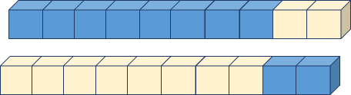

* Instruction includes opportunities to use five frames and two-color counters to represent addition fact families that represent the commutative property.
  + For example, students use five frames to represent the expressions 3 + 2 and 2 + 3. Teacher should guide the students to solve the expressions and notice their sum in relation to the order of the addends.

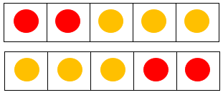

Instructional Tasks

*Instructional Task 1 (MTR.3.1)*

Provide students with ten two-sided counters, a cup and a ten frame. Students will dump the counters out (some will be one color face up, some will be the other color face up) and organize them onto the ten frame. With provided space students will record an addition equation that represents their counters; such as 3 + 7 = 10. Repeat the task allowing students to discover the various addends that give the sum of 10. Give students time to record their discoveries and discuss strategies and addend pairs with peers and teachers.

*Enrichment Task 1 (MTR.5.1)*

Patty has 3 pennies. How many more pennies will Patty need to have the same amount of money as one dime?

*Enrichment Task 2 (MTR.5.1)*

Mark has a dime and wants to buy a piece of candy from the school store that is worth 6 pennies. How many pennies will he receive in change?

Instructional Items

*Instructional Item 1*

Omar knows that 3 + 7 = 10, so he believes that 7 + 3 must also equal 10. Is Omar correct? Use models or drawings to explain your thinking.

How can we use that relationship to write a new equation if we know that 6 + 4 = 10?

*Instructional Item 2*

Use the number lines to determine how close each number is to 10.

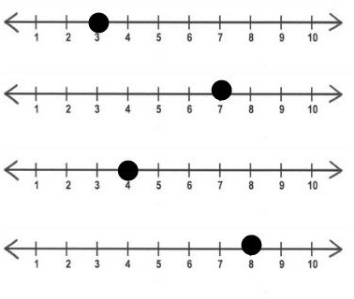

*The strategies, tasks and items included in the B1G-M are examples and should not be considered comprehensive.

### MA.K.AR.1.2

Benchmark

MA.K.AR.1.2 Given a number from 0 to 10, find the different ways it can be represented as the sum of two numbers.

Benchmark Clarifications:

*Clarification 1:* Instruction includes the exploration of finding possible pairs to make a sum using manipulatives, objects, drawings and expressions; and understanding how the different representations are related to each other.

Connecting Benchmarks/Horizontal Alignment

* MA.K.NSO.1.1
* MA.K.NSO.2.1
* MA.K.NSO.3.1/3.2
* MA.K.AR.2.1

Terms from the K-12 Glossary

* Commutative property of addition
* Equation
* Expression

Vertical Alignment

|  |  |
| --- | --- |
| **Previous Benchmarks**   * [VPK](http://flbt5.floridaearlylearning.com/standards.html#d%3DV%26a%3Dbirth_to_eight-months%2C18-24_months%2Ceight_to_eighteen-months%2Cthree_year_olds%2Ctwo_year_olds%2Cfour_year_olds) | **Next Benchmarks**   * MA.1.NSO.2.1 * MA.1.AR.1.11 |

Purpose and Instructional Strategies

The purpose of this benchmark is to allow students to continue to flexibly discover various sums as they work towards procedural reliability in Kindergarten, and automaticity in grade 1 *(MTR.2.1, MTR.5.1)*.

* Instruction allows students to see multiple ways to add numbers to make a given number, such as 1 + 3, 2 + 2, and 3 + 1 are all ways to make 4 (*MTR.2.1)*.
* Instruction includes the use of manipulatives and pictorial representations.
* Instruction includes the use of context to provide a purpose for adding *(MTR.7.1)*.
* Instruction includes making connections to subtraction equations related to addition equations *(MTR.5.1)*.
* Items include equations with one or both addends unknown.
* Though there is no expectation that students name the commutative property, they should begin to discover the connections and patterns and recognize that if 𝑎 + 𝑏 = 10, then
* 𝑏 + 𝑎 = 10*.*

Common Misconceptions or Errors

* Students may not connect pairs of addends through the commutative property. Though there is no expectation that students name the commutative property, they should begin to discover the connections and patterns and recognize that if 𝑎 + 𝑏 = 10, then 𝑏 + 𝑎 = 10.
* Students may not recognize that multiple pairs of addends represent the same sum.
* Students may not recognize that the two numbers don’t have to be different.
* For example, if the given number is 8 a student may not think to represent it as 4 + 4.

Strategies to Support Tiered Instruction

* Teacher provides opportunities to solve multiple expressions with the same sum using snap cubes (representing each addend with a different color).
  + For example, students use snap cubes to build 3 + 4, 2 + 5, and 1 + 6 to represent a sum of seven.

Example: 

* Instruction provides opportunities to build multiple pairs of addends to represent given numbers 1 – 10 using snap cubes, two-color counters, hands, etc.
  + For example, given the number 6, students model 1 + 5, 2 + 4, and 3 + 3 using snap cubes. Process repeats with multiple numbers, including odd numbers, so students begin to recognize that some numbers have repeating addends and others do not. Discussion should focus on the fact that the two addends can be the same number.

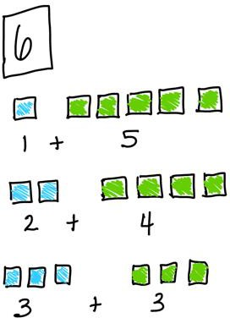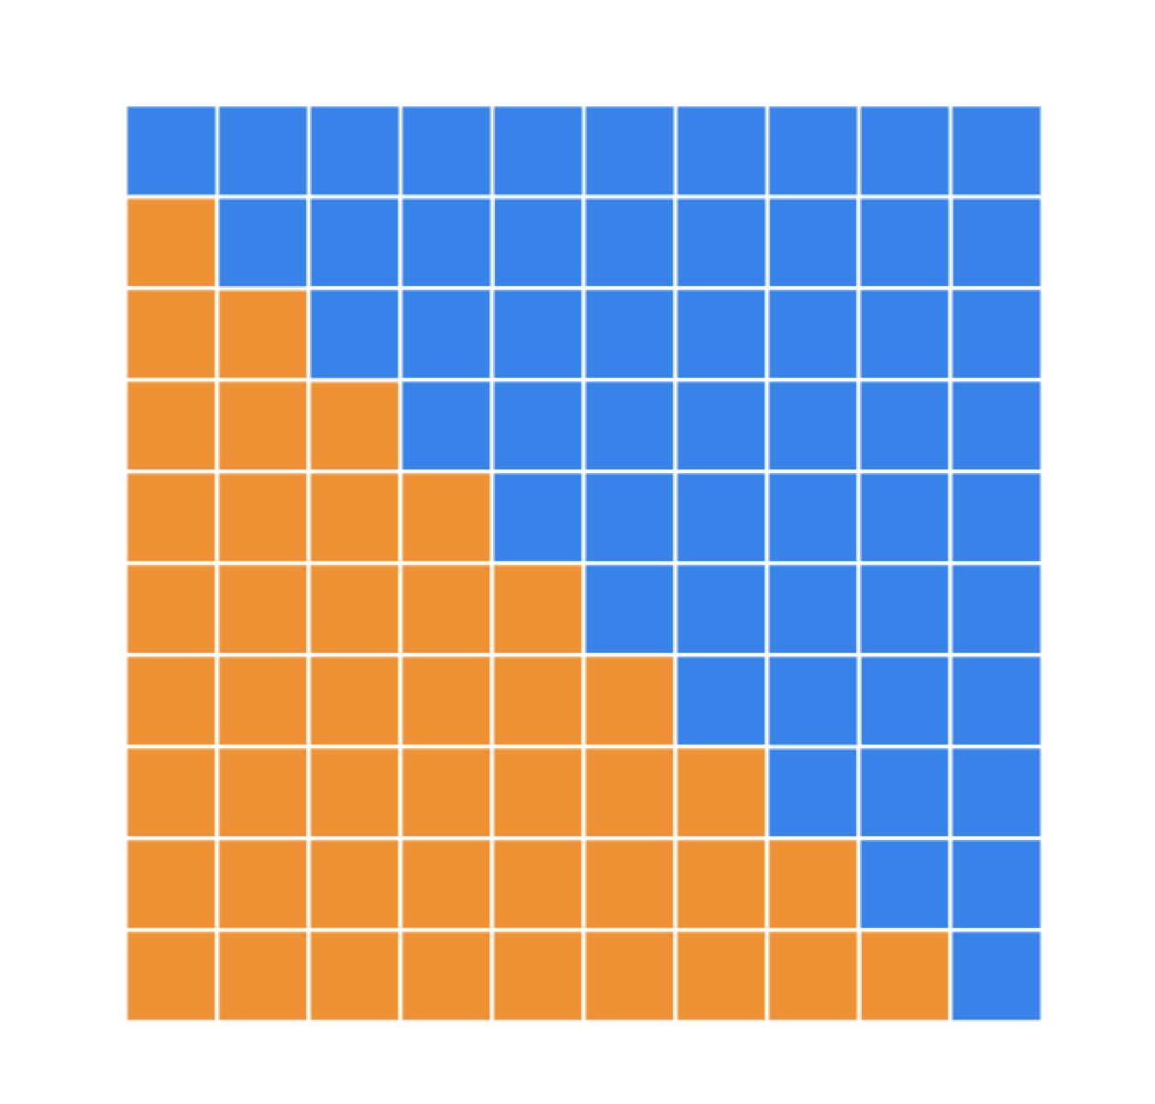

* Instruction includes the opportunity to build sets of five using two-color counters to represent the commutative property.
  + For example, students build 3 + 2 and 2 + 3 and 4 + 1 and 1 + 4. Students should write an equation to represent the counters.

Teacher asks: How is the set of 3 + 2 and 2 + 3 the same? How are they different? Does it matter which addend comes first? Do you get the same sum if you add them in a different order?

Students should use the models or two-sided counters to develop the understanding that the order of the addends does not change the sum.

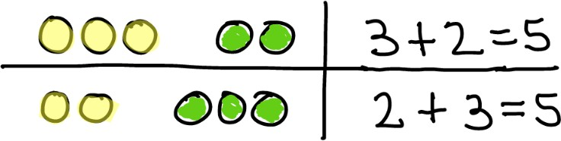

* Teacher provides instruction for using two-color counters to decompose a number into multiple addends that represent the same sum.
  + For example, students decompose a group of 7 counters into 6 red counters and 1 yellow counter, 5 red counters and 2 yellow counters, and 3 red counters 4 yellow counters. Students will write an equation for each representation to show that multiple pairs of addends can make the same sum.

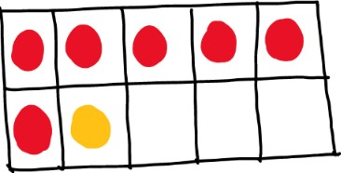 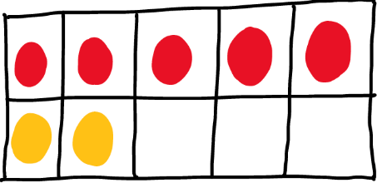 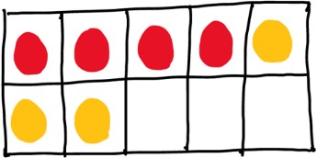

* Instruction includes the opportunity to use addend cards to build equations that represent doubles facts. Alternatively, math racks, dot cards, ten frames, etc... can be used in place of addend cards.
  + For example, students are provided with array cards that represent multiple numbers. Students will need more than one of each card. Students use the cards to build equations for doubles facts and record the equation in writing.

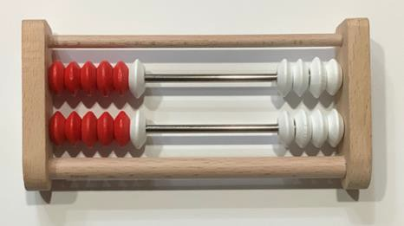 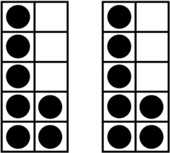

Instructional Tasks

*Instructional Task 1 (MTR.5.1)*

Show a student a number of counters from 0 to 10. Cover some of the counters and ask the student how many counters are hidden. Give the student an opportunity to record an equation for the situation. Repeat the task by covering different amounts of counters and/or starting with a different amount of counters.

*Instructional Task 2 (MTR.3.1)*

Write as many equations as you can to get to a sum of 9, a sum of 5, a sum of 6 and a sum of 7.

Instructional Items

*Instructional Item 1*

Given the number 8, find three different ways to represent 8 by adding two numbers together.

*Instructional Item 2*

Complete the equations to show different ways to make 7.

5 + = 7

+ 4 = 7

7 = +

*The strategies, tasks and items included in the B1G-M are examples and should not be considered comprehensive.

### MA.K.AR.1.3

Benchmark

MA.K.AR.1.3 Solve addition and subtraction real-world problems using objects, drawings or equations to represent the problem.

Benchmark Clarifications:

*Clarification 1:* Instruction includes understanding the context of the problem, as well as the quantities within the problem.

*Clarification 2:* Students are not expected to independently read word problems.

*Clarification 3:* Addition and subtraction are limited to sums within 10 and related subtraction facts. Refer to Situations Involving Operations with Numbers (Appendix A).

Connecting Benchmarks/Horizontal Alignment

* MA.K.NSO.2.1
* MA.K.NSO.3.1/3.2
* MA.K.AR.2.1
* MA.K.M.1.3

Terms from the K-12 Glossary

* Equal sign
* Equation

Vertical Alignment

|  |  |
| --- | --- |
| **Previous Benchmarks**   * [VPK](http://flbt5.floridaearlylearning.com/standards.html#d%3DV%26a%3Dbirth_to_eight-months%2C18-24_months%2Ceight_to_eighteen-months%2Cthree_year_olds%2Ctwo_year_olds%2Cfour_year_olds) | **Next Benchmarks**   * MA.1.AR.1.2 |

Purpose and Instructional Strategies

The purpose of this benchmark is to allow students to continue to flexibly discover various sums as they work towards procedural reliability in Kindergarten, and automaticity in grade 1. This benchmark allows students the opportunity to deepen understanding of addition and subtraction by connecting the concepts to real-world situations. Though this should not be the first exposure to contextual addition and subtraction problems, this benchmark provides the opportunity for making it explicit *(MTR.7.1)*.

* Instruction includes the relationship between addition and subtraction, providing opportunities for discovering subtraction facts that are related to addition facts *(MTR.5.1)*.
* Instruction includes opportunities for the use of various strategies and for students to collaborate and share strategies with each other *(MTR.2.1, MTR.4.1)*.
* Items or explanations including equations as strategies may help students begin to understand the meaning of the equal sign*.*

Common Misconceptions or Errors

* Students may not yet have an understanding of the equal sign when attempting to use equations as a strategy (see MA.K.AR.2.1).

Strategies to Support Tiered Instruction

* Teacher provides a graphic organizer to identify important information for solving the problem.
  + For example, students develop an understanding of context and reasoning by answering questions about the context and gathering information from the problem to promote reasoning.

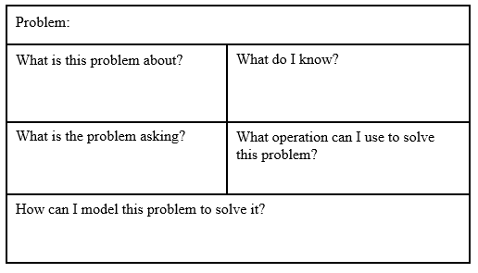

* Instruction provides opportunities to determine the context of numberless word problems with a focus on what is happening in the problem and how to solve it.
  + For example, the teacher provides the following word problem to students.

Daniella has ____ marbles and Shelby has ____ marbles. How many marbles do they have altogether?

Teacher asks: What is this problem about? What is happening in this problem? What information do we know? How do you think you would solve this problem?

* Instruction includes opportunities to write an equation given sets of pictures or manipulatives. Alternatively, students can work in reverse, pull a card from the stack that represents the sum and generate as many equations as possible to match the sum.
  + For example, students are given a set of cards, and they write an equation to represent the quantity of objects on the cards and their sum. In this case, 3 + 5 = 8.

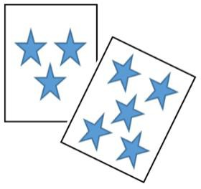

* Teacher models with manipulatives to represent equations.
* For example, the teacher models an equation, then gives students two-color counters or snap cubes to use to represent equations. Given the equation 4 + 2 = 6, students build a set of four and a set of two and then count to determine the sum.

Instructional Tasks

*Instructional Task 1 (MTR.7.1)*

Dani and Ciara colored 9 pages of a coloring book altogether. How many pages could Dani and Ciara each have colored. Use manipulatives, drawings, or equations to explain your thinking.

*Enrichment Task 1* (*MTR.2.1)*

Using Instructional Task 1, have students represent multiple solutions

Instructional Items

*Instructional Item 1*

Stan found 7 marbles cleaning his room. He found 3 marbles in the kitchen. How many marbles does Stan have?

*Instructional Item 2*

Eddie has 10 tokens saved for a class prize. He spent 8 tokens to get a prize from the class treasure box. How many tokens does Eddie have left?

*The strategies, tasks and items included in the B1G-M are examples and should not be considered comprehensive.

## **MA.K.AR.2** Develop an understanding of the equal sign.

## *MA.K.AR.2.1*

Benchmark

MA.K.AR.2.1 Explain why addition or subtraction equations are true using objects or drawings.

*Example:* The equation 7 = 9 − 2 can be represented with cupcakes to show that it is true by crossing out two of the nine cupcakes.

Benchmark Clarifications:

*Clarification 1:* Instruction focuses on the understanding of the equal sign.

*Clarification 2:* Problem types are limited to an equation with two or three terms. The sum or difference can be on either side of the equal sign.

*Clarification 3:* Addition and subtraction are limited to sums within 20 and related subtraction facts.

Connecting Benchmarks/Horizontal Alignment

* MA.K.NSO.1.4
* MA.K.NSO.2.3
* MA.K.NSO.3.1/3.2
* MA.K.AR.1.1/1.2/1.3

Terms from the K-12 Glossary

* Equal Sign
* Equation

Vertical Alignment

|  |  |
| --- | --- |
| **Previous Benchmarks**   * [VPK](http://flbt5.floridaearlylearning.com/standards.html#d%3DV%26a%3Dbirth_to_eight-months%2C18-24_months%2Ceight_to_eighteen-months%2Cthree_year_olds%2Ctwo_year_olds%2Cfour_year_olds) | **Next Benchmarks**   * MA.1.AR.2.1 * MA.1.AR.2.2 |

Purpose and Instructional Strategies

The purpose of this benchmark is to provide explicit opportunities for students to deepen understanding by justifying their solutions and explaining strategies they have chosen, as well as developing an understanding of the equal sign *(MTR.6.1, MTR.4.1)*.

* Instruction may present equations in different forms, such as 𝑎 + 𝑏 = 𝑐 or 𝑐 = 𝑎 + 𝑏

*(MTR.2.1)*.

* Instruction focuses on understanding and supporting, not only identifying whether or not an equation is true.
* Instruction helps students understand that the equal sign does not mean to compute but relates quantities to one another.
* Instruction includes the use of context to provide a purpose for adding or subtracting, and to support and scaffold student drawings *(MTR.7.1)*.

Common Misconceptions or Errors

* Students may think that “equals” just means to compute, and may not recognize equations and expressions represented in non-standard ways, such as with pictures or manipulatives.

Strategies to Support Tiered Instruction

* Teacher provides manipulatives to build sets that represent equations and determine if they are true or false.
* For example, the teacher provides students with the equation 3 + 4 = 7. Students build the addends using two-color counters with the yellow side facing up. Students build the sum with two-color counters with the red side facing up. Teacher asks “Are the two sides of the equation equal? Do they have the same value?” Students should count to find the sum of both sides and record the comparison as 7 = 7. Discussion should focus on the quantities on both sides of the equal sign being the same or different.

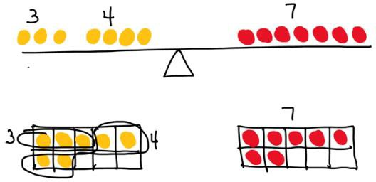

* Instruction includes opportunities to use money manipulatives (dollar bills) to build knowledge of enough.
  + For example, in groups, teacher provides students with eight 1-dollar bills. Teacher provides picture cards with costs labeled of things the students could buy with their eight 1-dollar bills. Teacher asks: Do you have enough money to buy the sticker and the lollipop? Do you have enough money to buy a book and a pencil? Discussion should focus on if the student has enough money to buy the items.
* Teacher provides a math number balance to explore the equal sign with quantities from 1 to 10.
  + For example, students can build the equation 3 + 2 = 6 and determine if the equation is true

Instructional Tasks

*Instructional Task 1 (MTR.6.1)*

Decide if each equation is true or false. Draw a picture or write a new equation to explain your thinking.

3 + 7 = 13

12 = 17 − 5

7 + 6 = 13

3 + 4 = 7

7 = 6 + 2

9 = 13 − 3

12 = 21

*Instructional Task 2 (MTR.3.1)*

Lamar says that there are 6 blue marbles and 7 green marbles. Jackie says that there are 13 marbles altogether. Is Lamar or Jackie correct? Draw a picture or write an equation to prove your answer.

Instructional Items

*Instructional Item 1*

Draw a picture to show that 17 = 7 + 10.

*The strategies, tasks and items included in the B1G-M are examples and should not be considered comprehensive.

# Measurement

## **MA.K.M.1** *Identify and compare measurable attributes of objects.*

## *MA.K.M.1.1*

Benchmark

MA.K.M.1.1 Identify the attributes of a single object that can be measured such as length, volume or weight.

Benchmark Clarifications:

*Clarification 1:* Within this benchmark, measuring is not required

Connecting Benchmarks/Horizontal Alignment

* MA.K.GR.1.1/1.2/1.3
* MA.K.DP.1.1

Terms from the K-12 Glossary

Vertical Alignment

|  |  |
| --- | --- |
| **Previous Benchmarks**   * [VPK](http://flbt5.floridaearlylearning.com/standards.html#d%3DV%26a%3Dbirth_to_eight-months%2C18-24_months%2Ceight_to_eighteen-months%2Cthree_year_olds%2Ctwo_year_olds%2Cfour_year_olds) | **Next Benchmarks**   * MA.1.M.1.1 |

Purpose and Instructional Strategies

The purpose of this benchmark is to develop an understanding for measurement and attributes that can be measured, without focusing on the value of the measurement. Through this benchmark students begin to develop related vocabulary they will also apply in later benchmarks and grade levels.

* Instruction includes students describing measurable attributes and using vocabulary such as tall, short, long, heavy and light *(MTR.4.1)*.
* Instruction includes the introduction of terms to compare measurable attributes, such as longer, shorter, heavier and lighter.
* Instruction includes using both concrete objects and images in real-world contexts to describe measurable attributes *(MTR.7.1)*.

The expectation of this benchmark is not to focus on numerical values of measurement by estimating or measuring, but to develop understanding of attributes that can be measured and vocabulary used to describe those attributes.

Common Misconceptions or Errors

* Students may confuse measurable attributes and call an object big when they mean it is heavy, long, or tall. Explain that tall is a measure of height from bottom to top and long is a measure of length from one end to the other.
* Students may assume that there is only one way to describe attributes.
  + Students may not understand that an object can be both short and heavy.
  + Students may think that because an item has a large volume it means that the item is also heavy.

Strategies to Support Tiered Instruction

* Instruction includes opportunities to use the same object to explore multiple attributes during different lessons, as they actively participate in experiences that include inquiries in which length, volume, and weight must be considered. Students are encouraged to verbalize their thinking while a teacher scaffolds instruction by teaching measurement vocabulary and providing sentence frames duringthe activity.

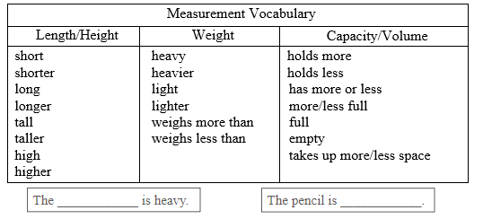

* Teacher guides student discussions and models a think-aloud about each attribute by connecting student-centered language with key mathematical vocabulary. The results of measurement investigations are recorded with drawings, labeling, and verbal communication to peers or teacher about their results.
* For example, how many ways can we measure a bucket?

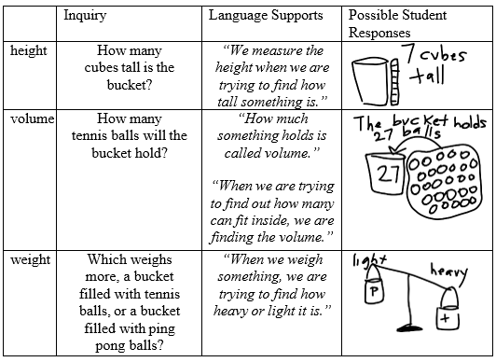

Instructional Tasks

*Instructional Task 1 (MTR.1.1, MTR.7.1)*

Provide students with various objects (or cards with pictures of objects) of different sizes (lengths, heights, and weights). In small groups, ask students to sort the objects by different attributes; such as objects that are heavy and objects that are light. Facilitate conversations with the group focusing on developing students’ vocabulary and the development of corresponding concepts. Compare different ways of sorting the objects (for example, items that are long may not be heavy, etc.).

Instructional Items

*Instructional Item 1*

Connect each object to (a) word(s) that could be used to describe it.

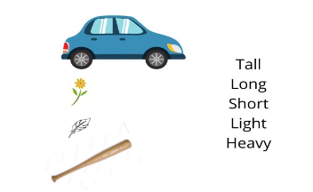

*\*The strategies, tasks and items included in the B1G-M are examples and should not be considered comprehensive.*

## *MA.K.M.1.2*

Benchmark

MA.K.M.1.2 Directly compare two objects that have an attribute which can be measured in common. Express the comparison using language to describe the difference.

Benchmark Clarifications:

*Clarification 1:* To directly compare length, objects are placed next to each other with one end of each object lined up to determine which one is longer.

*Clarification 2:* Language to compare length includes short, shorter, long, longer, tall, taller, high or higher. Language to compare volume includes has more, has less, holds more, holds less, more full, less full, full, empty, takes up more space or takes up less space. Language to compare weight includes heavy, heavier, light, lighter, weighs more or weighs less.

Connecting Benchmarks/Horizontal Alignment

* MA.K.NSO.1.1/1.4
* MA.K.NSO.2.3
* MA.K.GR.1.2/1.3

Terms from the K-12 Glossary

Vertical Alignment

|  |  |
| --- | --- |
| **Previous Benchmarks**   * [VPK](http://flbt5.floridaearlylearning.com/standards.html#d%3DV%26a%3Dbirth_to_eight-months%2C18-24_months%2Ceight_to_eighteen-months%2Cthree_year_olds%2Ctwo_year_olds%2Cfour_year_olds) | **Next Benchmarks**   * MA.1.M.1.2 |

Purpose and Instructional Strategies

The purpose of this benchmark is to continue to develop an understanding for attributes that can be measured, described and compared, not numerical measurement.

* Instruction includes comparing attributes such as length (including height), weight and capacity.
* There is no expectation of comparing numerical measurements, but to directly compare objects with one another *(MTR.5.1)*.
  + For example, the ladder is taller than the man.
* Instruction includes the development of vocabulary terms and phrases that can be used to describe and compare measurable attributes *(MTR.4.1)*.
* Instruction includes using both concrete objects and images in real-world contexts to describe measurable attributes *(MTR.7.1)*.

Common Misconceptions or Errors

* Students may incorrectly apply terms for comparing the attributes of objects.
* Students may assume that a larger object is also a heavier object.
* Students may assume that a taller container can hold more liquid.
* Students may confuse position with measurement, especially when dealing with height.

Strategies to Support Tiered Instruction

* Teacher provides repeated, hands-on experiences that challenge assumptions about length, volume, and weight. Instruction includes an emphasis on building essential language as it relates to the specific measurement tasks that emphasize comparison.
* 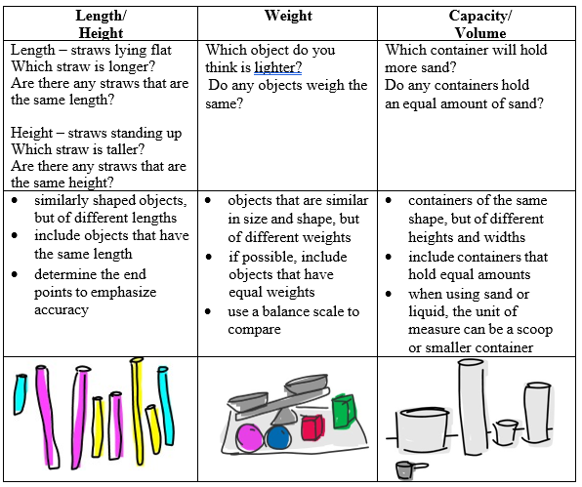Example:
* Instruction includes sorting pictures that include statements about attributes into categories of “true or false.” Teacher reads the statements to students if needed.
* Example:

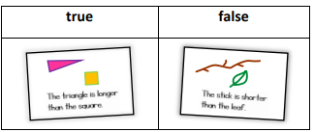



Instructional Tasks

*Instructional Task 1 (MTR.4.1)*

Working in groups, students are provided with an assortment of objects to compare (varied in height, length, weight, and capacities). Students will choose various objects from what is available and decide which attribute (height, length, weight, capacity or volume) they will compare. Give students time to discuss and record their findings using the sentence frames below.

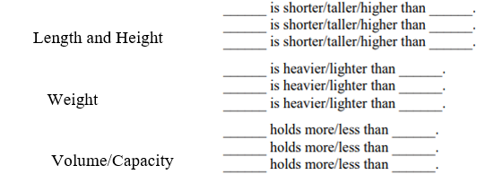

Instructional Items

*Instructional Item 1*

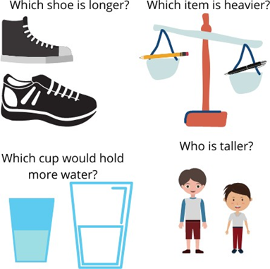

*\*The strategies, tasks and items included in the B1G-M are examples and should not be considered comprehensive.*

## *MA.K.M.1.3*

Benchmark

MA.K.M.1.3 Express the length of an object, up to 20 units long, as a whole number of lengths by laying non-standard objects end to end with no gaps or overlaps.

*Example:* A piece of paper can be measured using paper clips

Benchmark Clarifications:

*Clarification 1:* Non-standard units of measurement are units that are not typically used, such as paper clips or colored tiles. To measure with non-standard units, students lay multiple copies of the same object end to end with no gaps or overlaps. The length is shown by the number of objects needed.

Connecting Benchmarks/Horizontal Alignment

* MA.K.NSO.1.1/1.2
* MA.K.AR.1.3

Terms from the K-12 Glossary

Vertical Alignment

|  |  |
| --- | --- |
| **Previous Benchmarks**   * [VPK](http://flbt5.floridaearlylearning.com/standards.html#d%3DV%26a%3Dbirth_to_eight-months%2C18-24_months%2Ceight_to_eighteen-months%2Cthree_year_olds%2Ctwo_year_olds%2Cfour_year_olds) | **Next Benchmarks**   * MA.1.M.1.3 |

Purpose and Instructional Strategies

The purpose of this benchmark is to develop the foundation for measuring with given units. Though students will measure using non-standard units or objects, this will provide a foundation for standard units of measurement in later grades *(MTR.5.1)*.

* Instruction emphasizes the naming of units when recording or giving measurements.
  + For example, the pencil is 6 paperclips long.
* Instruction uses objects that can be measured in whole units, or close enough that there will be no misconceptions or errors related to rounding or estimating.
* Instruction includes using both concrete objects and images in real-world contexts to describe measurable attributes *(MTR.7.1)*.

Instruction includes students measuring an object using various non-standard units (erasers, paperclips or candy bars), comparing the results and seeing that when the unit is larger the number of units required is smaller *(MTR.2.1).*

Common Misconceptions or Errors

* Students may leave gaps or overlaps between objects when measuring, leading to inaccurate results.
* Students may mix different size units in the same measurement

Strategies to Support Tiered Instruction

* Instruction includes discussions about measurement during activities or tasks and should emphasize to students the idea that units of measure must be equal in length and size; and that each length unit must be touching the next. Tasks can include presenting students with identical objects being measured using similar non-standard units, some of which are incorrectly measured. Encourage students to evaluate and verbalize their thinking to justify why or how each object is measured correctly or not.
  + For example, images or pictures can be shown to students that include both examples and non-examples of the same object, such as a straw, that has been measured. Students can justify their thinking about how the object was measured, label each image with a “yes (green)” or a “no (red),” and then tell how to fix the mistake

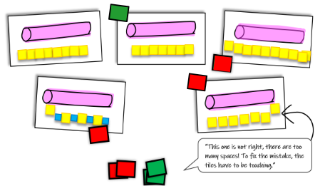

* Teacher models using one-inch grid paper cut into strips to place next to or below an object when measuring. One-inch square tiles are then placed on the grid paper strip to be used as a guide to place each unit precisely, with no gaps or overlaps. As students find success with tile placement, the grid paper strip can be used next to or below the placement of the tiles, until it is no longer needed.
* Example:

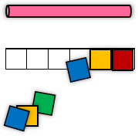

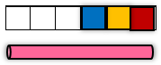

Instructional Tasks

*Instructional Task 1 (MTR.2.1)*

You will need objects to use as a unit of measurement (paperclips, tiles or other non-standard units) and various items to measure. In a group, have students pick which unit they will use to measure the objects with. (It is okay if students have different objects to measure with, but should all measure the same item.) Students will measure and report their findings to the group. The teacher will lead a discussion around their findings and compare responses.

The ____________________ is ______ paper clips long, but it is ______ color tiles long.

The group can discuss why they had different results even though they measured the same item. (The paperclip is shorter than the tile, so more paper clips are needed than tiles.). After the discussion, repeat the task. Students can be encouraged to make predictions based on the previous discussion.

Instructional Items

*Instructional Item 1*

How many paper clips long is the pencil?



How many paperclips long is the flower?



*\*The strategies, tasks and items included in the B1G-M are examples and should not be considered comprehensive.*

## **Geometric Reasoning**

**MA.K.GR.1** *Identify, compare and compose two- and three-dimensional figures.*

### MA.K.GR.1.1

Benchmark

MA.K.GR.1.1 Identify two- and three-dimensional figures regardless of their size or orientation. Figures are limited to circles, triangles, rectangles, squares, spheres, cubes, cones and cylinders.

Benchmark Clarifications:

*Clarification 1:* Instruction includes a wide variety of circles, triangles, rectangles, squares, spheres, cubes, cones and cylinders.

*Clarification 2:* Instruction includes a variety of non-examples that lack one or more defining attributes.

*Clarification 3:* Two-dimensional figures can be either filled, outlined or both.

Connecting Benchmarks/Horizontal Alignment

* MA.K.M.1.1
* MA.K.DP.1.1

Terms from the K-12 Glossary

* Circles
* Cones
* Cubes
* Cylinders
* Rectangles
* Spheres
* Squares
* Triangles

Vertical Alignment

|  |  |
| --- | --- |
| **Previous Benchmarks**   * [VPK](http://flbt5.floridaearlylearning.com/standards.html#d%3DV%26a%3Dbirth_to_eight-months%2C18-24_months%2Ceight_to_eighteen-months%2Cthree_year_olds%2Ctwo_year_olds%2Cfour_year_olds) | **Next Benchmarks**   * MA.1.GR.1.1 |

Purpose and Instructional Strategies

The purpose of this benchmark is to help students identify specific two- and three-dimensional figures, and to make connections between the figures *(MTR.2.1, MTR.5.1)*.

* It is not the expectation of this benchmark to make distinctions between two- and three- dimensional figures.
* Instruction focuses on using a variety of figures including different orientations, such as scalene, isosceles, and equilateral triangles, to build the understanding of triangles. (There is no expectation that students learn these terms, but it is important they recognize various types of triangles.) *(MTR.2.1)*
* Instruction for rectangles and squares includes their similarities and differences, and the relationship that all squares are rectangles, but not all rectangles are squares *(MTR.5.1)*.
* Instruction may use manipulatives and other concrete objects to develop student understanding.

Common Misconceptions or Errors

* Students may only recognize figures in a specific orientation or angle distribution (i.e., recognizing isosceles triangles but not scalene).
* Students may not recognize that a square is also a rectangle.
* Students may sort objects by size when asked to sort by shape.
  + For example, students may place large circles with large triangles, or separate large triangles and small triangles.

Strategies to Support Tiered Instruction

* Teacher provides students with a pair of shapes. Each pair consists of an example and a non-example of a specific shape. The non-example should look similar to the example. Ask the student to compare. The teacher might say, “What is the same? What is different?”
* For example, consider the following pair:



* Teacher provides students with a set of two-dimensional shapes to do the following activities in order:
  + At random, choose two shapes and try to find something that is alike about the two shapes and something that is different.
  + Choose one specific shape at random and place it in the middle of the table. Find all the other shapes that are like the specific shape according to the same attribute. The teacher might say, “This shape is like the original shape because it has a curved side and a straight side” then have the students add all the other shapes that meet that criterion into the collection. Repeat this sort with the same shape but a new criterion as a challenge.
  + Play “Guess My Rule” by creating a pile of three to four shapes that share a criterion only known to the creator. Ask students to find more shapes that fit the criteria and to figure out the “secret rule”.
* Teacher provides students with a set of three-dimensional shapes and repeats the previous set of activities with solid shapes.
* Teacher provides shapes that are cut out and present them to the students in various orientations (i.e., isosceles, scalene, and right triangles): squares, circles, triangles, rectangles. Shapes are scattered in the workspace. Students work to match the squares with the squares, the circles with the circles, etc., until all shapes are grouped. The focus is on students being able to identify shapes when they are oriented differently (i.e., not sitting flat on one side). This task can be replicated for any sets of shapes students are struggling with including three-dimensional figures. If needed, reduce the type of shapes being sorted (i.e., instead of sorting 4 types of shapes, only sort 2 types of shapes).
* Teacher provides the following two-dimensional shapes in multiple sizes: squares, circles, triangles, rectangles. Shapes are scattered in the workspace. Students work to match the squares with the squares, the circles with the circles, etc., until all shapes are grouped. The focus is on students recognizing that shapes of different sizes go in the same group (i.e., all circles large and small should be together). This task can be replicated for any sets of shapes students are struggling with including solid figures.
  + For example:

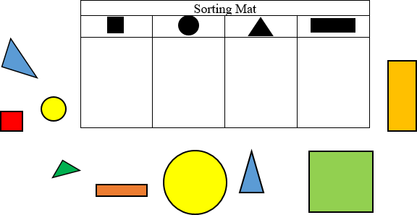

* Teacher provides instruction by doing a “Shape Show”. The teacher shows and names a large rectangle. Walk fingers around its perimeter, describing and exaggerating the actions (straight side...turn, straight side...turn, straight side...turn, straight side...stop), while asking students how many sides the rectangle has and count the sides with him or her. Repeat the actions for a large square, drawing connections between the similarities. The teacher explains that squares are a special kind of rectangle.



Instructional Tasks

*Instructional Task 1*

Circle the correct item

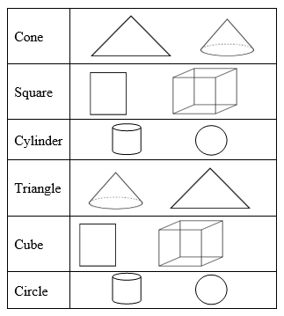

Instructional Items

*Instructional Item 1*

Using the image below, draw an “x” through all of the rectangles.

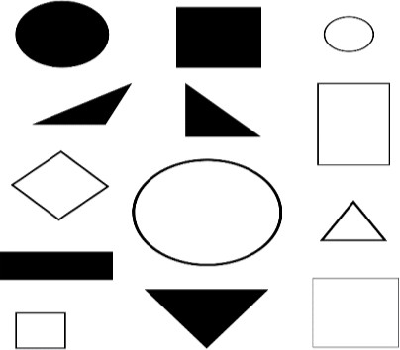

*The strategies, tasks and items included in the B1G-M are examples and should not be considered comprehensive.

### MA.K.GR.1.2

Benchmark

MA.K.GR.1.2 Compare two-dimensional figures based on their similarities, differences, and positions. Sort two-dimensional figures based on their similarities and differences. Figures are limited to circles, triangles, rectangles, and squares.

Connecting Benchmarks/Horizontal Alignment

* MA.K.M.1.1/1.2
* MA.K.DP.1.1
* MA.K.NSO.1.1/1.4

Terms from the K-12 Glossary

* Circle
* Rectangle
* Square
* Triangle

Vertical Alignment

|  |  |
| --- | --- |
| **Previous Benchmarks**   * [VPK](http://flbt5.floridaearlylearning.com/standards.html#d%3DV%26a%3Dbirth_to_eight-months%2C18-24_months%2Ceight_to_eighteen-months%2Cthree_year_olds%2Ctwo_year_olds%2Cfour_year_olds) | **Next Benchmarks**   * MA.1.GR.1.1 |

Purpose and Instructional Strategies

The purpose of this benchmark is for students to build on their understanding of classification of two-dimensional figures by finding similarities and differences between shapes *(MTR.5.1)*.

* Instruction includes opportunities for students to sort images based on various criteria, such as same number of sides, and figures with all straight sides *(MTR.2.1, MTR.5.1)*.
* Instruction includes helping students describe objects based on relative positions. Relative position refers to students identifying left/right, in front of/behind, apart and above/below. When comparing figures students should understand that relative position can change even though the other features of the figures stay the same.
* Instruction includes figures of various sizes and orientations, and may include figures that are not triangles, circles, rectangles or squares *(MTR.2.1)*.
* Instruction includes examples of squares when discussing rectangles.

Right angles are technically not addressed until grade 4, but it is appropriate to discuss “square corners” and corners that are not square in an informal way in Kindergarten.

Common Misconceptions or Errors

* Students may not understand that all squares are also classified as rectangles; however, only specific rectangles (with sides that are the same length) are also classified as squares.
  + Students may sort figures separately because of orientation and/or size rather than the identified attributes of the figures

Strategies to Support Tiered Instruction

* Teacher provides plane shapes (circles, squares, triangles, rectangles) for students to sort.
  + For example, instruction includes sorting shapes by how they are the same or by how they are different. The teacher asks follow up questions such as, “How did you decide to sort the shapes? How many sides does this group have?”



Instructional Tasks

*Instructional Task 1 (MTR.2.1, MTR.4.1)*

Using the figures below, create sorting cards for students.

Provide each student in a group with their own set of figures to sort. Ask each student to sort the figures in any way they choose. Once students have sorted their figures, give each student time to share about their choices, and explain how they sorted their figures (by shape, straight sides and circles, filled and not filled or number of sides). Once students have shared, ask them to sort their figures in a new way. Give time for sorting and sharing again. Repeat the task as needed.

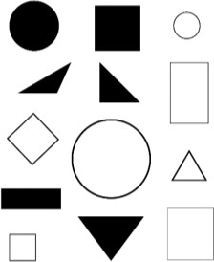

*Instructional Task 2*

Identify which of the figures below are rectangles and describe their relative positions.



Instructional Items

*Instructional Item 1*

Cross out all of the figures that have 4 sides.

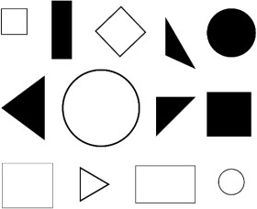

*Instructional Item 2*

How many figures have straight sides?



*\*The strategies, tasks and items included in the B1G-M are examples and should not be considered comprehensive.*

### MA.K.GR.1.3

Benchmark

MA.K.GR.1.3 Compare three-dimensional figures based on their similarities, differences and positions. Sort three-dimensional figures based on their similarities and differences. Figures are limited to spheres, cubes, cones and cylinders.

Benchmark Clarifications:

*Clarification 1:* Instruction includes exploring figures in a variety of sizes and orientations.

*Clarification 2:* Instruction focuses on using informal language to describe relative positions and the similarities or differences between figures when comparing and sorting.

Connecting Benchmarks/Horizontal Alignment

* MA.K.M.1.1/1.2
* MA.K.DP.1.1

Terms from the K-12 Glossary

* Cones
* Cubes
* Cylinders
* Spheres

Vertical Alignment

|  |  |
| --- | --- |
| **Previous Benchmarks**   * [VPK](http://flbt5.floridaearlylearning.com/standards.html#d%3DV%26a%3Dbirth_to_eight-months%2C18-24_months%2Ceight_to_eighteen-months%2Cthree_year_olds%2Ctwo_year_olds%2Cfour_year_olds) | **Next Benchmarks**   * MA.1.GR.1.1 |

Purpose and Instructional Strategies

The purpose of this benchmark is for students to build on their understanding of classification of three-dimensional figures by finding similarities and differences between shapes.

* Instruction focuses on sorting and classifying three-dimensional figures.
* Instruction includes opportunities for students to sort figures based on various criteria, such as same number of faces and figures with all flat sides *(MTR.5.1)*.
* Instruction includes figures of various sizes and orientations, and may include non- standard versions of figures as well *(MTR.2.1)*.
  + Relative position refers to students identifying left/right, in front of/behind, apart and above/below when comparing shapes.

Common Misconceptions or Errors

* Students may sort figures separately because of orientation and size rather than the identified attributes of the figures.
* Students may inaccurately name and sort three-dimensional figures based on the names of their two-dimensional faces.

Strategies to Support Tiered Instruction

* Teacher provides solid shapes (cones, cylinders, cubes, and spheres) for students to sort.
  + For example, instruction includes sorting shapes by how they are same or by how they are different. The teacher asks follow up questions such as, “How did you decide to sort the shapes? How many sides does this group have?”

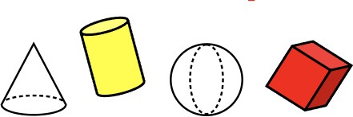

* Teacher collects flexible plastic drinking straws cut lengthwise down to the flexible joint. Insert the slit ends into the uncut bottom ends of the other straws, making flexible joints. The teacher can then ask students to construct different models of three-dimensional shapes by giving them some information.
* For example, the teacher can say, “Can you build a shape with four corners (vertices) and six sides (faces)?” Observe the student building the shape.
* Teacher constructs a Mystery Box where they position one solid figure out of sight of students. Display some shapes on top of the box. Students put a single hand into the box to feel the shape and then point to the matching shapes on display. To begin, let the student see the shapes when feeling the attributes. Then hide the shape on subsequent turns.

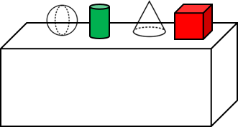

If students have trouble identifying the shapes to complete comparison, see activity from benchmark MA.K.G.1.1.

Instructional Tasks

*Instructional Task 1 (MTR.2.1, MTR.4.1)*

Using the figures below, create sorting cards for students.

Provide each student in a group with their own set of figures to sort. Ask each student to sort the figures in any way they choose. Once students have sorted their figures, give each student time to share about their choices, and explain how they sorted their figures (by shape, straight sides and circles, filled and not filled or number of faces). Once students have shared, ask them to sort their figures in a new way. Give time for sorting and sharing again. Repeat the task as needed.

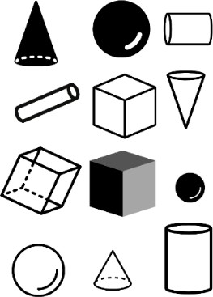

Instructional Items

*Instructional Item 1*

In what ways are the figures similar? In what ways are they different? Circle the cone. Draw a square around the cylinder.

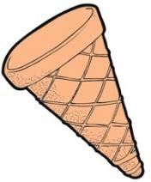

*\*The strategies, tasks and items included in the B1G-M are examples and should not be considered comprehensive.*

### MA.K.GR.1.4

Benchmark

MA.K.GR.1.4 Find real-world objects that can be modeled by a given two- or three- dimensional figure. Figures are limited to circles, triangles, rectangles, squares, spheres, cubes, cones and cylinders.

Connecting Benchmarks/Horizontal Alignment

* MA.K.M.1.1
* MA.K.DP.1.1

Terms from the K-12 Glossary

* Circles
* Cones
* Cubes
* Cylinders
* Rectangles
* Spheres
* Squares
* Triangles

Vertical Alignment

|  |  |
| --- | --- |
| **Previous Benchmarks**   * [VPK](http://flbt5.floridaearlylearning.com/standards.html#d%3DV%26a%3Dbirth_to_eight-months%2C18-24_months%2Ceight_to_eighteen-months%2Cthree_year_olds%2Ctwo_year_olds%2Cfour_year_olds) | **Next Benchmarks**   * MA.1.GR.1.4 |

Purpose and Instructional Strategies

The purpose of this benchmark is to allow students an opportunity to apply understanding of classification and language they have learned regarding figures to the real world *(MTR.7.1)*.

* Instruction should include objects that may not be a perfect representation, but are approximate models for representing appropriate figures.

Instruction should include bringing in additional items that are familiar and can be modeled by appropriate figures (cans of soup, cardboard boxes, waffle cones, coins etc.).

Common Misconceptions or Errors

* In real life, many objects can be appropriately modeled with both two-dimensional and three-dimensional figures. For this benchmark, do not struggle with this. Allow students flexibility and rely on their justifications *(MTR.4.1, MTR.6.1)*.

Strategies to Support Tiered Instruction

* Teacher provides paper pictures of real-world three-dimensional objects to help students develop the understanding that some three-dimensional objects can be modeled by using two- dimensional shapes.
  + For example, teachers can show students a picture of a window and explain that it can be described as a rectangle. Or if the window has several sections, it can be described as a figure being composed of several rectangles.



* + For example, teachers can show students a picture of a face of a nickel and explain that it can be described as a circle. Then teachers can show students an actual nickel and ask “Is there any other shape they can be used to describe the coin?”
    - Teacher can explain and demonstrate how both a circle and a cylinder are both correct responses. If students have difficulty recognizing that the nickel is a cylinder, the teacher can stack several nickels on top of each other to provide further support.
* Teacher provides a collection of items that can be found in everyday life (large container of rolled oats, tissue boxes, plastic spice container, shampoo bottles, orange cones used in sports, etc.) and asks the student to find the everyday items that matches a solid figure from the classroom set of shapes.
* For example, hold up the cylinder and ask the students, “Which of the items on the table are an example of the cylinder that is in my hand?”

Instructional Tasks

*Instructional Task 1 (MTR.4.1, MTR.6.1, MTR.7.1)*

Using a graphic organizer, allow students to observe objects they find around the classroom, providing students an opportunity to record their observations. After recording students can discuss in teams what they found, providing justifications for the choices they made.

Encourage students to use language and criteria they have developed regarding identifying figures, such as the number of sides, two-dimensional versus three-dimensional, straight sides or curved sides.

Instructional Items

*Instructional Item 1*

Using the chart, draw one item from the classroom that represents each shape:.

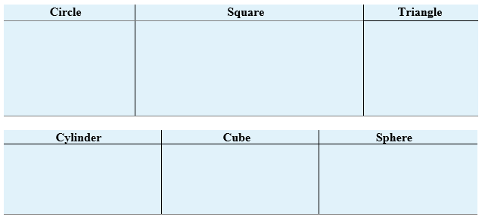

*\*The strategies, tasks and items included in the B1G-M are examples and should not be considered comprehensive.*

### 

### MA.K.GR.1.5

Benchmark

MA.K.GR.1.5 Combine two-dimensional figures to form a given composite figure. Figures used to form a composite shape are limited to triangles, rectangles and squares.

*Example:* Two triangles can be used to form a given rectangle

Benchmark Clarifications:

*Clarification 1:* This benchmark is intended to develop the understanding of spatial relationships.

Connecting Benchmarks/Horizontal Alignment

There are no direct connections outside of this standard; however, teachers are encouraged to find possible indirect connections.

Terms from the K-12 Glossary

* Composite Figures
* Rectangles
* Squares
* Triangle

Vertical Alignment

|  |  |
| --- | --- |
| **Previous Benchmarks**   * [VPK](http://flbt5.floridaearlylearning.com/standards.html#d%3DV%26a%3Dbirth_to_eight-months%2C18-24_months%2Ceight_to_eighteen-months%2Cthree_year_olds%2Ctwo_year_olds%2Cfour_year_olds) | **Next Benchmarks**   * MA.1.GR.1.3 |

Purpose and Instructional Strategies

The purpose of this benchmark is to allow students opportunities to discover further connections and patterns with two-dimensional figures. Students should have an opportunity to investigate combining figures in a variety of sizes and orientations *(MTR.2.1, MTR.5.1)*.

* Instruction includes composite figures that may be named based on previous benchmarks, as well as those not included in previous benchmarks, though there is no expectation of a formal name for new composite shapes outside of previously named figures.
  + For example, a triangle and square forming a pentagon, may not need to be formally identified as a pentagon. Two triangles that form a rectangle can be formally identified as a rectangle.
* Exploring with figures of different sizes and orientations allows students to continue to develop an understanding of spatial reasoning *(MTR.2.1)*.

Common Misconceptions or Errors

* Students may attempt to compose figures without regard to aligning sides or vertices. The overlap may cause difficulty in naming or describing the new composite figures.
* Students may avoid lining the edges of two figures if the sides aren’t the same length.
  + For example, it could be appropriate to join several rectangles of various sizes to make a figure that looks like a building with towers.

Strategies to Support Tiered Instruction

* Teacher provides explicit instruction by providing opportunities to compose shapes using pattern blocks. Begin by having students compose rectangles using squares.
  + Example:

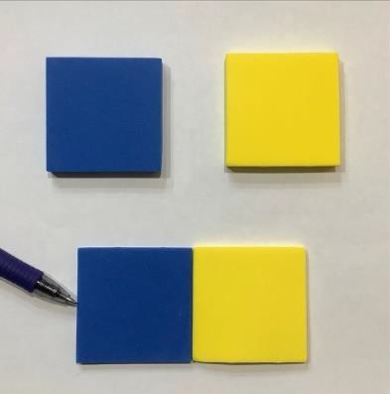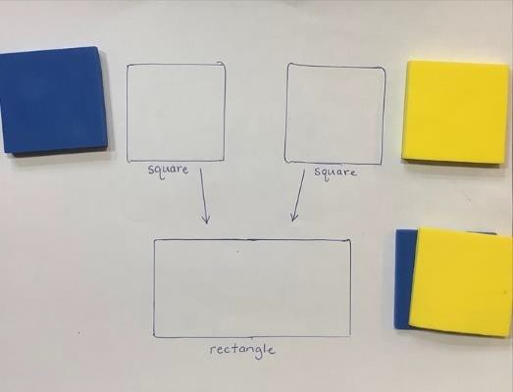

* Teacher provides opportunities for students to explore what happens when they compose shapes.
  + For example, teacher provides right triangles, squares, and rectangles in the middle of the workspace. The teacher may ask, “What shapes can you combine to make a square?” and places the square in front of the student.
  + To differentiate this activity, the teacher may place a different shape in front of each student.
* Teacher provides a set of tangram pieces for the students to explore how they can compose shapes to create a larger figure. If tangram pieces are not available to the teacher, the teacher may use a search engine to print a set of tangram pieces to copy.



Instructional Tasks

*Instructional Task 1 (MTR.2.1, MTR.4.1, MTR.5.1, MTR.7.1)*

Provide each student in a group or whole class with a plethora of rectangles, squares and triangles in a variety of shapes and sizes (be intentional in assuring that various sides are congruent for the purpose of composing new figures). Ask students, “can you make a new figure using two of the figures I have given you?” Give students time to explore, then opportunities to share. Record the findings, focusing on what may be considered “key” compositions (two squares making a rectangle, two triangles making a rectangle, a “house” from a rectangle and triangle, or an octagon from triangles).

Instructional Items

*Instructional Item 1*

Jamie says that you cannot make a rectangle using the 2 triangles below. Is she correct? Justify your answer scale.



*\*The strategies, tasks and items included in the B1G-M are examples and should not be considered comprehensive.*

## 

## **Data Analysis & Probability**

**MA.K.DP.1** *Develop an understanding for collecting, representing and comparing data.*

### MA.K.DP.1.1

Benchmark

MA.K.DP.1.1 Collect and sort objects into categories and compare the categories by counting the objects in each category. Report the results verbally, with a written numeral or with drawings.

*Example:* A bag containing 10 circles, triangles and rectangles can be sorted by shape and then each category can be counted and compared.

Benchmark Clarifications:

*Clarification 1:* Instruction focuses on supporting work in counting.

*Clarification 2*: Instruction includes geometric figures that can be categorized using their defining attributes.

*Clarification 3:* Within this benchmark, it is not the expectation for students to construct formal representations or graphs on their own.

Connecting Benchmarks/Horizontal Alignment

* MA.K.NSO.1.1/1.4
* MA.K.M.1.1
* MA.K.GR.1.1/1.2/1.3/1.4

Terms from the K-12 Glossary

* Data
* Statistical Question

Vertical Alignment

|  |  |
| --- | --- |
| **Previous Benchmarks**   * [VPK](http://flbt5.floridaearlylearning.com/standards.html#d%3DV%26a%3Dbirth_to_eight-months%2C18-24_months%2Ceight_to_eighteen-months%2Cthree_year_olds%2Ctwo_year_olds%2Cfour_year_olds) | **Next Benchmarks**   * MA.1.DP.1.1 * MA.1.DP.1.2 |

Purpose and Instructional Strategies

The purpose of this benchmark is to develop a foundation for statistical thinking, as well as provide a context to support the development of counting skills *(MTR.5.1)*. In grade 1, students will organize data using tally marks or pictographs and compare categories by counting the objects in each category.

* Instruction reinforces the counting and comparing benchmarks within the Number Sense and Operations strand *(MTR.5.1)*.
* Instruction reinforces the identifying and sorting of figures benchmarks within the Geometric Reasoning strand *(MTR.5.1)*.

Common Misconceptions or Errors

* Students may not clearly define categories for sorting objects which may lead to inaccurate data collection as objects fit into multiple categories.
* When students are presented with objects to be sorted into predefined categories, they may be frustrated that some objects don’t fit into any category.
* Students may misrepresent the count for each category.

Strategies to Support Tiered Instruction

* Instruction includes opportunities for students to sort objects by given attributes.
* For example, have students sort themselves into categories based on transportation to school (bus rider, car rider, extended day, walker). Students can report their sorting using drawings or numerals.
* For example, provide students crayons and ask students to sort crayons by color. Students will sort the crayons into 4 categories: red, blue, green, and yellow. Possible questions to ask during this activity:
  + How many red crayons are there?
  + How many green crayons are there?
  + Which category has the most crayons?
  + Which category has the least crayons?
  + How many more blue crayons are there than yellow crayons?
* Instruction includes opportunities to sort two-dimensional and three-dimensional geometric figures by attributes. For example, teacher places foam, wood and/or pattern blocks into a bucket. Students are asked to sort the figures. The teacher will see how students sort the figures and ask the students to explain why they sorted the figures a particular way (could be by color, size, texture etc.) If students are unsure of where to place a figure, help students determine what category in which to place the figure by having a discussion on the attributes of the figure in relationship to the attributes of the sorted figures. Students will count how many figures are in each of their categories and record the numeral. The teacher asks comparing questions about the groups such as:
* “How are these shapes different from one another?”
* “Are there more red shapes or blue shapes?”
* “Are there more squares than triangles?”
* The teacher will then ask the students to sort the figures another way and repeat the activity after the figures have been classified a new way.

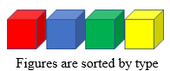 

Instructional Tasks

*Instructional Task 1 (MTR.5.1)*

Provide students with cards or objects that can be sorted multiple ways (i.e., shapes that are various colors and could be sorted by shape or color). In a group, give students time to think and discuss the various ways the cards or objects can be sorted. After a discussion, the group will decide a way to sort the cards or objects and do so. Then the teacher asks questions such as:

* “Which category has the most?”
* “Which category has the least?”
* “How many are in [fill in the blank] category”?

After a discussion, the cards or objects can be sorted using a different attribute and the task can begin again.

*Instructional Task 2 (MTR.3.1)*

Ask students to sort the figures into groups of circles, rectangles and triangles.

* “Which shape appears the most?”
* “How many more triangles are there than circles?”
* “How many squares are there?” “
* “How many figures have straight sides?”

Discuss how sorting makes answering the questions easier.

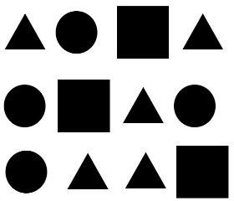

*Instructional Task 3 (MTR.1.1, MTR.7.1)*

Provide students with a “Question of the Day”. For example, post the question “What is your favorite food - pizza, spaghetti or tacos?” After each student has selected one option, have students to work in groups to represent the data in drawings or numerals. Possible questions to ask during this task:

* Which favorite food had the greatest number of votes?
* Which favorite food has the least number of votes?

Are there any favorite foods with the same number of votes

Instructional Items

*Instructional Item 1*

Based on the “Question of the Day” - What color is your shirt – blue, green, pink or red?

Part A: Sort the data.

Part B: Report the data with drawings.

*Instructional Item 2*

Part A. Circle the buttons that are shaped like triangles.

Part B. How many buttons are shaped like a triangle?



*Instructional Item 3*

Part A: Sort the figures by color.

Part B: How many figures are green?

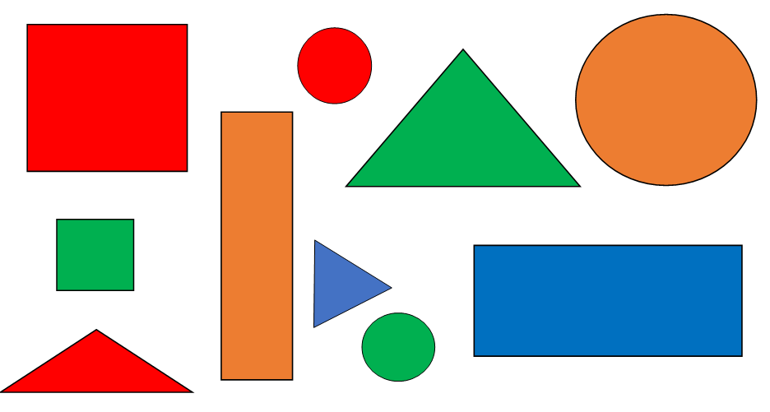

*The strategies, tasks and items included in the B1G-M are examples and should not be considered comprehensive.

Appendix A. Summary of Changes

The purpose of this table is to provide a summary of changes from for the latest version of the B1G-M. For questions or feedback on the B1G-M, please direct them to [BESTMath@fldoe.org](mailto:BESTMath@fldoe.org).

| **Benchmark** | **B1G-M Component** | **Change Made** |
| --- | --- | --- |
| K.NSO.1.1 | Horizontal Alignment | Removed K.M.1.2 |
| K.NSO.1.1 | Purpose | Added (Moved a bullet from S2STI) |
| K.NSO.1.1 | S2STI | Added a bullet for teacher think-aloud. |
| K.NSO.1.1 | S2STI | Moved a bullet from S2STI to Purpose |
| K.NSO.1.1 | Task 1 | Added MTR |
| K.NSO.1.1 | Instructional Item 2 | Add image of calendar |
| K.NSO.1.2 | Horizontal Alignment | Added AR.1.1 |
| K.NSO.1.2 | S2STI | Added 3rd bullet for strategy (number line) |
| K.NSO.1.2 | Instructional Task 1 & 2 | Added MTRs |
| K.NSO.1.2 | Instructional Item | New Item #2 |
| K.NSO.1.3 | Horizontal Alignment | Removed NSO.2.1 |
| K.NSO.1.3 | Vertical Alignment | Removed 3.AR.3.3/Added 1.NSO.1.4 & 1.M.1.2 |
| K.NSO.1.4 | Vertical Alignment | Added 1.AR.2.2 |
| K.NSO.1.4 | S2STI | 3rd Bullet added and 4th Bullet reformatted |
| K.NSO.1.4 | Instructional Task 1 | MTR added and last 2 questions added |
| K.NSO.2.1 | Purpose | Connection to future grades |
| K.NSO.2.1 | Instructional Item 1 | Added a line to address counting by tens |
| K.NSO.2.2 | Purpose | Connection to future grades |
| K.NSO.2.2 | Instructional Task 1 | Added “= 10” ones to image |
| K.NSO.2.3 | CM/E and S2STI | Changed “hash” to “tick” |
| K.NSO.2.3 | S2STI | Changed 1st bullet to clarify completing versus building a number line and adjusting the scaffold to match the language.  Removed 3rd bullet |
| K.NSO.2.3 | Instructional Item 1 | Removed “one more than” and “one less than” |
| K.NSO.3.1 | Vertical Alignment | Added 1.NSO.2.5 and put all 3 benchmarks on 1 line |
| K.NSO.3.1 | Purpose | Reworded for clarity and included “related subtraction facts” |
| K.NSO.3.1 | S2STI | Adjusted 2nd bullet and added part/part/whole image to it |
| K.NSO.3.1 | Instructional Item 2 | Numbers and questions have been changed – included facts beyond 10 |
| K.NSO.3.2 | S2STI | Removed last bullet |
| K.NSO.3.2 | Instructional Item 2 | Added 2nd item to address subtraction (number bonds) |
| K.AR.1.1 | Glossary | Added “Commutative property of addition” and “equation” and “expression” |
| K.AR.1.1 | S2STI | Changed equation to expression |
| K.AR.1.1 | Instructional Item 1 | Changed to Omar and is Omar correct? Added use models and strategies to explain your thinking. |
| K.AR.1.2 | Glossary | Added “Commutative property of addition” |
| K.AR.1.2 | Instructional Item 1 | Rewrote: Find three different ways to get a sum of 8 by adding 2 numbers together |
| K.AR.1.3 | Glossary | Added “equal sign” |
| K.AR.1.3 | S2STI | Updated using language from K.AR.2.1 for bullet 1 |
| K.AR.1.3 | Instructional Task 1 | Altogether and changed the situation to both addends unknown/made more open ended |
| K.AR.1.3 | Enrichment Task 1 | Added new task |
| K.AR.1.3 | Instructional Item 1 and 2 | Changed contexts and word problem types to match grade level |
| K.AR.2.1 | S2STI | Removed language and moved to K.AR.1.3 to add “3 Reads” and graphic organizer |
| K.M.1.1 | Horizontal Alignment | Remove K.GR.1.4 |
| K.M.1.1 | Misconceptions | Clarified 1st  2nd bullet - changed sub-bullet and added another sub-bullet |
| K.M.1.1 | S2STI | Added measurement vocab chart and sentence frame and clarified language |
| K.M.1.1 | Instructional Item | Replaced sword with bat and extra “short” |
| K.M.1.2 | S2STI | Adjusted activity in chart to address comparing 2 objects, added height |
| K.M.1.2 | Instructional Task | Adjusted wording |
| K.M.1.3 | S2STI | Adjusted images |
| K.M.1.3 | Instructional Task | Added sentence frame example |
| K.GR.1.1 | Strat to Support Tiered Instr. | Edited first bullet and created 2 more strategies.  Deleted picture |
| K.GR.1.2 | Horizontal Alignment | Added K.NSO.1.1/K.NSO.1.4 |
| K.GR.1.2 | S2STI | Deleted 2nd and 3rd Bullet |
| K.GR.1.2 | Item 1 | Draw an x, instead of circle |
| K.GR.1.3 | S2STI | Changed 2nd bullet |
| K.GR.1.4 | Purpose | Change examples of figures |
| K.GR.1.4 | S2STI | Added last bullet |
| K.GR.1.4 | Task 1 | Changed task |
| K.GR.1.5 | S2STI | New 2nd bullet, added a 3rd bullet and added image for 3rd bullet |
| K.DP.1.1 | Purpose | Connection to future grades |
| K.DP.1.1 | MCE | Added another misconception |
| K.DP.1.1 | S2STI | Added 1st bullet for teacher think aloud |
| K.DP.1.1 | S2STI | Rewrote 1st bullet – moved from Instructional Item 1 |
| K.DP.1.1 | Instructional Task 1 | Revised for clarity – bulleted questions and combined with Task 1 |
| K.DP.1.1 | Instructional Task 3 | New Instructional Task 3 |
| K.DP.1.1 | Instructional Item 1 | Moved original to S2STI and wrote a new item |
| K.DP.1.1 | Instructional Item 3 | New item |