# Grade 7 Accelerated B.E.S.T. Instructional Guide for Mathematics

The B.E.S.T. Instructional Guide for Mathematics (B1G-M) is intended to assist educators with planning for student learning and instruction aligned to Florida’s Benchmarks for Excellent Student Thinking (B.E.S.T.) Standards. This guide is designed to aid high-quality instruction through the identification of components that support the learning and teaching of the B.E.S.T. Mathematics Standards and Benchmarks. The B1G-M includes an analysis of information related to the B.E.S.T. Standards for Mathematics within this specific mathematics course, the instructional emphasis and aligned resources. This document is posted on the [B.E.S.T. Standards for Mathematics webpage](https://www.fldoe.org/academics/standards/subject-areas/math-science/mathematics/bestmath.stml) of the Florida Department of Education’s website and will continue to undergo edits as needed.

## Structural Framework and Intentional Design of the B.E.S.T. Standards for Mathematics

Florida’s B.E.S.T. Standards for Mathematics were built on the following.

* The coding scheme for the standards and benchmarks was changed to be consistent with other content areas. The new coding scheme is structured as follows:

Content.GradeLevel.Strand.Standard.Benchmark.

* Strands were streamlined to be more consistent throughout.
* The standards and benchmarks were written to be clear and concise to ensure that they are easily understood by all stakeholders.
* The benchmarks were written to allow teachers to meet students’ individual skills, knowledge and ability.
* The benchmarks were written to allow students the flexibility to solve problems using a method or strategy that is accurate, generalizable and efficient depending on the content (i.e., the numbers, expressions or equations).
* The benchmarks were written to allow for student discovery (i.e., exploring) of strategies rather than the teaching, naming and assessing of each strategy individually.
* The benchmarks were written to support multiple pathways for success in career and college for students.
* The benchmarks should not be taught in isolation but should be combined purposefully.
* The benchmarks may be addressed at multiple points throughout the year, with the intention of gaining mastery by the end of the year.
* Appropriate progression of content within and across strands was developed for each grade level and across grade levels.
* There is an intentional balance of conceptual understanding and procedural fluency with the application of accurate real-world context intertwined within mathematical concepts for relevance.
* The use of other content areas, like science and the arts, within real-world problems should be accurate, relevant, authentic and reflect grade-level appropriateness.

## Components of the B.E.S.T. Instructional Guide for Mathematics

The following table is an example of the layout for each benchmark and includes the defining attributes for each component. It is important to note that instruction should not be limited to the possible connecting benchmarks, related terms, strategies or examples provided. To do so would strip the intention of an educator meeting students’ individual skills, knowledge and abilities.

Benchmark

focal point for instruction within lesson or task

This section includes the benchmark as identified in the [B.E.S.T. Standards for Mathematics](https://www.cpalms.org/uploads/docs/standards/BEST/MA/MathBESTStandardsFinal.pdf). The benchmark, also referred to as the Benchmark of Focus, is the focal point for student learning and instruction. The benchmark, and its related example(s) and clarification(s), can also be found in the course description. The 9-12 benchmarks may be included in multiple courses; select the example(s) or clarification(s) as appropriate for the identified course.

Connecting Benchmarks/Horizontal Alignment

in other standards within the grade level or course

This section includes a list of connecting benchmarks that relate horizontally to the Benchmark of Focus. Horizontal alignment is the intentional progression of content within a grade level or course linking skills within and across strands. Connecting benchmarks are benchmarks that either make a mathematical connection or include prerequisite skills. The information included in this section is not a comprehensive list, and educators are encouraged to find other connecting benchmarks. Additionally, this list will not include benchmarks from the same standard since benchmarks within the same standard already have an inherent connection.

Terms from the K-12 Glossary

This section includes terms from Appendix C: K-12 Glossary, found within the B.E.S.T. Standards for Mathematics document, which are relevant to the identified Benchmark of Focus. The terms included in this section should not be viewed as a comprehensive vocabulary list, but instead should be considered during instruction or act as a reference for educators.

Vertical Alignment

across grade levels or courses

This section includes a list of related benchmarks that connect vertically to the Benchmark of Focus. Vertical alignment is the intentional progression of content from one year to the next, spanning across multiple grade levels. Benchmarks listed in this section make mathematical connections from prior grade levels or courses in future grade levels or courses within and across strands. If the Benchmark of Focus is a new concept or skill, it may not have any previous benchmarks listed. Likewise, if the Benchmark of Focus is a mathematical skill or concept that is finalized in learning and does not have any direct connection to future grade levels or courses, it may not have any future benchmarks listed. The information included in this section is not a comprehensive list, and educators are encouraged to find other benchmarks within a vertical progression.

Purpose and Instructional Strategies

This section includes further narrative for instruction of the benchmark and vertical alignment. Additionally, this section may also include the following:

* explanations and details for the benchmark;
* vocabulary not provided within Appendix C;
* possible instructional strategies and teaching methods; and
* strategies to embed potentially related Mathematical Thinking and Reasoning Standards (MTRs).

Common Misconceptions or Errors

This section will include common student misconceptions or errors and may include strategies to address the identified misconception or error. Recognition of these misconceptions and errors enables educators to identify them in the classroom and make efforts to correct the misconception or error. This corrective effort in the classroom can also be a form of formative assessment within instruction.

**Strategies** to Support Tiered Instruction

The instructional strategies in this section address the common misconceptions and errors listed within the above section that can be a barrier to successfully learning the benchmark. All instruction and intervention at Tiers 2 and 3 are intended to support students to be successful with Tier 1 instruction. Strategies that support tiered instruction are intended to assist teachers in planning across any tier of support and should not be considered exclusive or inclusive of other instructional strategies that may support student learning with the B.E.S.T. Mathematics Standards. For more information about tiered instruction, please see the Effective Tiered Instruction for Mathematics: ALL Means ALL document.

Instructional Tasks

demonstrate the depth of the benchmark and the connection to the related benchmarks

This section will include example instructional tasks, which may be open-ended and are intended to demonstrate the depth of the benchmark. Some instructional tasks include integration of the Mathematical Thinking and Reasoning Standards (MTRs) and related benchmark(s). Enrichment tasks may be included to make connections to benchmarks in later grade levels or courses. Tasks may require extended time, additional materials and collaboration.

Instructional Items

demonstrate the focus of the benchmark

This section will include example instructional items which may be used as evidence to demonstrate the students’ understanding of the benchmark. Items may highlight one or more parts of the benchmark.

*The strategies, tasks and items included in the B1G-M are examples and should not be considered comprehensive.

# Mathematical Thinking and Reasoning Standards

MTRs: Because Math Matters

Florida students are expected to engage with mathematics through the Mathematical Thinking and Reasoning Standards (MTRs) by utilizing their language as a self-monitoring tool in the classroom, promoting deeper learning and understanding of mathematics. The MTRs are standards which should be used as a lens when planning for student learning and instruction of the B.E.S.T. Standards for Mathematics.

## Structural Framework and Intentional Design of the Mathematical Thinking and Reasoning Standards

The Mathematical Thinking and Reasoning Standards (MTRs) are built on the following.

* The MTRs have the same coding scheme as the standards and benchmarks; however, they are written at the standard level because there are no benchmarks.
* In order to fulfill Florida’s unique coding scheme, the 5th place (benchmark) will always be a “1” for the MTRs.
* The B.E.S.T. Standards for Mathematics should be taught through the lens of the MTRs.
* At least one of the MTRs should be authentically and appropriately embedded throughout every lesson based on the expectation of the benchmark(s).
* The bulleted language of the MTRs were written for students to use as self-monitoring tools during daily instruction.
* The clarifications of the MTRs were written for teachers to use as a guide to inform their instructional practices.
* The MTRs ensure that students stay engaged, persevere in tasks, share their thinking, balance conceptual understanding and procedures, assess their solutions, make connections to previous learning and extended knowledge, and apply mathematical concepts to real-world applications.
* The MTRs should not stand alone as a separate focus for instruction but should be combined purposefully.
* The MTRs will be addressed at multiple points throughout the year, with the intention of gaining mastery of mathematical skills by the end of the year and building upon these skills as they continue in their K-12 education.

MA.K12.MTR.1.1 Actively participate in effortful learning both individually and collectively.

Mathematicians who participate in effortful learning both individually and with others:

* Analyze the problem in a way that makes sense given the task.
* Ask questions that will help with solving the task.
* Build perseverance by modifying methods as needed while solving a challenging task.
* Stay engaged and maintain a positive mindset when working to solve tasks.
* Help and support each other when attempting a new method or approach.

Clarifications:

Teachers who encourage students to participate actively in effortful learning both individually and with others:

* Cultivate a community of growth mindset learners.
* Foster perseverance in students by choosing tasks that are challenging.
* Develop students’ ability to analyze and problem solve.
* Recognize students’ effort when solving challenging problems.

MA.K12.MTR.2.1 Demonstrate understanding by representing problems in multiple ways.

Mathematicians who demonstrate understanding by representing problems in multiple ways:

* Build understanding through modeling and using manipulatives.
* Represent solutions to problems in multiple ways using objects, drawings, tables, graphs and equations.
* Progress from modeling problems with objects and drawings to using algorithms and equations.
* Express connections between concepts and representations.
* Choose a representation based on the given context or purpose.

Clarifications:

Teachers who encourage students to demonstrate understanding by representing problems in multiple ways:

* Help students make connections between concepts and representations.
* Provide opportunities for students to use manipulatives when investigating concepts.
* Guide students from concrete to pictorial to abstract representations as understanding progresses.
* Show students that various representations can have different purposes and can be useful in different situations.

MA.K12.MTR. 3.1 Complete tasks with mathematical fluency.

Mathematicians who complete tasks with mathematical fluency:

* Select efficient and appropriate methods for solving problems within the given context.
* Maintain flexibility and accuracy while performing procedures and mental calculations.
* Complete tasks accurately and with confidence.
* Adapt procedures to apply them to a new context.
* Use feedback to improve efficiency when performing calculations.

Clarifications:

Teachers who encourage students to complete tasks with mathematical fluency:

* Provide students with the flexibility to solve problems by selecting a procedure that allows them to solve efficiently and accurately.
* Offer multiple opportunities for students to practice efficient and generalizable methods.
* Provide opportunities for students to reflect on the method they used and determine if a more efficient method could have been used.

MA.K12.MTR.4.1 Engage in discussions that reflect on the mathematical thinking of self and others.

Mathematicians who engage in discussions that reflect on the mathematical thinking of self and others:

* Communicate mathematical ideas, vocabulary and methods effectively.
* Analyze the mathematical thinking of others.
* Compare the efficiency of a method to those expressed by others.
* Recognize errors and suggest how to correctly solve the task.
* Justify results by explaining methods and processes.
* Construct possible arguments based on evidence.

Clarifications:

Teachers who encourage students to engage in discussions that reflect on the mathematical thinking of self and others:

* Establish a culture in which students ask questions of the teacher and their peers, and error is an opportunity for learning.
* Create opportunities for students to discuss their thinking with peers.
* Select, sequence and present student work to advance and deepen understanding of correct and increasingly efficient methods.
* Develop students’ ability to justify methods and compare their responses to the responses of their peers.

MA.K12.MTR.5.1 Use patterns and structure to help understand and connect mathematical concepts.

Mathematicians who use patterns and structure to help understand and connect mathematical concepts:

* Focus on relevant details within a problem.
* Create plans and procedures to logically order events, steps or ideas to solve problems.
* Decompose a complex problem into manageable parts.
* Relate previously learned concepts to new concepts.
* Look for similarities among problems.
* Connect solutions of problems to more complicated large-scale situations.

Clarifications:

Teachers who encourage students to use patterns and structure to help understand and connect mathematical concepts:

* Help students recognize the patterns in the world around them and connect these patterns to mathematical concepts.
* Support students to develop generalizations based on the similarities found among problems.
* Provide opportunities for students to create plans and procedures to solve problems.
* Develop students’ ability to construct relationships between their current understanding and more sophisticated ways of thinking.

MA.K12.MTR.6.1 Assess the reasonableness of solutions.

Mathematicians who assess the reasonableness of solutions:

* Estimate to discover possible solutions.
* Use benchmark quantities to determine if a solution makes sense.
* Check calculations when solving problems.
* Verify possible solutions by explaining the methods used.
* Evaluate results based on the given context.

Clarifications:

Teachers who encourage students to assess the reasonableness of solutions:

* Have students estimate or predict solutions prior to solving.
* Prompt students to continually ask, “Does this solution make sense? How do you know?”
* Reinforce that students check their work as they progress within and after a task.
* Strengthen students’ ability to verify solutions through justifications.

MA.K12.MTR.7.1 Apply mathematics to real-world contexts.

Mathematicians who apply mathematics to real-world contexts:

* Connect mathematical concepts to everyday experiences.
* Use models and methods to understand, represent and solve problems.
* Perform investigations to gather data or determine if a method is appropriate.
* Redesign models and methods to improve accuracy or efficiency.

Clarifications:

Teachers who encourage students to apply mathematics to real-world contexts:

* Provide opportunities for students to create models, both concrete and abstract, and perform investigations.
* Challenge students to question the accuracy of their models and methods.
* Support students as they validate conclusions by comparing them to the given situation.
* Indicate how various concepts can be applied to other disciplines.

## Examples of Teacher and Student Moves for the MTRs

Below are examples that demonstrate the embedding of the MTRs within the mathematics classroom. The provided teacher and student moves are examples of how some MTRs could be incorporated into student learning and instruction. The information included in this table is not a comprehensive list, and educators are encouraged to incorporate other teacher and student moves that support the MTRs.

| **MTR** | **Student Moves** | **Teacher Moves** |
| --- | --- | --- |
| MA.K12.MTR.1.1  *Actively participate in effortful learning both individually and collectively.* | * Students engage in the task through individual analysis, student-to-teacher interaction and student-to-student interaction. * Students ask task-appropriate questions to self, the teacher and to other students. *(MTR.4.1)* * Students have a positive productive struggle exhibiting growth mindset, even when making a mistake. * Students stay engaged in the task to a purposeful conclusion while modifying methods, when necessary, in solving a problem through self-analysis and perseverance. | * Teacher provides flexible options (i.e., differentiated, challenging tasks that allow students to actively pursue a solution both individually and in groups) so that all students have the opportunity to access and engage with instruction, as well as demonstrate their learning. * Teacher creates a physical environment that supports a growth mindset and will ensure positive student engagement and collaboration. * Teacher provides constructive, encouraging feedback to students that recognizes their efforts and the value of analysis and revision. * Teacher provides appropriate time for student processing, productive struggle and reflection. * Teacher uses data and questions to focus students on their thinking; help students determine their sources of struggle and to build understanding. * Teacher encourages students to ask appropriate questions of other students and of the teacher including questions that examine accuracy. *(MTR.4.1)* |
| MA.K12.MTR.2.1  *Demonstrate understanding by representing problems in multiple ways.* | * Students represent problems concretely using objects, models and manipulatives. * Students represent problems pictorially using drawings, models, tables and graphs. * Students represent problems abstractly using numerical or algebraic expressions and equations. * Students make connections and select among different representations and methods for the same problem, as appropriate to different situations or context. *(MTR.3.1)* | * Teacher provides students with objects, models, manipulatives, appropriate technology and real-world situations. *(MTR.7.1)* * Teacher encourages students to use drawings, models, tables, expressions, equations and graphs to represent problems and solutions. * Teacher questions students about making connections between different representations and methods and challenges students to choose one that is most appropriate to the context. *(MTR.3.1)* * Teacher encourages students to explain their different representations and methods to each other. *(MTR.4.1)* * Teacher provides opportunities for students to choose appropriate methods and to use mathematical technology. |
| MA.K12.MTR.3.1  *Complete tasks with mathematical fluency.* | * Students complete tasks with flexibility, efficiency and accuracy. * Students use feedback from peers and teachers to reflect on and revise methods used. * Students build confidence through practice in a variety of contexts and problems. *(MTR.1.1)* | * Teacher provides tasks and opportunities to explore and share different methods to solve problems. *(MTR.1.1)* * Teacher provides opportunities for students to choose methods and reflect (i.e., through error analysis, revision, summarizing methods or writing) on the efficiency and accuracy of the method(s) chosen. * Teacher asks questions and gives feedback to focus student thinking to build efficiency of accurate methods. * Teacher offers multiple opportunities to practice generalizable methods. |
| MA.K12.MTR.4.1  *Engage in discussions that reflect on the mathematical thinking of self and others.* | * Students use content specific language to communicate and justify mathematical ideas and chosen methods. * Students use discussions and reflections to recognize errors and revise their thinking. * Students use discussions to analyze the mathematical thinking of others. * Students identify errors within their own work and then determine possible reasons and potential corrections. * When working in small groups, students recognize errors of their peers and offers suggestions. | * Teacher provides students with opportunities (through open-ended tasks, questions and class structure) to make sense of their thinking. *(MTR.1.1)* * Teacher uses precise mathematical language, both written and abstract, and encourages students to revise their language through discussion. * Teacher creates opportunities for students to discuss and reflect on their choice of methods, their errors and revisions and their justifications. * Teachers select, sequence and present student work to elicit discussion about different methods and representations. *(MTR.2.1, MTR.3.1)* |
| MA.K12.MTR.5.1 *Use patterns and structure to help understand and connect mathematical concepts.* | * Students identify relevant details in a problem in order to create plans and decompose problems into manageable parts. * Students find similarities and common structures, or patterns, between problems in order to solve related and more complex problems using prior knowledge. | * Teacher asks questions to help students construct relationships between familiar and unfamiliar problems and to transfer this relationship to solve other problems. *(MTR.1.1)* * Teacher provides students opportunities to connect prior and current understanding to new concepts. * Teacher provides opportunities for students to discuss and develop generalizations about a mathematical concept. *(MTR.3.1, MTR.4.1)* * Teacher allows students to develop an appropriate sequence of steps in solving problems. * Teacher provides opportunities for students to reflect during problem solving to make connections to problems in other contexts, noticing structure and making improvements to their process. |
| MA.K12.MTR.6.1 *Assess the reasonableness of solutions.* | * Students estimate a solution, including using benchmark quantities in place of the original numbers in a problem. * Students monitor calculations, procedures and intermediate results during the process of solving problems. * Students verify and check if solutions are viable, or reasonable, within the context or situation. *(MTR.7.1)* * Students reflect on the accuracy of their estimations and their solutions. | * Teacher provides opportunities for students to estimate or predict solutions prior to solving. * Teacher encourages students to compare results to estimations and revise if necessary for future situations. *(MTR.5.1)* * Teacher prompts students to self-monitor by continually asking, “Does this solution or intermediate result make sense? How do you know?” * Teacher encourages students to provide explanations and justifications for results to self and others. *(MTR.4.1)* |
| MA.K12.MTR.7.1 *Apply mathematics to real-world contexts.* | * Students connect mathematical concepts to everyday experiences. * Students use mathematical models and methods to understand, represent and solve real-world problems. * Students investigate, research and gather data to determine if a mathematical model is appropriate for a given situation from the world around them. * Students re-design models and methods to improve accuracy or efficiency. | * Teacher provides real-world context to help students build understanding of abstract mathematical ideas. * Teacher encourages students to assess the validity and accuracy of mathematical models and situations in real-world context, and to revise those models if necessary. * Teacher provides opportunities for students to investigate, research and gather data to determine if a mathematical model is appropriate for a given situation from the world around them. * Teacher provides opportunities for students to apply concepts to other content areas. |

# Grade 7 Accelerated Areas of Emphasis

In Grade 7 Accelerated, instructional time will emphasize six areas:

1. representing numbers in scientific notation and extending the set of numbers to the system of real numbers, which includes irrational numbers;
2. generate equivalent numeric and algebraic expressions including using the Laws of Exponents;
3. creating and reasoning about linear relationships including modeling an association in bivariate data with a linear equation;
4. solving linear equations, inequalities and systems of linear equations;
5. developing an understanding of the concept of a function and
6. analyzing two-dimensional figures, particularly triangles, using distance, angle and applying the Pythagorean Theorem.

The purpose of the areas of emphasis is not to guide specific units of learning and instruction, but rather provide insight on major mathematical topics that will be covered within this mathematics course. In addition to its purpose, the areas of emphasis are built on the following:

* Supports the intentional horizontal progression within the strands and across the strands in this grade level or course.
* Student learning and instruction should not focus on the stated areas of emphasis as individual units.
* Areas of emphasis are addressed within standards and benchmarks throughout the course so that students are making connections throughout the school year.
* Some benchmarks can be organized within more than one area.
* Supports the communication of the major mathematical topics to all stakeholders.
* Benchmarks within the areas of emphasis should not be taught within the order in which they appear. To do so would strip the progression of mathematical ideas and miss the opportunity to enhance horizontal progressions within the grade level or course.

The table below shows how the benchmarks within this mathematics course are embedded within the areas of emphasis.

| **Number Sense and**  **Operations** | Operations with and Representing Rational Numbers; Real Number System, Including Scientific Notation | Equivalent Expressions and Solving Equations, Inequalities, and Systems Including Law of Exponents | Two-variable Proportional Relationships, Linear Relationships Including Bivariate Data | Area and Volume of Geometric Figures; Two Dimensional Figures | Functions | Categorical and Numerical Data and Probability |
| --- | --- | --- | --- | --- | --- | --- |
| MA.7.NSO.1.1 | X | X |  |  |  |  |
| MA.7.NSO.1.2 | X | X | X | X |  | X |
| MA.8.NSO.1.1 | X | X |  |  |  |  |
| MA.8.NSO.1.2 | X |  | X |  | X |  |
| MA.8.NSO.1.3 |  | X |  |  |  |  |
| MA.8.NSO.1.4 | X | X |  |  |  |  |
| MA.8.NSO.1.5 | X | X |  |  |  |  |
| MA.8.NSO.1.6 | X | X |  |  |  |  |
| MA.8.NSO.1.7 | X | X | X | X |  | X |

|  |  |  |  |  |  |  |
| --- | --- | --- | --- | --- | --- | --- |
| **Algebraic Reasoning** | Operations with and Representing Rational Numbers; Real Number System, Including Scientific Notation | Equivalent Expressions and Solving Equations, Inequalities, and Systems Including Law of Exponents | Two-variable Proportional Relationships, Linear Relationships Including Bivariate Data | Area and Volume of Geometric Figures; Two Dimensional Figures | Functions | Categorical and Numerical Data and Probability |
| MA.7.AR.2.2 | X | X | X | X |  | X |
| MA.7.AR.3.3 | X | X |  | X |  |  |
| MA.7.AR.4.1 | X |  | X |  |  |  |
| MA.7.AR.4.2 | X |  | X |  |  |  |
| MA.7.AR.4.3 | X |  | X |  |  |  |
| MA.7.AR.4.4 | X |  | X |  |  |  |
| MA.7.AR.4.5 | X |  | X | X |  |  |
| MA.8.AR.1.1 |  | X |  |  |  |  |
| MA.8.AR.1.2 |  | X |  |  |  |  |
| MA.8.AR.1.3 |  | X |  |  |  |  |
| MA.8.AR.2.1 |  | X |  | X |  |  |
| MA.8.AR.2.2 |  | X |  | X |  |  |
| MA.8.AR.2.3 | X | X |  | X |  |  |
| MA.8.AR.3.1 |  |  | X |  | X |  |
| MA.8.AR.3.2 |  |  | X |  | X |  |
| MA.8.AR.3.3 |  |  | X |  | X |  |
| MA.8.AR.3.4 |  |  | X |  | X |  |
| MA.8.AR.3.5 |  |  | X |  | X |  |
| MA.8.AR.4.1 |  | X | X |  | X |  |
| MA.8.AR.4.2 |  | X | X |  |  |  |
| MA.8.AR.4.3 |  | X | X |  |  |  |

|  |  |  |  |  |  |  |
| --- | --- | --- | --- | --- | --- | --- |
| **Functions** | Operations with and Representing Rational Numbers; Real Number System, Including Scientific Notation | Equivalent Expressions and Solving Equations, Inequalities, and Systems Including Law of Exponents | Two-variable Proportional Relationships, Linear Relationships Including Bivariate Data | Area and Volume of Geometric Figures; Two Dimensional Figures | Functions | Categorical and Numerical Data and Probability |
| MA.8.F.1.1 |  |  |  |  | X |  |
| MA.8.F.1.2 |  |  | X |  | X |  |
| MA.8.F.1.3 |  |  | X |  | X |  |

|  |  |  |  |  |  |  |
| --- | --- | --- | --- | --- | --- | --- |
| **Geometric Reasoning** | Operations with and Representing Rational Numbers; Real Number System, Including Scientific Notation | Equivalent Expressions and Solving Equations, Inequalities, and Systems Including Law of Exponents | Two-variable Proportional Relationships, Linear Relationships Including Bivariate Data | Area and Volume of Geometric Figures; Two Dimensional Figures | Functions | Categorical and Numerical Data and Probability |
| MA.7.GR.1.3 | X | X | X | X |  |  |
| MA.7.GR.1.4 | X | X |  | X |  |  |
| MA.7.GR.1.5 | X | X | X | X |  |  |
| MA.7.GR.2.1 | X |  |  | X |  |  |
| MA.7.GR.2.2 | X | X |  | X |  |  |
| MA.7.GR.2.3 | X | X |  | X |  |  |
| MA.8.GR.1.1 | X | X |  | X |  |  |
| MA.8.GR.1.2 | X | X |  | X |  |  |
| MA.8.GR.1.3 | X | X |  | X |  |  |
| MA.8.GR.1.4 |  | X |  | X |  |  |
| MA.8.GR.1.5 |  | X |  | X |  |  |
| MA.8.GR.1.6 |  | X |  | X |  |  |
| MA.8.GR.2.1 |  |  |  | X |  |  |
| MA.8.GR.2.2 |  |  |  | X |  |  |
| MA.8.GR.2.3 |  |  |  | X |  |  |
| MA.8.GR.2.4 |  |  |  | X |  |  |

|  |  |  |  |  |  |  |
| --- | --- | --- | --- | --- | --- | --- |
| **Data Analysis & Probability** | Operations with and Representing Rational Numbers; Real Number System, Including Scientific Notation | Equivalent Expressions and Solving Equations, Inequalities, and Systems Including Law of Exponents | Two-variable Proportional Relationships, Linear Relationships Including Bivariate Data | Area and Volume of Geometric Figures; Two Dimensional Figures | Functions | Categorical and Numerical Data and Probability |
| MA.7.DP.1.4 | X | X |  |  |  | X |
| MA.7.DP.1.5 | X |  |  |  |  | X |
| MA.8.DP.1.1 |  |  | X |  | X |  |
| MA.8.DP.1.2 |  |  | X |  |  |  |
| MA.8.DP.1.3 |  |  | X |  |  |  |
| MA.8.DP.2.1 | X |  |  |  |  |  |
| MA.8.DP.2.2 | X |  |  |  |  |  |
| MA.8.DP.2.3 | X |  |  |  |  |  |

# Number Sense and Operations

**MA.7.NSO.1** *Rewrite numbers in equivalent forms.*

### MA.7.NSO.1.1

Benchmark

MA.7.NSO.1.1 Know and apply the Laws of Exponents to evaluate numerical expressions and generate equivalent numerical expressions, limited to whole-number exponents and rational number bases.

Benchmark Clarifications:

*Clarification 1:* Instruction focuses on building the Laws of Exponents from specific examples. Refer to the K-12 Formulas (Appendix E) for the Laws of Exponents.

*Clarification 2:* Problems in the form must result in a whole-number value for .

Connecting Benchmarks/Horizontal Alignment

* MA.7.NSO.2.1
* MA.7.GR.1.4
* MA.7.GR.2.2, MA.7.GR.2.3
* MA.8.AR.1.1
* MA.8.NSO.1.3, MA.8.NSO.1.7

Terms from the K-12 Glossary

* Base (of an exponent)
* Exponent (exponential form)
* Rational Number
* Whole Number

Vertical Alignment

|  |  |  |
| --- | --- | --- |
| **Previous Benchmarks**   * MA.6.NSO.3.3, MA.6.NSO.3.4 * MA.7.NSO.2.1 | | **Next Benchmarks**   * MA.912.NSO.1.1, MA.912.NSO.1.2 |
|  |

Purpose and Instructional Strategies

|  |
| --- |
| In previous courses, students evaluated positive rational numbers and integers with natural number exponents. In grade 7 accelerated, students use the Laws of Exponents to evaluate and generate numerical expressions, limited to whole-number exponents and rational number bases. Students extend their knowledge of the Laws of Exponents to generate equivalent algebraic expressions with integer exponents and monomial bases. In Algebra 1, students will use their knowledge of the Laws of Exponents to generate equivalent algebraic expressions with rational and variable exponents.   * Instruction includes allowing students to develop the Laws of Exponents based on patterns emerging from a series of examples related to each Law of Exponents (*MTR.5.1*). * Develop understanding of the zero exponent by using multiplication to increase values and division to decrease values (*MTR.5.1*). * For example, to show decreasing values, and then (or 5) and then (or ).   Table of Patterns in Expoents with the left column showing the base of 5 raised to a power and the right column showing the bases being multiplied by itself. The following are listed in the left column: five to the fifth power, five to the fourth power, five to the third power, five to the second power, five to the first power, and five to the zero power. The right column shows the expanded form of the base being multiplied by itself the given number of "power" or "exponent" times   * For this benchmark, exponents are limited to whole number exponents and rational number bases. This directly connects to MA.8.NSO.1.3 where it is extended to integer exponents. Full expansion of exponents should be modeled to help develop these patterns.   A sample problem of the expansion of exponents when multiplying the base of three to the fourth power times the base of three to the third power.   * Students should develop fluency with and without the use of a calculator when evaluating numerical expressions involving the Laws of Exponents. * Instruction includes cases where students must work backwards as well as cases where the value of a variable must be determined (*MTR.3.1*). Students should use relational thinking as well as algebraic thinking.   + For example, in , what is the value of ? Students should ask themselves, “If I know that is , what value would need to be so that ?”   + For example, in , what is the value of ? Students should ask themselves, “What power would be raised to equal ?” |

Common Misconceptions or Errors

* Students may incorrectly conclude that squaring a number means to multiply by 2. Likewise, cubing may be mistaken as multiplying by 3. Use length to show doubling and area of a square to show an exponent of 2. Use of two-dimensional and three-dimensional manipulatives *(MTR.2.1)* may also help to emphasize squares and cubes versus increasing length.
* When finding the product or quotient of powers, students may incorrectly multiply or divide the bases, rather than only manipulating the exponents. Use full expansion of the exponential expression *(MTR.2.1)* to develop the laws.
* Students may incorrectly invert the product of powers and power of a power laws, wanting to multiply in the first and add in the latter.

Strategies to Support Tiered Instruction

|  |
| --- |
| * Instruction includes modeling the differences between doubling and squaring a value. Doubling a value would be represented by multiplying a given length by whereas squaring a number would be represented by the area of a square with a given length.   + For example, students can be given the table below to show how the left column doubles a length whereas the right column squares a length.   A table for Doubling and Squaring. The left side shows Doubling by giving the length of a segment as 5 units and representing that segment being doubled as 5 times 2, with two 5-unit segments.  The right side shows Squaring by giving the length of a segment as 5 units and representing that segment being squared as 5 raised to the second power, with the representation of a 5 by 5 square.   * Instruction includes modeling the differences between tripling or cubing a value. Tripling a value would be represented by multiplying a given length by 3, whereas cubing a number would be represented by the volume of a cube with a given length. * For example, students can be given the table below to show how the left column triples a length whereas the right column cubes a length.   + A table for Tripling and Cubing. The left side shows Tripling by giving the length of a segment as 5 units and representing that segment being tripled as 5 times 3, with three 5-unit segments.  The right side shows Cubing by giving the length of a segment as 5 units and representing that segment being cubed as 5 raised to the third power, with the representation of a 5 by 5 by 5 cube. * The teacher provides opportunities for students who incorrectly apply the Laws of Exponents when generating equivalent numerical expressions to use full expansion of exponential expression as an additional step to visually represent the emerging patterns.   + For example, the expression can be expanded to which is equivalent to 4 or . This helps illustrate the product of powers Law. * Teacher creates and posts an anchor chart with visual representations of the base of an exponent, exponent and any factor(s) then encourages students to utilize the anchor chart to assist in correct academic vocabulary when evaluating exponential expressions.   + For example, the teacher can highlight different parts of the expression in different colors to visualize the base, exponents and factors: · . * Instruction includes co-creating a graphic organizer for each of the Laws of Exponents to include the name of the law, an original exponential expression, an equivalent expansion of the expression, the equivalent simplified expression, and a generalized rule for each of the laws.   + For example, a graphic organizer with some of the Laws is shown.   **A table showing the following 2 Laws of Exponents: Power of a Power and Power of a Quotient.** |
|  |

Instructional Tasks

*Instructional Task 1 (MTR.5.1)*

Complete the table by using numeric examples to develop a rule for each of the situations given. Then confirm or adjust your hypothesis as one of the Laws of Exponents.

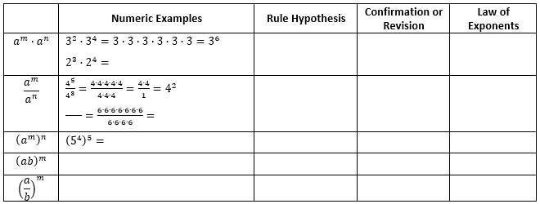

Instructional Items

*Instructional Item 1*

Generate an equivalent expression.

*Instructional Item 2*

Evaluate the following expression.

*Instructional Item 3*

Evaluate the following expression.

*The strategies, tasks and items included in the B1G-M are examples and should not be considered comprehensive.

### MA.7.NSO.1.2

Benchmark

MA.7.NSO.1.2 Rewrite rational numbers in different but equivalent forms including fractions, mixed numbers, repeating decimals and percentages to solve mathematical and real-world problems.

*Example:* Justin is solving a problem where he computes 17/3 and his calculator gives him the answer 5.6666666667. Justin makes the statement that 17/3=5.6666666667; is he correct?

Connecting Benchmarks/Horizontal Alignment

* MA.7.AR.1.2
* MA.7.AR.3.1, MA.7.AR.3.3
* MA.7.DP.1.4
* MA.7.DP.2.2, MA.7.DP.2.4
* MA.8.NSO.1.1, MA.8.NSO.1.2

Terms from the K-12 Glossary

* Rational Number

Vertical Alignment

|  |  |
| --- | --- |
| **Previous Benchmarks**   * MA.6.NSO.1.1, MA.6.NSO.1.2 * MA.6.NSO.3.5 * MA.7.NSO.2 | **Next Benchmarks**   * MA.912.NSO.1 |

Purpose and Instructional Strategies

|  |  |  |  |  |  |  |  |  |
| --- | --- | --- | --- | --- | --- | --- | --- | --- |
| In previous courses, students rewrote positive rational numbers in different but equivalent forms as long as the decimal form is terminating. This expectation expands to all rational numbers, including those with repeating decimals, as well as using this skill to solve mathematical and real-world problems. In grade 7 accelerated, students will learn about irrational numbers as well as working to plot, order and compare rational and irrational numbers. In Algebra 1, this benchmark is expanded into solving problems involving exponents and radicals.   * When solving problems with numbers written in various forms, students must be able to convert between these forms to perform operations or make comparisons (*MTR.2.1*). * Students should begin to develop charts, like the one below, that allow them to find patterns within the different forms of rational numbers. Students should have common fractions, decimals and percentages at their disposal in order to move to ones that are more difficult to determine.  |  |  |  |  | | --- | --- | --- | --- | | **Fraction** | **Mixed Number** | **Decimal** | **Percentage** | |  |  |  |  |  * Students should have practice with and without the use of technology to rewrite rational numbers in different but equivalent forms. * Students should work with simple problems to highlight how truncating repeated decimals may result in incorrect solutions.   + For example, using the fractional value of may provide a more precise answer than using the truncated decimal of 0.33. * versus Repeating decimals can be written using a repeating bar, a truncated decimal form, fraction or may be rounded depending on the problem and the directions to the problem. * Students should use reasonableness to determine if it is appropriate to use a specific equivalent form over another one when problem solving (*MTR.6.1*). |

Common Misconceptions or Errors

* Students may not differentiate between terminating decimals, repeating decimals and rounded decimals, and they may not use them appropriately within the given contexts.
* Students may incorrectly truncate repeating decimals when problem solving.
* Students may incorrectly divide when the quotient is not a whole number.
  + For example, students may use the remainder of a problem as a decimal representation.

Strategies to Support Tiered Instruction

* Instruction includes the use of estimation to find the approximate decimal value of a fraction or mixed number before rewriting in decimal form to help with correct placement of the decimal point.
* Teacher provides opportunities for students to explore and discuss the differences between repeating and truncated decimals and the impact of truncating repeating decimals when solving problems.
  + For example, provide students with the equation and have them create a table of values comparing using , 0.3, 0.333 and 0.33333 as the constant of proportionality. Students can discuss the differences in -values and importance of using exact values in some cases and approximate values in others.

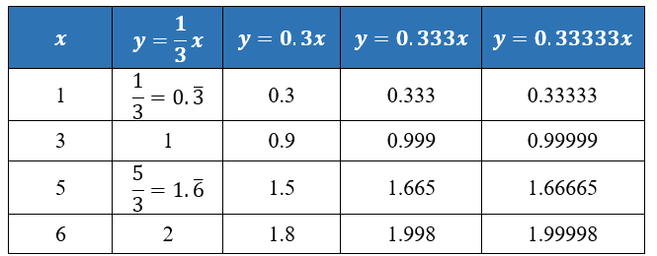

* Instruction includes co-creating a graphic organizer to highlight the differences between terminating decimals, repeating decimals, and rounded decimals.

Instructional Tasks

*Instructional Task 1 (MTR.2.1)*

Convert each of the following to an equivalent form in order to compare their values.

Part A. Graph the numbers on a number line to determine increasing order.

A number line ranging from negative ten on the left to positive ten on the right.

Part B. Robin plotted her number line using all decimals, whereas Courtney plotted them using the original forms. Describe why both would be acceptable answers.

*Instructional Task 2 (MTR.2.1, MTR.4.1, MTR.5.1)*

Complete the table to identify equivalent forms of each number. Explain how you approached your solutions. *Prompting questions:* What patterns did you use? How did you start? Which values in the table are you most comfortable in starting with?

|  |  |  |  |
| --- | --- | --- | --- |
| **Fraction** | **Mixed Number (if applicable)** | **Decimal** | **Percentage** |
|  |  |  |  |
|  |  |  |  |
|  |  |  |  |
|  |  |  |  |
|  |  |  |  |

Instructional Items

*Instructional Item 1*

All of the students in first period were given a glue stick to help build their interactive notebook. Benny said he has already used of his glue while Juniper has used 70% of hers. Which student has the most glue remaining for their notebooks?

*Instructional Item 2*

Ishana manages a corner store and wishes to give a discount to her customers for the holiday. If she subtracts 0.15 of the cost of any item in the store, what percent should her sale sign promote?

*Instructional Item 3*

Write three equivalent forms for .

*The strategies, tasks and items included in the B1G-M are examples and should not be considered comprehensive.

**MA.8.NSO.1** *Solve problems involving rational numbers, including numbers in scientific notation, and extend the understanding of rational numbers to irrational numbers.*

### MA.8.NSO.1.1

Benchmark

MA.8.NSO.1.1 Solve problems involving rational numbers, including numbers in scientific notation, and extend the understanding of rational numbers to irrational numbers.

*Example:* Within the expression , the irrational number can be estimated to be between and because is between and . By considering and , a closer approximation for is . So, the expression is equivalent to about .

Benchmark Clarifications:

*Clarification 1:* Instruction includes the use of number line and rational number approximations, and recognizing pi (π) as an irrational number.

*Clarification 2:* Within this benchmark, the expectation is to approximate numerical expressions involving one arithmetic operation and estimating square roots or pi (π).

Connecting Benchmarks/Horizontal Alignment

* MA.7.NSO.1.2
* MA.8.AR.2.3
* MA.8.GR.1.1, MA.8.GR.1.2

Terms from the K-12 Glossary

* Expression
* Irrational Numbers
* Number Line
* Pi
* Rational Numbers
* Real Numbers

Vertical Alignment

|  |  |
| --- | --- |
| **Previous Benchmarks**   * MA.6.NSO.1.2 | **Next Benchmarks**   * MA.912.AR.3.1 |
|  |  |

Purpose and Instructional Strategies

In previous courses, students compared quantities that have opposite direction using rational numbers and compared them on a number line. Students also expressed rational numbers using terminating and repeating decimals. In grade 7 accelerated, students define irrational numbers and determine their approximate location on a number line. In Algebra 1, students will expand their knowledge of the real number system to understand that complex numbers exist from their work with quadratics.

* Instruction includes using and creating a graphic organizer to show the relationship between the subsets of the real number system.

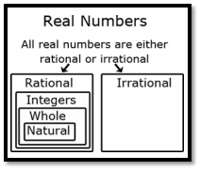

* Once students understand that (1) every rational number has a decimal representation that either terminates or repeats, and (2) every terminating or repeating decimal is a rational number, they can reason that on the number line, irrational numbers must have decimal representations that neither terminate nor repeat.
* Students sometimes overgeneralize that all square roots are rational numbers concluding that irrational numbers are unusual and rare. Instruction includes a variety of examples of irrational numbers. Irrational numbers are much more plentiful than rational numbers, in the sense that they are denser in the real number line.
* Instruction includes the understanding that the square root of a whole number is either another whole number or is irrational. When the result is another whole number, the original whole number is a perfect square. This fact is particularly relevant when the Pythagorean Theorem is applied to find a missing side length of a triangle whose other two side lengths are whole numbers.
* Instruction includes the understanding that the cube root of a whole number is either another whole number or is irrational. When the result is another whole number, the original whole number is a perfect cube.
* Instruction includes the understanding that adding or subtracting a rational number and an irrational number produces an irrational number. The same is true of multiplication or division unless the rational number is 0.
* Students should develop estimating skills when working with square roots without the use of a calculator. One strategy is to use benchmark square roots to determine an approximate value.
  + For example, to find an approximation of , first determine the perfect squares is between, which would be and . The square roots of and are and , respectively, so we know that is between and . Since is closer to , an estimate of the square root would be closer to .

Common Misconceptions or Errors

* Students may incorrectly believe that pi is a rational number since they have only been introduced to a decimal approximation and a fraction approximation. To address this misconception, instruction includes looking further at the decimal representation of pi so that students will notice that a pattern will not emerge. In fact, a pattern never emerges, therefore, pi is irrational.
* Students may incorrectly think that the number line only has the numbers that are labeled.
* Students may incorrectly think a numerical expression that includes addition or subtraction cannot be placed on a number line.
  + For example, can be placed on a number line at approximately .

Strategies to Support Tiered Instruction

* Teacher provides opportunities to look at the decimal representation of pi () and comparing decimal representations of rational numbers and irrational numbers.
* Teachers provide opportunities for practice with performing decimal expansion of rational and irrational numbers to check for a pattern.
* Teacher models how to estimate a numerical expression with addition or subtraction and locates a place on the number line.
  + For example, show a representation of pi () and compare it to a decimal representation of . Students should identify that is a rational number and repeats , and that is pi (…) and does not repeat.
  + For example, a first approximation of , students could approximate as 2.25 since 5 is between the perfect squares of 4 and 9, but closer to 4. Therefore would be in between 2 and 3, but closer to 2. So, a reasonable guess for can be 2.25 and therefore a reasonable estimate for would be which equals 5.25. If more accuracy is required, students should understand that a calculator is needed.
* Instruction includes looking further at the decimal representation of pi so that students will notice that a pattern will not emerge. In fact, a pattern never emerges, therefore, pi is irrational.

Instructional Tasks

*Instructional Task 1 (MTR.1.1)*

Part A. Provide an example of a rational number and explain how you can determine that it is rational.

Part B. Choose which number(s) below are irrational and explain how you can determine that they are irrational.



*Instructional Task 2 (MTR.4.1)*

Part A. Use the number lines below to estimate the value of . Explain why you put the points where you did.

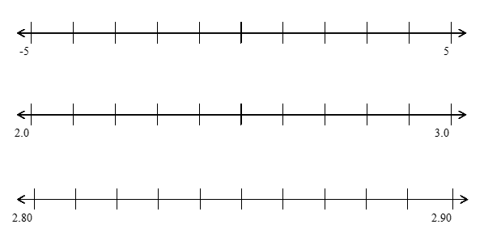

Part B. Plot on a number line. Explain your process with a partner.

Instructional Items

*Instructional Item 1*

Plot the following numbers on a number line showing their approximate location to the nearest hundredth.

*Instructional Item 2*

Is 0.12345 a rational or irrational number? Explain your answer.

*The strategies, tasks and items included in the B1G-M are examples and should not be considered comprehensive.

### MA.8.NSO.1.2

Benchmark

MA.8.NSO.1.2 Plot, order and compare rational and irrational numbers, represented in various forms.

Benchmark Clarifications:

*Clarification 1:* Within this benchmark, it is not the expectation to work with the number .

*Clarification 2:* Within this benchmark, the expectation is to plot, order and compare square roots and cube roots.

*Clarification 3:* Within this benchmark, the expectation is to use symbols (<, > or =).

Connecting Benchmarks/Horizontal Alignment

* MA.7.NSO.1.2
* MA.8.AR.2.3
* MA.8.GR.1.1, MA.8.GR.1.2

Terms from the K-12 Glossary

* Irrational numbers
* Rational numbers

Vertical Alignment

|  |  |
| --- | --- |
| **Previous Benchmarks**   * MA.6.NSO.1.2 | **Next Benchmarks**   * MA.912.NSO.1.4 * MA.912.GR.3.1 |

Purpose and Instructional Strategies

In previous courses, students were expected to plot, order and compare rational numbers. Students also expressed rational numbers with terminating and repeating decimals. In grade 7 accelerated, students define irrational numbers, recognizing and expressing them in various forms, and students compare rational numbers to irrational numbers. In Algebra 1, students will perform operations with radicals. In Geometry, students will extend their understanding of radical approximations to weighted averages on a number line.

* Students should have the opportunity to draw number lines with appropriate scales to plot the numbers to provide an understanding of where the numbers are in relation to numbers that are greater than and less than the number to be plotted.
* Students locate and compare rational and irrational numbers on the number line. Additionally, students understand that the value of a square root or a cube root can be approximated between integers.
  + For example, to find an approximation of , two methods are described below, each using the nearest perfect squares to the radicand:
    - determine the perfect squares is between, which would be and . The square roots of and are and , respectively, so we know that is between and . Since is closer to , an estimate of the square root would be closer to .
    - since 28 is located of the distance from 25 to 36, the is approximately located of the distance from to . So, this reasoning gives the approximation , which is about 5.27. This method is particularly relevant when students determine weighted averages on a number line in Geometry.
* Students also recognize that every positive number has both a positive and a negative square root. The negative square root of *n* is written as .
* Instruction includes the use of technology, including a calculator.

Common Misconceptions or Errors

* Students may not understand that square and cube roots can be plotted on a number line.

Strategies to Support Tiered Instruction

* Instruction includes providing students with examples of square and cube roots for them to place on a number line and facilitating a conversation on understanding the value of each square and cube root.
* Teacher provides opportunities to co-create number lines with appropriate scales and plot approximate values of cube roots and square roots.
  + For example, provide partially completed examples of non-perfect square roots and non-perfect cube roots by using perfect square roots and perfect cube roots as benchmark quantities.
* Teacher provides support in recognizing that every positive number has both a positive and negative square root.
  + For example, show examples of how multiplying two negative numbers gives a positive number, and how the square root of a number can be both positive and negative.
* Teacher assists students in writing an inequality to represent written statements.
  + For example:
* Katelyn has more books than Mary.
* Cameron has 5 pencils and Barry has 8.
* Animal Kingdom has at least 100 different species of animals.

Instructional Tasks

*Instructional Task 1 (MTR.6.1)*

Below are irrational and rational numbers.

Part A. Order the numbers from least to greatest by plotting on a number line.

Part B. Identify which numbers are irrational.

Part C. Write an inequality that compares a rational number and an irrational number from the list.

*Instructional Task 1 (MTR.3.1)*

Haylie is comparing and .

Part A. Describe how Haylie would approximate and .

Part B. Write an inequality for both numbers with the closest rational number.

Instructional Items

*Instructional Item 1*

Plot … on the number line below and explain how you determined its location.

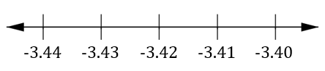

*Instructional Item 2*

Using the chart below, compare the irrational and rational numbers shown.

|  |  |  |
| --- | --- | --- |
| **Number** | **Write or** | **Number** |
|  |  | 9 |
|  |  |  |
|  |  |  |
|  |  |  |

*Instructional Item 3*

Plot the following cube roots on a number line , and .

*The strategies, tasks and items included in the B1G-M are examples and should not be considered comprehensive.

### MA.8.NSO.1.3

Benchmark

MA.8.NSO.1.3 Extend previous understanding of the Laws of Exponents to include integer exponents. Apply the Laws of Exponents to evaluate numerical expressions and generate equivalent numerical expressions, limited to integer exponents and rational number bases, with procedural fluency.

*Example:* The expression is equivalent to which is equivalent to .

Benchmark Clarifications:

*Clarification 1:* Refer to the K-12 Formulas (Appendix E) for the Laws of Exponents*.*

Connecting Benchmarks/Horizontal Alignment

* MA.7.NSO.1.1
* MA.8.AR.1.1, MA.8.AR.1.2

Terms from the K-12 Glossary

* Exponent
* Expressions
* Integer
* Rational Numbers

Vertical Alignment

|  |  |
| --- | --- |
| **Previous Benchmarks**   * MA.6.NSO.3.3 | **Next Benchmarks**   * MA.912.NSO.1.1 |

Purpose and Instructional Strategies

In previous courses, students evaluated positive rational numbers and integers with natural number exponents. In grade 7 accelerated, students are introduced to the Laws of Exponents with numerical expressions with a focus on generating equivalent numerical expressions with whole-number and integer exponents and rational number bases. In Algebra 1, students will extend the Laws of Exponents to include rational exponents.

* Instruction focuses on one law at a time to allow for conceptual understanding instead of just memorizing the rules. Students should be given the opportunity to derive the properties through experience and reasoning. During instruction, include examples that show the expansion of the bases using the exponents to show the equivalence. This strategy allows for moving beyond learning a rule or procedure.
* The expectation for this benchmark includes negative integer exponents but does not include fractional exponents.
* Students should develop and engage in understanding the rules of exponents from exploration. A strategy for developing meaning for integer exponents by making use of patterns is shown below:

|  |  |
| --- | --- |
| **Patterns in Exponents** | |
|  |  |
|  |  |
|  |  |
|  |  |
|  |  |
|  |  |
|  |  |
|  |  |
|  |  |
|  |  |
|  |  |

* Students should develop fluency with and without the use of a calculator when evaluating numerical expressions involving the Laws of Exponents.
* Instruction includes cases where students must work backward as well as cases where the value of a variable must be determined (*MTR.3.1*). Students should use relational thinking as well as algebraic thinking.

Common Misconceptions or Errors

* When working with negative exponents, students may not understand the connection to fractions and values in the denominator. To address this misconception, use expanded notation to show how to simplify to help support the understanding of exponents and values in the denominator of a fraction.
  + For example, can be rewritten as which can be rewritten as which can be rewritten as which can be rewritten as which is equivalent to .

Strategies to Support Tiered Instruction

* Instruction includes teacher modeling the use expanded notation to show how to simplify. Have students practice the properties by generating equivalent expressions.
  + For example, which equals or . Help students to discover how becomes a positive exponent in the denominator of a fraction, .
* Instruction includes the use of a conceptual approach as opposed to memorizing the rules of the laws of integer exponents. Provide examples of the processes that lead to the rules for each law, such as the “Patterns in Exponents” table within Instructional Strategies.
* Instruction includes using expanded notation to show how to simplify to help support the understanding of exponents and values in the denominator of a fraction.
  + For example, can be rewritten as , which can be rewritten as , which can be rewritten as , which can be rewritten as , which is equivalent to .

Instructional Tasks

*Instructional Task 1 (MTR.1.1)*

Create an example that will show and explain the difference between and .

*Instructional Task 2 (MTR.5.1)*

Create a pattern using the expanded form of the base, , between and . Explain why is equal to 1.

*Instructional Task 3 (MTR.1.1)*

Aryella states that is equivalent to . Do you agree or disagree? Explain.

Instructional Items

*Instructional Item 1*

What is the value of

*Instructional Item 2*

What is the value of the expression given below?

*Instructional Item 3*

Which of the following expressions are equivalent to ?

*The strategies, tasks and items included in the B1G-M are examples and should not be considered comprehensive.

### MA.8.NSO.1.4

Benchmark

MA.8.NSO.1.4 Express numbers in scientific notation to represent and approximate very large or very small quantities. Determine how many times larger or smaller one number is compared to a second number.

*Example:* Roderick is comparing two numbers shown in scientific notation on his calculator. The

first number was displayed as and the second number was displayed as

. Roderick determines that the first number is about times bigger

than the second number.

Connecting Benchmarks/Horizontal Alignment

* MA.7.NSO.1.1
* MA.8.NSO.1.5, MA.8.NSO.1.6
* MA.8.GR.1.2

Terms from the K-12 Glossary

* Exponent
* Scientific Notation

Vertical Alignment

|  |  |
| --- | --- |
| **Previous Benchmarks**   * MA.7.NSO.2.1 | **Next Benchmarks**   * MA.912.GR.4.5 |

Purpose and Instructional Strategies

In elementary school, students began to explore the place value system by understanding a number’s value is ten times larger than the number to its right and of the number to its left using whole numbers. In grade 7 accelerated, students develop an understanding of Laws of Exponents (Appendix E) with numerical expressions. Students also focus on generating equivalent numerical expressions with whole-number exponents and rational number bases. Additionally, students use the knowledge of Laws of Exponents to work with scientific notation. In Geometry, students will solve problems involving density in terms of area and volume which can be represented using scientific notation when the numbers are large. Additionally, students can apply their scientific notation knowledge in science courses.

* Instruction builds students’ number sense with scientific notation. Students should see how representing numbers in a given form allows for students to see the magnitude of the number in an efficient way.
* Instruction connects place value and expanded form with scientific notation. This will allow students to compare very large and very small numbers concisely.

|  |  |  |  |  |  |  |  |
| --- | --- | --- | --- | --- | --- | --- | --- |
| **thousands** | **hundreds** | **tens** | **ones** |  | **tenths** | **hundredths** | **thousandths** |
|  |  |  |  | . |  |  |  |
| 3 | 2 | 4 | 0 | . | 0 | 0 | 0 |
|  |  |  | 0 | . | 3 | 2 | 4 |

Scientific notation for the numbers within the chart would be represented as and respectively.

* Students should use place value knowledge to determine how many times larger a number is compared to another. Students should develop patterns to conclude that if the exponent increases by one, the value increases 10 times, as well as if the exponent decreases by one, the value decreases 10 times.
  + For example, if students are determining how many times bigger is than . Students will need to recognize that 7 is approximately 2 times larger than 3, and is times greater than . Therefore, to determine how many times greater, a student would reason that is approximately times greater than .
* Instruction connects student's understanding of scientific notation to choosing appropriate units of measures.
* When using calculators to represent very large and very small numbers with an exponent indicated as “E”, instruction relates the number following “E” as the power of 10.

Common Misconceptions or Errors

* Students often confuse the meaning of the exponent and the value of the number in scientific notation.
* Some students misrepresent scientific notation by not expressing the number as a product of a power of 10 and a number that is at least 1 and less than 10.
* Students may incorrectly interpret the “E” on a calculator display as an error message.
* Students may interpret the comparison of two numbers in scientific notation incorrectly.
  + For example, if students were asked what is 3 times larger than , they may respond with instead of the correct response of .
  + For example, if a student determines the first number is times bigger than the second number, they may incorrectly believe the first number is 4 times as big as the second number instead of 10,000 times bigger.

Strategies to Support Tiered Instruction

* Instruction includes making connections of a number written in standard form to the same number written in scientific notation. Key connections include recognizing the similarities in the first two digits of both numbers and the connections between the place value of the number in standard form and the exponent of the power.
* Teacher provides opportunities for students to utilize calculators and provides instruction on the various calculator notations for scientific notation.
* Instruction includes rewriting whole numbers in scientific notation when finding products or quotients with scientific notation to demonstrate the correct use of operations and laws of exponents.
  + For example, if the student is asked what is five times larger than , they should be multiplying , and not multiply by the exponent.
* Teacher provides opportunities for students to check their work by rewriting numbers in standard form and applying any necessary operations before comparing their solution to the solution found with the use of a calculator.
* Instruction includes the use of manipulatives such as base 10 blocks to make connections to the purpose of utilizing scientific notation.
  + For example, the teacher could pose the question: “What would be the best way for us to represent 2430 using Base Ten Blocks. We could use 2430 individual Base Ten Unit blocks, or we could use 2- Base Ten Cubes, 4 Base Ten Flats, and 3 Base Ten Rods. Students can then see that it would be easier to represent 2430 using the Cubes, Flats, and Rods as opposed to the large amount of individual Unit blocks. When students see how it would be easier to use the larger blocks to represent the number, the teacher can explain how it is similar to using scientific notation to write out very large or very small numbers. Instead of writing , they can write .

Instructional Tasks

*Instructional Task 1 (MTR.6.1)*

The diameter of fishing lines varies. Fishing lines can have a diameter as small as inch and as large as inch.

Part A. Which value belongs to the thicker fishing line?

Part B. How many times larger is the thick line compared to the thin line?

Part C. If you want a fishing line whose thickness is in between the two values, what would be a possible thickness for the line you would like to use?

*Instructional Task 2 (MTR.6.1)*

The state of Florida is approximately square miles. Lake Okeechobee is the largest freshwater lake in Florida and covers approximately square miles.

Part A. Is it reasonable to estimate Florida to be 100 times larger than Lake Okeechobee?

Why or why not?

Part B. How many times larger is Florida than Lake Okeechobee?

*Instructional Task 3 (MTR.6.1)*

In 2020, three of the countries with the highest population included China, the United States and Mexico. The population of the United States was 331.45 million. The population of China was 1.44 billion. The population of Mexico was 129.2 million.

Part A. What would be an appropriate estimate for the number of times larger China is

compared to the United States? Compared to Mexico?

Part B. How many times larger is China than the United States?

Part C. How many times larger is China than Mexico?

Instructional Items

*Instructional Item 1*

The distance in kilometers to Proxima Centauri, the closest star to Earth, is 39,900,000,000,000. Estimate the distance in kilometers to Proxima Centauri by writing it in the form of a single digit times an integer power of .

*Instructional Item 2*

The Bohr radius of a hydrogen atom is . Express the Bohr radius of a hydrogen atom in scientific notation.

*Instructional Item 3*

The average weight of a blue whale is pounds. The average weight of an elephant is pounds. Approximately how many times heavier is a blue whale than an elephant in pounds?

*The strategies, tasks and items included in the B1G-M are examples and should not be considered comprehensive.

### MA.8.NSO.1.5

Benchmark

MA.8.NSO.1.5 Add, subtract, multiply and divide numbers expressed in scientific notation with procedural fluency.

*Example:* The sum of and is .

Benchmark Clarifications:

*Clarification 1:* Within this benchmark, for addition and subtraction with numbers expressed in scientific notation, exponents are limited to within 2 of each other.

Connecting Benchmarks/Horizontal Alignment

* MA.7.NSO.1.1
* MA.8.NSO.1.4, MA.8.NSO.1.5, MA.8.NSO.1.6

Terms from the K-12 Glossary

* Scientific Notation

Vertical Alignment

|  |  |
| --- | --- |
| **Previous Benchmarks**   * MA.7.NSO.2.1 | **Next Benchmarks**   * MA.912.GR.4.5 |

Purpose and Instructional Strategies

In previous courses, students developed an understanding of Laws of Exponents (Appendix E) with numerical expressions. They focused on generating equivalent numerical expressions with whole-number exponents and rational number bases. In grade 7 accelerated, students use the knowledge of Laws of Exponents to work with scientific notation. In Geometry, students will solve problems involving density in terms of area and volume which can be represented using scientific notation when the numbers are large. Additionally, students can apply their scientific notation knowledge in science courses.

* Instruction connects scientific notation work with the Laws of Exponents with integer exponents.
* Instruction includes having students color code or use a highlighter to help keep the numbers together.
  + For example, when multiplying and , students can highlight the 3.2 and 6.7 in one color and the and in another color for organizational purposes.
* Students should develop fluency with and without using a calculator when performing operations with numbers expressed in scientific notation.
* It is helpful to include contextual problems to compare numbers written in scientific notation, including cross-curricular examples from science.

Common Misconceptions or Errors

* Some students may incorrectly apply addition and subtraction across a problem.
  + For example, students may miscalculate as
* Some students may incorrectly apply multiplication across a problem.
  + For example, students may miscalculate as .
* Some students may incorrectly represent their final answer, not in scientific notation.
  + For example, students may write as instead of .

Strategies to Support Tiered Instruction

* Instruction includes making connections to the use of place values when adding and subtracting numbers written in standard form to place values with scientific notation.
* Teacher demonstrates how rewriting numbers in scientific notation utilizing the same power of 10 represents numbers with the same place value.
* Instruction includes correct use of operations and laws of exponents when finding the products and quotients of numbers represented in scientific notation, paying close attention to the solution to ensure it is in scientific notation.
  + For example, when multiplying and , students can rearrange the expression as to determine which is equivalent to .
* Teacher provides opportunities for students to complete problems using scientific notation and standard form in order to check for the reasonableness of their solutions and build on connections between the two.

Instructional Tasks

*Instructional Task 1 (MTR.3.1, MTR.6.1)*

A collection of meteorites includes three meteorites that weigh grams, grams, and grams.

Part A. Why would a scientist represent the weights using scientific notation? Are all the meteorites approximately the same size?

Part B. What is the difference between the mass of the heaviest meteorite and the mass of the lightest meteorite? Write your answer in standard notation.

Part C. How many times heavier is the heaviest meteorite compared to the lightest meteorite?

Part D. If the display case at the Museum of Arts and Science in Daytona Beach can hold up to grams, will all three meteorites fit in the display case?

Instructional Items

*Instructional Item 1*

What is the sum of and ?

*Instructional Item 2*

Write the expression shown as a number in scientific number.

*The strategies, tasks and items included in the B1G-M are examples and should not be considered comprehensive.

### MA.8.NSO.1.6

Benchmark

MA.8.NSO.1.6 Solve real-world problems involving operations with numbers expressed in scientific notation.

Benchmark Clarifications:

*Clarification 1:* Instruction includes recognizing the importance of significant digits when physical measurements are involved.

*Clarification 2:* Within this benchmark, for addition and subtraction with numbers expressed in scientific notation, exponents are limited to within 2 of each other.

Connecting Benchmarks/Horizontal Alignment

* MA.7.NSO.1.1
* MA.8.NSO.1.4, MA.8.NSO.1.5

Terms from the K-12 Glossary

* Scientific Notation
* Significant Digits

Vertical Alignment

|  |  |
| --- | --- |
| **Previous Benchmarks**   * MA.7.NSO.2.1 | **Next Benchmarks**   * MA.912.GR.4.5 |

Purpose and Instructional Strategies

Previously, students developed an understanding of Laws of Exponents with numerical expressions. They focused on generating equivalent numerical expressions with whole-number exponents and rational number bases. In grade 7 accelerated, students use the knowledge of Laws of Exponents to work with scientific notation. In Geometry, students will solve problems involving density in terms of area and volume which can be represented using scientific notation when the numbers are large. Additionally, students can apply their scientific notation knowledge in science courses.

* Instruction includes opportunities to engage in virtual or physical situations to understand the importance of significant digits.
* Instruction includes student understanding of the following aspects:

1. zeros at the beginning of a number are never significant,
2. zeros at the end of a number are only significant if there is a decimal point and
3. zeros in the middle of a number are always significant.

* Students should develop fluency with and without the use of a calculator when performing operations with numbers expressed in scientific notation.
* For mastery of this benchmark, students are expected to express the product or quotient with the appropriate number of significant digits. In general, the number of significant digits in the result will be the least number of digits in the operands.
  + For example, when multiplying two numbers together, one that has 4 significant digits and the other that has 2 significant digits, then only two significant digits should be retained for the product.

Common Misconceptions or Errors

* Students may incorrectly identify zeros as significant digits.
* Some students may incorrectly apply addition and subtraction across a problem.
  + For example, students may miscalculate as
* Some students may incorrectly apply multiplication across a problem.
  + For example, students may miscalculate as .
* Some students may incorrectly represent their final answer, not in scientific notation.
  + For example, students may write as instead of 1.2.

Strategies to Support Tiered Instruction

* Instruction includes making connections of a number written in standard form to the same number written in scientific notation by noticing patterns. Key connections include recognizing the similarities in the first two digits of both numbers and the connections between the place value of the number in standard form and the exponent of the power.
* Teacher provides opportunities for students to utilize appropriate calculators and provides instruction on the various calculator notations for scientific notation.
* Instruction includes rewriting whole numbers in scientific notation when finding products or quotients with scientific notation to demonstrate correct use of operations and laws of exponents.
  + For example, if the student is asked what is five times larger than , they should be multiplying , and not multiply by the exponent.
* Instruction includes making connections to the use of place values when adding and subtracting numbers written in standard form to place values with scientific notation. Teacher should demonstrate how rewriting numbers in scientific notation utilizing the same power of 10 represents numbers with the same place value.
* Instruction includes modeling the correct use of operations and laws of exponents when finding the products and quotients of numbers represented in scientific notation, paying close attention to the solution to ensure it is in scientific notation.
  + For example, when multiplying and , students can rearrange the expression as to determine which is equivalent to .
* Teacher provides opportunities for students to check their work by rewriting numbers in standard form and applying any necessary operations before comparing their solution to the solution found with the use of a calculator.
* Instruction includes the use of manipulatives such as Base Ten blocks to make connections to the purpose of utilizing scientific notation.
  + For example, the teacher could pose the question: “What would be the best way for us to represent 2430 using Base Ten Blocks? We could use 2430 individual Base Ten Unit blocks, or we could use 2 Base Ten Cubes, 4 Base Ten Flats and 3 Base Ten Rods. Students can then see that it would be easier to represent 2430 using the Cubes, Flats, and Rods as opposed to the large amount of individual Unit blocks. When students see how it would be easier to use the larger blocks to represent the number, Teachers can explain how it is similar to using scientific notation to write out very large or very small numbers. Instead of writing , they can write .
* Teacher provides opportunities for students to complete problems using scientific notation and standard form to check for the reasonableness of their solutions and build on connections between the two.
* Instruction includes the use of a three-read strategy. Students read the problem three different times, each with a different purpose (laminating these questions on a printed card for students to utilize as a resource in and out of the classroom would be helpful).
  + First, read the problem with the purpose of answering the question: What is the problem, context, or story about?
  + Second, read the problem with the purpose of answering the question: What are we trying to find out?
  + Third, read the problem with the purpose of answering the question: What information is important in the problem?

Instructional Tasks

*Instructional Task 1 (MTR.6.1)*

Measures of population density indicate how crowded a place is by giving the approximate number of people per square unit of area. In 2009, the population of Puerto Rico was approximately people.

Part A. How many significant digits are there in the population of Puerto Rico?

Part B. If the population density was about 1000 people per square mile, what is the approximate area of Puerto Rico in square miles?

Part C. Does the number of significant digits change when finding the population density? Why or why not?

*Instructional Task 2 (MTR.7.1)*

Mid-Florida Data Processing decided to upgrade their computers. After the upgrade, their new computers can perform calculations per second.

Part A. How many calculations can this computer perform in one minute?

Part B. If there are 5 data processors, how many calculations can be performed in 20 minutes.

Instructional Items

*Instructional Item 1*

The Amazon River releases gallons of water into the Atlantic Ocean every second. There are about seconds in a year. How many gallons are released into the ocean in one year? Express your answer with the appropriate number of significant digits.

*Instructional Item 2*

The speed of light is . If the sun is meters from Jupiter, how many seconds does it take for sunlight to reach Jupiter? Write your answer in scientific notation.

*The strategies, tasks and items included in the B1G-M are examples and should not be considered comprehensive.

### MA.8.NSO.1.7

Benchmark

MA.8.NSO.1.7 Solve multi-step mathematical and real-world problems involving the order of operations with rational numbers including exponents and radicals.

*Example:* The expression is equivalent to which is equivalent to

which is equivalent to .

Benchmark Clarifications:

*Clarification 1:* Multi-step expressions are limited to 6 or fewer steps.

*Clarification 2:* Within this benchmark, the expectation is to simplify radicals by factoring square roots of perfect squares up to 225 and cube roots of perfect cubes from -125 to 125.

Connecting Benchmarks/Horizontal Alignment

* MA.8.AR.1.1, MA.8.AR.1.2
* MA.AR.2.1, MA.8.AR.2.3
* MA.8.GR.1.1, MA.8.GR.1.2, MA.8.GR.1.3

Terms from the K-12 Glossary

* Exponent
* Radical
* Rational Numbers

Vertical Alignment

|  |  |
| --- | --- |
| **Previous Benchmarks**   * MA.7.NSO.2.1 | **Next Benchmarks**   * MA.912.NSO.1.4 |

Purpose and Instructional Strategies

In previous courses, students solved mathematical problems using multi-step order of operations with rational numbers including whole-number exponents and absolute value. In grade 7 accelerated, students continue to solve multi-step problems involving the order of operations with rational numbers but including integer exponents and radicals. In Algebra 1, students will solve problems with numerical radicals.

* Instruction includes providing a structure for students to track steps as they work through problems (*MTR.5.1*). Students should show the equivalence from one step to another to further their understanding.
* Avoid mnemonics, such as PEMDAS, that do not account for other grouping symbols and do not exercise proper number sense that allows for calculating accurately in a different order.
* Instruction includes the use of technology to help emphasize the proper use of grouping symbols for order of operations.
* Students should have experience using technology with radicals, decimals and fractions as they occur in the real world. This experience will help students working with irrational numbers in this grade level.

Common Misconceptions or Errors

* Students may confuse square roots with cube roots.
* Some students may incorrectly apply the order of operations. To address this misconception, be sure to review operations with rational numbers and order of operations.
* Students may incorrectly perform operations with the numbers in the problem based on what has recently been taught, rather than what is most appropriate for a solution. To address this misconception, have students estimate or predict solutions prior to solving and then compare those predictions to their actual solution to see if it is reasonable (*MTR.6.1*).
* Students may incorrectly oversimplify a problem by circling the numbers, underlining the question, boxing in keywords, and eliminating important contextual information that may seem unimportant. This process can cause students to not be able to comprehend the context or the situation (*MTR.2.1, MTR.4.1, MTR.5.1, MTR.7.1*). Teachers and students should engage in questions such as:
  + What do you know from the problem?
  + What is the problem asking you to find?
  + Are you putting groups together? Taking groups apart? Or both?
  + Are the groups you are working with the same sizes or different sizes?
  + Can you create a visual model to help you understand or see patterns in your problem?”

Strategies to Support Tiered Instruction

* Teacher provides opportunities for students to comprehend the context or situation by engaging in questions (laminating these questions on a printed card for students to utilize as a resource in and out of the classroom would be helpful).
  + What do you know from the problem?
  + What is the problem asking you to find?
  + Can you create a visual model to help you understand or see patterns in your problem?
* Instruction includes the use of colors to highlight each step of the process used to evaluate an expression.
  + For example, when evaluating students can first highlight the grouping with any exponents, roots or parenthesis: . Then, students can determine any order of operations within each of those larger groupings. Students should see that within the cube root, they can perform and that they can perform . Students could have the expression , and then perform to obtain which is equivalent to .
* Instruction includes the use of a three-read strategy. Students read the problem three different times, each with a different purpose (laminating these questions on a printed card for students to utilize as a resource in and out of the classroom would be helpful).
  + First, read the problem with the purpose of answering the question: What is the problem, context, or story about?
  + Second, read the problem with the purpose of answering the question: What are we trying to find out?
  + Third, read the problem with the purpose of answering the question: What information is important in the problem?
* Teacher has students estimate or predict solutions prior to solving and then compare those predictions to their actual solution to see if it is reasonable *(MTR.6.1)*.

Instructional Tasks

*Instructional Task 1 (MTR.7.1)*

The Dotson’s family was designing their backyard to be a peaceful sanctuary with areas dedicated to working out, a swimming pool and a gazebo. Each space is a square design having the same size. The total backyard area is 600 square feet. The Dotsons want to fence the outside of their property but not what is up against the house. The diagram below shows the layout of the backyard.

Part A. How much fencing, in feet, would the Dotson’s need to purchase to fence in the property?

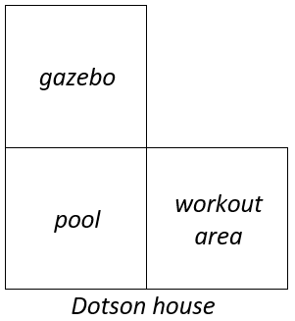

Part B. The Dotsons went to Fence2Fence and found the following options for purchase:

* feet feet Western Red Cedar Gothic Fence Panels for $60.05
* feet feet Western Red Cedar Essentials Fence Panels for $88.66

Which option is the better value? Why?

Instructional Items

*Instructional Item 1*

Calculate the value of the expression given.

*The strategies, tasks and items included in the B1G-M are examples and should not be considered comprehensive.

# Algebraic Reasoning

**MA.7.AR.2** *Write and solve equations and inequalities in one variable*

### MA.7.AR.2.2

Benchmark

MA.7.AR.2.2 Write and solve two-step equations in one variable within a mathematical or real-world context, where all terms are rational numbers.

Benchmark Clarifications:

*Clarification 1:* Instruction focuses on the application of the properties of equality. Refer to Properties of Operations, Equality and Inequality (Appendix D).

*Clarification 2:* Instruction includes equations in the forms and , where , and are specific rational numbers.

*Clarification 3:* Problems include linear equations where the variable may be on either side of the equal sign.

Connecting Benchmarks/Horizontal Alignment

* MA.7.AR.3.3
* MA.7.AR.4.5
* MA.7.GR.2.2, MA.7.GR.2.3
* MA.8.AR.2.1, MA.8.AR.2.3

Terms from the K-12 Glossary

* Equation
* Rational Number

Vertical Alignment

|  |  |
| --- | --- |
| **Previous Benchmarks**   * MA.6.AR.2.2, MA.6.AR.2.3 * MA.7.NSO.2 * MA.7.AR.3.1, MA.7.AR.3.2 | **Next Benchmarks**   * MA.912.AR.2.1 |

Purpose and Instructional Strategies

In previous courses, students wrote and solved one-step equations with integers. In grade 7 accelerated, students write and solve two-step equations and multi-step linear equations (*MTR.5.1*). In Algebra 1, students will write and solve linear equations in one variable in a real-world context, with rational number coefficients.

* Have students verbalize the Properties of Operations and Properties of Equality being used at each step of the solution.
* This directly connects to benchmark MA.8.AR.2.1, where students solve multi-step linear equations in one variable.
* Instruction includes real-world contexts as well as linear equations where the variable may be on either side of the equal sign (*MTR.7.1*).
* Use models or manipulatives, such as algebra tiles, bar diagrams or balances, to conceptualize equations (*MTR.2.1*). Build from these concrete models toward solving abstractly.
  + Algebra Tiles

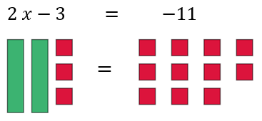

* + Bar Diagrams

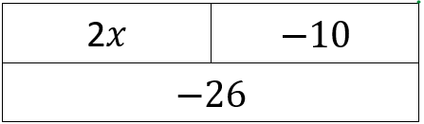

* Balances

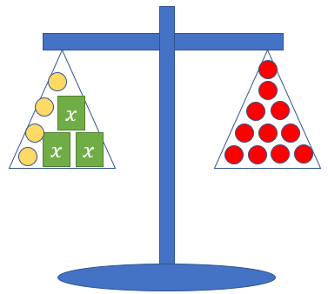

* Avoid a particular order when solving and allow students to proceed in multiple ways that are mathematically accurate.
* For example, in the equation , students may choose to divide both sides of the equation by 4 or use the Distributive Property with the 4. Compare the various strategies and ask students to determine which will be most efficient given different problem stems (*MTR.3.1*).

Common Misconceptions or Errors

* Some students may incorrectly use the addition and subtraction properties of equality on the same side of the equal sign while solving an equation. To address this misconception, use manipulatives such as balances, algebra tiles or bar diagrams to show the balance between the two sides of an equation *(MTR.2.1)*.
* Students may incorrectly identify the constants and the coefficients within a real-world context of the problem.

Strategies to Support Tiered Instruction

* Teacher provides opportunities for students to practice solving equations using the addition and subtraction properties of equality using an interactive computer equation balance, manipulatives and other visual representations.
* Teacher provides support for students in identifying the coefficients and constants within a real-world context of the problem. Present students with examples of real-world problems that can be solved with equations.
  + For example, Cameron’s fish tank can hold 12 gallons of water and he adds 2.5 gallons of water a minute. If there are already 3.4 gallons of water in the tank, how many minutes can Cameron fill his tank without overflowing?
* Teacher provides opportunities for students to comprehend the context or situation by engaging in questions (laminating these questions on a printed card for students to utilize as a resource in and out of the classroom would be helpful).
  + What do you know from the problem?
  + What is the problem asking you to find?
  + Can you create a visual model to help you understand or see patterns in your problem?
* Teacher provides opportunities for students to use algebra tiles to co-solve provided equations with the teacher without the need of writing the equation first.
* Teacher provides opportunities for students to co-write an algebraic equation with the teacher without requiring students to solve the equation.
* Instruction includes the use of a three-read strategy. Students read the problem three different times, each with a different purpose (laminating these questions on a printed card for students to utilize as a resource in and out of the classroom would be helpful).
  + First, read the problem with the purpose of answering the question: What is the problem, context, or story about?
  + Second, read the problem with the purpose of answering the question: What are we trying to find out?
  + Third, read the problem with the purpose of answering the question: What information is important in the problem?
* Teacher models the use of manipulatives such as balances, algebra tiles or bar diagrams to show the balance between the two sides of an equation.

Instructional Tasks

*Instructional Task 1 (MTR.1.1, MTR.7.1)*

A plumber has been called in to replace a broken kitchen sink. The material needed costs $341.25, and the total expected cost of the job is $424.09. How many hours will the plumber need to work in order to get the job completed?

Part A. What questions would need to be answered to approach this problem? Is there enough information given to solve the problem? Why or why not?

Part B. The average rate for a plumber in Florida is $20.71 per hour. Write and solve an equation to determine how many hours the plumber will be working.

*Instructional Task 2 (MTR.5.1)*

The length of the rectangle is twice its width. The perimeter of the rectangle totals 45 feet. What is the width of the rectangle?

Instructional Items

*Instructional Item 1*

What is the exact value of in the equation ?

Instructional Item 2

What is the value of in the equation ?

*The strategies, tasks and items included in the B1G-M are examples and should not be considered comprehensive.

**MA.7.AR.3** *Use percentages and proportional reasoning to solve problems.*

### MA.7.AR.3.3

Benchmark

MA.7.AR.3.3 Solve mathematical and real-world problems involving the conversion of units across different measurement systems.

Benchmark Clarifications:

*Clarification 1:* Problem types are limited to length, area, weight, mass, volume and money.

Connecting Benchmarks/Horizontal Alignment

* MA.7.NSO.1.2
* MA.7.AR.2.2
* MA.7.AR.4.3, MA.7.AR.4.4, MA.7.AR.4.5
* MA.8.GR.1.2

Terms from the K-12 Glossary

|  |
| --- |
| * Area * Capacity * Customary Units * Metric Units |

Vertical Alignment

|  |  |
| --- | --- |
| **Previous Benchmarks**   * MA.6.AR.3.5 * MA.7.NSO.2.1, MA.7.NSO.2.2, MA.7.NSO.2.3 | **Next Benchmarks**   * MA.912.FL.2.4 |

Purpose and Instructional Strategies

In previous courses, students performed conversions within the same measurement system. In grade 7 accelerated, students solve mathematical and real-world problems involving the conversion of units across different measurement systems. Students will also apply these conversions when solving problems involving the distance between two points in a coordinate plane. In future courses, students will convert between currencies given exchange rates.

* Focus on using conversion ratios to create equivalent values.
  + For example, if 1 foot 12 inches, you can use the ratio of to solve problems.

Students may also use conversion ratios in their science courses. Emphasize that multiplying by equivalent values of 1 does not change the value but gives an equivalent value in another unit of measurement.

* Instruction includes using manipulatives to estimate conversion ratios across measurement systems such as yardsticks, meter sticks, measuring cups and graduated cylinders (*MTR.2.1*).
* Students may need review on which units are used to measure length, volume and mass.
* Instruction includes using a reference sheet with conversion ratios.

Common Misconceptions or Errors

* Students may incorrectly place the values in a conversion ratio. To address this misconception, have students estimate values prior to calculations using the conversion ratio *(MTR.6.1)*.

Strategies to Support Tiered Instruction

* Teacher provides opportunities for students to comprehend the context or situation by engaging in questions (laminating these questions on a printed card for students to utilize as a resource in and out of the classroom would be helpful).
* What do you know from the problem?
* What is the problem asking you to find?
* Can you create a visual model to help you understand the problem?
* Teacher provides unit conversion sheet for students to determine the unit of measurement between different systems.
* Instruction focuses on using a unit conversion table to explicitly describe the process of converting between different units of measurement.
* Teacher provides instruction on color-coding and labeling the different units when setting up a proportional relationship to ensure corresponding units are placed in the corresponding positions within the proportion.
* Teacher encourages students to use their prior knowledge of proportions to convert units of measurement across different measurement systems.

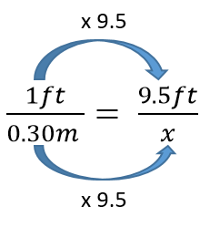

* Teacher provides students a visual of units of measurement between different systemsto compare and estimate the proper conversion ratio.
* Instruction includes the use of a three-read strategy. Students read the problem three different times, each with a different purpose (laminating these questions on a printed card for students to utilize as a resource in and out of the classroom would be helpful).
  + First, read the problem with the purpose of answering the question: What is the problem, context, or story about?
  + Second, read the problem with the purpose of answering the question: What are we trying to find out?
  + Third, read the problem with the purpose of answering the question: What information is important in the problem?
* Teacher has students estimate values prior to calculations using the conversion ratio *(MTR.6.1)*.

Instructional Tasks

*Instructional Task 1 (MTR.1.1, MTR.4.1)*

Joe was planning a business trip to Canada, so he went to the bank to exchange $200 U.S. dollars for Canadian (CDN) dollars. On the way home from the bank, Joe’s boss called to say that the destination of the trip had changed to Mexico City. Joe went back to the bank to exchange his Canadian dollars for Mexican pesos. What is the value of Mexican pesos that Joe has now?

Part A. What questions still need to be answered to approach this problem?

Part B. The rates for CDN to the U.S. dollar and the rate of pesos to the CDN are shown below.

* Rate of $1.02 CDN per $1 U.S.
* Rate of 20.8 pesos per $1 CDN

What is the value of Mexican pesos that Joe has now?

Instructional Items

*Instructional Item 1*

Mary is buying strings of lights to hang on her patio deck. She needs 80 feet of lights to go around the entire patio, but the lights she wants to buy are only sold in packs of 5 meters. If one meter is approximately 3.28 feet, how many packs of lights will Jia need for her patio?

*Instructional Item 2*

How many milliliters are in 12 fluid ounces?

*Instructional Item 3*

Convert 50 pounds to kilograms.

*Instructional Item 4*

When driving from Germany to Poland, the speed limit signs change from miles per hour (mph) to kilometers per hour (kph), but your rental car speedometer only reads in mph. If the speed limit on the highway is 100 kph, at what speed will you exceed the speed limit?

*\*The strategies, tasks and items included in the B1G-M are examples and should not be considered comprehensive.*

**MA.7.AR.4** *Analyze and represent two-variable proportional relationships.*

### MA.7.AR.4.1

Benchmark

MA.7.AR.4.1 Determine whether two quantities have a proportional relationship by examining a table, graph or written description.

Benchmark Clarifications:

*Clarification 1:* Instruction focuses on the connection to ratios and on the constant of proportionality, which is the ratio between two quantities in a proportional relationship.

Connecting Benchmarks/Horizontal Alignment

* MA.7.GR.1.3, MA.7.GR.1.4, MA.7.GR.1.5
* MA.8.GR.2.4
* MA.8.AR.2.1
* MA.8.AR.3.1
* MA.8.F.1.2
* MA.8.DP.1.3

Terms from the K-12 Glossary

* Constant of Proportionality
* Proportional Relationships

Vertical Alignment

|  |  |
| --- | --- |
| **Previous Benchmarks**   * MA.6.AR.3.3, MA.6.AR.3.4, MA.6.AR.3.5 * MA.7.NSO.2.1, MA.7.NSO.2.2, MA.7.NSO.2.3 * MA.7.AR.3.2 | **Next Benchmarks**   * MA.912.AR.2.4 |

Purpose and Instructional Strategies

In previous courses, students solved problems involving ratios, rates and unit rates, including comparisons, mixtures, ratios of lengths and conversions within the same measurement system. In grade 7 accelerated, students work with proportional relationships between two variables. In Algebra 1, students determine and interpret key features of linear functions.

* Instruction includes different ways of representing proportional relationships, such as tables and graphs. Multiplying or dividing one quantity in a ratio by a particular factor requires doing the same with the other quantity in the ratio to maintain the proportional relationship. Graphing equivalent ratios create a straight line passing through the origin.
  + Tables

|  |  |  |  |  |
| --- | --- | --- | --- | --- |
|  | 5 | 40 | 65 |  |
|  | 1 | 8 | 13 |  |

* + Graphs

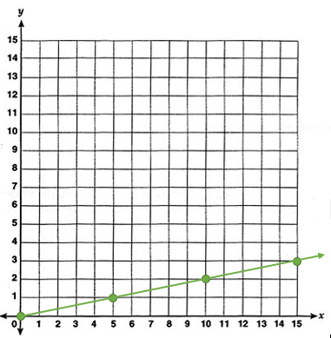

* Instruction should allow time for students to analyze real-world situations to determine if quantities are in proportional relationships (*MTR.7.1*).
* Instruction includes the connection between ratios and the constant of proportionality (*MA.7.AR.4.2*) as a method to determine whether a relationship is proportional or not. Determining the constant of proportionality may be helpful when given a table.
* Instruction builds on students’ knowledge of unit rates and equivalent fractions to determine this constant (*MTR.5.1*). Students should connect unit rates, the constant of proportionality and slope in order to represent similar ideas in different contexts.
* Compare various representations of the same relationship for students to make comparisons and identify patterns. This should include both proportional and non-proportional relationships for compare and contrast discussions (*MTR.4.1*).
* Instruction includes students graphing relationships and writing equations to determine if two linearly related quantities also have a proportional relationship. Students should be provided examples to show evidence that not all linear relationships are proportional. This directly connects to benchmark MA.8.AR.3.1 where students determine if a linear relationship is also a proportional relationship.

Common Misconceptions or Errors

* Using cross-products as a strategy to test for equivalent ratios may lead to errors and misconceptions in solving more complex equations in the future. To address this misconception, instruction focuses on testing equivalent ratios using tables or graphs to ensure students understand that two quantities are proportional to each other when each quantity in a ratio, multiplied by a constant, gives the corresponding quantity in the second ratio *(MTR.3.1)*.
  + For example, provide students with the relationship between feet and yards. Students can discuss how the relationship 6 feet = 2 yards connects to the relationship 1.5 feet = 0.5 yard.
* Students may incorrectly believe the relationship is not proportional if the origin is not visible in the graph or given in the table. Help students extend the graph or table, using the pattern between points, until it reaches the origin.
* Students may incorrectly believe all graphs that are straight lines represent proportional relationships. To address this misconception, instruction focuses on the understanding that proportional relationships have a constant ratio between the two coordinates of each point and pass through the origin.
* Students reverse the position of the variables when writing equations. Students may find it useful to use letters for the variables that are specifically related to the quantities.
* Students may neglect to test all values when given a table.

Strategies to Support Tiered Instruction

* Teacher provides students with examples and non-examples of proportional relationships in a table, a graph and a verbal description. Teacher provides instructions for students to understand the patterns in proportional and non-proportional relationships.
* Instruction includes determining the value of when the -value is zero to determine if the table is proportional.
* Instruction includes determining the ratio for each value of and in a table to ensure all values have the same ratio.
* Teacher reminds students to use their knowledge of unit rates or equivalent fractions to find the pattern and extend the graph to determine if the graph is proportional.
* Teacher co-creates a graphic organizer with examples and non-examples of proportional relationships in a table, graph and verbal description for students to compare and identify patterns in proportional and non-proportional relationships.
* Instruction includes the use of geometric software to represent proportional and non-proportional graphs to visually compare the models and clear the misconception that all linear graphs represent a proportional relationship.
* Instruction focuses on the understanding that proportional relationships have a constant ratio between the two coordinates of each point and pass through the origin.
* Instruction includes using the pattern between points to extend the graph or table until it reaches the origin.
* Teacher models how to use letters for the variables that are specifically related to the quantities.
  + For example, use for tacos, or for mice.

Instructional Tasks

*Instructional Task 1 (MTR.4.1, MTR.7.1)*

Barry and Mary went to their local gas station to collect information about the cost of fuel for compact cars. They observed both regular and premium gas purchases that day and recorded their data in the table below.

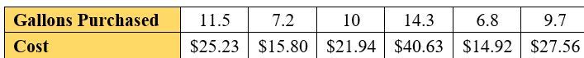

Part A. Is there a proportional relationship between the number of gallons of gas sold and the cost? Explain your answer.

Part B. If the relationship is not proportional, which data value or values should be changed to make the relationship proportional? What could explain this difference?

Instructional Items

*Instructional Item 1*

Kennedy is training for a marathon and completes her long mileage runs for training on the weekend. Over the last 3 weekends she ran 15 miles in 2 hours; 18 miles in 2 hours, 33 minutes; and 22 miles in 3 hours, 7 minutes. Determine if her weekend training runs showcase a proportional relationship.

*\*The strategies, tasks and items included in the B1G-M are examples and should not be considered comprehensive.*

### MA.7.AR.4.2

Benchmark

MA.7.AR.4.2 Determine the constant of proportionality within a mathematical or real-world context given a table, graph or written description of a proportional relationship.

Example: A graph has a line that goes through the origin and the point . This represents a proportional relationship and the constant of proportionality is .

*Example:* Gina works as a babysitter and earns $9 per hour. She can only work 6 hours this week. Gina wants to know how much money she will make. Gina can use the equation , where is the amount of money earned, is the number of hours worked and is the constant of proportionality.

Connecting Benchmarks/Horizontal Alignment

* MA.7.AR.3.3
* MA.7.GR.1.3, MA.7.GR.1.5
* MA.7.GR.3.3
* MA.8.AR.3.2

Terms from the K-12 Glossary

* Constant of Proportionality
* Origin
* Proportional Relationships

Vertical Alignment

|  |  |
| --- | --- |
| **Previous Benchmarks**   * MA.6.AR.3.2 * MA.7.NSO.2.1, MA.7.NSO.2.2, MA.7.NSO.2.3 * MA.7.AR.3.2 | **Next Benchmarks**   * MA.912.AR.2.2 |

Purpose and Instructional Strategies

In previous courses, students determined rates and unit rates in ratios. In grade 7 accelerated, students take a broader view of a rate or unit rate as they understand it to be the constant of proportionality in a proportional relationship. Students will also expand their understanding of the constant of proportionality in proportional relationships to slope in linear relationships. In Algebra1, students write linear two-variable equations in all forms from real-world and mathematical contexts.

* Instruction includes different ways of representing proportional relationships, such as tables and graphs. Multiplying or dividing one quantity in a ratio by a particular factor requires doing the same with the other quantity in the ratio to maintain the proportional relationship. Graphing equivalent ratios create a straight line passing through the origin.
  + Tables

|  |  |  |  |  |
| --- | --- | --- | --- | --- |
|  | 5 | 40 | 65 |  |
|  | 1 | 8 | 13 |  |

* + Graphs



* Starting instruction with real-world context rather than mathematical procedure allows students to reason through the meaning of the constant of proportionality (*MTR.7.1*). Connect prior knowledge of unit rates when developing the constant of proportionality.
* Instruction includes a connection to pi as the constant of proportionality in the circumference formula within MA.7.GR.1.3.
* Problem types include positive and negative constants of proportionality.

Common Misconceptions or Errors

* Some students reverse the order of the ratio between the two quantities in a proportional relationship.
* Students may neglect the scale(s) of the axes on a graph. To address this misconception, have students interpret the constant of proportionality in context and evaluate the reasonableness of the answer. This may prompt students to revisit the graphical representation for better details.

Strategies to Support Tiered Instruction

* Instruction focuses on students’ comprehension of the context or situation by engaging in questions (laminating these questions on a printed card for students to utilize as a resource in and out of the classroom would be helpful).
  + What do you know from the problem?
  + What is the problem asking you to find?
  + What are the two quantities in this problem?
  + How are the quantities related to each other?
* When determining the constant of proportionally in a graph, the teacher can instruct students to interpret the coordinate point as it relates to the titles of each axis. Teacher and students can use this information to co-creates a table to clear up the misconception of misinterpreting the context of the constant proportionality.
* Instruction includes the use of a three-read strategy. Students read the problem three different times, each with a different purpose (laminating these questions on a printed card for students to utilize as a resource in and out of the classroom would be helpful).
  + First, read the problem with the purpose of answering the question: What is the problem, context, or story about?
  + Second, read the problem with the purpose of answering the question: What are we trying to find out?
  + Third, read the problem with the purpose of answering the question: What information is important in the problem?
* Teacher has students interpret the constant of proportionality in context and evaluate the reasonableness of the answer. This may prompt students to revisit the graphical representation for better details.
* Teacher revisits the development of the equation and be sure students see all proportional relationships have the origin as a common point.

Instructional Tasks

*Instructional Task 1 (MTR.5.1, MTR.7.1)*

Part A. The daily fee for docking a boat at a marina in Tarpon is proportional to the length of the boat. The table displays the fee for four different boat lengths. Find the constant of proportionality and explain what it means in the context of this problem.

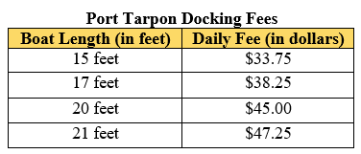

Part B. The daily fee for docking a boat at a marina in ForMyers is also proportional to the length of the boat. The graph displays the relationship between the fee and the boat length. Find the constant of proportionality and explain what it means in the context of this problem.

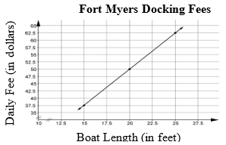

Part C. At which marina is it less expensive to dock a boat? Explain how you determined your answer.

Instructional Items

*Instructional Item 1*

After a workout at the gym, three friends made protein shakes to help in their recovery. Each protein shake contains 2 scoops of protein powder and 12 ounces of water. What is the constant of proportionality for this relationship?

*Instructional Item 2*

Determine the constant of proportionality for the following proportional relationships.

|  |  |  |  |
| --- | --- | --- | --- |
| 1. | A tablie listing the x- and y-values: (3, 4.5), (4, 6), (6, 9), and (9, 13.5). | 2. |  |

*\*The strategies, tasks and items included in the B1G-M are examples and should not be considered comprehensive.*

### MA.7.AR.4.3

Benchmark

MA.7.AR.4.3 Given a mathematical or real-world context, graph proportional relationships from a table, equation or a written description.

Benchmark Clarifications:

*Clarification 1:* Instruction includes equations of proportional relationships in the form of , where is the constant of proportionality.

Connecting Benchmarks/Horizontal Alignment

* MA.7.AR.3.3
* MA.8.AR.2.1
* MA.8.AR.3.4
* MA.8.AR.4.2, MA.8.AR.4.3
* MA.8.DP.1.3

Terms from the K-12 Glossary

* Constant of Proportionality
* Proportional Relationships
* Unit Rate

Vertical Alignment

|  |  |
| --- | --- |
| **Previous Benchmarks**   * MA.6.AR.3.4, MA.6.AR.3.5 * MA.6.GR.1.1 * MA.7.NSO.2.1, MA.7.NSO.2.2, MA.7.NSO.2.3 | **Next Benchmarks**   * MA.912.AR.2.4 |

Purpose and Instructional Strategies

In previous courses, students solved problems involving ratios, rates and unit rates, and began plotting points on the coordinate plane. In grade 7 accelerated, students begin working with proportional relationships, including graphing proportional relationships given a table, equation or written description. Students will also determine if a linear relationship is proportional and graph two-variable linear equations from a written description, table or equation in slope-intercept form. In Algebra 1, students graph linear equations in other forms, as well as from tables and written descriptions.

* Instruction includes different ways of representing proportional relationships, such as tables, equations, and graphs. Multiplying or dividing one quantity in a ratio by a particular factor requires doing the same with the other quantity in the ratio to maintain the proportional relationship. Graphing equivalent ratios create a straight line passing through the origin. The equations generated with the ratios will be unique in that they will follow the form of .
  + Tables

|  |  |  |  |  |
| --- | --- | --- | --- | --- |
|  | 5 | 40 | 65 |  |
|  | 1 | 8 | 13 |  |

* + Equations
* Given one representation, have students provide the other three in order to determine their mastery of these equivalencies (as noted in MA.7.AR.4.4).
  + For example, if given a written description, have students provide a table, an equation and a graph of the given proportional relationship.
* Students should understand that although the most common variable used to represent the constant of proportionality is , any other variable can be used.
  + For example, students can write the equation or to state that the constant of proportionality is given the equation .
* When an equation or written description is given, and have students create a corresponding table of values to assist with graphing. Be sure to emphasize the use of the origin as one of the points for the table (*MTR.2.1*).

Common Misconceptions or Errors

* Students may confuse the dependent and independent variables when graphing. To address this conception, instruction includes the understanding that the independent variable depends on the given context. Additionally, independent variables are not always the -axis and the dependent variables are not always the -axis.
* For example, if a student has a proportional relationship between feet and meters, they can graph feet either on the -axis or the -axis. The dependent one depends on the context. For instance, if one is given feet and converting to meters, then feet would be independent, and meters would be dependent.
* Students may confuse the - and -axis.
* Students may not recognize the appropriate axis scale to graph the given scenario efficiently.
  + For example, if a situation involves fractional numbers, using a scale of 1 may not be appropriate. Instead, students should consider using a scale with a fractional value.

Strategies to Support Tiered Instruction

* Instruction focuses on students’ comprehension of the context or situation by engaging in questions (laminating these questions on a printed card for students to utilize as a resource in and out of the classroom would be helpful).
  + What do you know from the problem?
  + What is the problem asking you to find?
  + What are the two quantities in this problem?
  + How are the quantities related to each other?
  + Which quantity do you want to consider as the independent variable?
  + Which quantity do you want to consider as the dependent variable?
* Instruction includes co-creating a graphic organizer with key features of coordinate plane such as -axis, -axis, origin, quadrants, scales, origin and coordinates.
* Instruction includes the understanding that the independent variable depends on the given context. Additionally, independent variables are not always the -axis and the dependent variables are not always the -axis.
  + For example, if one has a proportional relationship between feet and meters, students can graph feet either on the -axis or the -axis. The dependent variable depends on the context. For instance, if one is given feet and converting to meters, then feet would be independent, and meters would be dependent.
* Teacher provides instruction on creating a table of values to assist graphing an equation on a coordinate plane.

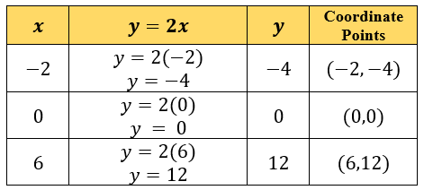

* Instruction includes modeling how to properly use a scale when situations involve fractional numbers. Instead of using a scale of 1, use a scale with a fractional value.

Instructional Tasks

*Instructional Task 1 (MTR.5.1)*

Coffee costs $18.96 for 3 pounds at the store, CoffeeUs.

Part A. What is the cost per pound of coffee?

Part B. At CoffeeUs, the price for a pound of coffee is the same no matter how many pounds you buy. Let be the number of pounds of coffee and be the total cost of pounds. Draw a graph of the proportional relationship between the number of pounds of coffee and the total cost.

Part C. Where can you see the cost per pound of coffee in the graph? What is it?

Instructional Items

*Instructional Item 1*

The cost of Hass avocados is a proportional relationship to the number of avocados being purchased. The equation represents this relationship where is the total cost and is the number of Hass avocados being purchased. Create a graph representing this relationship.

*Instructional Item 2*

Graph the proportional relationship given in the table below.

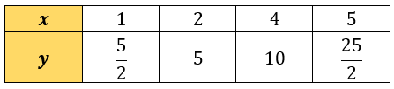

*\*The strategies, tasks and items included in the B1G-M are examples and should not be considered comprehensive.*

### MA.7.AR.4.4

Benchmark

MA.7.AR.4.4 Given any representation of a proportional relationship, translate the representation to a written description, table or equation.

*Example:* The written description, there are 60 minutes in 1 hour, can be represented as the equation .

*Example:* Gina works as a babysitter and earns $9 per hour. She would like to earn $100 to buy a new tennis racket. Gina wants to know how many hours she needs to work. She can use the equation , where is the amount of money earned, is the number of hours worked and is the constant of proportionality.

Benchmark Clarifications:

*Clarification 1:* Given representations are limited to a written description, graph, table or equation.

*Clarification 2:* Instruction includes equations of proportional relationships in the form of , where is the constant of proportionality.

Connecting Benchmarks/Horizontal Alignment

* MA.7.AR.3.3
* MA.7.GR.2.2
* MA.8.AR.3.2, MA.8.AR.3.3, MA.8.AR.3.4

Terms from the K-12 Glossary

* Constant of Proportionality
* Proportional Relationships
* Rate
* Unit Rates

Vertical Alignment

|  |  |
| --- | --- |
| **Previous Benchmarks**   * MA.6.AR.1.1 * MA.6.AR.3.2, MA.6.AR.3.5 * MA.7.NSO.2.2, MA.7.NSO.2.2, MA.7.NSO.2.3 * MA.7.AR.3.1, MA.7.AR.3.2 | **Next Benchmarks**   * MA.912.AR.2.2 |

Purpose and Instructional Strategies

In previous courses, students translated written descriptions into algebraic expressions and translated algebraic expressions into written descriptions. In grade 7 accelerated, students translate any representation of a proportional relationship to a written description, table or equation. Students will also extend this work to include linear relationships, write an equation in slope-intercept form from a written description, a table, or a graph. In Algebra 1, students write a linear two-variable equation to represent a relationship given by a variety of mathematical and real-world contexts.

* Instruction includes different ways of representing proportional relationships, such as tables, equations and graphs. Multiplying or dividing one quantity in a ratio by a particular factor requires doing the same with the other quantity in the ratio to maintain the proportional relationship. Graphing equivalent ratios create a straight line passing through the origin. The equations generated with the ratios will be unique in that they will follow the form of .
  + Tables

|  |  |  |  |  |
| --- | --- | --- | --- | --- |
|  | 5 | 40 | 65 |  |
|  | 1 | 8 | 13 |  |

* + Equations
  + Graphs

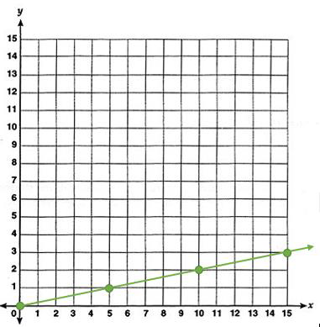

* When providing a graph, be sure there are easily identifiable points for students to use in calculating the constant of proportionality.
* As students are building meaning, instruction makes connections between the different representations.
* Even though proportional relationships exist in Quadrant I, instruction includes opportunities for students to realize that the line does continue into Quadrant III but are not appropriate for the real-world situation.
* Students should be able to explain examples from the points on a graph or the numbers within the table by putting it back into the real-world context when appropriate.
* Instruction includes flexibility in understanding of the dependent and independent variables. Students can represent situations in terms of or in terms of .
  + For instance, within example 1 students can represent the situation as or .
* Students should construct verbal descriptions.
  + For example, a student might describe the situation as “the number of packs of gum times the cost for each pack is the total cost in dollars.” They can use the verbal model to construct the equation.
* Students can check the equation by substituting values and comparing their results to the table. The checking process helps students revise and recheck their model as necessary (*MTR.6.1*).
* Provide tables of values for various proportional relationships. Ask students to look at the tables and generalize how they can find the -value in the tables given any -value (*MTR.1.1*). Have students look for patterns and assist with developing the equation where is the constant of proportionality (*MTR.5.1*).
* Ensure the formal development of the equation where is the constant of proportionality. Instruction supports flexibility in the variable used for the constant of proportionality. Provide practice for students to develop this equation using different variables based on given scenarios, as in *Example 2*.

Common Misconceptions or Errors

* Students may neglect the scales on the axes when calculating and interpreting the constant of proportionality.
* Students may not be able to approximate the constant of proportionality from the graphs. To address this misconception, begin with graphs having easily identifiable points before moving toward problems that need approximations.
* Students may not see the connection between the constant of proportionality and the steepness of the graph. To address this misconception, provide a variety of graphs with various steepness and ask students to organize them based on increasing order of the constants of proportionality.

Strategies to Support Tiered Instruction

* Instruction includes utilizing the - and -axis when determining the constant of proportionality. Teacher provides instruction on locating the values for the variables and from the axis labels, rather than counting the minor gridlines to the chosen point on the graph.
* Instruction includes utilizing graphs containing easily identifiable points on minor gridlines before moving toward graphs containing points that lie between gridlines which requires estimation to determine an appropriate constant of proportionality.
* Instruction includes the co-creation of a graphic organizer containing examples of proportional relationships with increasing levels of steepness. For each example, include a real-world scenario, a table, a graph and the constant of proportionality.
* Instruction includes using letters for variables that relate to the given scenario, such as for water.
* For students that are not able to approximate the constant of proportionality from the graphs, begin with graphs having easily identifiable points before moving toward problems that need approximations. For students that cannot see the connection between the constant of proportionality and the steepness of the graph, provide a variety of graphs with various steepness and ask students to organize them based on increasing order of the constants of proportionality.

Instructional Tasks

*Instructional Task 1 (MTR.5.1)*

Kell works at an after-school program at an elementary school. The table below shows how much money he earned every day last week.

|  |  |  |  |
| --- | --- | --- | --- |
|  | **Monday** | **Wednesday** | **Friday** |
| **time worked** | 1.5 hours | 2.5 hours | 4 hours |
| **money earned** | $12.60 | $21.00 | $33.60 |

Mariko has a job mowing lawns that pays $7 per hour.

Part A. Who would make more money for working 10 hours? Explain or show work.

Part B. Draw a graph that represents , the amount of money Kell would make for working hours, assuming he made the same hourly rate he was making last week.

Part C. Using the same coordinate axes, draw a graph that represents , the amount of money Mariko would make for working hours.

Part D. How can you see who makes more per hour just by looking at the graphs? Explain.

Part E. Write one equation to represent how much money Kell earns in hours and one equation to represent how much money Mariko earns in hours.

*Instructional Task 2 (MTR.3.1)*

Kelsi works as a lifeguard at the local pool. After an 8-hour day at work, she earns $100.

Part A. Write an equation that describes the relationship between the number of hours worked and the amount of money that she earns.

Part B. Kelsi would like to earn $450 to buy a new gaming system. Use your equation to determine how many hours she needs to work to buy a new gaming system.

Instructional Items

*Instructional Item 1*

Saylor needs to walk her dog Holloway every day after work. After 5 days Saylor walked her dog a total of 200 minutes. Write an equation that describes the relationship between the amount of minutes Saylor walked her dog each day.

*The strategies, tasks and items included in the B1G-M are examples and should not be considered comprehensive

### MA.7.AR.4.5

Benchmark

MA.7.AR.4.5 Solve real-world problems involving proportional relationships.

*Example:* Gordy is taking a trip from Tallahassee, FL to Portland, Maine which is about 1,407

miles. On average his SUV gets 23.1 miles per gallon on the highway and his gas tanks

holds 17.5 gallons. If Gordy starts with a full tank of gas, how many times will he be

required to fill the gas tank?

Connecting Benchmarks/Horizontal Alignment

* MA.7.AR.2.2
* MA.7.AR.3.3
* MA.7.GR.1.5
* MA.7.GR.2.2, MA.7.GR.2.3
* MA.7.DP.1.4
* MA.8.AR.3.4, MA.8.AR.3.5

Terms from the K-12 Glossary

* Proportional Relationships
* Rate
* Unit Rates

Vertical Alignment

|  |  |
| --- | --- |
| **Previous Benchmarks**   * MA.6.AR.3.5 * MA.7.NSO.2.1, MA.7.NSO.2.2, MA.7.NSO.2.3 * MA.7.AR.3.1, MA.7.AR.3.2 | **Next Benchmarks**   * MA.912.AR.2.4, MA.912.AR.2.5 * MA.912.F.1.5 |

Purpose and Instructional Strategies

In previous courses, students solved mathematical and real-world problems involving ratios, rates and unit rates, including comparisons, mixtures, ratios of lengths and conversions within the same measurement system. In grade 7 accelerated, students solve real-world problems involving proportional relationships. Students will solve real-world problems involving linear relationships. Students also interpret the slope and y-intercept of a two-variable linear equation within a real-world context when given a written description, a table, a graph or an equation. In Algebra 1, students will solve mathematical and real-world problems that are modeled by linear functions.

* This benchmark is a culmination of the work students have been doing throughout MA.7.AR.4.
* Instruction for this benchmark includes opportunities to compare two different proportional relationships to each other.
* Allow various methods for solving, encouraging discussion and analysis of efficient and effective solutions (*MTR.4.1*).
* In grade 7, it is not the expectation that students define independent and dependent variables. Students may have experience with these terms from other content areas.

Common Misconceptions or Errors

* Students may confuse the dependent and independent variables when graphing. To address this conception, instruction includes the understanding that the independent variable depends on the given context. Additionally, independent variables are not always on the -axis and the dependent variables are not always on the -axis.
  + For example, if one has a proportional relationship between feet and meters, they can graph feet either on the -axis or the -axis. Which one that is dependent depends on the context. For instance, if one is given feet and converting to meters, then feet would be independent and meters would be dependent.

Strategies to Support Tiered Instruction

* Teacher provides opportunities for students to comprehend the context or situation by engaging in questions.
  + What do you know from the problem?
  + What is the problem asking you to find?
  + What are the two quantities in this problem?
  + How are the quantities related to each other?
  + Which quantity do you want to consider as the independent variable?
  + Which quantity do you want to consider as the dependent variable?
* Instruction includes the use of a three-read strategy. Students read the problem three different times, each with a different purpose.
  + First, read the problem with the purpose of answering the question: What is the problem, context, or story about?
  + Second, read the problem with the purpose of answering the question: What are we trying to find out?
  + Third, read the problem with the purpose of answering the question: What information is important in the problem?
* Instruction includes the understanding that the independent variable depends on the given context. Additionally, independent variables are not always the -axis and the dependent variable are not always the -axis.
* For example, if one has a proportional relationship between feet and meters, they can graph feet either on the -axis or the -axis. Which one is dependent depends on the context. For instance, if one is given feet and converting to meters, then feet would be independent, and meters would be dependent.

Instructional Tasks

*Instructional Task 1 (MTR.4.1)*

Cassie is making shortbread cookies using the ingredients below.

|  |  |
| --- | --- |
| 10 tablespoons of butter  cups powdered sugar  teaspoon vanilla extract | cups flour  teaspoon salt |

Part A. This recipe makes 16 cookies, but Cassie needs 5 dozen. How much of each ingredient will she need to make the 5 dozen cookies she needs?

Part B. Once Harrison tasted Cassie’s shortbread cookies, he ordered 7 dozen for a birthday party. If Casie originally started with 4 cups of flour, 2 cups of powdered sugar and 16 tablespoons of butter, how much more (if any) will she need of each ingredient to complete Harrison’s order?

Part C. After the party, Cameron shared his recipe which calls for 2 cups of flour and cup of powdered sugar. Since adding powdered sugar to cookies should make them sweeter, Cameron claims his larger ratio of powdered sugar to flour will produce sweeter cookies. Is this statement correct?

Instructional Items

*Instructional Item 1*

A couple is taking a horse and carriage ride through Central Park in New York City. After 8 minutes, they had traveled mile.

Part A. Create a graph to represent the proportional relationship between miles traveled and the number of minutes they are on the carriage.

Part B. Use this graph to determine how long it will take to complete the 2.5-mile ride around the park.

*Instructional Item 2*

Trey is learning new music for his band class. He has 45 measures of music to learn. Last week, he learned 14 measures in 21 minutes on Monday, 9 measures in 13 minutes and 30 seconds on Tuesday, 11 measures in 16 minutes and 30 seconds on Wednesday, 3 measures in 4 minutes and 30 seconds on Thursday, and 8 measures in 12 minutes on Friday. Determine if there is a proportional relationship in his music practice during this week.

*\*The strategies, tasks and items included in the B1G-M are examples and should not be considered comprehensive.*

**MA.8.AR.1** *Generate equivalent algebraic expressions.*

### MA.8.AR.1.1

Benchmark

MA.8.AR.1.1 Apply the Laws of Exponents to generate equivalent algebraic expressions, limited to integer exponents and monomial bases.

Example: The expression is equivalent to .

Benchmark Clarifications:

*Clarification 1*: Refer to the K-12 Formulas (Appendix E) for the Laws of Exponents.

Connecting Benchmarks/Horizontal Alignment

* MA.7.NSO.1.1
* MA.8.NSO.1.3, MA.8.NSO.1.7
* MA.8.AR.1.3

Terms from the K-12 Glossary

* Base
* Expression
* Integers
* Monomial

Vertical Alignment

|  |  |
| --- | --- |
| **Previous Benchmarks**   * MA.6.NSO.3.3, MA.6.NSO.3.4 * MA.7.NSO.2.1 | **Next Benchmarks**   * MA.912.NSO.1.2 |

Purpose and Instructional Strategies

In previous courses, students evaluated positive rational numbers and integers with natural number exponents. In grade 7 accelerated, students use the Laws of Exponents to evaluate and generate numerical expressions, limited to whole-number exponents and rational number bases. Students extend their knowledge of the Laws of Exponents to generate equivalent algebraic expressions with integer exponents and monomial bases. In Algebra 1, students will use their knowledge of the Laws of Exponents to generate equivalent algebraic expressions with rational and variable exponents.

* At the onset of learning about exponents, students learn that it is a way to write expanded multiplication in a more condensed form. It is foundational that students understand that the value of the exponent determines how many times the base is multiplied by itself.
* This benchmark can be paired with MA.7.NSO.1.1 where students use the Law of Exponents to evaluate numerical expressions using whole-number exponents and rational number bases as well as with MA.8.NSO.1.3 which helps students work within numerical expressions with integer exponents and rational bases. Students should move from numerical expressions to algebraic expressions to best enhance their conceptual understanding of the Laws of Exponents.
* A strategy for developing meaning for integer exponents is to make use of patterns as shown below:

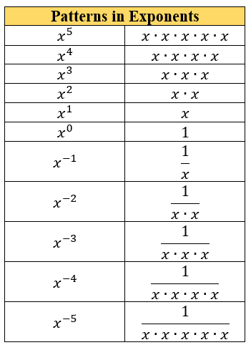

* For conceptual understanding, instruction should focus on one law at a time and students should derive the law of exponents through experience and reason. During instruction, include examples that show the expansion of the bases with the use of the exponents to show equivalence.
* For mastery of this benchmark, monomials can be defined in the following way: a base may be a product of a coefficient and one or more variables with integer exponents. This limitation should not prevent students from understanding that a negative exponent can be represented equivalently as a positive exponent with the reciprocal base (changing numerator to denominator or denominator to numerator).

Common Misconceptions or Errors

* + When working with negative exponents, students may not understand the connection to fractions and values in the denominator.
  + Students may incorrectly multiply the exponent with the base number.

Strategies to Support Tiered Instruction

* Teachers should write out the expanded form and then use it to model condensed multiplication as exponential form, providing opportunities to notice patterns as discussed in MA.8.NSO.1.3. Teachers can use the “Patterns in Exponents” chart shown in the Purpose and Instructional Strategies section with the right-side blank so that students can begin to complete and understand the patterns of integer exponents.
* Teachers should re-emphasize the structure of exponents, and how they indicate the number of times the base is multiplied by itself as denoted by the exponent.
* Teacher provides a review of the relationship between the base and the exponent by modeling an example of operations using a base and exponent.
  + For example, evaluate .

A diagram showing 6 is the base and 3 is the exponent for six to the third power.

which is equivalent to which is equivalent to 216.

Instructional Tasks

*Instructional Task 1 (MTR.2.1)*

Two students were working on generating equivalent expressions for and showed their solutions below.

|  |  |
| --- | --- |
| **Rachel's Answer** | **Justina's Answer** |
|  |  |

The teacher said Rachel and Justina both have the correct answer. Do you agree with the teacher? Explain your reasoning.

*Instructional Task 2 (MTR.5.1)*

Create a pattern using the expanded form of the base, , between  and . Explain why is equal to 1.

*Instructional Task 3 (MTR.1.1, MTR.4.1, MTR.6.1)*

Discuss with a partner/group the difference between  and .

Instructional Items

*Instructional Item 1*

Write with the variable used only one time.

*Instructional Item 2*

An expression is given.

Write an equivalent expression with only two exponents and no negative exponents.

*Instructional Item 3*

Write with only positive exponents.

*The strategies, tasks and items included in the B1G-M are examples and should not be considered comprehensive.

### MA.8.AR.1.2

Benchmark

MA.8.AR.1.2 Apply properties of operations to multiply two linear expressions with rational coefficients.

Example: The product of and can be expressed as or .

Benchmark Clarifications:

*Clarification 1*: Problems are limited to products where at least one of the factors is a monomial.

*Clarification 2:* Refer to Properties of Operations, Equality and Inequality (Appendix D).

Connecting Benchmarks/Horizontal Alignment

* MA.7.NSO.1.1
* MA.8.NSO.1.3, MA.8.NSO.1.7
* MA.8.AR.1.3

Terms from the K-12 Glossary

* Coefficient
* Linear Expression
* Rational

Vertical Alignment

|  |  |
| --- | --- |
| **Previous Benchmarks**   * MA.7.NSO.1.1 * MA.7.AR.1.2 | **Next Benchmarks**   * MA.912.AR.1.3, MA.912.AR.1.4, MA.912.AR.1.7 |

Purpose and Instructional Strategies

In previous courses, students applied properties of operations to add and subtract linear expressions with rational coefficients. Additionally, students determined if two linear expressions were equivalent. In grade 7 accelerated, students apply properties of operations to multiply two linear expressions with rational coefficients. In Algebra 1, students will add, subtract, multiply and divide polynomial expressions.

* Instruction includes working with multiplying two linear expressions and connecting the distributive property.
* Instruction includes modeling this benchmark concretely. One way to do this is to model with algebra tiles to generate equivalent expressions.
  + For example, can be modeled using the algebra tiles to showcase the equivalent expression of .

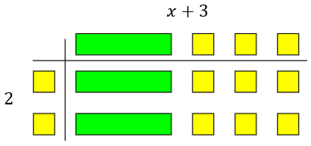

* Instruction moves from concrete models of examples with integer coefficients to rational coefficients.
* Instruction includes providing and discussing tasks that involve students analyzing errors which helps their ability to self-correct misconceptions within their own work.

Common Misconceptions or Errors

* + Students may incorrectly apply the distributive property by multiplying the monomial to only one of the terms in the parentheses. To address this misconception, emphasize that it is the distributive property (multiplication to all terms) to help support student understanding.
  + Students may incorrectly apply the rules of integers as they distribute. Students may incorrectly change the degree of the variable to simplify terms.

Strategies to Support Tiered Instruction

* Teacher models examples using the area model for multiplication, showing that the monomial should be multiplied by each term of the polynomial.
  + For example, the area model can be used to determine the product between and is . Once students understand how distribution works, teachers re-introduce variables and solve problems the same way.

|  |  |  |
| --- | --- | --- |
|  |  |  |
|  |  |  |

* + For example, the area model can be used to determine the product between and is .

|  |  |  |
| --- | --- | --- |
|  |  |  |
|  |  |  |

* + For example, the area model can be used to determine the product between and is .

|  |  |  |
| --- | --- | --- |
|  |  |  |
|  |  |  |

* Algebra tiles could be used when solving problems using the distributive property. This will help students who incorrectly distribute the monomial to only one term of the polynomial.
* Teachers may color code each step of the problem so students can see the progression of distribution.
  + For example, the expression is equivalent to .

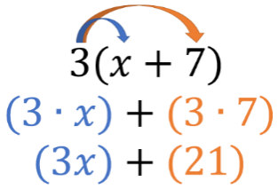

* Instruction includes emphasizing that it is the distributive property of multiplication over addition to help support student understanding.

Instructional Tasks

*Instructional Task 1 (MTR.4.1, MTR.5.1)*

Students were working on the math problem Kevin’s result is shown in the table below.

Part A. Is Kevin’s answer correct?

Part B. If no, explain his misconception and how he can correct his mistake. If yes, explain why he is correct and the steps he could have used.

|  |
| --- |
| **Kevin's Answer** |
|  |

*Instructional Task 2 (MTR.7.1)*

A rectangle is given below. *Note: The figure is not drawn to scale.*

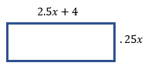

Part A. Find the area in terms of

Part B. If the value of is 4 cm, what is the area of the rectangle in square centimeters?

Instructional Items

*Instructional Item 1*

An expression is given below.

What is the product of the expression?

*Instructional Item 2*

Find the product of .

*The strategies, tasks and items included in the B1G-M are examples and should not be considered comprehensive.

### MA.8.AR.1.3

Benchmark

MA.8.AR.1.3 Rewrite the sum of two algebraic expressions having a common monomial factor as a common factor multiplied by the sum of two algebraic expressions.

Example: The expression can be rewritten as or as .

Connecting Benchmarks/Horizontal Alignment

* MA.8.AR.1.1, MA.8.AR.1.2
* MA.8.AR.2.1, MA.8.AR.2.2

Terms from the K-12 Glossary

* Monomial
* Regular Polygon

Vertical Alignment

|  |  |
| --- | --- |
| **Previous Benchmarks**   * MA.6.NSO.3.2 * MA.7.AR.1.2 | **Next Benchmarks**   * MA.912.AR.1.4, MA.912.AR.1.7 |

Purpose and Instructional Strategies

In previous courses, students learned to write the sum of two composite whole numbers that have a common factor, as a common factor multiplied by the sum of two whole numbers. Students also applied the properties of operations to add and subtract linear expressions with rational coefficients and determine if two linear expressions are equivalent. In grade 7 accelerated, students rewrite the sum of two algebraic expressions having a common monomial factor as a common factor multiplied by the sum of two algebraic expressions. In Algebra 1, students will extend this learning to divide a polynomial by a monomial and to rewrite a polynomial expression as a product of polynomials by using a common factor.

* This benchmark is a foundational benchmark for work with the distributive property and factoring in more complex problems.
* Instruction begins with whole number coefficients to ensure students understand the process first. Then, move to rational number values (*MTR.3.1*).
* Instruction includes a review of common factors of two numbers (MA.6.NSO.3.2) so students can show understanding of the first step before applying it to the work of this benchmark.
* Instruction includes a review of the order of operations when working with multi-step problems (*MTR.3.1*).
* Instruction includes having expressions with more than one variable.
  + For example, can be rewritten as .
* Emphasize properties of operations to determine equivalence when rewriting the expressions. Use manipulatives such as algebra tiles to represent the distributive property of multiplication over addition *(MTR.2.1)*.
  + Manipulatives



* + Area Models

|  |  |  |
| --- | --- | --- |
|  |  |  |
|  |  |  |

Common Misconceptions or Errors

* + Students may incorrectly apply integer operations.
  + Students may incorrectly apply the Laws of Exponents.
  + Students may incorrectly change the degree of a variable to simplify terms.
  + Students may incorrectly factor out only one of the terms from the parentheses.
    - For example, in , students may incorrectly factor the first term only resulting in
  + Students may incorrectly combine terms.

Strategies to Support Tiered Instruction

* When factoring algebraic expressions, the teacher will provide instruction to review the process for finding the greatest common factor (GCF) of two numbers before attempting to factor algebraic expressions. Once students understand the process of finding factors, more specifically the GCF, the teacher will provide instruction on factoring variables with and without exponents.
* Teacher models how to expand the degrees of variables to better understand what they truly have in common.
  + For example, if the expression was , it would be expanded as . Now that the expression is expanded, students can identify what variables each term has in common. This example shares one five, two ’s, and one .
* Instruction includes breaking up expressions to compare similar portions will help students focus on each step of factoring the algebraic expressions.
  + For example, when factoring , the expression could be broken up to factor as .

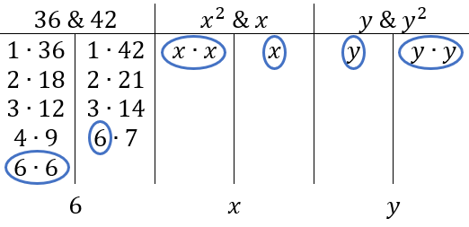

* Once students understand how to factor each portion of the expression individually, teachers model how to “remove” the common factor from each portion of the expression, and how to use what is left over.

Instructional Tasks

*Instructional Task 1 (MTR.2.1)*

Tammy is designing seating around a new fire pit for her outdoor patio. One of the fire pit designs is a regular octagon with a side length of . The other design is a regular hexagon with a side length of .

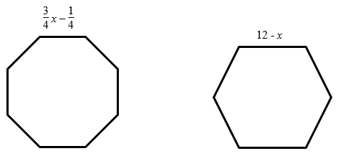

Part A. Find the perimeter of the regular octagon fire pit.

Part B. Find the perimeter of the regular hexagon fire pit.

Part C. Write an expression with the fewest number of terms to show the difference between the perimeters of the two fire pits.

Part D. Rewrite an equivalent expression from Part C as a common factor multiplied by the sum of two algebraic expressions.

*Instructional Task 2 (MTR.1.1, MTR.4.1)*

John and Savannah both rewrote the expression as a common factor multiplied by the sum of two algebraic expressions. Their answers are shown below.

A table showing how John rewrote the expression as 12x(-3x + 2) and how Savannah rewrote the expression as -6x(6x - 4).

Explain who is correct and why.

Instructional Items

*Instructional Item 1*

Determine an equivalent expression written as a common factor multiplied by the sum of two algebraic expression

*Instructional Item 2*

For each expression shown, determine an equivalent expression written as a common factor multiplied by the sum of two algebraic expressions.

*The strategies, tasks and items included in the B1G-M are examples and should not be considered comprehensive.

**MA.8.AR.2** *Solve multi-step one-variable equations and inequalities.*

### MA.8.AR.2.1

Benchmark

MA.8.AR.2.1 Solve multi-step linear equations in one variable, with rational number coefficients. Include equations with variables on both sides.

Benchmark Clarifications:

*Clarification 1:* Problem types include examples of one-variable linear equations that generate one solution, infinitely many solutions or no solution.

Connecting Benchmarks/Horizontal Alignment

* MA.8.NSO.1.7
* MA.8.AR.1.3
* MA.8.AR.4.1
* MA.8.GR.1.4, MA.8.GR.1.5, MA.8.GR.1.6

Terms from the K-12 Glossary

* Coefficient
* Linear Equation
* Rational Number

Vertical Alignment

|  |  |
| --- | --- |
| **Previous Benchmarks**   * MA.7.AR2.2 | **Next Benchmarks**   * MA.912.AR.2.1 |

Purpose and Instructional Strategies

In previous courses, students wrote and solved two-step equations in one variable within a mathematical or real-world context, where all terms are rational numbers. In grade 7 accelerated, students solve multi-step linear equations in one variable, with rational number coefficients, including equations with variables on both sides. In Algebra 1, students will write and solve linear equations in one variable in a real-world context, with rational number coefficients.

* In this benchmark, students work with linear equations, which is foundational for the work with both linear equations and nonlinear equations throughout all future mathematics courses.
* Instruction includes the use of manipulatives, drawings, models, properties of operations and properties of equality.
  + Algebra Tiles

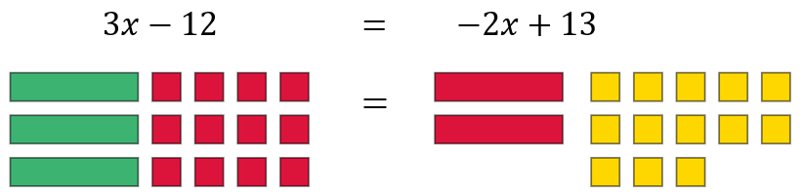

* + Balance

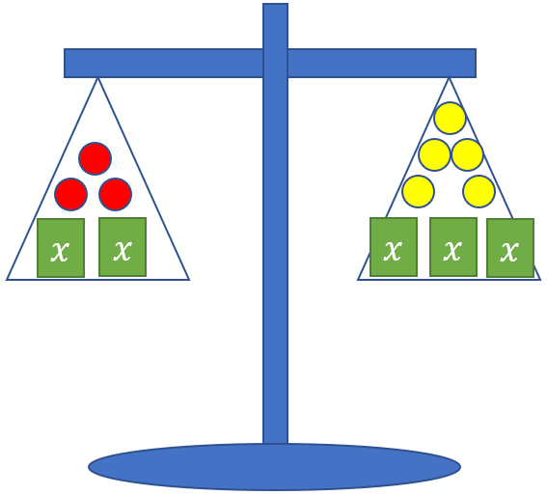

* Problem types involve multi-step problems that require the use of the distributive property, combining like terms, and variables on both sides of the equation.
* Since there are variables on both sides of the equation, instruction includes discovering that one-variable equations can result in three possible solution sets. The possible solutions are one solution, no solution or infinitely many solutions. This benchmark provides a foundation for MA.8.AR.4 when students are working with systems of equations and two-variable equations.

Common Misconceptions or Errors

* + Students may incorrectly apply the distributive property by multiplying the monomial to only one of the terms in the parentheses. To address this misconception, emphasize that it is the distributive property of multiplication over addition to help support student understanding.
  + Students may incorrectly apply the rules of integer arithmetic as they distribute when working with the operations of negative numbers and applying the distributive property of multiplication over addition.
  + Students may incorrectly think that you always need a constant as a solution when given a variable. To address this misconception, provide examples that show a constant equal to a variable as a solution, a constant equal to a constant or a false equality statement.

Strategies to Support Tiered Instruction

* Teacher provides opportunities to demonstrate the distributive property as repeated addition of the given expression.
  + For example, when using algebra tiles, the expression can be represented as adding three times together.



Or

* Instruction includes support with relating that if the solution is in the form , where x is the unknown value, there is only one solution. If the solution is in the form , there are infinitely many solutions. If the solution is in the form , where *a* and *b* are different values, there are no solutions.
* Teacher co-creates a graphic organizer with examples of one, no solutions, and infinitely many solutions. Demonstrate using substitution to help students make sense of the solutions.
* Teacher co-creates an anchor chart for multiplying negative integers for students that incorrectly apply the rules of negative integers as they distribute.
* Teacher provides examples for students that need additional support for distributive property by using the area model for

|  |  |  |
| --- | --- | --- |
|  |  |  |

* Instruction includes emphasizing that it is the distributive property of multiplication over addition to help support student understanding.

Instructional Tasks

*Instructional Task 1 (MTR.1.1, MTR.4.1)*

Part A. How many solutions does the equation, have? Explain your reasoning to another student and justify your answer.

Part B. How many solutions does the equation, have? Explain your reasoning to another student and justify your answer.

Part C. What do you notice about the equations in Part A and Part B?

*Instructional Task 2* *(MTR.1.1, MTR.4.1)*

For each equation, state whether there is no solution, one solution, or infinitely many solutions. Explain your reasoning.

|  |  |  |
| --- | --- | --- |
| **Equation** | **Number of Solutions** | **Explanation** |
|  |  |  |
|  |  |  |
|  |  |  |

Instructional Items

*Instructional Item 1*

Solve for

*\*The strategies, tasks and items included in the B1G-M are examples and should not be considered comprehensive.*

### MA.8.AR.2.2

Benchmark

MA.8.AR.2.2 Solve two-step linear inequalities in one variable and represent solutions algebraically and graphically.

Benchmark Clarifications:

*Clarification 1:* Instruction includes inequalities in the forms and , where , and are specific rational numbers and where any inequality symbol can be represented.

*Clarification 2:* Problems include inequalities where the variable may be on either side of the inequality.

Connecting Benchmarks/Horizontal Alignment

* MA.7.AR.2.2
* MA.8.AR.1.3
* MA.8.GR.1.3

Terms from the K-12 Glossary

* Coefficient
* Linear expression
* Rational Number

Vertical Alignment

|  |  |
| --- | --- |
| **Previous Benchmarks**   * MA.6.AR.2.2, MA.6.AR.2.3 * MA.7.AR.2.1 | **Next Benchmarks**   * MA.912.AR.2.6 |

Purpose and Instructional Strategies

In previous courses, students wrote and solved one-step inequalities in one variable within a mathematical context and represented solutions algebraically or graphically. In grade 7 accelerated, students solve two-step linear inequalities in one variable and represent solutions algebraically and graphically. In Algebra 1, students will extend this learning to write and solve one-variable linear inequalities, including compound inequalities representing solutions algebraically or graphically. Additionally, students will write and solve two-variable linear inequalities to represent relationships between quantities from a graph or a written description within a mathematical or real-world context.

* Instruction emphasizes the properties of inequality with connections to the properties of equality (*MTR.5.1*).
* Instruction includes showing why the inequality symbol reverses when multiplying or dividing both sides of an inequality by a negative number.
  + For example, if the inequality is multiplied by , it results in which is a false statement; therefore, the inequality symbol must be reversed to keep a true statement. Since 6 is to the right of -7 on the number line and multiplying by a negative number reverses directions, will be to the left of on the number line.
* Instruction includes cases where the variable is on the right side of the inequality.
* Variables are not limited to ; instruction includes using a variety of lowercase letters for their variables; however, the letters , , and should be avoided as they too closely resemble zero and one.
* Instruction emphasizes the understanding of defining an algebraic inequality. Students should have practice with inequalities in the form of , , and . Students should explore how "is greater than or equal to" and "is strictly greater than" are similar and different as well as "is less than or equal to" and "is strictly less than." Students should use academic language when describing an algebraic inequality.

Common Misconceptions or Errors

* Students may confuse when to use an open versus closed circle when graphing an inequality. Emphasize the inclusion versus non-inclusion of that value as a viable solution and provide problems that motivate reasoning with different ranges of possible values for the variable.
* Some students are unable to see the difference between the multiplication or division property of equality and the multiplication or division property of inequality.
* Students may misunderstand the direction the inequality symbol is pointing is always the direction they shade on the number line. To address this misconception, emphasize reading the inequality sentence aloud and use numerical examples to test for viable solutions *(MTR.6.1)*.

Strategies to Support Tiered Instruction

* Instruction includes the use of real-world inequality problems to help students determine when to use an open versus closed circle when graphing an inequality. Teacher facilitates discussion around whether various solutions make sense by having students graph all possible solutions on a number line and then deciding if the solutions make sense in the context of the problem.
* For example, Henry has up to $20 to spend at the football game and the dance after the game. He must buy a dance ticket for $13 and can spend the rest on hot dog and drink combinations at the football game for $2 per combo. After Henry buys his dance ticket, how many hot dog and drink combinations could Henry purchase? (The *c* represents the hotdog and drink combo.)

Students can write the inequality to represent the situation. Students should get the algebraic solution as , however, within the context of the problem the possible solutions are 0, 1, 2 or 3.

* Teacher models solving an equation and its corresponding inequality. Teacher facilitates discussion about their similarities and differences, paying close attention to cases when multiplying or dividing with negative values and using substitution to verify the solutions.
* Instruction includes using substitution to test possible solutions to determine the correct direction to shade on the number line.
* Teacher provides opportunities for students to use manipulatives for solving inequalities. When using manipulatives, ensure students use the appropriate inequality symbol, rather than an equal sign.
* Instruction includes emphasizing reading the inequality sentence aloud and use numerical examples to test for viable solutions.

Instructional Tasks

*Instructional Task 1 (MTR.7.1)*

As a social media employee, Rick is paid $100 a week plus $5 for every person that he adds to the website. This week, Rick wants his pay to be at least $200.

Part A. Write and solve an inequality for the number of sales Rick needs to make.

Part B. Graph the solution on a number line.

Part C. Describe what the solutions mean within the context of the problem.

*Instructional Task 2 (MTR.4.1, MTR.7.1)*

At his job, Jake earns $7.50 per hour. He also earns a $55 bonus every month. Jake needs to earn at least $235 every month.

Part A. Jake determines that the inequality can be used to calculate the number of hours he needs to work each month. Explain why the symbol is used within the inequality.

Part B. Solve and graph the solution set for the number of hours Jake needs to work each month.

Instructional Items

*Instructional Item 1*

Represent the solutions to the inequality graphically.

*Instructional Item 2*

Solve and graph the inequality .

*\*The strategies, tasks and items included in the B1G-M are examples and should not be considered comprehensive.*

### MA.8.AR.2.3

Benchmark

MA.8.AR.2.3 Given an equation in the form of and , where is a whole number and is an integer, determine the real solutions.

Benchmark Clarifications:

*Clarification 1:* Instruction focuses on understanding that when solving , there is both a positive and negative solution.

*Clarification 2:* Within this benchmark, the expectation is to calculate square roots of perfect squares up to 225 and cube roots of perfect cubes from -125 to 125.

Connecting Benchmarks/Horizontal Alignment

* MA.7.AR.2.2
* MA.8.NSO.1.1, MA.8.NSO.1.7
* MA.8.GR.1.1, MA.8.GR.1.2

Terms from the K-12 Glossary

|  |
| --- |
| * Integer * Real Numbers * Whole Numbers |

Vertical Alignment

|  |  |
| --- | --- |
| **Previous Benchmarks**   * MA.6.AR.2.2 | **Next Benchmarks**   * MA.912.AR.3.1 |

Purpose and Instructional Strategies

In previous courses, students wrote and solved one-step equations in one variable. In grade 7 accelerated, when given an equation in the form and , where is a whole number and is an integer, students determine the real solutions. In Algebra 1, students will write and solve quadratic equations over the real number system.

* This benchmark involves students understanding the concepts of how to square a number and find the square root as well as how to cube a number and find the cube root.
* Students should recognize that squaring a number and taking the square root of a number are inverse operations, therefore, cubing a number and taking the cube root are inverse operations as well. Students should use this understanding to solve equations containing square or cube numbers.
* In finding the square root, instruction involves discussion that there is both a positive and negative solution. Instruction can include relating the lengths of the sides of a square for square root and the length of the side of a cube to cube roots.
* Within this benchmark, it is not the expectation that students are required to isolate the term or the term when solving an equation.

Common Misconceptions or Errors

* + Students may incorrectly conclude that squaring a number means to multiply by 2. Likewise, cubing may be mistaken as multiplying by 3. Use length to show doubling and area of a square to show an exponent of 2. Use of two-dimensional and three-dimensional manipulatives (*MTR.2.1*) may also help to emphasize squares and cubes versus increasing length.
  + Students may think that since a negative number has no square root in the real number system, then a negative number has no cube root in the real number system.

Strategies to Support Tiered Instruction

* Instruction includes modeling the differences between doubling and squaring a value using a graphic organizer. Doubling a value would be represented by multiplying a given length by whereas squaring a number would be represented by the area of a square with a given length.
  + For example, students can be given the table below to show how the left column doubles a length whereas the right column squares a length.

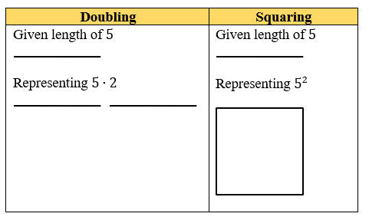

* Instruction includes modeling the differences between tripling or cubing a value using a graphic organizer. Tripling a value would be represented by multiplying a given length by 3,whereas cubing a number would be represented by the volume of a cube with a given length.
  + For example, students can be given the table below to show how the left column triples a length whereas the right column cubes a length.

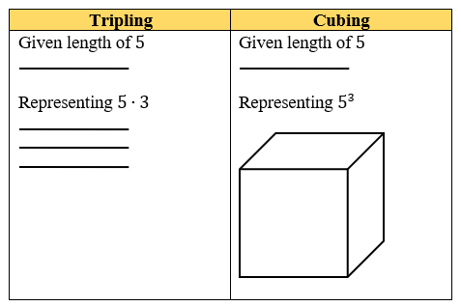

Instruction may include providing students with the opportunity to develop their own note sheet or graphic organizer for the cubes of numbers from -5 to 5.

|  |  |  |
| --- | --- | --- |
|  |  |  |
|  |  |  |
|  |  |  |
|  |  |  |
|  |  |  |
|  |  |  |
|  |  |  |
|  |  |  |
|  |  |  |
|  |  |  |
|  |  |  |
| 5 |  |  |

Instructional Tasks

*Instructional Task 1(MTR.7.1)*

A square tile in a kitchen has an area of 121 square inches.

Part A. What is the length of one side of the square tile in inches? Is this tile smaller or larger than a one-foot by one-foot tile?

Part B. The owner of the house, Kiana, wants to put larger tiles in their kitchen to change the look of the kitchen. The new tile is a square with an area of 196 square inches.

* What is the length of the side of the new tile?
* How does this larger tile compare to the current tile used in the kitchen?

Part C. A third tile has a side length of . Kiana is trying to determine which square tile covers the most area. Put the tile’s side lengths of the tiles in order from greatest to least. Justify your thinking.

*Instructional Task 2 (MTR.3.1)*

The volume of a large cube is 125 cubic inches. The volume of a small cube is 27 cubic inches. What is the difference between the length of one side of the large cube and the length of one side of the small cube?

*Instructional Task 3 (MTR.1.1, MTR.3.1, MTR.4.1, MTR.5.1, MTR.6.1)*

Part A. Using the equations below, discuss with a partner the possible values of *x*.

Part B. Discuss with a partner the possible values of *x* if .

Part C. With your partner, design a short presentation on the relationship between square roots and cube roots, and the possible values of the roots.

Instructional Items

*Instructional Item 1*

An equation is given.

What are the values of ?

*Instructional Item 2*

Solve for in the equation .

*\*The strategies, tasks and items included in the B1G-M are examples and should not be considered comprehensive.*

**MA.8.AR.3** *Extend understanding of proportional relationships to two-variable linear equations.*

### MA.8.AR.3.1

Benchmark

MA.8.AR.3.1 Determine if a linear relationship is also a proportional relationship.

Benchmark Clarifications:

*Clarification 1:* Instruction focuses on the understanding that proportional relationships are linear relationships whose graph passes through the origin.

*Clarification 2:* Instruction includes the representation of relationships using tables, graphs, equations and written descriptions.

Connecting Benchmarks/Horizontal Alignment

* MA.7.AR.4.1
* MA.8.F.1.2
* MA.8.GR.2.4
* MA.8.DP.1.3

Terms from the K-12 Glossary

* Constant of Proportionality
* Proportional Relationship

Vertical Alignment

|  |  |
| --- | --- |
| **Previous Benchmarks**   * MA.6.AR.3.3, MA.6.AR.3.4, MA.6.AR.3.5 | **Next Benchmarks**   * MA.912.AR.2.2, MA.912.AR.2.4 * MA.912.F.1.3 |

Purpose and Instructional Strategies

In previous courses, students solved problems involving ratios, rates and unit rates, including comparisons, mixtures, ratios of lengths and conversions within the same measurement system. In grade 7 accelerated, students determined if two quantities are in a proportional relationship from a table and determined the constant of proportionality. Students also determine whether a given linear relationship is also a proportional relationship. In Algebra 1, students will use two-variable linear equations to represent mathematical or real-world contexts.

* Instruction includes using a variety of variables to represent the slope, which is the same as the constant of proportionality when the linear relationship is also a proportional relationship. Students used or in grade 7 to represent the constant of proportionality and now in grade 8 may use to represent slope. Students should understand that the slope or constant rate of change can be represented by any variable.
* Instruction includes students graphing relationships and writing equations to determine if two linearly related quantities are also proportional. Students need to be provided examples to show evidence that not all linear relationships are proportional.
* Students should connect unit rates, the constant of proportionality and slope to represent similar ideas in different contexts.

Common Misconceptions or Errors

* Students may incorrectly state a relationship is not proportional if the origin is not visible in the graph or given in the table.
* Students may incorrectly think all linear relationships are proportional. Some students find a constant rate of change and confuse this with a constant ratio. Help students understand that a constant ratio is only possible if the relationship passes through the origin.

Strategies to Support Tiered Instruction

* Instruction includes providing opportunities to explore relationships represented on graphs and in tables that do not include the origin. Students should determine the rate of change in these situations and use ratio reasoning to determine if the relationships pass through the origin or not.
* Instruction includes the use of geometric software to visually compare proportional and non-proportional graphs to model that all linear graphs are not proportional relationships.
* Teacher co-creates a graphic organizer to represent the similarities and differences of the terms: unit rate, constant of proportionality, and slope. Specifically include the different contexts applicable to each.

Instructional Tasks

*Instructional Task 1 (MTR.4.1, MTR.6.1, MTR.7.1)*

A student is making trail mix for each serving size in the table given.

|  |  |  |  |  |
| --- | --- | --- | --- | --- |
| **Serving Size** | **1** | **2** | **3** | **4** |
| Cups of Nuts | 2 | 3 | 4 | 5 |
| Cups of Fruit | 4 | 6 | 8 | 10 |

Part A. Is this relationship linear? If so, state the constant rate of change.

Part B. Determine if this relationship is also proportional.

Part C. What do you notice about the number of cups of nuts and fruit that would be in a serving size of zero? Discuss with a partner.

*Instructional Task 2 (MTR.4.1)*

Which graph represents a proportional relationship? Justify your answer.

|  |  |
| --- | --- |
| **Graph #1** | **Graph #2** |
| A graph with an approximate slope of positive one-half. Y-intercept is at 1. | Graph with an approximate slope of positive 2 with the y-intercept at zero. |

Instructional Items

*Instructional Item 1*

Alexia earns $14.75 an hour as a hostess at a local restaurant. She earns an additional $30 in tips each night from take-out orders. Determine if this linear relationship is proportional.

*Instructional Item 2*

The circumference of a circle is proportional to its diameter. This relationship can be expressed by the equation Determine if this linear relationship is proportional.

*\*The strategies, tasks and items included in the B1G-M are examples and should not be considered comprehensive.*

### MA.8.AR.3.2

Benchmark

MA.8.AR.3.2 Given a table, graph or written description of a linear relationship, determine the slope.

Benchmark Clarifications:

*Clarification 1:* Problem types include cases where two points are given to determine the slope.

*Clarification 2:* Instruction includes making connections of slope to the constant of proportionality and to similar triangles represented on the coordinate plane.

Connecting Benchmarks/Horizontal Alignment

* MA.7.AR.4.2
* MA.8.AR.3.3, MA.8.AR.3.5
* MA.8.F.1.1
* MA.8.GR.2.4
* MA.8.DP.1.3

Terms from the K-12 Glossary

* Slope

Vertical Alignment

|  |  |
| --- | --- |
| **Previous Benchmarks**   * MA.6.AR.4.2 * MA.7.AR.3.2 | **Next Benchmarks**   * MA.912.AR.2.2 |

Purpose and Instructional Strategies

In previous courses, students determined rates, and unit rates in ratios. In grade 7 accelerated, students are determining the constant of proportionality in a proportional relationship. Students are also determining the slope of a linear relationship from a given table, graph, or written relationship. In Algebra 1, students will write a two-variable linear equation from a graph, written description, or a table to represent relationships between quantities in mathematical and real-world context.

* Students identified the unit rate or the constant of proportionality in prior grade levels. This benchmark is the first one that references the slope, which represents a constant rate of change. This is not the same as a constant of proportionality unless the relationship goes through the origin.
* Instruction includes interpreting the meaning and value of slope in real-world context.
* Understanding slope can be introduced through a graph and the change in value of the and the .
* To introduce the concept to students, use at least two points on a graph in quadrant one.
* Instruction includes using a variety of vocabulary to make connections to real-world concepts and future courses. To describe the slope, one can say either “the vertical change divided by the horizontal change” or “rise over run.”

Common Misconceptions or Errors

* + Students may invert the - and -values when calculating slope. To address this misconception, students should represent the relationship visually.

Strategies to Support Tiered Instruction

* Teacher supports students who invert the - and -values when calculating slope by using real-world problems that students can relate to and helping students represent the relationship visually.
* Instruction includes providing students with graph paper with grid lengths larger than 1 centimeter and using appropriate scaling of the axes to allow for students to see the unit rate more easily.

Instructional Tasks

*Instructional Task 1 (MTR.6.1)*

Mr. Elliot needs to drain his above ground pool before the winter. The graph below represents the relationship between the number of gallons of water remaining in the pool and the number of hours that the pool has drained. Determine the slope and explain what it means in this situation.

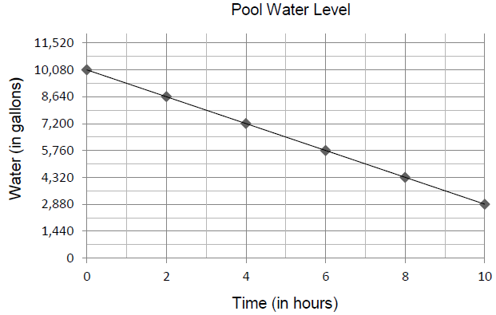

*Instructional Task 2 (MTR.4.1, MTR.7.1)*

Jack and Jill are selling gallons of water that are sold in different size pails. Jack charges $1.75 for every 2 gallons of water a pail holds. Additionally, he charges a $2 service fee. Jill's prices can be modeled with the graph shown.

Price (in dollars)

Gallons of Water

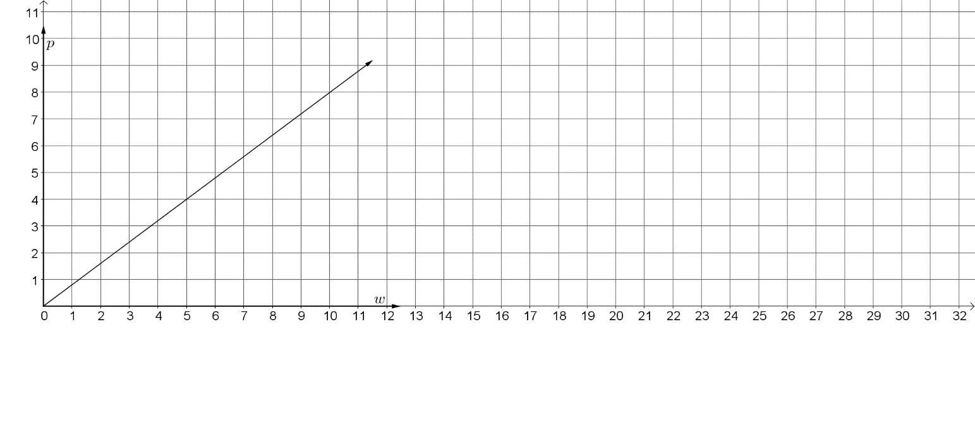

Part A. Identify the slope of Jack's relationship. Explain what it means.

Part B. Identify the slope of Jill's graph and explain what it means.

Part C. Graph Jack’s prices on the same graph as Jill.

Part D. Whose has the better deal, Jack or Jill? Explain.

Instructional Items

*Instructional Item 1*

Cameron joins a local gym. There is an initial fee of $25 and then a fee of $5 per month. Determine the slope. After 12 months how much money has Cameron paid to the gym?

*Instructional Item 2*

A linear relationship is given in the table below. Determine the slope of the relationship.

|  |  |  |  |  |  |
| --- | --- | --- | --- | --- | --- |
|  |  |  |  |  |  |
|  |  |  | 0 | 9 | 18 |

*\*The strategies, tasks and items included in the B1G-M are examples and should not be considered comprehensive.*

### MA.8.AR.3.3

Benchmark

MA.8.AR.3.3 Given a table, graph or written description of a linear relationship, write an equation in slope-intercept form.

Connecting Benchmarks/Horizontal Alignment

* MA.7.AR.4.4
* MA.8.AR.3.2, MA.8.AR.3.5
* MA.8.F.1.1
* MA.8.DP.1.3

Terms from the K-12 Glossary

* Intercept
* Slope

Vertical Alignment

|  |  |
| --- | --- |
| **Previous Benchmarks**   * MA.6.AR.4.4 * MA.7.AR.4.4 | **Next Benchmarks**   * MA.912.AR.2.2, MA.912.AR.2.3 |

Purpose and Instructional Strategies

In previous courses, students determined rates, and unit rates in ratios. In grade 7 accelerated, students translate between different representations of proportional relationships. Students also write an equation in slope-intercept form from a written description, a table, or a graph. In Algebra 1, students will write a linear two-variable equation to represent a relationship given by a variety of mathematical and real-world contexts.

* Point-slope form and standard form are not expectations at this grade level.
* Instruction connects proportional relationships to support the generation of the equation . Helping students see how the linear equation is both the same and different from the proportional relationship will support the appropriate use of proportional thinking using the rate of change.
* Using an online dynamic graphing tool to explore how the graph changes as either the slope or the -intercept changes help students visualize the coefficients and constants in the equation (*MTR.4.1*).
* Students should recognize in a table that the -intercept is the -value when is equal to 0. The slope can be determined by finding the ratio between the change in two -values and the change between the two corresponding -values.
* Using graphs, students identify the -intercept as the point where the line crosses the -axis and the slope as the vertical change divided by the horizontal change. In a linear equation, the coefficient of is the slope and the constant is the -intercept. Students need to be given the equations in formats other than , such as or .
* Instruction includes using a variety of vocabulary to make connections to real-world concepts and future courses. To describe the slope, one can say either “the vertical change divided by the horizontal change” or “rise over run.”
* The instruction includes examples where the slope is positive or negative and the -intercept is given as a positive or a negative in the equation.
* When providing a graph, be sure there are easily identifiable points for students to use in calculating the slope.
* Instruction allows students to make connections between the different representations of a linear relationship (*MTR.2.1*).

Common Misconceptions or Errors

* Students may incorrectly identify the values for the slope and -intercept.
* Students may incorrectly calculate the slope with a common error of inverting the change in and the change in .

Strategies to Support Tiered Instruction

* Teacher supports students who incorrectly identify the values for the slope and -intercept by providing opportunities to notice patterns between a given value for , a line graphed on the coordinate plane, and a given equation of the same line.
* Teacher supports students who incorrectly calculate the slope by inverting the change in and the change in using error analysis tasks, in which the expression is incorrectly written as , and has students find and correct the error.
* Teacher supports students who invert the and values when calculating slope by using real-world problems that students can relate to and helping students represent the relationship visually.
* Teacher co-creates an anchor chart naming the slope and -intercept of a given line and then discusses where to start when graphing the line.
* Instruction incudes graphing various linear equations from a table and then discussing the pattern students notice in regard to the -intercept.
* Teacher provides students with graphs and equations of several linear equations then co-illustrates connections between the slopes and -intercepts of each line to the corresponding parts of each equation using the same color highlights.
* Teacher co-creates a graphic organizer with students to include examples of positive and negative slope; the meaning of each variable in slope intercept form; and how to determine the slope and -intercept in a table, graph and verbal description.

Instructional Tasks

*Instructional Task 1 (MTR.7.1)*

Victoria owns a store that sells board games. She made the following graph to relate the number of board games she sells to her overall profits.

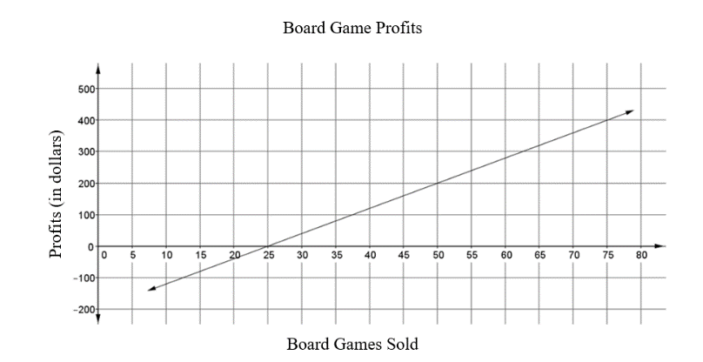

Part A. Write an equation in slope-intercept form to describe this relation. Explain how to determine the equation.

Part B. What is the meaning of the -intercept in the given context? What is the meaning of the slope in the given context?

Instructional Items

*Instructional Item 1*

Write an equation that represents the graph shown.

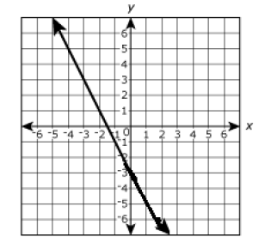

*Instructional Item 2*

The table shown represents a linear relationship. Using the table, write an equation in slope-intercept form.

|  |  |
| --- | --- |
|  |  |
|  |  |
|  |  |
|  |  |
| 3 | 5 |

*\*The strategies, tasks and items included in the B1G-M are examples and should not be considered comprehensive.*

### MA.8.AR.3.4

Benchmark

MA.8.AR.3.4 Given a mathematical or real-world context, graph a two-variable linear equation from a written description, a table or an equation in slope-intercept form.

Connecting Benchmarks/Horizontal Alignment

* MA.7.AR.4.3
* MA.8.AR.4.2, MA.8.AR.4.3
* MA.8.DP.1.3

Terms from the K-12 Glossary

* Intercept
* Linear Equation
* Slope

Vertical Alignment

|  |  |
| --- | --- |
| **Previous Benchmarks**   * MA.6.GR.1.1 | **Next Benchmarks**   * MA.912.AR.2.4 |

Purpose and Instructional Strategies

In previous courses, students plotted rational number ordered pairs in all four quadrants and on both axes. In grade 7 accelerated, students graph proportional relationships from a table, equation or a written description. Students also graph an equation from slope-intercept form from a written description, a table, a graph or an equation. In Algebra 1, students will graph a linear function when given a table, equation or written description.

* Point-slope form and standard forms are not expectations at this grade level.
* Review the concept of slope from MA.8.AR.3.2 for students who may need additional work to determine the slope and understand the meaning of slope.
* The instruction includes examples where the slope is positive or negative and the -intercept is given as a positive or a negative in the equation.
* When introducing the benchmark, review graphing on the coordinate plane and determining appropriate scales for the graph.
* Instruction includes the understanding that a real-world context can be represented by a linear two-variable equation even though it only has meaning for discrete values. Discussing discrete values will prepare students to represent domain and range of real-world contexts in later courses.
  + For example, if a gym membership cost $10.00 plus $6.00 for each class, this can be represented as . When represented on the coordinate plane, the relationship is graphed using the points , , , and so on.
* For mastery of this benchmark, students should be given flexibility to represent real-world contexts with discrete values as a line or as a set of points.

Common Misconceptions or Errors

* Students may incorrectly identify the slope and -intercept.
* When graphing, students may incorrectly graph the line by inverting the directions of the slope values.
  + For example, if the slope is , a student may think that 2 represents the change in the horizontal direction rather than the vertical direction.

Strategies to Support Tiered Instruction

* Teacher supports students who incorrectly identify the values for the slope and -intercept by providing opportunities to notice patterns between a given value for , a line graphed on the coordinate plane, and a given equation of the same line.
* Teacher supports students who invert the - and -values when calculating slope by using real-world problems that students can relate to and helping students represent the relationship visually.
* Instruction includes supporting students who incorrectly graph the line by inverting the directions of the slope values. Students may incorrectly calculate the slope with a common error of inverting the change in 𝑦 and the change in 𝑥. Teachers can support students using error analysis tasks, in which the expression is incorrectly written as .
* Instruction includes having students find the error and make corrections.
* Teacher supports students who incorrectly graph the slope of a given line through error analysis tasks, in which a line is incorrectly graphed by inverting the change in and the change in and then have students find and correct the error.
* Teacher co-creates an anchor chart naming the slope and -intercept of a given line and then discusses where to start when graphing the line.
* Teacher provides graphs and equations of several linear equations then co-illustrates connections between the slopes and -intercepts of each line to the corresponding parts of each equation using the same color highlights.
* Teacher co-creates a graphic organizer with students to include examples of positive and negative slope; the meaning of each variable in slope-intercept form; and how to determine the slope and -intercept in a table, graph and verbal description.
* Teacher provides instruction on creating an equation table to clear up the misconception of incorrectly graphing an equation on a coordinate plane.

|  |  |  |  |
| --- | --- | --- | --- |
|  |  |  | **Coordinate Points** |
| 0 |  | 5 |  |
| -2 |  | 1 |  |
| 6 |  | 17 |  |

* Teacher provides instruction on determining the slope and -intercept when reading verbal description.

Instructional Tasks

*Instructional Task 1 (MTR.6.1, MTR.7.1)*

Brent wants to buy a 60" LED Smart TV. He opened a savings account and added money to the account every month. The table below shows the relationship between the number of months Brent has been saving and the total amount of money in his account.

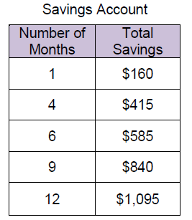

Part A. Graph the relationship on a coordinate plane.

Part B. If the new Smart TV costs $1500 and tax will be $110, approximately how many more months does he need to save money in order to make the purchase?

*Instructional Task 2 (MTR.3.1, MTR.4.1)*

Part A. Graph on the coordinate plane.

Part B. Discuss with a partner your method of graphing the equation of the line.

Instructional Items

*Instructional Item 1*

Graph on the coordinate plane.

*Instructional Item 2*

Supplies for the car wash cost $25. The booster club is charging $10 per car. Graph the relationship between the amount of money earned and the number of cars washed.

*Instructional Item 3*

The table shown represents a linear relationship. Use the table to graph the relationship

|  |  |
| --- | --- |
|  |  |
|  |  |
|  |  |
|  |  |
|  |  |

*\*The strategies, tasks and items included in the B1G-M are examples and should not be considered comprehensive.*

### MA.8.AR.3.5

Benchmark

MA.8.AR.3.5 Given a real-world context, determine and interpret the slope and -intercept of a two-variable linear equation from a written description, a table, a graph or an equation in slope-intercept form.

Example: Raul bought a palm tree to plant at his house. He records the growth over many months and creates the equation , where is the height of the palm tree in feet and is the number of months. Interpret the slope and -intercept from his equation.

Benchmark Clarifications:

*Clarification 1:* Problems include conversions with temperature and equations of lines of fit in scatter plots.

Connecting Benchmarks/Horizontal Alignment

* MA.7.AR.4.5
* MA.8.AR.3.2, MA.8.AR.3.3
* MA,8.AR.4.1, MA.8.AR.4.2, MA.8.AR.4.3
* MA.8.F.1.3
* MA.8.DP.1.3

Terms from the K-12 Glossary

* Intercept
* Linear Equation
* Slope

Vertical Alignment

|  |  |
| --- | --- |
| **Previous Benchmarks**   * MA.6.AR.3.2 | **Next Benchmarks**   * MA.912.AR.2.5 * MA.912.F.1.5 |

Purpose and Instructional Strategies

In grade 7, students solved real-world problems involving proportional relationships. In grade 8, students interpret the slope and -intercept of a two-variable linear equation within a real-world context when given a written description, a table, a graph or an equation. In Algebra 1, students will solve mathematical and real-world problems that are modeled by linear functions and will interpret key features of the graph in terms of the context.

* The purpose of this benchmark is to focus on interpreting the slope and -intercept in a real-world context using information from a table, graph or written description.
* Students identify the rate of change (slope) and initial value (-intercept) from tables, graphs, equations or verbal descriptions. Students recognize that if the value is in a table, the -intercept is the corresponding -value. Otherwise, the -intercept can be found by substituting a point and the slope into the slope-intercept form of the equation and solving for the -intercept. The slope can be determined by finding the ratio between the change in two -values and the change between the two-corresponding -values.
* Using graphs, students identify the -intercept as the point where the line crosses the -axis and the slope as the vertical change divided by the horizontal change. In a linear equation, the coefficient of is the slope and the constant is the -intercept. Students should have practice with equations in formats other than , such as or .
* Instruction includes using a variety of vocabulary to make connections to real-world concepts and future courses. To describe the slope, one can say either “the vertical change divided by the horizontal change” or “rise over run.”
* In contextual situations, the -intercept is generally the starting value or the value in the situation when the independent variable is 0.
* The slope is the rate of change that occurs in the problem. Rates of change can often occur over years. In these situations, it is helpful for the years to be "converted" to the number of years since the start year.
  + For example, the years of 1960, 1970, and 1980 could be represented as 0 for 1960, 10 for 1970 and 20 for 1980.
* Students use the slope and -intercept to write a linear function in the form .
* Students should remember to interpret the line of fit within the context of the data provided by the scatter plot (MA.8.DP.1.3). The line of fit is meant to understand the general trend of data, but it might not be able to explain everything about it.
* For mastery of this benchmark, it is not the expectation to compare slopes or -intercepts of two linear equations in two variables.
* Instruction includes learning about linear relationships within other content areas. Students should recognize that the conversion between Fahrenheit and Celsius represents a linear relationship, but not a proportional one. Memorization of the formulas is not an expectation of the benchmark.
  + The formula for converting Fahrenheit to Celsius is:
  + The formula for converting Celsius to Fahrenheit is:

Common Misconceptions or Errors

* Students may incorrectly identify the slope and -intercept.
* Students may incorrectly interpret the slope and -intercept.
* The misconceptions of this benchmark may develop for some students based on the real-world context of the problems presented. To address this misconception, scaffold questions to help students understand the context.

Strategies to Support Tiered Instruction

* Teacher provides opportunities for students to comprehend the context or situation by engaging in questions.
  + What do you know from the problem?
  + What is the problem asking you to find?
  + What are the two quantities in this problem?
  + How are the quantities related to each other?
  + Which quantity do you want to consider as the independent variable?
  + Which quantity do you want to consider as the dependent variable?
* Instruction includes the use a three-read strategy. Students read the problem three different times, each with a different purpose.
* First, read the problem with the purpose of answering the question: What is the problem, context, or story about?
* Second, read the problem with the purpose of answering the question: What are we trying to find out?
* Third, read the problem with the purpose of answering the question: What information is important in the problem?
* Instruction includes the understanding that the independent variable depends on the given context. Additionally, independent variables are not always the 𝑥-axis and the dependent variable are not always the 𝑦-axis.
* For example, if one has a proportional relationship between feet and meters, they can graph feet either on the 𝑥-axis or the 𝑦-axis. Which one that is dependent depends on the context. For instance, if one is given feet and converting to meters, then feet would be independent and meters would be dependent.

Instructional Tasks

*Instructional Task 1 (MTR.7.1)*

The graph below shows a scatter plot and its line of fit for data collected on the height and foot length of a sample of 10 male students.

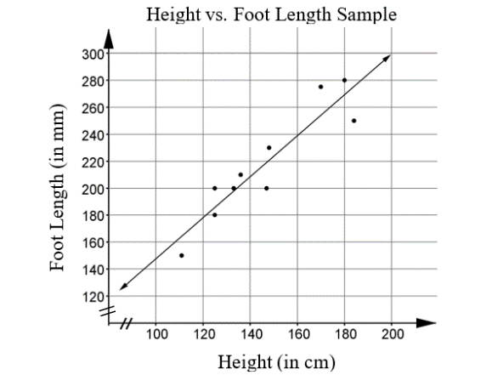

Part A. What does the graph indicate about the relationship between foot length and height?

Part B. The equation of the line of fit is , where is foot length in millimeters and is height in centimeters. Explain the meaning of the slope and the -intercept of this equation in the context of the data.

Instructional Items

*Instructional Item 1*

At Stay-a-While Coffee shop, they display their internet fees on a chart like the one shown below. Determine the slope for the relationship between the number of minutes, , and the amount charged, .

|  |  |
| --- | --- |
| **Time** | **Amount Charged** |
| 1 hour | $3.95 |
| 2 hours | $6.95 |
| 4 hours | $12.95 |

*Instructional Item 2*

Joshua adopted a puppy from a dog shelter. He records the puppy’s height over many months and creates the equation , where is the height of the puppy, in feet, and is the number of months. Interpret the slope and -intercept from his equation.

*\*The strategies, tasks and items included in the B1G-M are examples and should not be considered comprehensive.*

**MA.8.AR.4** *Develop an understanding of two-variable systems of equations.*

### MA.8.AR.4.1

Benchmark

MA.8.AR.4.1 Given a system of two linear equations and a specified set of possible solutions, determine which ordered pairs satisfy the system of linear equations.

Benchmark Clarifications:

*Clarification 1:* Instruction focuses on the understanding that a solution to a system of equations satisfies both linear equations simultaneously.

Connecting Benchmarks/Horizontal Alignment

* MA.7.AR.4.2, MA.7.AR.4.3
* MA.8.AR.2.1
* MA.8.AR.3.5
* MA.8.AR.4.2, MA.8.AR.4.3

Terms from the K-12 Glossary

* Linear Equation

Vertical Alignment

|  |  |
| --- | --- |
| **Previous Benchmarks**   * MA.6.AR.2.1 | **Next Benchmarks**   * MA.912.AR.9.1 |

Purpose and Instructional Strategies

In elementary mathematics, students identified true and false equations involving the four operations. In previous courses, students determined which values made an equation or inequality true or false given an equation or inequality and a specified set of integer values. In grade 7 accelerated, students determine constants of proportionality and graph proportional relationships from a table, equation or a written description given in a mathematical or real-world context. Students also extend this learning to systems of two linear equations to determine possible solutions from a specified set of ordered pairs. In Algebra 1, students will write and solve a system of two-variable linear equations algebraically and graphically given a mathematical or real-world context.

* The focus of this benchmark is on the understanding that the solution of a system is a set of points that satisfy both equations of the system.
* Systems of linear equations can have one solution, infinitely many solutions or no solutions.
  + A system of linear equations whose graphs meet at one point (intersecting lines) has only one solution, the ordered pair representing the point of intersection.
  + A system of linear equations whose graphs are coincident (the same line) has infinitely many solutions, the set of ordered pairs representing all the points on the line.
  + A system of linear equations whose graphs do not meet (parallel lines) has no solutions and the slopes of these lines are the same. The technical name for these kinds of systems is "inconsistent".

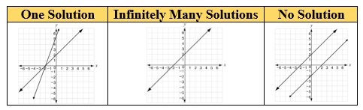

* A system of linear equations is two linear equations that should be solved at the same time.
* Instruction includes understanding that systems are on the same coordinate plane to determine solutions (*MTR.4.1*).

Common Misconceptions or Errors

* + Students may incorrectly substitute solutions into the equations. To address this misconception, remediate work with integers.
  + Students may not understand how a pair of values can be a single solution to a pair of equations. Emphasize the connection between the two variables in the equations and the two coordinates of the point on the coordinate plane.

Strategies to Support Tiered Instruction

* Instruction includes drawing connections between systems of equations represented graphically and with equations. Using a graphic organizer, reinforce the solution to a system of equations as the ordered pair that satisfies both equations simultaneously.
  + When there is one solution, the two lines intersect at one point and when using substitution, the coordinates of that one point will result in true statements for both equations.
  + When there is no solution, the two lines do not intersect and therefore there are no coordinates that will result in true statements for both equations.
  + When there are infinite solutions, the two lines coincide and intersect with an infinite number of points. When using substitution, all the points on the lines will result in true statements for both equations.
* Teacher provides opportunities to utilize manipulatives when substituting values into given equations to help visualize evaluating operations with integers.
  + - , both positive, sum is positive. When the signs are the same the counters would be the same color, so add them.
    - , different signs, more negative counters, the sum is negative.
    - , both negative signs, the sum is negative.
    - , different signs, more positive counters, the sum is positive.
* Teacher provides scaffolding opportunities by first having students identify which value in each ordered pair represents the -coordinate and which represents the -coordinate. Once students correctly identify the coordinates, the teacher provides opportunities to use substitution to replace the variables in the provided equations with the correct value. Finally, students evaluate each equation to determine if the provided coordinates result in true statements or not.
* Instruction includes remediating work with integers for students that incorrectly substitute solutions into the equations.

Instructional Tasks

*Instructional Task 1 (MTR.7.1, MTR 6.1)*

The students in Mr. Cruz's Algebra class were determining the solution of a system of equations and determined what they believe are possible solutions. When Mr. Cruz checked their solutions, each of the students had a different set of points. Determine which student has the correct solution and explain why the other student's answers are not correct.

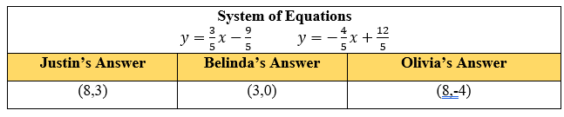

Instructional Items

*Instructional Item 1*

Determine which of the following points are a solution(s) of the given system of equations.

*\*The strategies, tasks and items included in the B1G-M are examples and should not be considered comprehensive.*

### MA.8.AR.4.2

Benchmark

MA.8.AR.4.2 Given a system of two linear equations represented graphically on the same coordinate plane, determine whether there is one solution, no solution or infinitely many solutions.

Connecting Benchmarks/Horizontal Alignment

* MA.7.AR.4.3, MA7.AR.4.4, MA.7.AR.4.5
* MA.8.AR.2.1
* MA.8.AR.3.4, MA.8.AR.3.5
* MA.8.AR.4.1, MA.8.AR.4.3

Terms from the K-12 Glossary

* Linear Equation

Vertical Alignment

|  |  |
| --- | --- |
| **Previous Benchmarks**   * MA.6.GR.1 | **Next Benchmarks**   * MA.912.AR.9.1, MA.912.AR.9.4 |

Purpose and Instructional Strategies

|  |  |  |  |  |  |  |
| --- | --- | --- | --- | --- | --- | --- |
| In previous courses, students plotted an identified points in all four quadrants of the coordinate plane. In grade 7 accelerated, students determine constants of proportionality and graph proportional relationships from a table, equation or a written description given in a mathematical or real-world context. Students also extend this learning to a system of two linear equations represented graphically on the same coordinate plane. Students will also determine whether there is one solution, no solution or infinitely many solutions. In Algebra 1, students will write and solve a system of two-variable linear equations algebraically and graphically given a mathematical or real-world context.   * The focus of this benchmark is on the understanding that the solution of a system is a set of points that satisfy both equations of the system. * Systems of linear equations can have one solution, infinitely many solutions or no solutions.   + A system of linear equations whose graphs meet at one point (intersecting lines) has only one solution, the ordered pair representing the point of intersection.   + A system of linear equations whose graphs are coincident (the same line) has infinitely many solutions, the set of ordered pairs representing all the points on the line.   + A system of linear equations whose graphs do not meet (parallel lines) has no solutions and the slopes of these lines are the same. The technical name for these kinds of systems is "inconsistent.”  |  |  |  | | --- | --- | --- | | **One Solution** | **Infinitely Many Solutions** | **No Solution** | | A graph of a system of equations with one solution where they intersect. | A graph of a system of equations with infinitely many solutions due to the two lines being exactly on top of the other. | A graph of a system of equations with no solution since the lines are parallel to one another. |  * A system of linear equations is two linear equations that should be solved at the same time. * Instruction includes understanding that systems are on the same coordinate plane to determine solutions (*MTR.4.1*). |

Common Misconceptions or Errors

* + Students may incorrectly interpret the solution when the lines are the same and have an infinite number of solutions. To address this misconception, provide multiple examples to show how the equations and graphs will be the same line on the coordinate plane.

Strategies to Support Tiered Instruction

* Instruction includes testing possible solutions for a given system of linear equations to demonstrate whether the equations have the same solution set, one common solution (only one ordered pair) or no common solution.
* Instruction includes drawing connections between systems of equations represented graphically and with equations. Using a graphic organizer, reinforce the solution to a system of equations as the ordered pair that stratifies both equations simultaneously.
* When there is one solution, the two lines intersect at one point and when using substitution, the coordinates of that one point will result in true statements for both equations.
* When there is no solution, the two lines do not intersect and therefore there are no coordinates that will result in true statements for both equations.
* When there are infinite solutions, the two lines coincide and intersect with an infinite number of points. When substituting ordered pairs, all will result in true statements for both equations.

Instructional Tasks

*Instructional Task 1 (MTR.6.1)*

Ashley looks at the following system of equations. She concludes that because there is no -intercept value, the lines cannot intersect.

Part A. Graph the system of equations on a coordinate plane.

Part B. Is Ashley's conclusion correct? Explain your answer and support your reasoning with mathematical examples.

*Instructional Task 2 (MTR.3.1*

Part A. Identify the solution of the graphed system of equations. Explain why it is the solution.

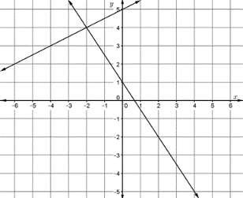

Part B. Identify the solution of the graphed system of equations. Explain how you know it is the solution. What conjecture can you make about parallel lines?

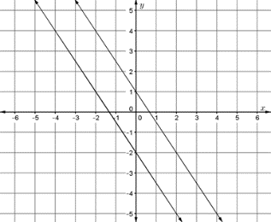

Instructional Items

*Instructional Item 1*

Determine the number of solutions of each graphed system of linear equations, A, B and C.

|  |  |  |
| --- | --- | --- |
| **System A** | **System B** | **System C** |
|  |  |  |

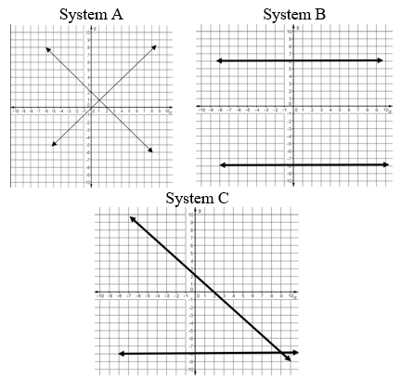

*Instructional Item 2*

Given the system, and , graphed on the coordinate plane below,

determine the number of solutions and discuss your understanding with a partner.

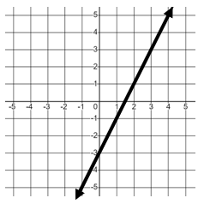

*The strategies, tasks and items included in the B1G-M are examples and should not be considered comprehensive.

### MA.8.AR.4.3

Benchmark

MA.8.AR.4.3 Given a mathematical or real-world context, solve systems of two linear equations by graphing.

Benchmark Clarifications:

*Clarification 1:* Instruction includes approximating non-integer solutions.

*Clarification 2:* Within this benchmark, it is the expectation to represent systems of linear equations in slope-intercept form only.

*Clarification 3:* Instruction includes recognizing that parallel lines have the same slope.

Connecting Benchmarks/Horizontal Alignment

* MA.7.AR.4.3, MA.7.AR.4.4, MA.7.AR.4.5
* MA.8.AR.3.4, MA.8.AR.3.5
* MA.8.AR.4.1, MA.8.AR.4.2

Terms from the K-12 Glossary

* Linear Equation

Vertical Alignment

|  |  |
| --- | --- |
| **Previous Benchmarks**   * MA.6.GR.1 | **Next Benchmarks**   * MA.912.AR.9.1, MA.912.AR.9.6 |

Purpose and Instructional Strategies

In previous courses, students plotted an identified points in all four quadrants of the coordinate plane. In grade 7 accelerated, students determine constants of proportionality and graph proportional relationships from a table, equation or a written description given in a mathematical or real-world context. Students also extend this learning to a system of two linear equations and graphing the system on the same coordinate plane. Students also determine whether there is one solution, no solution or infinitely many solutions. In Algebra 1, students will write and solve a system of two-variable linear equations algebraically and graphically given a mathematical or real-world context.

* Systems of linear equations can have one solution, infinitely many solutions or no solutions.
  + A system of linear equations whose graphs meet at one point (intersecting lines) has only one solution, the ordered pair representing the point of intersection.
  + A system of linear equations whose graphs are coincident (the same line) has infinitely many solutions, the set of ordered pairs representing all the points on the line.
  + A system of linear equations whose graphs do not meet (parallel lines) has no solutions and the slopes of these lines are the same. The technical name for these kinds of systems is "inconsistent.”

|  |  |  |
| --- | --- | --- |
| **One Solution** | **Infinitely Many Solutions** | **No Solution** |
| A graph of a system of equations with one solution. | A graph of a system of equations with infinitely many solution. | A graph of a system of equations with no solution. |

* A system of linear equations is two linear equations that should be solved at the same time. Instruction includes understanding that systems are on the same coordinate plane to determine solutions (*MTR.4.1*).
* The purpose of this benchmark is to focus on graphing to solve the system of equations. This allows for the visual representation of what the solution means in context (*MTR.7.1*).
* Instruction includes recognizing when the system does not have a solution: if there are two distinct lines, but the slopes of the two lines are the same, then the result is a pair of parallel lines. This could be modeled on a graph on paper or through an online resource to support students being able to visualize the lines.

Common Misconceptions or Errors

* Students make errors in plotting points and graphing lines on the coordinate plane, leading to incorrect solutions. To address this misconception, use graph paper, a printed coordinate plane or an online tool for graphing.
* Students incorrectly identify the solution to equations of the same line by stating only the graphed points are the solution set.
  + For example, in the system below with the infinitely many solutions, students may incorrectly not identify as a solution because it is not a point graphed on the coordinate plane.

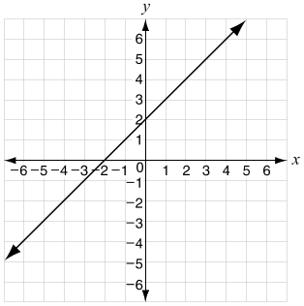

Strategies to Support Tiered Instruction

* Instruction includes the use of graph paper, a printed coordinate plane, or an online tool for graphing.
* Teacher provides opportunities for students to comprehend the context or situation by engaging in questions.
  + What do you know from the problem?
  + What is the problem asking you to find?
  + Can you create a visual model to help you understand or see patterns in your problem?
* Instruction includes drawing connections between systems of equations represented graphically and with equations. Using a graphic organizer, reinforce the solution to a system of equation as the ordered pair that satisfies both equations simultaneously.
* When there is one solution, the two lines intersect at one point and when using substitution, the coordinates of that one point will result in true statements for both equations.
* When there is no solution, the two lines do not intersect and therefore there are no coordinates that will result in true statements for both equations.
* When there are infinite solutions, the two lines coincide and intersect with an infinite number of points. When using substitution, all the points on the lines will result in true statements for both equations.
* Instruction includes the use of a three-read strategy. Students read the problem three different times, each with a different purpose.
* First, read the problem with the purpose of answering the question: What is the problem, context, or story about?
* Second, read the problem with the purpose of answering the question: What are we trying to find out?
* Third, read the problem with the purpose of answering the question: What information is important in the problem?

Instructional Tasks

*Instructional Task 1 (MTR.6.1)*

Part A. Graph the line on a coordinate plane. Draw two other lines with the same slope but different -intercepts.

Part B. Compare the lines graphed in part A. What do you notice about the other two lines when compared to the given line?

Instructional Items

*Instructional Item 1*

Solve the system of linear equations by graphing.

*Instructional Item 2*

Solve the system of linear equations by graphing.

*Instructional Item 3*

Solve the system of linear equations by graphing.

*Instructional Item 4*

Solve the system of linear equations by graphing.

*\*The strategies, tasks and items included in the B1G-M are examples and should not be considered comprehensive.*

# Functions

**MA.8.F.1** *Define, evaluate and compare functions.*

### MA.8.F.1.1

Benchmark

MA.8.F.1.1 Given a set of ordered pairs, a table, a graph or mapping diagram, determine whether the relationship is a function. Identify the domain and range of the relation.

Benchmark Clarifications:

*Clarification 1:* Instruction includes referring to the input as the independent variable and the output as the dependent variable.

*Clarification 2:* Within this benchmark, it is the expectation to represent domain and range as a list of numbers or as an inequality.

Connecting Benchmarks/Horizontal Alignment

* MA.7.AR.4.1, MA.7.AR.4.2, MA.7.AR.4.3
* MA.8.AR.3.2, MA.8.AR.3.3
* MA.8.F.1.2, MA.8.F.1.3

Terms from the K-12 Glossary

* Domain
* Function
* Range

Vertical Alignment

|  |  |
| --- | --- |
| **Previous Benchmarks**   * MA.6.GR.1 | **Next Benchmarks**   * MA.912.F.1.1, MA.912.F.1.2 |

Purpose and Instructional Strategies

In previous courses, students plotted an identified points in all four quadrants of the coordinate plane. In grade 7 accelerated, students determined whether two quantities have a proportional relationship by examining a table, graph or written description and they determined the constant of proportionality. Students also work with linear equations with two variables and begin the introduction of functions. In Algebra 1, students will classify the function type and represent it using function notation. Additionally, students will extend learning to compare linear and nonlinear functions and begin work with quadratic and exponential functions.

* A mapping diagram consists of a list of -values and their corresponding -values shown with an arrow.
  + An example of a mapping diagram can include domain and range values or - and -values.

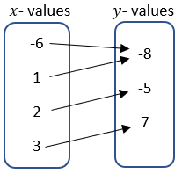 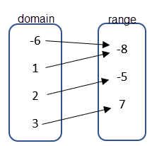

* The “vertical line test” should be treated with caution because (1) it allows you to apply a rule without thinking and (2) it may create misconceptions for later mathematics.
* Vocabulary is important in this benchmark as it connects to future learning in Algebra related to domain and range.  Using the terms independent and dependent variables during instruction will support connections to functions.
* Students should explain how they verified if the given context was a function or non-function (*MTR.4.1*). Students should provide counterexamples to deepen their knowledge of the relationships in functions.
  + For example, students can be asked to create - and -values that create relations that are functions and non-functions.

|  |  |
| --- | --- |
| **Functions** | **Non-Functions** |
| An example of a function using a x- and y-table with coordinates listed as: (-3, 6), (0, 8), (3, 20), (8, 4), and (-10, 8).  An example of a graph that is a function. It represents a curved line with three x-intercepts.  A mapping diagram of a function with the x-values listed on the left and the y-values listed on the right. Coordinates include: (-6, -8), (1, -8), (2, -5), and (3, 7). | An example of a non-function using a x- and y-table with coordinates listed as: (-2, 6), (0, 8), (-2, 20), (7, 4), and (-8, 8).  An example of a graph that is a non-function. It represents an oval or an ellipse.  A mapping diagram of a non-function with the x-values listed on the left and the y-values listed on the right. Coordinates include: (-8, 7), (-1, 9), (0, 9), (15, 7), and (15, 9). |

* Domain and range can be shown as a list, an inequality or as a verbal description depending on how the relation is given. The inequalities can be represented as inclusive or non-inclusive as determined by the context.
  + For example, if a graph represents a real-world context, with non-negative values, with the equation , the domain and range can be described as below.
    - *List*

A list cannot be used to represent this relation because it has infinitely many values.

* + - *Inequality*

Domain: ; Range:

* + - *Verbal Description*

The domain is all real numbers that are greater than or equal to zero. The range is all real numbers that are greater than or equal to five.

* + For example, for the relation {, the domain and range can be described as below.
    - *List*

Domain: {4, 5, 6, 7, 8}; Range: {12, 15, 18, 21, 24}

* + - *Inequality*

An inequality, such as , cannot be used to represent this relation because it is based on a discrete set of values.

* + - *Verbal Description*

The domain is all whole numbers from four to eight, inclusive. The range is the multiples of three from 12 to 24, inclusive.

Common Misconceptions or Errors

* + Students may invert the terms independent and dependent variable. To address this misconception, focus on the vocabulary and relationship to the input and output.

Strategies to Support Tiered Instruction

* Teacher reviews vocabulary and the difference between the terms. Once students understand that independent variables represent the input of the relation, they can make sense of real-world problems to accurately identify independent and dependent variables.
  + For example, in a scientific experiment one can determine that the input is the variable controlled by the scientist. So, the independent variable is the one controlled in the experiment and the dependent is the result of the experiment.
  + Students may need specific connections with the terms independent and dependent variables to other content areas such as a science experiment.
    - For example, a plant needs sunlight (independent variable) since you can determine how much sunlight a plant receives. Since the growth of the plant depends on the sunlight, the growth is the dependent variable.
* Teacher creates a matching activity with real-world situations. Students match the dependent variable and independent variable for the situation. Teacher facilitates discussion among students on their reasoning behind their matches from the activity in order to clear up any lingering misconceptions.
* Instruction includes helping students see how no number within the domain is repeated when the relationship is a function.

Instructional Tasks

*Instructional Task 1 (MTR.4.1)*

A relation is shown below where represents the independent variable and represents the dependent variable.

Part A. Create a mapping diagram, table and graph to represent this relation.

Part B. Determine the domain and range of the relation.

Part C. Determine if the relation represents a function or does not represent a function and justify your decision.

Part D. If the relation is not a function, which point could be removed to make it a function? If it is a function, add a point that would no longer make it a function.

*Instructional Task 2 (MTR.4.1)*

Create a relation that includes values for the domain and the range that are rational

numbers less than 10 that is a function. Create a mapping diagram, table and graph to

represent this relation.

Instructional Items

*Instructional Item 1*

A relation is shown in the table below where represents the independent variable and represents the dependent variable. Decide whether the table can represent a function or cannot represent a function.

|  |  |
| --- | --- |
|  |  |
| 4 | 12 |
| -1 | -3 |
| 0 | -4 |
| -5 | -21 |
| 1 | -3 |
| 4 | 12 |
| -2 | 0 |

*Instructional Item 2*

Identify the domain and range for the relation {.

*Instructional Item 3*

Identify the missing domain values to create a function. {(0,1), (1, 2), (__, 3), (__, 4). Verify your results by graphing on a coordinate plane.

*The strategies, tasks and items included in the B1G-M are examples and should not be considered comprehensive.

### MA.8.F.1.2

Benchmark

MA.8.F.1.2 Given a function defined by a graph or an equation, determine whether the function is a linear function. Given an input-output table, determine whether it could represent a linear function.

Benchmark Clarifications:

*Clarification 1:* Instruction includes recognizing that a table may not determine a function.

Connecting Benchmarks/Horizontal Alignment

* MA.7.AR.4.1
* MA.8.AR.3.1
* MA.8.F.1.1, MA.8.F.1.3

Terms from the K-12 Glossary

* Function
* Linear Function

Vertical Alignment

|  |  |
| --- | --- |
| **Previous Benchmarks**   * MA.7.AR.4.1 | **Next Benchmarks**   * MA. 912.F.1.1, MA.912.F.1.6 |

Purpose and Instructional Strategies

In previous courses, students generated or completed a two- or three- column table to display equivalent ratios. In grade 7 accelerated, students determine whether a relationship is proportional, given a table, equation or written description. Students also determine whether the function defined by a graph or an equation is a linear function. In Algebra 1, students will classify the function type given an equation or graph and compare key features of linear and nonlinear functions. Students will also begin using function notation when working with functions in mathematical and real-world contexts.

* Instruction includes determining if the function has a constant rate of change between the - and -values.
  + For example, students can depict the rate of change between the values in a table like below.

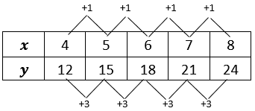

* Instruction includes a focus on the connection between the equation and the graph for a function.
* Students should develop an understanding of a linear function by using example and non-example situations.

|  |  |
| --- | --- |
| **Examples** | **Non-Examples** |
| An example of a linear function being a horizontal line on a graph.  An example of a linear function being a line with a negative slope on a graph.  An example that is a linear function using an x- and y-table with the following coordinates: (0, 4), (1, 8), (2, 12), (3, 16), and (4, 20). | An example that is not a linear function which is represented as a vertical line on a graph.  An example that is not a linear function which is represented as a curve or parabola.  An example that is not a linear function using an x- and y-table with the following coordinates: (-2, 4), (-1, 1), (0, 0), (1, 1), and (2, 4). |

Common Misconceptions or Errors

* + Students may not understand the connection from a table to the visual of a graph of the same function.
  + Students may not understand the connection of the domain, range, input, output and the equation to the resulting table and graph. To address this, include vocabulary throughout instruction.

Strategies to Support Tiered Instruction

* Teacher models how to get from a set of points displayed on a table to the points graphed on a coordinate plane, and how points from a coordinate plan can be written in a table. Then, the teacher provides opportunities to notice any patterns in the graph or table that will help identify if the function is linear.
* Teacher co-creates s a graph from a table with students, as well as a table from a graph to increase understanding of the relationship between the two. Once students become comfortable moving between graphs and tables, students can begin inspecting tables that represent functions. Teachers can review proportional and linear relationships and work with students to dissect tables to find if they contain a proportional relationship, meaning they are linear. Students should note that not all linear relationships are proportional, but all proportional relationships are linear.
* Teacher provides opportunities for students to make connections and see the graph and table of the same function side by side.
* Teacher plans opportunities to intentionally discuss vocabulary throughout instruction, specifically with a focus on the connections between domain and input, and range and output.

Instructional Tasks

*Instructional Task 1 (MTR.6.1)*

The area, , of an isosceles right triangle is a function of the length of its legs, , and is represented by the equation .

Part A. Create a table of values to represent this function.

Part B. Plot the points on a coordinate plane.

Part C. What is the domain and range of the function?

Part D. Is this function linear or nonlinear? Explain and justify your answer.

*Instructional Task 2 (MTR.2.1)*

Part A. Create a table that could represent a linear function.

Part B. Create a table that could represent a non-linear function.

Part C. Compare your table from Part B with a partner.

Instructional Items

*Instructional Item 1*

Taro and Jiro climbed a mountain and hiked back down. At the summit and at every station along the way back down, they recorded their altitude and the amount of time they had been traveling. Can the data in the table represent a linear function?

|  |  |
| --- | --- |
| **Time Traveled (in minutes)** | **Altitude (in meters)** |
| 0 | 3776 |
|  | 3600 |
| 126 | 3020 |
|  | 2700 |
| 231 | 2390 |

*Instructional Item 2*

Does the graph below represent a linear function? If so, justify your answer.

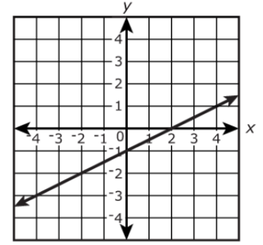

*The strategies, tasks and items included in the B1G-M are examples and should not be considered comprehensive.

### MA.8.F.1.3

Benchmark

MA.8.F.1.3 Analyze a real-world written description or graphical representation of a functional relationship between two quantities and identify where the function is increasing, decreasing or constant.

Benchmark Clarifications:

*Clarification 1:* Problem types are limited to continuous functions.

*Clarification 2:* Analysis includes writing a description of a graphical representation or sketching a graph from a written description.

Connecting Benchmarks/Horizontal Alignment

* MA.7.AR.4.2
* MA.8.AR.3.5
* MA.8.F.1.1, MA.8.F.1.2

Terms from the K-12 Glossary

* Function

Vertical Alignment

|  |  |
| --- | --- |
| **Previous Benchmarks**   * MA.6.GR.1 | **Next Benchmarks**   * MA. 912.F.1.5, MA.912.F.1.6 |

Purpose and Instructional Strategies

In previous courses, students plotted an identified points in all four quadrants of the coordinate plane. In grade 7 accelerated, students determine one of the key features of a proportional relationship, its constant of proportionality~~,~~ from its graph. Students also determine where a function is increasing or decreasing from its graph. In Algebra 1, students will compare key features of linear and nonlinear functions represented algebraically, graphically, in tables or written descriptions.

* Graphs can be described by using knowledge of functions, equations, and graphs. Students should be able to describe a graph in words and be able to draw a graph if given a qualitative description.
* When working with graphs, instruction includes students reasoning through asking questions such as:
* Does the graph represent a function?
* Does the graph show increase, decrease, both, or neither?
* Are there intervals of the domain in which the graph shows that the function increases, decreases, or stays constant?
* Does the graph represent a linear function?
* What is the (approximate) slope of a given interval within the graph?
* Students should be given opportunities to analyze graphs individually and with others (*MTR.4.1*).
* When sketching a graph based on a written description, students may use curved or straight lines to represent portions of increase or decrease based on the description.
* Problems where students are creating a graph are not expected to differentiate between linear and nonlinear functions to represent the written description.
  + For example, if the description has a rapid increase, a student can sketch a curve that increases rapidly or a straight line with a steep slope.
  + For example, in grade 8 students are not expected to recognize curves that represent exponential growth or decay.

Common Misconceptions or Errors

* Students may invert domain and range.
* Students may incorrectly describe increasing, decreasing or constant intervals using elements outside of the domain.

Strategies to Support Tiered Instruction

* Teacher reviews vocabulary and the difference between the terms. Once students understand that domain represents the input variable (independent variable), they can make sense of real-world problems to accurately identify domain and range.
* Teacher poses questions to encourage discourse to gain information about graphs. Students have the opportunity to discuss what they see and know from the graph and have the ability to make inferences about its description.
* Instruction includes providing real-world situations and having the students identify domain and range for the situation, giving justification as to their reasoning. Students can create their own situation and identify the domain and range for their situation.
* Teacher provides examples of different characteristics of graphs. Once students can identify basic attributes of the graphs, they can begin to reason through more specific questions about each graph.
  + For example, describing if the graph is increasing or decreasing, if the graph is a linear function, if the graph is a function, what is the slope of the graph (if linear), etc.
  + Use a card sort to match terms and examples as vocabulary is being introduced.
* Instruction includes creating an anchor chart with students describing increasing, decreasing, or constant graph.
* Teacher provides students opportunities to use the vocabulary during instruction and make connections.

Instructional Tasks

*Instructional Task 1 (MTR.6.1)*

The graph describes the number of bacteria in a culture over time.

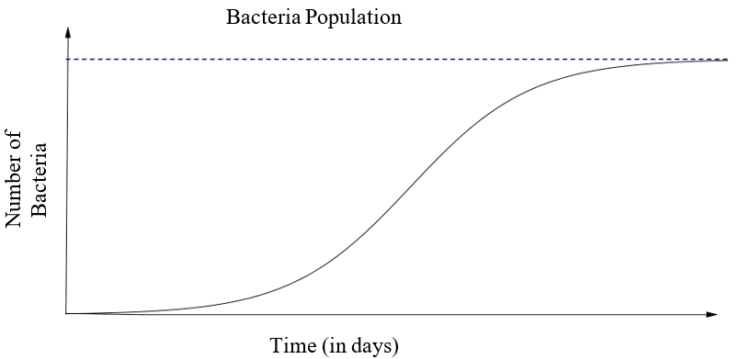

Describe in detail the relationship between the number of bacteria in the culture and time. Include where it is increasing, decreasing or remaining constant.

*Instructional Task 2 (MTR.6.1)*

Create a graph with a real-world scenario that includes increasing, decreasing and a portion

of the graph that remains constant. Explain the scenario and use the terms domain and range

to support the mathematics of the scenario.

Instructional Items

*Instructional Item 1*

Sketch a graph of the representation described below.

Madison is studying the growth of bacteria in food and learned it has four phases. Label the axes and show a graph of the four stages, assuming an initial bacterium count of 50.

*Phase 1*: No growth in the number of cells for the first hour.

*Phase 2*: Rapid growth in the number of bacteria for the next two hours.

*Phase 3*: Growth stops for one hour as nutrients are used up and waste accumulates.

*Phase 4*: All bacteria gradually die off during the final four-hour phase.

*The strategies, tasks and items included in the B1G-M are examples and should not be considered comprehensive.

# Geometric Reasoning

**MA.7.GR.1** *Solve problems involving two-dimensional figures, including circles.*

### MA.7.GR.1.3

Benchmark

MA.7.GR.1.3 Explore the proportional relationship between circumferences and diameters of circles. Apply a formula for the circumference of a circle to solve mathematical and real-world problems.

Benchmark Clarifications:

*Clarification 1:* Instruction includes the exploration and analysis of circular objects to examine the proportional relationship between circumference and diameter and arrive at an approximation of pi () as the constant of proportionality.

*Clarification 2:* Solutions may be represented in terms of pi () or approximately.

Connecting Benchmarks/Horizontal Alignment

* MA.7.AR.4.1, MA.7.AR.4.2
* MA.7.GR.2.1, MA.7.GR.2.2
* MA.8.GR.1.2

Terms from the K-12 Glossary

* Circumference
* Constant of Proportionality
* Diameter
* Pi ()
* Proportional Relationship

Vertical Alignment

|  |  |
| --- | --- |
| **Previous Benchmarks**   * MA.6.GR.1.3 * MA.7.NSO.2.1, MA.7.NSO.2.2, MA.7.NSO.2.3 | **Next Benchmarks**   * MA.912.GR.7.2, MA.912.GR.7.3 |

Purpose and Instructional Strategies

In previous courses, students solved problems involving the perimeter and area of two-dimensional figures. In grade 7 accelerated, students explore the proportional relationship between circumferences and diameters of circles and develop and learn a formula to solve circumference problems. Students will also learn and use the Pythagorean Theorem to find the distance between points in the coordinate plane. In Geometry, students will build on this foundation to solve problems involving the equation of a circle.

* Instruction includes opportunities for students to see circular or cylindrical household objects of different sizes. Students will measure the diameter and the circumference of the circle in each object to the nearest tenth of a centimeter to arrive at an approximation of pi () as the constant of proportionality. Students can record the values in a table and plot the points on a coordinate plane to discover the pattern that arises (*MTR.5.1*). Students should complete multiple trials to best support their conclusions using both radius and diameter.

Trial #1

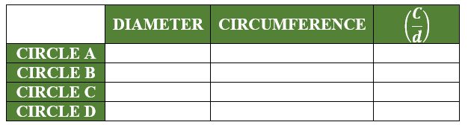

Trial #2

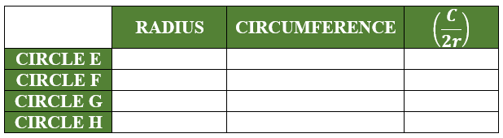

* Instruction emphasizes the relationship between radius and diameter so students will easily move between the equivalent forms of the circumference formula (*MTR.3.1*).
* Instruction includes student understanding that the circumference of a circle is the same as the perimeter of any other two-dimensional figure.
* Students are expected to know the approximations of pi .

Common Misconceptions or Errors

* Students may invert the terms radius and diameter. To address this misconception, review parts of a circle including radii, diameters and chords.

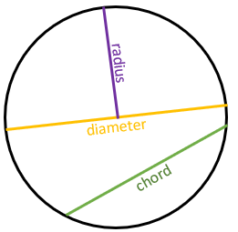

* Students may incorrectly believe pi is a variable, rather than a constant for every circle.
* Students may confuse circumference and area. To address this misconception, help students connect the circumference as the perimeter of a circle.

Strategies to Support Tiered Instruction

* Teacher provides opportunities for students to measure the radius and diameter of various circles and to explore and discuss the similarities and differences between radius and diameter.
* To clarify misconceptions between the relationship of diameter and circumference, instruction includes solving for the constant of proportionality between a given diameter and circumference of a circle and discussing the patterns that arise. Teacher provides opportunities for students to solve for the circumference of a given circle in terms of pi before replacing the value of pi with an approximation to determine the estimated circumference.
* Teacher co-creates a graphic organizer with students containing color-coded examples of circumference, area, diameter and radius.

Instructional Tasks

*Instructional Task 1 (MTR.4.1, MTR.7.1)*

Amy and Eunice are participating in a bike-a-thon this weekend. Amy has 29-inch road bike wheels and Eunice has 26-inch mountain bike wheels, where the bike wheel measurements are based on their diameter.

Part A. If they choose a bike-a-thon distance of 5 miles, whose bike wheels will need to do the fewest revolutions to reach the finish line?

Part B. How many more revolutions will the other bike need to make to reach the finish line? Explain your reasoning.

Instructional Items

*Instructional Item 1*

Determine the circumference of the following circles.

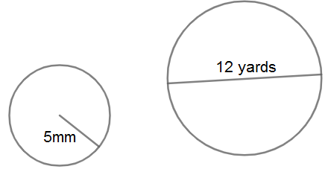

*Instructional Item 2*

When baking an apple pie, a strip of aluminum foil needs to be placed around the edge of the crust until the last 20 minutes of baking so that it will not burn. If using a -inch diameter pie pan, how long should the strip of foil be?

*The strategies, tasks and items included in the B1G-M are examples and should not be considered comprehensive.

### MA.7.GR.1.4

Benchmark

MA.7.GR.1.4 Explore and apply a formula to find the area of a circle to solve mathematical and real-world problems.

*Example:* If a 12-inch pizza is cut into 6 equal slices and Mikel ate 2 slices, how many square

inches of pizza did he eat?

Benchmark Clarifications:

*Clarification 1:* Instruction focuses on the connection between formulas for the area of a rectangle and the area of a circle.

*Clarification 2:* Problem types include finding areas of fractional parts of a circle.

*Clarification 3:* Solutions may be represented in terms of pi () or approximately.

Connecting Benchmarks/Horizontal Alignment

* MA.7.NSO.1.1
* MA.7.AR.4.1
* MA.7.GR.2.1, MA.7.GR.2.2, MA.7.GR.2.3
* MA.7.DP.1.4

Terms from the K-12 Glossary

* Area
* Circle
* Pi ()
* Rectangle

Vertical Alignment

|  |  |
| --- | --- |
| **Previous Benchmarks**   * This is the first introduction to circles outside of recognizing the shape in early elementary. | **Next Benchmarks**   * MA.912.GR.4.4, MA.912.GR.4.6 * MA.912.GR.6.4 |

Purpose and Instructional Strategies

In previous courses, students found the areas of rectangles and triangles, and solved problems involving the area of quadrilaterals and composite figures by decomposing them into triangles or rectangles. In grade 7 accelerated, students find the area of a circles and other geometric figures. In this and future courses, students build on their knowledge of area to find the surface areas and volumes of various three-dimensional figures.

* Students are not expected to memorize the formula for the area of a circle (*MTR.5.1*).
* Students are expected to know approximations of pi .
* Instruction includes students exploring circles. Provide students with a circle and have them highlight the circumference. Students will then fold the circle in half, half again, and half once more to allow them to cut it into 8 wedges of equal size. Then arrange the wedges so they alternately point up and down, forming a rectangle, with the highlighted circumference being the bases. Ensure students realize that the length of the rectangle is approximately equal to half the circumference, or , of the circle and the height of the rectangle is equal to the radius, , of the circle (*MTR.4.1*).
  + For more accuracy, provide a circle with lines drawn for students to cut the circle into 16 equal-sized wedges.

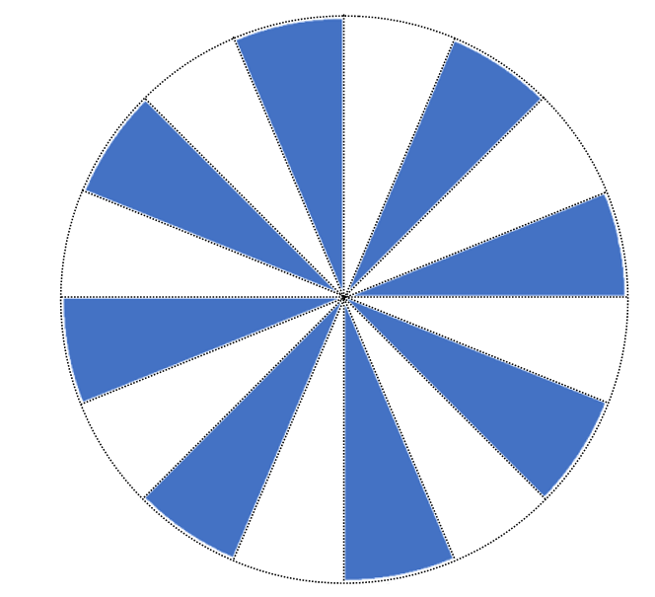 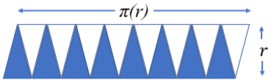

* Have students describe the area of a circle and explain if the area of a circle changes if it is cut up and rearranged.
* Ask questions to elicit student thinking (*MTR.4.1*) such as:
  + - What formula was used to find the area of a circle?
    - How is the formula for the area of a circle related to the formula for the area of a parallelogram?
* Instruction includes using circles on grid paper for students to estimate area before making precise calculations.
* The expectation of this benchmark is not to find the radius or diameter of a circle when given the area.

Common Misconceptions or Errors

* Students may invert the terms radius and diameter. To address this misconception, review parts of a circle including radii, diameters and chords.



* Students may incorrectly believe pi is a variable, rather than a constant that does not change from one circle to the next. Review the development of pi in MA.7.GR.1.3.
* Students may confuse circumference and area. To address this misconception, help students connect area of a circle to area of a rectangle.
* Students may incorrectly double the radius (finding diameter), rather than squaring it, when finding an area. To address this misconception, review exponent rules from MA.6.NSO.3.3 and MA.7.NSO.1.1.

Strategies to Support Tiered Instruction

* Teacher provides opportunities for students to measure the radius and diameter of various circles and to explore and discuss the similarities and differences between radius and diameter.
* Instruction includes modeling the area of a given circle in terms of pi before replacing the value of pi with an approximation to determine the estimated area.
* Teacher co-creates a graphic organizer with students containing color-coded examples of circumference, area, diameter and radius.
* Teacher co-creates a table to find the constant of proportionality between the diameter and circumference of a circle, allowing students to discover the pattern that represents pi ().
* Instruction includes modeling the differences between doubling and squaring a radius. Doubling a radius would be represented by multiplying the given length by , whereas squaring a number would be represented by the area of a square with the given radius.
  + For example, students can be given the table below to show how the left column doubles a length whereas the right column squares a length.

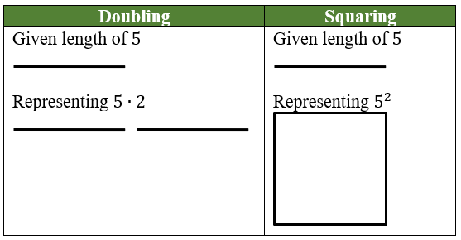

* Instruction includes rewriting the area formula for a circle in expanded form before evaluating.
  + For example, the formula for the area of a circle, , can be rewritten as .
* Teacher helps students connect area of a circle to area of a rectangle.

Instructional Tasks

*Instructional Task 1 (MTR.1.1)*

The figure below is composed of eight circles, with seven small circles inside one large circle containing them all. Neighboring circles only share one point, and two regions between the smaller circles have been shaded. Each small circle has a radius of 5 centimeters.

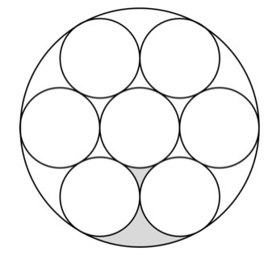

Part A. What is the area of the large circle?

Part B. What is the area of the shaded part of the figure?

*Instructional Task 2 (MTR.1.1)*

A garden, located inside of a circular walkway, is designed so people can walk around the garden to view the flower arrangements. The radius of the garden is 6 feet and the area of the entire walkway, including the garden is 100 square feet. What is the approximate width of the walkway?



Instructional Items

*Instructional Item 1*

What is the area of a circle whose radius is 4 centimeters? Round to the nearest hundredth.

*Instructional Item 2*

Find the exact area, in centimeters (cm), of each circle below.

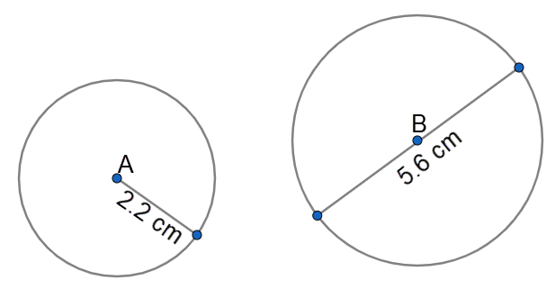

*Instructional Item 3*

Jamilah wants to add to her kitchen countertop, which is currently in the shape of a rectangle. If she adds the solid, semicircular piece shown in the picture below, determine how many square feet, to the nearest tenth of a foot, of marble Jamilah will need for the addition.

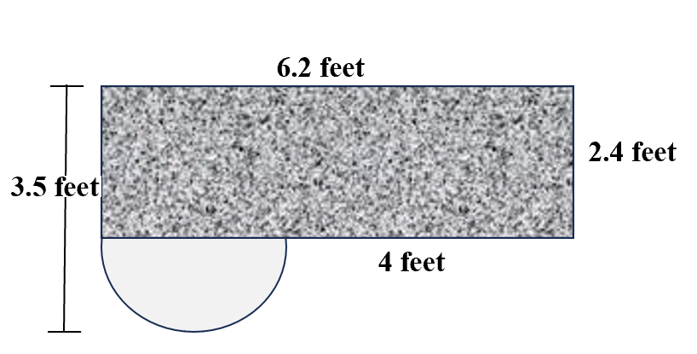

*The strategies, tasks and items included in the B1G-M are examples and should not be considered comprehensive.

### MA.7.GR.1.5

Benchmark

MA.7.GR.1.5 Solve mathematical and real-world problems involving dimensions and areas of geometric figures, including scale drawings and scale factors.

Benchmark Clarifications:

*Clarification 1:* Instruction focuses on seeing the scale factor as a constant of proportionality between corresponding lengths in the scale drawing and the original object.

*Clarification 2:* Instruction includes the understanding that if the scaling factor is , then the constant of proportionality between corresponding areas is .

*Clarification 3:* Problem types include finding the scale factor given a set of dimensions as well as finding dimensions when given a scale factor.

Connecting Benchmarks/Horizontal Alignment

* MA.7.AR.4.1, MA.7.AR.4.2, MA.7.AR.4.5
* MA.8.GR.2.2

Terms from the K-12 Glossary

* Area
* Constant of Proportionality
* Scale Factor

Vertical Alignment

|  |  |
| --- | --- |
| **Previous Benchmarks**   * MA.6.AR.3.5 * MA.6.GR.2.2 | **Next Benchmarks**   * MA.912.GR.4.3, MA.912.GR.4.4 |

Purpose and Instructional Strategies

In previous courses, students solved problems relating to the perimeter or area of a rectangle as well as the area of composite figures by decomposing them into triangles or rectangles. In grade 7 accelerated, students solve mathematical and real-world problems involving dimensions and areas of geometric figures, including scale drawings and scale factors. Students will also continue to work with scale factor and apply it to dilation. In future courses, students will determine how dilations affect the area of two-dimensional figures and the surface area or volume of three-dimensional figures.

* Scale drawings of geometric figures connect proportionality to geometry, which leads to future work in similarity and congruence. Initially, students explore scale drawings as an enlargement or reduction of one object to obtain a similar object by using a scale factor. Calculations begin with whole number measurements, progressing to rational numbers as students deepen their understanding.
* Instruction focuses on seeing the scale factor as a constant of proportionality between corresponding lengths in the scale drawing and the original object. Use manipulatives such as Geoboards/pegboards, dot paper, centimeter grid paper, etc. to enlarge and reduce shapes by simple scale factors *(MTR.2.1)*. Discuss whether multiplication or division may be used, reminding students that division can be represented by multiplication using its multiplicative inverse, and reinforcing that multiplication by a factor whose absolute value is between 0 and 1 will be a reduction in size.
  + Geoboards

green square has a scale factor of 3 from the original red square

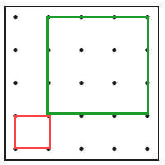

* + Dot or Grid Paper

green rectangle has a scale factor of 2 from the original red rectangle

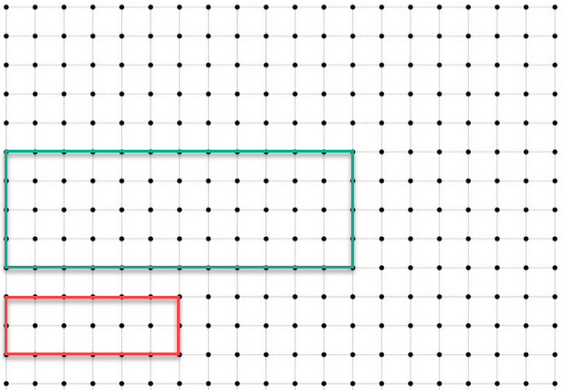

* Instruction includes having students construct scale drawings of the classroom, school, their homes and/or backyards or other familiar places where they can take measurements (*MTR.7.1*).
* Instruction includes the understanding that if the scaling factor is , then the constant of proportionality between corresponding areas is . Once students have become comfortable with scaling dimensions, extend their knowledge to solving problems with area. Provide several figures where students will determine new dimensions based on a given scale factor. Then have students calculate the original and new perimeters, as well as the original and new areas. Finally, students should analyze/compare the scale factors used in scaling the perimeters versus the scale factors used for area (*MTR.1.1, MTR.4.1*).
* Instruction supports flexibility in the variable used for the constant of proportionality.
* This benchmark directly connects to MA.8.GR.2.2 as students engage in problems involving a single dilation and scale factors.

Common Misconceptions or Errors

* Students may not understand how to read a map. To address this misconception, practice map reading skills, using familiar areas when possible.
* Students may incorrectly scale area in the same way they scale side length. To address this misconception, have students calculate areas of similar figures prior to determining the scale factor between the figures, then make comparisons. Interactive software can also be used to demonstrate.
* Students may incorrectly set up their proportions.
* Students may believe the scale factor is always greater than 1.
  + For example, students may respond the scale factor is 2 when it is .

Strategies to Support Tiered Instruction

* Teacher provides instruction utilizing different types of maps to familiarize students with how to read a map and the key features of a map. Teacher can choose maps that are familiar to students within their region.
* Instruction includes the use of geometric software to allow students to explore the area of an original figure relative to its scale and draw conclusions on the impact of the scale factor.
* Teacher co-creates a graphic organizer with students containing examples of applying a scale factor to a length or to an area.
* Teacher provides instruction focused on color-coding and labeling the different units when setting up a proportional relationship to ensure corresponding units are placed in corresponding positions within the proportion.
* Teacher has students calculate areas of figures where the side lengths of one figure is a constant multiple of the corresponding side lengths of the other figure prior to determining the scale factor between the figures. Students can then make comparisons between the areas of the figures. Interactive software can also be used to demonstrate.

Instructional Tasks

*Instructional Task 1 (MTR.7.1)*

Many supersonic jet aircraft in the past have used triangular wings called delta wings. Below is a scale drawing of the top of a delta wing.

Scale: 2 centimeters (cm) in the drawing equals 192 cm on the actual wing.

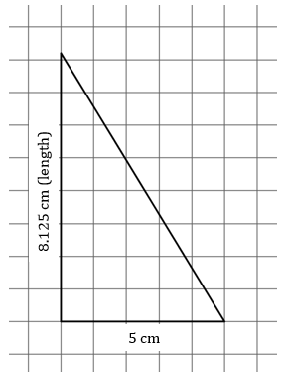

Part A. What is the length of the actual wing? Explain how you found your answer.

Part B. What is the area of the actual wing? Explain how you found your answer.

*Instructional Task 2 (MTR.7.1)*

Mariko has an 80:1 scale drawing of the floor plan of her house. On the floor plan, the dimensions of her rectangular living room are inches by inches. What is the area of her real living room in square feet?

Instructional Items

*Instructional Item 1*

The triangle below will be recreated using the scale factor that produced Figure 2 from Figure 1. What scale factor should be used?

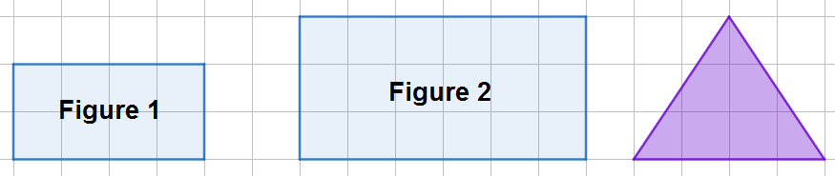

*Instructional Item 2*

Andrew needs to paint the side of his building white to prepare for a new mural that will be painted there. He measured the actual wall to be 26.25 feet long but he cannot easily measure the height. On his blueprints of the building, the wall measures 3.5 inches long and 4 inches tall. What is the actual area Andrew will need to paint?

*The strategies, tasks and items included in the B1G-M are examples and should not be considered comprehensive.

**MA.7.GR.2** *Solve problems involving three-dimensional figures, including right circular cylinders.*

### MA.7.GR.2.1

Benchmark

MA.7.GR.2.1 Given a mathematical or real-world context, find the surface area of a right circular cylinder using the figure’s net.

Benchmark Clarifications:

*Clarification 1:* Instruction focuses on representing a right circular cylinder with its net and on the connection between surface area of a figure and its net.

*Clarification 2:* Within this benchmark, the expectation is to find the surface area when given a net or when given a three-dimensional figure.

*Clarification 3:* Within this benchmark, the expectation is not to memorize the surface area formula for a right circular cylinder.

*Clarification 4:* Solutions may be represented in terms of pi () or approximately.

Connecting Benchmarks/Horizontal Alignment

* MA.7.GR.1.3
* MA.7.GR.2.3

Terms from the K-12 Glossary

* Cylinder (Circular)
* Net
* Pi (π)
* Surface Area

Vertical Alignment

|  |  |
| --- | --- |
| **Previous Benchmarks**   * MA.7.NSO.2.1, MA.7.NSO.2.2, MA.7.NSO.2.3 * MA.7.GR.1.2 * This is the first introduction to cylinders outside of recognizing the shape in early elementary. | **Next Benchmarks**   * MA.912.GR.4.6 |

Purpose and Instructional Strategies

In previous courses, students found the area of quadrilaterals and composite figures by decomposing them into triangles or rectangles, which developed into finding the surface area of right rectangular prisms and right rectangular pyramids using a figure’s net. In grade 7 accelerated, students find the area of a circle as well as the surface area of a right circular cylinder using the figure’s net. In future courses, students will solve mathematical and real-world problems involving the surface area of cylinders, pyramids, prisms, cones and spheres.

* Instruction includes problems that make connections to the understanding of a formula for the surface area of a right circular cylinder and its net (soup can and finding the area of the paper around the can). Show how different parts of the formula correspond to different parts of the net (*MTR.7.1*).
* Instruction allows students the opportunity to develop the formula for the surface area of a right circular cylinder.
  + For example, provide students cans of various sizes, paper, scissors, and tape (*MTR.2.1*). Ask students to cover the can completely without overlapping the paper and only using as little tape as possible. Ask students to explain their method if they feel it was successful in covering the can completely without overlapping any paper, until someone presents the idea of cutting two circles, taping them to the base and then one rectangle to cover the curved surface (*MTR.4.1*, *MTR.5.1*).
* Instruction allows students to use various nets for cylinders which they can cut out and form the three-dimensional figure or use virtual simulations which show the “unrolling” of the cylinder into its net (*MTR.2.1*).

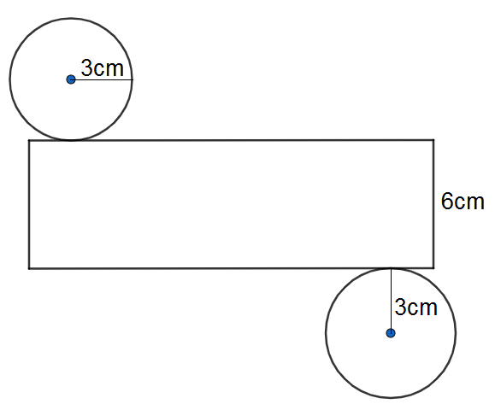

* Instruction focuses on recognizing the height of a cylinder as the perpendicular distance between the parallel (circular) bases.

Common Misconceptions or Errors

* Students often confuse the vocabulary base, length, height and “” (base area), when moving between two- and three-dimensional figures.
* Students may incorrectly invert the height and base of a cylinder when the cylinder is presented horizontally. To address this misconception, remind students that while a cylinder may lay on its side, the bases are the parallel circles.
* Students may incorrectly apply the formulas for area, surface area and volume. To address this misconception, use these concepts in context, or a manner in which they understand the meaning behind the terms to foster their conceptual development *(MTR.7.1)*.

Strategies to Support Tiered Instruction

* Instruction includes the use of geometric software to allow students to explore the difference between base, length, height and “” (base area).
* Instruction includes co-creating a graphic organizer to define the dimensions of rectangles, circles and right circular cylinders.
* Teacher provides students with an example of a three-dimensional figure in its original position then provides multiple orientations to discuss how the location of the figure’s base changes, but the dimensions of the figure do not change.
  + For example, two right circular cylinders are shown below with the same dimensions but in different orientations. A base is highlighted in each.



* Teacher instructs students to draw a visual of a three-dimensional figure and its dimensions in the context of a real-world problem.
* Instruction includes finding the exact area of a given circle in terms of pi before replacing the value of pi with an approximation to determine the estimated area.
* Instruction includes color-coding and labeling the dimensions of rectangles, circles and right circular cylinder.
* Teacher provides instruction using manipulatives or geometric software for students to understand the difference between the formulas for area, surface area and volume.
* Teacher encourages students to continue to use the parts of the net to calculate the surface area, rather than focusing on a formula.
* Teacher uses formulas for area, surface area and volume in context, or a manner in which students can understand the meaning behind the terms.
* Provide multiple orientations of cylinders, focusing on the height as the perpendicular distance between the parallel bases, continuing to break them down to their nets.

Instructional Tasks

*Instructional Task 1 (MTR.7.1)*

An ocean resort decided to build a large room in the shape of a cylinder to host events. The room is 34 feet in diameter with a height of 9 feet. They are going to paint the floor, wall and ceiling blue to make attendees feel like they are floating in the sky. Determine the surface area that needs to be painted.

*Instructional Task 2 (MTR.7.1)*

Reviews from several events in a blue room at a resort have come in and attendees are reporting feeling trapped in the enclosed room. The room is 34 feet in diameter with a height of 9 feet. The resort has decided to replace the solid wall with windows for a 360o view of the ocean and surrounding area.

Part A. How many square feet of windows will need to be ordered to do so?

Part B. If the resort decided to make a glass ceiling instead of replacing the curved wall,

how much glass would be needed?

Instructional Items

*Instructional Item 1*

Determine the surface area of the cylinder below. Round to the nearest tenth.

*Note: Figure is not drawn to scale.*

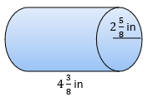

*Instructional Item 2*

Determine the surface area of the cylinder below. Write your answer as the exact surface area.



*Instructional Item 3*

Lyndon is making a nylon case for his new snare drum which measures 14 inches in diameter and is 6 inches deep. If the case fits snugly around the drum, how much nylon will Lyndon need?

*The strategies, tasks and items included in the B1G-M are examples and should not be considered comprehensive.

### MA.7.GR.2.2

Benchmark

MA.7.GR.2.2 Solve real-world problems involving surface area of right circular cylinders.

Benchmark Clarifications:

*Clarification 1:* Within this benchmark, the expectation is not to memorize the surface area formula for a right circular cylinder or to find radius as a missing dimension.

*Clarification 2:* Solutions may be represented in terms of pi () or approximately.

Connecting Benchmarks/Horizontal Alignment

* MA.7.NSO.1.1
* MA.7.AR.2.2
* MA.7.AR.4.4
* MA.7.GR.1.3, MA.7.GR.1.4
* MA.7.GR.2.3

Terms from the K-12 Glossary

* Cylinder (Circular)
* Pi (π)
* Surface Area

Vertical Alignment

|  |  |
| --- | --- |
| **Previous Benchmarks**   * MA.7.NSO.2.1, MA.7.NSO.2.2, MA.7.NSO.2.3 * MA.7.GR.1.2 * This is the first introduction to cylinders outside of recognizing the shape in early elementary. | **Next Benchmarks**   * MA.912.GR.4.6 |

Purpose and Instructional Strategies

In previous courses, students found the area of quadrilaterals and composite figures by decomposing them into triangles or rectangles, which developed into finding the surface area of right rectangular prisms and right rectangular pyramids using a figure’s net. In grade 7 accelerated, students find the surface area of a right circular cylinder using the figure’s net and build that into solving real-world problems involving surface area of right circular cylinders. In future courses, students will solve mathematical and real-world problems involving the surface area of cylinders, pyramids, prisms, cones and spheres.

* Instruction includes finding the height or the circumference when given the surface area of a right circular cylinder, but students will not be expected to find the radius as a missing dimension (*MTR.3.1*).

Common Misconceptions or Errors

* Students often confuse the vocabulary base, length, height and “B” (base area), when moving between two- and three-dimensional figures. To address this misconception, continue to use the parts of the net to calculate the surface area, rather than focusing on the formula.
* Students may incorrectly invert the height and base of a cylinder when the cylinder is presented horizontally. To address this misconception, remind students that while a cylinder may lay on its side, the bases are the parallel circles.
* Students may incorrectly apply the formulas for area, surface area and volume. To address this misconception, use these concepts in context, or a manner in which they understand the meaning behind the terms to foster their conceptual development *(MTR.7.1)*.

Strategies to Support Tiered Instruction

* Instruction includes the use of geometric software to allow students to explore the difference between base, length, height and “” (base area).
* Teacher creates and posts an anchor chart with visual representations of a right circular cylinder to assist in correct academic vocabulary when solving real-world problems.
* Teacher provides students with an example of a three-dimensional figure in its original position then provides multiple orientations to discuss how the location of the figure’s base changes, but the dimensions of the figure do not change.
  + For example, two right circular cylinders are shown below with the same dimensions but in different orientations. The base is highlighted in each.



* Teacher co-creates a visual of a three-dimensional figure and its dimensions in the context of a real-world problem.
* Instruction includes opportunities for students to solve for the surface area of a given right circular cylinder in terms of pi before replacing the value of pi with an approximation to determine the estimated surface area.
* Instruction includes co-creating a graphic organizer of a right circular cylinder and color-coding and labeling the dimensions.
* Teacher provides instruction focused on manipulatives or geometric software for students to develop understanding of the difference between the formulas for area, surface area and volume.
* Teacher provides opportunities for students to comprehend the context or situation by engaging in questions (laminating these questions on a printed card for students to utilize as a resource in and out of the classroom would be helpful).
  + What do you know from the problem?
  + What is the problem asking you to find?
  + Can you create a visual model to help you understand or see patterns in your problem?
* Teacher encourages students to continue to use the parts of the net to calculate the surface area, rather than focusing on the formula.
* Provide multiple orientations of cylinders, focusing on the height as the perpendicular distance between the parallel bases, continuing to break them down to their nets.

Instructional Tasks

*Instructional Task 1 (MTR.4.1)*

The Fine Arts Club will be making and selling a soda can snuggie for a fundraiser. They researched the dimensions of a standard soda can to be 4.83 inches high with a diameter of 2.13 inches across the top and 2.6 inches at the widest part of the can. A soda snuggie that will keep the soda cold will require an insulated layer, a liner and a decorative outer fabric.

Part A. Provide a design the Fine Arts Club could use to make their soda snuggie. How much of each material will be needed for each soda snuggie?



Part B. Compare your design with a partner (or group). What are the similarities? What changes (if any) would you make to your design based on the ideas of others?

Part C. Various companies have changed the size of cans for specialty drinks such as coffee and flavored water drinks. Research other size cans and compare the surface area of the various cans to the soda can. Determine how much material would be needed for each. Compare potential costs for the Fine Arts Club if they wanted to offer any of these additional sized snuggie options.

Instructional Items

*Instructional Item 1*

A cosmetics company is selling a new line of lipstick and needs to determine how much plastic is needed to wrap each cylindrical tube. If the lipstick tube is 12.1 millimeters (mm) in diameter with a length of 72 mm, how many mm2 of plastic is needed for one tube? How much will be needed for a box of 24?

*Instructional Item 2*

Melanie is buying a candle for a gift. She has 80.07 in2 of wrapping paper and all of the candles she is looking at have a radius of 1.5 in. What height candle can Melanie buy if she uses all of the wrapping paper she has?

*The strategies, tasks and items included in the B1G-M are examples and should not be considered comprehensive.

### MA.7.GR.2.3

Benchmark

MA.7.GR.2.3 Solve mathematical and real-world problems involving volume of right circular cylinders.

Benchmark Clarifications:

*Clarification 1:* Within this benchmark, the expectation is not to memorize the volume formula for a right circular cylinder or to find radius as a missing dimension.

*Clarification 2:* Solutions may be represented in terms of pi () or approximately.

Connecting Benchmarks/Horizontal Alignment

* MA.7.NSO.1.1
* MA.7.AR.2.2
* MA.7.AR.4.5
* MA.7.GR.1.4
* MA.7.GR.2.1, MA.7.GR.2.2

Terms from the K-12 Glossary

* Cylinder (Circular)
* Pi (π)
* Volume

Vertical Alignment

|  |  |
| --- | --- |
| **Previous Benchmarks**   * MA.6.GR.2.3 * MA.7.NSO.2.1, MA.7.NSO.2.2, MA.7.NSO.2.3 | **Next Benchmarks**   * MA.912.GR.4.5 |

Purpose and Instructional Strategies

In previous courses, students solved problems involving volumes with a focus of right rectangular prisms. In grade 7 accelerated, students solve problems involving the volumes of right circular cylinders. In Geometry, students will solve problems involving the volume of cylinders, pyramids, prisms, cones and spheres.

* Instruction builds on students’ knowledge of finding the volume of a rectangular prism, which also includes the area of the base multiplied by the height.
* Instruction encourages students to make conjectures about how to calculate the volume of a right circular cylinder. Students are provided the radius and height of several cylinders to verify or revise their conjecture (*MTR.6.1*).
* Instruction includes physical or virtual representations for the volume of a right circular cylinder (*MTR.2.1*).
  + For example, stack quarters one at a time to show repeated addition (the height) on the area of the base (the first quarter used).
* Instruction focuses on real-world situations to reinforce conceptual understanding of volume versus surface area (*MTR.7.1*).

Common Misconceptions or Errors

* Students often confuse the vocabulary base, length, height and “B” (base area), when moving between two- and three-dimensional figures. To address this misconception, continue to use the parts of the net to calculate the surface area, rather than focusing on the formula.
* Students may incorrectly believe that whatever is lying flat is the base of the figure. To address this misconception, remind students that while a cylinder may lay on its side, the bases are the parallel circles with the height being the perpendicular distance between them. Provide multiple orientations of objects and continue to break them down to their nets.
* Students may incorrectly apply the formulas for area, surface area and volume. To address this misconception, use these concepts in context, or a manner in which they understand the meaning behind the terms to foster their conceptual development (MTR.7.1).

Students may incorrectly invert the height and base of a cylinder when the cylinder is presented horizontally.

Strategies to Support Tiered Instruction

* Instruction includes the use of geometric software to allow students to explore the difference between base, length, height and “” (base area).
* Teacher creates and posts an anchor chart with visual representations of a right circular cylinder to assist in correct academic vocabulary when solving real-world problems.
* Teacher provides students with an example of a three-dimensional figure in its original position then provides multiple orientations to discuss how the location of the figure’s base changes, but the dimensions of the figure do not change.
* For example, two right circular cylinders are shown below with the same dimensions but in different orientations. The base is highlighted in each.



* Teacher co-creates a visual of a three-dimensional figure and its dimensions in the context of a real-world problem, and color-coding and labeling the dimensions.
* Instruction includes opportunities for students to solve for the volume of a given right circular cylinder in terms of pi before replacing the value of pi with an approximation to determine the estimated volume.
* Teacher provides instruction focused on manipulatives or geometric software for students to develop understanding of the difference between the formulas for area, surface area and volume.
* Teacher provides opportunities for students to comprehend the context or situation by engaging in questions (laminating these questions on a printed card for students to utilize as a resource in and out of the classroom would be helpful).
  + What do you know from the problem?
  + What is the problem asking you to find?
  + Can you create a visual model to help you understand or see patterns in your problem?
* Teacher encourages students to continue to use the parts of the net to calculate the surface area, rather than focusing on the formula.
* Provide multiple orientations of cylinders, focusing on the height as the perpendicular distance between the parallel bases, continuing to break them down to their nets.

Instructional Tasks

*Instructional Task 1 (MTR.1.1)*

Coffee2Go wants to build a record-breaking giant coffee cup for a promotional celebration at a convention for coffee drinkers. In 2020, the Guinness Book of World Records reported that the World’s Largest Cup of Coffee contained 2,010 gallons of fresh-brewed coffee brewed.

Part A. What questions would need to be answered to approach this problem? Do you have all the information you need to solve the problem? Why or why not?

Part B. The Guinness Book of World Records, in 2020, documented the Largest Coffee Cup with a height of 8 feet and a diameter of 8 feet. How many cubic feet of coffee can be held in the World’s Largest Coffee Cup?

Part C. There are approximately 1.25 gallons of coffee in a cubic foot. If Coffee2Go has a goal of creating a coffee cup that holds 2,410 gallons of coffee, what could be the height and diameter of the coffee cup if they are the same size?

*Instructional Task 2 (MTR.7.1)*

Karim is setting up an inflatable pool in the yard for the little kids to play. The pool measures feet across and 16 inches deep. What is the volume of water needed to fill the pool 2 inches from the top? Justify your solution.

Instructional Items

*Instructional Item 1*

What is the height of a cylinder, with a radius of 3.4 meters (m), whose volume is 198 m3? Round to the nearest hundredth.

*Instructional Item 2*

Determine the exact volume of each of the following cylinders.

*A blue cylinder with a height of 4 and three-eighths inches and a radii of 2 and five-eighths inches.
*

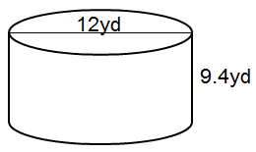

*Instructional Item 3*

A candle mold has 24π in3 of space in which wax can be poured to make a candle. If the radius of the mold is 2 inches (in), what is its height?

*The strategies, tasks and items included in the B1G-M are examples and should not be considered comprehensive.

**MA.8.GR.1** *Develop an understanding of the Pythagorean Theorem and angle relationships involving triangles.*

### MA.8.GR.1.1

Benchmark

MA.8.GR.1.1 Apply the Pythagorean Theorem to solve mathematical and real-world problems involving unknown side lengths in right triangles.

Benchmark Clarifications:

*Clarification 1:* Instruction includes exploring right triangles with natural-number side lengths to illustrate the Pythagorean Theorem.

*Clarification 2:* Within this benchmark, the expectation is to memorize the Pythagorean Theorem.

*Clarification 3:* Radicands are limited to whole numbers up to 225.

Connecting Benchmarks/Horizontal Alignment

* MA.8.NSO.1.1, MA.8.NSO.1.2, MA.8.NSO.1.7
* MA.8.AR.2.3

Terms from the K-12 Glossary

* Pythagorean Theorem
* Converse of Pythagorean Theorem
* Hypotenuse

Vertical Alignment

|  |  |
| --- | --- |
| **Previous Benchmarks**   * MA.6.GR.2.1 | **Next Benchmarks**   * MA.912.GR. 1.3 * MA.912.GR.7.2 * MA.912.T.1.2 |

Purpose and Instructional Strategies

In previous courses, students worked with right triangles, with a focus on how the area of a right triangle is determined by its side lengths. In grade 7 accelerated, students use the Pythagorean Theorem to determine side lengths of right triangles. In Geometry, students will use trigonometry to continue their work with right triangles, and they extend the understanding of the Pythagorean Theorem to create the equation of a circle.

* While it is not the expectation of this benchmark for students to prove the Pythagorean Theorem, instruction includes building understanding of the Pythagorean Theorem () by proving it in various ways. Many of them connect the side lengths of right triangles to the areas of associated squares.
  + Instruction includes using exploration activities that allow students to see how to use areas of squares to find missing sides. Students can use grid paper to draw right triangles from given measures and represent and compute the areas of the squares on each side. Below is an example of what students can visualize to understand the conceptual understanding within the Pythagorean Theorem.

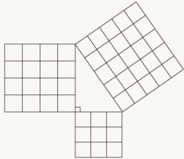

* + Data can be recorded in a chart such as the one below, allowing for students to conjecture about the relationship among the areas of squares and side lengths of right triangles.

|  |  |  |  |  |  |
| --- | --- | --- | --- | --- | --- |
| **Triangle** | **Measure of Leg 1** | **Measure of Leg 2** | **Area of Square on Leg 1** | **Area of Square on Leg 2** | **Area of Square on Hypotenuse** |
| 1 |  |  |  |  |  |
| 2 |  |  |  |  |  |

* When introducing the Pythagorean Theorem, some students may not be able to visualize the side lengths and the connection to the values of , and . Using colors to color code the sides and hypotenuse will allow students to see the connection and identify with the , , and used to represent the sides.
* While solving real-world problems, students should be encouraged to draw diagrams where they can see the right triangles being used. Students will need to understand the ideas within the Triangle Inequality Theorem to help differentiate between the legs and the hypotenuse of a right triangle.

Common Misconceptions or Errors

* Students may make errors in calculations when using the Pythagorean Theorem and finding square roots. To support students, include time for reviewing the process for solving for variables and finding square roots prior to instruction on this benchmark.
* Students may not be able to spatially visualize triangles within the real-world problems. To address this misconception, instruction includes models for these problems with triangles and drawings to help students orient the ideas within the tasks.
* Students may misidentify the side lengths and hypotenuse when connecting to the formula of . To support students as they are developing the conceptual understanding of this benchmark, using the idea of as a transition to using the formula.

Strategies to Support Tiered Instruction

* Instruction includes modeling the differences between doubling and squaring a radius. Doubling a radius would be represented by multiplying the given length, whereas squaring a number would be represented by the area of a square with the given radius.
  + For example, students can be given the table below to show how the left column doubles a length whereas the right column squares a length.

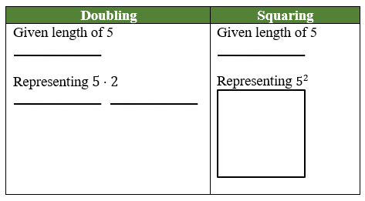

* Teacher co-creates and posts an anchor chart for calculating the Pythagorean Theorem with visuals focused on solving for the variable and finding the square root.
* Instruction includes providing students with the right triangle as a visual in the context of a real-world problem. Teacher provides instruction using the information from the real-world problem to label the visual representation before solving.
* Instruction includes co-creating a graphic organizer for the square root of perfect squares from 0 to 225 to provide students with the opportunity to determine benchmark numbers for non-perfect squares.
* Instruction includes color-coding and labeling a right triangle or a rectangular prism to provide a visual representation of variables, side lengths and hypotenuse.

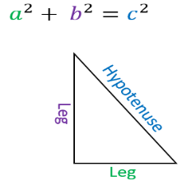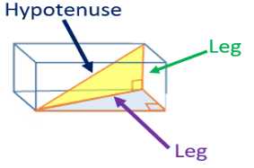

* Instruction includes co-creating a model with students and completing a graphic organizer to make the connection between the side lengths of right triangles to the area of the associated square.
* Instruction includes including time for reviewing solving for variables and finding square roots prior to instruction on this benchmark.
* Instruction includes models for problems with triangles and drawings to help students orient the ideas within the tasks.
* Instruction includes the use of the idea of as a transition to using the formula to assist in developing a conceptual understanding of the benchmark for students who incorrectly identify the side lengths and hypotenuse when connecting the formula of (laminating formulas on a printed card for students to utilize as a resource in and out of the classroom would be helpful).

Instructional Tasks

*Instructional Task 1 (MTR.2.1, MTR.4.1, MTR.7.1)*

The bases on a baseball diamond are 90 feet apart on a standard baseball field.

Part A. Draw a model of the baseball diamond.

Part B. What is the distance, in feet, for the catcher to throw from home plate to second base?

Part C. What is the distance, in feet, from first base to third base?

*Instructional Task 2 (MTR.1.1)*

You are wrapping a gift for your teacher’s birthday. It is a very long and skinny pencil. You want to wrap it in a box so that your teacher cannot tell what shape it is. Your friend has a shoe box that measures 10 inches by 7 inches by 5 inches.

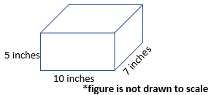

Part A. What questions would still need to be answered to approach this problem? Do you need all the measurements provided in the problem? Explain your answer.

Part B. If the pencil measures 13 inches long, will it fit in the shoe box with the lid closed? Explain your answer.

Part C. What are the possible dimensions of a box that can just barely fit a pencil measuring 9 inches long?

Instructional Items

*Instructional Item 1*

The bottom of a ladder must be placed 3 feet from a wall. The ladder is 12 feet long. How far above the ground does the ladder touch the wall? Round your answer to the nearest tenth.

*Instructional Item 2*

Using the figure below, find the value of the length of side in meters.

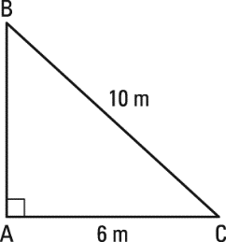

*Enrichment Task 1*

If a right triangle’s legs are both the same length, , and the hypotenuse of the triangle is 20 feet, what is the value of , in feet? Round your answer to the nearest tenth.

*The strategies, tasks and items included in the B1G-M are examples and should not be considered comprehensive.

### MA.8.GR.1.2

Benchmark

MA.8.GR.1.2 Apply the Pythagorean Theorem to solve mathematical and real-world problems involving the distance between two points in a coordinate plane.

Example: The distance between and can be found by creating a right triangle with the vertex of the right angle at the point . This gives a height of the right triangle as 1 unit and a base of 2 units. Then using the Pythagorean Theorem the distance can be determined from the equation , which is equivalent to . So, the distance is units.

Benchmark Clarifications:

*Clarification 1:* Instruction includes making connections between distance on the coordinate plane and right triangles.

*Clarification 2:* Within this benchmark, the expectation is to memorize the Pythagorean Theorem. It is not the expectation to use the distance formula.

*Clarification 3:* Radicands are limited to whole numbers up to 225.

Connecting Benchmarks/Horizontal Alignment

* MA.8.NSO.1.1, MA.8.NSO.1.2, MA.8.NSO.1.7
* MA.8.AR.2.3

Terms from the K-12 Glossary

* Coordinate
* Coordinate Plane

Vertical Alignment

|  |  |
| --- | --- |
| **Previous Benchmarks**   * MA.6.GR.1.2, MA.6.GR.1.3 | **Next Benchmarks**   * MA.912.GR.3.2, MA.912.GR.3.3, MA.912.GR.3.4 * MA.912.GR.7.2 * MA.912.T.1.2 |

Purpose and Instructional Strategies

In previous courses, students used their understanding of the coordinate plane to plot rational-number ordered pairs in all four quadrants and on both axes, and they found the distances between ordered pairs with the same -coordinate or the same -coordinate represented on the coordinate plane. In grade 7 accelerated, students find the distance between two points using the Pythagorean Theorem. In Geometry, students will use coordinate geometry to classify or justify definitions, properties and theorems involving circles, triangles or quadrilaterals. Additionally, students will extend this understanding to using coordinate geometry and trigonometry to solve mathematical and real-world problems involving lines, circles, triangles, quadrilaterals and finding the perimeter or area of polygons.

* Instruction includes creating a right triangle from two given points and then using the Pythagorean Theorem to find the distance between the two given points. This work can be started by using Geoboards to see the triangle that is formed within the coordinate plane. Students can show how to make a right triangle using vertical and horizontal lines. From there they can build the area models of the Pythagorean Theorem to support understanding.

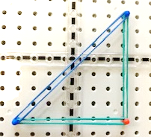

* Students should be given multiple opportunities to see the importance of using the coordinate plane to find the distance between two points.
* Instruction includes providing students with a structure to support the organization of their work since using the Pythagorean Theorem may require multiple steps. Provide students with resources, including the coordinate plane and graph paper, as a way to plan out their work.

Common Misconceptions or Errors

* Students may have the misconception that the Pythagorean Theorem will apply to any triangle.
* Students may invert the - and -value of the point.
* When finding distances that cross over an axis students may incorrectly use operations with integers.
  + For example, if given the points and , students may calculate the distance as 1 unit instead of 5 units.

Strategies to Support Tiered Instruction

* Instruction includes the use of geometric software to explore the Pythagorean Theorem on obtuse, acute and right triangles.
* Instruction includes students adding the absolute value of two *x*-coordinates or two *y*-coordinates when the given points cross over an axis.
  + For example, if the given points are and students will add the absolute value of and .
* Teacher provides opportunities for students to comprehend the context or situation by engaging in questions.
  + What do you know from the problem?
  + What is the problem asking you to find?
  + Can you create a visual model to help you understand or see patterns in your problem?
* Instruction includes labeling the - and -value of a coordinate point before graphing to reinforce the process of graphing - and -values.
* Instruction includes laying tracing paper on top of a coordinate plane, tracing the points, drawing a number line through the two points, and counting the space between the points to find the distance.
* Teacher co-creates an anchor chart while students create a similar own graphic organizer to include key features of a coordinate plane. Features include the -axis, -axis, origin, quadrants, numbered scales and an ordered pair.
* Instruction includes the use of a three-read strategy. Students read the problem three times, each with a different purpose (laminating these questions on a printed card for students to utilize as a resource in and out of the classroom would be helpful).
* First, read the problem with the purpose of answering the question: What is the problem, context, or story about?
* Second, read the problem with the purpose of answering the question: What are we trying to find out?
* Third, read the problem with the purpose of answering the question: What information is important in the problem?

Instructional Tasks

*Instructional Task 1 (MTR.2.1, MTR.7.1)*

Pineridge Middle School was given a grant from Home Helper Depot to create a triangular garden along a wall of the cafeteria for fresh vegetables. The length of the hypotenuse and the sides are being determined to see if it will fit in the space. On the model for the garden, the designer started by plotting the points and on a coordinate plane and connected the points with a line. She needs to complete the triangular model and determine all three side lengths.

Part A. Using a coordinate grid, complete the designer's drawing.

Part B. Calculate the side lengths of the triangular garden on the model.

Part C. What would be appropriate lengths for a triangular garden if the length of one side of the building is 20 feet? Use your model to help determine the side lengths.

Instructional Items

*Instructional Item 1*

On a coordinate plane, plot the points and . Using the Pythagorean Theorem, determine the distance between the two points.

*Instructional Item 2*

Using the Pythagorean Theorem, determine the distance from point to the origin.

*The strategies, tasks and items included in the B1G-M are examples and should not be considered comprehensive.

### MA.8.GR.1.3

Benchmark

MA.8.GR.1.3 Use the Triangle Inequality Theorem to determine if a triangle can be formed from a given set of sides. Use the converse of the Pythagorean Theorem to determine if a right triangle can be formed from a given set of sides.

Connecting Benchmarks/Horizontal Alignment

* MA.8.NSO.1.7
* MA.8.AR.2.2

Terms from the K-12 Glossary

* Converse of the Pythagorean Theorem

Vertical Alignment

|  |  |
| --- | --- |
| **Previous Benchmarks**   * MA.5.GR.1.1 | **Next Benchmarks**   * MA. 912.GR.1.3 |

Purpose and Instructional Strategies

In previous courses, students classified triangles based on their angle measures and their side lengths. In grade 7 accelerated, students use the Triangle Inequality Theorem and Pythagorean Theorem to determine whether triangles, or right triangles, can be formed from a given set of sides. In Geometry, students will extend this understanding to prove relationships and theorems about triangles.

* Instruction includes modeling and drawing triangles with different side lengths to determine if they can make a triangle to help in conceptual understanding. Students can physically construct triangles with manipulatives such as straws, sticks, string or geometry apps prior to using rulers (*MTR.2.1*).
* Exploration should involve giving students three side measures to determine if a triangle can be made. Through discussion of their exploration results, students should conclude that triangles cannot be formed by any three arbitrary side measures.
  + For example, if students are given 4, 5 and 10, they should conclude that it does not form a triangle.
  + Through charting, students should realize that for a triangle to result, the sum of any two side lengths must be greater than the third side length. This can be charted in a table like the one below.

|  |  |  |  |  |
| --- | --- | --- | --- | --- |
| **Length 1 (smallest)** | **Length 2**  **(middle)** | **Length 3 (largest)** | **Triangle?** |  |
|  |  |  |  |  |

* Once students understand the Triangle Inequality Theorem, they can apply their knowledge to the converse of the Pythagorean Theorem. In work with the previous benchmark, students verify using a model that the sum of the squares of the legs is equal to the square of the hypotenuse in a right triangle. Students should also understand that if the sum of the squares of the 2 smaller legs of a triangle is equal to the square of the third leg, then the triangle is a right triangle.

Common Misconceptions or Errors

* Students may incorrectly think that the Triangle Inequality Theorem only applies to right triangles due to the work with the Pythagorean Theorem. Discussion of the two theorems and examples will help with this misconception.
* Students may incorrectly believe endpoints of the sides of the triangle do not have to meet at a vertex.
  + For example, students will attempt to make a triangle such as the example below.



Strategies to Support Tiered Instruction

* Instruction includes co-creating a graphic organizer to highlight key differences and use of the Pythagorean Theorem and the Triangle Inequality Theorem.
* Instruction includes the use of manipulatives, such as angle legs and geometric software, to allow for students to explore the similarities and differences between the Pythagorean Theorem and the Triangle Inequality Theorem.
* Teacher provides instruction on the definition of a triangle and allows for students to explore various side lengths using geometric software or manipulatives to determine if the lengths form a triangle.

Instructional Tasks

*Instructional Task 1 (MTR.6.1, MTR.7.1)*

The following side lengths, in meters, were given to a carpenter to build a front porch with a triangular design. The carpenter needs to determine which set of lengths will make a triangle to be able to use it in his design.

Option 1: Side lengths: 4, 4, 8

Option 2: Side lengths: 6, 8, 10

Option 3: Side lengths: 6, 6, 13

Option 4: Side lengths: 5, 6, 10

Part A. Which of the options would create a triangle for his design?

Part B. The homeowner would like the porch to be in the shape of a right triangle. Will the carpenter be able to use any of the given options?

Part C. For any option that does not form a triangle, what side length could be changed to form a triangle? Explain your answer.

Instructional Items

*Instructional Item 1*

Can the side lengths of a triangle be 2, 4 and 8? Justify your answer.

*Instructional Item 2*

John drew a triangle with side lengths of 5, 12 and 13. His friend, Bryan, looked at it and asked John if it is a right triangle. John’s response was yes. Explain or show how John can prove to Bryan that the triangle is a right triangle.

*The strategies, tasks and items included in the B1G-M are examples and should not be considered comprehensive.

### MA.8.GR.1.4

Benchmark

MA.8.GR.1.4 Solve mathematical problems involving the relationships between supplementary, complementary, vertical or adjacent angles.

Connecting Benchmarks/Horizontal Alignment

* MA.8.AR.2.1

Terms from the K-12 Glossary

* Angle
* Complementary
* Supplementary
* Vertical

Vertical Alignment

|  |  |
| --- | --- |
| **Previous Benchmarks**   * MA.4.GR.1.1, MA.4.GR.1.2, MA.4.GR.1.3 * MA.5.GR.1.1 | **Next Benchmarks**   * MA.912.GR.1.1 |

Purpose and Instructional Strategies

In previous courses, students were introduced to acute, right, obtuse, straight reflex angles and solved real-world and mathematical problems involving angle measures. They also used angles to classify triangles and quadrilaterals. In grade 7 accelerated, students solve problems involving supplementary, complementary, vertical and adjacent angles. In Geometry, students will extend the learning from this benchmark to prove relationships and theorems involving lines and angles.

* This benchmark is foundational to help develop the understanding of angles and connections related to parallel lines cut by a transversal.
* For students to learn relationships between angles, it is important to provide an opportunity to connect complementary and supplementary angles to work with triangles. Students should draw or be given a right triangle to explore rearranging the angles to show both the 90 and 180 degrees that can be created for a right angle and a straight line, respectively.
* To support the concept of adjacent angles, students should have examples and non-examples to write their own definition and revise it based on critiques from others (*MTR.4.1*). Students should trace each angle with different colors to ensure that there isn’t overlap but has a common side.

|  |  |  |
| --- | --- | --- |
| **Criteria** | **Example** | **Non-Example** |
| pair of angles | An example of a pair of angles: Angle ABC and Angle CBD. | A non-example of a pair of angles: Angle ABC, Angle CBD, and Angle DBE. |
| common vertex | An example of a pair of angles with a common vertex: Angle ABC and Angle CBD. | A non-example of a pair of angles with a common vertex: Angle ACB and Angle CBD which do not share a vertex. |
| common side | An example of a pair of angles which share a common side: Angle ABC and Angle CBD. | A non-example of a pair of angles with a common side: Angle ABC and Angle EBD which do not share a common side but share a common vertex. |
| do not overlap | An example of a pair of angles which do not overlap: Angle ABC and Angle CBE with a common vertex and common side. | A non-example of a pair of angles which do not overlap: Angle ABC and Angle ABE with a common side of BA. |

* When discussing vertical angles, use a model of two strips of paper with a small brad at the center where they cross. Then, moving the paper to create different-sized angles, measure each angle to show the vertical angle measures to lead to understanding that the vertical angles will have the same measure.
* Vertical angles can be explored using the same activity as adjacent angles with examples and non-examples. The criteria could include the following:
  + Formed from exactly 2 straight intersecting lines
  + Pair of angles
  + Non-adjacent
  + Common vertex
* Student reasoning can be supported by making statements such as “always true, sometimes true, never true.”
  + For example, a linear pair of angles (a type of adjacent angles) are always supplementary because they form a straight line.
* Once conceptual understanding and definitions are built, introduce algebraic concepts for students to write and solve equations using facts about the angle relationships. Students should be able to generate equations written in different forms.
  + For example, if students are provided the figure below, they can generate multiple equivalent equations to represent their thinking. For this figure, three possible equations are:

|  |  |
| --- | --- |
|  | A straight angle comprised of 2 supplementary angles with angle ABC measuring 147 degrees and angle CBD measuring (2x + 3) degrees. |

Common Misconceptions or Errors

* Students may invert the definition of complementary and supplementary.

Strategies to Support Tiered Instruction

* Instruction includes co-creating a graphic organizer with students to measure, label and record the angle measurement of two intersecting lines. The teacher facilitates discussion and documents the relationships between different angle pairs.
* Instruction includes erasing or covering part of a line for students to visually see the supplementary angles within two intersecting lines.

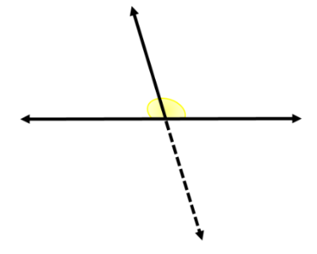

* Instruction includes co-creating a graphic organizer identifying the relationships between supplementary, complementary, vertical, and adjacent angles. Include a strategy for solving problems involving each type of angle pair, such as setting vertical angle measures equal.

Instructional Tasks

*Instructional Task 1 (MTR.1.1, MTR.2.1)*

Complete the table below that includes the following types of angles:

|  |  |  |
| --- | --- | --- |
| **Angle Pairs** | **Draw an Example (include points to identify the angles)** | **Estimate the angle measures** |
| Complementary |  |  |
| Supplementary |  |  |
| Adjacent |  |  |
| Vertical |  |  |

*Instructional Task 2 (MTR.4.1)*

Determine if each of the following statements is always true, sometimes true or never true. For each statement that you chose as “sometimes true”, provide an example and non-example.

1. The sum of the measures of two supplementary angles is .
2. Vertical angles are also adjacent angles.
3. Two adjacent angles are complementary.
4. If two lines intersect, each pair of vertical angles are complementary.

Instructional Items

*Instructional Item 1*

The measure of angle 6 is 43˚ and the measure of angle 7 is 82˚. What is the measure of angle 1?

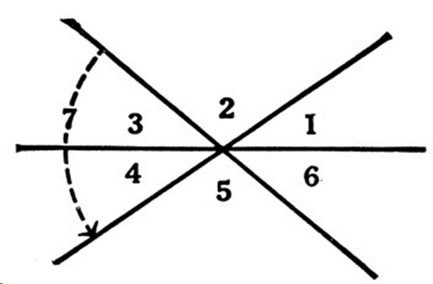

*Instructional Item 2*

The measure of angle 1 is 12 more than the measure of angle 2. What is the degree measure of angle 3?

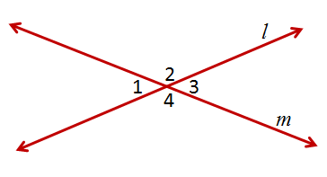

*Instructional Item 3*

If two angles are supplementary, and one angle is represented as *x*, how could you describe

the other angles using x?

*The strategies, tasks and items included in the B1G-M are examples and should not be considered comprehensive.

### MA.8.GR.1.5

Benchmark

MA.8.GR.1.5 Solve problems involving the relationships of interior and exterior angles of a triangle.

Benchmark Clarifications:

*Clarification 1:* Problems include using the Triangle Sum Theorem and representing angle measures as algebraic expressions.

Connecting Benchmarks/Horizontal Alignment

* MA.8.AR.2.1

Terms from the K-12 Glossary

* Angle
* Supplementary Angles

Vertical Alignment

|  |  |
| --- | --- |
| **Previous Benchmarks**   * MA.4.GR.1.2, MA.4.GR.1.3 * MA.5.GR.1.1 | **Next Benchmarks**   * MA.912.GR.1.3 |

Purpose and Instructional Strategies

In elementary mathematics, students used angle measures as an attribute of two-dimensional figures and identified and classified angles as acute, right, obtuse, straight and reflex. In grade 7 accelerated, students solve problems involving the interior and exterior angles of a triangle. In Geometry, the work in this benchmark will be extended to proving relationships and theorems about triangles.

* Students should explore the concept before being provided with the theorem. Once conceptual understanding is developed, students can use numerical equations to solve problems involving finding missing interior or exterior angles. From there, students should develop algebraic equations to solve for both missing angle measurements as well as variables.
* Instruction includes students exploring and using deductive reasoning to determine relationships that exist between angle sums and exterior angle sums of triangles. Students should construct various triangles and find the measures of both the interior and exterior angles. Applying knowledge of these relationships, students can use deductive reasoning to find the measure of any missing angles.
* Using an investigation, such as the one below, for the Triangle Sum Theorem will help students conceptually understand the total degree measures of a triangle related to a straight line.
  + Give each student a triangle. (A variety of triangle sizes will allow for discussion.)
  + Have students use a lined sheet of paper or draw a straight line using a ruler to represent the straight angle of .
  + Next, have the students tear off each angle of the triangle.
  + Then, putting the angle side towards the line, the students will be able to model the of the triangle measures to a straight line. This is illustrated in the top part of the figure below.

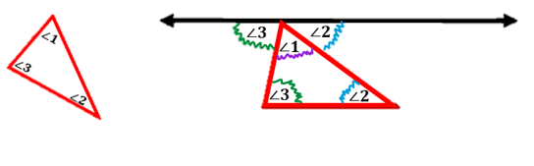

* + A similar investigation can be used to connect the measure of an exterior angle of a triangle and the two opposite interior angles in the triangle.
* Students can also use tracing paper to trace the concepts to make connections.

Common Misconceptions or Errors

* Students may incorrectly think that the exterior angle is the whole reflex angle of the interior angle.
* Students may not recognize that there are two exterior angles for each interior angle and that the exterior angles are congruent.

Strategies to Support Tiered Instruction

* Teacher provides a visual with one angle of the triangle on a straight line of 180°, similar to the illustration below. Teacher provides instruction on how to measure each of the angles with a protractor and color code congruent angles.
* Teacher provides tracing paper or patty paper to trace the related interior and exterior angles and have discussion about the angle relationships.

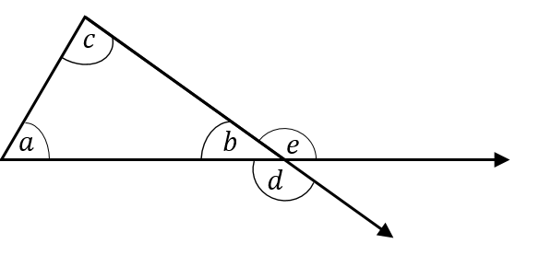

* Instruction includes providing a visual with one angle of the triangle on a straight line of 180° and measuring each angle in the figure. Teacher co-creates a graphic organizer with students to document the angle measurements, color-code congruent angles in the figure and in the graphic organizer, and identifies the relationships between interior and exterior angles of a triangle and the Triangle Sum Theorem.



|  |  |  |
| --- | --- | --- |
| **Interior Angles** | **Exterior Angles** | **Relationship** |
|  |  |  |
|  |  |  |
|  |  |  |

Instructional Tasks

*Instructional Task 1 (MTR.1.1, MTR.2.1)*

and share a common side of . Angle is and angle is .

Part A. Create a diagram to represent this description.

PartB. What will be the measure of angle ? Provide an explanation to support how to find the measurement of angle .

Part C. Are there questions that still need to be answered to approach Part B?

Instructional Items

*Instructional Item 1*

In triangle , the measure of angle is and the measure of angle . What is the measure of the exterior angle to angle ?

*Instructional Item 2*

One measure of an angle in a triangle is 96°. The other two angle measures are represented by and . Determine the other two degree measures for the missing angles.

*The strategies, tasks and items included in the B1G-M are examples and should not be considered comprehensive.

### MA.8.GR.1.6

Benchmark

MA.8.GR.1.6 Develop and use formulas for the sums of the interior angles of regular polygons by decomposing them into triangles

Benchmark Clarifications:

*Clarification 1:* Problems include representing angle measures as algebraic expressions.

Connecting Benchmarks/Horizontal Alignment

* MA.8.AR.2.1

Terms from the K-12 Glossary

* Regular Polygon

Vertical Alignment

|  |  |
| --- | --- |
| **Previous Benchmarks**   * MA.6.GR.2.2 * MA.7.GR.1.2 | **Next Benchmarks**   * MA.912.GR.1.3, MA.912.GR.1.4, MA.912.GR.1.5 |

Purpose and Instructional Strategies

In previous courses, students found areas of quadrilaterals and other polygons by decomposing them into triangles and trapezoids. In grade 7 accelerated, students develop and use formulas for the sums of the interior angles of regular polygons by decomposing them into triangles. In Geometry, students will use this knowledge to prove relationships and theorems about triangles, parallelograms, trapezoids and other polygons.

* Once students understand the conceptual understanding associated with this benchmark, students should progress from numerical expressions to algebraic expressions.
* When beginning the exploration with polygons with four or more sides, students should be able to use one vertex to draw diagonals to non-adjacent vertices. Once students have drawn the diagonals, have them cut along the diagonals to showcase triangles.

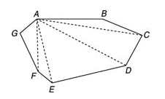

* Once the triangles are cut, then students can lay them out to see the number of triangles and relate the work to prior work with the sum of the angles of a triangle. Students can label their angles and show their equations that help provide information on the sum of the interior angles as shown below.

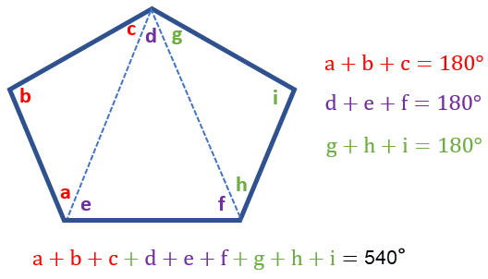

* Students should record this information in a chart like the one shown below to help them create a rule to use instead of counting the triangles each time.

|  |  |  |  |
| --- | --- | --- | --- |
| **Shape** | **Sides** | **# of Triangles** | **Sum of Interior Angles** |
| triangle | 3 | 1 |  |
| quadrilateral | 4 | 2 |  |
| pentagon | 5 | 3 |  |
| … | … | … | … |
| any polygon |  |  |  |

* Once students understand the sum of the interior angles, connections should be made to regular polygons. Students can add a column to indicate the regular polygon measurements of each angle.
* Encourage students to use proper vocabulary terms for polygons and regular polygons.

Common Misconceptions or Errors

* Students may incorrectly draw additional lines from the vertex to create additional triangles.

Strategies to Support Tiered Instruction

* Teacher encourages students to begin at an identified vertex and move around the polygon from that vertex when decomposing the polygons into triangles.
* Teacher provides multiple polygons for students to explore creating triangles from one vertex. Using polygons that are cut out or using precut manipulatives may support students who need to interact with the polygons.
* Teacher provides clear sleeves to put a sheet of polygons inside so student can use a dry-erase marker to draw the lines to create triangles. This will provide students with an opportunity to explore and easily adjust if incorrect lines are drawn.

Instructional Tasks

*Instructional Task 1 (MTR.5.1)*

Use your knowledge about shapes to complete the following task.

Part A. Draw a pentagon, hexagon, heptagon and an octagon.

Part B. Determine the number of triangles that can be drawn from one vertex to each of the others in each figure.

Part C. Develop a conjecture to determine if there is a pattern or formula that can be determined to find the sums of the interior angles for any polygon.

Instructional Items

*Instructional Item 1*

Find the number of degrees for the sum of the interior angles of a regular 12-sided figure.

*Instructional Item 2*

Saylor computed that a polygon with 9 sides has 7 interior triangles, and the sum of

the interior angles of that polygon is 1,260. Is Saylor correct? Explain your answer.

*The strategies, tasks and items included in the B1G-M are examples and should not be considered comprehensive.

**MA.8.GR.2** *Understand similarity and congruence using models and transformations*

### MA.8.GR.2.1

Benchmark

MA.8.GR.2.1 Given a preimage and image generated by a single transformation, identify the transformation that describes the relationship.

Benchmark Clarifications:

*Clarification 1:* Within this benchmark, transformations are limited to reflections, translations or rotations of images.

*Clarification 2:* Instruction focuses on the preservation of congruence so that a figure maps onto a copy of itself.

Connecting Benchmarks/Horizontal Alignment

* MA.7.GR.1.5
* MA.8.GR.2.2, MA.8.GR.2.3

Terms from the K-12 Glossary

* Congruent
* Reflection
* Rigid Transformation
* Rotation
* Translation

Vertical Alignment

|  |  |
| --- | --- |
| **Previous Benchmarks**   * MA.6.GR.1.1 | **Next Benchmarks**   * MA.912.F.2.1, MA.912.F.2.2 * MA.912.GR.2.1, MA.912.GR.2.3, MA.912.GR.2.4 |

Purpose and Instructional Strategies

In previous courses, students identified the 𝑥-or 𝑦-axis as the line of reflection when two ordered pairs have an opposite 𝑥-or 𝑦coordinate. In grade 7 accelerated, students identified the - or -axis as lines of reflection. Students will also solve problems involving scale drawings of geometric figures. Students are also introduced to the geometric transformations of reflection, dilation (scaling) and translation. In Algebra 1, students will describe transformations applied to functions. In Geometry, students will describe transformations given a preimage and an image and represent the transformation algebraically using coordinates. They will use transformations to justify congruence and similarity.

* Informal language such as turns, flips, and slides can be used when exploring the concepts. As students transition, they should use formal mathematical language of rotations, reflections and translations. Students should have materials such as shapes cut from paper to model the transformations.
* Instruction includes the use of real-world examples that don’t have to be a geometric figure.
  + For example, wallpaper, art, architecture and mirrors have images generated by simple transformations.
* The work of transformations builds from students being able to visually see the images and developing a spatial understanding as the images move about the coordinate plane.
* Transformations can be noted using the prime notation () for the image and its vertices. The preimage and its vertices will not have prime notation.
  + For example, the picture below showcases a single transformation.

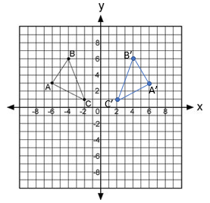

* Problem types include stating which direction, clockwise or counterclockwise, for rotations.
* The expectation of this benchmark is not to represent a transformation on the coordinate plane as this will be included in MA.8.GR.2.3 instruction. During instruction, there should be flexibility moving from this benchmark to MA.8.GR.2.3 with each transformation which allows students to build conceptually prior to algorithmically.
* For mastery of this benchmark, single transformations include one vertical translation or one horizontal translation. A vertical and horizontal translation would be considered two transformations.

Common Misconceptions or Errors

* Students may incorrectly visualize the movement of a figure. To support instruction, students may need manipulatives, such as tangrams and tessellations, to help with physically moving the figures to understand the transformations.

Strategies to Support Tiered Instruction

* Teacher supports instruction by using manipulatives, such as tangrams and tessellations, to help with physically moving the figures to understand the transformations.
* Teacher models using geometric software and creates a graphic organizer to understand each transformation with relatable vocabulary.
* Teacher uses example images and preimages to demonstrate the different types of transformation and how to identify images and preimages.
* Teacher encourages the use of manipulatives and models counting the units moved to verify the proper movement of the transformation.
* Instruction includes the use of tracing paper to trace the pre-image and explore possible transformations by slides, rotating, and flipping the image to try to reproduce the image.
* Teacher uses oversized grid paper or a white board with a grid to support visual movement.

Instructional Tasks

*Instructional Task 1 (MTR.6.1)*

Is it possible to have make one translation, rotation, or reflection to become the image of ? Explain why or why it is not possible. Determine which transformation(s) may be used.

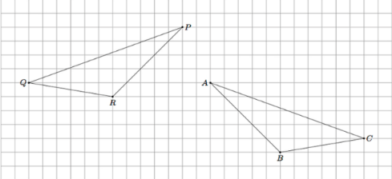

*Extension.* Discuss with a partner any similarities or differences in your method of transforming

.

Instructional Items

*Instructional Item 1*

Determine the transformation from the preimage above line *m* to the image below line .

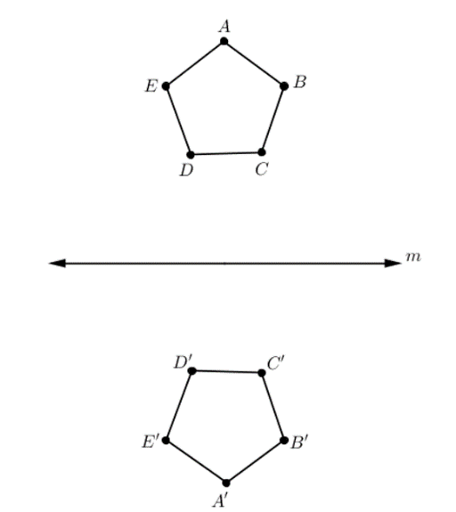

*Instructional Item 2*

Draw a right triangle labeled with vertices and then sketch the right triangle that has been rotated 90° counterclockwise.

*The strategies, tasks and items included in the B1G-M are examples and should not be considered comprehensive.

### MA.8.GR.2.2

Benchmark

MA.8.GR.2.2 Given a pre-image and image generated by a single dilation, identify the scale factor that describes the relationship.

Benchmark Clarifications:

*Clarification 1:* Instruction includes the connection to scale drawings and proportions.

*Clarification 2:* Instruction focuses on the preservation of similarity and the lack of preservation of congruence when a figure maps onto a scaled copy of itself, unless the scaling factor is 1.

Connecting Benchmarks/Horizontal Alignment

* MA.7.GR.1.5
* MA.8.GR.2.1, MA.8.GR.2.3

Terms from the K-12 Glossary

* Dilation
* Scale Factor

Vertical Alignment

|  |  |
| --- | --- |
| **Previous Benchmarks**   * MA.6.AR.3.1 | **Next Benchmarks**   * MA.912.F.2.1, MA.912.F.2.2 * MA.912.GR.2.1, MA.912.GR.2.3, MA.912.GR.2.4 |

Purpose and Instructional Strategies

In previous courses, students write and interpret ratios to show relative sizes of two quantities using appropriate notation. In grade 7 accelerated, students solve mathematical and real-world problems involving scale factors. Students also determine the scale factor that describes the relationship after a single dilation. In Geometry, students will use dilations to study similarity.

* This directly connects to the work with MA.7.GR.1.5 as students engage in problems involving scale drawings and scale factors.
* Instruction includes the use of real-world examples that do not have to be a geometric figure.
  + For example, projections, photocopies and maps have images generated by a single dilation.
* Students will need to understand scale factor to help in the idea of an image enlarging or reducing. A scale factor between 0 and 1 will be a reduction in the image. A scale factor that is greater than one will result in an enlargement of the image.
* Transformations can be noted using the prime notation () for the image and its vertices. The preimage and its vertices will not have prime notation.
  + For example, the picture below showcases a single dilation.

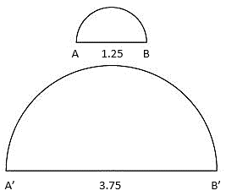

* The expectation of this benchmark is not to represent a dilation on the coordinate plane as this will be included in MA.8.GR.2.3 instruction.

Common Misconceptions or Errors

* Students may incorrectly visualize the images with scale factors. To address this misconception, include practice in visualizing the reduction and enlargement based on the scale factors.

Strategies to Support Tiered Instruction

* Instruction includes practice in visualizing the reduction and enlargement based on the scale factors for students that incorrectly visualize images with scale factors.
  + For example, two figures that have the same shape are said to be similar. When two figures are similar, the ratios of the lengths of their corresponding sides are equal and corresponding angles are congruent. Similar figures have the same shape, but not necessarily the same size.

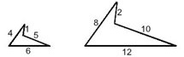

* Teachers can help students understand that two figures that have the same shape are said to be similar. When two figures are similar, the ratios of the lengths of their corresponding sides are equal. In example 1, the corresponding sides are 8:4, 2:1, 10:5, and 12:6. These ratios are equal to 2, meaning the shapes must be similar. The figures do not have to be the same size to be similar.
* Instruction includes practice in visualizing the reduction and enlargement based on the scale factors.

Instructional Tasks

*Instructional Task 1 (MTR. 7.1)*

The height of a document on your computer is 20 centimeters. When you change the setting to zoom in or out, you change it from 100% to 25%. The new image of your document is a dilation of your original document, the preimage. Determine the scale factor and the height of the new image.

*Instructional Task 2 (MTR.5.1, MTR. 7.1)*

The band director at Ocean Side Middle School wants to enlarge a photograph of the staff from picture day to give to the principal. The picture is 10 inches wide by 8 inches tall, and he wants to enlarge it to 65 inches tall by 52 inches wide to hang in the main office.

Part A. Determine the scale factor of the enlargement.

Part B. If he decided to also enlarge the student band picture to hang in the back of the

band room, and the band picture is also 10 inches wide by 8 inches tall, how wide

could the picture be if the height can be 168 inches tall?

Instructional Items

*Instructional Item 1*

Does the image show reduction or enlargement from the quadrilateral ? What is the scale factor?

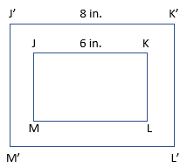

*The strategies, tasks and items included in the B1G-M are examples and should not be considered comprehensive.

### MA.8.GR.2.3

Benchmark

MA.8.GR.2.3 Describe and apply the effect of a single transformation on two-dimensional figures using coordinates and the coordinate plane.

Benchmark Clarifications:

*Clarification 1:* Within this benchmark, transformations are limited to reflections, translations, rotations or dilations of images.

*Clarification 2:* Lines of reflection are limited to the -axis, -axis or lines parallel to the axes.

*Clarification 3:* Rotations must be about the origin and are limited to 90°, 180°, 270° or 360°.

*Clarification 4*: Dilations must be centered at the origin.

Connecting Benchmarks/Horizontal Alignment

* MA.7.GR.1.5
* MA.8.GR.2.1, MA.8.GR.2.2

Terms from the K-12 Glossary

* Coordinates
* Coordinate Plane

Vertical Alignment

|  |  |
| --- | --- |
| **Previous Benchmarks**   * MA.6.GR.1.1 | **Next Benchmarks**   * MA.912.F.2.1, MA.912.F.2.2 * MA.912.GR.2.1, MA.912.GR.2.3, MA.912.GR.2.4 |

Purpose and Instructional Strategies

In previous courses, students identified the 𝑥-or 𝑦-axis as the line of reflection when two ordered pairs have an opposite 𝑥-or 𝑦coordinate. In grade 7 accelerated, students solve mathematical and real-world problems involving scale factors. Students also apply a single transformation using coordinates and the coordinate plane. In Algebra 1, students will apply a single transformation to functions. In Geometry, students will describe transformations given a preimage and an image and represent the transformation algebraically using coordinates and use them to study congruence and similarity.

* Instruction includes using grid paper to illustrate translations of a line or triangle to demonstrate the relationship between them and a new image. Then, illustrate translations of more complex figures such as polygons.
* Transformations can be noted using the prime notation () for the image and its vertices. The preimage and its vertices will not have prime notation.
  + For example, the picture below showcases a single transformation.



* Problem types include telling which direction, clockwise or counterclockwise, for rotations.
* Instruction includes looking for patterns to create rules for transformations on the coordinate plane.
* For mastery of this benchmark, single transformations include one vertical translation or one horizontal translation. A vertical and horizontal translation would be considered two transformations.

Common Misconceptions or Errors

* Students may incorrectly visualize transformation on the coordinate plane. To address this misconception, provide students with manipulatives.
* Students may incorrectly apply rules for transformations. To address this misconception, students should generate examples and non-examples of given transformations.
* Students may invert clockwise and counterclockwise.

Strategies to Support Tiered Instruction

* Teacher supports understanding of transformations on the coordinate plane by providing examples using geometric software. Instruction includes the use of manipulatives, tracing paper and graph paper.
* Teacher reminds students when plotting points on a coordinate plane that they can first find the -coordinate on the -axis (horizontal axis) and then find the -coordinate on the -axis (vertical axis).
* Teacher reviews vocabulary discussing the meaning of the terms.
  + Translation is a vertical or horizontal slide of the figure. To determine the coordinates of the image of a translated figure you must add or subtract the horizontal distance to the -coordinate of each vertex and add or subtract the vertical distance to the -coordinate of each vertex. (Note that in later courses, students learn that translation can also occur diagonally.)
  + Preimage is the figure before any transformations are performed.
  + Image is the figure after a transformation is performed.
* Teacher co-creates a graphic organizer to generate examples and non-examples of reflections, translations, rotations, or dilations of images.
* Teacher provides instruction to support understanding of applying the translation to all vertices, not just one vertex.
* Teacher reviews directions of rotations. Clockwise is the direction the hands go on an analog clock Image showing clockwise like the hands of the clock.. Counterclockwise is the opposite direction of the hands on an analog clock Image showing counterclockwise, which is opposite of the hands of a clock..
  + For example, which quadrant would the image be in if you rotated the figure?
  + 90 degrees clockwise
  + 90 degrees counterclockwise
  + 180 degrees clockwise
  + 180 degrees counterclockwise

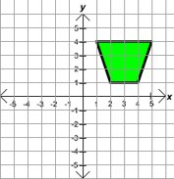

* Teacher reviews which is the -axis and which is the -axis for students that incorrectly reflect across the wrong axis. Teacher co-creates anchor chart explaining different parts of the coordinate plane and how to plot and label points.
  + For example, teachers could ask students which quadrant the image would be in if you reflected the figure across the -axis or across the -axis.
* Instruction includes providing students with manipulatives for students that incorrectly visualize transformations on the coordinate plane.
* Teacher uses oversized grid paper or a white board with a grid to support visual movement.

Instructional Tasks

*Instructional Task 1 (MTR.1.1, MTR.2.1)*

Use the information you have learned about transformations to complete the task below.

Part A. Using graph paper, plot the following points to create an image on the coordinate plane.

, , and

Part B. Using a different color for each transformation, complete each of the following transformations on the same coordinate plane.

* 1. A reflection over the -axis
  2. A rotation of 180° about the origin

Part C. Will any of the new images include the origin?

Instructional Items

*Instructional Item 1*

Find the coordinates of the vertices of the image of triangle after the translation 3 units to the left.

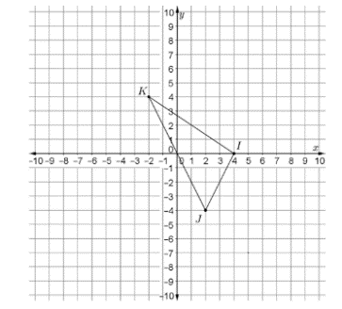

*Instructional Item 2*

Find the coordinates of the vertices of the image of triangle after a 270° counterclockwise rotation about the origin.

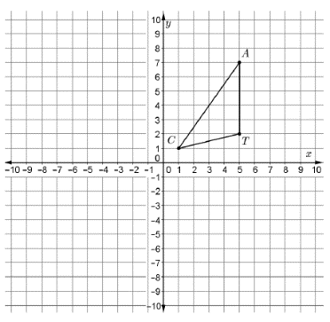

*The strategies, tasks and items included in the B1G-M are examples and should not be considered comprehensive.

### MA.8.GR.2.4

Benchmark

MA.8.GR.2.4 Solve mathematical and real-world problems involving proportional relationships between similar triangles.

Example: During a Tampa Bay Lightning game one player, Johnson, passes the puck to his teammate, Stamkos, by bouncing the puck off the wall of the rink. The path of the puck creates two line segments that form hypotenuses for each of two similar right triangles, with the height of each triangle the distance from one of the players to the wall of the rink. If Johnson is 12 feet from the wall and Stamkos is 3 feet from the wall. How far did the puck travel from the wall of the rink to Stamkos if the distance traveled from Johnson to the wall was 16 feet?

Connecting Benchmarks/Horizontal Alignment

* MA.7.AR.3.2
* MA.7.GR.1.5
* MA.8.AR.3.1, MA.8.AR.3.2

Terms from the K-12 Glossary

* Proportional Relationships
* Similarity

Vertical Alignment

|  |  |
| --- | --- |
| **Previous Benchmarks**   * MA.6.AR.3.1 | **Next Benchmarks**   * MA.912.GR.1.2, MA.912.GR.1.3, MA.912.GR.1.6 |

Purpose and Instructional Strategies

In previous courses, students wrote and interpreted ratios to show the relative sizes of two quantities using appropriate notation. In grade 7 accelerated, students solve mathematical and real-world problems involving scale factors. Students also make connections of slope to the constant of proportionality through the use of similar triangles when represented in the coordinate plane (as stated in *Clarification 2* in MA.8.AR.3.2). Additionally, students solve problems involving similar triangles. In future courses, students will prove triangle congruence or similarity using Side-Side-Side, Side-Angle-Side, Angle-Side-Angle, Angle-Angle-Side, Angle-Angle and Hypotenuse-Leg.

* Instruction includes the definition of similarity applied to similar triangles, noting that the similar triangles will have the same shape but not necessarily the same size. This will extend to the angles being congruent and the sides being proportional.
* Students should be given real-world problem-solving opportunities in and out of the classroom to be able to visualize the work with similar triangles.
  + For example, students should draw a picture to represent an application problem. If students were given the problem: If a tree casts a 24-foot shadow at the same time that a yardstick casts a 2-foot shadow, find the height of the tree. Students can draw triangles to represent the situation.

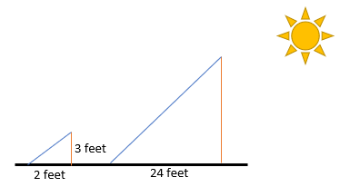

Common Misconceptions or Errors

* Students may incorrectly assume the sides and angles of similar triangles must be equivalent. To address this misconception, show a variety of examples of sizes of triangles that are similar.
* When checking to see if the triangles are proportional, students may incorrectly make connections to corresponding sides.
  + For example, when triangles have been turned to a different orientation, students may incorrectly match the sides to check for proportionality.

Strategies to Support Tiered Instruction

* Instruction includes co-creating foldables or graphic organizers with “Definition in Student’s Words, Examples, Non-Examples, and Real-World Application.” Present students with examples of triangles that are similar and of different sizes.
* Teacher provides objects that have the same shape and students label the corresponding sides.
* Teacher models use of geometric software to practice similarity and congruence.
* Instruction includes showing a variety of examples of sizes of triangles that are similar for students that incorrectly assume the sides and angles of similar triangles must be equivalent.

Instructional Tasks

*Instructional Task 1 (MTR.6.1, MTR.7.1)*

Given the description of two similar triangles below, sketch each triangle described in the table.

|  |  |
| --- | --- |
| **Triangle 1** | **Triangle 2** |
| The height of the triangle is the height of a man who is 6 feet tall. The base of the triangle makes a 90-degree angle with the height and is 4 feet long. | The height of the triangle is unknown since it represents the height of a cell phone tower. The base of the triangle makes a 90-degree angle with the height and is 20 feet long. |

Part A. What would be a reasonable height of a cell phone tower?

Part B. Find the height of the cell phone tower. Is this a realistic height for the cell phone tower?

Part C. Research the heights of cell phone towers in your area. How does this answer compare to cell phone towers in your area?

Part D. Using a typical height of cell phone towers in your area, what could you use in the real world to create similar triangles to be able to calculate the height of your local cell phone tower?

Instructional Items

*Instructional Item 1*

Given the two triangles, are they similar?

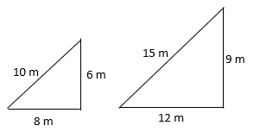

*Instructional Item 2*

What is the height, , in meters?

The smaller triangle has the following leg measurements: 0.9 meters and 6 meters.
The larger triangle has the following leg measurements: "h" meters and (6 + 12) meters.

*The strategies, tasks and items included in the B1G-M are examples and should not be considered comprehensive.

# Data Analysis and Probability

**MA.7.DP.1** *Represent and interpret numerical and categorical data.*

### MA.7.DP.1.4

**Benchmark**

**MA.7.DP.1.4 Use proportional reasoning to construct, display and interpret data in circle graphs.**

Benchmark Clarifications:

*Clarification 1:* Data is limited to no more than 6 categories.

**Connecting Benchmarks/Horizontal Alignment**

* MA.7.NSO.1.2
* MA.7.GR.1.4

**Terms from the K-12 Glossary**

* Circle Graph
* Data
* Proportional Relationships

**Vertical Alignment**

|  |  |
| --- | --- |
| **Previous Benchmarks**   * MA.6.AR.3.4 * MA.7.AR.3.1 | **Next Benchmarks**   * MA.912.DP.1.1, MA.912.DP.1.2 |

**Purpose and Instructional Strategies**

|  |
| --- |
| In previous courses, students worked with solving problems using ratio and proportional relationships. In grade 7 accelerated, students apply their knowledge of ratios to solve problems involving proportions, including using proportional reasoning to construct, display and interpret categorical data in circle graphs. In future courses, students will select an appropriate method to represent data, depending on whether it is numerical or categorical data and on whether it is univariate or bivariate.   * Circle graphs can be used to show how categories represent part of a whole, or compositions. Totals are represented as percentages that equal 100%, which illustrates the percentage breakdown of items and visually represents a comparison. * Students should be able to identify strengths and limitations in showcasing data within a circle graph.z   Table listing srengths and limitations. Strengths include: compares parts to a whole and to each other, each response is shown as a percent, and size of sectors compare results.   * Instruction begins with data sets out of 100 to allow for easier calculations of percentages. * Instruction should include opportunities for students to brainstorm how they might split up their circle into the needed percentages (*MTR.5.1*).   + For example, students can slice a circle into 4 equal parts to show students the 4 right angles at the center which total 360o. Then use proportional relationships to determine the central angle sizes needed based on the percentage size of each “slice” of the circle. * Students should collect their own data with which to create a circle graph (*MTR.7.1*).   + For example, have students count colored candy/snacks or survey other students in the room about their favorite color, favorite sport or favorite genre of music/movies. * Use protractors or online software to assist in creating circle graphs accurately. |

**Common Misconceptions or Errors**

* Students may incorrectly use the percent of a category for the central angle degrees instead of finding the degrees by using a proportion.
* Students may incorrectly round or make other errors in calculations that will lead to the circle graph sections not totaling 100%.
* Students may incorrectly use a protractor. To address this issue, provide students with a circle and allow them to measure sections and then find the percent.

**Strategies to Support Tiered Instruction**

* Teacher models several examples to work through with students, showing how to set up the proportion to find the central angle degrees, referencing patterns for students to discuss.
  + For example, if students need to determine the angle measure that corresponds to 21%, the proportion below can be used.
* Teacher models and works through several problems while discussing how to properly round when having to total to 100%, reinforcing to students to work through the problems carefully as to not make computation errors.
* Teacher models using computer-based software to create circle graphs to verify appropriate rounding.
* Teacher provides students with fill in the blank examples working from percent of a category using proportions to find the central angle degrees.
* Teacher provides several completed examples of problems where rounding was needed for students to reference while working through multiple problems together.
* Teacher models using fraction circle manipulatives to support converting fractions to percentages.

**Instructional Tasks**

*Instructional Task 1 (MTR.4.1, MTR.7.1)*

A group of friends has been given $800 to host a party. They must decide how much money will be spent on food, drinks, paper products, music and decorations.

Part A. As a group, develop two options for the friends to choose from regarding how to spend their money. Decide how much to spend in each area and create a circle graph for each option to represent your choices.

Part B. Mikel presented the circle graph below with his recommendations on how to spend the money. How much did he choose to spend on food and drinks? How much did he choose to spend on music?

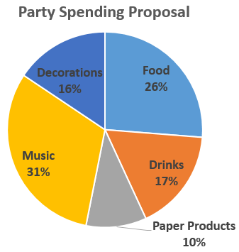

**Instructional Items**

*Instructional Item 1*

Circle Point High School surveyed its students to determine which mode of transportation they use to get to and from school. Create and label a circle graph based on the results given below.

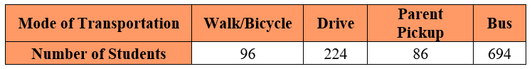

*\*The strategies, tasks and items included in the B1G-M are examples and should not be considered comprehensive.*

### MA.7.DP.1.5

**Benchmark**

**MA.7.DP.1.5 Given a real-world numerical or categorical data set, choose and create an appropriate graphical representation.**

Benchmark Clarifications:

*Clarification 1:* Graphical representations are limited to histograms, bar charts, circle graphs, line plots, box plots and stem-and-leaf plots.

**Connecting Benchmarks/Horizontal Alignment**

* MA.8.AR.3
* MA.8.DP.1.1

**Terms from the K-12 Glossary**

* Bar Graph
* Box Plot
* Categorical Data
* Circle Graph
* Histogram
* Line Plot
* Stem-and-Leaf Plot

**Vertical Alignment**

|  |  |
| --- | --- |
| **Previous Benchmarks**   * MA.6.DP.1.5 * MA.7.AR.3.1 | **Next Benchmarks**   * MA.912.DP.1.1 |

**Purpose and Instructional Strategies**

In previous courses, students created box plots and histograms to represent numerical data. In grade 7 accelerated, students must choose and create an appropriate graphical representation for a given numerical or categorical data set. Students will also construct a scatter plot or a line graph for a given set of bivariate numerical data. In Algebra 1, students select an appropriate method to represent data depending on whether it is numerical or categorical and on whether it is univariate or bivariate given a set of data.

* Students were introduced to bar charts (bar graphs) in grade 3, students may need to be reintroduced to this graphical representation.
* Graphical representations of categorical data sets are helpful for showing trends that can be analyzed and making comparisons of categories, among different items, or items over time periods. They visually show the mode of the data and, at a quick glance, show categories in a set of data that dominate others. Depending on the graphical representation chosen, either the frequency (number of items) or relative frequency (percentage) for each category can be illustrated.
* Histograms (for numerical data) and box plots (for categorical data) work well in grouping large sets of data to be easily compared but do not allow viewers access to each individual data point if needed for other calculations such as the mean.
* Circle graphs are not ideal when too many categories are included as it is difficult to distinguish the difference in sizes of the sectors. Bar charts (or bar graphs) make a similar comparison but the heights of the bars make the comparison more easily distinguishable.
* Stem-and-leaf plots and line plots are useful in displaying the shape of a numerical data set, easily identifying the mode and outliers, and they contain all of the values in the data set allowing for additional calculations such as the mean. They are not ideal when there is a large volume of data since it is time-consuming to create and becomes difficult to read or interpret.
* As an enrichment to this benchmark, students could explore segmented bar charts as they will be introduced to this in Algebra 1 (MA.912.DP.1.1)

**Common Misconceptions or Errors**

* Students may not distinguish between histograms (numerical data) and bar charts, also called bar graphs (categorical data).

**Strategies to Support Tiered Instruction**

* Instruction includes displaying histograms and bar charts side by side and allowing students to compare and contrast each one to help them understand the difference between the two, and what information we can learn from each one.
* Teacher provides a graphic organizer for each type of data display for students to reference in the future.
* Teacher co-creates examples of both bar graphs and histograms with students, explaining step-by-step how to create them and how/why they are different.

**Instructional Tasks**

*Instructional Task 1 (MTR.2.1)*

The following data shows the grams of protein in 21 protein bars.

Part A. Create two different graphical representations of the data using a histogram, bar chart, circle graph, line plot, box plot or stem-and-leaf plot.

Part B. Compare and contrast the two displays and determine which is more appropriate. Explain your reasoning.

**Instructional Items**

*Instructional Item 1*

Select an appropriate type of display for each of the following situations.

* + the salaries of all 40 employees at a small company
  + the salaries of all 250 people at a mid-sized company
  + the distribution of colors in a bag of colored candies
  + the number of siblings students in the 7th grade class have

*Instructional Item 1*

Using the data below showing the number of points earned this season in basketball by the

point guard of Eastside Middle School, which graphical representation (histograms, bar

charts, circle graphs, line plots, box plots and stem-and-leaf plots) would you chose? Explain

your reasoning.

*\*The strategies, tasks and items included in the B1G-M are examples and should not be considered comprehensive.*

**MA.8.DP.1** *Represent and investigate numerical bivariate data.*

### MA.8.DP.1.1

Benchmark

MA.8.DP.1.1 Given a set of real-world bivariate numerical data, construct a scatter plot or a line graph as appropriate for the context.

*Example:* Jaylyn is collecting data about the relationship between grades in English and grades in mathematics. He represents the data using a scatter plot because he is interested if there is an association between the two variables without thinking of either one as an independent or dependent variable.

Example: Samantha is collecting data on her weekly quiz grade in her social studies class. She represents the data using a line graph with time as the independent variable.

Benchmark Clarifications:

*Clarification 1:* Instruction includes recognizing similarities and differences between scatter plots and line graphs, and on determining which is more appropriate as a representation of the data based on the context.

*Clarification 2:* Sets of data are limited to 20 points.

Connecting Benchmarks/Horizontal Alignment

* MA.7.DP.1.5
* MA.8.DP.1.2, MA.8.DP.1.3

Terms from the K-12 Glossary

* Bivariate Data
* Scatter Plot

Vertical Alignment

|  |  |
| --- | --- |
| **Previous Benchmarks**   * MA.6.DP.1 * MA.7.DP.1.1, MA.7.DP.1.2 | **Next Benchmarks**   * MA.912.DP.2.4, MA.912.DP.2.6 * MA.912.DP.3.1 |

Purpose and Instructional Strategies

In previous courses, students began to work with both numerical and categorical univariate data. In grade 7 accelerated, students encounter bivariate data, and it is restricted to numerical data, which is often displayed with a scatter plot, but in some circumstances, may also be displayed with a line graph. In Algebra 1, students will continue working with scatter plots and line graphs for bivariate numerical data, but expand their knowledge to bivariate categorical data, displayed with frequency tables.

* Bivariate data refers to the two-variable data, with one variable graphed on the -axis and the other variable on the -axis. Instruction includes flexibility in the understanding of the dependent and independent variables. Students can represent situations in terms of or in terms of .
* Instruction includes proper labeling of graphical representations, including axes, scales and a title.
* Line graphs are a way to map independent and dependent variables. Line graphs showcase data by connecting each data point together. The rate of change from a single data point to another data point can be measured. An overall trend can be described, but the trend is between individual or small groups of points. A line graph allows for the interpretation of the rate of change, or slope, between individual data points. The independent variable can be either numerical or categorical.
  + For example, independent variables can be shown as months of the year.

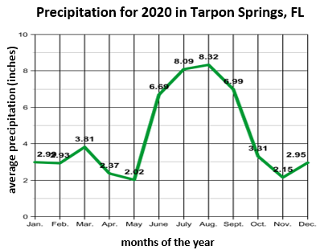

* Scatter plots are another way to show the relationship between two variables having individual points that will not be connected directly together. Often neither variable is thought of as the independent or dependent variable, so it is a matter of choice of which variable will be represented on the -axis and which will be represented on the -axis. Trends can be seen through the distribution of points. Scatter plots are used to collect a large number of data points to illustrate patterns in the data including linear or non-linear trends, clusters and outliers.
* Instruction includes the understanding that with bivariate data, a single -value can be associated with more than one -value. When this is the case, a scatter plot should be used as the graphical display rather than a line graph.
* Instruction includes providing opportunities for students to interact with scatter plots through the development of statistical questions.
* Students should label and determine appropriate scales when completing work with bivariate numerical data.

Common Misconceptions or Errors

* When discussing and interpreting the data, students may incorrectly identify an association when the scatter plot shows no association. To address this misconception, provide examples for students that would help them understand that some data will not have an association.
  + For example, the height of a person and their number of pets.
* Students may confuse the dependent and independent variables when creating line graphs.
* Students may incorrectly believe bivariate data can only be displayed as a scatter plot.

Strategies to Support Tiered Instruction

* Teacher provides instruction on different types of associations, then provides clear examples of associations of scatter plots for students who need additional assistance identifying associations.

**Positive Association Negative Association No Association**

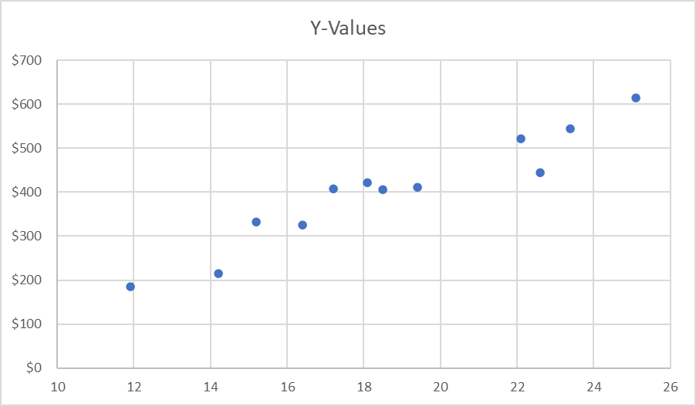 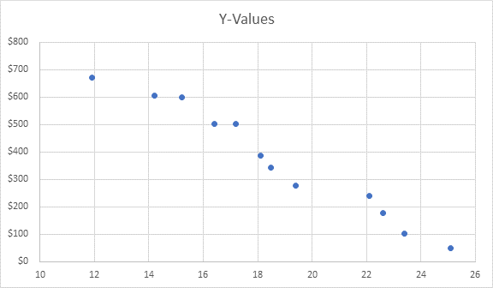 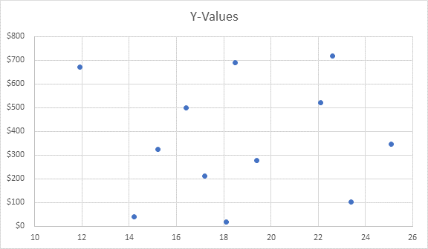

* Teacher provides instruction on independent and dependent variables and the difference between them. Instruction includes the use of real-world situations to accurately identify independent and dependent variables.
* Teacher co-creates anchor chart/graphic organizer showing different ways to display data.
* Teacher provides examples for students to help them understand that some data will not have an association.
* For example, the height of a person and their number of pets.

Instructional Tasks

*Instructional Task 1 (MTR.2.1, MTR.4.1, MTR.6.1)*

Scientists at the new company, BunG, tested their bungee cords, used for bungee jumping, with weights from 10 to 200 pounds. They identified a random sample of cords and measured the length that each cord stretched when different weights were applied. The table displays the average stretch length for the sample of cords for each weight.

|  |  |  |  |  |  |  |  |  |  |
| --- | --- | --- | --- | --- | --- | --- | --- | --- | --- |
| **Weight (in pounds)** | 10 | 30 | 50 | 70 | 100 | 125 | 150 | 175 | 200 |
| **Length (in feet)** | 11.5 | 16.4 | 20.7 | 25.1 | 29.6 | 35.2 | 38.8 | 42.3 | 44.7 |

Part A. Construct a scatter plot and a line graph for this set of data.

Part B. Which representation is most appropriate for displaying and describing the relationship between the weights applied to a bungee cord and the length the cord stretches? Explain your reasoning.

Instructional Items

*Instructional Item 1*

A pool cleaning service drained a full pool. The following table shows the number of hours it drained and the amount of water remaining in the pool at that time.

|  |  |  |  |  |  |
| --- | --- | --- | --- | --- | --- |
| **Time (hours)** | 3 | 5 | 7 | 9 | 11 |
| **Water Remaining (gallons)** | 13,200 | 12,050 | 10,900 | 9,800 | 8,750 |

Construct a line graph or scatter plot for the data above based on which is most appropriate for the context.

*Instructional Item 2*

Kennedy ran the Gasparilla marathon with a group of 25 of her friends. The table below

shows the number of her friends that stopped at each water break during the race.

|  |  |  |  |  |  |  |  |  |  |
| --- | --- | --- | --- | --- | --- | --- | --- | --- | --- |
| **Number of friends that stopped** | 5 | 7 | 4 | 2 | 15 | 10 | 2 | 6 | 25 |
| **Water break Station** | 1 | 2 | 3 | 4 | 5 | 6 | 7 | 8 | 9 |

*The strategies, tasks and items included in the B1G-M are examples and should not be considered comprehensive.

### MA.8.DP.1.2

Benchmark

MA.8.DP.1.2 Given a scatter plot within a real-world context, describe patterns of association.

Benchmark Clarifications:

*Clarification 1:* Descriptions include outliers; positive or negative association; linear or nonlinear association; strong or weak association.

Connecting Benchmarks/Horizontal Alignment

* MA.8.DP.1.1, MA.8.DP.1.3

Terms from the K-12 Glossary

* Association
* Outlier
* Scatter Plot

Vertical Alignment

|  |  |
| --- | --- |
| **Previous Benchmarks**   * MA.6.DP.1 * MA.7.DP.1.1., MA.7.DP.1.2 | **Next Benchmarks**   * MA.912.DP.2.4, MA.912.DP.2.6   MA.912.DP.3.1 |

Purpose and Instructional Strategies

In previous courses, students described and interpreted, quantitatively and qualitatively, both numerical and categorical univariate data. In grade 7 accelerated, students encounter bivariate data and use scatter plots to determine whether there is any association between the variables. In Algebra 1, students will continue working with scatter plots to display association but expand their knowledge to consider association in bivariate categorical data, displayed with frequency tables.

* Instruction includes students communicating the relationships between two variables. Students should analyze scatter plots to determine the type and degree of association.

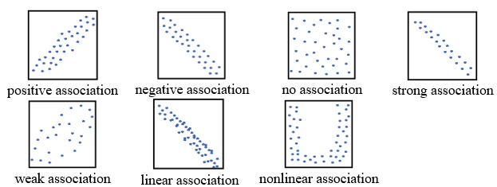

* Outliers in scatter plots are different than outliers in box plots. There is no special rule for determining if a data point is an outlier in a scatter plot. Instead, students need to consider why the outlier does not fit the pattern. Students should examine if outliers are valid or represent a recording or measurement error. Students should identify outliers and clusters and give possible reasons for their existence (*MTR.4.1*, *MTR.7.1*).
* Instruction includes opportunities to discuss the effects of changing the data slightly and how the changes impact the scatter plots (*MTR.4.1*).

Common Misconceptions or Errors

* Students may invert positive and negative correlations.
* Students may incorrectly assume that associations can only have one descriptor.
  + For example, students may only say that the correlation is a positive association instead of describing it as a strong, positive linear association.
* Students may misinterpret an outlier and why it may occur in a set of data.

Strategies to Support Tiered Instruction

* Teacher provides clear examples of associations of scatter plots (representing positive, negative, no, strong, weak, linear and non-linear associations). Teacher facilitates discussion about whether each association is positive or negative.

|  |  |  |
| --- | --- | --- |
| Scatter plot showing a positive association. | Scatter plot showing a negative association. | Scatter plot showing no association. |
| **Positive Association** | **Negative Association** | **No Association** |

* Teacher provides examples of different outliers and discusses with students why this occurred. Creating this dialogue will help students begin to understand how outliers can be used differently depending on the type of data collected, and what the data is intended for.
* Instruction includes co-creating a graphic organizer to include examples of different patterns to association. Categories include trends in association (positive, negative, no), strength of association (strong, weak) and pattern of association (linear or nonlinear).

Instructional Tasks

*Instructional Task 1 (MTR.4.1, MTR.7.1)*

The graphs below show the test scores of the students in Dexter's class. The first graph shows the relationship between test scores and the amount of time the students spent studying, and the second graph shows the relationship between test scores and shoe size.

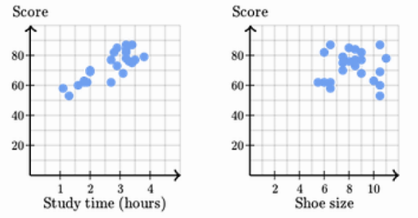

Part A. Describe and explain the pattern of association for each of the graphs.

Part B. If you were to add an outlier to the first graph, describe the data point and what it would mean in context.

*Instructional Task 2 (MTR.4.1, MTR.7.1)*

Population density measures are approximations of the number of people per square unit of area. The following scatter plot represents data from each of the 50 states comparing population (in millions) to land area (in 10,000 square miles) in 2012.

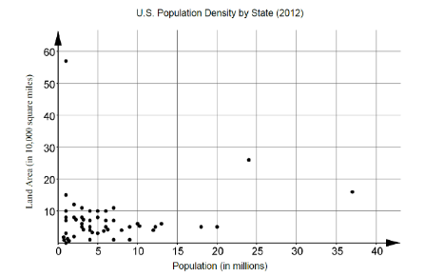

Part A. Describe the type and degree of association between population and land area.

Part B. Discuss with a partner possible interpretations of your answer to Part A. Do you think this would hold true for other countries?

Instructional Items

*Instructional Item 1*

The scatter plot below compares middle school students' scores on the Epworth Sleepiness Scale (ESS) to their scores on a recent math test. The Epworth Sleepiness Scale measures excessive daytime sleepiness with zero being least sleepy. Describe the type and degree of association between scores on the Epworth Sleepiness Scale and scores on the math test.

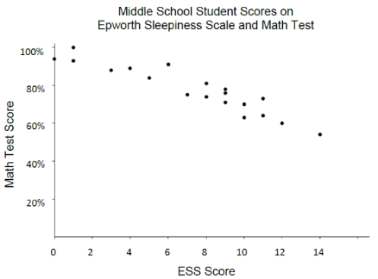

*The strategies, tasks and items included in the B1G-M are examples and should not be considered comprehensive.

### MA.8.DP.1.3

Benchmark

MA.8.DP.1.3 Given a scatter plot with a linear association, informally fit a straight line.

Benchmark Clarifications:

*Clarification 1:* Instruction focuses on the connection to linear functions.

*Clarification 2:* Instruction includes using a variety of tools, including a ruler, to draw a line with approximately the same number of points above and below the line.

Connecting Benchmarks/Horizontal Alignment

* MA.8.AR.3.1, MA.8.AR.3.2, MA.AR.3.3, MA.8.AR.3.4, MA.8.AR.3.5
* MA.8.DP.1.1, MA.8.DP.1.2

Terms from the K-12 Glossary

* Association
* Line of Fit
* Scatter Plot

Vertical Alignment

|  |  |
| --- | --- |
| **Previous Benchmarks**   * MA.6.DP.1 * MA.7.DP.1.1, MA.7.DP.1.2 | **Next Benchmarks**   * MA.912.DP.2.4, MA.912.DP.2.6   MA.912.DP.3.1 |

Purpose and Instructional Strategies

In previous courses, students created graphical representations for both numerical and categorical univariate data. In grade 7 accelerated, students encounter bivariate data displayed with scatter plots, and they use their knowledge of graphing lines to determine approximate lines of fit. In Algebra 1, students will continue working with scatter plots and lines of fit to make sense of real-world applications.

* Instruction includes the understanding that a straight line can be used to display a linear association in a scatter plot. This line allows predictions of other potential data points. Instruction includes students discussing what it means to be above and below the line of fit (*MTR.4.1*).
* Instruction includes providing opportunities to look at multiple lines of fit and determining which would be the best model for the scatter plot. The use of manipulatives is a way for students to make adjustments on their informal fit of a line. Students should compare and contrast their models and explain why their models best represent the fit of the data (*MTR.4.1*).
* Instruction includes the use of linear models to represent the line of fit. Students should describe the -intercept and slope in terms of the context within the scatter plot.

Common Misconceptions or Errors

* Students may incorrectly believe the line of fit should go through all the data points. To address this misconception, provide examples to students to show some lines that do go through data points and examples that may go through very few or no data points.
* Students may incorrectly think the line of fit should go through the first and last data point on the scatter plot. To address this misconception, provide examples to students to show some lines that do not go through the first and last data points.

Strategies to Support Tiered Instruction

* Using digital tools to model graphing a line of fit will provide clarity for misunderstanding that a line of fit needs to either start with the first and end with the last point or go through all points.
* Teacher provides examples of lines of fit that go through data points and examples that may go through very few or no data points.
* Teacher provides examples to show lines of fit that do not go through the first and last data points.

Instructional Tasks

*Instructional Task 1 (MTR.6.1, MTR.7.1)*

Each graph shows the same set of data and a line that has been fitted to the data.

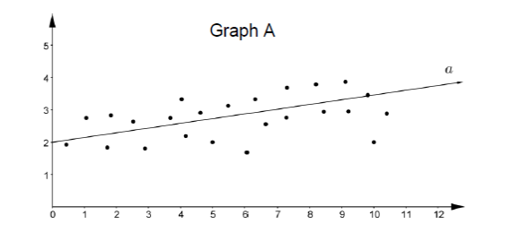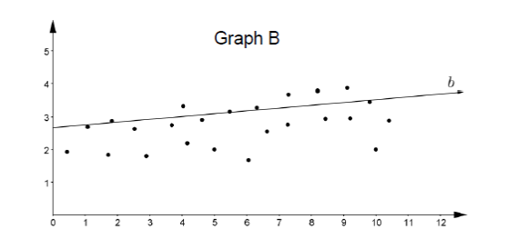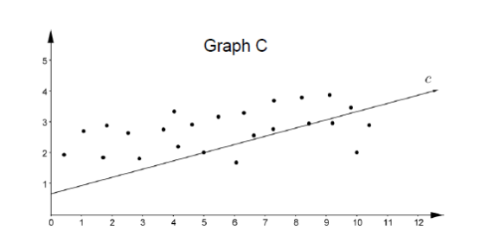

Part A. Determine which line, , or *,* most appropriately fits the data and explain why.

Part B. What statistical question could be asked to represent the set of data?

Instructional Items

*Instructional Item 1*

The scatter plot below shows the relationship between the ages and weights of 50 female infants. Draw a line on the scatter plot that fits the data.

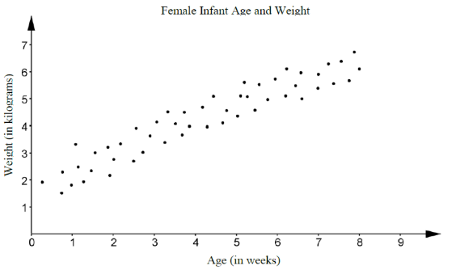

*Instructional Item 2*

A scatter plot is shown in the coordinate plane. Draw a line on the scatter plot that fits the data.

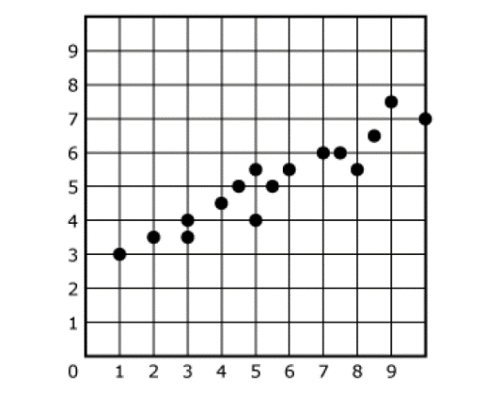

*The strategies, tasks and items included in the B1G-M are examples and should not be considered comprehensive.

**MA.8.DP.2** *Represent and find probabilities of repeated experiments.*

### MA.8.DP.2.1

Benchmark

MA.8.DP.2.1 Determine the sample space for a repeated experiment.

Benchmark Clarifications:

*Clarification 1:* Instruction includes recording sample spaces for repeated experiments using organized lists, tables or tree diagrams.

*Clarification 2:* Experiments to be repeated are limited to tossing a fair coin, rolling a fair die, picking a card randomly from a deck with replacement, picking marbles randomly from a bag with replacement and spinning a fair spinner.

*Clarification 3:* Repetition of experiments is limited to two times except for tossing a coin.

Connecting Benchmarks/Horizontal Alignment

* MA.8.DP.2.2

Terms from the K-12 Glossary

* Event
* Sample Space

Vertical Alignment

|  |  |
| --- | --- |
| **Previous Benchmarks**   * MA.7.DP.2.1 | **Next Benchmarks**   * MA.912.DP.4.1 |

Purpose and Instructional Strategies

In previous courses, students determined the sample space for a single experiment. In grade 7 accelerated, students find the sample space for a repeated experiment. In future courses, students will describe events as subsets of a sample space and consider unions, intersections and complements of events.

* For mastery of this benchmark, an experiment is an action that can have more than one outcome. Experiments tend to have randomness, or uncertainty, in their outcomes.
  + For example, an experiment can be the action of tossing a coin more than once. Possible outcomes would be whether the coin lands on heads or lands on tails each time.
* For mastery of this benchmark, repeated experiments are restricted to those listed in *Clarification 2*.
  + Tossing a coin

Coins are not limited to those with heads or tails.

* + Rolling a die

Dice are not limited to 6-sided dice.

* + Picking a card from a deck

Card decks are not limited to a standard 52-card deck.

* + Picking a marble from a bag

Picking a marble from a bag is not limited to colors. Picking a tile, slip of paper, or other objects from a bag are acceptable for this benchmark.

* + Spinning a spinner

Spinning a spinner is not limited to colors.

* Instruction includes the understanding that when an experiment is repeated, the full sample space is kept for each repetition. For the experiments of drawing a card from a deck or a marble from a bag, this idea is referred to as “with replacement.”
  + For example, if you are selecting a card from a deck that card must be returned to the deck before selecting another card.
* Due to some repeated experiments having a large sample space, instruction may focus on repeating experiments that have at most 6 outcomes for each individual repetition.
  + For example, rolling a 6-sided die twice would have 6 outcomes for each individual repetition giving 36 outcomes for the repeated experiment.
  + For example, drawing a card with replacement twice from a deck containing 2 red cards, 1 green card and 1 blue card would have 4 outcomes for each individual repetition giving 16 outcomes for the repeated experiment.
  + For example, tossing a coin three times would have 2 outcomes for each individual repetition giving 8 outcomes for the repeated experiment.
* For repeating experiments that have more than 6 outcomes for each individual repetition, students should understand that a written description is likely the best way to describe the sample space because complete lists, tables and tree diagrams become challenging.
* Students should experience experiments before discussing the theoretical concept of probability. Within this benchmark, students are creating a sample space for an experiment that is repeated more than once.
  + For example, students could roll a die or spin a spinner twice, or randomly select a card from a deck or a marble from a bag twice, with replacement, or students could toss a coin multiple times.
* Students should informally explore the idea of likelihood, fairness, and chance while building the meaning of a probability value. In this benchmark, all experiments are fair, meaning that all the individual outcomes are equally likely.
  + For example, if the experiment is to draw a marble from a bag twice with replacement, then each marble is equally likely to be chosen on each draw.
* Have students practice making models to represent sample spaces to gain understanding on how probabilities are determined. Use familiar tools, including virtual manipulatives such as a coin, fair die, deck of cards and fair spinner *(MTR.2.1)*.
* For repeated experiments, a sample space will typically be represented by a list of outcomes, a written description, a table or a tree diagram. Providing opportunities for students to match situations and sample spaces will assist with building their ability to visualize the sample space for any given experiment.
  + For example, the repeated experiment of tossing a coin three times has the sample space that can be written as:
    - List

{HHH, HHT, HTH, HTT, THH, THT, TTH, TTT}

* + - Written Description

The collection of ordered triples in which each element is either H or T.

* + - Table

This representation is not appropriate when an experiment is repeated more than twice.

* + - Tree Diagram

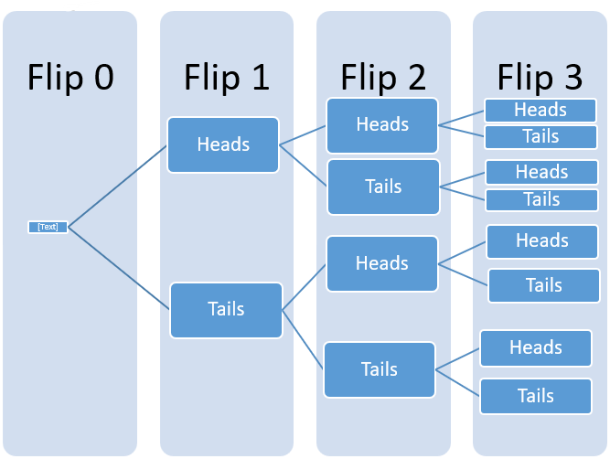

* + For example, the repeated experiment of drawing a marble twice from a bag containing 2 red marbles (each notated as and to distinguish them) and 1 blue marble (notated as b) has the sample space that can be written as:
    - List

{, b, , b, b, b, bb, , }

* + - Written Description

The collection of ordered pairs in which each element is either r1, r2 or b (as shown in the list).

* + - Table

|  |  |  |  |
| --- | --- | --- | --- |
|  | **Red 1** | **Red 2** | **Blue** |
| **Red 1** | R1, R1 | R1, R2 | R1, B |
| **Red 2** | R2, R1 | R2, R2 | R2, B |
| **Blue** | B, R1 | B, R2 | B, B |

* + - Tree Diagram (two options shown)

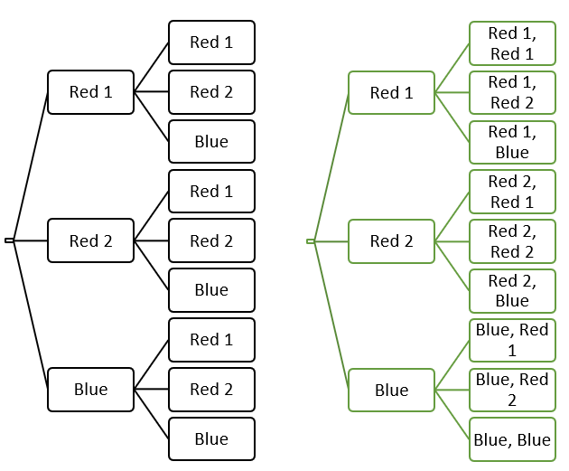

Common Misconceptions or Errors

* Students may incorrectly organize the data using tables or tree diagrams. To address this misconception, start with a small sample space first to ensure students understand the process.

Strategies to Support Tiered Instruction

* Teacher provides examples of small sample spaces and discusses with students how the options are logical, and where they come from. Once students begin to understand small sample spaces, the teacher continues to increase size of sample spaces and have the same conversations.
* Teacher provides examples of situations and has students decide on the sample space necessary.
* Teacher co-creates models with students to represent sample spaces using a coin, die, spinner or a standard deck of cards.
* Instruction includes the use of real-world objects (coin, die, deck of cards, spinner, marbles in a bag, etc.) to demonstrate the possible outcomes for a single experiment and then the possible outcomes if the experiment is repeated.
  + For example, there are three marbles in a bag that are green, yellow and blue. The sample space for the single experiment of drawing a marble in the bag can be written as . If this experiment is repeated twice, the sample space could be written as .
* Instruction includes starting with a small sample space first to ensure students understand the process.

Instructional Tasks

*Instructional Task 1 ((MTR.7.1)*

Brianna flips a round, flat game piece with yellow on one side and white on the other side. Make a tree diagram to show the sample space for flipping the game piece four times.

*Instructional Task 2 (MTR.4.1)*

List or describe all the possible outcomes for each experiment.

|  |  |
| --- | --- |
| **Experiment** | **Sample Space** |
| rolling a fair 6-sided die two times |  |
| flipping a coin three times |  |
| pulling two cards from standard deck with replacement |  |
| a spin from the spinner below two times |  |

Compare your list with a partner and identify any differences. Allow each partner time to discuss their reasoning until an agreement is reached on the correct sample space.

Instructional Items

*Instructional Item 1*

Joanna is spinning a spinner twice with 4 equal sections numbered 1 to 4. What are all the possible outcomes in the sample space?

*The strategies, tasks and items included in the B1G-M are examples and should not be considered comprehensive.

### MA.8.DP.2.2

Benchmark

MA.8.DP.2.2 Find the theoretical probability of an event related to a repeated experiment.

Benchmark Clarifications:

*Clarification 1:* Instruction includes representing probability as a fraction, percentage or decimal.

*Clarification 2:* Experiments to be repeated are limited to tossing a fair coin, rolling a fair die, picking a card randomly from a deck with replacement, picking marbles randomly from a bag with replacement and spinning a fair spinner.

*Clarification 3:* Repetition of experiments is limited to two times except for tossing a coin.

Connecting Benchmarks/Horizontal Alignment

* MA.8.DP.2.1, MA.8.DP.2.3

Terms from the K-12 Glossary

* Event
* Theoretical Probability
* Repeated Experiment
* Experimental Probability

Vertical Alignment

|  |  |
| --- | --- |
| **Previous Benchmarks**   * MA.7.DP.2.1, MA.7.DP.2.2, MA.7.DP.2.3 | **Next Benchmarks**   * MA.912.DP.4.3, MA912.DP.4.9 |

Purpose and Instructional Strategies

|  |
| --- |
| In previous courses, students found the theoretical probability of an event related to a simple experiment. In grade 7 accelerated, students find the theoretical probability of an event related to a repeated experiment. In future courses, students will determine theoretical probabilities to more general experiments and will use a variety of methods, including the addition and multiplication rules.   * Instruction builds on finding sample spaces from MA.8.DP.2.1. Have students discuss their understanding of the words “theoretical” and “probability” to build toward a formal definition of theoretical probability. * Encourage students to use a variety of representations for the sample space, such as a table, tree diagram or list, to assist in determining the total possible outcomes when calculating the probability. Providing opportunities for students to match situations and sample spaces will assist with building their ability to visualize the sample space for any given experiment. * When finding theoretical probability, have students work from their sample space. Doing so will lead to the understanding that since experiments for this benchmark are fair, the probability of an event is equivalent to .   + For example, if tossing a fair coin three times, the sample space is {HHH, HHT, HTH, HTT, THH, THT, TTH, TTT}. If one wants to find , students can circle all the outcomes in the sample space that have at least one T. Since there are 7 such outcomes, one can determine the probability as , or 87.5%. * Instruction focuses on the experiments listed in *Clarification 2*.   + For example, when rolling a 6-sided die twice, . This can be determined by looking at the table of outcomes and circling the 6 outcomes that give a sum of 7.   + For example, when picking a card twice with replacement from a deck that contains each of the five vowels of the alphabet (A, E, I, O and U), . This can be determined by reasoning that there are 9 ways to draw an A, so there are 16 ways to not draw an A.   + For example, when spinning a spinner twice that contains 3 sections where two of the sections are red and the other section is blue, . This can be determined by looking at the list {, b, , b, b, b, bb, , } and circling each of the four outcomes that has the same color twice. * Instruction includes discussing student understanding of the words “theoretical” and “probability” to develop a formal definition of theoretical probability. * Instruction includesnotation. * Students should develop the understanding that the order in which the outcome (from the simple experiment) occurs matters so that probabilities of the outcomes (from the repeated experiment) are the same.   + For example, if the simple experiment is to draw a marble out of bag (that contains 1 blue, 1 green and 1 yellow marble), the outcomes for that simple experiment are {B, G, Y}. If this experiment is repeated two times, there are now nine outcomes: {BB, BG, BY, GG, GB, GY, YY, YB, YG}. If one wanted the , students should be able to see that the drawing a yellow and then a green is as equally likely as drawing a green and then a yellow. Therefore, those are two distinct outcomes. |

Common Misconceptions or Errors

* Students may incorrectly assume that all events are equally likely. To help address this misconception, reinforce that the likelihood of each event depends on the number of possible outcomes in the event.
* Students may incorrectly convert forms of probability between fractions and percentages. To address this misconception, scaffold with more familiar values initially to facilitate the interpretation of the data.

Strategies to Support Tiered Instruction

* Teacher encourages the use of precise language when working with simple experiments and repeated experiments. Students should always note when discussing “outcomes” they specify whether it is an outcome from a simple experiment, such as “heads,” or from a repeated experiment, such as “heads, heads.”
* Teacher facilitates discussion to explain that the outcome for a repeated experiment (a simple experiment that occurs more than once) consists of a sequence of outcomes that occur in the repeated simple experiment. Students should understand that the order in which the outcomes of the simple experiment occur matters when combining to form an outcome of the repeated experiment.
  + For example, if the simple experiment is to toss a coin once, the outcomes for that simple experiment are {H, T}. If this experiment is repeated three times, there are now eight outcomes, each of which is a sequence of Hs and Ts: {HHH, HHT, HTH, HTT, THH, THT, TTH, TTT}. Note that order matters, for instance, HHT is a different outcome than HTH or THH.
* Once students have correctly written the sample space, they can calculate the probability by counting.
  + For example, for the experiment of tossing a coin three times, the sample space can be represented as {HHH, HHT, HTH, HTT, THH, THT, TTH, TTT}. If students want to determine the probability of obtaining exactly one tails in this experiment, they can look through the outcomes of the sample space and highlight all that have exactly one T: {HHH, HHT, HTH, HTT, THH, THT, TTH, TTT}. Then, it can be observed that there are three out of eight highlighted. Therefore, the probability is .
* Instruction includes the use of estimation to find the approximate decimal value of a fraction or mixed number before rewriting in decimal form to help with correct placement of the decimal point.
* Teacher co-creates a graphic organizer modeling conversions between fractions and percentages to understand and visually comprehend the relationship of the equivalent forms.
* Teacher provides opportunities for students to use a 100 frame to review place value for and the connections to decimal, fractional, and percentage forms.

Instructional Tasks

*Instructional Task 1 (MTR.7.1)*

A quiz contains 2 multiple-choice questions with five possible answers each, only one of which is correct. A student plans to guess the answers.

Part A. What is the sample space?

Part B. What is the probability the student guesses wrong answers for both questions?

Part C. What is the probability the student guesses the correct answers for both questions?

Part D. What is the probability the student guesses at least one correct answer?

*Instructional Task 2 (MTR.3.1)*

A fair 6-sided die is tossed twice.

Part A. What is the sample space?

Part B. Find the probability that the sum of the two results is even.

Instructional Items

*Instructional Item 1*

There are 3 red, 1 blue and 2 green marbles in a bag. A marble is randomly drawn from the bag twice, with replacement. What is the theoretical probability of choosing one red marble and one green marble?

*Instructional Item 2*

A fair coin is tossed four times. What is ?

*The strategies, tasks and items included in the B1G-M are examples and should not be considered comprehensive.

### MA.8.DP.2.3

Benchmark

MA.8.DP.2.3 Solve real-world problems involving probabilities related to single or repeated experiments, including making predictions based on theoretical probability.

Example: If Gabriella rolls a fair die 300 times, she can predict that she will roll a 3 approximately 50 times since the theoretical probability is .

Example: Sandra performs an experiment where she flips a coin three times. She finds the theoretical probability of landing on exactly one head as . If she performs this experiment 50 times (for a total of 150 flips), predict the number of repetitions of the experiment that will result in exactly one of the three flips landing on heads.

Benchmark Clarifications:

*Clarification 1:* Instruction includes making connections to proportional relationships and representing probability as a fraction, percentage or decimal.

*Clarification 2:* Experiments to be repeated are limited to tossing a fair coin, rolling a fair die, picking a card randomly from a deck with replacement, picking marbles randomly from a bag with replacement and spinning a fair spinner.

*Clarification 3:* Repetition of experiments is limited to two times except for tossing a coin.

Connecting Benchmarks/Horizontal Alignment

* MA.8.DP.2.2

Terms from the K-12 Glossary

* Theoretical Probability

Vertical Alignment

|  |  |
| --- | --- |
| **Previous Benchmarks**   * MA.7.DP.1.3, MA.7.DP.1.4 * MA.7.DP.2.1, MA.7.DP.2.3 | **Next Benchmarks**   * MA.912.DP.4.3, MA.912.DP.4.9 |

Purpose and Instructional Strategies

In previous courses, students used a simulation of a simple experiment to find experimental probabilities and compare them to theoretical probabilities. In grade 7 accelerated, students solve real-world problems involving probabilities related to single or repeated experiments, including making predictions based on theoretical probability. In future courses, students will expand their knowledge to include more general experiments as well as using and interpreting independence and probability.

* Students should understand that results from an experiment do not always match the theoretical results, but if they perform a large number of trials, they should be close.
* When determining experimental probabilities, students should understand that this may be done by performing a simple experiment more than once and also by performing a repeated experiment more than once.
  + For example, to determine the experimental probability of tossing four heads in a row, the repeated experiment of tossing a coin four times will need to be performed many times (see also *Benchmark Example 2*).
* Instruction includesnotation.
* Instruction includes opportunities for students to run various numbers of trials to discover that the increased repetition of the experiment will bring the experimental probability closer to the theoretical. Use virtual simulations to quickly show higher and higher volumes of repetition that would be difficult to create with physical manipulatives *(MTR.5.1)*.
* When comparing theoretical to experimental probability, it is important to not just compare the number of times the event occurs, but the probabilities themselves.

Common Misconceptions or Errors

* Students may incorrectly assume the theoretical and experimental probabilities of the same experiment will always be the same. To address this misconception, provide multiple opportunities for students to experience simulations of different situations, with physical or virtual manipulatives, to find and compare the experimental and theoretical probabilities.
* Students may incorrectly expect to see every possible outcome occur during a simulation. While all may occur in a simulation, it is not certain to happen. Students may inadvertently let their own experience with an experiment affect their response.
  + For example, during an experiment if a student never draws an ace from a standard deck of cards, this does not indicate it could never happen.
* Students may incorrectly believe the theoretical probability of an event is the proportion of times that event will actually occur.

Strategies to Support Tiered Instruction

* Teacher reviews the root words theoretical (theory) and experimental (experiment) and discusses the difference between a theoretical probability and experimental probability. Teacher provides a graphic organizer to keep as a reference for root words.
  + For example, experimental probabilities are from simulations whereas theoretical probabilities are from calculations.
* Teacher provides opportunities to discuss the difference between simulating simple experiments and simulating repeated experiments.
  + For example, students could discuss tossing a coin 150 times as a simulation of the simple (single) experiment “tossing a coin” and tossing a coin 150 times as a simulation of the repeated experiment “tossing a coin three times.” In the first case, the simulation has 150 trials whereas the second simulation has 50 trials.
* Teacher sets up a simulation with several trials to work through and discuss what ‘we think’ should happen (Theoretical Probability) and what actually happens when the experiment is completed (Experimental Probability). Then, the teacher models how to find experimental probability, showing how the more trials that are done, the closer the results should get closer to the theoretical probability. Teacher provides instruction focused on color-coding when setting up a proportional relationship to ensure corresponding parts are placed in corresponding positions within the proportion.
  + For example, if Jason chooses a card from a standard deck of cards 104 times and replaces the card each time, what is a reasonable prediction on how many times he will choose a heart?
* Instruction includes providing multiple opportunities to experience simulations of different situations, with physical or virtual manipulatives, to find and compare the experimental and theoretical probabilities.

Instructional Tasks

*Instructional Task 1 (**MTR.5.1)*

The bar graph shows the results of spinning the spinner 200 times.

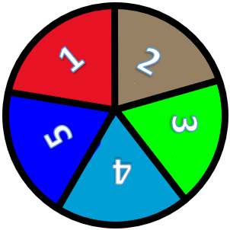 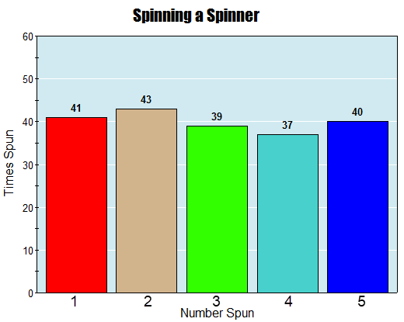

Part A. If the repeated experiment is to spin the spinner twice, predict how many times the event of landing on the same number twice will occur in 100 simulations of the repeated experiment.

Part B. Using technology, perform a simulation of the experiment described in Part A.

Part C. Compare the number of times you actually landed on the same number twice during the simulation to your prediction from Part A.

*Extension:* How would you expect the data to change if the spinner had 6 equal sessions?

Instructional Items

*Instructional Item 1*

If Jackson rolls a fair 6-sided die 200 times, what is a reasonable prediction on how many times he will roll a 4?

*Instructional Item 2*

A spinner is divided into three equal parts 1-3. The repeated experiment of spinning the spinner twice is simulated 300 times. A table of outcomes is shown.

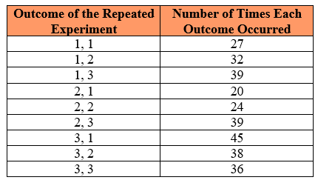

Based on the table, what is the experimental probability that the sum of the two outcomes is at least 4?

*The strategies, tasks and items included in the B1G-M are examples and should not be considered comprehensive.

# Appendix A. Summary of Changes

The purpose of this table is to provide a summary of changes from the latest version of the B1G-M. For questions or feedback on the B1G-M, please direct them to [BESTMath@fldoe.org](mailto:BESTMath@fldoe.org).

| **Benchmark** | **B1G-M Component** | **Change Made** |
| --- | --- | --- |
| MA.7.NSO.1.1 | Vertical Alignment | REMOVED hyperlink and text; ADDED MA.8.NSO.1.7 |
| MA.7.NSO.1.1 | Strategies to Support Tiered Instruction | ADDED headings (centered) to tables under bullet 1 open bullet and under bullet 2 open bullet to read: "Doubling " in the left column header and "Squaring" in the right column header for BOTH tables. |
| MA.7.NSO.1.2 | Connecting Benchmarks/Horizontal Alignment | REMOVED benchmarks MA.7.NSO.2, MA.7.AR.3, MA.7.GR.1, MA.7.GR.2, MA.7.DP.2.5; ADDED benchmarks MA.7.AR.3.1, MA.7.AR.3.3, MA.7.DP.2.2, MA.7.DP.2.4 |
| MA.7.NSO.1.2 | Vertical Alignment | REMOVED hyperlink and text |
| MA.7.NSO.1.2 | Purpose and Instructional Strategies | 4th bullet DELETE "-" after "to" and DELETED "showcase" and REPLACED with "highlight. At the 4th bullet and open bullet, INDENTED example and highlight INSTEAD of using it as a 2nd open bullet. |
| MA.7.NSO.1.2 | Purpose and Instructional Strategies | Added a NEW bullet after bullet 4: "Repeating decimals can be written using a repeating bar, a truncated decimal form, fraction or maybe rounded depending on the problem and the directions to the problem." |
| MA.8.NSO.1.4 | Connecting Benchmarks/Horizontal Alignment | ADDED benchmarks MA.8.NSO.1.5 and MA.8.NSO.1.6; REMOVED MA.8.GR.1.2 |
| MA.8.NSO.1.4 | Vertical Alignment | REMOVED hyperlink and text; EDITED MA.912.GR.4 to include .5 at the end |
| MA.8.NSO.1.5 | Connecting Benchmarks/Horizontal Alignment | ADDED MA.8.NSO.1.4 and MA.8.NSO.1.6; REMOVED GR.1.2 |
| MA.8.NSO.1.5 | Vertical Alignment | REMOVED hyperlink and text |
| MA.8.NSO.1.6 | Connecting Benchmarks/Horizontal Alignment | ADDED benchmarks MA.8.NSO.1.4 and MA.8.NSO.1.5; REMOVED MA.8.GR.1.2 |
| MA.8.NSO.1.6 | Vertical Alignment | REMOVED hyperlink and text |
| MA.8.NSO.1.7 | Connecting Benchmarks/Horizontal Alignment | REMOVED benchmark MA.8.AR.1.3 |
| MA.8.NSO.1.7 | Vertical Alignment | REMOVED hyperlink and text |
| MA.7.AR.2.2 | Connecting Benchmarks/Horizontal Alignment | REMOVED benchmark MA.7.NSO.2 and MA.7.NSO.3; ADDED benchmarks MA.7.NSO.2.1, MA.7.NSO.2.2, MA.7.NSO.2.3, MA.7.AR,.3.1, MA.7.AR.3.2, MA.7.AR.3.3 |
| MA.7.AR.2.2 | Purpose and Instructional Strategies | In the introductory paragraph MOVED "In grade 6" and "In grade 7" and "In grade 8" to the beginning of the sentence instead of the end; DELETED "being critical as" and "then" in sentence 2 of the introductory paragraph. In sentence 3 ADDED "students solve" in front of "multi-step". |
| MA.7.AR.3.3 | Connecting Benchmarks/Horizontal Alignment | REMOVED benchmarks MA.7.NSO.2, MA.7.GR.1 and MA.7.GR.2 and ADDED benchmarks MA.7.NSO.2.1, MA.7.NSO.2.2, MA.7.NSO.2.3, MA.7.AR.2.2, MA.7.AR.4.3 |
| MA.7.AR.4.1 | Connecting Benchmarks/Horizontal Alignment | REMOVED benchmark MA.7.NSO.2 and ADDED benchmarks MA.7.NSO.2.1, MA.7.NSO.2.2, MA.7.NSO.2.3 |
| MA.7.AR.4.1 | Purpose and Instructional Strategies | Introductory paragraph, 2nd sentence, DELETED the -s in "grades 7" and place a period after variables. Begin the next sentence with a capital letter and REPLACED "they" with "students". |
| MA.7.AR.4.1 | Purpose and Instructional Strategies | In the 2nd bullet CHANGE "allow" to "should allow" |
| MA.7.AR.4.1 | Strategies to Support Tiered Instruction | CHANGED "co-constructs" to "co-creates" |
| MA.7.AR.4.2 | Connecting Benchmarks/Horizontal Alignment | REMOVED benchmark MA.7.NSO.2 and ADDED benchmarks MA.7.NSO.2.1, MA.7.NSO.2.2, MA.7.NSO.2.3 |
| MA.7.AR.4.2 | Strategies to Support Tiered Instruction | CHANGED "co-constructs" to "co-creates" |
| MA.7.AR.4.3 | Connecting Benchmarks/Horizontal Alignment | REMOVED benchmark MA.7.NSO.2 and ADDED benchmarks MA.7.NSO.2.1, MA.7.NSO.2.2, MA.7.NSO.2.3 |
| MA.7.AR.4.3 | Common Misconceptions or Errors | REMOVED open bullet point about determining dependent and independent values; INSERTED new 2nd bullet to follow the 1st bullet: "In grade 7, it is not the expectation that students define independent and dependent variables. Students may have experience with these terms from other content areas." |
| MA.7.AR.4.4 | Connecting Benchmarks/Horizontal Alignment | EXPANDED benchmark MA.7.NSO.2 to include 2.1, 2.2, 2.3; EXPANDED benchmark MA.7.AR.3 to include 3.1, 3.2, 3.3; ADDED benchmark MA.7.GR.2.2 |
| MA.7.AR.4.4 | Instructional Tasks | ADDED task 2: "Instructional Task 2: Kelsi works as a lifeguard at the local pool. After an 8-hour day at work, she earns $100. Part A. Write an equation that describes the relationship between the number of hours worked and the amount of money that she earns. Part B. Kelsi would like to earn $450 to buy a new gaming system. Use your equation to determine how many hours she needs to work to buy a new gaming system." |
| MA.7.AR.4.4 | Instructional Items | REMOVED item 1 to Instructional Task 2 and ADDED a new Instructional item 1: "Saylor needs to walk her dog Holloway every day after work. After 5 days Saylor has walked her dog a total of 200 minutes. Write an equation that describes the relationship between the amount of minutes Saylor walked her dog each day." |
| MA.7.AR.4.5 | Connecting Benchmarks/Horizontal Alignment | EXPANDED benchmark MA.7.NSO.2 to include 2.1, 2.2, 2.3; ADDED benchmark MA.7.AR.2.2; EXPANDED benchmark MA.7.AR.3 to include 3.1, 3.2, 3.3; ADDED benchmark MA.7.GR.1.5, MA.7.GR.2.2 and MA.7.GR.2.3 |
| MA.7.AR.4.5 | Purpose and Instructional Strategies | ADDED a new bullet 4: "In grade 7, it is not the expectation that students define independent and dependent variables. Students may have experience with these terms from other content areas." |
| MA.7.AR.4.5 | Common Misconceptions or Errors | DELETED both bullets and INSERT a new bullet to read: "Students may invert values when setting up proportions." |
| MA.7.AR.4.5 | Strategies to Support Tiered Instruction | Bullet 1, REMOVED last two open bullets about independent and dependent variables |
| MA.7.AR.4.5 | Instructional Item 1 | CHANGED "will it" to "it will" |
| MA.8.AR.1.3 | Instructional Items | ADDED a new Instructional Item 1 and updated the one that was already there as the 2nd Instructional Item. |
| MA.8.AR.2.1 | Connecting Benchmarks/Horizontal Alignment | REMOVED benchmarks MA.8.AR.3 and MA.8.AR.4; ADDED MA.8.AT.4.1 and MA.8.GR.1.6 |
| MA.8.AR.2.1 | Vertical Alignment | EDITED benchmark MA.7.AR.2.1 to be MA.7.AR.2.2 |
| MA.8.AR.2.1 | Common Misconceptions or Errors | EDITED 3rd bullet point for clarification |
| MA.8.AR.2.1 | Strategies to Support Tiered Instruction | EDITED 1st bullet point and 1st open point; ADDED spacing before example of repeated addition; EDITED 2nd bullet point to define the variable and clarity; edited 5th bullet point for grammar and removed example of added addition |
| MA.8.AR.2.2 | Vertical Alignment | EDITED benchmark MA.7.AR.2.1 to be MA.7.AR.2.2; REMOVED benchmarks MA.912.AR.2.7 and MA.912.AR.2.8 |
| MA.8.AR.2.2 | Purpose and Instructional Strategies | EDITED for grammar |
| MA.8.AR.2.2 | Strategies to Support Tiered Instruction | EDITED first open bullet point to define the variable |
| MA.8.AR.2.3 | Connecting Benchmarks/Horizontal Alignment | ADDED benchmark MA.8.NSO.1.1; REMOVED benchmark MA.8.NSO.1.2 |
| MA.8.AR.2.3 | Terms from the K-12 Glossary | ADDED "whole numbers" |
| MA.8.AR.2.3 | Strategies to Support Tiered Instruction | LABELED example table under both open points |
| MA.8.AR.3.1 | Connecting Benchmarks/Horizontal Alignment | REMOVED MA.8.AR.2.1 and ADDED MA.8.GR.2.4 |
| MA.8.AR.3.1 | Vertical Alignment | ADDED benchmarks MA.7.AR.4.2 and MA.7.AR.4.4 as well as MA.912.AR.2.4 and MA.912.F.1.3 |
| MA.8.AR.3.1 | Purpose and Instructional Strategies | EDITED for grammar |
| MA.8.AR.3.1 | Instructional Tasks | EDITED task 2 by removing Part A and making it a one-part question |
| MA.8.AR.3.2 | Connecting Benchmarks/Horizontal Alignment | REMOVED MA.8.AR.2.1 and ADDED benchmarks MA.8.AR.3.3, MA.8.AR.3.5 and MA.8.GR.2.4 |
| MA.8.AR.3.2 | Purpose and Instructional Strategies | EDITED for grammar AND to ensure the slope formula matches the reference sheet |
| MA.8.AR.3.2 | Instructional Item | ADDED a new Instructional Item 1 and updated the one that was already there as the 2nd Instructional Item. |
| MA.8.AR.3.3 | Connecting Benchmarks/Horizontal Alignment | REMOVED MA.8.AR.2.1 and ADDED benchmarks MA.8.AR.3.2 and MA.8.AR.3.5 |
| MA.8.AR.3.3 | Strategies to Support Tiered Instruction | EDITED to ensure the slope formula matches the reference sheet |
| MA.8.AR.3.4 | Connecting Benchmarks/Horizontal Alignment | REMOVED MA.8.AR.2.1 |
| MA.8.AR.3.4 | Strategies to Support Tiered Instruction | EDITED to ensure the slope formula matches the reference sheet |
| MA.8.AR.3.5 | Connecting Benchmarks/Horizontal Alignment | DELETED MA.8.AR.2.1 and ADDED benchmarks MA.AR.3.2 and MA.8.AR.3.3 |
| MA.8.AR.3.5 | Strategies to Support Tiered Instruction | EDITED to ensure the slope formula matches the reference sheet |
| MA.8.AR.4.1 | Connecting Benchmarks/Horizontal Alignment | ADDED benchmarks MA.8.AR.4.2 and MA.8.AR.4.3 |
| MA.8.AR.4.2 | Connecting Benchmarks/Horizontal Alignment | ADDED benchmarks MA.8.AR.4.1 and MA.8.AR.4.3 |
| MA.8.AR.4.2 | Strategies to Support Tiered Instruction | EDITED final sentence |
| MA.8.AR.4.3 | Connecting Benchmarks/Horizontal Alignment | REMOVED MA.8.R.2.1 and ADDED benchmarks MA.8.AR.4.1 and MA.8.AR.4.2 |
| MA.8.AR.4.3 | Instructional Items | EDITED the slope and arrangement on item 4 |
| MA.8.F.1.1 | Connecting Benchmarks/Horizontal Alignment | ADDED MA.8.F.1.2 and MA.8.F.1.3 |
| MA.8.F.1.1 | Strategies to Support Tiered Instruction | EDITED for grammar |
| MA.8.F.1.2 | Connecting Benchmarks/Horizontal Alignment | ADDED benchmarks MA.8.F.1.1 and MA.8.F.1.3 |
| MA.8.F.1.2 | Strategies to Support Tiered Instruction | CHANGED "co-constructs" to "co-creates" |
| MA.8.F.1.3 | Connecting Benchmarks/Horizontal Alignment | ADDED benchmarks MA.8.F.1.1 and MA.8.F.1.2 |
| MA.7.GR.1.3 | Connecting Benchmarks/Horizontal Alignment | Expanded benchmarks to include: MA.7.NSO.2.1, MA.7.NSO.2.2, MA.7.NSO.2.3, MA.7.AR.3.2, MA.7.GR.2.1, MA.7.GR.2.2 |
| MA.7.GR.1.3 | Strategies to Support Tiered Instruction | CHANGED "co-constructs" to "co-creates" |
| MA.7.GR.1.4 | Connecting Benchmarks/Horizontal Alignment | EXPANDED benchmark MA.7.GR.2 to include 2.1, 2.2, 2.3; ADDED benchmark MA.7.NSO.1.1; REMOVED benchmarks MA.7.NSO.2 and MA.7.DP.1.4 |
| MA.7.GR.1.4 | Vertical Alignment | ADDED sentence: "This is the first introduction to circles outside of recognizing the shape in early elementary". REMOVED MA.6.GR.2.2 |
| MA.7.GR.1.4 | Purpose and Instructional Strategies | Introductory paragraph DELETED "a" in front of "circles". 1st open bullet: CHANGED "dashed lined" to "lines drawn". Added an image under 1st open bullet. |
| MA.7.GR.1.4 | Strategies to Support Tiered Instruction | 3rd and 4th bullets CHANGED "co-constructs" to "co-creates"; ADDED "of" in front of "proportionality" in bullet 4. |
| MA.7.GR.1.4 | Strategies to Support Tiered Instruction | ADDED headings to tables under bullet 5 open bullet to read: "Doubling " in the left column header and "Squaring" in the right column header. |
| MA.7.GR.1.4 | Instructional Task 1 | Introductory paragraph DELETED "and" and REPLACED with "inside" in the 1st sentence; ADDED "with" in front of "seven small circles" |
| MA.7.GR.1.4 | Instructional Item 3 | REPLACED image under item 3 to an updated image. |
| MA.7.GR.1.5 | Connecting Benchmarks/Horizontal Alignment | REMOVED benchmarks MA.7.NSO.2, MA.7.AR.3.3, MA.7.AR.4.1 |
| MA.7.GR.1.5 | Vertical Alignment/Next Benchmarks | REMOVED benchmarks MA.6.GR.1.3 and MA.912.GR.4.4 |
| MA.7.GR.1.5 | Purpose and Instructional Strategies | Bullet 1 ADDED "Calculations" in front of "begin" in the 3rd sentence. |
| MA.7.GR.1.5 | Purpose and Instructional Strategies | Bullet 2, 3rd sentence, INSERTED "using its multiplicative inverse" after "by multiplication" and INSERTED "whose absolute value is" after "by a factor". |
| MA.7.GR.1.5 | Purpose and Instructional Strategies | Bullet 3, DELETED "Have" and REPLACED with "Instruction includes having" |
| MA.7.GR.1.5 | Purpose and Instructional Strategies | Bullet 4, 4th sentence, ADDED "Then" in front of "have" and DELETED "then" after "students". 5th sentence DELETED "Then" and REPLACED with "Finally, students should". |
| MA.7.GR.1.5 | Strategies to Support Tiered Instruction | 2nd bullet DELETED "verses" and REPLACE with "relative to" |
| MA.7.GR.1.5 | Instructional Task 2 | DELETED the "dash" in-between "scale" and "drawing" |
| MA.7.GR.1.5 | Instructional Item 1 | 1st sentence: DELETED "needs to" and REPLACED with "will". 2nd sentence: DELETED "is this" and ADDED "should be used?" at the end. |
| MA.7.GR.1.5 | Instructional Item 2 | 1st sentence CHANGED "repaint" to "paint". DELETED the last sentence and REPLACED with a question at the end: "What is the actual area Andrew will need to paint?" |
| MA.7.GR.2.1 | Connecting Benchmarks/Horizontal Alignment | EXPANDED benchmark MA.7.NSO.2 to include 2.1, 2.2, 2.3; ADDED benchmark MA.7.GR.2.3; REMOVED benchmarks MA.7.GR.1.2 and MA.7.GR.1.4 |
| MA.7.GR.2.1 | Vertical Alignment/Previous Benchmarks | ADDED sentence: "This is the first introduction to cylinders outside of recognizing the shape in early elementary." REMOVED MA.6.GR.2.2 and MA.6.GR.2.4 |
| MA.7.GR.2.1 | Purpose and Instructional Strategies | 3rd bullet DELETED "for" after "allows"; ADDED a bullet point at the end: "Instruction focuses on recognizing the height of a cylinder as the perpendicular distance between the parallel (circular) bases." |
| MA.7.GR.2.1 | Common Misconceptions or Errors | 2nd bullet, 1st sentence, DELETED "believe" and REPLACED with "invert the height and base of a cylinder when the cylinder is presented horizontally." Also in this same bullet 2, DELETED "that the part of the cylinder is lying flat is the base of the figure." 2nd bullet, 2nd sentence, DELETED "with the height being the perpendicular distance between them. Provide multiple orientations of objects and continue to break them down to their nets" and ADDED "parallel" in front of "circles". |
| MA.7.GR.2.1 | Common Misconceptions or Errors | 3rd bullet, 1st sentence, DELETED "often forget" and "or confuse" and REPLACED with "may incorrectly apply". 3rd bullet, 2nd sentence, DELETED "will be important in fostering" and REPLACED with "to foster". |
| MA.7.GR.2.1 | Strategies to Support Tiered Instruction | Bullet 3 @ open bullet and last sentence, DELETED "The" and REPLACED with "A" in front of "base is highlighted…" |
| MA.7.GR.2.1 | Strategies to Support Tiered Instruction | Bullet 5 DELETED "Teacher directs students to" and REPLACED with "Instruction includes" and CHANGED "find" to "finding" |
| MA.7.GR.2.1 | Strategies to Support Tiered Instruction | Bullet 7 DELETED "focused on" and REPLACED with "using" |
| MA.7.GR.2.1 | Strategies to Support Tiered Instruction | Bullet 8 DELETED "the" and REPLACE with "a" in front of formula. |
| MA.7.GR.2.1 | Strategies to Support Tiered Instruction | DELETED the last bullet and REPLACED with "Provide multiple orientations of cylinders, focusing on the height as the perpendicular distance between the parallel bases, continuing to break them down to their nets." |
| MA.7.GR.2.1 | Instructional Task 1 | Task 1, last sentence, ADDED "that needs" after "surface area" and DELETED "so they may order the needed supplies." |
| MA.7.GR.2.1 | Instructional Task 2 | Task 2, 1st sentence, DELETED "the" and REPLACED with "a" in front of blue room, INSERTED "at the resort after "blue room", DELETED "rather than floating". NEXT, ADDED this sentence: "The room is 34 feet in diameter with a height of 9 feet." Next sentence, DELETED "So" and capitalize "The". |
| MA.7.GR.2.2 | Connecting Benchmarks/Horizontal Alignment | EXPANDED benchmark MA.7.NSO.2 to include 2.1, 2.2, 2.3; ADDED benchmarks MA.7.NSO.1.1, MA.7.AR.2.2, MA.7.AR.4.4, MA.7.GR.2.3 |
| MA.7.GR.2.2 | Vertical Alignment/Previous Benchmarks | ADDED sentence: "This is the first introduction to cylinders outside of recognizing the shape in early elementary." REMOVED MA.6.GR.2.2 and MA.6.GR.2.4 |
| MA.7.GR.2.2 | Purpose and Instructional Strategies | REMOVED "(working backwards)" |
| MA.7.GR.2.2 | Common Misconceptions or Errors | REMOVED the last bullet point; ADDED two bullet points: Bullet 2, "Students may incorrectly invert the height and base of a cylinder when the cylinder is presented horizontally. To address this misconception, remind students that while a cylinder may lay on its side, the bases are the parallel circles." Bullet 3, "Students may incorrectly apply the formulas for area, surface area and volume. to address this misconception, use these concepts in context, or a manner in which they understand the meaning behind the terms to foster conceptual development (MTR.7.1)." |
| MA.7.GR.2.2 | Strategies to Support Tiered Instruction | Bullet 4, REPLACED "co-creates" with "models". |
| MA.7.GR.2.2 | Strategies to Support Tiered Instruction | Bullet 6 INSERTED "co-creating a graphic organizer of a right circular cylinder and…" after "Instruction includes" and DELETED "of a right circular cylinder" at the end of the sentence. |
| MA.7.GR.2.2 | Strategies to Support Tiered Instruction | Last bullet, DELETED both sentences and REPLACED with "Provide multiple orientations of cylinders, focusing on the height as the perpendicular distance between the parallel bases, continuing to break them down to their nets." |
| MA.7.GR.2.3 | Connecting Benchmarks/Horizontal Alignment | EXPANDED benchmark MA.7.NSO.2 to include 2.1, 2.2, 2.3; ADDED benchmark MA.7.NSO.1.1, MA.7.AR.2.2, MA.7.AR.4.5, MA.7.GR.2.1, MA.7.GR.2.2 |
| MA.7.GR.2.3 | Purpose and Instructional Strategies | Introductory paragraph DELETED "Students progress...and spheres in high school." and REPLACED with "In grade 6, students found the volume of rectangular prisms and right rectangular pyramids using the area of the base. In grade 7m students find the volume of a right circular cylinder and build that into solving real-world problems involving their volume using the area of their circular base. In high school, students will solve mathematical and real-world problems involving the volume of cylinders, pyramids, prisms, cones and spheres." INDENTED a new bullet with "Instruction builds on students' knowledge..." |
| MA.7.GR.2.3 | Purpose and Instructional Strategies | 2nd bullet DELETED "Ask" and REPLACE with "Instruction encourages". DELETED "Provide" and REPLACED with "Students are provided"…DELETED "for students" after "cylinders". |
| MA.7.GR.2.3 | Common Misconceptions or Errors | 2nd bullet, 2nd sentence, INSERTED "parallel" in front of circles |
| MA.7.GR.2.3 | Common Misconceptions or Errors | ADDED two bullet points: Bullet 3, "Students may incorrectly invert the height and base of a cylinder when the cylinder is presented horizontally. To address this misconception, remind students that while a cylinder may lay on its side, the bases are the parallel circles." Bullet 4, "Students may incorrectly apply the formulas for area, surface area and volume. To address this misconception, use these concepts in context, or a manner in which they understand the meaning behind the terms to foster their conceptual development (MTR. 7.1)." |
| MA.7.GR.2.3 | Strategies to Support Tiered Instruction | Bullet 4 DELETED "instructs students to draw" and REPLACED with "co-creates". At the end of the sentence REMOVED the period and REPLACE with a comma and ADDED "and color-coding and labeling dimensions." |
| MA.7.GR.2.3 | Strategies to Support Tiered Instruction | REMOVED bullet 6 "Instruction includes co-constructing…" |
| MA.7.GR.2.3 | Strategies to Support Tiered Instruction | DELETED last bullet and REPLACED with "Provide multiple orientations of cylinders, focusing on the height as the perpendicular distance between the parallel bases, continuing to break them down to their nets." |
| MA.7.GR.2.3 | Instructional Task 1 | Task 1, ADDED a dash in between to read as follows: "record-breaking" |
| MA.7.GR.2.3 | Instructional Task 2 | Task 2, last sentence, CHANGED to read as follows: "What is the volume of water needed to fill the pool 2 inches from the top? Justify your solution." |
| MA.8.GR.2.1 | Vertical Alignment | ADDED benchmarks MA.912.F.2.2 and MA.912.GR.2.3 and MA.912.GR.2.4 |
| MA.8.GR.2.1 | Purpose and Instructional Strategies | EDITED introductory paragraph for consistency and grammar |
| MA.8.GR.2.2 | Connecting Benchmarks/Horizontal Alignment | ADDED benchmarks MA.8.GR.2.1 and MA.8.GR.2.3 |
| MA.8.GR.2.2 | Vertical Alignment | ADDED benchmarks MA.912.F.2.1, MA.912.F.2.2, MA.912.GR.2.1, MA.912.2.3, and MA.912.GR.2.4; REMOVED benchmarks MA.912.F.2 and MA.912.GR.2 |
| MA.8.GR.2.3 | Connecting Benchmarks/Horizontal Alignment | ADDED benchmarks MA.8.GR.2.1 and MA.8.GR.2.2 |
| MA.8.GR.2.3 | Vertical Alignment | ADDED benchmarks MA.912.F.2.1, MA.912.F.2.2, MA.912.GR.2.1, MA.912.2.3, and MA.912.GR.2.4; REMOVED benchmarks MA.912.F.2 and MA.912.GR.2 |
| MA.8.GR.2.3 | Purpose and Instructional Strategies | Edited first bullet point for clarification |
| MA.8.GR.2.3 | Common Misconceptions or Errors | ADDED another bullet point |
| MA.8.GR.2.3 | Strategies to Support Tiered Instruction | ADDED "tracing paper" to the first bullet point |
| MA.8.GR.2.4 | Connecting Benchmarks/Horizontal Alignment | DELETED MA.8.GR.1.4, MA.8.GR.1.5 and MA.8.GR.1.6 |
| MA.8.GR.2.4 | Vertical Alignment | ADDED benchmark MA.7.AR.3.2 |
| MA.7.DP.1.4 | Connecting Benchmarks/Horizontal Alignment | REMOVED benchmarks MA.7.AR.3.2 and MA.7.AR.4.5, ADDED benchmarks MA.7.GR.1.4, MA.7.AR.3.1 |
| MA.7.DP.1.4 | Purpose and Instructional Strategies | Introductory paragraph, 1st sentence, ADDED "and their percentages." to the end of that sentence. The last sentence DELETED "data, depending on whether it is" and DELETED "on whether it is" after "and". |
| MA.7.DP.1.4 | Purpose and Instructional Strategies | 1st bullet, 2nd sentence, CHANGED "totaling" to "that equal" |
| MA.7.DP.1.4 | Purpose and Instructional Strategies | MOVED the end of 1st bullet point into "Limitations" and DELETED the word "however" and the punctuation around "however" |
| MA.7.DP.1.4 | Purpose and Instructional Strategies | 4th bullet, 1st sentence DELETED "Students should" and REPLACED with "Instruction should include opportunities for students to…" 4th bullet, open bullet, 2nd sentence DELETED "emphasize" and CHANGED "using" to "use" |
| MA.7.DP.1.4 | Common Misconceptions or Errors | ADDED bullet 3: "Students may incorrectly use a protractor. To address this issue, provide students with a circle and allow them to measure sections and then find the percent." |
| MA.7.DP.1.4 | Strategies to Support Tiered Instruction | Bullet 2 DELETED "aloud" |
| MA.7.DP.1.4 | Strategies to Support Tiered Instruction | Bullet 3 DELETED "how to properly round proper" and REPLACED with "appropriate rounding" |
| MA.7.DP.1.4 | Strategies to Support Tiered Instruction | DELETED bullet 6, which reads "For students incorrectly…" |
| MA.7.DP.1.5 | Connecting Benchmarks/Horizontal Alignment | REMOVED benchmark MA.7.NSO.1.2 |
| MA.7.DP.1.5 | Purpose and Instructional Strategies | 4th bullet, 2nd sentence DELETED "graph" and REPLACED with "charts"; in parentheses DELETED "charts" and REPLACED with "graphs". NEW bullet 5 should start at "Stem-and-leaf plots…" |
| MA.7.DP.1.5 | Purpose and Instructional Strategies | ADDED last bullet: "As an enrichment to this benchmark, students could explore segmented bar charts as they will be introduced to this in Algebra I. (MA.912.DP.1.1)" |
| MA.7.DP.1.5 | Instructional Task 1 | Part A ADDED "a" in front of "histogram" and DELETED "-s" at the end of "histograms, bar charts, circle graphs, line plots, box plots, stem-and-leaf plots". |
| MA.8.DP.1.1 | Connecting Benchmarks/Horizontal Alignment | DELETED MA.8.AR.3 and ADDED MA.8,.DP.1.2 and MA.8.DP.1.3 |
| MA.8.DP.1.1 | Instructional Tasks | EDITED values in task 1 |
| MA.8.DP.1.1 | Instructional Items | Updated Item 2 |
| MA.8.DP.1.2 | Connecting Benchmarks/Horizontal Alignment | DELETED MA.8.AR.3 and ADDED MA.8,.DP.1.1 and MA.8.DP.1.3 |
| MA.8.DP.1.2 | Purpose and Instructional Strategies | EDITED grammar |
| MA.8.DP.1.2 | Strategies to Support Tiered Instruction | EDITED first bullet point for clarity and inclusion of all associations |
| MA.8.DP.1.3 | Connecting Benchmarks/Horizontal Alignment | ADDED MA.8.AR.3.1, 3.2, 3.3, 3.4, & 3.5; ADDED MA.8.DP.1.1 and MA.8.DP.1.2 |
| MA.8.DP.1.3 | Purpose and Instructional Strategies | EDITED grammar |
| MA.8.DP.2.1 | Connecting Benchmarks/Horizontal Alignment | ADDED benchmark MA.8.DP.2.2 |
| MA.8.DP.2.1 | Purpose and Instructional Strategies | MOVED a bullet point up on the list |
| MA.8.DP.2.2 | Connecting Benchmarks/Horizontal Alignment | ADDED benchmark MA.8.DP.2.1 and MA.8.DP.2.2 |
| MA.8.DP.2.2 | Terms from the K-12 Glossary | ADDED "Repeated Experiment" and "Experimental Probability" |
| MA.8.DP.2.2 | Vertical Alignment | ADDED MA.7.DP.2.1 and MA.7.DP.2.2 REMOVED benchmarks MA.912.DP.4.2, MA.912.DP.4.7 and MA.912.DP.4.8 |
| MA.8.DP.2.2 | Purpose and Instructional Strategies | EDITED for grammar |
| MA.8.DP.2.2 | Common Misconceptions or Errors | EDITED for grammar |
| MA.8.DP.2.3 | Connecting Benchmarks/Horizontal Alignment | REMOVED benchmarks MA.8.NSO.1.2 and MA.8.NSO.1.7; ADDED benchmark MA.8.DP.2.2 |
| MA.8.DP.2.3 | Vertical Alignment | ADDED benchmarks MA.7.DP.1.3, MA.7.DP.1.4, MA.7.DP.2.3 and MA.912.DP.4.9 |