Florida Workforce Regions
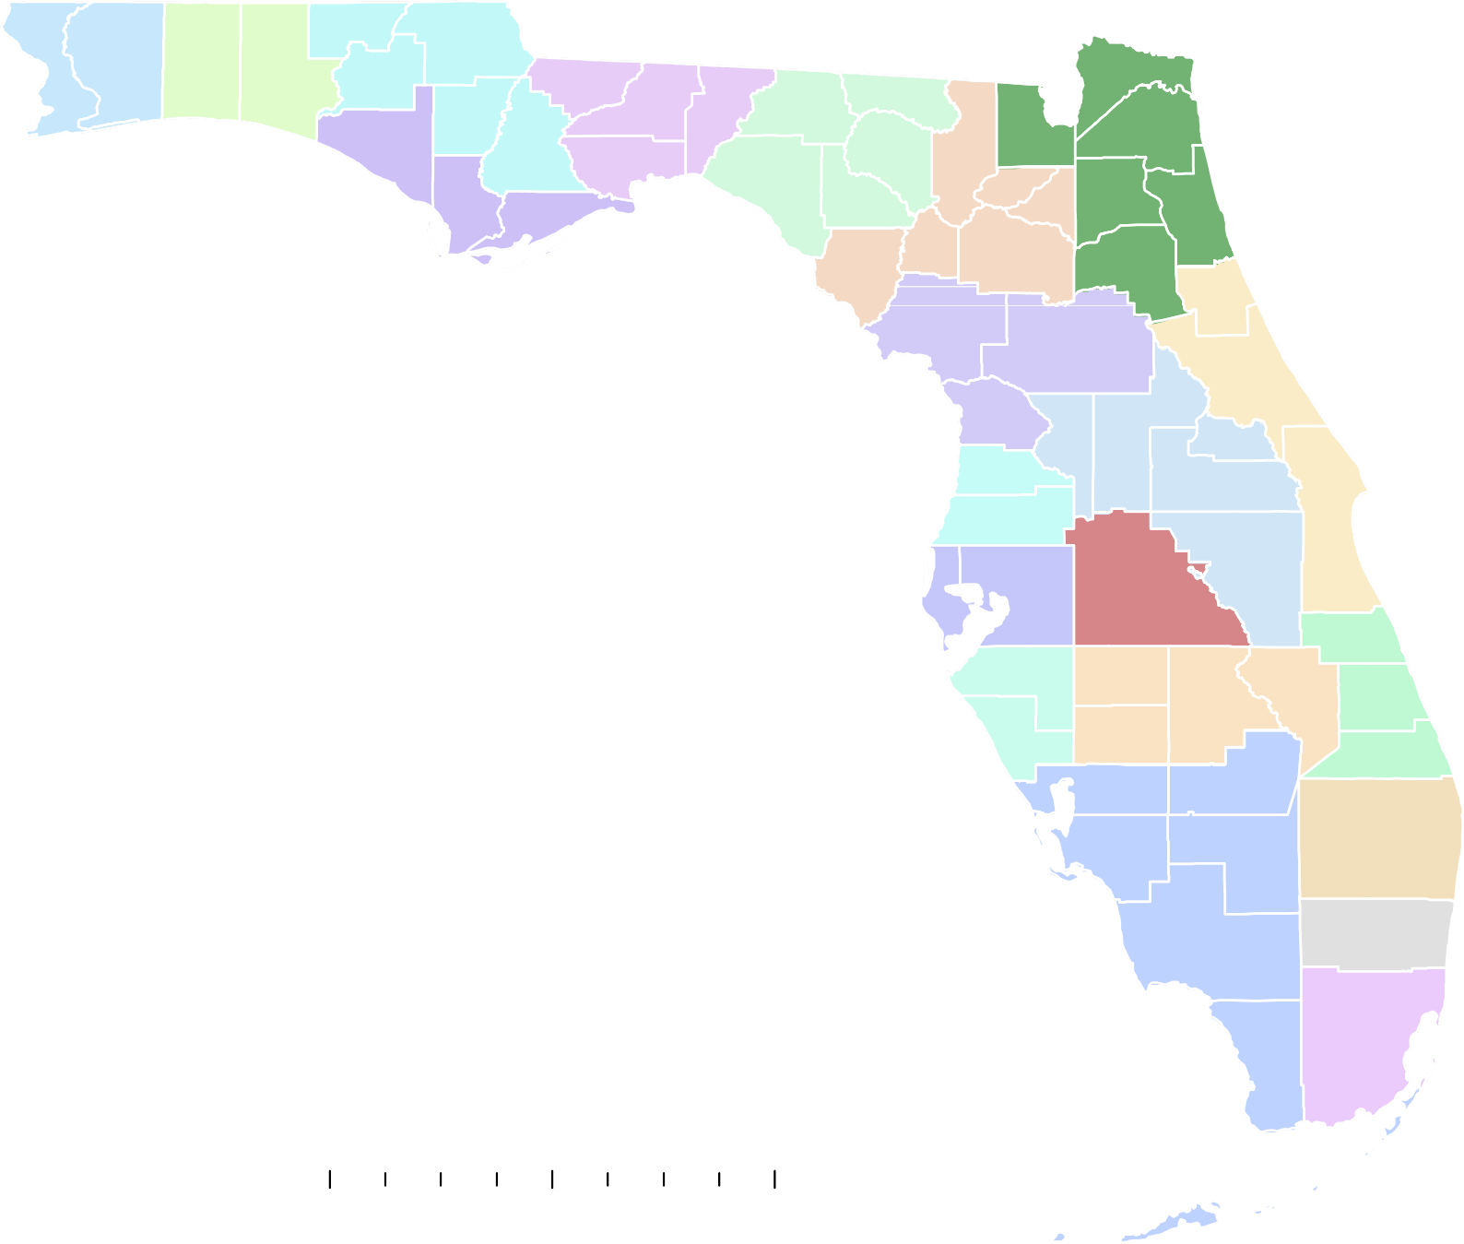

Local Workforce Development & Regional Area WIOA Plans 2024-2028 - FloridaJobs.org

1 2 Holmes

Jackson

EscambiaSanta Rosa Okaloosa
Walton
Washington
3
Calhoun

Gadsden
5

Leon

Jefferson

Madison

Hamilton

Baker
Nassau

Duval

Bay
4
Liberty

Wakulla
6
Taylor
Columbia
Suwannee
Union
8
Clay

Legend:
CareerSource Escarosa (1) CareerSource Okaloosa Walton (2)
Gulf

Franklin
Lafayette

Dixie
26
Gilchrist

Levy
Bradford Alachua

Putnam

St. Johns

Flagler

CareerSource Chipola (3) CareerSource Gulf Coast (4) CareerSource Capital Region (5) CareerSource North Florida (6)
10

Citrus

Hernando
16Pasco
Marion

Lake
Sumter
12

Volusia
27
Seminole Orange

Brevard

CareerSource Northeast Florida (8) CareerSource Citrus Levy Marion (10)

Pinellas

Hillsborough
28

Polk
17
Osceola

Indian River

CareerSource Central Florida (12)
Manatee
Hardee 19
Okeechobee

CareerSource Pasco Hernando (16) CareerSource Polk (17)
CareerSource Suncoast (18)
18
Sarasota

DeSoto Charlotte
Highlands

Glades
St. Lucie
20
Martin

Palm Beach
24

CareerSource Heartland (19) CareerSource Research Coast (20)
Lee
Hendry 21

CareerSource Palm Beach County (21) CareerSource Broward (22) CareerSource South Florida (23) CareerSource Southwest Florida (24) CareerSource North Central Florida (26)
CareerSource Brevard Flagler Volusia (27)

0 40
.
80 160 Miles
Collier

Monroe
Broward 22

Miami-Dade
23

CareerSource Hillsborough Pinellas (28)
Effective Date: July 1, 2024 Prepared by: Florida Commerce, Bureau of Workforce Statistics & Economic Research

