SAFE SCHOOLS APPROPRIATION EXPENDITURES REPORT

2010-2011 School Year

Office of Safe Schools

Florida Department of Education

http://www.fldoe.org
This product was developed by the State of Florida, Department of Education, Division of Public Schools, and the Bureau of Family and Community Outreach.

Office of Safe Schools
Florida Department of Education
Tallahassee, Florida 32399-0400
Telephone: (850) 245-0416
Fax: (850) 245-9978

The following staff members may assist you via telephone or e-mail:

Brooks Rumenik, Director
Telephone: (850) 245-0749
E-Mail: Brooks.Rumenik@fldoe.org

Copyright
State of Florida
Department of Education
2013

Authorization for reproduction is hereby granted to the State System of Public Education consistent with Section 1006.39(2), Florida Statutes. No authorization is granted for distribution or reproduction outside the state system of public education without prior approval in writing.

TABLE OF CONTENTS

Introduction 1
History and Background 1
Safe Schools Appropriation Allocations and Expenditures 2
Middle School After-School Programs 4
Middle School After-School Program Specifics 4
Primary Goals of Middle Schools After-School Programs 5
Middle School After-School Program Partners 6
Alternative Placement Programs for Adjudicated Youth 7
Alternative Placement Program Specifics 9
Alternative Placement Program Goals 9
School Safety and Security Program Activities 10
School Safety and Security Program Activities Effectiveness 12
Types of School Safety and Security Program Activities 15
School Resource Officers (SROs), School Campus Police, or Other School Law
Enforcement Officers (LEOs) on Campus 17
School Resource Officers (SROs), School Campus Police, or Other School Law
Enforcement Officers (LEOs) on Campus - Salaries 21
Security Equipment 23
Critical Issues for School Safety 24
K-20 Flexibility Act 26
School Uniforms and Drug Testing Policies 27
Summary 28
Appendices 29
Appendix A: Safe Schools Appropriation Proviso Language 30
Appendix B: 2010-2011 FEFP Final Calcuation Safe Schools Allocation 35
Appendix C: Analysis of After-School Expenditures Based on Total Expenditures 38
Appendix D: Analysis of Alternative Placement Program Expenditures Based on
Total Expenditures 39
Appendix E: Analysis of School Safety and Security Program Activities Expenditures Based on
Total Expenditures 40

LIST OF TABLES

Table 1 - Safe Schools Fiscal Summary 2
Table 2 - Total Safe Schools Funds Expended by Program Components 2
Table 3 - Analysis of Middle School After-School Programs 4
Table 4 - Operational Characteristics of Middle School After-School Programs 4
Table 5 - Primary Goals of Middle School After-School Programs 5
Table 6 - Middle School After-School Program Partners 6
Table 7 - Analysis by Districts of Alternative Placement Programs 7
Table 8 - Total Number of Adjudicated Students Served 8
Table 9 - Alternative Placement Program Expenditure Categories 9
Table 10 - Alternative Placement Program - Primary Goals 9
Table 11 - Analysis of School Safety and Security Program Activities 10
Table 12 - Types of Safety and Security Activities & Types of Measurements 12
Table 13 - School Safety and Security Program Activities and Funds Used 15
Table 14 - Additional Breakout of Spending on School Safety and Security Programs Activities 16
Table 15 - Number of SROs/LEOs in Districts 17
Table 16 - Funding Sources for SROs/LEOs Salaries 21
Table 17 - Number of Surveillance Cameras by School Level 23
Table 18 - Number and Type of Metal Detectors by School Level 24
Table 19 - Critical Saftey Issues 24
Table 20 - School Uniforms / Drug Testing Policies 27

LIST OF FIGURES

Figure 1 - Trend Analysis of Program Expenditures 2004-2010 3
Figure 2 - Trend Analysis of Operational Charteristics for Middle School After-School Programs 5
Figure 3 - Trend Analysis of Dollars Spent for Alternative Placement Programs 8
Figure 4 - District Critical Safety Issues 25

INTRODUCTION

The 2010-2011 edition of the Safe Schools Appropriation Expenditures Report was prepared by the Office of Safe Schools in the Bureau of Family and Community Outreach at the Florida Department of Education. This report summarizes school district expenditures, budgeting, and activities of the Florida Safe Schools Appropriation for the 2010-2011 school year. This report includes a history of the safe schools efforts in Florida and presents the data collected from the 2010-2011 Safe Schools Appropriation Survey of Expenditures. The appendices include documents associated with these program activities as well as related reference information. For additional information on Safe Schools Appropriation activities, contact the Office of Safe Schools at (850) 245-0416.

History and Background

The funding allocated for the Safe Schools Program dates back to the 1983-1984 school year. In 1986, the Florida Legislature enacted the Florida Safe Schools Act. During this time the funding was based solely on the juvenile crime index which disproportionately went primarily to large urban school districts. This method of allocation continued through the 1992-1993 school year. Subsequently, the Florida Safe Schools Act remained unfunded for several years and was rescinded by the 1997 Florida Legislature.

However, in 1994, the Florida legislature funded safe schools activities through proviso language in its General Appropriations Act. This funding has continued each year into the present year (see Appendix A - Safe Schools Appropriation Proviso Language). The purpose of the funding is to provide resources for after-school middle school programs, alternative placements for adjudicated youth, and to enhance the safety and security of the learning environment. Presently, each school district receives a minimum of $50,000 towards the aforementioned purpose. The balance of the Safe Schools Appropriation fund is distributed based upon the following formula: two-thirds based on the latest Florida Department of Law Enforcement Crime Index and one-third on each district’s share of the state’s total unweighted student enrollment.

Data for this report were collected via web-based survey from each school district in the spring of 2012 through the State Safe Schools Appropriation Survey of Activities. The survey was developed to collect information from each school district on the actual expenditures of safe schools funds during the 2011-12 school year. All 67 school districts that received Safe School funds responded to the survey and provided expenditure information. One district was not required to report their expenditures due to their need to exercise and place all of their funds in the categorical flexibility through the K-20 Flexibility Act as defined in Florida Statute 1011.62(6). Two other districts allocated part of their funds to categorical flexibility. Although Developmental Research Schools (DRS) receive Safe Schools Appropriation Funds, their expenditures are managed through the university system, not the Department of Education and, therefore, are not included in this report. The district and DRS school breakdown of the 2010-2011 Safe Schools Appropriation allocation is provided in Appendix B. Additionally, the format of this report follows closely the format of the online survey.

SAFE SCHOOLS APPROPRIATION ALLOCATIONS AND EXPENDITURES

Since 1996-1997, the Safe Schools Appropriation has continued to be a major source of funding for school districts toward developing, implementing, and enforcing school safety and security programs and activities. The Safe Schools Appropriation allows districts to use a portion of their allocation in a manner that best fits their safe schools needs. Specifically, school districts have spent Safe Schools Appropriation dollars in the following three categories: After-School Programs, Alternative Placement Programs for Adjudicated Youth, and School Safety and Security Activities. Beginning with fiscal years 1996-1997 through 1998-1999, the appropriation was established at $50,350,000. In fiscal year 1999-2000, the amount of the Safe Schools Appropriation was increased by $20 million to $70,350,000, and in 2001-2002, the amount increased by an additional five million dollars ($75,350,000). The appropriation allocation remained constant at $75,350,000 from 2001-2002 to 2007-2008. In 2007-2008, the appropriation increased by $240,988 to $75,590,988. For the first time, in 2008-2009, the amount decreased by $3,572,658 to $71,998,330. In 2009-2010, the amount decreased again by $4,737,490 to $67,260,840. For 2010-2011, there was an additional decrease of $127,056 which brought the total appropriation to $67,133,784. Table 1 provides a comprehensive summary of the Safe Schools Appropriation funds allocated beginning with the 2004-2005 academic school year.

Table 1 - Safe Schools Fiscal Summary

Program Components | 2004-2005 | 2005-2006 | 2006-2007 | 2007-2008 | 2008-2009 | 2009-2010 | 2010-2011
Safe Schools Appropriation | $75,350,000 | $75,350,000 | $75,350,000 | $75,570,988 | $71,998,330 | $67,260,840 | $67,133,784
Previous Year Roll Forward* | $10,648,367 | $6,527,244 | $4,593,493 | $4,449,399 | $5,078,420 | $4,902,247 | $2,651,874
Expenditures | $79,085,848 | $75,874,209 | $75,108,556 | $74,349,803 | $71,325,824 | $68,823,111 | $67,865,706
Unexpended at Year End** | $6,519,520 | $4,593,493 | $4,449,399 | $5,078,420 | $4,902,247 | $2,651,874 | $1,306,461
Safe School (FEFP) Appropriation (Source: Funding for Florida Schools)
* Roll-Forward dollars are unexpended dollars from the previous year.
** “Unexpended at Year End” is calculated by adding “Safe School Appropriation (67 Districts Only)” and “Roll-Forward” rows and subtracting the “Expenditures” and "Categorical Flexibility Expenditures" (not listed on table).

Table 2 provides specific information on the portions of the appropriation that were spent in the three main categories of (1) After-School Activities for Middle Schools; (2) Alternative Placement for Adjudicated Youth; and (3) Safety and Security Program Activities. Since 1996-1997, districts have spent the majority of the funds on school safety and security program activities. In 2010-2011, 89% of the appropriation funds were spent on safety and security program activities.

Table 2 - Total Safe Schools Funds Expended by Program Components

Program Component Totals Expended | 2004-2005 | 2005-2006 | 2006-2007 | 2007-2008 | 2008-2009 | 2009-2010 | 2010-2011
After-School Activities for Middle Schools | 6% | 5% | 4% | 4% | 3% | 3% | 3%
Alternative Placement for Adjudicated Youth | 8% | 8% | 8% | 8% | 10% | 10% | 8%
Safety/Security Program Activities | 86% | 87% | 88% | 88% | 87% | 87% | 89%
Figure 1 depicts trend data about expenditures in each of the three authorized program areas over the past six school years starting from 2004-2005 through 2010-2011. As illustrated in the graph below, the percent of Safe School Appropriation funds expended on after-school programs for middle schools has steadily decreased since 2004-2005. In 2006-2007, it decreased by one percent (1%), stayed consistent from 2006 to 2008, decreased again by one percent (1%) in 2008-2009, and then remained consistent from 2008 to 2011. The spending for alternative placement programs for adjudicated youth has remained consistent from 2004-2005 to 2007-2008, then increased by two percent (2%) in 2008-2009, and then remained consistent again from 2008 to 2010. During school year 2010-2011, funding for alternative placement programs decreased by 2%. Funds expended on school safety and security activities and other improvements to make schools safe has remained the same or slightly increased each year since 2004-2005. For 2010-2011, funds expended on school safety and security activities and other improvements to make schools safe increased by 2% from the year before.

Figure 1 - Trend Analysis of Program Expenditures 2004-2011

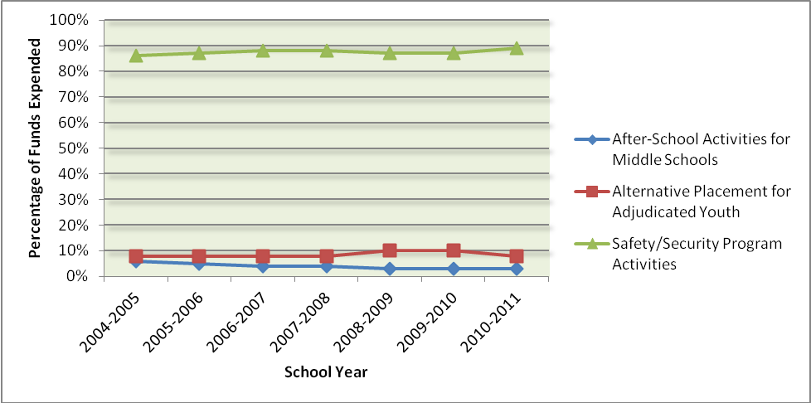

MIDDLE SCHOOL AFTER-SCHOOL PROGRAMS

Middle School After-School Program Specifics

In 2010-2011, eight school districts used a portion of their Safe Schools Allocation funds for after-school programs, which accounted for three percent (3%) of total appropriated dollars expended. As Table 3 shows, three of the districts spent at least twenty-five percent (25%) of their total appropriation dollars on after-school programming. During this surveying interval, districts were not asked to provide data concerning other sources of funding for middle school after-school programs.

Table 3 - Analysis of Middle School After-School Programs

District | # of Schools | # of Students Served | $ Spent on After-School Programs | % of Total Safe Schools Expenditures
Baker | 1 | 250 | $15,190 | 12%
Collier | 10 | 2,978 | $436,044 | 58%
Indian River | 1 | 70 | $3,370 | 1%
Lee | 0 | 0 | $832* | .04%
Nassau | 3 | 397 | $18,937 | 7%
Palm Beach | 36 | 3,500 | $1,917,853 | 43%
Sumter | 1 | 140 | $4,804 | 2%
Taylor | 2 | 376 | $30,341 | 27%
TOTAL | 54 | 7,711 | 2,426,539 | 4%
(*The $832 in after-school program expenses were for program costs from the 2009-2010 school year that were paid out in July and August of 2010.)

Table 4 provides information on characteristics of after-school programs funded by the Safe Schools Appropriation. According to the United States Department of Agriculture, providing snacks for after-school programs promote a healthy eating environment and offers students an opportunity to practice healthy eating habits. From 2004-2005 to 2006-2007, there was a steady increase of snacks and meals provided in the after-school programs; however, in 2007-2008, this decreased by sixty percent (60%). In 2010-2011, it decreased again by twelve percent (12%). The total number of programs operating on weekends and holidays has steadily declined since 1999-2000, with zero programs operating on the holidays since 2005, and zero programs operating on the weekends since 2007. Each year, beginning in 2004 through 2007, using funds to provide transportation for middle school after-school programs increased; however, in 2007-08 there was a fifty three percent (53%). decrease. For 2010-2011, this figure decreased again, by sixteen percent (16%).

Table 4 - Operational Characteristics of Middle School After-School Programs

Program Characteristics | 2004-2005 | 2005-2006 | 2006-2007 | 2007-2008 | 2008-2009 | 2009-2010 | 2010-2011
Provides Snacks and Meals | 106 | 112 | 115 | 46 | 49 | 49 | 43
Operates on Weekends | 8 | 8 | 5 | 0 | 0 | 0 | 0
Provides Transportation | 104 | 107 | 118 | 56 | 55 | 55 | 46
Operates on Holidays | 1 | 0 | 0 | 0 | 0 | 0 | 0

Figure 2 depicts trends in the number of programs with the aforementioned characteristics.

Figure 2 - Trend Analysis of Operational Characteristics for

Middle School After-School Programs

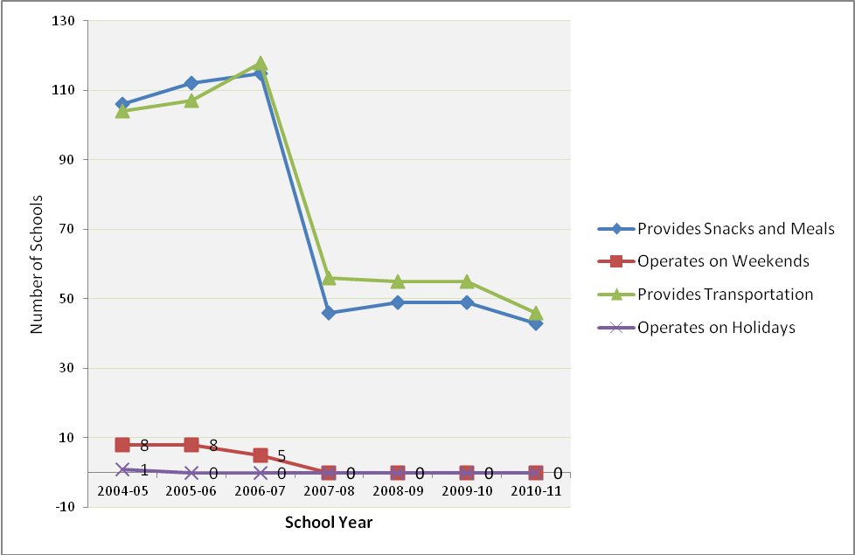

Primary Goals of Middle School After-School Programs

Districts reported one or multiple primary goals for their Safe Schools funded after-school programs. Table 5 presents the top nine primary goals identified for after-school programs and the number of districts that identified each goal as one of their own. Identification of goals has primarily declined or experienced no change since 2005.

Table 5 - Primary Goals of Middle School After-School Programs

Program Goals | 2004-2005 | 2005-2006 | 2006-2007 | 2007-2008 | 2008-2009 | 2009-2010 | 2010-2011
Provide Homework Assistance | 11 | 12 | 11 | 8 | 6 | 6 | 5
Provide Academic Enrichment Instruction | 12 | 11 | 12 | 7 | 6 | 7 | 6
Provide Supervision | 9 | 8 | 7 | 6 | 6 | 6 | 5
Provide Enrichment | 10 | 8 | 8 | 7 | 6 | 6 | 4
Provide Social Skills Development | 8 | 10 | 8 | 5 | 4 | 6 | 4
Prevent Negative Influences | 10 | 10 | 10 | 7 | 5 | 6 | 4
Provide Recreational Activities | 8 | 8 | 8 | 6 | 6 | 6 | 4
Provide Violence Prevention | 6 | 9 | 7 | 3 | 3 | 4 | 2
Provide Counseling | 6 | 7 | 7 | 3 | 2 | 3 | 2

Other goals that were listed by districts include service clubs, life skills instruction and sports instruction.

Middle School After-School Program Partners

Throughout the state, school districts collaborated with a variety of external agencies and organizations to offer and operate after-school programs for their students. Table 6 lists the agencies and programs with which the school district worked and the number of districts identifying a collaborator as one of their own.

Table 6 - Middle School After-School Program Partners

Middle School After School Partners | 2004-2005 | 2005-2006 | 2006-2007 | 2007-2008 | 2008-2009 | 2009-2010 | 2010-2011
Associated Marine Institute | 1 | 1 | 0 | 0 | 0 | 0 | 0
Boys and Girls Club | 6 | 5 | 6 | 5 | 5 | 4 | 3
Boy and Girl Scouts | 4 | 4 | 0 | 0 | 0 | 0 | 0
Business Partners | 7 | 6 | 5 | 4 | 3 | 3 | 2
Civic Organizations | 3 | 3 | 5 | 1 | 3 | 1 | 1
City Governments (Parks & Recreation) | 6 | 5 | 3 | 1 | 1 | 2 | 0
Community Colleges | 1 | 1 | 0 | 0 | 0 | 0 | 0
County Government (Parks & Recreation) | 7 | 6 | 3 | 2 | 2 | 2 | 1
Department of Children and Families | 2 | 2 | 2 | 0 | 0 | 0 | 0
Department of Juvenile Justice | 3 | 2 | 2 | 1 | 1 | 0 | 0
Faith-Based Groups | 1 | 1 | 2 | 1 | 1 | 1 | 2
Local Law Enforcement | 4 | 4 | 3 | 1 | 0 | 2 | 1
Mental Health Agencies | 3 | 2 | 0 | 1 | 1 | 1 | 0
Military Bases | 0 | 0 | 0 | 0 | 0 | 0 | 0
Practical and Cultural Education for Girls | 1 | 1 | 0 | 0 | 0 | 0 | 0
Private Industry Council | 0 | 0 | 0 | 0 | 0 | 0 | 0
PTA/PTO | 4 | 4 | 5 | 1 | 1 | 2 | 3
School Volunteers | 7 | 6 | 3 | 1 | 3 | 3 | 0
State Attorney’s Office | 3 | 3 | 0 | 1 | 1 | 0 | 0
Substance Abuse Agencies | 1 | 1 | 0 | 0 | 0 | 0 | 0
Universities/Colleges | 2 | 1 | 1 | 1 | 1 | 1 | 0
Urban League | 2 | 1 | 1 | 1 | 0 | 0 | 1
YMCA/YWCA | 2 | 1 | 2 | 2 | 2 | 1 | 0

The identification of external agency collaborators has steadily declined since 1999, with the biggest decline in 2002. The most common partners in 2008-2009 were entities such as the Boys and Girls Club, business partners, civic organizations, and school volunteers. In 2010-2011, the Boys and Girls Club and the PTA/PTO were the most commonly reported external partners in after-school programs funded with Safe Schools Appropriation.
Alternative Placement Programs For AdjudicaTED yOUTH

The alternative placement program category for adjudicated youth is the second largest category in which Safe Schools Appropriation funds were spent. (Note, during this survey period, districts were not asked to provide information pertaining to dollars spent from other sources nor were they asked to provide the number of programs funded by other sources or to provide the number of adjudicated youth served by funding from other sources.) Additionally, two new data points were added in 2002-2003 that asked districts to provide the number of on- and off-campus housing facilities. In 2010-2011, districts spent approximately eight percent (8%) of Safe Schools Appropriation funds on developing and maintaining alternative placement programs.

Collectively, Safe Schools Appropriations funds supported nine school districts that provided a wide range of both on- and off-campus alternative placement programs. Districts served 11,131 youth (down 12% from the 2009-2010 number 12,696) with Safe Schools Appropriations funds. Youth may have also been served through other funding sources. Table 7 provides a district analysis of the number of youth served, the number of programs in each district, and the amount of Safe Schools Allocation funds expended on these programs.

Table 7 - Analysis by Districts of Alternative Placement Programs

District | Amount Expended | # Programs Housed on Campus | # Programs Housed Off Campus | # Adjudicated Students Served
Baker | $32,190 | 1 | 0 | 22
Brevard | $883,621 | 0 | 6 | 709
Broward | $2,642,295 | 4 | 3 | 8,849
Clay | $49,922 | 1 | 0 | 409
Escambia | $71,213 | 1 | 1 | 481
Hardee | $56,974 | 0 | 1 | 12
Hendry | $200,008 | 2 | 0 | 42
Hillsborough | $54,333 | 2 | 0 | 467
Palm Beach | $1,332,797 | 4 | 0 | 140
TOTAL | $5,323,353 | 15 | 11 | 11,131

Figure 3 presents a trend analysis of dollars spent for alternative placement programs from 2004-2005 to 2010-2011.

Figure 3 - Trend Analysis of Dollars Spent for Alternative Placement Programs

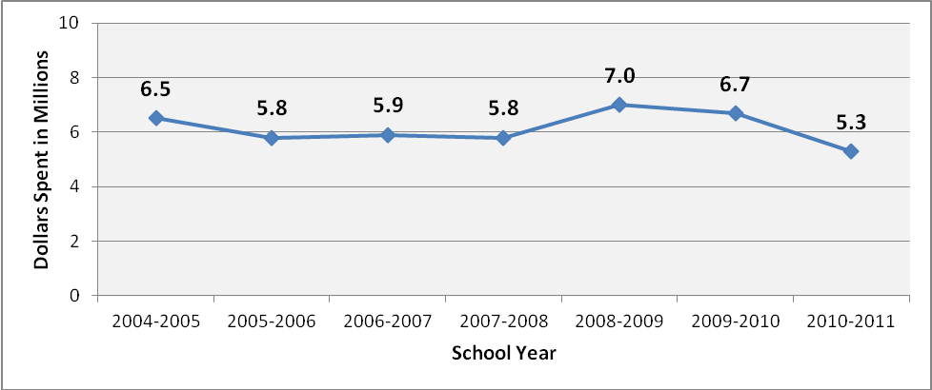

Table 8 presents the total number of adjudicated students served by Safe Schools Appropriation funds from 2006-2007 to 2010-2011.

Table 8 - Total Number of Adjudicated Students Served

District | # of Adjudicated Youth Served 2006-2007 | # of Adjudicated Youth Served 2007-2008 | # of Adjudicated Youth Served 2008-2009 | # of Adjudicated Youth Served 2009-2010 | # of Adjudicated Youth Served 2010-2011
Baker | 96 | 0 | 0 | 15 | 22
Bay | 639 | 818 | 0 | 0 | 0
Brevard | 149 | 165 | 429 | 709 | 709
Broward | 9,855 | 9,855 | 9071 | 10,347 | 8849
Clay | 3,134 | 3,234 | 510 | 488 | 409
Dade | 1,525 | 0 | 0 | 0 | 0
Desoto | 51 | 0 | 0 | 0 | 0
Escambia | 0 | 191 | 50 | 539 | 481
Hardee | 0 | 50 | 106 | 5 | 12
Hendry | 6 | 28 | 144 | 42 | 42
Hillsborough | 0 | 0 | 0 | 467 | 467
Lafayette | 0 | 0 | 0 | 4 | 0
Okeechobee | 0 | 75 | 0 | 0 | 0
Palm Beach | 45 | 76 | 74 | 80 | 140
Taylor | 0 | 8 | 45 | 0 | 0
TOTAL | 15,500 | 14,500 | 10,429 | 12,696 | 11,131

Alternative Placement Program Specifics

The 2010-2011 survey asked school districts to identify the programmatic use of Safe Schools Appropriation funds for alternative placement programs for adjudicated youth. Table 9 provides the four major categories in which districts expended the funds and the number of districts that expended funds in each category. In 2010-11, eighty nine percent (89%) of the school districts funding alternative placement programs for adjudicated youth reported using portions of the funds to maintain existing programs.

Table 9 - Alternative Placement Program Expenditure Categories

Expenditure Categories | # Districts  2004-2005 | # Districts  2005-2006 | # Districts 2006-2007 | # Districts 2007-2008 | # Districts 2008-2009 | # Districts 2010-2011
Maintained Existing Programs | 8 | 10 | 7 | 7 | 6 | 8
Enhanced (Improved) Existing Programs | 3 | 3 | 3 | 3 | 2 | 0
Used Other District Programs | 0 | 0 | 0 | 0 | 0 | 0
Expanded Existing Programs | 1 | 0 | 0 | 0 | 0 | 0

Alternative Placement Program Goals

An item was added to the 1999-2000 survey which requested districts to identify the primary goals of their Safe Schools Appropriation funded alternative placement programs. Most districts identified multiple goals. Table 10 provides a list of the primary goals and the number of school districts that identified these goals as their own. The two most prevalent district goals during the 2010-2011 reporting period were “providing alternative placements in lieu of expulsion” (eight districts) and “removing violent offenders from campus” (six districts). The third most frequently reported goal was “providing an alternative to suspension” (four districts). (Note: This goal question was new for the 2006-07 survey year.)

Table 10 - Alternative Placement Program - Primary Goals

Primary Goals | # Districts 2004-2005 | # Districts 2005-2006 | # Districts 2006-2007 | # Districts 2007-08 | # Districts 2008-09 | # Districts 2009-10 | # Districts 2010-11
Provide an alternative placement in lieu of expulsion | 13 | 12 | 7 | 10 | 8 | 10 | 8
Remove violent offenders from campus | 12 | 11 | 7 | 8 | 6 | 6 | 6
Provide an alternative to suspension | n/a | n/a | 5 | 3 | 4 | 5 | 4
Provide a problem assessment referral to outside agency for substance abuse, mental health services, etc. | 9 | 6 | 3 | 2 | 2 | 3 | 3
Provide a “cooling-off” period | 5 | 3 | 3 | 2 | 2 | 3 | 2

School Safety and Security Program Activities

As with previous years, school safety continues to be a top priority at both the national and state levels. Accordingly, most districts spent the majority of the Safe Schools Appropriation funds to support school safety and security program initiatives. In 2010-2011, approximately 97% of school districts reported using Safe Schools Appropriation funds on school safety and security program activities. Of these districts, approximately 78% of them spent 100% ($46 million) of their Safe Schools Appropriation funds on this category. Table 11 shows the total amount of Safe Schools Appropriation funds spent on safety and security, and the percentage of the total Safe Schools Appropriation funds spent on this category.

Table 11 - Analysis of School Safety and Security Program Activities

Districts | Total Amount of Safe Schools Funds Expended on Safety and Security | Total Safe Schools Funds Expended | % of Total Expended
Alachua | $926,012 | 926,012 | 100%
Baker | $79,198 | 126,578 | 63%
Bay | $676,141 | 676,141 | 100%
Bradford | $120,339 | 120,339 | 100%
Brevard | $835,211 | 1,718,832 | 49%
Broward | $3,442,506 | 6,084,801 | 57%
Calhoun | $88,387 | 88,387 | 100%
Charlotte | $427,493 | 427,493 | 100%
Citrus | $453,716 | 453,716 | 100%
Clay | $618,757 | 668,679 | 93%
Collier | $312,751 | 748,795 | 42%
Columbia | $327,935 | 327,935 | 100%
Dade | $10,007,815 | 10,007,815 | 100%
DeSoto | $161,564 | 161,564 | 100%
Dixie | $115,617 | 115,617 | 100%
Duval | $4,656,386 | 4,656,386 | 100%
Escambia | $1,017,583 | 1,088,796 | 93%
Flagler | $297,234 | 297,234 | 100%
Franklin | $86,256 | 86,256 | 100%
Gadsden | $220,907 | 220,907 | 100%
Gilchrist | $100,260 | 100,260 | 100%
Glades | $89,427 | 89,427 | 100%
Gulf | $93,226 | 93,226 | 100%
Hamilton | $101,289 | 101,289 | 100%
Hardee | $90,855 | 147,829 | 61%
Hendry | 0 | 200,008 | 0%
Hernando | $515,310 | 515,310 | 100%
Highlands | $320,899 | 320,899 | 100%
Hillsborough | $4,058,706 | 4,113,039 | 99%
Holmes | 0 | 106,808 | 0%
Indian River | $423,996 | 427,366 | 99%
Jackson | $177,769 | 177,769 | 100%
Jefferson | $28,269 | 28,269 | 100%
Lafayette | $135,127 | 135,127 | 100%
Lake | $845,383 | 845,383 | 100%
Lee | $2,055,431 | 2,056,263 | 100%
Leon | $979,038 | 979,038 | 100%
Levy | $186,498 | 186,498 | 100%
Liberty | $73,682 | 73,682 | 100%
Madison | $104,270 | 104,270 | 100%
Manatee | $1,214,386 | 1,214,386 | 100%
Marion | $917,905 | 917,905 | 100%
Martin | $417,124 | 417,124 | 100%
Monroe | $353,095 | 353,095 | 100%
Nassau | $240,825 | 259,761 | 93%
Okaloosa | $621,434 | 621,434 | 100%
Okeechobee | $158,816 | 158,816 | 100%
Orange | $4,658,766 | 4,658,766 | 100%
Osceola | $1,026,322 | 1,026,321 | 100%
Palm Beach | $1,213,694 | 4,464,344 | 27%
Pasco | $1,478,860 | 1,478,860 | 100%
Pinellas | $3,365,494 | 3,365,494 | 100%
Polk | $2,033,785 | 2,033,785 | 100%
Putnam | $351,130 | 351,130 | 100%
St. Johns | $595,029 | 595,029 | 100%
St. Lucie | $829,109 | 829,109 | 100%
Santa Rosa | $325,676 | 325,676 | 100%
Sarasota | $1,160,861 | 1,160,861 | 100%
Seminole | $1,296,956 | 1,296,955 | 100%
Sumter | $200,455 | 205,259 | 98%
Suwannee | $165,405 | 165,405 | 100%
Taylor | $83,959 | 114,300 | 73%
Union | $92,047 | 92,047 | 100%
Volusia | $1,608,835 | 1,608,835 | 100%
Wakulla | $148,072 | 148,072 | 100%
Walton | $199,510 | 199,510 | 100%
Washington | $106,191 | 106,191 | 100%
TOTAL | $60,114,983 | 67,865,706 | 89%

School Safety and Security Program Activities Effectiveness
Districts were asked to provide information regarding the types of safety and security programmatic activities that were funded and how effectiveness of these activities was measured. Table 12 provides information on how districts measured the effectiveness of their programming activities.

Table 12 - Types of Safety and Security Activities and Types of Measurements

Safety and Security Activity | Types of Activity | No. of Districts | Objective Data Source | Subjective Data Source
A.  Emergency  Preparedness, Planning, and Implementation | Crisis Intervention Plan Implementation | 10 | - Crisis Incident Reports  - Performance Data from action reports of drills, exercises, and actual emergencies  - Reports of actual prevention of incidents of crime/violence from knowledge gained | - Climate Survey Results  - Interviews and Debriefing with Involved Parties  - Safety and Security Self-Assessment
A.  Emergency  Preparedness, Planning, and Implementation | Critical Response Training | 6
A.  Emergency  Preparedness, Planning, and Implementation | Florida Association  Of School Resource  Officers Conference  Expenses | 7
A.  Emergency  Preparedness, Planning, and Implementation | Mock Disaster Drills | 5

Safety and Security Activity | Types of Activity | No. of Districts | Objective Data Source | Subjective Data Source
B.  Establishing a Safe, Nurturing Learning Environment | Assessing School Climate | 6 | - Disciplinary action data: suspensions and expulsions  - Discipline referral data  - Performance data of desired actions  - Safety Reports  - School Environmental Safety Incident Report data (SESIR) | - Climate Survey data  - Focus Group  - Interview Data with Stakeholders  - Participant Satisfaction Data  - Safety & Security Self-Assessment
B.  Establishing a Safe, Nurturing Learning Environment | Teacher/Staff Personnel Resource Training | 11
B.  Establishing a Safe, Nurturing Learning Environment | Developing Uniform Discipline Procedures | 4
B.  Establishing a Safe, Nurturing Learning Environment | In-School Suspension Programs | 8
B.  Establishing a Safe, Nurturing Learning Environment | Guidance Services | 5
B.  Establishing a Safe, Nurturing Learning Environment | Implementing School-wide Positive Behavior System | 5
B.  Establishing a Safe, Nurturing Learning Environment | Implementing Single School Culture | 4
B.  Establishing a Safe, Nurturing Learning Environment | Evaluation Activities | 2

Safety and Security Activity | Types of Activity | No. of Districts | Objective Data Source | Subjective Data Source
C.  School Safety Equipment, Resources, and Personnel | Behavior Resource Teacher | 3 | - Disciplinary action data: suspensions and expulsions  - Discipline referral data  - Incidents at school crossings  - Incidents of crime or violence prevented  - Performance data of desired actions  - Performance appraisal data  - Reports by SROs  - Safety Reports  - School Environmental Safety Incident Report data (SESIR)  - Telephone logs | - Climate Surveys  - Focus Groups addressing effectiveness  - Interviews w/ parents and key informants  - School Safety and Security Self-Assessment Data
C.  School Safety Equipment, Resources, and Personnel | Crossing Guards | 8
C.  School Safety Equipment, Resources, and Personnel | Metal Detectors | 3
C.  School Safety Equipment, Resources, and Personnel | Radio/Communication Equipment | 11
C.  School Safety Equipment, Resources, and Personnel | Safe Schools Coordinators | 9
C.  School Safety Equipment, Resources, and Personnel | Security Personnel (non-SRO) | 13
C.  School Safety Equipment, Resources, and Personnel | School Facility/Safety Improvements | 7
C.  School Safety Equipment, Resources, and Personnel | SROs or other campus law enforcement | 56
C.  School Safety Equipment, Resources, and Personnel | School Safety Hotline | 5
C.  School Safety Equipment, Resources, and Personnel | Surveillance Cameras | 8
C.  School Safety Equipment, Resources, and Personnel | Staff Support for In-School Suspension | 7
C.  School Safety Equipment, Resources, and Personnel | Trained Dogs for Drugs/Guns | 2

Safety and Security Activity | Types of Activity |  |  | No. of Districts |  | Objective Data Source |  | Subjective Data Source
D.  Student Programs | Big Brother/Big Sister |  |  | 1 |  | - Counselor’s log  - Discipline referral data  - Performance data of actions desired  - Pre-test, Post-test results  - Recidivism data  - School Environmental Safety Incident Report (SESIR) data |  | - Climate surveys  - Customer satisfaction data  - Focus groups addressing effectiveness  - Interviews w/ parents or key informants
D.  Student Programs | Conflict Resolution Instruction |  |  | 5
D.  Student Programs | Mock DUIs |  |  | 3
D.  Student Programs | Peer Mediation |  |  | 3
D.  Student Programs | Student Assistance Program |  |  | 4
D.  Student Programs | Student to Student Violence Prevention Program |  |  | 4
D.  Student Programs | Teen Court |  |  | 0
D.  Student Programs | Violence Prevention Instruction |  |  | 8
D.  Student Programs | Suicide |  |  | 1
Safety and Security Activity |  | Types of Activity | No. of Districts |  | Objective Source Data |  | Subjective Data Source
E.  School Improvement Planning for Safety |  | Assistance for the Development of School Improvement Plans | 8 |  | - Disciplinary action data: suspensions and expulsions  - Discipline referral data  - Results data from schools utilizing Positive Behavior Supports systems  - School Environmental Safety Incident Report (SESIR) data |  | - School Climate Surveys  - Focus Groups data  - Safety & Security Self-Assessment Data

Safety and Security Activities | Types of Activity | No. of Districts | Objective Data Source | Subjective Data Source
F.  Data System Improvements | Internet Firewall | 2 | - Statewide Report on School Safety and Discipline  - Student referral records  - System Incident Data | - Focus Groups  - Interviews with key informants
F.  Data System Improvements | Truancy and Attendance Data | 4 |  | - Focus Groups  - Interviews with key informants
F.  Data System Improvements | SESIR Reporting System | 6 |  | - Focus Groups  - Interviews with key informants

*Objective Data Source= independently quantifiable data.
**Subjective Data Source= opinion or perception data.

Types of School Safety and Security Program Activities

With the majority of the Safe Schools Appropriation funds expended for school safety and security program activities, the types of activities and the amounts used to support those activities varied across districts. Table 13 lists six activity categories, the amount of Safe Schools Appropriation funds used to support those activities and whether the activities would continue in the absence of Safe Schools Appropriation funding.

Table 13 – School Safety and Security Program Activities and Funds Used

Activity | # of Districts Using Appropriation Funds for this Activity | Amount | # of Districts that would Continue Activity without Appropriation Funds
 |  |  | Yes | No
Providing School Resource / School Safety Officers | 62 | $46,378,900 | 6 | 56
Funding District-level Positions for Safe Schools Activities | 20 | $3,550,096 | 5 | 15
Purchasing / Maintaining Security Equipment | 16 | $1,587,332 | 3 | 13
Training Teachers/Staff | 16 | $280,290 | 3 | 13
Developing and/or Purchasing Curriculum | 8 | $175,343 | 0 | 8
Planning for School Improvements | 3 | $524,125 | 0 | 3
TOTAL |  | $48,280,147 | 17 | 108

In Table 13, districts were asked to provide additional information about other categories of spending over and above the six designated categories of spending broken out. Table 14 provides a breakout of the spending on “other” school safety and security activities, by district, that was greater than $10,000.
Table 14– Additional Breakout of Spending on School Safety and Security
Program Activities

District | Activity | Amount | Continue Funding in the Absence of Safe Schools Funding
Bay | Charter Schools  Safe School Supplies | $54,766  $29,964 | no  no
Bradford | School-Level Safety  After-Hours Security  Crossing Guards | $46,955  $11,326  $11,102 | no  no  no
Broward | Broward Truancy Intervention Program | $467,574 | no
Calhoun | Assistant Principals | $39,927 | yes
Charlotte | School Security Officers | $104,868 | no
Clay | Communications  Local Travel for District-Level Psychologists | $4,454  $13,607 | no  no
Collier | Safe School Assistants | $312,751 | no
Dade | Security Personnel | $6,001,000 | yes
Desoto | Parent Notification  Raptor/Fingerprinting System  Drug Testing for Athletes | $7,750  $3,456  $2,220 | yes  yes  yes
Dixie | Behavioral Unit | $61,617 | yes
Duval | Charter School Payments | $113,333 | no
Escambia | Computer Equipment  AV Equipment  Renaissance Learning Software | $547  $5,754  $2,919 | no  no  no
Glades | In-School Suspension | $51,607 | no
Hamilton | Assistant Principal  School Campus Security | $33,184  $25,945 | no  no
Hernando | Alternative to Expulsion  Charter School, Safe School Activities | $185,358  $3,142 | no  no
Indian River | Charter School - Conflict Resolution Strategies  Charter School – Drug Testing  Charter School – Security Contract | $16,843  $14,168  $3,431 | no  no  no
Lafayette | Alternative and In-School Suspension Program/Teachers  Dean of Discipline/Bullying Contact | $20,180  $26,140 | yes  yes
Lake | Charter Schools  SRO Trainings  Alert Now / Drug Testing | $117,456  $4,544  $8,242 | no  no  no
Lee | Charter School Allocation  Alternative to Suspension  Correction to FY09 Report | $218,587  $77,010  $5,112 | no  no  no
Leon | Charter School Allocation  Alternative to Suspension Programs | $220,294  $73,699 | no  no
Levy | Crossing Guards  Camera Equipment | $23,989  $9,782 | yes  yes
Monroe | Charter School Allocation  Security Personnel | $27,880  $49,269 | no  no
Okaloosa | School Safety and Security Activities | $3,594 | no
Okeechobee | Security Monitor Position for High School Gate  Paraprofessional for Drop Out Prevention Program serving grades 4-5 | $9,654  $22,062 | yes  no
Orange | School-based SAFE Coordinators | $1,626,119 | no
Pasco | Charter Schools  Traffic Control  Year End Security | $46,936  $15,314  $6,290 | no  no  no
St. Johns | Student Service Workers at all Middle and High Schools | $595,029 | no
Seminole | Security Officers  Train Drug Dogs | $781,636  $1,000 | no  no
Sumter | Charter Schools Distribution | $53,134 | no
Suwannee | Security Guards | $15,405 | no
Union | Other Certified Instructional  Retirement  FICA/Insurance | $22,395  $2,412  $3,739 | no  no  no
Volusia | Campus Advisors | $411,397 | no
Walton | Red Ribbon Week | $794 | no
Washington | Fingerprinting of Volunteers | $172 | no
TOTAL |  | $12,128,834 | Y | N
TOTAL |  | $12,128,834 | 11 | 51

School Resource Officers (SROs), School Campus Police, or other School Law Enforcement Officers (LEOs) on Campus

An area of public interest is the presence of school resource officers (SROs) and other school law enforcement officers (LEOs) on school campuses across the state of Florida. Table 15 shows the number of school resource officers and law enforcement officers (SROs/LEOs) at each school level within districts as well as the number of schools served per district. “Multi-level” refers to SROs/LEOs, who were used at various school levels and who visit several schools throughout the week. This table accounts for officers that may be supported by by other sources of revenue, in addition to Safe Schools Appropriation.

Table 15 – Number of School Resource Officers / Law Enforcement Officers in Districts

District | # Officers Elementary Schools | # Elementary Schools Served | # Officers Middle Schools | # Middle Schools Served | # Officers High Schools | # High Schools Served
Alachua | 1 | 12 | 7 | 7 | 9 | 6
Baker | 1 | 4 | 1 | 1 | 1 | 1
Bay | 1 | 1 | 2 | 5 | 5 | 5
Bradford | 0 | 0 | 0 | 0 | 0 | 0
Brevard | 0 | 0 | 12 | 12 | 12 | 12
Broward | 51 | 83 | 39 | 39 | 35 | 30
Calhoun | 0 | 0 | 0 | 0 | 0 | 0
Charlotte | 2 | 11 | 4 | 4 | 3 | 3
Citrus | 4 | 11 | 4 | 4 | 3 | 3
Clay | 0 | 0 | 0 | 0 | 6 | 6
Collier | 15 | 29 | 10 | 10 | 14 | 9
Columbia | 0 | 0 | 4 | 2 | 8 | 2
Dade | 0 | 0 | 41 | 41 | 39 | 39
DeSoto | 0 | 0 | 0 | 0 | 0 | 0
Dixie | 0 | 0 | 1 | 1 | 1 | 1
Duval | 0 | 0 | 26 | 24 | 23 | 19
Escambia | 0 | 0 | 8 | 8 | 12 | 7
Flagler | 0 | 0 | 2 | 2 | 2 | 2
Franklin | 0 | 0 | 0 | 0 | 0 | 0
Gadsden | 0 | 0 | 5 | 2 | 6 | 2
Gilchrist | 0 | 0 | 0 | 0 | 0 | 0
Glades | 0 | 0 | 0 | 0 | 0 | 0
Gulf | 0 | 0 | 0 | 0 | 0 | 0
Hamilton | 0 | 0 | 0 | 0 | 0 | 0
Hardee | 0 | 0 | 1 | 1 | 2 | 1
Hendry | 0 | 0 | 0 | 0 | 0 | 0
Hernando | 0 | 0 | 4 | 4 | 5 | 5
Highlands | 0 | 0 | 0 | 0 | 0 | 0
Hillsborough | 19 | 19 | 44 | 44 | 32 | 27
Holmes | 0 | 0 | 0 | 0 | 0 | 0
Indian River | 1 | 13 | 4 | 4 | 3 | 2
Jackson | 1 | 5 | 1 | 1 | 5 | 4
Jefferson | 0 | 0 | 0 | 0 | 0 | 0
Lafayette | 0 | 0 | 0 | 0 | 0 | 0
Lake | 0 | 0 | 11 | 10 | 14 | 7
Lee | 0 | 0 | 16 | 16 | 13 | 13
Leon | 2 | 25 | 7 | 9 | 5 | 5
Levy | 0 | 0 | 0 | 0 | 0 | 0
Liberty | 0 | 0 | 0 | 0 | 1 | 1
Madison | 0 | 0 | 0 | 0 | 1 | 1
Manatee | 0 | 0 | 10 | 10 | 7 | 6
Marion | 0 | 0 | 9 | 9 | 7 | 7
Martin | 1 | 12 | 5 | 5 | 3 | 3
Monroe | 0 | 0 | 3 | 3 | 3 | 3
Nassau | 0 | 0 | 0 | 0 | 0 | 0
Okaloosa | 0 | 0 | 7 | 7 | 4 | 5
Okeechobee | 1 | 5 | 2 | 2 | 2 | 2
Orange | 30 | 122 | 35 | 37 | 40 | 22
Osceola | 2 | 4 | 8 | 8 | 9 | 9
Palm Beach | 18 | 107 | 34 | 33 | 38 | 23
Pasco | 0 | 0 | 15 | 15 | 13 | 12
Pinellas | 4 | 74 | 18 | 18 | 21 | 17
Polk | 3 | 67 | 11 | 19 | 7 | 12
Putnam | 0 | 0 | 0 | 0 | 0 | 0
St. Johns | 0 | 0 | 1 | 1 | 7 | 7
St. Lucie | 0 | 0 | 3 | 4 | 11 | 6
Santa Rosa | 0 | 0 | 0 | 0 | 4 | 4
Sarasota | 0 | 0 | 7 | 8 | 9 | 5
Seminole | 3 | 8 | 12 | 12 | 10 | 9
Sumter | 0 | 0 | 1 | 1 | 1 | 1
Suwannee | 0 | 0 | 1 | 1 | 1 | 1
Taylor | 1 | 3 | 1 | 1 | 1 | 1
Union | 0 | 0 | 0 | 0 | 0 | 0
Volusia | 0 | 0 | 2 | 5 | 4 | 4
Wakulla | 0 | 0 | 2 | 2 | 1 | 1
Walton | 0 | 0 | 3 | 3 | 4 | 3
Washington | 0 | 0 | 0 | 0 | 2 | 2
TOTAL | 161 | 615 | 444 | 455 | 469 | 378

Table 15 – Number of School Resource Officers / Law Enforcement
Officers in Districts (continued…)

District |  | # Officers Alternative Schools |  | # Alternative Schools Served |  | # Officers Multi-Level Schools |  | # Multi-Level Schools Served |  | Were Multi-Level Elementary Schools Served? |  | Were Multi-Level Middle Schools Served? |  | Were Multi-Level High  Schools?
Alachua | 4 |  | 2 |  | 2 |  | 2 |  | yes |  | yes |  | yes
Baker | 1 |  | 1 |  | 0 |  | 0
Bay | 1 |  | 1 |  | 1 |  | 1 |  | yes |  | yes |  | yes
Bradford | 0 |  | 0 |  | 3 |  | 8 |  | yes |  | yes |  | yes
Brevard | 0 |  | 0 |  | 4 |  | 4 |  |  |  | yes |  | yes
Broward | 4 |  | 4 |  | 0 |  | 0
Calhoun | 0 |  | 0 |  | 2 |  | 5 |  | yes |  | yes |  | yes
Charlotte | 1 |  | 1 |  | 1 |  | 1
Citrus | 1 |  | 1 |  | 2 |  | 2
Clay | 1 |  | 1 |  | 1 |  | 1
Collier | 1 |  | 7 |  | 0 |  | 0
Columbia | 1 |  | 1 |  | 0 |  | 0
Dade | 2 |  | 2 |  | 6 |  | 6 |  | yes |  | yes
DeSoto | 0 |  | 0 |  | 2 |  | 5 |  | yes |  | yes |  | yes
Dixie | 0 |  | 0 |  | 0 |  | 0
Duval | 2 |  | 2 |  | 4 |  | 4 |  | yes |  | yes |  | yes
Escambia | 0 |  | 0 |  | 0 |  | 0
Flagler | 1 |  | 1 |  | 0 |  | 0
Gadsden | 0 |  | 0 |  | 1 |  | 1
Gilchrist | 5 |  | 2 |  | 0 |  | 0
Glades | 0 |  | 0 |  | 1 |  | 4 |  | yes
Gulf | 0 |  | 0 |  | 1 |  | 3 |  | yes |  | yes |  | yes
Hamilton | 0 |  | 0 |  | 2 |  | 6 |  | yes |  | yes |  | yes
Hardee | 0 |  | 0 |  | 2 |  | 4
Hendry | 0 |  | 0 |  | 0 |  | 0
Hernando | 1 |  | 1 |  | 2 |  | 3
Highlands | 1 |  | 1 |  | 5 |  | 17
Hillsborough | 4 |  | 2 |  | 8 |  | 8 |  | yes |  | yes |  | yes
Holmes
Indian River | 1 |  | 1 |  | 0 |  | 0
Jackson | 1 |  | 1 |  | 2 |  | 2
Jefferson | 0 |  | 0 |  | 1 |  | 1 |  |  |  | yes |  | yes
Lafayette | 0 |  | 0 |  | 1 |  | 2 |  | yes
Lake | 0 |  | 0 |  | 0 |  | 0
Lee | 3 |  | 4 |  | 4 |  | 4
Leon | 3 |  | 7 |  | 4 |  | 2
Levy | 1 |  | 1 |  | 3 |  | 11 |  | yes |  | yes |  | yes
Liberty | 0 |  | 0 |  | 2 |  | 3 |  |  |  |  |  | yes
Madison | 0 |  | 0 |  | 1 |  | 1
Manatee | 3 |  | 2 |  | 0 |  | 0
Marion | 0 |  | 0 |  | 2 |  | 2 |  |  |  | yes |  | yes
Martin | 1 |  | 1 |  | 1 |  | 1
Monroe | 0 |  | 0 |  | 0 |  | 0
Nassau | 0 |  | 0 |  | 6 |  | 15 |  | yes |  | yes |  | yes
Okaloosa | 1 |  | 3 |  | 2 |  | 7 |  | yes |  | yes |  | yes
Okeechobee | 1 |  | 1 |  | 0 |  | 0
Orange | 2 |  | 2 |  | 0 |  | 0
Osceola | 1 |  | 1 |  | 3 |  | 3
Palm Beach | 6 |  | 17 |  | 11 |  | 11
Pasco | 3 |  | 4 |  | 0 |  | 0
Pinellas | 2 |  | 1 |  | 7 |  | 6
Polk | 2 |  | 3 |  | 22 |  | 10 |  | yes |  | yes |  | yes
Putnam | 0 |  | 0 |  | 11 |  | 19 |  | yes |  | yes |  | yes
St. Johns | 0 |  | 0 |  | 1 |  | 2 |  |  |  | yes |  | yes
St. Lucie | 2 |  | 2 |  | 7 |  | 10
Santa Rosa | 0 |  | 0 |  | 2 |  | 2 |  | yes |  | yes |  | yes
Sarasota | 1 |  | 5 |  | 3 |  | 2
Seminole | 1 |  | 1 |  | 0 |  | 0
Sumter | 0 |  | 0 |  | 3 |  | 3
Suwannee | 0 |  | 0 |  | 3 |  | 5 |  | yes |  | yes |  | yes
Taylor | 0 |  | 0 |  | 0 |  | 0
Union | 0 |  | 0 |  | 1 |  | 3 |  | yes |  | yes |  | yes
Volusia | 0 |  | 0 |  | 7 |  | 15 |  |  |  | yes |  | yes
Wakulla | 1 |  | 1 |  | 0 |  | 0
Walton | 1 |  | 1 |  | 1 |  | 1
Washington | 0 |  | 0 |  | 2 |  | 3 |  | yes |  | yes
Total: | 68 |  | 89 |  | 163 |  | 231

School Resource Officers (SROs), School Campus Police, or other School Law Enforcement Officers (LEOs) on Campus - Salaries

Throughout the state, most districts collaborated with law enforcement agencies to provide SROs/LEOs and other security personnel in schools. Table 16 shows a breakout of the percent of salaries from each funding source and the total amount of Safe Schools Appropriation spent on SROs, Police, and LEOs. By far, most of the salaries were paid for by Safe Schools Appropriation funds. The second largest funding source was the county sheriff departments. There were twelve districts that spent over a million dollars of Safe Schools Appropriation on salaries.

Table 16 - Funding Sources for SROs/LEOs Salaries

District | % Safe Schools Funds | % City Police Department | % County Sheriff's Office | % Federal Grants | % General School District Funds | % State Grant | Total Expended for SROs/LEOs from Safe Schools Appropriation
Alachua |  | 20% | 58% | 0 | 7% | 0 | $398,249
  15% | 20 | 58 |  | 7
Baker | 75% | 0 | 25% | 0 | 0 | 0 | $79,198
Bay | 100% | 0 | 0 | 0 | 0 | 0 | $527,692
Bradford | 25% | 50% | 25% | 0 | 0 | 0 | $19,745
Brevard | 50% | 41% | 9% | 0 | 0 | 0 | $806,333
Broward | 1% | 55% | 30% | 0 | 14% | 0 | 1,886,069
Calhoun | 50% | 0 | 0 | 0 | 50% | 0 | $48,460
Charlotte | 35% | 32% | 33% | 0 | 0 | 0 | $322,625
Citrus | 25% | 0 | 75% | 0 | 0 | 0 | $368,550
Clay | 75% | 0 | 15% | 0 | 10% | 0 | $469,479
Collier | 0 | 0 | 0 | 0 | 0 | 0 | $0
Columbia | 100% | 0 | 0 | 0 | 0 | 0 | $273,824
Dade | 25% | 0 | 0 | 0 | 75% | 0 | $9,001,280
DeSoto | 60% | 0 | 40% | 0 | 0 | 0 | $78,161
Dixie | 100% | 0 | 0 | 0 | 0 | 0 | $54,000
Duval | 100% | 0 | 0 | 0 | 0 | 0 | $4,463,912
Escambia | 100% | 0 | 0 | 0 | 0 | 0 | $825,408
Flagler | 100% | 0 | 0 | 0 | 0 | 0 | $297,234
Franklin | 90% | 0 | 4% | 0 | 6% | 0 | $83,645
Gadsden | 78% | 0 | 22% | 0 | 0 | 0 | $220,907
Gilchrist | 100% | 0 | 0 | 0 | 0 | 0 | $42,584
Glades | 50% | 0 | 50% | 0 | 0 | 0 | $37,820
Gulf | 80% | 0 | 10% | 0 | 10% | 0 | $93,226
Hamilton | 65% | 0 | 35% | 0 | 0 | 0 | $40,000
Hardee | 38% | 0 | 46% | 0 | 16% | 0 | $90,855
Hernando | 65% | 0 | 35% | 0 | 0 | 0 | $293,000
Highlands | 50% | 15% | 35% | 0 | 0 | 0 | $320,899
Hillsborough | 50% | 25% | 25% | 0 | 0 | 0 | $4,113,039
Indian River | 50% | 0 | 50% | 0 | 0 | 0 | $386,052
Jackson | 47% | 4% | 22% | 0 | 27% | 0 | $177,769
Jefferson | 11% | 0 | 89% | 0 | 0 | 0 | $4,390
Lafayette | 100% | 0 | 0 | 0 | 0 | 0 | $43,642
Lake | 29% | 0 | 2% | 0 | 69% | 0 | $249,577
Lee | 53% | 26% | 21% | 0 | 0 | 0 | $1,710,750
Leon | 50% | 0 | 50% | 0 | 0 | 0 | $979,038
Levy | 25% | 0 | 75% | 0 | 0 | 0 | $59,300
Liberty | 100% | 0 | 0 | 0 | 0 | 0 | $62,266
Madison | 67% | 0 | 0 | 33% | 0 | 0 | $104,270
Manatee | 50% | 10% | 40% | 0 | 0 | 0 | $990,444
Marion | 100% | 0 | 0 | 0 | 0 | 0 | $711,750
Martin | 100% | 0 | 0 | 0 | 0 | 0 | $417,124
Monroe | 37% | 9% | 49% | 0 | 5% | 0 | $240,626
Nassau | 61% | 6% | 33% | 0 | 0 | 0 | $240,825
Okaloosa | 100% | 0 |  | 0 | 0 | 0 | $617,840
Okeechobee | 50% | 0 | 50% | 0 | 0 | 0 | $127,101
Orange | 100% | 0 | 0 | 0 | 0 | 0 | $3,018,600
Osceola | 100% | 0 | 0 | 0 | 0 | 0 | $1,026,321
Palm Beach | 0% | 0 | 0 | 0 | 0 | 0 | $0
Pasco | 84% | 0 | 0 | 0 | 16% | 0 | $1,410,320
Pinellas | 60% | 20% | 20% | 0 | 0 | 0 | $3,365,494
Polk | 75% | 0 | 25% | 0 | 0 | 0 | $2,033,785
Putnam | 55% | 0 | 16% | 0 | 29% | 0 | $351,130
St. Johns | 0 | 0 | 0 | 0 | 0 | 0 | $0
St. Lucie | 24% | 0 | 76% | 0 | 0 | 0 | $588,196
Santa Rosa | 100% | 0 | 0 | 0 | 0 | 0 | $321,092
Sarasota | 39% | 9% | 43% | 0 | 9% | 0 | $1,160,861
Seminole | 25% | 0 | 0 | 0 | 25% | 0 | $538,142
Sumter | 50% | 0 | 50% | 0 | 0 | 0 | $146,492
Suwannee | 20% | 0 | 80% | 0 | 0 | 0 | $150,000
Taylor | 50% | 25% | 25% | 0 | 0 | 0 | $80,547
Union | 100% | 0 | 0 | 0 | 0 | 0 | $45,896
Volusia | 100% | 0 | 0 | 0 | 0 | 0 | $1,197,438
Wakulla | 85% | 0 | 0 | 0 | 15% | 0 | $148,072
Walton | 50% | 0 | 50% | 0 | 0 | 0 | $198,717
Washington | 50% | 0 | 50% | 0 | 0 | 0 | $104,808
TOTAL |  |  |  |  |  |  | $46,378,900*
(*Note: Hendry and Holmes County are not included in this section. Both districts spent $0 Safe Schools Appropriation funds for SROs/LEOs.)
Security Equipment

The use of Safe Schools Appropriation funds to purchase or maintain security technology has increased statewide for all grade levels over the past six years starting from 2004-2005 through 2010-2011. Surveillance cameras were by far the most common types of security equipment used by districts to monitor and enforce safety and security on school campuses. Table 17 provides detailed information on the number of surveillance cameras present at the different school levels and in school buses. From the 2009-10 school year to the 2010-2011 school year, the total number of cameras increased ten percent (10%). The high school level had an increase of eight percent (8%) while cameras on school buses increased by nine percent (9%).

Note that the figures reflected in Tables 17 and 18 do not necessarily reflect equipment purchased using Safe Schools Appropriation funds.

Table 17 – Number of Surveillance Cameras by School Level

School Level | # Cameras 2004-2005 | # Cameras 2005-2006 | # Cameras 2006-2007 | # Cameras 2007-2008 | # Cameras 2008-2009 | # Cameras 2009-2010 | Cameras 2010-2011 | % Change from 2009-2010 to 2010-11
High Schools | 7,427 | 8,522 | 9,106 | 10,715 | 17,748 | 20,808 | 22,403 | 8%
Middle Schools | 4,683 | 6,565 | 7,154 | 8,707 | 13,055 | 14,757 | 15,811 | 7%
Elementary Schools | 4,367 | 6,594 | 7,345 | 8,397 | 11,263 | 12,659 | 14,970 | 18%
Alternative Schools | 1,246 | 1,263 | 1,644 | 1,850 | 2,436 | 2,486 | 2,950 | 19%
School Buses | 7,372 | 8,880 | 10,943 | 11,716 | 11,641 | 12,103 | 13,195 | 9%
Other* | 74 | 444 | 1,379 | 1,382 | 3,864 | 3,720 | 3,622 | -3%
TOTAL | 25,169 | 32,268 | 37,571 | 42,767 | 60,007 | 66,533 | 72,951 | 10%
* Districts reported using surveillance cameras in other buildings and locations including: (1) multi-level schools; (2) administration buildings; (3) technical centers; (4) early learning centers and schools; (5) ancillary building’, (6) charter schools; (7) facilities and plant operation areas; (8) transportation; (9) new buses, (10) bus compounds; (11) planning and construction projects

Table 18 provides information on the number of metal detectors present at the various school levels within districts and the number of schools that possess these detectors. In 2010-2011, 491 schools across the state used metal detectors, a 14% increase from the previous year. Of the various types of metal detectors, the vast majority (97%) were hand-held, which allowed SROs/LEOs and other security personnel to be very mobile during security checks.

The elementary and middle schools total number of metal detectors have increased by five percent (5%) from school year 2009-2010 to 2010-2011. The total number of metal detectors increased twenty four percent (24%) in high schools and decreased by eleven percent (11%) in alternative schools. Detectors used in other school facility buildings increased by thirty six percent (36%) in 2010-2011.

Table 18 – Number and Type of Metal Detectors by School Level

School Level | # Hand-Held Devices 2009-2010 | # Hand-Held Devices 2010-2011 | # Schools with Hand-Held Devices 2010-2011 | # Walk-Through Devices 2009-2010 | # Walk-Through Devices 2010-2011 | # Schools with Walk-Through Devices  2010-2011 | TOTAL  Detectors  2009-2010 | TOTAL  Detectors  2010-2011
High Schools | 215 | 268 | 141 | 4 | 4 | 4 | 219 | 272
Middle Schools | 242 | 233 | 147 | 1 | 1 | 1 | 243 | 234
Elementary Schools | 60 | 85 | 58 | 0 | 0 | 0 | 60 | 85
Alternative Schools | 61 | 48 | 34 | 11 | 16 | 14 | 72 | 64
Other | 100 | 141 | 88 | 7 | 4 | 4 | 107 | 145
TOTAL | 678 | 775 | 468 | 23 | 25 | 23 | 701 | 800

Critical Issues for School Safety

Districts were asked to rank the three most critical school safety concerns affecting their schools. This ranking was compiled and listed as Priorities #1, #2, and #3. Table 19 provides a summary of the top safety concerns according to priority. Districts identified “Controlling Access to Campus,” “Controlling Aggressive Student Behavior,” “Lack of School Resources Officers and Security Personnel on Campus,” and “Controlling Disrespect Towards Teachers and Staff,” as top priorities for the 2010-2011 school year. The second level of top priorities for 2010-2011 was “Controlling Aggressive Student Behavior,” “Controlling Disrespect towards Teachers and Staff,” “Controlling Access to Campus,” and “Controlling Drugs on Campus.” The third level of top priorities for 2010-2011 was “Controlling Drugs on Campus,” “Controlling Aggressive Student Behavior,” “Controlling Access to Campus,” and “Controlling Disrespect Towards Teachers and Staff.” Figure 3 provides a graphical analysis of district ranking of these priorities.

Table 19 - Critical Safety Issues

Priority #1 | # of Districts
Control access to campus | 19
Control aggressive student behavior | 15
Lack of school resource officers and security personnel on campus | 10
Control disrespect towards teachers and staff | 8
Priority #2 | # of Districts
Control aggressive student behavior | 16
Control disrespect towards teachers and staff | 13
Control access to campus | 8
Control drugs on campus | 6
Priority #3 | # of Districts
Control drugs on campus | 12
Control aggressive student behavior | 11
Control access to campus | 10
Control disrespect towards teachers and staff | 9

Figure 4: District Critical Safety Issues

% of Districts Ranking Priority No. 1 Safety Issues

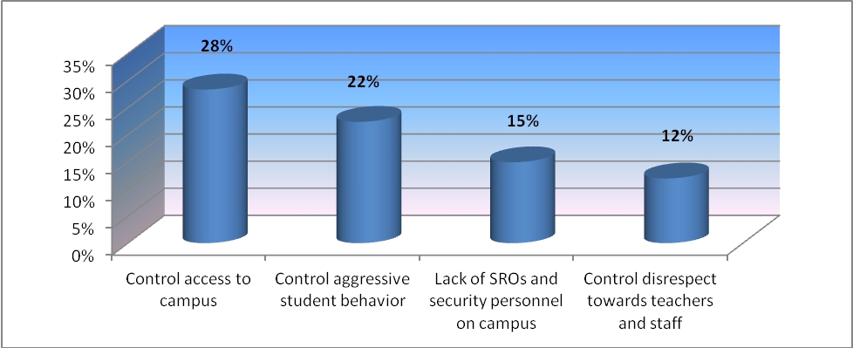

% of Districts Ranking Priority No. 2 Safety Issues

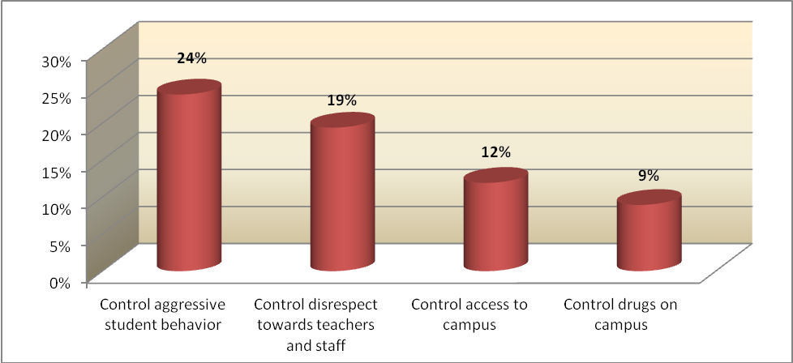

% of Districts Ranking Priority No. 3 Safety Issues

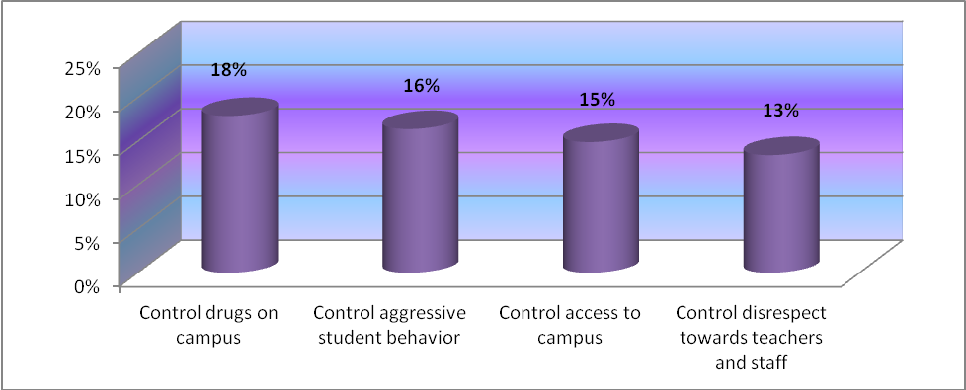

K-20 Flexibility Act

The K-20 Flexibility Act allows for funds allocated for safe schools activities to be expended for specific academic instruction. This year, two districts participated in the flexibility option: Holmes, Franklin and Jefferson Counties all reported spending flex dollars with Holmes at $106,808; Franklin at $5,378, and Jefferson at $61,606.
School Uniforms and Drug Testing Policies

In the interest of reducing the number of surveys issued from the Office of Safe Schools in the Department of Education, two additional questions were added to the 2006-2007 Safe Schools Appropriation Survey concerning school uniform and drug testing policies. Table 20 reflects the responses to these survey questions, for each grade grouping for school year 2010-2011.

Table 20 – School Uniforms / Drug Testing Policies

School Level | Have a School Uniform Policy |  | Have a Random Drug Testing Policy |  | Have a Random Drug Testing Policy for Athletes Only
 | YES | NO | YES | NO | YES | NO
Elementary | 26 | 51 | 1 | 66 | 12 | 15
Middle | 22 | 53 | 9 | 56 | 12 | 15
High | 9 | 59 | 22 | 42 | 12 | 15

SUMMARY

Safe Schools Appropriations has remained at $75,350,000 since 2000-2001, increased to $75,570,988 in 2007-2008, decreased to $71,998,330 in 2008-2009, to $67,260,840 in 2009-2010 and to $67,133,784 in 2010-2011. Districts rolled forward approximately $2.7 million from the 2009-2010 funding appropriation to help strengthen their efforts to make schools safe. Moreover, at the end of the 2010-2011 reporting period, districts left approximately $1.3 million unspent, to be rolled forward to the 2011-2012 appropriation period. Of the three primary spending categories, funds were spent according to the following breakdown: (1) After-School Programs ($2.4 million); (2) Alternative Placement Programs ($5.3 million); and (3) Safety and Security Activities ($60.1 million). The great majority of expended Safe Schools Appropriation funds were used for safety and security activities and other improvements to make schools safe. Within the safety and security activities category, districts spent the majority of their funds and other multiple funding streams for the services of 1,305 school resource officers. The total Safe Schools Appropriation expenditure for SROs was approximately $46.4 million; however, there are other collaborative funding streams used to support this effort.

The percentage of total expended Safe School Appropriation funds, for each category, breakdown as follows: (1) Safety and Security Program Activities (89%); Alternative Placement Programs for Adjudicated Youth (8%); After-School Programs (3%).

Over 7,700 middle-school students were served in after-school programs funded with Safe Schools Appropriation dollars, and over 11,000 adjudicated youth were served in Alternative Placement Programs.

Districts were asked to identify the most critical school safety issues affecting their schools. The following list shows the top three issues that were ranked as the number one priority:

- Controlling Access to Campus
- Controlling Aggressive Student Behavior
- Lack of School Resource Officers and Security Personnel on Campus
- Controlling Disrespect Towards Teachers and Staff

“Controlling Access to Campus” is the major concern reported by schools regarding school safety. Twenty eight percent (28%) of districts rated “Controlling Access to Campus” as the number one school safety issue affecting their schools, followed by “Controlling Aggressive Student Behavior” with twenty-two percent (22%), followed by “Lack of School Resource Officers and Security Personnel on Campus” with fifteen percent (15%). The last of the top four priorities was identified as “Controlling Disrespect Towards Teachers and Staff” at twelve percent (12%).

Beginning with the 2000-2001 survey, a data collection question was added for districts to report on methods used to determine the effectiveness of their safety and security activities/strategies. Responses indicated use of both objective data sources, such as performance data and the School Environmental Safety Incident Reporting (SESIR) data, as well as subjective data sources, such as school climate survey results and interview data.

Fiscal year 2001-2002 was the first year districts could choose to use their Safe Schools Appropriation funds for classroom instruction activities according to the K-20 Flexibility Act. Accordingly, the 2010-2011 funding period observed that three districts chose to spend approximately $173,792. These funds can be spent on computer hardware/software, contracted professional/technical services, materials and supplies, teacher salaries and benefits, curriculum, and other approved flexibility expenditures. The total flexibility expenditure was less than one percent (1%) of the total Safe Schools Appropriation expenditures.

While the current report provides information on each district’s use of safe schools funds, it does not provide insight into the reasons for annual changes in expenditure categories.

APPENDICES

APPENDIX A

Safe Schools Appropriation Proviso Language

Proviso Language in 2011-2012 General Appropriation Act
From the funds in Specific Appropriations 6 and 68, $64,456,019 is provided for Safe Schools activities and shall be allocated as follows: $62,660 shall be distributed to each district, and the remaining balance shall be allocated as follows: two-thirds based on the latest official Florida Crime Index provided by the Department of Law Enforcement and one-third based on each district's share of the state's total unweighted student enrollment. Safe Schools activities include: (1) after school programs for middle school students; (2) other improvements to enhance the learning environment, including implementation of conflict resolution strategies; (3) alternative school programs for adjudicated youth; (4) suicide prevention programs; and (5) other improvements to make the school a safe place to learn. Each district shall determine, based on a review of its existing programs and priorities, how much of its total allocation to use for each authorized Safe Schools activity. Each school district shall report to the Department of Education the amount of funds expended for each of the five activities.

Proviso Language in 2010-2011 General Appropriation Act
From the funds in Specific Appropriation 76, $67,260,840 is provided for Safe Schools activities and shall be allocated as follows: $65,387 shall be distributed to each district, and the remaining balance shall
be allocated as follows: two-thirds based on the latest official Florida Crime Index provided by the Department of Law Enforcement and one-third based on each district's share of the state's total unweighted student enrollment. Safe Schools activities include: (1) after school programs for middle school students; (2) other improvements to enhance the learning environment, including implementation of conflict resolution strategies; (3) alternative school programs for adjudicated youth; (4) suicide prevention programs; and (5) other improvements to make the school a safe place to learn. Each district shall determine, based on a review of its existing programs and priorities, how much of its total allocation to use for each authorized Safe Schools activity.

Revised Proviso Language in 2008-2009 General Appropriation Act
From the funds in Specific Appropriation 42, the 2008-2009 third calculation of the Florida Education Finance Program dated December 18, 2008, shall be revised to include the adjustments provided in Specific Appropriation 2, 3 and 42 through 45 and an adjustment that provides all districts with an equal percentage reduction to total potential funds. The equal percentage reduction shall not be recalculated. The appropriation in Specific Appropriation 42 shall include the following adjustments: A reduction of $1,589,497 for the Safe Schools Allocation, including a reduction to the minimum district allocation of $1,545.

The total Safe Schools Allocation for 2008-2009 is $71,998,330 and $69,993 shall be distributed to each district.

Proviso Language in 2008-2009 General Appropriation Act
From the funds in Specific Appropriation 81, $73,587,827 is provided for Safe Schools activities and shall be allocated as follows: $71,538 shall be distributed to each district, and the remaining balance shall
be allocated as follows: two-thirds based on the latest official Florida Crime Index provided by the Department of Law Enforcement and one-third based on each district's share of the state's total unweighted student enrollment. Safe Schools activities include: (1) after school programs for middle school students; (2) other improvements to enhance the learning environment, including implementation of conflict resolution strategies; (3) alternative school programs for adjudicated youth; (4) suicide prevention programs; and (5) other improvements to make the school a safe place to learn. Each district shall determine, based on a review of its existing programs and priorities, how much of its total allocation to use for each authorized Safe Schools activity.

Revised Proviso Language in 2007-2008 General Appropriation Act
From the funds in Specific Appropriation 29, the 2007-2008 third calculation of the Florida Education Finance Program dated December 19, 2007, and revised January 2, 2008, shall be further revised to include the adjustments provided in Specific Appropriation 2 and 29 through 32 and an adjustment that provides all districts with an equal percentage reduction to total potential funds. The equal percentage reduction shall not be recalculated. The appropriation in Specific Appropriation 29 shall include the following adjustments: -$1,026,677 for the Safe Schools Allocation, including an adjustment to the minimum district allocation of -$998.

The total Safe Schools Allocation for 2007-2008 is $75,590,988 and $73,485 shall be distributed to each district.

Proviso Language in 2007-2008 General Appropriation Act
From the funds in Specific Appropriation 86, $77,150,000 is provided for Safe Schools activities and shall be allocated as follows: $75,000 shall be distributed to each district, and the remaining balance shall
be allocated as follows: two-thirds based on the latest official Florida Crime Index provided by the Department of Law Enforcement and one-third based on each district's share of the state's total unweighted student enrollment. Safe Schools activities include: (1) after school programs for middle school students; (2) other improvements to enhance the learning environment, including implementation of conflict resolution strategies; (3) alternative school programs for adjudicated youth; (4) suicide prevention programs; and (5) other improvements to make the school a safe place to learn. Each district shall determine, based on a review of its existing programs and priorities, how much of its total allocation to use for each authorized Safe Schools activity.

2006-07 Safe Schools Appropriation Conference Report on House Bill 5001
For 2006-07, the Legislature added “suicide prevention programs” to those activities that are authorized for the Safe Schools Appropriation. From funds in Specific Appropriation 91, $75,350,000 is provided for Safe Schools activities and shall be allocated as follows: $50,000 shall be distributed to each district, and the remaining balance shall be allocated as follows: two-thirds based on the latest official Florida Crime Index provided by the Department of Law Enforcement and one-third based on each district’s share of the state’s total unweighted student enrollment. Safe Schools activities include: (1) after school programs for middle school students; (2) other improvements to enhance the learning environment, including implementation of conflict resolution strategies; (3) alternative school programs for adjudicated youth; (4) suicide prevention programs; and (5) other improvements to make the school a safe place to learn. Each district shall determine, based on a review of its existing programs and priorities, how much of its total allocation to use for each authorized Safe Schools activity.

Proviso Language in 2005-2006 General Appropriation Act
From the funds in Specific Appropriation 73, $75,350,000 is provided for Safe Schools activities and shall
be allocated as follows: $50,000 shall be distributed to each district, and the remaining balance shall be
allocated as follows: two-thirds based on the latest official Florida Crime Index provided by the Department
of Law Enforcement and one-third based on each district’s share of the state’s total unweighted student
enrollment. Safe Schools activities include: (1) after school programs for middle school students; (2) other
improvements to enhance the learning environment, including implementation of conflict resolution
strategies; (3) alternative school programs for adjudicated youth; and (4) other improvements to make the
school a safe place to learn. Each district shall determine, based on a review of its existing programs and
priorities, how much of its total allocation to use for each authorized Safe Schools activity.

Proviso Language in 2004-2005 General Appropriation Act

From the funds in Specific Appropriation 81, $75,350,000 is provided for Safe Schools activities and shall be allocated as follows: $30,000 shall be distributed to each district, and the remaining balance shall be allocated as follows: two-thirds based on the latest official Florida Crime Index provided by the Department of Law Enforcement and one-third based on each district’s share of the state’s total unweighted student enrollment. Safe Schools activities include (1) after school programs for middle school students, (2) other improvements to enhance the learning environment, including implementation of conflict resolution strategies, (3) alternative school programs for adjudicated youth, and (4) other improvements to make the school a safe place to learn. Each district shall determine, based on a review of its existing programs and priorities, how much of its total allocation to use for each authorized Safe Schools activity.

Proviso Language in 2003-2004 General Appropriation Act
From the funds in Specific Appropriation 81, $75,350,000 is provided for Safe Schools activities and shall be allocated as follows: $30,000 shall be distributed to each district, and the remaining balance shall
be allocated as follows: two-thirds based on the latest official Florida Crime Index provided by the Department of Law Enforcement and one-third based on each district's share of the state's total unweighted
student enrollment. Safe Schools activities include: (1) after school programs for middle school students; (2) other improvements to enhance the learning environment, including implementation of conflict
resolution strategies; (3) alternative school programs for adjudicated youth; and (4) other improvements to make the school a safe place to learn. Each district shall determine, based on a review of its existing programs and priorities, how much of its total allocation to use for each authorized Safe Schools activity.

Proviso Language in 2002-2003 General Appropriation Act

From the funds appropriated in Specific Appropriation 105, $75,350,000 is provided for Safe Schools activities and shall be allocated as follows: $30,000 shall be distributed to each district, and the remaining balance shall be allocated as follows: two-thirds based on the latest official Florida Crime Index provided by the Department of Law Enforcement and one-third based on each district's share of the state's total unweighted student enrollment. Safe school activities include: (1) after school programs for middle school students, (2) other improvements to enhance the learning environment, including implementation of conflict resolution strategies, (3) alternative school programs for adjudicated youth, and (4) other improvements to make the school a safe place to learn. For the purpose of a school district's compliance with the approved Safety and Security Best Practices, the local school board may determine that an appropriate use of these funds would be for the implementation of a parental emergency notification system that includes a personalized identification and validation component. Each district shall determine, based on a review of its existing programs and priorities, how much of its total allocation to use for each authorized Safe School activity.

Proviso Language in 2001-2002 General Appropriation Act

From the funds provided in Specific Appropriation 118, $75,350,000 is provided for Safe schools activities and shall be allocated as follows: $30,000 shall be distributed to each district, and the remaining balance shall be allocated as follows: two-thirds based on the latest official Florida Crime Index provided by the Department of Law Enforcement and one-third based on each district’s share of the state’s total unweighted student enrollment. Safe schools activities include (1) after-school programs for middle school students, (2) other improvements to enhance the learning environment, including implementation of conflict resolution strategies, (3) alternative school programs for adjudicated youth, and (4) other improvements to make the school a safe place to learn. Each district shall determine, based on a review of its existing programs and priorities, how much of its total allocation to use for each authorized safe schools activity.

Proviso Language in 2000-2001 General Appropriation Act

From the funds provided in Specific Appropriation 78, $75,350,000 is provided for Safe schools activities and shall be allocated as follows: $30,000 shall be distributed to each district, and the remaining balance shall be allocated as follows: two-thirds based on the latest official Florida Crime Index provided by the Department of Law Enforcement and one-third based on each district’s share of the state’s total unweighted student enrollment. Safe schools activities include (1) after-school programs for middle school students, (2) other improvements to enhance the learning environment, including implementation of conflict resolution strategies, (3) alternative school programs for adjudicated youth, and (4) other improvements to make the school a safe place to learn. Each district shall determine, based on a review of its existing programs and priorities, how much of its total allocation to use for each authorized safe schools activity.

Proviso Language in 1999-2000 General Appropriation Act

From the funds provided in Specific Appropriation 109, $70,350,000 is provided for safe schools activities and shall be allocated as follows: $30,000 shall be distributed to each district, and the remaining balance shall be allocated as follows: two-thirds based on the latest official Florida Crime Index provided by the Department of Law Enforcement and one-third based on each district’s share of the state’s total weighted student enrollment. Safe schools activities include (1) after-school programs for middle school students, (2) other improvements to enhance the learning environment, including implementation of conflict resolution strategies, (3) alternative school programs for adjudicated youth, and (4) other improvements to make the school a safe place to learn. Each district shall determine, based on a review of its existing programs and priorities, how much of its total allocation to use for each authorized safe schools activity.

Proviso Language in 1998-1999 General Appropriation Act
From the funds provided in Specific Appropriation 117, $50,350,000 is provided for the safe schools activities and shall be allocated as follows: two-thirds shall be based on the latest official Florida Crime Index provided by the Department of Law Enforcement and one-third shall be based on each district’s share of the state’s total weighted student enrollment. Safe schools activities include (1) after-school programs for middle school students, (2) other improvements to enhance the learning environment, including implementation of conflict resolution strategies, and (3) alternative school programs for adjudicated youth. Each district shall determine, based on a review of its existing programs and priorities, how much of its total allocation to use for each authorized safe schools activity.

Proviso Language in 1997-1998 General Appropriation Act
From the funds provided in Specific Appropriation 105, $50,350,000 is provided for safe schools activities and shall be allocated as follows: two-thirds based on the latest official Florida Crime Index provided by the Department of Law Enforcement and one-third shall be based on each district’s share of the state’s total weighted student enrollment. Safe schools activities include (1) after-school programs for middle school students, (2) other improvements to enhance the learning environment, including implementation of conflict resolution strategies, and (3) alternative school programs for adjudicated youth. Each district shall determine, based on a review of its existing programs and priorities, how much of its total allocation to use for each authorized safe schools activity. Districts may use funds provided in Specific Appropriation 105 for authorized safe schools activities and to support any other instructional activity designated by the district school board.

Proviso Language in 1996-1997 General Appropriation Act
From the funds provided in Specific Appropriation 140, $50,350,000 is provided for safe schools activities and shall be allocated as follows: two-thirds based on the latest official Florida Crime Index provided by the Department of Law Enforcement, and one-third shall be based on each district’s share of the state’s total weighted student enrollment. Safe schools activities include (1) after-school programs for middle school students, (2) other improvements to enhance the learning environment, including implementation of conflict resolution strategies, and (3) alternative school programs for adjudicated youth. Each district shall determine, based on a review of its existing programs and priorities, how much of its total allocation to use for each authorized safe schools activity. Districts may use funds provided in Specific Appropriation 140 for authorized safe schools activities and to support any other instructional activity designated by the district school board.

Proviso Language in 1995-1996 General Appropriation Act
From the funds provided in Specific Appropriation 150, $70,350,000 is provided for safe schools activities and shall be allocated as follows: 80% based on the latest official Florida Crime Index provided by the Department of Law Enforcement, and 20% shall be based on each district’s share of the state’s total weighted student enrollment. The entire amount of a district’s allocation of safe schools funds must be used for authorized safe schools activities. Those activities are (1) after-school programs for middle school students, (2) other improvements to enhance the learning environment, and (3) alternative school programs for adjudicated youth. However, each district shall determine, based on a review of its existing programs and priorities, how much of its total allocation to use for each authorized Safe School activity. Each district may choose to use none, some, or all of its total allocation for a particular authorized activity.

Proviso Language in 1994-1995 General Appropriation Act
From the funds provided in Specific Appropriation 528, $37,000,000 is provided for an after-school program designed for at-risk students in middle schools. Districts are encouraged to build on existing after-school programs within their communities. Districts are further encouraged to form partnerships with community groups in an effort to maximize resources. $12,000,000 is provided for an Alternative School Program for adjudicated students, and $11,350,000 for a security program that will provide for school resource officers, equipment, and other improvements to enhance the environment for learning. The school districts shall not use these funds to supplant programs that are currently operational in the school districts. The school districts shall develop plans for the implementation of the specified programs and each affected school shall report on the progress of the programs in their Annual School Report. However, in the case of school districts with FTE enrollment of 25,000 or less, the funds from Alternative School Program and the Security Program in Specific Appropriation 528 may be combined to allow the development of a coordinated plan for the district.

APPENDIX B

Florida Department of Education

2010-2011 FEFP Final Calculation
SAFE SCHOOLS ALLOCATION

 |  |  |  | Allocation |  | Allocation | Total
 |  | Allocation | 2009 | Based on | 2010-11 | Based on | Safe
 |  | Minimum | Crime | Crime | Unweighted | Unweighted | Schools
 |  |  | Index | Index | FTE | FTE | Allocation
 | District | -1- | -2- | -3- | -4- | -5- | -6-
1 | Alachua | 65,263 | 12,823 | 649,854 | 26,873.13 | 211,119 | 926,236
2 | Baker | 65,263 | 442 | 22,400 | 4,954.78 | 38,925 | 126,588
3 | Bay | 65,263 | 8,154 | 413,235 | 25,126.91 | 197,401 | 675,899
4 | Bradford | 65,263 | 787 | 39,884 | 3,126.53 | 24,562 | 129,709
5 | Brevard | 65,263 | 21,592 | 1,094,256 | 71,212.66 | 559,457 | 1,718,976
6 | Broward | 65,263 | 79,130 | 4,010,210 | 255,690.23 | 2,008,740 | 6,084,213
7 | Calhoun | 65,263 | 117 | 5,929 | 2,188.12 | 17,190 | 88,382
8 | Charlotte | 65,263 | 4,623 | 234,288 | 16,274.34 | 127,854 | 427,405
9 | Citrus | 65,263 | 3,604 | 182,646 | 15,352.11 | 120,608 | 368,517
10 | Clay | 65,263 | 5,663 | 286,994 | 35,682.84 | 280,330 | 632,587
11 | Collier | 65,263 | 6,911 | 350,241 | 42,429.48 | 333,332 | 748,836
12 | Columbia | 65,263 | 2,596 | 131,562 | 9,797.37 | 76,970 | 273,795
13 | Miami-Dade | 65,263 | 142,651 | 7,229,375 | 345,375.65 | 2,713,321 | 10,007,959
14 | DeSoto | 65,263 | 1,456 | 73,788 | 4,989.67 | 39,200 | 178,251
15 | Dixie | 65,263 | 679 | 34,411 | 2,027.18 | 15,926 | 115,600
16 | Duval | 65,263 | 52,356 | 2,653,337 | 125,171.86 | 983,368 | 3,701,968
17 | Escambia | 65,263 | 15,499 | 785,470 | 39,909.26 | 313,533 | 1,164,266
18 | Flagler | 65,263 | 2,588 | 131,157 | 12,828.56 | 100,783 | 297,203
19 | Franklin | 65,263 | 326 | 16,521 | 1,255.28 | 9,862 | 91,646
20 | Gadsden | 65,263 | 1,294 | 65,578 | 5,839.58 | 45,877 | 176,718
21 | Gilchrist | 65,263 | 296 | 15,001 | 2,548.39 | 20,021 | 100,285
22 | Glades | 65,263 | 250 | 12,670 | 1,462.44 | 11,489 | 89,422
23 | Gulf | 65,263 | 249 | 12,619 | 1,953.07 | 15,344 | 93,226
24 | Hamilton | 65,263 | 399 | 20,221 | 1,697.58 | 13,336 | 98,820
25 | Hardee | 65,263 | 887 | 44,952 | 5,117.90 | 40,207 | 150,422
26 | Hendry | 65,263 | 1,602 | 81,187 | 6,816.47 | 53,551 | 200,001
27 | Hernando | 65,263 | 5,853 | 296,623 | 22,624.39 | 177,740 | 539,626
28 | Highlands | 65,263 | 3,172 | 160,753 | 12,079.42 | 94,898 | 320,914
29 | Hillsborough | 65,263 | 49,971 | 2,532,468 | 192,852.31 | 1,515,076 | 4,112,807
30 | Holmes | 65,263 | 308 | 15,609 | 3,298.96 | 25,917 | 106,789
31 | Indian River | 65,263 | 4,484 | 227,243 | 17,560.88 | 137,961 | 430,467
32 | Jackson | 65,263 | 1,157 | 58,635 | 6,849.22 | 53,808 | 177,706
33 | Jefferson | 65,263 | 322 | 16,319 | 1,058.96 | 8,319 | 89,901
34 | Lafayette | 65,263 | 100 | 5,068 | 1,149.04 | 9,027 | 79,358
35 | Lake | 65,263 | 9,134 | 462,900 | 40,390.97 | 317,317 | 845,480
36 | Lee | 65,263 | 20,501 | 1,038,965 | 80,819.69 | 634,931 | 1,739,159
37 | Leon | 65,263 | 12,836 | 650,512 | 33,057.04 | 259,701 | 975,476
38 | Levy | 65,263 | 1,520 | 77,032 | 5,616.44 | 44,124 | 186,419
39 | Liberty | 65,263 | 0 | 0 | 1,406.75 | 11,052 | 76,315
40 | Madison | 65,263 | 684 | 34,664 | 2,699.84 | 21,210 | 121,137
41 | Manatee | 65,263 | 15,930 | 807,312 | 43,516.20 | 341,870 | 1,214,445
42 | Marion | 65,263 | 10,391 | 526,603 | 41,439.61 | 325,556 | 917,422
43 | Martin | 65,263 | 4,190 | 212,344 | 17,757.58 | 139,506 | 417,113
44 | Monroe | 65,263 | 4,445 | 225,267 | 7,964.72 | 62,572 | 353,102
45 | Nassau | 65,263 | 2,126 | 107,743 | 11,121.44 | 87,372 | 260,378
46 | Okaloosa | 65,263 | 5,704 | 289,072 | 28,582.06 | 224,545 | 578,880
47 | Okeechobee | 65,263 | 1,620 | 82,100 | 6,754.65 | 53,065 | 200,428
48 | Orange | 65,263 | 63,771 | 3,231,835 | 174,720.05 | 1,372,626 | 4,669,724
49 | Osceola | 65,263 | 11,694 | 592,637 | 52,893.29 | 415,537 | 1,073,437
50 | Palm Beach | 65,263 | 60,011 | 3,041,283 | 172,831.74 | 1,357,791 | 4,464,337
51 | Pasco | 65,263 | 17,566 | 890,223 | 65,913.08 | 517,823 | 1,473,309
52 | Pinellas | 65,263 | 49,132 | 2,489,948 | 103,142.24 | 810,300 | 3,365,511
53 | Polk | 65,263 | 24,306 | 1,231,798 | 93,810.54 | 736,989 | 2,034,050
54 | Putnam | 65,263 | 4,237 | 214,726 | 10,881.61 | 85,487 | 365,476
55 | St. Johns | 65,263 | 5,717 | 289,730 | 30,591.71 | 240,333 | 595,326
56 | St. Lucie | 65,263 | 9,070 | 459,656 | 38,732.33 | 304,287 | 829,206
57 | Santa Rosa | 65,263 | 2,200 | 111,493 | 25,092.42 | 197,130 | 373,886
58 | Sarasota | 65,263 | 15,282 | 774,473 | 40,879.01 | 321,151 | 1,160,887
59 | Seminole | 65,263 | 13,106 | 664,196 | 63,907.27 | 502,065 | 1,231,524
60 | Sumter | 65,263 | 1,334 | 67,605 | 7,437.45 | 58,430 | 191,298
61 | Suwannee | 65,263 | 1,038 | 52,604 | 6,042.05 | 47,467 | 165,334
62 | Taylor | 65,263 | 750 | 38,009 | 2,845.58 | 22,355 | 125,627
63 | Union | 65,263 | 159 | 8,058 | 2,204.08 | 17,316 | 90,637
64 | Volusia | 65,263 | 21,120 | 1,070,335 | 61,410.23 | 482,448 | 1,618,046
65 | Wakulla | 65,263 | 840 | 42,570 | 5,123.01 | 40,247 | 148,080
66 | Walton | 65,263 | 1,557 | 78,907 | 7,253.13 | 56,982 | 201,152
67 | Washington | 65,263 | 247 | 12,518 | 3,440.35 | 27,028 | 104,809
68 | Washington Special¹ | 0 | 0 | 0 | 273.70 | 2,150 | 2,150
69 | FAMU Lab School | 65,263 | 0 | 0 | 502.67 | 3,949 | 69,212
70 | FAU - Palm Beach | 65,263 | 0 | 0 | 682.11 | 5,359 | 70,622
71 | FAU - St. Lucie | 65,263 | 0 | 0 | 1,441.16 | 11,322 | 76,585
72 | FSU Lab - Broward | 65,263 | 0 | 0 | 657.00 | 5,161 | 70,424
73 | FSU Lab - Leon | 65,263 | 0 | 0 | 1,705.92 | 13,402 | 78,665
74 | UF Lab | 65,263 | 0 | 0 | 1,139.89 | 8,955 | 74,218
75 | Virtual School² | 0 | 0 | 0 | 0.00 | 0 | 0
 | TOTAL | 4,764,199 | 824,559 | 41,787,622 | 2,619,855.18 | 20,581,963 | 67,133,784
1. The Washington Special school district does not receive the Crime Index portion of Safe School funding.
2. The Florida Virtual School does not receive Safe School funding.

APPENDIX C

Analysis of District After-School Expenditures

Based on Total Expenditures

District | After-School Expenditures | Total District Expenditures | % of District Safe Schools Total Expenditures
Baker | $15,190 | $126,578 | 12%
Collier | $436,044 | $748,795 | 58%
Indian River | $3,370 | $427,366 | 1%
Lee | $832 | $2,056,263 | .04%
Nassau | $18,937 | $259,761 | 7%
Palm Beach | $1,917,853 | $4,464,344 | 43%
Sumter | $4,804 | $205,259 | 2%
Taylor | $30,341 | $114,300 | 27%
TOTAL | $2,427,371 | $8,402,666 | 19%

APPENDIX D

Analysis of District Alternative Placement Program Expenditures

Based on Total Expenditures

District | Amount Expended | Total District Expenditures | % of District Safe Schools Total Expenditures
Baker | $32,190 | $126,578 | 25%
Brevard | $883,621 | $1,718,832 | 51%
Broward | $2,642,295 | $6,084,801 | 43%
Clay | $49,922 | $668,679 | 7%
Escambia | $71,213 | $1,088,796 | 7%
Hardee | $56,974 | $147,829 | 39%
Hendry | $200,008 | $200,008 | 100%
Hillsborough | $54,333 | $4,113,039 | 1%
Palm Beach | $1,332,797 | $4,464,344 | 30%
TOTAL | $5,323,353 | $18,612,906 | 29%

APPENDIX E

Analysis of District School Safety and Security Expenditures

Based on Total Expenditures

Districts | Total Amount of Safe Schools Funds Expended on Safety and Security | Total Safe Schools Funds Expended | % of Total Expended
Alachua | $926,012 | 926,012 | 100%
Baker | $79,198 | 126,578 | 63%
Bay | $676,141 | 676,141 | 100%
Bradford | $120,339 | 120,339 | 100%
Brevard | $835,211 | 1,718,832 | 49%
Broward | $3,442,506 | 6,084,801 | 57%
Calhoun | $88,387 | 88,387 | 100%
Charlotte | $427,493 | 427,493 | 100%
Citrus | $453,716 | 453,716 | 100%
Clay | $618,757 | 668,679 | 93%
Collier | $312,751 | 748,795 | 42%
Columbia | $327,935 | 327,935 | 100%
Dade | $10,007,815 | 10,007,815 | 100%
DeSoto | $161,564 | 161,564 | 100%
Dixie | $115,617 | 115,617 | 100%
Duval | $4,656,386 | 4,656,386 | 100%
Escambia | $1,017,583 | 1,088,796 | 93%
Flagler | $297,234 | 297,234 | 100%
Franklin | $86,256 | 86,256 | 100%
Gadsden | $220,907 | 220,907 | 100%
Gilchrist | $100,260 | 100,260 | 100%
Glades | $89,427 | 89,427 | 100%
Gulf | $93,226 | 93,226 | 100%
Hamilton | $101,289 | 101,289 | 100%
Hardee | $90,855 | 147,829 | 61%
Hendry | 0 | 200,008 | 0%
Hernando | $515,310 | 515,310 | 100%
Highlands | $320,899 | 320,899 | 100%
Hillsborough | $4,058,706 | 4,113,039 | 99%
Holmes | 0 | 106,808 | 0%
Indian River | $423,996 | 427,366 | 99%
Jackson | $177,769 | 177,769 | 100%
Jefferson | $28,269 | 28,269 | 100%
Lafayette | $135,127 | 135,127 | 100%
Lake | $845,383 | 845,383 | 100%
Lee | $2,055,431 | 2,056,263 | 100%
Leon | $979,038 | 979,038 | 100%
Levy | $186,498 | 186,498 | 100%
Liberty | $73,682 | 73,682 | 100%
Madison | $104,270 | 104,270 | 100%
Manatee | $1,214,386 | 1,214,386 | 100%
Marion | $917,905 | 917,905 | 100%
Martin | $417,124 | 417,124 | 100%
Monroe | $353,095 | 353,095 | 100%
Nassau | $240,825 | 259,761 | 93%
Okaloosa | $621,434 | 621,434 | 100%
Okeechobee | $158,816 | 158,816 | 100%
Orange | $4,658,766 | 4,658,766 | 100%
Osceola | $1,026,322 | 1,026,321 | 100%
Palm Beach | $1,213,694 | 4,464,344 | 27%
Pasco | $1,478,860 | 1,478,860 | 100%
Pinellas | $3,365,494 | 3,365,494 | 100%
Polk | $2,033,785 | 2,033,785 | 100%
Putnam | $351,130 | 351,130 | 100%
St. Johns | $595,029 | 595,029 | 100%
St. Lucie | $829,109 | 829,109 | 100%
Santa Rosa | $325,676 | 325,676 | 100%
Sarasota | $1,160,861 | 1,160,861 | 100%
Seminole | $1,296,956 | 1,296,955 | 100%
Sumter | $200,455 | 205,259 | 98%
Suwannee | $165,405 | 165,405 | 100%
Taylor | $83,959 | 114,300 | 73%
Union | $92,047 | 92,047 | 100%
Volusia | $1,608,835 | 1,608,835 | 100%
Wakulla | $148,072 | 148,072 | 100%
Walton | $199,510 | 199,510 | 100%
Washington | $106,191 | 106,191 | 100%
TOTAL | $60,114,983 | 67,865,706 | 89%

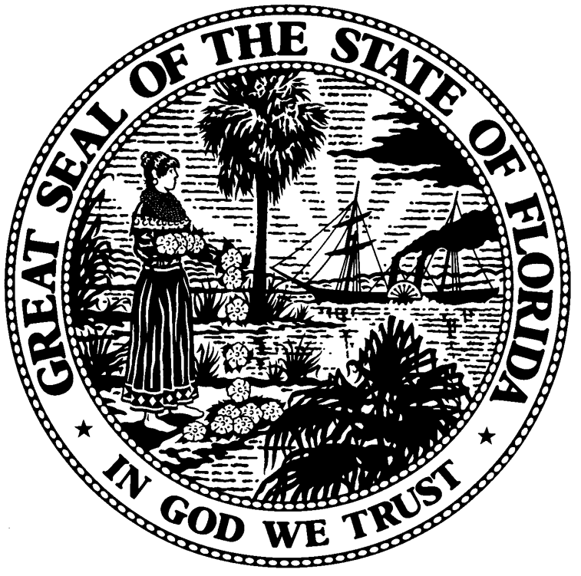

Dr. Tony Bennett
COMMISSIONER

