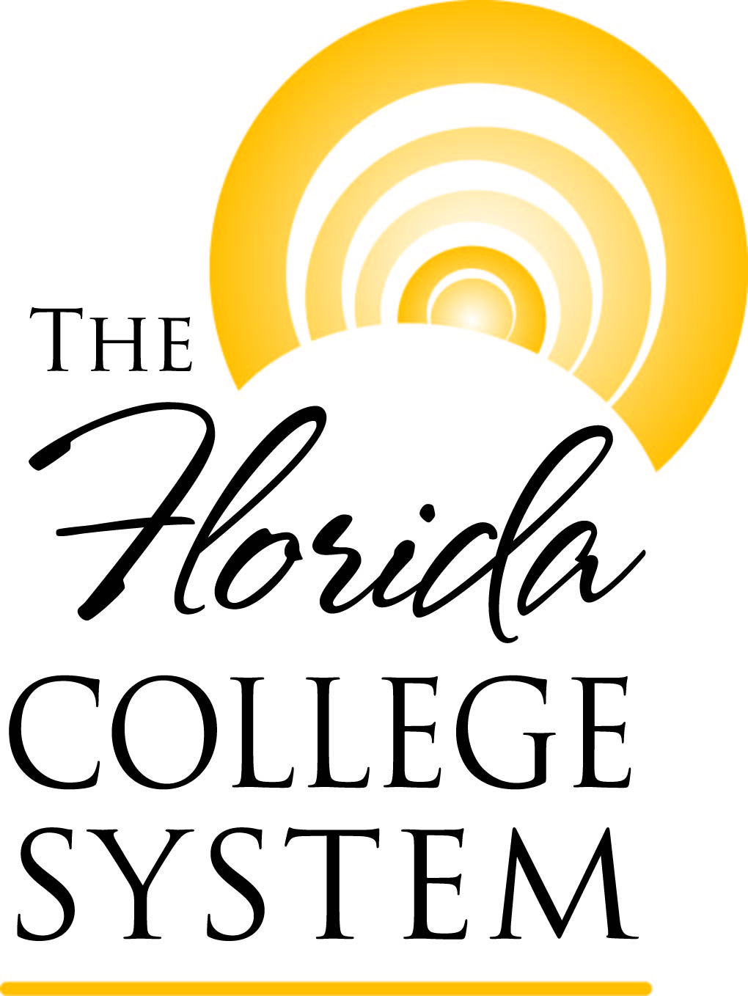 | Guide for Nonpublic Institutions: Statewide Articulation Agreements with The Florida College System

Guide for Nonpublic Institutions:
Statewide Articulation Agreements with the Florida College System

Background
The Florida College System (FCS) is comprised of 28 locally-governed colleges that enrolled more than 855,000 students statewide in 2011-12. The mission of FCS is to: provide access to high-quality, affordable academic and career education programs that maximize student learning and success, develop a globally competitive workforce, and respond rapidly to diverse state and community needs. The Division of Florida Colleges (DFC) provides leadership and advocacy to promote education innovation and continuous improvement within the FCS.

A statewide articulation agreement exists in Florida Statutes and Florida Administrative Code to establish an effective and orderly transfer process for students entering a FCS institution, completing an Associate in Arts degree, and transferring to a state university or a Florida College System institution. Florida Statutes also encourage collaboration between the public and independent – or nonpublic – sectors of postsecondary education. DFC currently has agreements with the following institutions:
- Independent Colleges and Universities of Florida (http://www.fldoe.org/articulation/pdf/ICUF_Agreement.pdf)
- Keiser University (http://www.fldoe.org/articulation/pdf/Keiser_Agreemt.pdf)
- Strayer University (http://www.fldoe.org/articulation/pdf/StrayerUAgreement.pdf)
- Association of Jesuit Colleges and Universities (http://www.fldoe.org/articulation/pdf/JesuitUAgreement.pdf)
- DeVry University (http://www.fldoe.org/articulation/pdf/dvaa.pdf)
- Western Governors University (http://www.fldoe.org/articulation/pdf/WesternGovernorsAg.pdf)
- Union Institute & University
(http://www.fldoe.org/articulation/pdf/uiuaa.pdf)

This guide is intended to provide information to nonpublic postsecondary institutions that seek to enter into an articulation agreement with FCS institutions. Below is a step-by-step overview of the process for the nonpublic institution to work with DFC in developing the desired articulation agreement.

Process
Step 1 Initiate Contact
- Nonpublic institution (institution) initiates contact with DFC by completing the “Intent to Develop Nonpublic Articulation Agreement” form (see Appendix A).
- Institution emails completed form to Abbey Ivey at Abbey.Ivey@fldoe.org.
- DFC sends confirmation email to institution indicating receipt of form and notice that the institution can begin developing draft agreement using Word template (see Appendix B).
Step 2 Draft Agreement
- Institution completes the draft agreement using track changes feature in Word.
- Institution emails Word document, with tracked changes, to Abbey Ivey at Abbey.Ivey@fldoe.org.

Step 3 Revise Agreement
- DFC reviews and, if necessary, revises draft agreement. DFC returns agreement to institution.
- Institution reviews DFC’s revisions, makes any necessary changes, and returns agreement to DFC.
- DFC and institution finalize agreement.

Step 4 Seek Approval
- DFC provides agreement with a cover sheet and institutional data to Articulation Coordinating Committee (ACC). ACC reviews and makes recommendation to approve or disapprove the agreement.
- DFC provides draft agreement, cover letter, institutional data, and ACC recommendation to Florida College System Council of Presidents (COP). COP reviews agreement and makes recommendation.
- Upon COP’s recommendation, Chancellor signs agreement.

Step 5 Finalize Agreement
- Institution prints and signs two agreements and ground mails both to:
Ms. Abbey Ivey
Division of Florida Colleges
Florida Department of Education
325 West Gaines Street, Ste. 1544
Tallahassee, FL 32399-0400
- Chancellor signs agreement.
- DFC scans and emails PDF version of the agreement to institution and ground mails one signed copy to institution. DFC retains the other signed copy.
- DFC provides notice of the articulation agreement to:
  - Council of Presidents
  - Council of Instructional Affairs
  - Council of Student Affairs
- Florida Department of Education posts articulation agreement to Office of Articulation website.
Step 6 Participation Agreements
- DFC collects participation agreements from FCS institutions choosing to participate in the articulation agreement.
- DFC provides participation agreements to the institution.

Step 7 Create Manual
- Institution creates articulation manual outlining details of student transfer (see Appendix C). For an example, see Western Governor University’s manual at http://files.facts.usf.edu/pdfDocuments/manuals/otherPrivateArticulationManuals/WGUFLCC%20Articulation%20Manual%204%204%2011.pdf.

Step 8 Publish Manual
- Institution submits articulation manual to DFC for posting on the Florida Virtual Campus website.

Step 9 Maintain Agreement
- Institution annually updates manual in June.
- Institution submits Annual Accountability Report in June (see Appendix D).

Contacts
If you have any questions, the primary contact for nonpublic articulation agreements is:
Ms. Abbey Ivey
Director of Academic Affairs
Division of Florida Colleges
Abbey.Ivey@fldoe.org
(850) 245-9492

Additional contacts include:

Ms. Julie Alexander
Vice Chancellor for Academic and Student Affairs
Division of Florida Colleges
Julie.Alexander@fldoe.org

(850) 245-9523

Ms. Carla Campbell
Administrative Assistant
Division of Florida Colleges
Carla.Campbell@fldoe.org
(850) 245-9471

Appendix A
Intent to Develop Nonpublic Articulation Agreement
with the Division of Florida Colleges

Intent to Develop Nonpublic Articulation Agreement
with The Division of Florida Colleges

1. Name of Institution: Click here to enter text.
2. Brief History of Institution: Click here to enter text.
3. Institution type (for-profit or not-for-profit): Click here to enter text.
4. Location: Click here to enter text.
5. Accreditation: Click here to enter text.
6. Licensure in Florida, if applicable: Click here to enter text.
7. For which programs are you interested in creating articulation agreements? List all that apply. Click here to enter text.

8. Provide the contact information for the individual coordinating the agreement process. Click here to enter text.

9. List any existing agreements with Florida College System institutions. Click here to enter text.

Upon completion, please email this form to Abbey.Ivey@fldoe.org.

Appendix B
Nonpublic Articulation Agreement Template

ARTICULATION AGREEMENT BETWEEN

THE DIVISION OF FLORIDA COLLEGES

AND

________________________________

A Statement of Philosophy and Intent

The State of Florida, long a national leader in higher education, has given broad policy directions to the system of postsecondary education with regard to transfer and articulation between and among two- and four-year institutions. A statewide articulation agreement exists in Florida Statutes and Florida Administrative Code to establish an effective and orderly transfer process for students entering a Florida college, completing an Associate in Arts degree, and transferring to a state university. Florida Statutes also encourage collaboration between the public and independent sectors of postsecondary education.

________________ [brief history and description of the partner institution, its location(s), accreditation, and licensure in Florida].

The purpose of this agreement is to set forth the uniform conditions regarding articulation between the Florida College System (FCS) and _________________. It is intended to increase the options available to ________________________________ [students it will serve and how]. This agreement serves as an overarching statement of cooperation between the FCS and _______________, thus benefiting FCS graduates in _____________ degree programs. However, it is not intended to supersede more specific college and program articulation agreements as developed in geographic areas served by campuses of _______________. This articulation agreement between the FCS and _______________ was established in ____ [year].

ARTICULATION AGREEMENT BETWEEN

THE DIVISION OF FLORIDA COLLEGES

AND

________________________________

This Articulation Agreement is entered into this ________ day of ______________, _____, by and between the Division of Florida Colleges and _________________.

WHEREAS, the parties desire to promote the most efficient and effective use of their resources and to offer students the broadest possible range of educational opportunities, and

WHEREAS, the parties desire to encourage and facilitate the establishment of specific articulation provisions between Florida’s public colleges and _________________, and

WHEREAS, the intent of this agreement is to facilitate the transfer of qualified _______ (degree type) students from Florida’s public colleges to _________________,

NOW, THEREFORE, the parties agree to cooperate in articulating programs in accordance with the terms set forth herein.

I. _____________ shall recognize the ___________ degree(s) as the transfer degree(s) from the Florida College System.

II. ____________ shall publish an articulation manual that specifies the programs articulated with the ___________ degree(s), including the course requirements and related prerequisite courses for each program. This articulation manual will be made available to students, faculty, and advisors through [explain].

III. ____________ shall develop course equivalency tables, specifically for program prerequisites and course requirements, insofar as it is reasonable and necessary to do so. Courses that are designated as equivalent in objectives, content, and credit hours must be treated as equivalent for all colleges.

IV. ____________ shall annually provide data to the Division of Florida Colleges on the number of FCS graduates by academic term who enroll under the provisions of this agreement and graduate with the baccalaureate degree.

V. _____________ and the Division of Florida Colleges shall agree to the following conditions:

A. Admission of a Florida college student to ______________ will depend on the number of spaces in each academic year [if appropriate, otherwise delete] and the continuation of the program. Program discontinuance will remove any obligation (beyond those protections afforded to native students) of ____________ to comply with the provisions of the Articulation Agreement relative to the discontinued program.

B. College students who transfer with a(n) _________ degree under the terms of this Agreement shall enter with junior standing, provided that transfer students shall meet the same standards and program requirements as native students. This includes admissions requirements (i.e., standard high school diploma, high school equivalency diploma, or other credential as authorized by Florida Statutes), college placement testing, and prior successful completion of all college preparatory coursework as mandated by state-approved assessments and standards. Failure to demonstrate adherence to agreed-upon standards of individual student college readiness may abrogate guarantees for transfer of credit for specific students or termination of this agreement.

C. A college student transferring under the terms of this Agreement shall be governed by the graduation requirements set forth in the __________________ catalog in effect at the time of the student’s initial enrollment in a Florida college, provided the student maintains continuous enrollment as defined by _________________ and receives an _________ degree and transfers to ____________ within six years of initial enrollment in a Florida college. Continuous enrollment as defined by _________________ is _____________ [explain]. The student will also have the option of graduating under the catalog in effect at the time of transfer.

D. Credit awarded by a participating Florida college as experiential credit and/or credit awarded by exam, such as College Level Examination Program (CLEP), International Baccalaureate (IB) Program, Advanced International Certificate of Education (AICE) Program, and Advanced Placement (AP), while acceptable to satisfy associate degree requirements, may or may not satisfy specific requirements of the baccalaureate degree. ___________ policy on accepting credits awarded as experiential credit and credit by exam is [specify policy here].

E. College students who transfer under the terms of this Agreement shall be considered as having completed the general education requirements of __________. [If needed, specify any differences based on degree.] However, ___________ may specify additional courses that must be completed prior to the awarding of the baccalaureate degree. These courses may be completed at either institution.

F. For the students accepted for transfer, the grade of “D” will be treated the same as grades of “D” obtained by native students at __________. ___________ may require a grade point average (GPA) of not less than 2.0 overall or a grade of “C” or better in all prerequisite courses, provided the same policy is applied equitably for native and transfer students. [Specify if different.]

G. All credit from ___________ degrees awarded by a participating Florida college will transfer to _____________, based on the established number of credits in the college program of study. This includes a minimum of 60 credits for the Associate in Arts and ___________________ [specify for other articulated degrees]. However, the student must meet the specific degree course requirements of _____________, which may mean extending the number of credit hours to earn the degree, if the 60 hours [revise if needed] transferred and applied do not include all of the degree prerequisites.

H. Programmatically, the forgiveness policy for ___________ shall prevail. [Specify policy here.]

I. Authority over all academic policies or practices not mentioned in this agreement shall remain with ____________________.

VI. During the period of this Agreement, the Division of Florida Colleges shall:

A. Publicize the Articulation Agreement among the faculty, staff, and students in the Florida College System via the Florida Virtual Campus website as well as other Department of Education and Division of Florida Colleges publications, correspondence, and outreach activities.

B. Make available to state college faculty members, counselors, students, and other appropriate individuals within the Florida College System, the ________________ admission requirements; preferred general education requirements; program prerequisite courses, other related requirements, and the course equivalency lists. This will be done via the Florida Virtual Campus website.

VII. Both parties agree:

A. To cooperate on curricular and advising issues that will facilitate future student transfer.

B. To encourage the development of scholarships and other financial aid opportunities for Florida college transfer students who are directly affected by this Agreement. [If appropriate, specify here. Otherwise, delete.]

C. To foster communication between _______________, the Division, and the Florida College System. The following individuals will serve as liaison officers for matters relating to this agreement:

Division of Florida Colleges:  Ms. Abbey Ivey  Director of Academic Affairs  (850) 245-9492 or Abbey.Ivey@fldoe.org | _________________________________:  [Name and Contact Information]
Both parties agree to notify the other of any changes in contact information for their respective liaison officers.

D. To provide for periodic review of the Agreement to evaluate articulation between the Florida College System and ___________. The review should be initiated by the Division and should take place at least once every three years, following initial implementation of the Agreement.
VIII. Participation Agreements.

A. Each Florida College System institution that elects to participate shall submit to the Division of Florida Colleges a Participation Agreement. The Participation Agreement shall be in effect until terminated.

B. Proposed modifications, additions, or deletions to a Participation Agreement must be in writing and signed by both parties.

C. Termination of a Participation Agreement must be submitted in writing to the Division of Florida Colleges prior to April 1 of each year. The termination of the agreement will be in effect beginning with the following Fall term. shall abide by the terms and conditions of the Articulation Agreement and the Participation Agreement for all students who were enrolled in a Florida College System institution on or before the effective date of termination, except with regard to terminated programs.

VIII. Applicable Law. This Agreement will be governed and construed in accordance with the laws of the State of Florida and the rules of the State Board of Education.

IX. Modifications. Any modifications, additions, or deletions to this Agreement must be in writing and signed by both parties. The designated representatives are the ____________ of ______________ and the Chancellor for the Division of Florida Colleges.

X. Termination of the Articulation Agreement. Either party may terminate this Agreement by giving written notice to the other party. The notice shall state the effective date of termination which shall be at least one year after the date on which the notice is received by the other party. Any student enrolled in a Florida college during the time this Agreement is in effect shall continue to receive the benefits of the Agreement until the effective date, one year after notification, provided all conditions contained herein are met by the student.

This Articulation Agreement between _____________ and the Division of Florida Colleges was accepted and approved by the participating entities this ________ day of ______________, 20__.

By: ______________________________ By: _________________________________
Title, Institution Chancellor, Division of Florida Colleges

THIS AGREEMENT shall take effect on ____________, and shall remain in effect until terminated by either party.

Appendix C
Nonpublic Articulation Manual Content Guidelines

Nonpublic Articulation Manual Content Guidelines

NAME OF INSTITUTION:

ACADEMIC YEAR:

PROGRAM OF STUDY (MAJOR): Name the program, i.e., biology, accounting, etc.

COLLEGE: Name the academic college at the institution, i.e., the College of Arts and Sciences.

SCHOOL: If applicable, name the academic school, i.e., School of Engineering.

DEGREE: Name the degree offered, i.e., Bachelor of Arts.

OPTIONS/TRACKS: If applicable, name the option or track under the major. For example, a school may offer specialized tracks under the biology major, such as cell biology or marine biology. You may elect to classify a "track" as a program of study if it has numerous distinct requirements.

CONTACT: Provide the name, title, mailing address, telephone number, fax number, and email address of the individual at your institution who can answer specific questions regarding the academic program requirements for the program of study. For example, the department chairperson or dean.

PROGRAM OF STUDY TO BE TAKEN AT THE FCS INSTITUTION (Lower Level Course Requirements): List the statewide course prefix and number, course name and/or course title, and credit hours needed for any lower level courses that may be taken at the FCS institution and that are either required for admission to the major; are required for completion of the degree program; or are recommended for the major. In addition, list any preferred general education courses that are suggested for a student transferring pursuant to the Articulation Agreement. For example, to be admitted to the upper division as a biology major, a student may be required to have completed general chemistry, elementary college physics, and trigonometry. All course listings should include the prefix, number and title, and credit hours. Include any explanatory footnotes or comments when necessary.

GENERAL ADMISSION REQUIREMENTS TO THE NONPUBLIC INSTITUTION: Specify any requirements needed for admission to the institution, such as minimum grade point average, specific test requirements, performance requirements, required documents, immunization or other health requirements, and any other requirements of which students need to be aware.

ADMISSION REQUIREMENTS TO THE MAJOR/PROGRAM OF STUDY: List any special requirements, in addition to the above requirements, that are prerequisite to admission in the upper division program of study; for example, if a student needs a higher grade point average than stated above, additional performance requirements such as auditions or portfolios, test scores, etc.

PROGRAM OF STUDY AT THE NONPUBLIC INSTITUTION (Upper Level Course Requirements): List the course prefix and number, course name and/or course title, and credit hours needed for all upper level courses of study that must be completed at the nonpublic institution to earn the baccalaureate degree. Also describe any other information that students need to be aware of to complete the program of study and graduate. The courses listed under this section, combined with the courses listed under the section titled Program of Study to be taken at the FCS Institution, should contain all program-specific course work necessary to obtain the degree under this major.

Appendix D
Annual Accountability Report Template

Statewide Articulation Agreement Accountability Report, 20XX-XX
Nonpublic Institution: Click here to enter text.

Please complete the following table for Florida College System students who transferred to your institution under the Statewide Articulation Agreement for the specified years (provide for years data are available). Report students for the year they entered your institution, regardless of the term in which they began.

 | 2007-08 |  | 2008-09 |  | 2009-10 |  | 2010-11 |  | 2011-12
Student Enrollment (First year of enrollment) | Male | Female | Male | Female | Male | Female | Male | Female | Male | Female
Race: White
Race: Black
Race: Hispanic
Race: Other
Race: Unknown
Report the number of entering Florida College System institution students by the degree program to which they were admitted. Enter N/A for degree programs you do not offer or that are not included in the statewide articulation agreement. Indicate the degree type (i.e., Bachelor of Arts, Bachelor of Science, etc.).
Degree Program Enrollment (First year of enrollment) | 2007-08 |  | 2008-09 |  | 2009-10 |  | 2010-11 |  | 2011-12
Computer & Information Science
Education
Engineering
Nursing
Business
Other (list all that apply)
Report the number of prior Florida College System institution students who complete within the year regardless of when they were admitted to the institution.
Degree Program Completion | 2007-08 |  | 2008-09 |  | 2009-10 |  | 2010-11 |  | 2011-12
Bachelor's Degrees Awarded
Average time to degree (in years) for prior Florida College System students
Average credits to degree for prior Florida College System students
Degree Recipients Placed into Careers within Field

Section 1007.22, Florida Statutes. Retrieved from http://www.leg.state.fl.us/Statutes/index.cfm?App_mode=Display_Statute&Search_String=&URL=1000-1099/1007/Sections/1007.22.html
Rule 6A-10.024, Florida Administrative Code. Retrieved from https://www.flrules.org/gateway/readFile.asp?sid=0&tid=1069733&type=1&file=6A-10.024.doc

