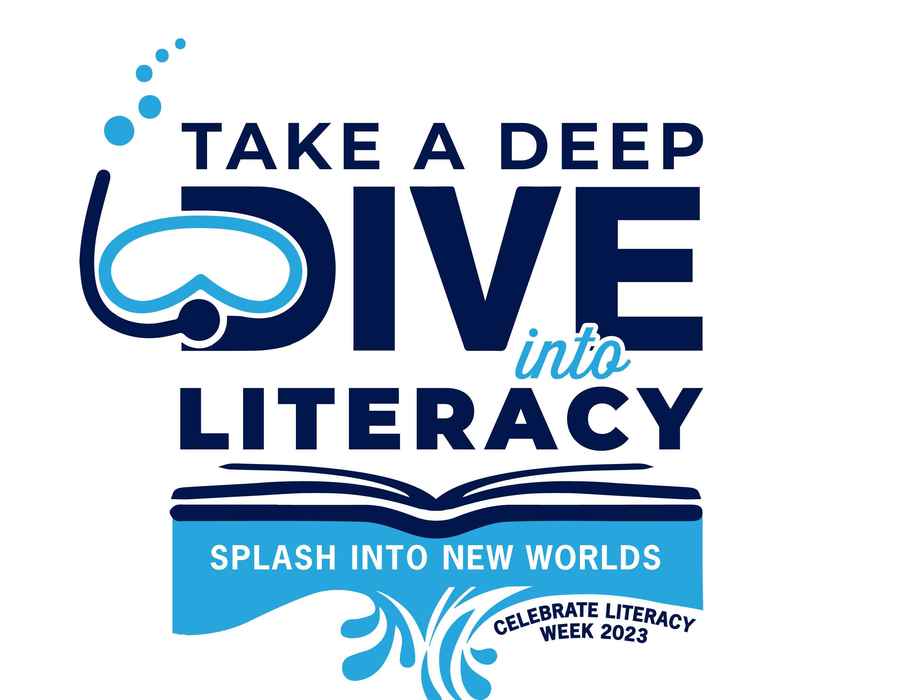
Celebrate Literacy Week, Florida!

January 23-27, 2023

District:

Monday,
January 23rd
Tuesday,
January 24th
Wednesday, January 25th
Thursday,
January 26th
Friday,
January 27th

