Attachment C
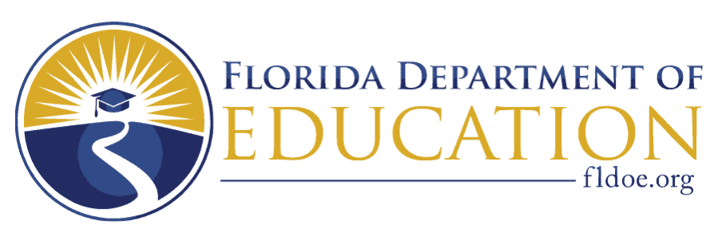

Notice of Intent-to-Apply Form
Linking Industry to Nursing Education (LINE) Fund

Enclosed is the Notice of Intent-to-Apply form, which is required in order to submit a proposal for the Linking Industry to Nursing Education (LINE) Fund. The purpose of the LINE Fund is to meet local, regional, and state workforce demand by recruiting faculty and clinical preceptors, increasing the capacity of high-quality nursing education programs, and increasing the number of nursing education program graduates who are prepared to enter the workforce.

To apply for the LINE Fund, this Notice of Intent-to-Apply form must be completed and signed by an authorized agency official and submitted to LINE_Fund@fldoe.org by September 15, 2022. Eligible organizations that file a Notice of Intent-to-Apply are not required to apply.

Part I – Intent to submit proposal
Please print or type
Agency Name: |  | Agency Type: (Mark with X)  __ School district  __ Florida College System institution  __ Independent Colleges and Universities of Florida member  __ Commission for Independent Education member
Mailing Address:
City: |  | State: | Zip Code:
Name of Authorized Officer: |  | Title of Authorized Officer:
Phone Number of Authorized Officer: |  | Email Address of Authorized Officer:
If multiple health care partners are anticipated, please provide the information below for each partner by copying and pasting the table
Health Care Partner Name:

Mailing Address: |  | Fund, Foundation, Assn. Name (if applicable):
City: | State: | Zip Code: | Total cash contribution:  $
Part II – Evidence of eligibility based on minimum performance standards
To be eligible for the LINE Fund, the following minimum performance standards are required for eligible school districts, Florida College System (FCS) institutions, and independent nonprofit colleges or universities located and chartered in this state and accredited by an agency or association that is recognized by the database created and maintained by the United States Department of Education to grant baccalaureate degrees.

- For a certified nursing assistant program (CNA), a completion rate of at least 70 percent for the prior year.
- For a licensed practical nurse (LPN), associate of science in nursing (ASN), and bachelor of science in nursing (BSN) program, a first-time passage rate on the National Council of State Boards of Nursing Licensing Examination of at least 70 percent for the prior year.

To be eligible to apply, agencies must present data that demonstrates a performance metric has been met for at least one eligible, active program. Applicants with more than one program type are not required to have met performance metrics for every active program if at least one program meets the statutory requirement. Additionally, school districts with more than one postsecondary technical center are not required to meet performance metrics for all operating postsecondary technical centers in order to apply; however, awarded funds may only be spent at the postsecondary technical centers that meet performance metrics. Note: new programs that have not been active long enough to calculate performance on the metrics may not be used for eligibility determinations.

Please refer to the tables provided in Attachment B as a resource for agencies to use to determine LINE Fund eligibility. For CNA programs, school district and FCS institution completion rates have been calculated by the Florida Department of Education. For all institutional types, first-time NCLEX passage rates provided by the Florida Board of Nursing for 2020 are included. Agencies that reference the Attachment B tables are not required to provide additional documentation.

Agencies wishing to provide alternative data to justify eligibility may do so when submitting this form. In addition to providing the rates in the tables below, agencies should provide a detailed description of the methodology used to arrive at the data provided. The department will review all information provided and will determine whether the criteria provided meet the performance metrics requirements outlined in s. 1009.8962, F.S. Agencies will be notified via email of the outcome of their eligibility within 10 business days.

Does your agency have an active certified nursing assistant program? (Mark with X) | Yes ___  No ___
If yes, what is the completion rate for the most recent reporting year?
Data Source | Attachment B __  Other (Please specify and provide documentation) __

 | Licensed Practical Nursing | Associate in Science in Nursing | BSN (Pre-licensure only)
Does your agency have an active program? (Mark with X) | Yes ___  No ___ | Yes ___  No ___ | Yes ___  No ___
If yes, what is the first-time passage rate on the National Council of State Boards of Nursing Licensing Examination for 2020?
Data Source | Attachment B __  Other (Please specify and provide documentation) __ | Attachment B __  Other (Please specify and provide documentation) __ | Attachment B __  Other (Please specify and provide documentation) __

I certify that the institution listed above has confirmed it is an eligible applicant, and intends to submit an application for the Linking Industry to Nursing Education (LINE) Fund. Additionally, it is understood that in order to apply for the LINE Fund, the institution must have an eligible health care partner under section (s.) 768.38(2), Florida Statutes (F.S.), who has pledged a monetary contribution to the institution, to be spent on an eligible purpose, as defined in s. 1009.8962, F.S. and Rule 6A-10.0325, F.A.C.

Signature _______________________________________ Date _________________

