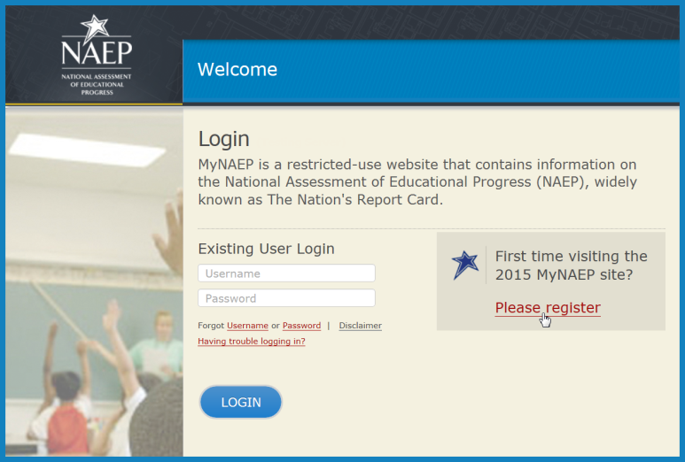
Figure 1
- Go to https://www.mynaep.com and select the Please register link.

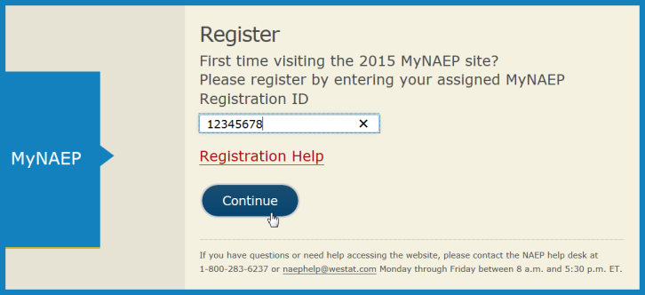
Figure 2

- Enter your NAEP registration ID and select Continue.

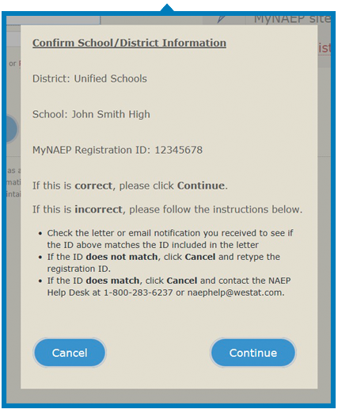
Figure 3
- A confirmation window will appear to ensure that you are registering for the correct school or district. Select Continue if the information is correct. If the information is incorrect, follow the instructions in the window and
select Cancel.

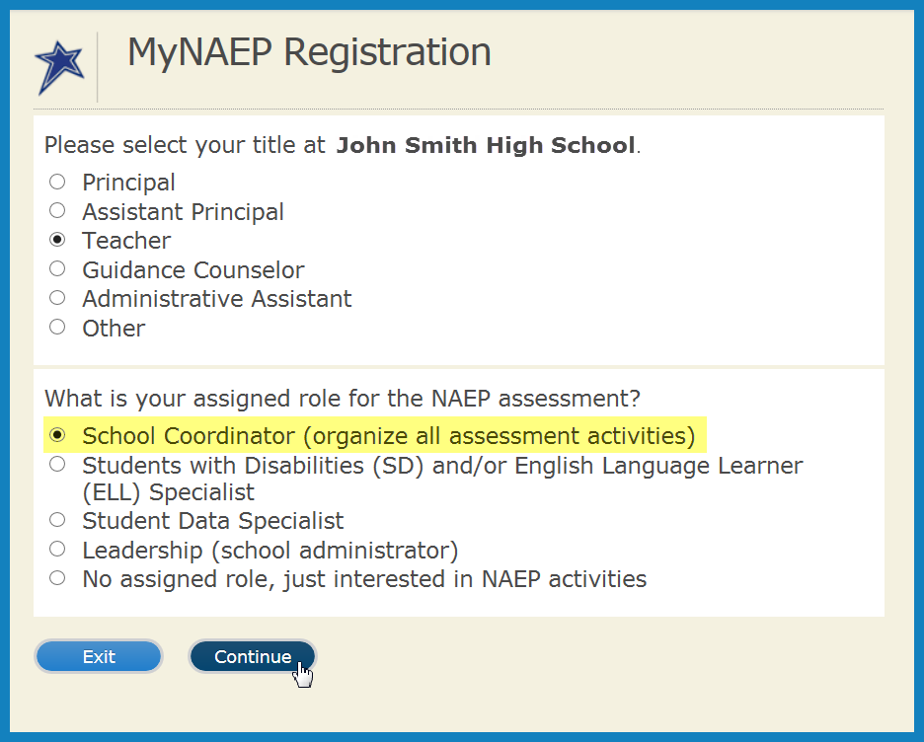
- Select your job title and your assigned role for the NAEP assessment. If you are the designated NAEP coordinator at your school, make sure to select School Coordinator for the assigned role (see Figure 4).
Figure 4

- The registration form will appear. Enter your name, phone number, and email address (see Figure 5).
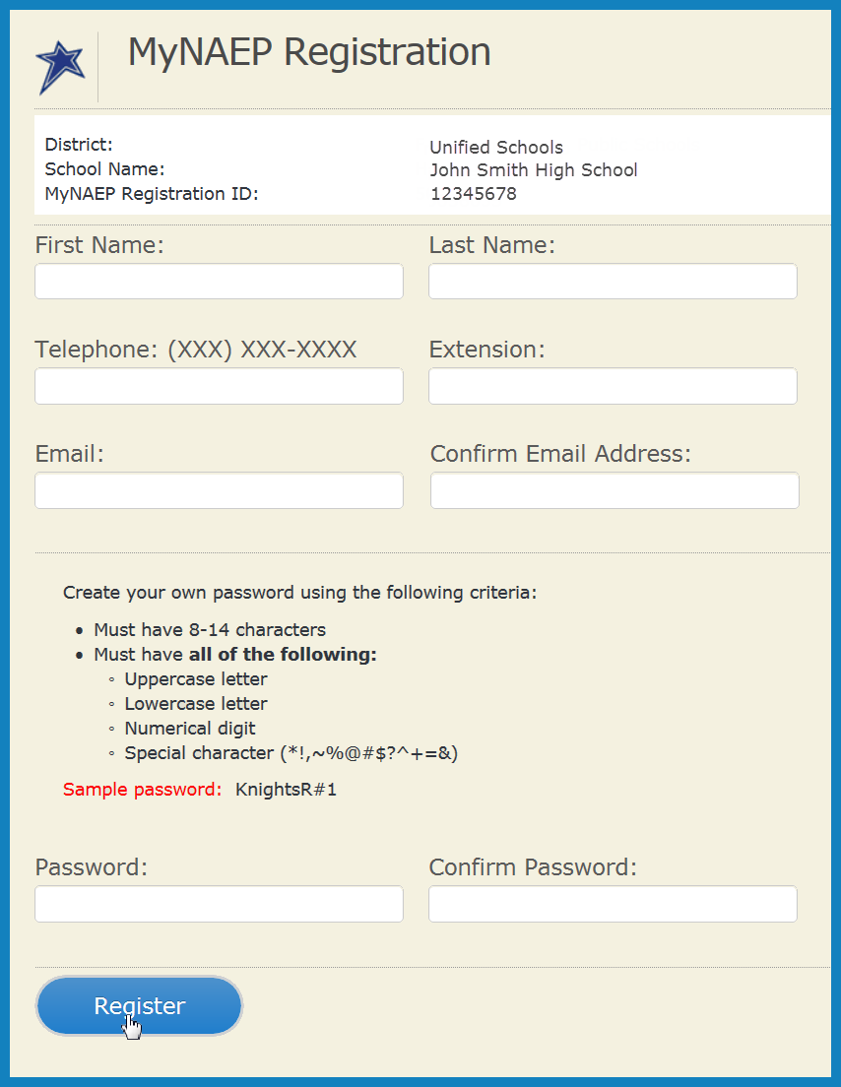
Figure 5

- Create your own password using the following criteria (see Figure 5).
  - Must have 8-14 characters
  - Needs at least one of each:
    - uppercase letter
    - lowercase letter
    - numerical digit
    - special character
(*!,~%@#$%?^+=& )
Sample password: KnightsR#1

- Make sure to remember your password – write it down if necessary. Select Register (see Figure 5).

- Write down your assigned username. You will need your username and password to access MyNAEP throughout the year. Select Continue to MyNAEP.
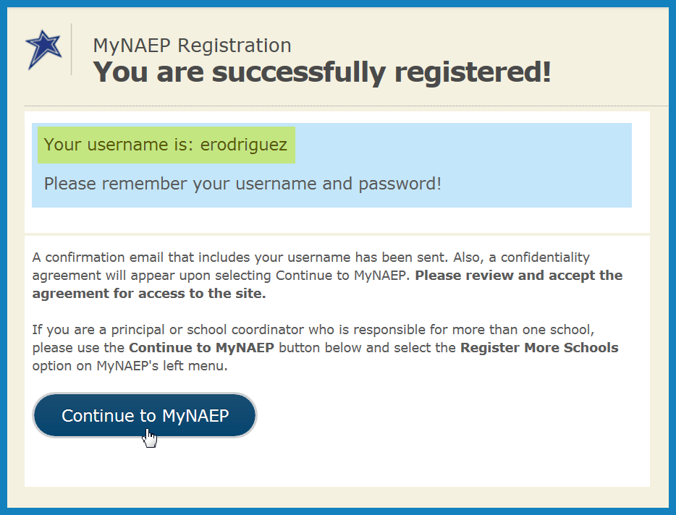
Figure 6

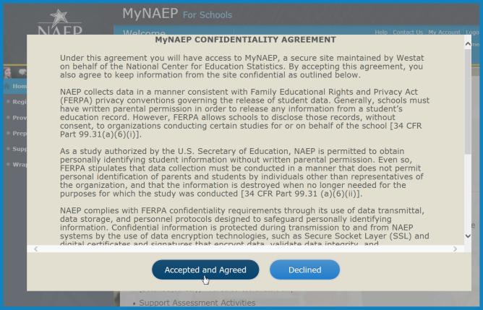
Figure 7
- All school personnel that register for MyNAEP must accept a confidentiality agreement. The confidentiality agreement will appear in a new window, please review and accept the agreement to access the site.
  - Multiple people from your school or district may register for MyNAEP by using the same registration ID.
  - District registrants will automatically be able to view the MyNAEP page for each selected school by using a drop-down menu in the blue banner.
  - If you are a principal or school coordinator who is responsible for more than one school, select Register More Schools from MyNAEP's left menu and enter the additional registration ID(s), one at a time.

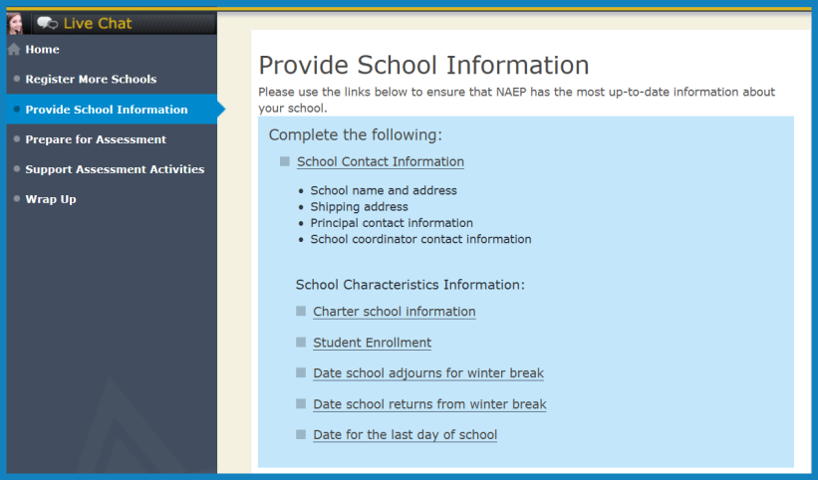
Figure 8

- Select Provide School Information from the left hand menu. Use the links to enter your school’s contact and characteristics information, including your school’s name, address, and the number of students enrolled in the selected grade.

