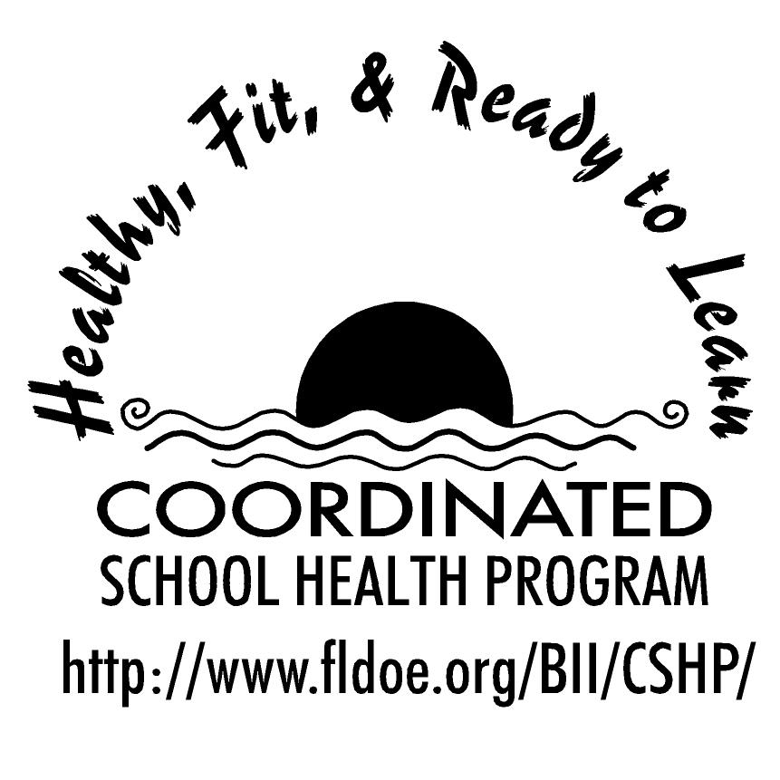
Wellness Wakeup Call Tobacco Prevention Tips
Month _______________

Each day, start the message with: “Good morning, this is your Wellness Wakeup Call!”
Read message for the day. End each message with “Enjoy your day, the healthy way!”

- “An apple a day keeps the doctor away, but a cigarette a day takes your life away!” Every cigarette smoked reduces life expectancy by about 11 minutes.

- Be smart and don’t start! Each day, nearly 4,400 youths between the ages of 12 and 17 try their first cigarette and another 2,000 become regular, daily smokers. Of those, about a third will die from a smoking-related disease in the future.

- Do the MATH- Smoking is expensive! Using tobacco eats up a lot of money. A pack of cigarettes cost $4.50 on average. A pack a day adds up to $1600 in a year! Think of the CDs, computer games, and clothes you could buy instead.

- Don’t stunt your growth! Tobacco affects your body’s development. The 200 known poisons in cigarette smoke affect your growing and changing body and can cause life-threatening diseases, such as chronic bronchitis, heart disease, and stroke.

- You don’t have to smoke to be affected by its ill effects. Secondhand smoke is responsible for approximately 3,000 lung cancer deaths annually of nonsmokers in the U.S. So if you don’t smoke, it’s still important to not hang around those that do.

- Smoking stinks and its not so glamorous! Smoking makes you smell bad, gives you bad breath, makes your fingers turn yellow, and gives you premature wrinkles.

- Does advertising affect you? Consider this: one recent study demonstrated that advertising plays a greater role than peer pressure in getting teens to smoke. So be smart — don't let deceptive tobacco ads mislead you!

- A mind is a terrible thing to waste! Blood vessels in the body, including those that supply the brain with needed oxygen and other nutrients, are damaged by chemicals found in tobacco products.

- Remember, you DON’T NEED to smoke to be cool. If you think “everybody’s doing it,” you’re wrong! Smoking won't make you happy or popular. In fact, smoking puts your health and the health of those around you at risk.

- Stay Smoke Free! All forms of tobacco — cigarettes, pipes, cigars, and smokeless tobacco — are hazardous. The only thing that really helps a person avoid the problems associated with smoking is staying Smoke Free!!!

Choose wisely; your life depends on it! When you make your own decisions you take the responsibility of deciding your own future. You are what you choose to be.

Once you start, it’s hard to STOP! Tobacco is addictive. Nicotine is a very addictive substance. Three-quarters of young people who use tobacco daily continue to do so because they find it hard to quit.

- Tobacco can kill you! Smoking kills more people than AIDS, alcohol, drug abuse, car crashes, murders, suicides and fires combined. Smoking causes 1 of 5 deaths and over 400,000 Americans die from tobacco related causes each year.

- Do you play sports or dance? Do you sing or play an instrument in the band? If you smoke, you will not be able to do any of these things very well. Bodily damage starts right away and gets worse as you keep smoking.

- Don’t believe the hype! Even though some teens smoke, the good news is that many more are choosing NOT to smoke. There are much better ways to spend your time and money than wasting it on cigarettes!

- Did you know? Cigarettes contain disgusting chemicals and poisons you would never think to put in your body. Some poisons include nicotine (used in cockroach and other insect killing products), ammonia bromide (used in toilet cleaner), arsenic (used for rat poison), formaldehyde (used to embalm bodies), and hydrogen cyanide, the gas chamber poison.

- Your lungs don’t discriminate! NO form of tobacco is safe to use. Cigarette smoking among youth may reduce the rate of lung growth and the level of maximum lung function that can be achieved.

- "Light" cigarettes aren’t safe. You may think that “light” cigarettes are not as bad as regular cigarettes. Think again! Light cigarettes put smokers at the same risk for smoking-related health problems as regular cigarettes.

- You can get “hooked from the first cigarette.” One in three adolescents who are "just experimenting" end up being addicted by the age of 20. Experimenting with smoking could lead to full-fledged addiction and a lifetime of trying to quit.

- Don’t put a price tag on your own self worth! Many kids smoke or use tobacco products to feel "cool", fit in with peers, or to rebel. Whatever the reason may be- is it worth your health, your friends, your appearance - Your Life?

- Remember, all kinds of tobacco damage your health. Smokeless tobacco can cause mouth cancer, tooth loss, and other health problems.

- Don’t be fooled! Many girls think that smoking is a good way to lose weight, but this is not true. Eating healthy foods and exercising are the only ways to stay fit and keep your body healthy and beautiful!

- If you know someone who uses tobacco, urge him or her to quit. If you are using it--Stop! It's never too late! Talk to your parents, a doctor, a counselor, a teacher, or another adult you trust.

References for these tips cans be found at www.fldoe.org/BII/CSHP/h-pilot.asp

