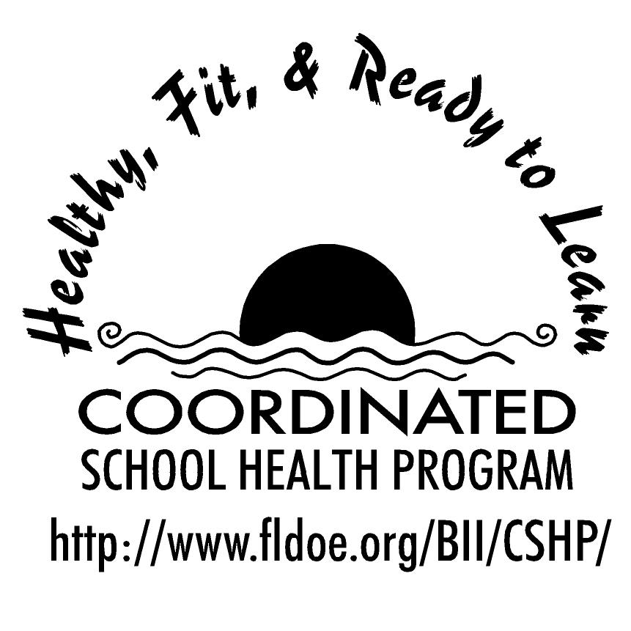
Wellness Wakeup Call Physical Activity Tips
Month _______________

Each day, start the message with: “Good morning, this is your Wellness Wakeup Call!”
Read message for the day. End each message with “Enjoy your day, the healthy way!”

- Did you know, less than 50% of Floridians get the required amount of exercise? Change that stat and get out there and move it!

- What may seem an easy solution is not always best. Anabolic steroids have dangerous side effects that include: acne, disruption of the body’s hormone system, liver disease, and increased risk for heart disease and cancer.

- When performed regularly, stretching exercises help maintain or improve the range of motion in joints. For each stretch, hold the position for 10-30 seconds.

- What is the best exercise? One you enjoy! So go and run, jump, dance, play, swim, bike, surf, lift, climb, or paddle your way to a or more fit you!

- Exercise improves alertness and memory and can also improve mood, stimulate creativity, reduce anxiety, and provide an outlet for anger or aggression.

- Get your carbs! Carbohydrates supply energy for body cells, brain, and muscles. Some cells, such as the brain and blood cells only use carbohydrates for fuel.

- Exercise can save your life! It can help prevent heart disease, some types of cancer, high blood pressure, Type 2 diabetes, obesity and osteoporosis.

- Weight bearing physical activity such as lifting weights, jumping, and running helps build strong, healthy bones.

- Be a team player! Physical activity, through sports, can improve your teamwork skills!

- Take five! Warming up for five minutes before you exercise improves your performance and decreases your chances of injury.

- Give yourself a break! If you've been injured, wait until you are completely healed and have been instructed by your doctor before you start exercising again. This will decrease the risk of re-injuring yourself.

- Achieve the recommended national goal! Growing teens should be physically active for 60 minutes or more on most days of the week.

- Don’t fret! If you’re not active for 60 minutes straight, it’s okay to exercise for 10 or 20 minutes at a time to reach your 60 minute goal!

- Nutrition and exercise go hand-in-hand! You need to exercise in order to build muscles and consume enough calories in order to repair muscles!

- Are you interested in pumping iron? Work with a physical fitness expert or coach to learn how to lift weights properly.

- Right now get up and stretch! But be mindful, stretch positions should be held motionless because “bouncing” while stretching can cause injury.

- Remember, drinking water before, during, and after exercise is important to enhance athletic performance and prevent dehydration.

- 4 Tips to begin a work out routine: 1. Set realistic goals. 2. Increase your intensity and duration gradually. 3. Make your program fun. 4. Exercise with a buddy.

- Practice makes perfect! Practice allows your brain and body to work together while improving your performance.

- It is important to wear appropriate equipment that fits properly. Doing this will reduce your chances of injury.

- Did you know that sports drinks do not benefit you more than water, except if you are exercising for more than 90 minutes or in really hot weather?

- Don’t ignore it! Pain is the body's way of signaling something is wrong. If you have a lot of pain, stop exercising and seek advice from your doctor.

- Rules and regulations are put into practice to enforce fairness and promote safety so that everyone can enjoy the game!

References for these tips cans be found at www.fldoe.org/BII/CSHP/h-pilot.asp

