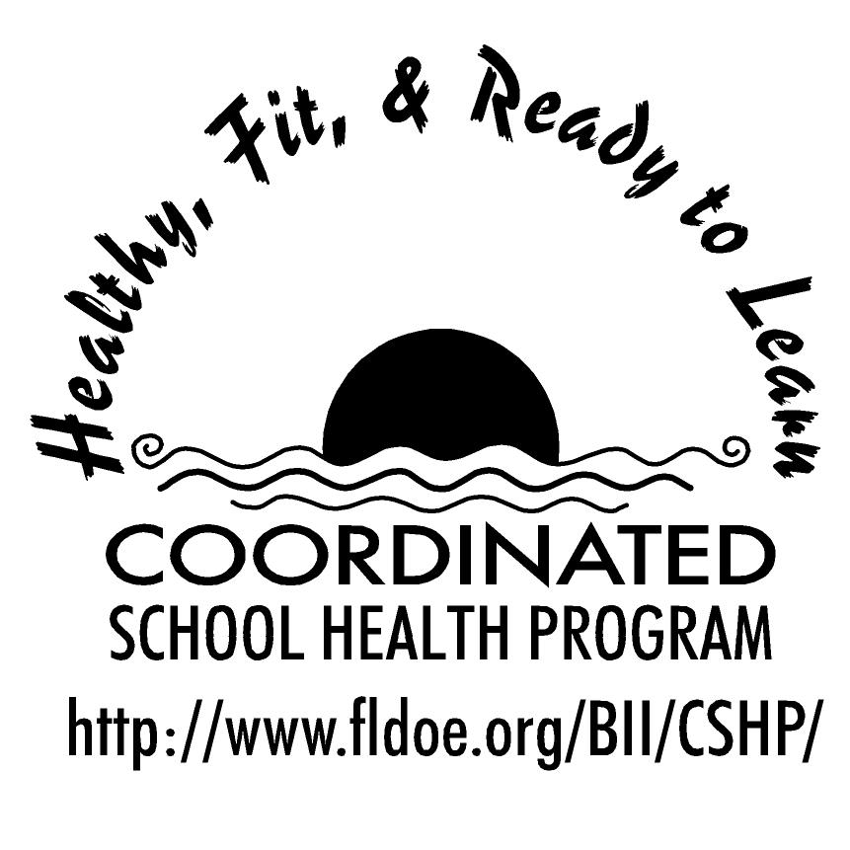
Wellness Wakeup Call Personal and Consumer Health
Month _______________

Each day, start the message with: “Good morning, this is your Wellness Wakeup Call!”
Read message for the day. End each message with “Enjoy your day, the healthy way!”

- When selecting sunscreen, choose one that protects against UVA and UVB rays with an SPF of 15 or higher. Apply generously and enjoy the sun!

- You’re just a spray away! Wash kitchen surfaces with disinfectant spray before and after cooking to protect against the spread of bacteria.

- Twice-daily brushing and once-daily flossing helps remove bits of food from the mouth which is important in preventing tooth decay.

- Animals and Hand Washing: If You Pet It, Don't Forget It. Wash Your Hands. You Won't Regret It.

- Don’t learn the hard way! Tanning beds provide skin damage, not “safe tans.” Protect your skin by avoiding tanning beds.

- Replace your toothbrush every four months because the bristles become worn. A worn toothbrush won't do a good job of cleaning your teeth.

- The best way to prevent common illnesses such as the flu is to wash your hands. Enjoy three easy steps: Soap, Lather, and Rinse!

- Think ahead! Apply sunscreen 30 minutes before going into the sun which allows it time to seep into your skin. Doing this will help protect your skin from the sun’s rays.

- Strive for five! Eat 5 to 10 servings of fruits and vegetables a day for better health.

- By not smoking you reduce your risk to not only lung cancer but cancer of the esophagus, kidney and bladder.

- Remember to clean between teeth daily with floss. Decay–causing bacteria still linger between teeth where toothbrush bristles can’t reach.

- Hand washing is important to reduce the spread of germs. To ensure a complete hand wash, use warm water and sing the “Happy Birthday” song twice quickly.

- For the best teeth on the block: Visit your dentist regularly for professional cleanings and oral exams.

- Did you know that people with a quick temper and negative attitude are more likely to develop heart disease than those with a calmer, more positive attitude?

- Engaging in good eating and exercise habits now leads to strong, healthy bones in the future. For strong healthy bones, drink milk and be active everyday.

- No matter how light or dark your skin is, you can develop skin cancer. Protect your skin with sunscreen to decrease your risk.

- Would you like to live to be 100? Those that live until 100 have a positive outlook, challenge their minds, eat fruits and vegetables and don’t smoke.

- Sleep to prevent sickness! Getting enough sleep allows your immune system to function at its full potential which prevents you from becoming sick.

- There are three types of skin cancer: basal cell, squamous cell, and melanoma. All of them are dangerous and can be prevented by using sunscreen.

- Brush for the benefits! Good oral health habits play a part in having a nice smile, speaking well and being confident.

- Did you know eating plenty of vegetables and fruits reduces the risk of cancer? It’s true! So, remember to include these food groups with each meal.

- A toothbrush is one thing you don’t have to share. Sharing a toothbrush causes bacteria to be exchanged which increases your chance of getting sick. So keep your toothbrush to yourself!

- Strive for more activity! By becoming more active and maintaining an ideal body weight you reduce your risk of certain types of cancer.

References for these tips cans be found at www.fldoe.org/BII/CSHP/h-pilot.asp

