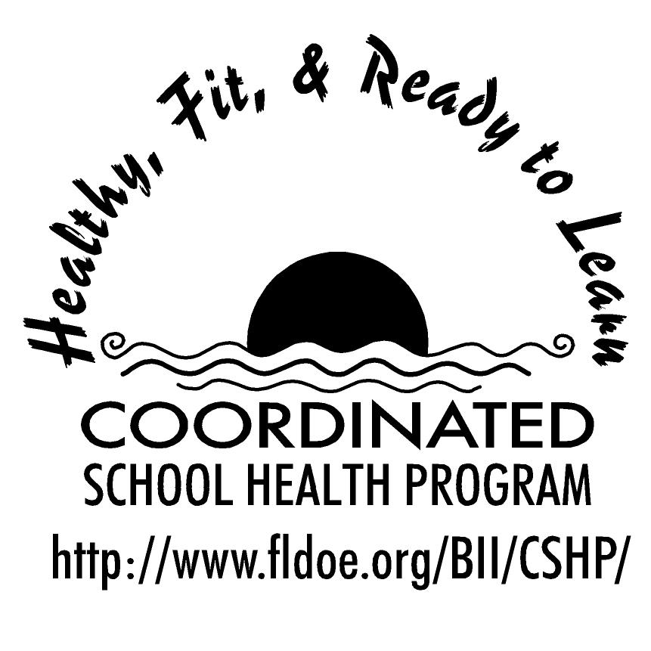
Wellness Wakeup Call Nutrition Facts
Month _______________

Each day, start the message with: “Good morning, this is your Wellness Wakeup Call!”
Read message for the day. End each message with “Enjoy your day, the healthy way!”

- An apple a day keeps the doctor away. Enjoy a crunchy, medium-sized apple with the peel and get the benefits of 4 grams of dietary fiber in just 80 calories!

- Beans truly are a one of a kind vegetable that provide a unique combination of protein, fiber, vitamins, and minerals! Eat more, and you’ll reduce your risk of heart disease and multiple types of cancer.

- Can you name a plant source containing many important health-promoting minerals such as zinc, magnesium, copper, chromium, nickel, and boron? If you said nuts, you’re correct!

- Antioxidants are a key ingredient in many fruits, vegetables, and grains that help preserve healthy cells in the body and may help prevent chronic disease such as cancer and heart disease.

- Fish contain beneficial omega-3 fatty acids that keep brain activity healthy. So eat well and keep your brain sharp by adding fish such as tuna, salmon, mackerel and sardines to your diet.

- Need a healthy breakfast option? Enjoy a bowl of oatmeal which is a rich source of soluble fiber. Try making it with low-fat milk!

- Did you know: You can live up to 50 days without food, but only a few days without water? Water makes up about 60% of our bodies.

- Tip for eating out: Avoid super-sized servings by sharing an entrée or by taking half of it to go!

- Not all fats are created equal! Saturated fats raise cholesterol while unsaturated fats lower cholesterol. Fish, avocados, nuts, and olive oil are some of these unsaturated healthy fats.

- Vitamin C-rich foods help us fight off infection. A few great sources of vitamin C include: oranges, tomatoes, broccoli, spinach, strawberries, potatoes, cabbage, and peppers!

- The daily recommended amount of fiber is 20-35 grams. However, Americans on average consume only about 16 grams. Boost up that fiber intake by adding fruits, vegetables, and nuts into your daily diet!

- When you exercise, you sweat. When you sweat, you lose water. During exercise you need to drink an extra 4-6 ounces of water for every 15-20 minutes of activity.

- Vitamin E-rich foods may reduce the risk of heart disease and stroke. Great sources of vitamin E include: nuts, seeds, vegetable oils, whole grains, green leafy vegetables, and asparagus!

- Trans fats raise cholesterol levels and clog arteries to the heart and brain. Avoid trans fats by staying away from products that list “partially hydrogenated oil” on the ingredient list.

- Did you know the normal American diet contains nearly two times the required amount of protein? Thus, protein powders and shakes are unnecessary. Obtaining protein from natural protein sources can meet the requirement needed.

- Vitamin A promotes normal vision and helps your eyes see naturally in the dark. Great sources of vitamin A include: orange and deep green vegetables and fruits, liver, milk, butter, and cheese!

- Prevent brittle bones! Get your daily calcium from low-fat dairy and calcium fortified products such as orange juice!

- The average American eats over 130 pounds of sugar each year! Don’t let those food labels trick you! Sugar can be present in the form of sucrose, sorbitol, high-fructose corn syrup, and dextrose.

- The best way to stay hydrated is to realize that you need to take in about 1 milliliter of water for each calorie you burn! This equals about 8 cups, or 2 liters, of fluid per day.

- Here’s a tasty solution to improve your memory! Blueberries, strawberries, prunes and fatty fish enhance short-term memory!

- Pizza lover? Build yourself a healthy meal! Use a whole grain crust, smother it with tomato sauce, top that with part skim mozzarella cheese, add chicken, and pile it high with vegetables! You’ll be consuming a healthy variety of nearly every food group!

- The major health problems in North America are largely caused by a poor diet, excessive energy intake, and not enough physical activity. Coincidently enough, these are three things we can prevent ourselves.

- A fast-food hamburger in 1957 contained one ounce of cooked meat, compared with 6 ounces today. A theater serving of popcorn was 3 cups, compared with 16 cups today. Watch those portion sizes!

References for these tips cans be found at www.fldoe.org/BII/CSHP/h-pilot.asp

