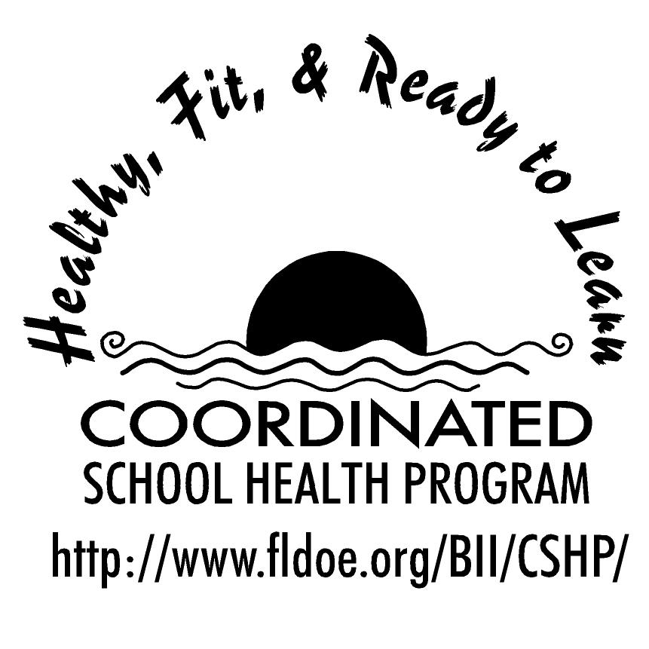
Wellness Wakeup Call

Welcome to the Wellness Wakeup Call! The intention of this initiative is to promote a healthy school environment by providing high schools with a daily healthy lifestyle message that can be read over the morning announcements every day of the school year. There are 9 categories of health messages that can be used for the corresponding months of the school year. Each category has 23 tips. The 9 categories are:

- Healthy Eating Tips
- Personal and Consumer Health
- Physical Activity
- Injury Prevention
- Nutrition Facts
- Mental and Emotional Health

- Tobacco Prevention
- Alcohol and Other Drug Use

- Community and Environmental Health

Each day, start the message with: “Good morning, this is your Wellness Wakeup Call!”
Read message for the day. End each message with “Enjoy your day, the healthy way!”

Health messages and references can be found at www.fldoe.org/BII/CSHP/h-pilot.asp. Additional healthy school tools are also available.

