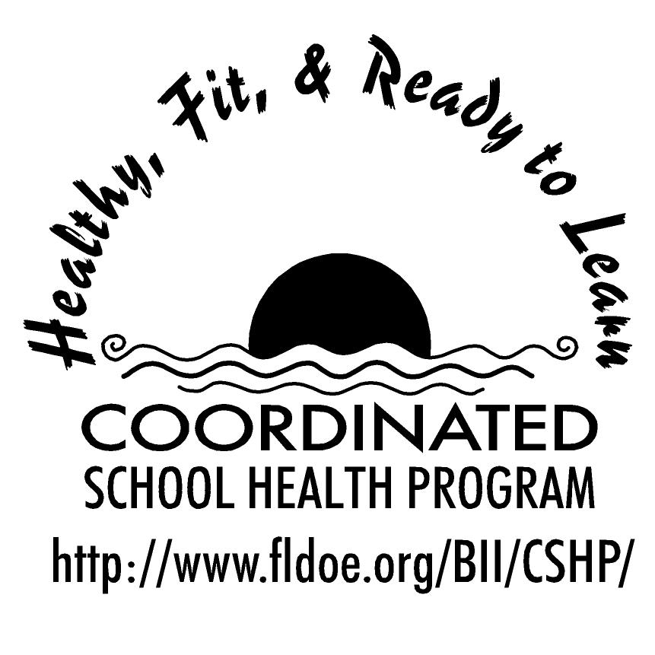
Wellness Wakeup Call Injury Prevention
Month _______________

Each day, start the message with: “Good morning, this is your Wellness Wakeup Call!”
Read message for the day. End each message with “Enjoy your day, the healthy way!”

- Sun stroke is a serious condition that usually follows prolonged exposure to very hot or humid conditions. Symptoms include: flushed face, hot dry skin, strong pulse, and unconsciousness or confusion.

- Wear protective head gear! One of the most common reasons people get concussions is through a sports injury. High-contact sports such as football, boxing, and hockey pose a high risk of head injury!

- Try water. Cooling of burns with cold water as soon as possible is safe, feasible and effective as a first aid treatment.

- Take time to ice. Ice is effective for reducing pain, swelling, and duration of most minor injuries. Limit ice application to 20 minutes or less at a time with a protective barrier such as a plastic bag or damp cloth.

- Distraction while driving has been estimated to contribute in 25-50% of all car crashes. As a driver, your primary obligation is to pay attention to the road, for your own safety and the safety of others.

- After a concussion, the brain needs time to heal. It's important to wait until all symptoms of a concussion have cleared before returning to normal activities.

- Did you know: Of drivers not wearing a seat belt who have been killed in automobile crashes, an estimated 60-70% would have survived if they had been wearing one?

- Be sure your home has a smoke detector on every floor. Smoke detectors should be checked monthly and the batteries should be changed at least once a year.

- There is no sure way to tell if someone will become abusive or violent, but you can listen to your own uneasiness and stay away from someone who disrespects you or wants or needs you intensely and exclusively.

- Two out of three bicycle-related deaths are related to head injuries. When choosing a bicycle helmet remember the four S’s: Size, Strap, Straight fit on your head, and a Sticker that ensures the helmet has met safety standards.

- Young people who bully are more likely than those who don't bully to skip school and drop out of school. They are also more likely to smoke, drink alcohol and get into fights.

- Violence that occurs electronically is called cyber bullying. It includes using electronic media to embarrass, harass, or threaten peers.

- Most people who commit suicide have talked about doing it. If someone you know brings up suicide, discuss it with a trusted adult.

- If you get a nosebleed, don't blow your nose. Doing so can cause additional nosebleeds. Also, don't tilt your head back. This causes blood to run into your throat. If you swallow the blood, you might get sick.

- Symptoms of a concussion include: dizziness, nausea or vomiting, headaches, blurred vision, slurred speech, difficulty concentrating or making decisions, and memory loss.

- Motor vehicle crashes are the leading cause of death for U.S. teens, accounting for one-third of all deaths in this age group.

- “First Aid” is a basic term for assessments and interventions that can be performed by a bystander (or by the patient/victim) with minimal or no medical equipment.

- Back injuries are common in the workplace. Many can be prevented through proper lifting. Always bend at the knees and hips when picking up large objects.

- Did you know that unintentional injuries at home, such as falls and fires cause three deaths every hour?

- Tips to avoid cyber stalking: never use your real name as an e-mail or username, avoid filling out profiles, do not share personal information in public spaces, log off and do not respond to a harasser online.

- Tip for driving: try to use a hands free device for your cell phone so that you can keep both hands on the steering wheel or don’t use your cell phone at all.

- Athletes can reduce their risk of injury by: warming up, staying hydrated, avoiding overtraining, eating a well-balanced diet with healthy snacks, and getting adequate sleep.

- Performing the Heimlich maneuver can prevent someone from dying from choking on food.

References for these tips cans be found at www.fldoe.org/BII/CSHP/h-pilot.asp

