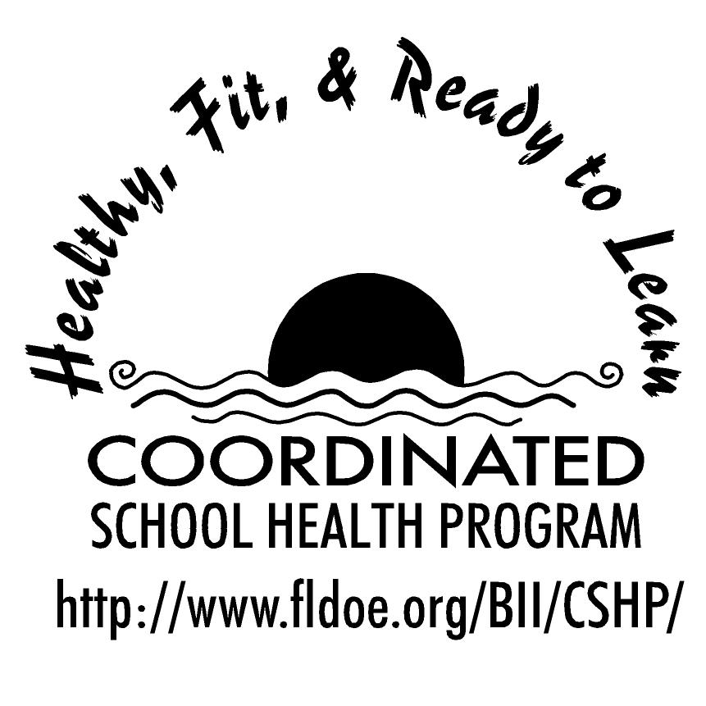

Wellness Wakeup Call References

http://familydoctor.org/online/famdocen/home/common/addictions/alcohol/273.html
http://ncadi.samhsa.gov
http://teendrugabuse.us/teen_drug_use.html
http://www.ada.org/
http://www.bhs.umn.edu/selfcare/stdhiv.htm
http://www.cdc.gov/
http://www.cdc.gov/tobacco/data_statistics/sgr/sgr_2004/index.htm
http://www.drugabuse.gov/
http://www.eatright.org/
http://www.epa.gov/
http://www.faqs.org/health/index.html
http://www.fitness.gov/
http://www.floridashealth.com/
http://www.girlshealth.gov/
http://www.hrsa.gov/
http://www.kidshealth.org/
http://www.lambtonhealth.on.ca/
http://www.nida.nih.gov/scienceofaddiction/addiction.html
http://www.nida.nih.gov/scienceofaddiction/addiction.html
http://www.realtime.net/anr/10eattip.html
http://www.safeyouth.org
http://www.sprc.org/
http://www.teenpregnancy.org/resources/data/pdf/pregrate_Oct2006.pdf
http://www.teenpregnancy.org/resources/data/pdf/TeenSexActivityOnePagerJune06.pdf
http://www.teenpregnancy.org/resources/data/pdf/WOV2007_fulltext.pdf
http://www.teenpregnancy.org/resources/data/polling.asp
http://www.teenpregnancy.org/wim/risky_behaviors.pdf
http://www.thenationalcampaign.org/resources/things-you-might-not-know.aspx
http://www.usa.gov/
http://www.usda.gov
http://www.webmd.com/
Insel, Paul and Roth, Walton. Core Concepts in Health. McGraw Hill, Boston, MA: 2002.
Marcus, Susan Archibald. The Hungry Brain: The Nutrition/ Cognition Connection. Corwin Press, Thousand Oaks, CA, 2007.
Part 10: First Aid. Circulation, 2005; 112: III-115-III-125.
Wardlaw, Gordon, Hampl, Jeffrey, and DiSilvestro, Robert. Perspectives in Nutrition Sixth Edition. McGraw Hill, Boston, MA, 2004.

