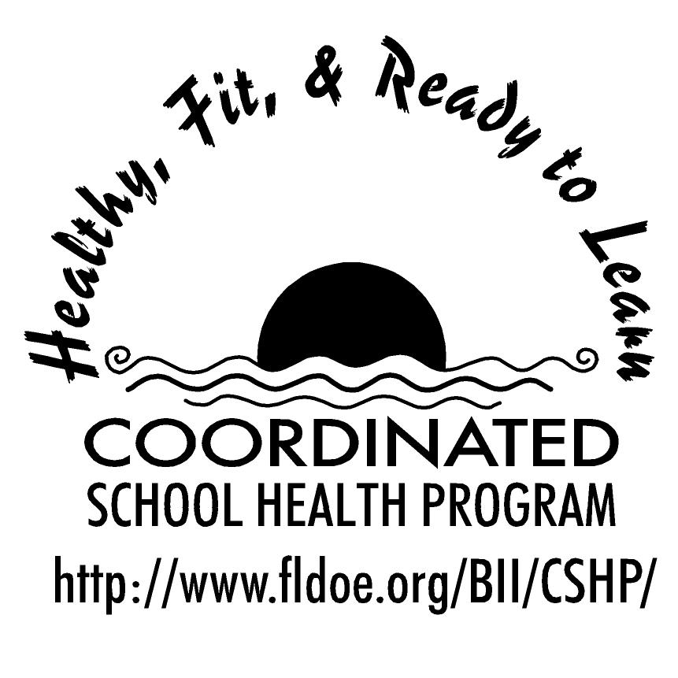
Wellness Wakeup Call Healthy Eating Tips
Month _______________

Each day, start the message with: “Good morning, this is your Wellness Wakeup Call!”
Read message for the day. End each message with “Enjoy your day, the healthy way!”

- Get your fiber fix! To increase the amount of daily fiber in your diet, choose whole-grain foods such as raisin bran cereal or oatmeal.

- The 3 B’s of healthy living: Be adventurous by trying new foods. Be flexible by balancing sweets with healthy foods. Be active by including physical activity everyday.

- After sleeping through the night your body needs to be refueled. Without breakfast, your brain and your muscles will not have the energy needed to start the day.

- Don't feel guilty if you love foods such as potato chips, candy bars or ice cream. Just eat them in small amounts.

- Give veggies a try! Eating vegetables at lunch and dinner will decrease your risk of getting sick.

- For many teens, dinner consists of eating on the run or snacking in front of the TV. Enjoy your dinner by sitting down at the table. This way you are likely to get more fruits and vegetables.

- A tip to eat more veggies: Add a little green to your eggs by including broccoli; add some ham and you’ve got green eggs and ham!

- Fruit, Fiber and your Heart! Try to eat whole fruits instead of drinking fruit juice to increase daily fiber intake. An increase in fiber will help your heart.

- For a healthy snack, eat ants on a log! Slice celery, spread peanut butter and add some raisins.

- Want more energy? Your brain needs fuel just like the rest of your body. Fuel your body with healthy foods.

- We often snack when we’re not hungry. Listen to your body’s cues to determine if you need a snack.

- Feeding your brain before a day of learning is just as important as coming to school with your homework. What are the food fuels needed by the brain? Fruits, vegetables and whole grains.

- Good vs. Bad? No way! There are no foods that are good or bad. So pick a variety of foods for balanced eating.

- Breakfast is best! People who eat a hearty breakfast usually eat less during the rest of the day.

- A fast food fact: America spends more than $110 billion a year on fast food; this is more than the country spends on new cars or computers.

- Rethink your drinks. Soda often replaces milk and water but soda has many calories and sugar. Think of drinking more milk and water.

- Did you know that people who skip breakfast feel more tired and cranky in the morning? On the other hand, those who eat breakfast have more energy and a better attitude to start their day.

- Sandwiches are the most popular food prepared at home. To make a sandwich healthier use wheat bread, lean turkey, tomatoes, cucumbers and a light tasty spread.

- Are you nutty about nuts? Enjoying a handful of nuts is a great way to include healthy fat into your day.

- Whether you buy lunch or pack your own, it should give you the nutrients you need. A lunch of chips, candy and soda gives you a lot of calories and not many nutrients. So buy or bring a lunch that includes nutritious foods!

- Can you name the five food groups? You are correct if you named bread, fruit, vegetables, milk, and meat and beans. For a balanced intake, choose foods from all five food groups.

- A healthy snack can give you the energy boost you need to get through the day. Try popcorn, frozen yogurt or chips and salsa.

- Variety is vital! Choose from many different foods in order to get all the nutrients you need.

References for these tips cans be found at www.fldoe.org/BII/CSHP/h-pilot.asp

