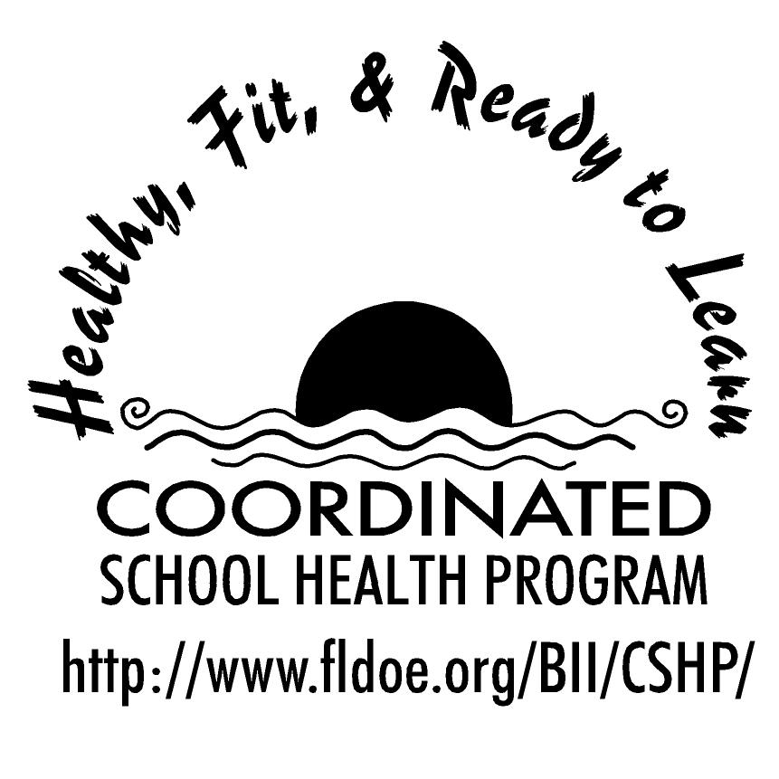
Wellness Wakeup Call Alcohol and Other Drug Use
Month _______________

Each day, start the message with: “Good morning, this is your Wellness Wakeup Call!”
Read message for the day. End each message with “Enjoy your day, the healthy way!”

- Remember, you DON'T NEED drugs or alcohol. Over 86% of 12-17 year-olds have never tried marijuana.

- The three leading causes of death for 15- to 24-year-olds are automobile crashes, homicides, and suicides—alcohol is a leading factor in all three.

- Face your problems. Using drugs won't help you escape your problems, it will only create more.

- Punishment is severe. Teens who drink put themselves at risk for obvious problems with the law. It's illegal and you can get arrested. Teens who drink are also more likely to get into fights and commit crimes than those who don't.

- Do the smart thing, don’t start. Using drugs puts your health, education, family ties, and social life at risk.

- Keep your edge. Drug use can ruin your looks, make you depressed, and contribute to slipping grades.

- Alcohol puts your health at risk. Teens who drink are more likely to engage in unsafe, unprotected sexual behaviors. Resulting pregnancies and sexually transmitted diseases can change — or even end — lives.

- Be aware of the risks! Drinking or using drugs increases your risk of injury. Car crashes, falls, burns, drowning, and suicide are all linked to drug use.

- Sweep away the myths. Having a designated driver is no excuse to drink. Drinking only at home does not make drinking any "safer."

- Know the Law. Alcohol is illegal to buy or possess if you are under age 21.

- About 40 percent of those who start drinking at age 13 or younger develop alcohol dependence later in life. Ten percent of teens who begin drinking after age 17 develop dependence.

- Does your school have a SADD chapter? Student Against Destructive Decisions school chapters empower teens through education and encourage them to make safe choices that will directly impact their futures. Visit www.sadd.org for more information.

- Don’t embarrass yourself. The impression is that drinking is cool, but the nervous system changes that come from drinking alcohol can make people do embarrassing things. Drinking also gives people bad breath, and no one enjoys a hangover.

- The risk of injuring yourself, maybe even fatally, is higher when you're under the influence of alcohol. One half of all drowning deaths among teen guys are related to alcohol use. Use of alcohol greatly increases the chance that a teen will be involved in a car crash, homicide, or suicide.

- Each year, almost 2000 people under the age of 21 years die in car crashes in which underage drinking is involved. Alcohol is involved in nearly half of all violent deaths involving teens.

- Substance abuse can lead to serious problems such as poor schoolwork, loss of friends, problems at home, and lasting legal problems. Alcohol and drug abuse is a leading cause of teen death or injury related to car accidents, suicides, violence, and drowning.

- Even casual use of certain drugs can cause severe medical problems, such as an overdose or brain damage. Many illegal drugs today are made in home labs, so they can vary greatly in strength. These drugs also may contain bacteria, dangerous chemicals, and other unsafe substances.

- Alcohol is a powerful drug that slows down the body and mind. It impairs coordination; slows reaction time; and impairs vision, clear thinking, and judgment.

- Beer and wine are not “safer” than hard liquor. A 12-ounce can of beer, a 5-ounce glass of wine, and 1.5 ounces of hard liquor all contain the same amount of alcohol and have the same effects on the body and mind.

- Alcohol can ruin your health. The more you drink, the more damage is done. You can get alcohol poisoning if you drink too much. As the level of alcohol in your blood rises, the chemicals in your body can cause vomiting or seizures, or you may pass out.

- Alcohol is a drug and you can become addicted to it. Alcohol changes the way your mind and your body work. Even one beer can slow your reactions and confuse your thinking. This means anything that requires concentration and coordination, like driving, is dangerous when you've had a drink.

- Alcohol also changes the way you act. It can make you let go of the feelings that keep you from doing things you know are risky or dangerous. This can lead you to make bad decisions.

- Illegal drug use among teenagers is declining. However, the abuse of prescription drugs, especially pain relievers is increasing. Don’t assume that prescription drugs are safe, because they are actually highly addictive and can cause severe side effects.

References for these tips cans be found at www.fldoe.org/BII/CSHP/h-pilot.asp

