
Series 2014-01D August 2013

Enrollment Size of Florida’s Public Schools

State and National Comparisons—Elementary, Middle, and High Schools
According to data published by the National Center for Education Statistics (NCES), Florida public elementary schools have the highest average enrollment in the nation. For the 2010-11 school year, Florida averaged 622.5 students per elementary school, slightly higher than the second ranked state, Georgia, which averaged 616.6 students per elementary school. By comparison, Utah averaged 565.4 students per elementary school, Texas averaged 554.5, and Nevada averaged 551.8. The state with the lowest average enrollment is Montana, at 164.0. The national average is 453.1.
Average enrollment for Florida’s middle schools is also the highest in the nation at 871.4 students per school followed by Nevada with 847.8 students. Utah follows with 811.8, then California with 779.5 and Georgia with 754.9. The state with the lowest average was Montana with 126.3 students per middle school. The national average was 575.7.
At 1,533.8 students per school, average enrollment for Florida’s public high schools was nearly twice the national average, which was 846.6. California (1,462.5), Maryland (1,313.4), Hawaii (1,313.1), and Nevada (1,260.6) rounded out the top five states for largest average high school enrollment. North Dakota has the smallest average high school enrollment with 191.7 students.
Nationally, as well as in Florida, high schools tend to be larger than both middle and elementary schools, though the difference is more significant in Florida (Figure 1).

Figure 1: School Type Comparisons, 2010-11
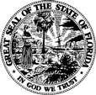
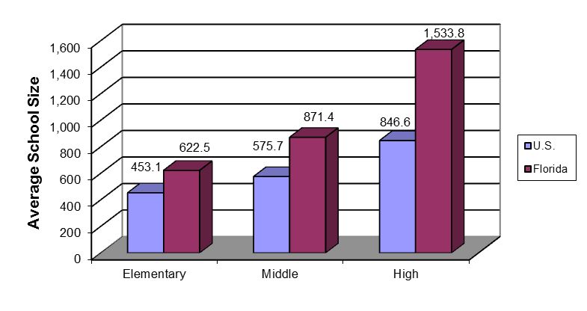
Florida Department of Education
Pam Stewart, Commissioner

Comparison of Averages among Selected States
Schools tend to be smaller in predominantly rural states, such as South Dakota, Montana, and Nebraska, and larger in states with larger urban populations, such as Florida and California.²
Table 1: Elementary Schools, 2010-113
State | Largest | State | Smallest
Florida | 622.5 | Montana | 164.0
Georgia | 616.6 | North Dakota | 177.1
Utah | 565.4 | South Dakota | 182.6
Texas | 554.5 | Vermont | 212.9
Nevada | 551.8 | Wyoming | 221.6
Table 2: Middle Schools, 2010-114
State | Largest | State | Smallest
Florida | 871.4 | Montana | 126.3
Nevada | 847.8 | South Dakota | 164.3
Utah | 811.8 | Wyoming | 293.4
California | 779.5 | D.C. | 307.6
Georgia | 754.9 | Vermont | 310.1

Table 3: High Schools, 2010-115
State | Largest | State | Smallest
Florida | 1,533.8 | North Dakota | 191.7
California | 1,462.5 | South Dakota | 225.2
Maryland | 1,313.4 | Montana | 256.6
Hawaii | 1,313.1 | Nebraska | 350.2
Nevada | 1,260.6 | Oklahoma | 359.4

Florida’s Schools – Distribution by Enrollment
The following figures compare the percentage distribution of Florida public schools by size of enrollment between 2006-07 and 2011-12. The percentage of smaller schools (500 students or fewer) has increased since 2006-07. The percentage of small elementary schools increased from 26.7 in 2006-07 to 31.0 in 2011-12; the percentage of small middle schools increased from 13.9 to 17.2; and the percentage of small high schools increased from 21.3 to 51.9. However, the percentage of small combination schools decreased from 80.4 in 2006-07 to 68.3 in 2011-12. Conversely, the percentage of larger schools (more than 1,000 students) has decreased over the same period. The percentage of large elementary schools decreased from 9.0 in 2006-07 to 4.6 in 2011-12; the percentage of large middle schools decreased from 48.3 to 37.2; and the percentage of large high schools decreased from 71.1 to 40.0. Large combination schools increased from 4.0 percent in 2006-07 to 14.3 percent in 2011-12.
Figures 2 through 5 are accompanied by Tables 4 through 7, which show the largest schools in Florida by grade level. Tables 8 through 11 display, by district, the distribution of elementary, middle, high, and combination schools by enrollment for 2011-12. Please note that, beginning with 2007-08 enrollment data, editions of this report contain separate tables and charts for combination schools as a result of an alteration in the reporting of school types in the Master School Identification File. Therefore, school totals for enrollment size in editions of this report for school years 2008-09 to the present will not be comparable with prior issues.
Figure 2: Elementary Schools
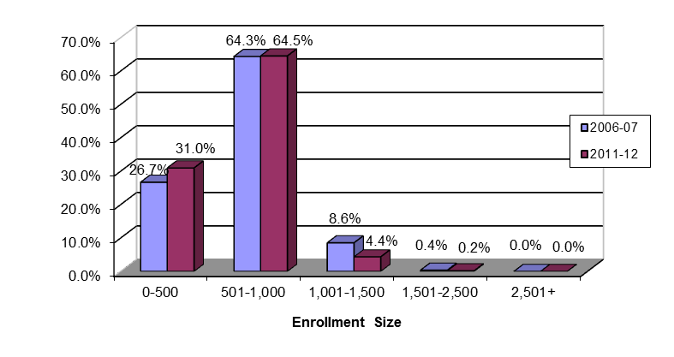
Table 4: Ten Largest Elementary Schools in Florida, 2011-12
DISTRICT | SCHOOL | STUDENT MEMBERSHIP
BROWARD | CITY OF PEMBROKE PINES CHARTER | 1,928
DADE | SPANISH LAKE ELEMENTARY SCHOOL | 1,699
ORANGE | METROWEST ELEMENTARY | 1,516
ORANGE | WHISPERING OAK ELEMENTARY SCHOOL | 1,435
BROWARD | QUIET WATERS ELEMENTARY SCHOOL | 1,401
FLAGLER | BELLE TERRE ELEMENTARY SCHOOL | 1,400
DADE | NORMA BUTLER BOSSARD ELEMENTARY | 1,317
FLAGLER | RYMFIRE ELEMENTARY SCHOOL | 1,307
BROWARD | PARK LAKES ELEMENTARY SCHOOL | 1,282
BROWARD | FOX TRAIL ELEMENTARY SCHOOL | 1,261

Figure 3: Middle Schools
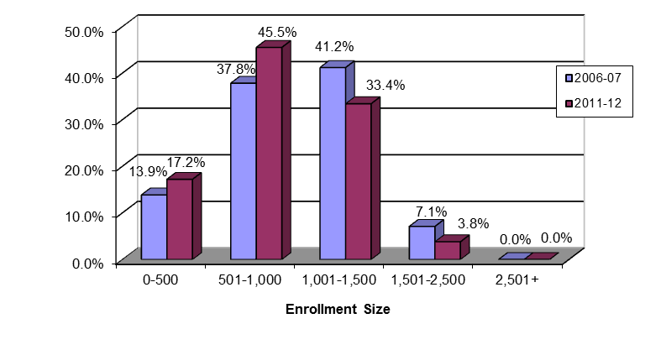
Table 5: Ten Largest Middle Schools in Florida, 2011-12
DISTRICT | SCHOOL | STUDENT MEMBERSHIP
BROWARD | FALCON COVE MIDDLE SCHOOL | 2,466
BROWARD | INDIAN RIDGE MIDDLE SCHOOL | 1,992
DADE | JORGE MAS CANOSA MIDDLE SCHOOL | 1,950
DADE | HIALEAH GARDENS MIDDLE SCHOOL | 1,873
BROWARD | LYONS CREEK MIDDLE SCHOOL | 1,869
SEMINOLE | MILLENNIUM MIDDLE SCHOOL | 1,711
BROWARD | DRIFTWOOD MIDDLE SCHOOL | 1,619
DADE | MIAMI SPRINGS MIDDLE SCHOOL | 1,616
BROWARD | GLADES MIDDLE SCHOOL | 1,603
BROWARD | CORAL SPRINGS MIDDLE SCHOOL | 1,590

Figure 4: High Schools
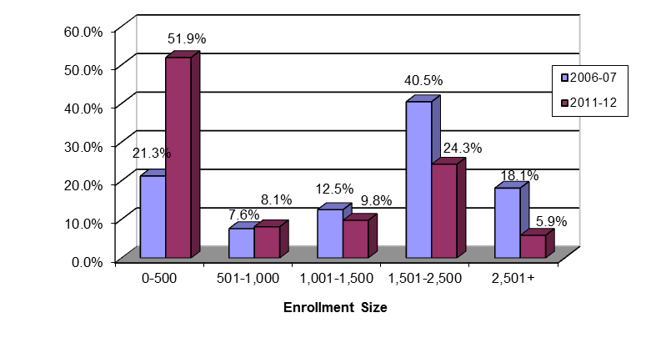
Table 6: Ten Largest High Schools in Florida, 2011-12
DISTRICT | SCHOOL | STUDENT MEMBERSHIP
DADE | JOHN A. FERGUSON SR HIGH | 4,245
BROWARD | CYPRESS BAY HIGH SCHOOL | 4,192
ORANGE | DR. PHILLIPS HIGH | 3,641
DADE | SOUTH DADE SENIOR HIGH SCHOOL | 3,427
SEMINOLE | SEMINOLE HIGH SCHOOL | 3,395
ORANGE | WINTER PARK HIGH | 3,387
ORANGE | WEST ORANGE HIGH | 3,339
DADE | CORAL GABLES SENIOR HIGH SCHOOL | 3,285
ORANGE | COLONIAL HIGH | 3,282
DADE | G. HOLMES BRADDOCK SENIOR HIGH | 3,223

Figure 5: Combination Schools
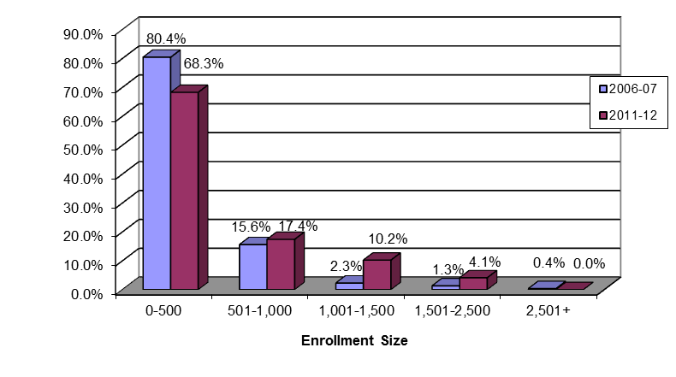
Table 7: Ten Largest Combination Schools in Florida, 2011-12
DISTRICT | SCHOOL | STUDENT MEMBERSHIP
SUMTER | VILLAGES CHARTER SCHOOL | 2,246
SARASOTA | PINE VIEW SCHOOL | 2,196
DADE | KEYS GATE CHARTER SCHOOL | 1,941
DADE | BOB GRAHAM EDUCATION CENTER | 1,885
DADE | AVENTURA WATERWAYS K-8 CENTER | 1,846
DADE | NORMAN S. EDELCUP/SUNNY ISLES | 1,817
FL VIRTUAL | FLORIDA VIRTUAL SCHOOL FULL TIME | 1,793
HERNANDO | EXPLORER K-8 | 1,761
DADE | DR. ROLANDO ESPINOSA K-8 CENTER | 1,754
FSU CHTR SCH | FLORIDA STATE UNIVERSITY SCHOOL | 1,699

Sources: Master School Identification File; 2006-07 Florida School Indicators Report

The six largest school districts – Miami-Dade, Broward, Hillsborough, Orange, Palm Beach, and Duval – account for over 48 percent of the total student population. Of the 100 largest schools in Florida, 72 are in these six districts.

Table 8: Elementary Schools Enrollment Size, 2011-12
District | 0-500 | 501-1,000 | 1,001-1,500 | 1,501-2,500 | 2,501+ | Total
Alachua | 24 | 10 |  |  |  | 34
Baker |  | 4 |  |  |  | 4
Bay | 9 | 13 | 1 |  |  | 23
Bradford | 3 | 2 |  |  |  | 5
Brevard | 20 | 42 | 1 |  |  | 63
Broward | 47 | 119 | 13 | 1 |  | 180
Calhoun |  | 1 |  |  |  | 1
Charlotte | 1 | 10 |  |  |  | 11
Citrus | 2 | 9 |  |  |  | 11
Clay | 5 | 21 | 1 |  |  | 27
Collier | 3 | 27 |  |  |  | 30
Columbia | 6 | 5 |  |  |  | 11
Miami-Dade | 77 | 116 | 15 | 1 |  | 209
DeSoto | 1 | 3 |  |  |  | 4
Dixie | 1 | 2 |  |  |  | 3
Duval | 64 | 39 | 10 |  |  | 113
Escambia | 16 | 21 |  |  |  | 37
Flagler | 1 | 1 | 4 |  |  | 6
Franklin |  |  |  |  |  | 0
Gadsden | 7 | 3 |  |  |  | 10
Gilchrist |  | 2 |  |  |  | 2
Glades | 4 |  |  |  |  | 4
Gulf | 1 | 1 |  |  |  | 2
Hamilton | 5 |  |  |  |  | 5
Hardee | 2 | 3 |  |  |  | 5
Hendry | 1 | 5 |  |  |  | 6
Hernando |  | 10 |  |  |  | 10
Highlands | 2 | 9 |  |  |  | 11
Hillsborough | 54 | 100 | 4 |  |  | 158
Holmes | 1 | 1 |  |  |  | 2
Indian River | 6 | 11 |  |  |  | 17
Jackson | 3 | 3 |  |  |  | 6
Jefferson |  | 1 |  |  |  | 1
Lafayette |  | 1 |  |  |  | 1
Lake | 5 | 20 | 3 |  |  | 28
Lee | 9 | 36 | 4 |  |  | 49
Leon | 6 | 18 |  |  |  | 24
Levy | 2 | 3 |  |  |  | 5
Liberty | 1 |  |  |  |  | 1
Madison | 4 |  |  |  |  | 4
Manatee | 14 | 26 | 1 |  |  | 41
Marion | 11 | 22 |  |  |  | 33
Martin | 4 | 12 |  |  |  | 16
Monroe | 5 | 3 |  |  |  | 8
Nassau | 1 | 7 |  |  |  | 8
Okaloosa | 3 | 16 |  |  |  | 19
Okeechobee | 3 | 4 |  |  |  | 7
Orange | 33 | 88 | 9 | 1 |  | 131
Osceola | 2 | 22 | 2 |  |  | 26
Palm Beach | 28 | 82 | 10 |  |  | 120
Pasco | 6 | 41 | 1 |  |  | 48
Pinellas | 19 | 59 |  |  |  | 78
Polk | 30 | 50 | 1 |  |  | 81
Putnam | 6 | 5 |  |  |  | 11
St. Johns | 1 | 12 | 3 |  |  | 16
St. Lucie | 3 | 16 |  |  |  | 19
Santa Rosa | 5 | 13 |  |  |  | 18
Sarasota | 6 | 21 |  |  |  | 27
Seminole | 3 | 35 | 2 |  |  | 40
Sumter |  | 4 |  |  |  | 4
Suwannee |  | 4 |  |  |  | 4
Taylor | 1 | 2 |  |  |  | 3
Union |  | 1 |  |  |  | 1
Volusia | 20 | 31 |  |  |  | 51
Wakulla | 3 | 3 |  |  |  | 6
Walton | 2 | 4 |  |  |  | 6
Washington |  | 2 |  |  |  | 2
Deaf/Blind | 2 |  |  |  |  | 2
FSU Chtr Sch |  | 1 |  |  |  | 1
Florida | 604 | 1,258 | 85 | 3 |  | 1,950
Source: Master School Identification File
Table 9: Middle Schools Enrollment Size, 2011-12
District | 0-500 | 501-1,000 | 1,001-1,500 | 1,501-2,500 | 2,501+ | Total
Alachua | 6 | 5 | 1 |  |  | 12
Baker |  |  | 1 |  |  | 1
Bay | 4 | 5 |  |  |  | 9
Bradford |  | 1 |  |  |  | 1
Brevard | 2 | 8 | 2 |  |  | 12
Broward | 14 | 12 | 20 | 10 |  | 56
Calhoun | 1 |  |  |  |  | 1
Charlotte |  | 3 | 1 |  |  | 4
Citrus |  | 3 | 1 |  |  | 4
Clay | 1 | 4 | 2 |  |  | 7
Collier | 1 | 7 | 3 |  |  | 11
Columbia |  | 1 | 1 |  |  | 2
Miami-Dade | 22 | 28 | 23 | 4 |  | 77
DeSoto |  | 1 |  |  |  | 1
Dixie | 1 |  |  |  |  | 1
Duval | 4 | 13 | 10 | 1 |  | 28
Escambia | 3 | 5 | 3 |  |  | 11
Flagler |  | 2 |  |  |  | 2
Franklin |  |  |  |  |  | 0
Gadsden | 1 | 1 |  |  |  | 2
Gilchrist |  |  |  |  |  | 0
Glades | 1 |  |  |  |  | 1
Gulf |  |  |  |  |  | 0
Hamilton |  |  |  |  |  | 0
Hardee |  |  | 1 |  |  | 1
Hendry |  | 2 |  |  |  | 2
Hernando | 1 | 3 | 1 |  |  | 5
Highlands |  | 4 |  |  |  | 4
Hillsborough | 11 | 23 | 19 | 1 |  | 54
Holmes |  | 1 |  |  |  | 1
Indian River | 1 | 4 |  |  |  | 5
Jackson |  | 1 |  |  |  | 1
Jefferson |  |  |  |  |  | 0
Lafayette |  |  |  |  |  | 0
Lake |  | 8 | 2 |  |  | 10
Lee | 1 | 13 | 5 |  |  | 19
Leon | 4 | 6 | 1 |  |  | 11
Levy | 4 |  |  |  |  | 4
Liberty |  |  |  |  |  | 0
Madison |  |  |  |  |  | 0
Manatee | 3 | 7 | 2 |  |  | 12
Marion |  | 4 | 5 |  |  | 9
Martin | 1 | 3 | 1 |  |  | 5
Monroe |  | 1 |  |  |  | 1
Nassau |  | 3 |  |  |  | 3
Okaloosa |  | 7 |  |  |  | 7
Okeechobee |  | 2 |  |  |  | 2
Orange | 2 | 10 | 22 | 2 |  | 36
Osceola |  | 1 | 7 |  |  | 8
Palm Beach |  | 8 | 23 | 2 |  | 33
Pasco |  | 8 | 6 | 1 |  | 15
Pinellas | 1 | 5 | 13 |  |  | 19
Polk | 4 | 17 | 3 |  |  | 24
Putnam | 2 | 2 |  |  |  | 4
St. Johns | 1 | 5 | 2 |  |  | 8
St. Lucie |  | 3 |  |  |  | 3
Santa Rosa |  | 6 | 1 |  |  | 7
Sarasota | 2 | 6 | 2 |  |  | 10
Seminole |  | 2 | 8 | 2 |  | 12
Sumter |  | 1 |  |  |  | 1
Suwannee |  |  | 1 |  |  | 1
Taylor |  | 1 |  |  |  | 1
Union |  | 1 |  |  |  | 1
Volusia |  | 3 | 9 |  |  | 12
Wakulla |  | 2 |  |  |  | 2
Walton | 2 | 2 |  |  |  | 4
Washington | 1 | 1 |  |  |  | 2
Deaf/Blind | 2 |  |  |  |  | 2
Florida | 104 | 275 | 202 | 23 |  | 604
Source: Master School Identification File

Table 10: High Schools Enrollment Size, 2011-12
District | 0-500 | 501-1,000 | 1,001-1,500 | 1,501-2,500 | 2,501+ | Total
Alachua | 10 | 1 | 2 | 2 |  | 15
Baker | 1 |  | 1 |  |  | 2
Bay | 7 |  | 3 | 1 |  | 11
Bradford |  | 1 |  |  |  | 1
Brevard | 9 | 3 | 5 | 8 |  | 25
Broward | 20 | 6 | 3 | 19 | 10 | 58
Calhoun | 1 |  |  |  |  | 1
Charlotte | 2 |  | 1 | 2 |  | 5
Citrus | 4 |  | 1 | 2 |  | 7
Clay | 1 |  | 2 | 5 |  | 8
Collier | 5 | 1 | 3 | 4 |  | 13
Columbia | 3 |  | 1 | 1 |  | 5
Miami-Dade | 64 | 8 | 6 | 18 | 15 | 111
DeSoto | 2 |  | 1 |  |  | 3
Dixie |  | 1 |  |  |  | 1
Duval | 17 | 4 | 6 | 8 | 2 | 37
Escambia | 11 | 1 | 1 | 5 |  | 18
Flagler | 2 |  |  | 2 |  | 4
Franklin |  |  |  |  |  | 0
Gadsden | 4 | 2 |  |  |  | 6
Gilchrist |  | 2 |  |  |  | 2
Glades | 3 |  |  |  |  | 3
Gulf | 1 | 1 |  |  |  | 2
Hamilton | 1 | 1 |  |  |  | 2
Hardee | 2 |  | 1 |  |  | 3
Hendry | 2 | 1 | 1 |  |  | 4
Hernando | 3 | 1 | 2 | 1 |  | 7
Highlands | 2 | 2 |  | 1 |  | 5
Hillsborough | 24 |  | 2 | 25 |  | 51
Holmes | 4 |  |  |  |  | 4
Indian River | 1 | 1 |  | 1 | 1 | 4
Jackson | 3 | 2 |  |  |  | 5
Jefferson | 4 |  |  |  |  | 4
Lafayette | 1 | 1 |  |  |  | 2
Lake | 4 | 1 | 4 | 3 |  | 12
Lee | 20 | 3 | 1 | 11 |  | 35
Leon | 8 |  | 2 | 3 |  | 13
Levy | 2 | 2 |  |  |  | 4
Liberty | 3 |  |  |  |  | 3
Madison | 3 | 1 |  |  |  | 4
Manatee | 9 |  | 2 | 5 |  | 16
Marion | 9 |  | 2 | 5 |  | 16
Martin | 5 |  |  | 3 |  | 8
Monroe | 5 | 2 | 1 |  |  | 8
Nassau | 2 | 2 | 2 |  |  | 6
Okaloosa | 11 |  |  | 4 |  | 15
Okeechobee | 4 |  | 1 |  |  | 5
Orange | 32 | 2 |  | 7 | 11 | 52
Osceola | 6 | 3 | 1 | 6 |  | 16
Palm Beach | 24 | 2 | 5 | 13 | 6 | 50
Pasco | 8 |  | 6 | 7 |  | 21
Pinellas | 22 |  | 3 | 12 | 1 | 38
Polk | 19 | 2 | 6 | 9 |  | 36
Putnam | 2 | 2 | 1 |  |  | 5
St. Johns | 7 |  | 2 | 4 |  | 13
St. Lucie | 6 |  | 1 | 4 | 1 | 12
Santa Rosa | 6 |  |  | 4 |  | 10
Sarasota | 3 | 2 | 1 | 3 | 1 | 10
Seminole | 4 | 1 |  | 5 | 3 | 13
Sumter | 2 | 1 | 1 |  |  | 4
Suwannee | 1 | 1 | 1 |  |  | 3
Taylor | 1 | 1 |  |  |  | 2
Union | 1 | 1 |  |  |  | 2
Volusia | 12 |  | 2 | 6 | 2 | 22
Wakulla | 2 |  | 1 |  |  | 3
Walton | 5 | 2 |  |  |  | 7
Washington | 2 | 1 |  |  |  | 3
Deaf/Blind | 3 |  |  |  |  | 3
Washington Special | 1 |  |  |  |  | 1
Florida Virtual Sch |  | 1 |  |  |  | 1
Florida | 468 | 73 | 88 | 219 | 53 | 901
Source: Master School Identification File
.
Table 11: Combination Schools Enrollment Size, 2011-12
District | 0-500 | 501-1,000 | 1,001-1,500 | 1,501-2,500 | 2,501+ | Total
Alachua | 4 | 1 |  |  |  | 5
Baker |  |  |  |  |  | 0
Bay | 2 |  | 1 |  |  | 3
Bradford | 1 |  |  |  |  | 1
Brevard | 9 | 2 |  |  |  | 11
Broward | 20 | 7 | 1 |  |  | 28
Calhoun | 2 | 1 |  |  |  | 3
Charlotte | 3 |  |  |  |  | 3
Citrus | 1 |  |  |  |  | 1
Clay | 3 |  |  |  |  | 3
Collier | 8 |  |  |  |  | 8
Columbia |  |  |  |  |  | 0
Miami-Dade | 38 | 18 | 14 | 12 |  | 82
DeSoto | 4 |  |  |  |  | 4
Dixie | 1 |  |  |  |  | 1
Duval | 8 | 5 | 2 |  |  | 15
Escambia | 5 |  |  |  |  | 5
Flagler | 2 | 1 |  |  |  | 3
Franklin | 2 | 1 |  |  |  | 3
Gadsden | 3 |  |  |  |  | 3
Gilchrist |  |  |  |  |  | 0
Glades | 1 |  |  |  |  | 1
Gulf |  |  |  |  |  | 0
Hamilton | 2 |  |  |  |  | 2
Hardee | 1 |  |  |  |  | 1
Hendry | 2 |  |  |  |  | 2
Hernando | 1 |  | 2 | 2 |  | 5
Highlands | 2 |  |  |  |  | 2
Hillsborough | 17 | 6 |  |  |  | 23
Holmes | 2 | 1 |  |  |  | 3
Indian River | 2 | 1 |  |  |  | 3
Jackson | 5 | 1 |  |  |  | 6
Jefferson | 1 |  |  |  |  | 1
Lafayette |  |  |  |  |  | 0
Lake | 6 |  | 1 |  |  | 7
Lee | 10 | 3 | 3 |  |  | 16
Leon | 6 | 2 |  |  |  | 8
Levy | 4 |  |  |  |  | 4
Liberty | 2 | 1 |  |  |  | 3
Madison | 2 |  | 1 |  |  | 3
Manatee | 9 |  |  |  |  | 9
Marion | 4 |  | 1 |  |  | 5
Martin | 4 |  |  |  |  | 4
Monroe | 2 | 2 |  |  |  | 4
Nassau | 1 |  |  |  |  | 1
Okaloosa | 7 | 2 | 1 |  |  | 10
Okeechobee | 1 |  |  |  |  | 1
Orange | 14 | 2 | 2 |  |  | 18
Osceola | 3 | 4 | 4 |  |  | 11
Palm Beach | 14 | 3 | 1 |  |  | 18
Pasco | 6 | 2 |  |  |  | 8
Pinellas | 21 |  | 1 |  |  | 22
Polk | 10 | 4 | 1 |  |  | 15
Putnam | 1 |  |  |  |  | 1
St. Johns | 4 | 1 | 1 |  |  | 6
St. Lucie | 4 | 2 | 7 | 1 |  | 14
Santa Rosa | 1 | 1 |  |  |  | 2
Sarasota | 6 | 2 | 1 | 1 |  | 10
Seminole | 5 |  |  |  |  | 5
Sumter | 1 |  |  | 1 |  | 2
Suwannee | 2 |  |  |  |  | 2
Taylor | 2 |  |  |  |  | 2
Union |  |  |  |  |  | 0
Volusia | 5 | 1 |  |  |  | 6
Wakulla | 2 |  |  |  |  | 2
Walton | 2 | 1 |  |  |  | 3
Washington | 1 |  |  |  |  | 1
Florida Virtual Sch |  |  |  | 1 |  | 1
FAU Lab Sch |  | 1 | 1 |  |  | 2
FSU Chtr Sch |  |  |  | 1 |  | 1
FAMU Lab Sch |  | 1 |  |  |  | 1
UF Lab Sch |  |  | 1 |  |  | 1
Florida | 314 | 80 | 47 | 19 |  | 460
Source: Master School Identification File

Source: Keaton, Patrick. Documentation to the NCES Common Core of Data Public Elementary/Secondary School Universe Survey: School Year 2010-11. Washington, D.C.: National Center for Education Statistics, Institute of Education Sciences, U.S. Department of Education. NCES 2012-338rev (Sept 2012), B-26.

