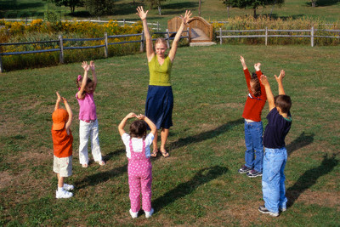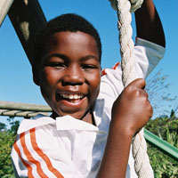

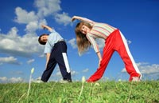
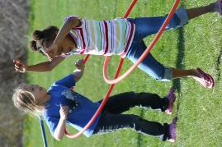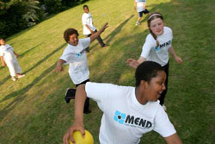

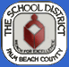
Fulton-Holland Educational Services Center
3300 Forest Hill Boulevard West Palm Beach, FL 33406
561:434:8000 866:930:8402

These lessons can be used to address the 150 minutes of mandated physical activity (30 minutes of continuous exercise daily).
Fitness and brain-based movement have been proven to increase academic achievement.
These lessons can be incorporated into academic lesson plans to enhance learning.

Eric Stern: Program Planner

Jane Panse: HL Watkins Middle School
Shawn Roney: Grassy Waters Elementary
Amie Schneider: Equestrian Trails
Ellen Smith: Gove Elementary
Jane Solomon: Cross Pointe Elementary
Amie Souder: Panther Run Elementary

Palm Beach County Physical Activity Lessons

www.braingym.org
www.pecentral.com

The following are ideas to obtain or create
your own physical activity equipment.

Inexpensive or free equipment ideas

- Put a “recess bag” on your classroom donation wish list.
- Visit a dollar store which sells balls, cones and jump ropes.
- Bowling alleys will donate old pins and bowling balls.
- Golf courses will donate old golf balls.
- Tennis clubs will donate old tennis balls.

Create your own equipment ideas

- 2 liters: Fill with a small amount of water and use for bowling pins.
- Paper Plates: Write exercises on them for fitness stations. They are also great for frisbees.
- Old Sheets: Use as a parachute for games.
- Old colored socks: Use as flags for tag or to designate teams. (Students tuck them in their waist band.)
- Buckets or boxes: Use for target practice to throw balls into.

Palm Beach County Physical Activity Lessons
Page 1

Target Objective: Stretch your muscles lightly when stressed or after a warm-up or activity.

What You Say: Be sure to stretch light, these stretches should not be painful. Hold for 15-25 seconds or until you feel it release tension. Be sure to breathe slowly in and out!
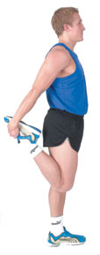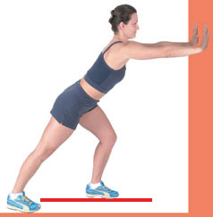 | 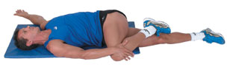  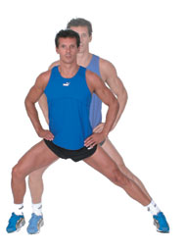  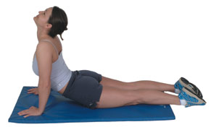 | 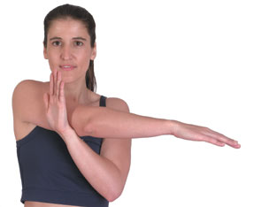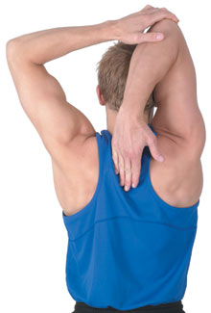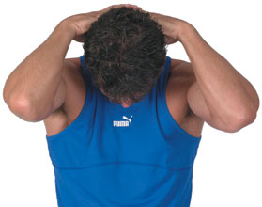

Modifications: Do various other stretches. If student is in a wheelchair or hurt, they can do upper body stretches or stretch the area that does not have pain.

Palm Beach County Physical Activity Lessons
Page 2

- Continually move around and monitor activity areas and employ the “lifeguard” approach of continually scanning the class area.
- Establish and reinforce routines, rules of acceptable behavior, and expectations of the students.
- Ensure that outdoor and indoor playing areas are clean and free of obstacles.
- Regularly check all playground and sports equipment for defects or broken parts.
- Modify the rules, equipment and playing area for activities to accommodate the age, strength, experience and abilities of the students.
- Teach specific rules of activities or games before play begins and enforce the rules during play.
- Establish a “stop” signal that is used to tell students that they must stop play immediately, freeze where they are and listen to instructions.
- Encourage healthy cooperation and competition, implementing strategies to reinforce these concepts for the safety of all students.
- Avoid using students as targets.
- Avoid using walls as turning points or finish lines.
- Establish procedures for emergency situations.
- Require the removal of sharp objects, such as combs, pencils, etc. from pockets or hair.

- Use equipment properly
- Do not go down the slide until the student in front has touched the ground and walked out of the landing area.
- Do not stand or climb up the slides, or stand on the top of tubes or bars.
- Do not hang on the volleyball or basketball nets.
- Keep balls out of the playground area and do not play tag on the equipment.
- Do not hang upside down on equipment.

Palm Beach County Physical Activity Lessons
Page 3
Activity Name: Animal Grammar Walks
Target Objective: Fine and gross motor skills, problem solving, cardiovascular endurance
Grades: K-2 | Equipment: None |  | Location: Inside or outside
Activity |  | What You Do | What You Say
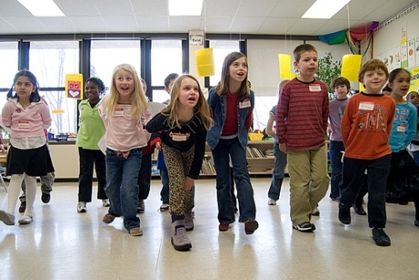 |  | - Teacher decides on a pattern where students go: over, under, around and through imaginary or real objects. The students take turns deciding what animal they will imitate.  - Lead the line of students around the room, following this pattern for at least 2 laps.  Examples: add more adjectives  Over Under Around Through  mountain subway round rock dark cave  ocean sand your desk creaky door  bridge dog chair long tunnel  steep hill water circle window  bush limbo stick the school a swamp | - Get in a line and keep your personal space in the front and back. We will be traveling around the perimeter of the room as we find new ways to go over, under, around and through our path.  - We are going over the Pacific Ocean and under the San Francisco Bridge, around Alcatraz Island and through the pier.  - Let’s make a crazy path as a lamb’s skipping over a turtle, under a big dog, around the elephant and through a giraffe’s legs.  - Let’s go over a sea of sticky peanut butter, under a cherry tree, around an ice cream cone and through a bowl of jell-o.
Academic Modifications: Language arts with story telling and prepositions

Palm Beach County Physical Activity Lessons
Activity Name: As if…
Target Objective: Cardiovascular endurance, flexibility, storytelling, vocabulary building
Grades: K-2 | Equipment: None |  | Location: Inside or outside
Activity |  | What You Do | What You Say
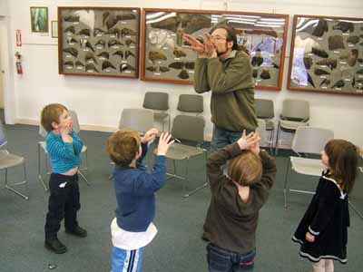 |  | - Teacher reads sentence to class. Have students act out each sentence for 30 seconds.  - Following are examples:  - Jog in place as if a big scary bear is chasing you.  - Walk forward as if you’re walking through chocolate pudding.  - Jump in place as if you are popcorn popping.  - Reach up as if the paint brush is attached to your head.  - Swim as if you are in a giant pool of Jell-o.  - Move your feet on the floor as if you are ice skating.  - Shake your body as if you are a wet dog.  - Students act out each sentence for 30 seconds.  - Students may create their own sentence, then add a partner for additional activities. | - Listen carefully to each sentence I read aloud.  Act out each action verb.  - Can you make a sentence and act it out for the class?  - Get a partner and form an action sentence to act out for another group.
Academic Modifications: Language arts and vocabulary building

Palm Beach County Physical Activity Lessons
Activity Name: Balloon Tracing
Target Objective: Hand-eye coordination, cardiovascular endurance, balance
Grades: K-2 | Equipment: Balloon and bubbles (scarves optional) |  |  | Location: Inside or outside
Activity |  | What You Do | What You Say
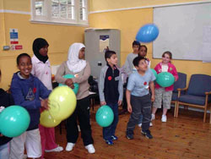 |  | - Demonstrate for the children how bubbles, feathers and balloons float through the air. If you have scarves available for the children, hand them out and let each child explore for himself or herself how the scarves gently float back down to the ground - no matter how hard they may toss them up.  - Challenge the children to pretend to be floating in the air. Is the movement strong or light? Are their muscles tight or loose?  - Inform the students that these exercises can warm up and strengthen the eyes for tracking skills in reading and writing. To trace a figure eight the student must start in the middle of their body at nose level and trace to the left (just as in reading), come back to the middle and loop the balloon to the left.  - For a cool down and to promote deep breathing, ask them to pretend to be a balloon, slowly inflating (by inhaling through the nose) and deflating (by exhaling through the mouth). Demonstrate for them first. | - Everyone stand by your desk with your chair tucked in. Keep personal space by your desk as we explore and challenge our eyes and hand movements. Toss and catch the balloon (blow and catch bubbles) with your hand that you write with; then use your other hand. Which was easier? Is the movement light or heavy? What are words you would use to describe the movement? Are the balloons or bubbles lighter?  - Close your right eye and try and catch your balloon. Can you toss and catch five times in a row? Switch eyes. What was different? What was the same? Trace a figure eight with your balloon.  - Let’s do the same thing with our lower body. Repeat above with legs.  - Let’s use our right eye and our left leg. Do the same for all combinations.
Academic Modifications: Reciting math facts or spelling words is easily implemented.
Palm Beach County Physical Activity Lessons
Activity Name: Beach ball Volleyball
Target Objective: Throwing and catching skills
Grades: K-2 | Equipment: Beach ball or very light large ball (net optional) |  |  | Location: Outside
Activity |  | What You Do | What You Say
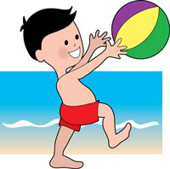 |  | - Regular volleyball or catch, pass and throw or hit over. The game looks the same as regular volleyball except you use a lighter ball to make everyone more successful.  - If you are catching the ball and you miss and it hits the ground, the other side gets a point. If you catch the ball, you must pass or hit the ball over the net. If it lands on the other side or someone does not hit it over, you get a point.  - No matter what side the ball lands on, players can start the serve from anywhere to speed up the game. Repeat until a team scores 15 points.  - If you do not have a net, use an area that is marked on the ground, big crack on the ground, sidewalk chalk, jump rope, etc. | - This game is more simple than regular volleyball.  - There are not as many rules!  - You can catch, pass, throw or hit over and it does not matter how many times, as long as the ball does not hit your side and it makes it over to the other side of the net.
Academic / Physical Modifications: Students in wheelchairs can start the game by serving the ball or hitting the ball from their chairs.
Palm Beach County Physical Activity Lessons

Activity Name: Beat the Clock
Target Objective: Team work, locomotive movement.
Grades: K-2 | Equipment: 12 paper plates with the numbers 1–12 written on them |  |  | Location: Inside or outside
Activity |  | What You Do | What You Say
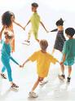 |  | - Students stand in a circle with hands joined to create a human clock.  - Place the numbered paper plates in the circle to form a clock.  - Students work together to turn their circle one rotation clockwise until the same person gets back to 12 o’clock.  - Select one student to be the minute hand and have all the students turn together to count by fives as they move past the plates. | - Your challenge is to move our human clock one rotation until you are back where you started.  - You must remain on your feet and keep holding hands.  - Who knows which way is clockwise?  - Each number represents 5 minutes in the clock.  - Let’s count as we move around the clock.
Academic Modifications: Geography integration: Discuss time zones in the US and different countries.

Palm Beach County Physical Activity Lessons

Activity Name: Bucket Bash
Target Objective: Bouncing, catching, and aiming for a target

Grades: K-2 | Equipment: 1 tennis ball per student, 1 bucket or box per 2 students |  |  | Location: Outside
Activity |  | What You Do | What You Say
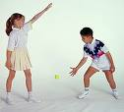 |  | - Give each student a tennis ball.  - Have them find a partner.  - Place a bucket or box in between each of the 2 students.  - Have them stand back 3 feet from the bucket.  - Students must bounce the ball on the ground to make the ball land inside the bucket. | - Bounce the ball on the ground to see if you can get it into the bucket.  - You must bounce the ball on the ground first.  - Do not bounce it too hard.  - When you make it, take a step back.  - See how far back you can go!

Palm Beach County Physical Activity Lessons

Activity Name: Builders and Destroyers
Target Objective: Cardio fitness.
Grades: K-2 | Equipment: As many cones as you have (basketballs optional) |  |  | Location: Outside
Activity |  | What You Do | What You Say
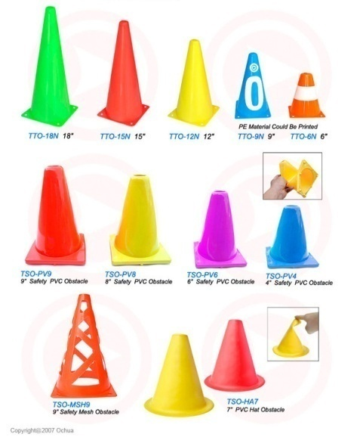 |  | - Show kids a space they have to play in.  - Divide the class into 2 halves: “builders” and “destroyers”  - Spread all different cones or sized cones in a playing area. Put half on one side and the other half standing up.  - When the teacher says “Go!”, the builders run around and bend down and put the cones up. The destroyers run around and knock them down with their hands only (no feet). After 1 minute, switch roles.  - Many kids like to play girls vs. boys game, so try that as well. | - Explain how to knock over the cones.  - Destroyers cannot kick the cones.  - After 1 minute, we will switch roles as builders and destroyers.  - If you have basketballs, they can also dribble the ball and play the same game…great for 2nd grade and above to work on dribbling skills.
Academic / Physical Modifications: Give kids in wheelchairs a stick or noodle to knock the cones down.
Palm Beach County Physical Activity Lessons
Activity Name: Check your heart rate
Target Objective: Students will run and walk for a predetermined amount of time and learn how to take their pulse and target heart rate while jogging for .5 or 1 mile.
Grades: K-2 | Equipment: Jogging area, bus loop or track. |  |  | Location: Outside or inside
Activity |  | What You Do | What You Say
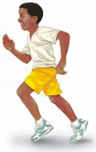 |  | - Students need to learn how to pace themselves and learn how to jog for at least 6 minutes.  - Measure an area where you know what equals a half mile and 1 mile. At first, make kids jog ¼ mile or .5 mile without stopping at all.  - They can walk for a little, but encourage them to keep jogging until they learn how to pace themselves so they can run for 6-12 minutes straight.  - Each week tell them to remember or graph their progress (lower times each week). | - Everyone will learn how to take their pulse today.  - If you get tired of jogging….walk a little and then start jogging again.  - Put two fingers to the side of your neck, next to your throat. Do you feel the beating of your heart? That is called your pulse.  - After exercising, your heart rate increases. Show them how to count for 10 seconds and then multiply that number by 6 or take the pulse for 30 seconds and double it, whichever is easier for the grade level.
Academic / Physical Modifications: Children can walk or go about the area in a wheelchair or do upper body activities that increase their H.R.
Palm Beach County Physical Activity Lessons
Activity Name: Doctor Ball
Target Objective: Cooperation activity that promotes communication and fitness

Grades: K-2 | Equipment: 2 or 3 red soft playground balls (“gator” or “Nerf”) and 1 or 2 green balls (or make your own colors) |  |  | Location: Outside
Activity |  | What You Do | What You Say
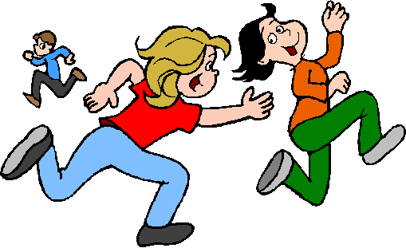 |  | - Play this game in a specified area or under the pavilion. The two (or three) germs try to tag or throw the ball at everyone (below the head or lower part of body only). If they get someone, they are “sick” and must sit down.  - The only way to play again is to shout, “Doctor help me!” When the doctor with the green ball touches your head, you are “all better” and can play again.  - After 1-2 minutes, switch roles with other kids so they have a chance to be the doctor and others can be germs. | - Explain how the game is played.  - Once you are tagged, you must sit down and yell, “Doctor, help me!”  - The germs need to get as many people as they can.
Academic / Physical Modifications: Make sure all students get a chance to be a doctor if they wish.
Palm Beach County Physical Activity Lessons
Activity Name: Flag Tag
Target Objective: Kids increase their heart rate while playing a game of flag tag.
Grades: K-2 | Equipment: Ribbons or long socks for flag belts |  |  | Location: Outside
Activity |  | What You Do | What You Say
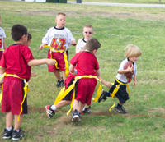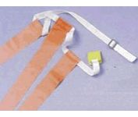 |  | - Each child wears a flag (sock tucked in the waist band) around their waist. There are lots of ways to play, so try them all.  - Colors: Red vs. Blue – Red tries to get blue and blue tries to pull off the red flags. If your flag is pulled off, you are out….or they are out and cannot play until they put it back on again.  - Everyone is it – everyone tries to get everyone else’s flag. If your flag is pulled off, you can not play and are out until you put it back on again (They are only out temporarily.)  - Elimination - If the flag gets pulled off, you are out and sit down until there are only about 2 people left. | - Kids can NOT hold onto the flags (or ribbons or bags).  - You must stay in the area designated for play.  - No pushing or shoving.
Academic / Physical Modifications: Make sure belts fit around all waists. If not, tie two together, but do not make it obvious.
Palm Beach County Physical Activity Lessons

Activity Name: Food Groups Tag
Target Objective: Nutrition, team work, locomotive skills and cardiovascular endurance
Grades: K-2 | Equipment: None |  |  | Location: Outside
Activity |  | What You Do | What You Say
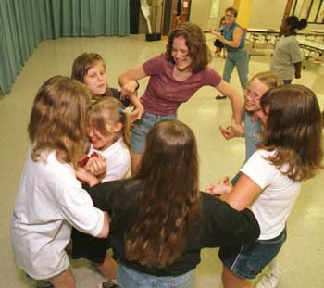 |  | - One person is chosen as the “It.” This student will tag any of the students who are not in the designated group which is called out by the instructor (i.e. calling in two’s or more is suggested).  - When the instructor calls out the designated number, all children attempt to get into groups of this number, holding hands together to be considered safe. Any left-over students must avoid “It” till the group counts even numbers to 20.  - Variations: “It” becomes a chef and the first two to join hands decide on what food group they are. Everyone must name a food from that group for a point. | - We are going to play a fun game to strengthen our heart muscle while we play. Feel your heart now and notice how the beat changes when you move.  - When I call out a number, you will find that many students to form your circle. Anyone that is left over will have to avoid “It” until everyone has recited the even numbers from 2 to 20.  - Everyone get some personal space and listen for the number.
Academic Modifications: Use different themes and benchmarks to recite during the chase.

Palm Beach County Physical Activity Lessons
Activity Name: Frogger
Target Objective: Cardiovascular fitness and teamwork
Grades: K-2 | Equipment: 2 hula hoops for every 3 students. |  |  | Location: Outside
Activity |  | What You Do | What You Say
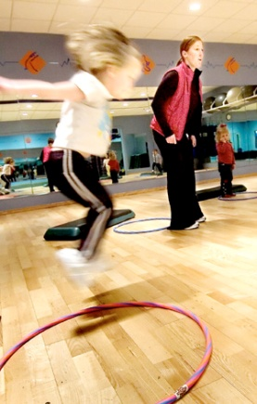 |  | - Split the class into teams of three.  - Give each team 2 hula hoops.  - Assign 2 students to be the tadpoles, and one to be the frog.  - Have all students stay in their groups and line up on one side of a court or fence.  - The object is to get the frog to the other side of the area.  - The frog can only move forward by jumping into the hoops.  - The tadpoles can move outside the hoops. Every time the frog jumps, the tadpole must move the hoop up so the frog can advance.  - The first team to the other side of the area wins. | - The object of the game is to move the frog to the other side.  - The frog can only move by jumping into the hoops.  - The tadpoles can move outside the hoops. Every time the frog jumps into the hoop, the tadpole must move the next hoop up for the frog to move forward.  - The first team to the other side of the area wins.
Palm Beach County Physical Activity Lessons
Activity Name: Fun Push-Ups
Target Objective: To help students increase muscular strength and endurance
Grades: K-2 | Equipment: Floor /Mats and various other manipulative objects depending on the push-up activity | Location: Inside or outside
Activity | What You Do | What You Say
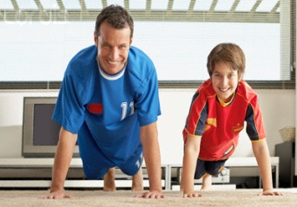 | - Patty Cake: Two people in push-up position face each other. Tap right hand to right hand and then left to left. Continue alternating until too tired to go on. To make harder, increase distance between partners.  - Push-up Hockey: Two people in push-up position face each other about 5 feet apart. Using a bean bag or ball, try to slide or roll the object between your partner’s two hands. The partner may stop it with one hand only. Students may choose to keep score if they would like.  - Alphabet Push-ups: Two students are in push-up position across from each other about arms length apart. They are to high-five each other using opposite hands while working their way through the ABC's. This can then be modified and low-fives can be used.  - Bean Bag Push-ups: Materials needed for this activity are a crate, box, or basket which stands about 1 1/2 feet off the ground and bean bags, balls, rolled up paper. Students are in push-up position with beanbags and baskets in front of them. They start by picking 1 beanbag up off the floor with left hand and placing it on the crate, then the next with the right hand, then the next with the left until all the beanbags are on the crate. Now they take the beanbags off the crate one by one, alternating hands until they are all off the crate. This repeats until a given time limit such as one minute is over. | - Basically you have to demonstrate or get kids to demonstrate how to do these.  - Be safe and if you are tired, take a break. We do not want students to fall on their faces.
Academic / Physical Modifications: If they cannot do push-ups, do modified push-ups or get exercise bands and do upper body exercises.

Palm Beach County Physical Activity Lessons

Activity Name: Hula Madness
Target Objective: Students will practice various ways to do hula hoop activities.
Grades: K-2 | Equipment: Hula hoop for each child or at least half the class. |  |  | Location: Inside or outside
Activity |  | What You Do | What You Say
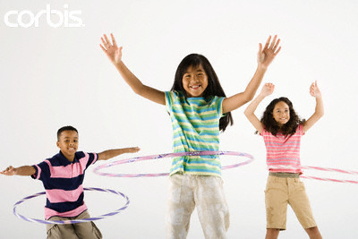 |  | - Hula hoop by themselves to practice.  Games:  - Hula until you are the last person.  - Hula hoop while walking.  - Hula hoop while walking backwards.  - Hula hoop relay race.  - Put 3 or 4 hula hoops around his/her waist and see how long he/she can continue.  - Hula hoop while doing dances such as Cha-Cha Slide and Cupid Shuffle. | - Stay in your own space and do not bump others.  - If you can not hula hoop while moving, keep practicing on your own.
Academic / Physical Modifications: Students in wheelchairs can do this on their arms.
Palm Beach County Physical Activity Lessons
Activity Name: Juggling Scarves
Target Objective: Fine and gross motor skills, problem solving, directions, levels body parts, cardiovascular endurance
Grades: K-2 | Equipment: Silk scarves or grocery bags |  |  | Location: Inside or outside
Activity |  | What You Do | What You Say
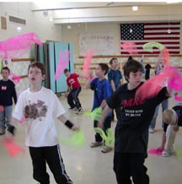 |  | - Each student will be given a scarf or bag after they have personal space. The teacher will give a variety of instructions to explore space, movements and body.  - They will move on the whistle, hear the shape, and after they hear the whistle blown two times, stop and form the shape. If they touch anyone while they are moving in different pathways and directions, the scarf will be taken away for 10 seconds per contact.  - Odds and evens will be utilized for turns of students. (K-1) Students will place scarf on body part (other than hair and face) as they do motor skills.  - D\Use discipline technique of taking the scarf away for a short time if they do not hug it to their heart. They must pretend to use it till they get it back. | - Toss the scarf over your head five times counting in Spanish  - Who can catch the scarf before it gets to the medium level?  - Who is able to toss the scarf from a medium to a high level, turn 90,180,360 degrees and catch it before it touches the ground?  - Can you make a square, rectangle and triangle with their scarf?  - Get a partner and throw scarf back and forth from different levels.  - Place your scarf on your chest and see how far you can go before it falls. What could you do to keep it up?  - Hug the scarf to your heart muscle when I say stop, so you will not have it taken away.
Academic Modifications: The students could also call out the planets, and spell shapes and words of the week (grade appropriate) as they catch the scarf. In classroom the teacher can use a permanent marker and write spelling words and more on the plastic bags for students to review as they toss them.
Palm Beach County Physical Activity Lessons
Activity Name: Jump for fun
Target Objective: Jumping rope, cardio endurance
Grades: K-2 | Equipment: Jump rope for each child, at least 2 double-dutch ropes. |  |  | Location: Inside or outside
Activity |  | What You Do | What You Say
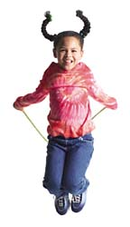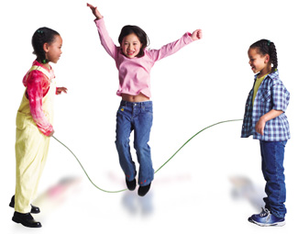 |  | - Show kids the basic jump. Then challenge them to:  - Jump on one foot.  - Jump rope backwards.  - Jump rope while jogging.  - Jump rope relay race.  - Jump rope while acting like you are doing ski jumps on a mountain.  - See if you can jump 20 times without making a mistake or for 2 whole minutes. Or, while jumping for 1 minute, can you do 3 different jump rope skills?  - Have students make groups of 3:  2 people turn, while one jumps.  - Practice double-dutch (recommended for at least 2nd grade and above). | - Make sure you are in your own space.  - Do not hit others with the rope on purpose.  - Once you are doing well with jumping in your own area and jogging with a rope, move onto the other skills.  - Double-dutch is a hard skill. Do not be discouraged.  - Jumping rope is great for an individual or team sport and is great for your heart.
Academic / Physical Modifications: Students can help turn the rope or do another activity nearby.
Palm Beach County Physical Activity Lessons
Activity Name: Jump Rope Fun
Target Objective: To jump over an object.
Grades: K-2 | Equipment: 1 jump rope for 3 students |  | Location: Outside
Activity | What You Do | What You Say
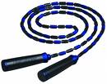 | - Tight Rope Walking: Students put the jump rope on the ground and walk across it like a tightrope.  - Up the Hill: One student stands and holds one end of the rope. Another student sits and holds the other end of the rope. A third student starts at the bottom and tries to jump from side to side going higher and higher up the rope.  - Making Waves: 2 students hold each end of the rope and wiggle it on the ground while the third student jumps from side to side over the rope without touching it.  - Rope Limbo: 2 students hold each end of the rope tight (like a limbo stick) while the third goes under it. Lower the rope each time they pass under.  - Helicopter: One student holds the end of the rope while spinning. (The other end of the rope stays on the ground.) The other 2 students jump over the rope as it comes by. | - Today we are going to play jump rope games.  - It is important that you follow the rules so that we do not trip and fall.
Palm Beach County Physical Activity Lessons
Activity Name: Let it fly
Target Objective: Working together as a team, hand eye coordination, tossing and catching
Grades: K-2 | Equipment: 2 large old sheets and 2 bean bags |  |  | Location: Outside
Activity |  | What You Do | What You Say
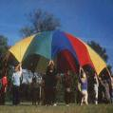 |  | - Split the class into two groups.  - Have each group hold onto the edges of the sheet.  - Have the groups move at least 5 feet from each other.  - Have students practice working as a team to raise and lower the sheet before you place the bean bag in the middle.  - Place a bean bag in the middle of each sheet.  - Have one group toss the bean bag while the other group catches it. | - Hold the sheet tight and do not let go.  - Your team must work together to raise and lower the sheet at the same time or the game will not work.  - Try different ways to see what works best: raise the sheet fast and slow.  - Use the sheet to throw the bean bag to the other team to catch.
Academic Modifications: Math: As the students lift the sheet, have them count by factors every time the sheet rises.
Language: As groups toss and catch the bean bag, they call out opposites.
Palm Beach County Physical Activity Lessons
Activity Name: Magic Memory
Target Objective: Cardio fitness, auditory sequential, memory and listening skills
Grades: K-2 | Equipment: Music | Location: Inside and outside
Activity | What You Do | What You Say
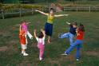 | - Tell the children you’re going to give them a list of movements to do, but that they’re not to start doing them until you’ve finished speaking. Start with a short sequence, for example: clap twice, jump; clap twice, jump and blink.  - When the children are ready, lengthen the sequence; for example: clap twice, blink eyes, turn around (jump in place, sit down, etc.).  - Remind students to be aware of personal space of themselves and others while incorporating moving in space.  - Use different locomotor movements during the transition before they stop to do their sequence: backwards, side to side, slow, fast… | - Students, you’re going to do many movements in a row after you stop traveling around the room. Do not start doing them until I finish speaking. (Start with a short sequence, for example: clap twice, jump; clap twice, jump and blink.) Remember to stop when I ring the bell.  - What awesome memory skills we have! Now you are ready to do more, for example: clap twice, blink eyes, turn around (jump in place, sit down, etc.).  - Remember to be aware of personal space of yourself and others when you travel in a variety of ways around the room. When do we need to be more careful?
Academic Modifications: Use vocabulary building skills by spelling site words as part of the task. Math and social studies and science facts can be inserted in sequence.
Palm Beach County Physical Activity Lessons
Activity Name: Monster Ball
Target Objective: Throwing and catching, working as a team
Grades: K-2 | Equipment: One large exercise ball. A line on the ground for the students to throw over. (Can also be played with a lowered volleyball net if available.) |  | Location: Outside
Activity | What You Do | What You Say
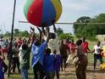 | - Split the students into 2 even teams.  - Place each team on either side of the line facing each other.  - Student throws the large ball over a line or net (if available) to the team on the other side.  - The other team ties to catch the ball.  - The object of the game is to get as many people as possible to drop the “monster ball.” If the ball is touched and dropped, the person who drops the ball is out.  - When no one is left on a team, the other team wins. | - If you touch the ball and the ball hits the ground you are out.  - You may save a teammate by attempting to help him/her catch the ball, but if you both drop it, you are both out. (This is true for no matter how many people touch the ball.)  - If you dodge the ball or back up to let the ball hit the ground, you are out.  - Students may not peg the ball (throw it hard) at the opposite team.  - If the ball lands on the line, you are out.  - If the ball does not make it over the line, you are out.  - If the ball bounces and then you touch it, you are NOT out. If you throw the ball and no one catches it, you are NOT out.
Palm Beach County Physical Activity Lessons
Activity Name: Noodle Tag
Target Objective: Cardio fitness, fleeing and chasing
Grades: K-2 | Equipment: Foam noodles cut to 1 - 2 foot lengths. One for each student |  |  | Location: Outside or inside
Activity |  | What You Do | What You Say
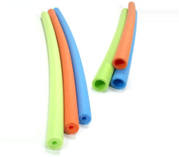 |  | - Demonstrate these games. Make sure students stay in the assigned area.  - Toe fencing: Students get a partner. They try to hit the partner’s foot or toe with the noodle. 1 point is awarded if they get them. Play to 5.  - Color tag: If there are 3 or 4 different colors, pick one color to be “it”. Example: The teacher yells, “Orange!” All the people with orange noodles are it and try to touch anyone with a different color. Play for 30 seconds, and then call out a different color.  - Noodle Frenzy: Put all noodles in one hula hoop. One person gets to be it and they get one noodle. When they tag someone, that person runs over to the noodle pile and starts tagging others. Keep going until there is nobody left. | - Do not hit anyone in the face.  - Try to play these different games in a safe way.
Academic / Physical Modifications: Students who are in wheelchairs may use a longer noodle.
Palm Beach County Physical Activity Lessons
Activity Name: Obstacle Course
Target Objective: Agility, running and jumping
Grades: K-2 | Equipment: Materials from your classroom, P.E. teacher or just use playground area / equipment |  |  | Location: Outside
Activity |  | What You Do | What You Say
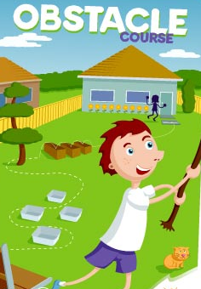 |  | - Swamp jump - Lay out 4 boxes, cones or other object in a line about a yard apart, then jump from one to another without touching the grass.  - Cave crawl - Make a tunnel by putting a blanket across the back of two chairs (or outdoor equipment), then crawl through on your stomach.  - Dodging the enemy - Lay out five or six cones or objects in zigzag pathway; then run in and out of them as fast as you can.  - Laser beam move - Lay a broom across the backs of two chairs; then limbo underneath without touching it.  - Log balance - Set up a long plank of wood, stick or use a balance beam, and then walk along it without falling off to the finish. | - Think of other ways you can just use the playground equipment as an obstacle course.  Example:  Climb to the top of the slide, go down then go to the monkey bars and make it to the end. From there, swing over a bar or shuffle across the parallel bars to another obstacle. Time the students during the course.

Palm Beach County Physical Activity Lessons
Activity Name: Roll to Bowl
Target Objective: Aim for a target; roll a ball.
Grades: K-2 | Equipment: 18 two liters filled with 2 inches of water for pins, any kind of ball. |  |  | Location: Inside or outside
Activity |  | What You Do | What You Say
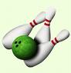 |  | - Place the pins in groups of 6.  3 in the back row,  2 in the middle row,  1 in the front row.  - Split the class into 3 groups.  - Have a student stand next to the pins to reset them, and another student to retrieve the ball. They can rotate these jobs. | - Roll the ball; throwing is not permitted.  - A strike is when you knock down all the pins.  - A spare is when you knock down the pins in 2 tries.  - When you roll the ball, point your hand where you want it to go to aim.  - Everyone gets 2 turns to bowl.  - Everyone takes turns doing a job.
Academic Modifications: Math: Students add up their scores. Students figure out their averages.

Palm Beach County Physical Activity Lessons
Activity Name: Snake Pit
Target Objective: Jumping, running and cardio fitness
Grades: K-2 | Equipment: 2 long jump ropes |  | Location: Outside
Activity | What You Do | What You Say
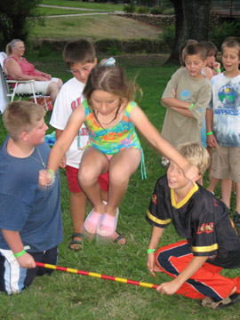 | - Choose 4 students be the snake charmers. These students will hold each end of the jump rope.  - NOTE: The jump ropes stay on the ground.  - The snake charmers will hold the jump ropes parallel to each other.  - They will keep them on the ground, but they will wiggle them side to side.  - All other students form a line.  - They run and jump over both ropes.  - If they make it, they keep running back to the end of the line.  - If they touch the ropes, they become the snake charmer.  - Once everyone in line jumps over the pit, the snake charmer moves the ropes further apart. | - Keep running after you jump over the snake pit.  - You are trying to jump over the pit. If you land in it, you become the snake charmer.  - Look where you are going.  - Once everyone makes it over, we will widen the snake pit.
Palm Beach County Physical Activity Lessons
Activity Name: Star Wars
Target Objective: Throwing to a target
Grades: K-2 | Equipment: About 12-20 small balls and one very large ball |  |  | Location: Outside
Activity |  | What You Do | What You Say
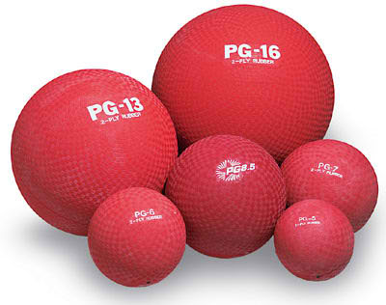 |  | - Divide the class into two. You can play this in a large circle area on the basketball court or use the sideline.  - Put one ball in the center of the two teams or in the middle of the circle. The object is to throw little balls and make the big ball move.  - The first team to make the ball cross over the line or go to the other team’s side of the circle wins. Repeat over again until they get tired of the game. | - Do not throw the ball at anyone.  - The object is to hit the big ball towards the other side or area of the circle.  - Do not cheat by using the small balls to push the big balls. You can only throw the small balls to hit the large ball.  - Science/ Outer space discussion: The big ball in the middle is the meteor and the small balls are the asteroids.
Academic / Physical Modifications: Make sure wheelchair students get to throw or roll a ball to the big ball.

Palm Beach County Physical Activity Lessons

Activity Name: Theme Walks
Target Objective: Cardio endurance
Grades: K-2 | Equipment: None or set up objects for students to notice and remember in one of the theme walks |  |  | Location: Inside or outside
Activity |  | What You Do | What You Say
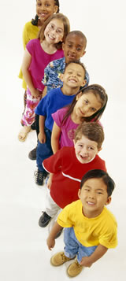 |  | - Students can walk around the perimeter of the room or playground to walking themes of words that begin with ABC’s, counting similar shapes, colors and more.  - Students could count in another language.  - Use multiplication tables.  - Use odd and even numbers.  - Use colors or shapes. | - How many steps do you think it will take to walk around the room?  - Let’s be scientists and take an educated guess before we take our steps around.  - Was your number close to what you guessed? Was it an even or odd number?  - Count how many objects in the room begin with the letter A. Let’s do that many jumbo jumps.  - Guess how many squares you think are in our classroom. Let’s walk around the perimeter and count them while we do cross crawls.  Sign to the Military Cadence  Left…Left…Left-Right-Left  To cross a street to the other side, these safety rules I chant with pride  First I STOP before the street to see if any cars I’ll meet.  Left…Left…Left-Right-Left  Then I LOOK – first left then right and listen for cars not in sight.  Look left once more, just so I know if it’s clear then I can go!  Left…Left…Left-Right-Left  I look at driver: I wait to see- if they wave back, then they see me!  I walk – not run – I take it slow- I watch and listen as I go.
Academic Modifications: Implement any teaching theme through these movement games to engrain learning.
Palm Beach County Physical Activity Lessons

Activity Name: Traveling Ball Skill
Target Objective: Increase perceptual motor skills, identify body parts, bouncing, catching
Grades: K-2 | Equipment: ball, bean bag or wad of paper |  | Location: Inside or outside
Activity |  | What You Do | What You Say
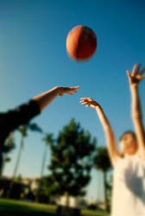 |  | - After each student finds personal space, distribute the balls according to students who have pets or green colored shirt.  - Warm up with students going around the world with their ball (can use 7 continents body marks). Toe Touch – Hold the ball at the waist; touch the toes; touch the waist; raise arms overhead.  - Stop and Go Ball –Students can hold the ball and move other ways. Students may explore freely and then the teacher may suggest specific movements: walk backwards, gallop, jog, hop, jump, slide sideways, etc.  - On a given signal, the children should stop, quickly toss the ball into the air and catch it. The signal might be a bell or whistle, a bang on a tambourine, or a clap of the hands. Remember to vary the direction and type of movement.  - Toss the ball into air and catch it. You will have to challenge some children to toss higher and others to toss lower. | - Find personal space and I will give the ball to the students with green, then white shirts.  - Hold the ball over the head and circle to the right; touch the floor and stand up three times, repeat to the left.  - Hold the ball in your hands and walk in general space. (This allows the children to get used to moving with a ball while watching out for each other)  - When I ring the bell, stop and toss and/or bounce the ball and catch it. Let’s gallop this time and see who can listen and stop and catch the ball.
Academic Modifications: During the toss you can include any academic benchmark.
Palm Beach County Physical Activity Lessons
Activity Name: Ultimate Frisbee
Target Objective: Throwing and catching an object
Grades: K-2 | Equipment: as many Frisbees as you have. | Location: Outside
Activity | What You Do | What You Say
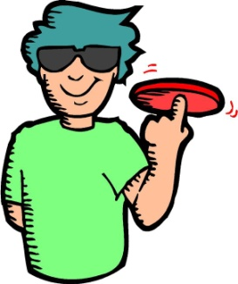 | - First let the children practice throwing the Frisbee in small groups.  - Divide the class into two groups or even 4. You can do 2 games at a time if you have enough space.  - Start the game with a “tip-off.” Have one child from each side come to the center. The teacher throws the Frisbee in the air and the game starts. Each child can throw the Frisbee to a teammate. The person who has the Frisbee can take up to three steps forward and then must shoot or pass the Frisbee. Then can move as much as they want sideways, but only 3 steps forward.  - If they throw the Frisbee and the person does not catch it, or they drop it, the other team gets it. Keep playing until they throw the Frisbee through the goal area. When a goal is scored, do another tip-off and pick new kids to do this. | - Remember to pass to all the members of your team when you can.  - Try to make short passes.  - Only try to score if you are close.  - If the Frisbee hits the ground, it goes to the other team. Back up and get ready to defend your side.
Academic / Physical Modifications: Students’ in wheelchairs or who cannot grasp a Frisbee can use a larger one or a ball instead.
Palm Beach County Physical Activity Lessons

Activity Name: Who Gets the Worm?
Target Objective: Cardiovascular endurance, team building and problem solving
Grades: K-2 | Equipment: None |  | Location: Outside
Activity |  | What You Do | What You Say
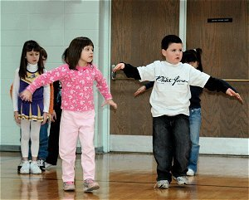 |  | - Divide the class into three groups, making sure that the first and second groups have equal number of girls and boys. The first two groups pair off as father and mother birds. The third group is the worms. The object of the game is for the mother and father birds to try to get a worm to bring back to the nest to feed the baby birds.  - A student who is the worm runs out and takes any position he desires behind the cones (designated area). When he calls “worm” two pairs of flying birds, with arms flapping all the way, race to where he is standing. During the trip, the father and mother birds must stay together. The pair that reaches the worm first gets him and brings him back to their side. The game continues till all the worms are caught. | - We will be dividing our class into three groups. When I call your name, go to one group. Go to the NE, NW and SE corners. The two groups that are paired with a boy and girl will be the parents. The third group will be the worms.  - The student who is the worm will run out and find personal space. When I call out “worm” the pairs will go out to get their worm. You must stay together while getting your worm and returning it to the nest.  - You will switch places after all the worms are caught.
Academic Modifications: Use different names of birds as cues.

Palm Beach County Physical Activity Lessons

Activity Name: Word Wall Chants and Cheers
Target Objective: Fine and gross motor skills, cardiovascular endurance
Grades: K-2 | Equipment: Word Walls and flash card for theme |  |  | Location: Inside or outside
Activity |  | What You Do | What You Say
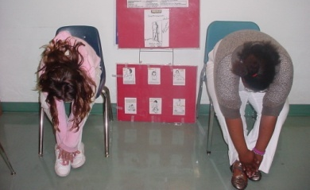 |  | - Use one or more of the chants and cheers as students move around the perimeter of the room. Below are some helpful hints for word walls:  - Make sure word walls can be viewed by all students. Use a variety of colors or fonts to differentiate between similar words.  - Be selective about the words.  - Address all modalities when learning the words.  - Have a variety of review activities to engrain words and their meaning.  - Use themes and/or reference grade level books to associate with word. | - Word Wall Cheers and Chants:  - Chant or cheer – Students shout “Give me a…” (Spell out word.)  - Saturday Night Fever – Point up and then cross over and point down saying the letters.  - Batter Up – Get into the batting position and swing on each letter as you say it.  - Throw Kisses – Throw your arm from your mouth outward and blow a kiss with each letter.  - Locomotion – Move arms in circular motions saying the letters.  - Sadie Skills – Recite words and/or letters while skipping, hopping, jumping, etc.  - Twist – Turn your hips and pelvic area and move sideways, twisting your arms around your body.  - Basket Ball – Pretend you are shooting or dribbling while repeating each letter.  - Mexican Hat Dance – Alternate feet in front while saying letters.  - Dancer – Move side to side while saying each letter.  - Around the World by Your Body – Start at the toes of your body spelling your word. When you get to the head, sound it out.  - Yo-yo – Bend our arms at the elbow and alternate your hands up and down as you say the words.
Academic Modifications: Vocabulary building and break down of words with prefix and suffix root word meanings.
Palm Beach County Physical Activity Lessons

Activity Name: Alphabet game
Target Objective: Cardiovascular endurance

Grades: 3-5 | Equipment: Alphabet sheets, pencils |  |  | Location: Outside
Activity |  | What You Do | What You Say
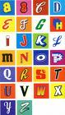 |  | - Make sure students are staying on the designated route.  - If necessary, moderate any challenges. | - You will walk around a route that is set up and you must stay on the route. You must be very observant while you are walking.  - Write down everything you see that starts with each letter of the alphabet.  - At the end, everyone will share your list with your classmates.  - If you want to challenge an item on a classmate’s list, you can. The person who wrote the item on the list must tell where he saw it.

Palm Beach County Physical Activity Lessons

Activity Name: Art in Motion
Target Objective: Cardio fitness
Grades: 3-5 | Equipment: Several pieces of paper for each group, one pencil per group;  box, bowl or bag with small pieces of paper upon which the  words are written for the drawer to draw |  |  | Location: Inside
Activity |  | What You Do | What You Say
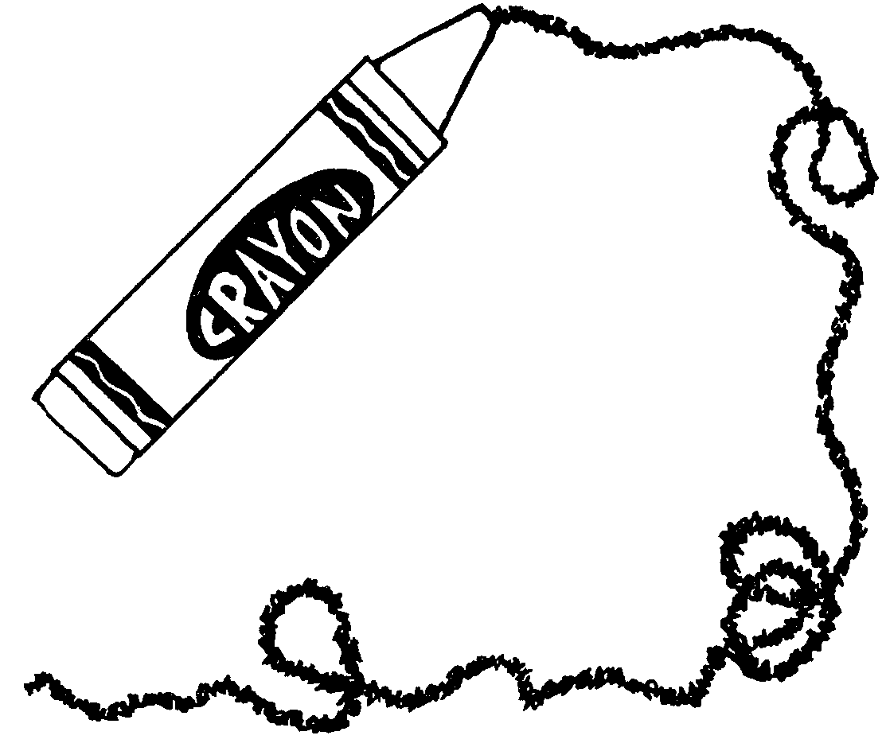 |  | Divide the students into groups of three. In each group there is one drawer who picks an object from a box to draw. The group members take turns guessing until someone guesses correctly or until time runs out at 3 minutes.  Write the designated exercise on the board.  Change the designated exercise often. | We are going to take turns drawing and guessing what it is that has been drawn. We will be using objects and activities that are related to sports.  The goal is to be the first group to make the correct guess of what the drawing is.
After each guess, guessers must do the designated exercise.
Each additional guess increases the number of repetitions of the exercise that the guessers do.
Guessers must do the exercises immediately after guessing and before guessing again.
After the group guesses correctly, they do jumping jacks for joy until the other groups guess correctly or time runs out.
Another member then draws for the group.

Objects to draw:
bat, tennis racquet, glove, basketball, lacrosse stick, hockey stick, cleats, puck, skates, football, softball, tennis ball, tennis court, pitcher, jump rope, scooter, volleyball, bike, soccer ball

Activities to draw:
throwing, catching, volleying, batting, running, jumping, hopping, serving, swimming, surfing, lifting weights, dancing, skating, sailing, hiking, diving, dancing
Exercise ideas:
Curl-ups, push-ups, hops, jumps, cross crawls

Palm Beach County Physical Activity Lessons

Activity Name: Crazy Cones
Target Objective: Build endurance levels

Grades: 3-5 | Equipment: Cones or cups |  |  | Location: Outside
Activity |  | What You Do | What You Say
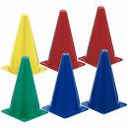 |  | - Split the class into two teams.  - Place cones randomly throughout the area. | - On my signal, half of the class will set cones up and the other half will turn them upside down.  - On my signal again, the team with the most up or down wins.

Palm Beach County Physical Activity Lessons

Activity Name: Beach Ball Bat Ball
Target Objective: Throwing, catching, teamwork

Grades: 3-5 | Equipment: Beach balls (4-6), cones or other markers |  |  | Location: Outside
Activity |  | What You Do | What You Say
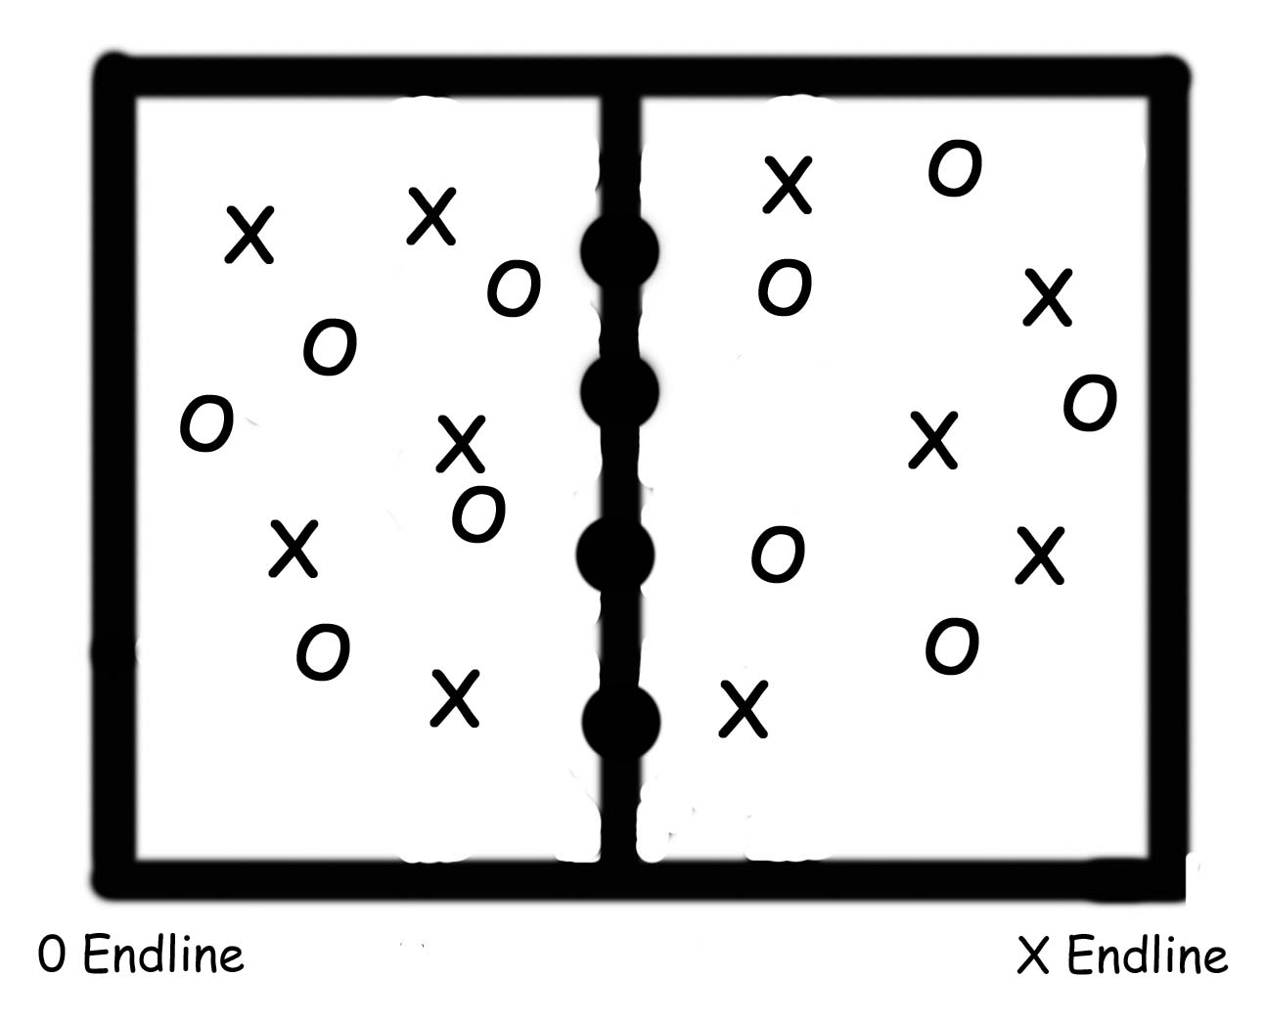   |  | - Set up an area with cones, designating the end lines and the centerline.  - Divide the students into two teams.  - Place the balls along the centerline to start and then signal for play to begin.  - Reinforce that no one may carry or run/walk with a ball. | - You can score a point for your team if you bat a ball over your team’s end line. You bat the ball with one or both hands.  - The balls will start at the center line and when the signal is given, you will try to bat the ball toward teammates who try to bat it closer and closer to the end line, and then over the end line.  - Once the ball is over the end line, it is not played. You should focus on the remaining balls in play until they are over the end line.  - If the ball is on the floor, you can pick it up and bat it into play, but you may not carry the ball or run or walk with it.  - After all of the balls have scored, the game ends and a new game will start.

Palm Beach County Physical Activity Lessons
Activity Name: Card Walk
Target Objective: Understand the benefits of walking for fitness
Grades: 3-5 | Equipment: One or more decks of cards |  |  | Location: Outside
Activity |  | What You Do | What You Say
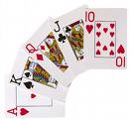 |  | - Set up an area for walking laps.  - Give the “Go!” signal and hand each student a card each time they pass.  - After the students have completed a specific number of laps or a designated time period, have them add up the point values of the cards they collected.  - If the students have score sheets, have students record the total value of their cards, the number of laps walked and the distance covered.  - Encourage students to walk at their best pace for greater aerobic benefits. | - I will be the dealer of the cards.  - The value of the cards are: aces and face cards equal 10 points. All other cards equal the number that appears on the card.  - When I give the “Go!” signal, start walking laps.  - Each time you pass me, I will hand you a card.  - The winner is the student or team with highest score.

Palm Beach County Physical Activity Lessons

Activity Name: Catch 500
Target Objective: Throwing and catching
Grades: 3-5 | Equipment: One beanbag or other catchable object for each student |  |  | Location: Inside or Outside
Activity |  | What You Do | What You Say
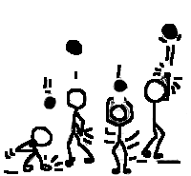 |  | - Ensure that each student has a beanbag, paper ball or other object that can thrown and caught.  - Situate the students so that they can hear the tasks called out and also have room to move. | - We are going to try to catch 500 times.  - I will call out various tasks that you are going to do using throwing and catching skills.  - I will tell you how many times to do each task.  - Each student is responsible for keeping track of his/her own numbers.
Students toss the object upward to themselves and catch it with:
1. palms facing upward
2. the hand opposite the one throwing
3. the left hand and then toss with the right hand
4. both hands, clapping once between the toss and catch
5. both hands, clapping once behind the back between the toss
and catch
6. both hands, clapping twice between the toss and catch
7. both hands, turning around once before making the catch
8. both hands, clapping twice, turning around once, and
slapping the knees before making the catch

In partners:
Partners complete __ successful throws.
If they complete the designated number, they can take a step back to increase the distance between them. They must stay where they are until they have completed the designated number of successful throws and catches.
On a signal, partners can switch.
If there are different types of objects being throw on a signal students can switch with another student.
Palm Beach County Physical Activity Lessons
Activity Name: Classroom Highway
Target Objective: Cardio fitness and spatial awareness
Grades: 3-5 | Equipment: CD player with music for movement (optional) |  |  | Location: Inside
Activity |  | What You Do | What You Say
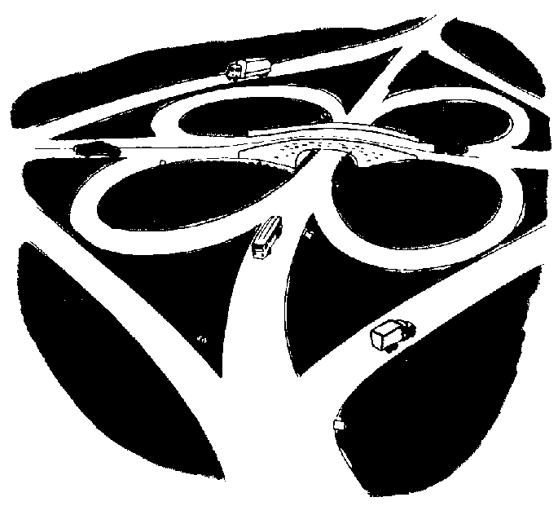 |  | - The colors or types of vehicles can be designated or students can select.  - Call out the color and/or type of vehicle and those students perform the task that is called out.  - Ensure students move safely, Issue “tickets” for time out after warnings for collisions. | - You are all drivers. Show us how you steer the steering wheel with your hands and arms. (If there are deck rings or other rings available, students can use them as steering wheels.)  - You will listen to my signal or the music; you will do the task that is called out as you are “driving”.
Examples of tasks:
1. Drive forward.
2. Stop.
3. Go slow-rush hour.
4. Reverse and back into a parking space.
5. Turn right and go into McDonalds. Do 25 jumping
jacks before driving again
6. Pull into a gas station and do 10 push-ups
7. Stop to fix a flat tire-do 20 arm circles-small, large,
forward, backward.
8. Drive through a tunnel slowly, staying low.
9. Drive over a bridge; move quickly on toes.
10. Jump for bumpy road.

Other ideas:
- Call out actions for different colors/types for different directions.
- Make a U-turn, turn right, drive fast (skip), drive slow (hop), cruise (walk), etc.
- Drive in directional patterns (zig zag, curve, circles, straight lines).

Palm Beach County Physical Activity Lessons
Activity Name: Cross the Great Divide
Target Objective: Group cooperation and sequences

Grades: 3-5 | Equipment: 4 cones for boundaries, CD player for music |  |  | Location: Outside
Activity |  | What You Do | What You Say
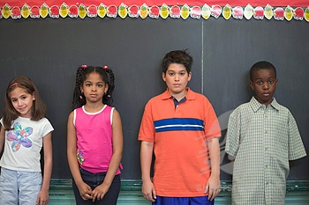 |  | - Set up activity area.  - Line up students so they are standing side by side on a line, facing next line only 5’ away.  - Encourage students to communicate, to problem solve, and to be persistent.  - Debrief on key points (teamwork, cooperation, achieving a group goal).  - For academic integration in classroom, discuss historical significance of the “Great Divide” (for example, location and importance in national events). | - The object is to work together and cross the Great Divide as a group.  - The Great Divide is between you and the next set of cones.  - It is very close but getting there will be a great challenge.  - First touch the sides of your feet with the person next to you.  - When I say “Go!” work together and cross the great divide. Keep your feet touching.  - Everyone must make it across. If anyone’s feet disconnect, everyone starts over.

Palm Beach County Physical Activity Lessons

Activity Name: Eggs in the Basket
Target Objective: Strategy and endurance

Grades: 3-5 | Equipment: 5 hula hoops or chalk circles, chalk, 7 balls, or paper balls |  |  | Location: Outside
Activity |  | What You Do | What You Say
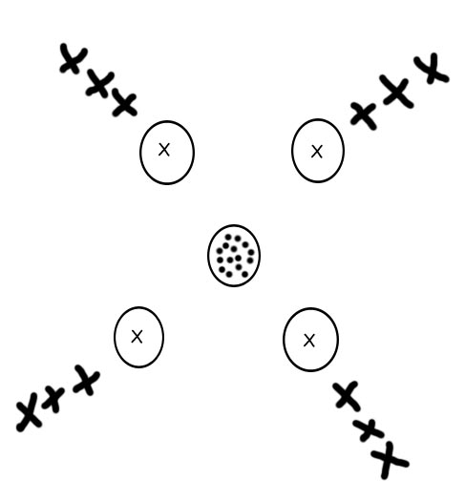 |  | - Place seven balls in center hoop.  - One student stands behind each of the four outside hoops. | - On my signal, run and grab a ball from the center hoop.  - The first student to get 3 eggs (balls) in their hoop wins. Those 4 students go the end of their lines.  - Once balls are gone from the center, you may steal from a neighbor.  - You may carry only one ball at a time.

Palm Beach County Physical Activity Lessons

Activity Name: Exercise Tag
Target Objective: Endurance/fitness

Grades: 3-5 | Equipment: None |  |  | Location: Outside
Activity |  | What You Do | What You Say
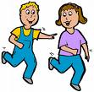 |  | - Set up a clear area for activity  - Designate the first tagger.  - Examples of locomotor movements:  Skip, Walk, Run, Jump, Gallop  - Examples of exercises:  Jumping jacks, Arm circles,  Push-ups, Curl-ups, Wind mills | - I will call out a locomotor skill for everyone to do (including tagger) and also an exercise.  - One person is “It” and runs and tags other students.  - Once tagged, the student who was tagged has to do the exercise that I have called out.  - Once you have done 10 of these, you can rejoin the game.  - The skills and exercises will change after a few minutes.

Palm Beach County Physical Activity Lessons

Activity Name: Factor It In
Target Objective: Endurance and Math

Grades: 3-5 | Equipment: 4 pieces of scrap paper labeled 2, 3, 4,and 5 |  |  | Location: Inside or outside
Activity |  | What You Do | What You Say
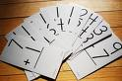 |  | - Label each corner of the room with one of the pieces of scrap paper.  - Call out a number that is a multiple of 2, 3, 4 or 5.  - Students who are in a corner that is a factor of that number will move to another corner.  - Movements include jumping, skipping, hopping, marching, crab walk, inch worm, bear walk, gallop.  - Example: If “6” is called out, students in corners labeled 2 and 3 will move to another corner. | - Define “factors”.  - When I call a number, you must travel to the corner of the room that is a factor of that number.  - Each time we will travel a different way.

Palm Beach County Physical Activity Lessons

Activity Name: Fitness Circuit
Target Objective: Cardio fitness

Grades: 3-5 | Equipment: CD player, music for movement |  |  | Location: Inside
Activity |  | What You Do | What You Say
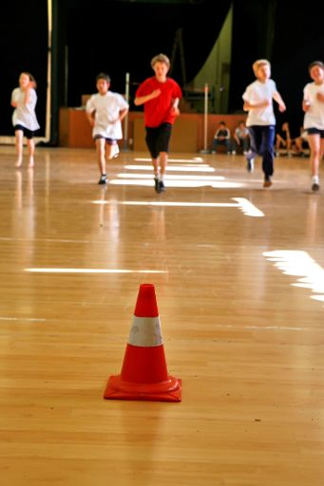  Ideas for Stations:  Jog in place  Stretching-sit and reach  Jumping Jacks  Curl-ups  Standing cross crawls (knee to opposite elbow, alternate sides)  Push-ups  Jump rope with imaginary jump rope |  | - Set up stations around the room. The number of stations depends on the space available, the number of students, and the available time.  - Vary the order of the stations so that a more intense station is followed by one that is less intense.  - Explain the tasks for the students to do at each station. | - A fitness circuit allows you to get many fitness benefits by being active over a short period of time. Some stations will be harder to do, or more intense, than others.  - On the signal you will move clockwise to the next station and perform the tasks for 2 minutes until I give the signal to rotate again.  - You are not competing against anyone. You are trying to do your best.
Palm Beach County Physical Activity Lessons
Activity Name: Fitness Walk
Target Objective: Students understand how muscles are used in the body

Grades: 3-5 | Equipment: CD player, music, and task cards |  |  | Location: Outside
Activity |  | What You Do | What You Say
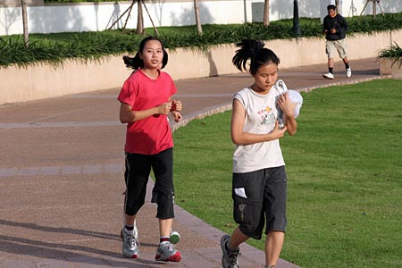 |  | - Set up/designate an area for walking and jogging.  - Explain/demonstrate the exercises or activities on the task cards.  - Tasks on the cards might include curl-ups, twisting, bending, push-ups, etc.  - Stop the music or give a signal every 15-20 seconds.  - Assign a leader to give the signal. | - You will be walking or jogging.  - Every 15-20 seconds the music will stop or I will give you a signal. You will then go to the closest station and perform the task on the card.  - When the music starts again or the signal is given, walk, jog or skip, or whatever I call out.  - We will switch leaders periodically.

Palm Beach County Physical Activity Lessons

Activity Name: Four Chiefs
Target Objective: Gross motor skills, socialization skills, boundaries

Grades: 3-5 | Equipment: Four different colored squares (20 each) |  |  | Location: Outside
Activity |  | What You Do | What You Say
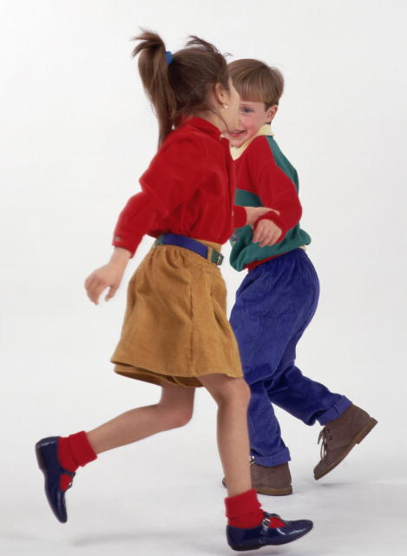 |  | - Choose four players to be the chiefs.  - Demonstrate how to tag.  - Give the signal for players to scatter and chiefs start to tag.  - When all but 3-4 players have been tagged, start a new game.  - The chief with the most players wins. | - This is a tag game, and you must tag gently on the arm.  - Four players will be the chiefs.  - On my signal everyone will scatter and try to avoid being tagged by the chiefs.  - When a chief tags a player he will give the player a color and that player goes to the spot for that color.  - Who has the biggest village? Who has the smallest village?  - Is it better to have a small village or large village? Talk about the advantages and disadvantages.
Academic Modifications: This game comes from the country of Nigeria. Have students research Nigeria and report on it to the class.
Palm Beach County Physical Activity Lessons

Activity Name: Hungry Crabs
Target Objective: To help improve upper body strength, endurance and the concept of working together as a team

Grades: 3-5 | Equipment: Bean bags or anything that is easy to pick up;  4-6 hula hoops |  |  | Location: Outside
Activity |  | What You Do | What You Say
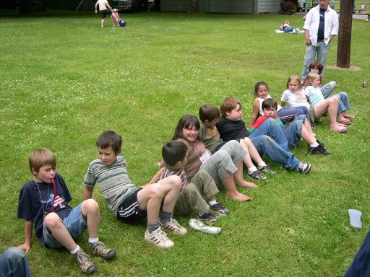 |  | - Divide the students into 4-6 groups and line up each group behind a different color hula hoop.  - Place the bean bags or objects in the center. | - Each team will be trying to collect the most pieces.  - You will get into the crab walk position and will go one at a time, pick up an object, put it on your stomach, crab walk back and put the object in the hoop.  - Only one student goes at a time and when he gets back he goes to the end of the line  - When all of the objects are gone, the game is over and you will then count how many objects your team collected.
Academic Modifications: Give the students a math problem to solve with the objects they collected. For example, the team collected 20 objects. Have them add to any number, divide by any number and multiply by any number. Using chalk, calculate on the sidewalk or have them bring paper and pencil.

Palm Beach County Physical Activity Lessons

Activity Name: Jump Start Your Heart
Target Objective: Endurance and healthy heart (Science)

Grades: 3-5 | Equipment: 6 pieces of paper labeled with parts of the heart |  |  | Location: Inside or outside
Activity |  | What You Do | What You Say
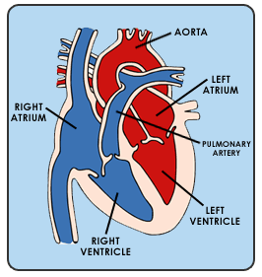 |  | - Label 6 pieces of paper with the following words:  Right Atrium  Right Ventricle  Lungs  Left Atrium  Left Ventricle, Body  - On each of these papers, write an exercise, for example: Right Atrium- Jumping Jacks.  - Divide class into six groups.  - The students do the activity at each labeled part of the room. | - On my signal, you will go to the group I assign you to. When I say ”Start your heart,” begin that activity. When I say “blood flow,” go to the next part of the heart.  - The correct blood flow starts in the right atrium to the right ventricle, from there it goes to the lungs and back to the left atrium. It then travels to the left ventricle and from there it goes to the rest of the body. It then starts all over again.

Palm Beach County Physical Activity Lessons

Activity Name: Heart Smart
Target Objective: Heart knowledge and fitness builders

Grades: 3-5 | Equipment: None |  |  | Location: Inside
Activity |  | What You Do | What You Say
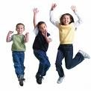 |  | - Call out an activity, using the examples below and others.  Examples:  - Riding a bike (jump)  - Eating 4 pepperoni pizzas (squat)  - Walking your dog (jump)  - Smoking cigarettes (squat) | .We’re going to talk about the heart:  - Where is it? (left side of chest)  - What size is it? (size of your fist)  - What is its function? (deliver blood to the body)  - What strengthens the heart? (jumping, swimming, jogging)  - What weakens the heart? (smoking, unhealthy diet)  I will call out an activity.  - If it strengthens the heart, you should jump for 15 seconds.  - If it weakens the heart, you should squat for 5 seconds.  .
Academic Modifications: Science - Have students complete a diagram labeling the heart and describing the function of each part. Palm Beach County Physical Activity Lessons

Activity Name: Line Tag
Target Objective: Students will be able to build endurance and foster strategies.

Grades: 3-5 | Equipment: Two vests/ identifiers for taggers |  |  | Location: Outside
Activity |  | What You Do | What You Say
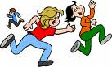 |  | - Students will space themselves around the basketball court.  - Pick two students to be “it”.  - Give these students a vest or wristband for ID | - You may not run, only walk fast.  - If you are tagged out, you have to report to an area out of the way and perform some type of movement skill. Examples: Jumping jacks, push-ups, toe touches.  - A new game will start when two students are left untagged. They will become the new taggers.

Palm Beach County Physical Activity Lessons

Activity Name: Meet Me in the Middle
Target Objective: Sequence and endurance

Grades: 3-5 | Equipment: None |  |  | Location: Inside or outside
Activity |  | What You Do | What You Say
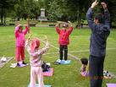 |  | - Split students into 2 groups at opposite sides of court or classroom.  - Call an activity.  - Students go to the middle of the room to complete the activity and then return to their side.  - When the next activity is called, students must complete the new exercise first and then the previous one.  - Students have to remember the activity and all the preceding ones. | - When I say “Meet me in the middle and give me 10 push-ups”, go to the middle of the room and do 10 push-ups. You will then return to your side.  - Next time I’ll say “Meet me in the middle and do 10 jumping jacks.”  - Students do 10 push-ups and 10 jacking jumps.  - Next time I’ll call a different activity (10 high fives).
Palm Beach County Physical Activity Lessons

Activity Name: Memory Lane
Target Objective: Sequencing

Grades: 3-5 | Equipment: None |  |  | Location: Inside
Activity |  | What You Do | What You Say
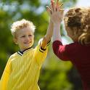 |  | - Make up a card with any sequence of movements.  - Have the students get in pairs.  - Call out tasks in a sequence.  . Examples:  - High five right  - High five left  - Low five right  - Low five left  - High ten  - Backwards ten high  - Backwards ten low  - Jumping jacks  - Arm circles  - Toe touches  - Side bend | - You will be in pairs, and I will call out a task.  - You will complete that task, and then I’ll call out another one.  - You will complete that task and the one before it.  - Each time a task is added, you must do the previous ones in order.

Palm Beach County Physical Activity Lessons
Activity Name: Moon Ball
Target Objective: Throwing and catching

Grades: 3-5 | Equipment: Beach ball(s) or balloon(s) |  |  | Location: Inside or Outside
Activity |  | What You Do | What You Say
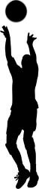 |  | - Designate an area where students can move to hit the beach ball up in the air.  - Divide students into groups of 5-6.  - Start the ball by hitting it up in the air, starting the students counting out loud with each hit. Enforce the rule of players not hitting the ball twice in a row.  - Encourage students to hit the ball high in the air so that another student has time to get underneath it for the hit. | - You will take turns hitting the beach ball so that it stays in the air without hitting the floor/ground. The goal is to work together to keep the ball in the air. You can’t hit the ball two times in a row.  - The whole group will count out loud each hit that is made. When the ball touches the ground, the counting starts over. See what the highest number of hits can be.  - We will also try for time. Can we keep the ball in the air for 20 seconds?
Academic Modifications: Groups can count by 2’s, 3’s, 4’s, 5’s and 10’s.

Palm Beach County Physical Activity Lessons

Activity Name: One Bounce Free
Target Objective: Bouncing and catching

Grades: 3-5 | Equipment: Playground balls (1-3), cones, chalk or other markers |  |  | Location: Outside
Activity |  | What You Do | What You Say
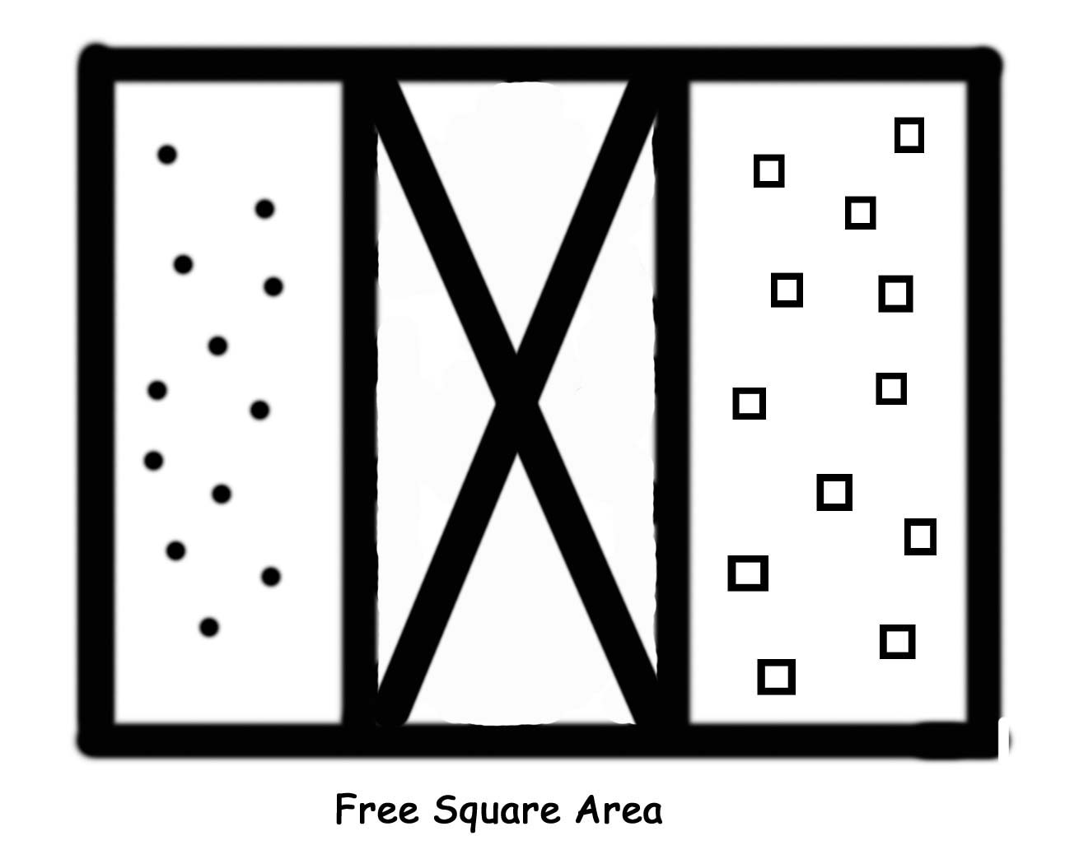 |  | - Mark off an area with cones, spots or chalk.  - Designate two scorers, one to keep score for each team.  - More balls can be used to increase physical activity and interest if appropriate for the students. | - The object of the game is to bounce the ball in the free square area, causing it to land in bounds so that it can’t be caught.  - When you have the ball, bounce it into the free square area.  - If a ball from the other team bounces in the free square area, catch the ball before it bounces again.  - You can’t stand in the free square area.  - Your team will get a point if the ball bounces in the opponent’s area (is not caught).

Palm Beach County Physical Activity Lessons

Activity Name: Paper Plate Fitness
Target Objective: Understand fitness and how it pertains to daily life
Grades: 3-5 | Equipment: 5-6 paper plates or sheets of paper |  |  | Location: Inside
Activity |  | What You Do | What You Say
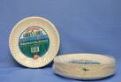  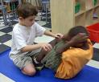 |  | - Have students get in groups of 5-6.  - Give each group time to draw an example of a fitness skill on a paper plate.  - Select one volunteer from each group to demonstrate the skill that the group has drawn.  - Spread paper plates around the room in a circular pattern.  - Have groups start at their own paper plate activity.  - Stop the music or give a signal periodically to signal the students to move to the next paper plate. | - In small groups you will draw an example of a fitness skill on a paper plate or sheet of paper.  - Once all of the groups have drawn their skill, we will demonstrate each one before we start to rotate through the stations (paper plates).  - We will then spread the paper plates around the room to form a circle.  - You and your group will start at your own paper plate and do that activity until the music stops or until I give the signal.  - You will then move with your group clockwise to the next paper plate and do that activity until the signal is given or the music stops.  - Remember to respect others’ personal space.
Academic Modifications: Math: Write math problems on each plate to determine the number of exercises the student must complete. Example: 2X5=? How many push ups?

Palm Beach County Physical Activity Lessons

Activity Name: Pass It On UNO Style
Target Objective: Increase fitness levels
Grades: 3-5 | Equipment: One deck of UNO cards |  |  | Location: Inside
Activity |  | What You Do | What You Say
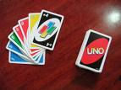 |  | - Remove all skips, reverse, and draw 2 cards from the pack of UNO cards.  - Write the following on white board:  Blue- Jump to the sky  Red – Squats  Yellow- Lunges  Green- Jog in place  Wild- Your choice  - Demonstrate each exercise.  - Pass out a card to each student.  - On your signal have students pass their card to someone in the room.  That student must perform the exercise for twenty seconds or until you say pass it on. | - Each color on each card represents a different exercise.  - Look on the board to see what your color represents.  - Every time that I say “Switch,” you are going to hand your card to someone new.
Academic Modifications: Math: Give each student two cards, and give the class an operation. They must use the numbers on the cards to perform the math problem before they begin the exercise. Example: The student has a 4 and 3 and the operation for the class is to add. The answer would be 7.

Palm Beach County Physical Activity Lessons
Activity Name: Rhythm Stations
Target Objective: Rhythm, sequencing

Grades: 3-5 | Equipment: CD player, music for movement, noodles (long and short) or tinikling sticks and lummi sticks or paper towel rolls |  |  | Location: Inside
Activity |  | What You Do | What You Say
 |  | Set up four stations around the room and describe that task to be performed at each station.  Divide students into four groups. | You will work in groups, rotating through the stations, performing rhythmic activities at each station.  What is important is that you keep moving.
Station 1:
Tinikling –Start with 2 hits down, 2 hits together. Jumpers jump inside and outside of the sticks (noodles). Students take turns jumping and moving the noodles.

Station 2:
Lummi sticks or small noodle sections – Students build a rhythm with the others in the group, with everyone having an opportunity to contribute to the sequence.

Station 3:
Dancing freestyle-Students dance either as a group or as individuals in an age- and school-appropriate dance.

Station 4:
Creative dancing- In groups of at least three, students create dances and rhythmic movements to the music.
Palm Beach County Physical Activity Lessons

Activity Name: Silent Signs
Target Objective: Endurance, map skills

Grades: 3-5 | Equipment: Map |  | Location: Inside or on a map outside
Activity |  | What You Do | What You Say
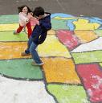 |  | - Choose 1 student to go to the map.  - Choose a location (state or country) and tell everyone in the class (except the student at the map).  - Write these movements on the board:  - East: knee lifts  - West: jumping jacks  - North: raise the roof  - South: squats  - The class uses these movements to direct the student to the location on the map.  - Repeat with new location and new student. | - When I tell you a location, you must try to direct the person to the location by using the exercises written on the board.  - You cannot talk.

Palm Beach County Physical Activity Lessons

Activity Name: Spelling Game
Target Objective: Motor skills, team work

Grades: 3-5 | Equipment: Chalk and white board |  |  | Location: Inside
Activity |  | What You Do | What You Say
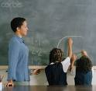 |  | - Divide students into 2-4 teams.  - Variation-hop on 2 feet, hands on head, hands on knees | - I will give one team a spelling word and you need to write big enough for your team to see it.  - You will stand in single file. The first student hops on one foot to the board and writes the first letter of the spelling word that I will give.  - You hop back and get to the end of the line. The next student hops to the board and writes the next letter and goes to the end of the line.  - Keep the letters in order and write neatly.  - When you are hopping to the board, be careful and use one foot only.  - The first team to spell the word gets a point.

Palm Beach County Physical Activity Lessons

Activity: SPUD
Target Objective: Spatial awareness and listening skills

Grades: 3-5 | Equipment: One playground ball |  |  | Location: Outside
Activity |  | What You Do | What You Say
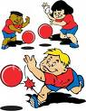 |  | - You can choose to have the students receive “a letter” in the word SPUD, or in a spelling word, if they are hit below the knees with the ball or if they are the player with the ball and their throw misses the other player.  - Remind the students to remember the letters that they have. | - You will stand in a circle with one person in the middle holding the ball.  - The person in the middle will throw the ball straight up in the air and call the number or name of another player.  - All of the other players run away from the ball.  - The called player catches the ball and yells “Spud!” and the other players must stop where they are.  - The player with the ball takes 3 giant steps and tries to roll the ball to hit the closest player’s feet.  - We will then repeat the game.  - Be sure to roll the ball so that it hits the player from the knees down.
Palm Beach County Physical Activity Lessons

Activity Name: Stop and Scribble
Target Objective: Endurance, spelling

Grades: 3-5 | Equipment: Piece of paper and pencil |  |  | Location: Inside
Activity |  | What You Do | What You Say
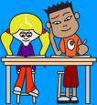 |  | - Call out a physical activity for the students to perform until you call out a spelling word.  - Students freeze and partners work together to try to spell the word correctly on a piece of paper.  - After 10-15 seconds, call out a new activity.  Examples:  Jumping jacks  Jogging  Hopping  Marching  Knee lifts  - Continue until all spelling words are used.  - As students cool down, write correct spelling on the board and students will check their work. | - When I call out an exercise you must complete it until I call out a spelling word.  - When I call out the spelling word, you must stop and try to spell on the paper with your partner.
Academic Modifications: Math problems can also be called out or written on the board.
Palm Beach County Physical Activity Lessons
Activity Name: Ten in a Row
Target Objective: Throwing and catching skills.

Grades: 3-5 | Equipment: Playground balls or any kind of balls for throwing and catching; cones or other markers |  |  | Location: Outside
Activity |  | What You Do | What You Say
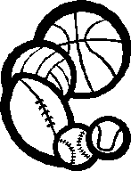 |  | - Divide students into two teams.  - If there is space, instead of one game, there can be two concurrent games. At intervals, change the pairings.  - Game areas should be marked with cones or markers.  - The types of passes can be varied: for example, only overhand, only underhand, etc. | - The object of the game is for teams to try to complete 10 passes in a row without the ball being dropped or intercepted.  - The player with the ball can take two steps before passing the ball.  - There is no contact with another player.  - A dropped or intercepted ball goes to the team who recovers or intercepts the ball.  - Count the passes out loud.

Palm Beach County Physical Activity Lessons

