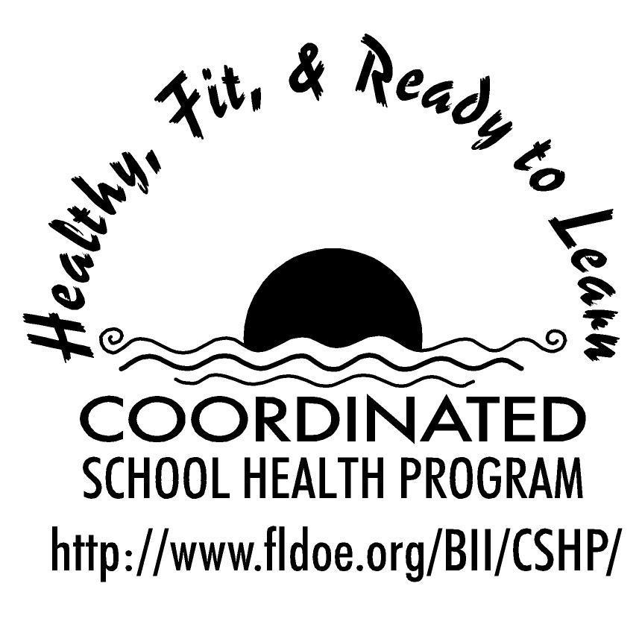

Wellness Wakeup Call

Welcome to the Wellness Wakeup Call! The intention of this initiative is to promote a healthy school environment by providing students with a daily healthy lifestyle message that can be read over the morning announcements each school day. There are 9 categories of health messages that can be used every month of the school year. There are many daily tips to choose from in each category.

The 9 categories are:

- Healthy Eating Tips
- Mental and Emotional Health
- Personal and Consumer Health
- Physical Activity
- Injury Prevention
- Nutrition Fun Facts
- Tobacco Prevention
- Alcohol and Other Drug Use
- Community and Environmental Health

How to use daily healthy lifestyle messages:

- Each day, start the message with: “Good morning, this is your Wellness Wakeup Call!”
- Read message for the day.
- End each message by saying: “Enjoy your day, the healthy way!”

Health messages, references, and additional healthy school tools are available at:
www.fldoe.org/BII/CSHP/h-pilot.asp

Wellness Wakeup Call
Month _____________

Nutrition Facts for Grades 6-12

- Each day, start the message with: “Good morning, this is your Wellness Wakeup Call!”
- Read message for the day.
- End each message by saying: “Enjoy your day, the healthy way!”

There are handy check-off boxes next to each tip, so you can keep track of which ones
you’ve used!

- An apple a day keeps the doctor away. Enjoy a crisp, medium-sized apple with the peel on for lots of nutrients and fiber and just 80 calories!

- Beans provide a unique combination of protein, fiber, vitamins, and minerals! Eat
more, and you’ll reduce your risk of heart disease and multiple types of cancer.

- Antioxidants are a key ingredient in many fruits, vegetables, and grains. They help preserve healthy cells in the body and may prevent chronic illnesses like cancer and heart disease.

- Fish contains beneficial omega-3 fatty acids that keep brain activity healthy. Keep your brain sharp by eating fish such as tuna, salmon, mackerel and sardines.

- Need a healthy breakfast option? Enjoy a bowl of oatmeal which has tons of
soluble fiber. Try making it with low-fat or skim milk!

- Did you know: You can live up to 8 weeks without food, but only a few days
without water? Water makes up about 60% of our bodies.

- Not all fats are created equal! Saturated fats raise cholesterol while unsaturated
fats can lower cholesterol. Fish, avocados, nuts, and olive oil contain some of these healthy unsaturated healthy fats.

- Vitamin C-rich foods help us fight off infection. A few great sources of vitamin C
include: oranges, tomatoes, broccoli, spinach, strawberries, potatoes, cabbage, and peppers!

- The daily recommended amount of fiber is 20-35 grams. On average, Americans
consume only about 16 grams. Boost up that fiber intake by adding fruits, vegetables, and whole grains into your daily diet!

- When you exercise, you sweat. When you sweat, you lose water. During exercise you need to drink an extra 4-6 ounces of water for every 15-20 minutes of activity.

- Vitamin E-rich foods may reduce the risk of heart disease and stroke. Great
sources of vitamin E include: nuts, seeds, whole grains, green leafy vegetables, and asparagus.

- Trans fats raise cholesterol levels and clog arteries to the heart and brain. Avoid
trans fats by staying away from products that list “partially hydrogenated oil” on the ingredient list.

- Did you know the normal American diet contains nearly two times the
recommended amount of protein? Thus, protein powders and shakes are often more useful for athletes than the average person.

- Vitamin A promotes normal vision and helps your eyes see naturally in the dark.
Great sources of vitamin A include: orange and dark green-colored vegetables and fruits, and milk!

- Grow strong bones! Get your daily calcium from dairy like low-fat or skim milk,
and yogurt and cheese. Calcium fortified orange juice, and broccoli are also great sources of calcium.

- The average American eats over 150 pounds of sugar each year! Don’t let those
food labels trick you! Watch out for sugar, high-fructose corn syrup, cane syrup, sucrose and dextrose.

- Here’s a tasty solution to improve your memory: blueberries, strawberries, dried
plums and fish enhance short-term memory!

- The major health problems in the US are often caused by a poor diet, high calorie intake, and not enough physical activity. These are three things we can prevent ourselves!

- A fast-food hamburger in 1957 contained one ounce of cooked meat, compared
with 6 ounces today. A theater serving of popcorn was 3 cups, compared with 16 cups today. Watch those portion sizes!

- Did you know that 1 cup of whole milk has almost as much saturated fat as a
single-patty cheeseburger? Reduce your saturated fat intake by choosing skim or 1% milk.

- Broccoli contains twice the amount of vitamin C of an orange. Support your
immune system by adding broccoli as a side to your meal!

- Did you know that one can of regular soda contains 10 teaspoons of sugar? If you drink 1 can of soda each day, that’s over 35 pounds of sugar a year!

- Two-thirds of Americans are overweight. The best way to lose weight is to reduce
the calories you eat and increase exercise. Experts suggest aiming for a weight loss goal of one to two pounds per week.

- Eating ice cream to cool off? No way! Ice cream feels cool, but it has tons of
calories - the units of heat - and can make your body warmer as it burns off that energy.

- Not all smoothies are healthy! One McDonald’s fruit smoothie has the same
amount of sugar as four Reese’s Peanut Butter Cups.

- It is easy to overeat when you are not paying attention. Eating while watching TV,
reading, or chatting can make you consume more food than you need.

- Do you know which fast food item has the most calories worldwide? A milkshake!

- Yogurt contains probiotics that fight harmful bacteria in your body and boost your immune system. It is also loaded with protein and calcium! Look for yogurt with the lowest amount of added sugar.

- All beans are good for you, but if you want to get all the benefits of eating beans
and improve brain function, choose black beans.

- Thinking about a new diet? Think again. Diets lead to short term results and that’s not what you want. The best thing you can do for a true weight control and improved health is to adopt lifestyle changes to include regular exercise and healthy eating.

- Good news! Chocolate does not cause acne. In fact, dark chocolate with no added sugar contains vitamins, minerals and antioxidants that help to reduce stress, level cholesterol, and stimulate brain function.

- Fact or fiction: Food cravings mean you have a nutrient deficiency. Fiction! Most
food cravings are caused by stress and emotions.

- There are many diets out there and different ones may work or not work for
different people. A diet that works for everyone is a balanced diet!

References for these tips cans be found at www.fldoe.org/BII/CSHP/h-pilot.asp

Wellness Wakeup Call
Month _____________

Healthy Eating Tips for Grades 6-12
- Each day, start the message with: “Good morning, this is your Wellness Wakeup Call!”
- Read message for the day.
- End each message by saying: “Enjoy your day, the healthy way!”

There are handy check-off boxes next to each tip, so you can keep track of which ones
you’ve used.

- Get your fiber fix! Fiber helps keep your digestive system healthy. To get more fiber into your diet, choose whole-grain foods like oatmeal, whole grain bread, or brown rice instead of white rice.

- The 3 B’s of healthy living: Be adventurous by trying new foods. Be flexible by balancing sweets with healthy foods. Be active by including physical activity every day.

- After sleeping through the night your body needs to be refueled. Eat breakfast to give your brain and muscles the energy needed to start the day.

- Give veggies a try! Eating more vegetables at lunch and dinner will help give your immune system the nutrients it needs, and decrease your risk of getting sick. The less time you spend being sick, the more time you can spend doing well in school and having fun!

- For many teens, dinner consists of eating on the run or snacking in front of the TV. You are more likely to get in healthy fruits and vegetables if you enjoy your dinner sitting down at the table.

- A tip to eat more veggies: Add some broccoli or spinach and ham to your eggs and you’ve got green eggs and ham!

- Fruit, fiber and your heart! Instead of drinking fruit juice, try to eat whole fruits to increase fiber intake for a healthy heart.

- For a healthy snack, eat ants on a log! Spread some peanut butter on the inside of celery sticks and add some raisins on top for a delicious, protein-packed treat.

- Want to feel more energetic during the day? Fuel your body with healthy foods like fruits and veggies, and don’t forget your protein!

- In order to concentrate at school, you have to feed your brain first! What are the food fuels needed by the brain? Fruits, vegetables and whole grains.

- Do you have trouble finishing your fresh fruit before it goes bad? Try keeping frozen fruit in your freezer and buying only enough fresh fruit for a few days at a time. Frozen fruits can have just as much nutritional value as fresh fruits, because they are processed at the peak of ripeness.

- Breakfast is the most important meal of the day! Breakfast helps to jump-start your metabolism in the morning, and gives your brain the energy it needs for the school day.

- A fast food fact: America spends more than $110 billion a year on fast food - this is more than the country spends on new cars or computers.

- Rethink your drinks. Soda is full of empty calories and sugar. This means that they add calories to your diet with few or no added nutrients. Water is the best way to stay hydrated and lean!

- Did you know that people who skip breakfast often feel more tired and cranky in the morning? On the other hand, those who eat breakfast tend to have more energy and a better attitude to start their day.

- Sandwiches are the most popular food prepared at home. To make a sandwich healthier, make sure to use whole grain bread, lean meats like turkey, chicken, or tuna, and lots of veggies like lettuce, cucumbers, tomatoes, and bell peppers.

- Are you nutty about nuts? Enjoying a handful of nuts is a great way to include Omega-3’s, which are healthy fats, into your day.

- Whether you buy lunch or pack your own, it should give you the nutrients you need. A lunch of chips, candy and soda will give you a lot of calories and not many nutrients. So make sure your lunch includes nutritious foods like whole grains, vegetables, and protein!

- Get in an extra serving of fruit at breakfast time by adding sliced apples or berries to your cereal, oatmeal, or yogurt!

- Can you name the five food groups? You are correct if you named grains, fruit, vegetables, dairy, and protein. For a balanced diet, choose foods from all five food groups.

- A healthy snack can give you the energy boost you need to get through the day. Try veggies with hummus, Greek yogurt, or a delicious piece of fruit.
- Eat the rainbow! Eat many different types of foods in order to get all the nutrients you need. An easy way to make sure you’re getting a variety of nutrients is to fill your plate with colorful vegetables.

- Breakfast tip: A simple way to make your oatmeal taste sweeter without adding sugar or sweeteners is by making it with skim milk instead of water!

- In place of fries or chips, choose a side salad, fruit, or a baked potato when eating out. Or share a side of fries with a friend.

- Steam fresh or frozen veggies in the microwave using a bowl with just a small amount of water for a quick, healthy addition to your meal.

- Portion control! Food portions at restaurants are often enough for more than one meal. Before digging in, put half of your meal in a to-go box to take home. You’ll have an extra meal for later, and help stretch your dollar!

- Snack only when you are hungry! Don’t mix the feeling of hunger with being bored, stressed or frustrated.

- To help make sure you get your servings of fruit in, have a visible reminder by keeping a bowl of whole fruit somewhere you will see it every day.

- Top your waffle with low-fat or fat-free yogurt and fruit slices instead of syrup for a healthier breakfast!

- Avoid starving yourself! Always carry a healthy snack like low fat string cheese, whole grain crackers, fruit, or granola bars.

- Make it a habit to taste your food before adding extra salt. To add flavor without using salt, use sodium-free spice blends, herbs, or lemon juice instead.

- “Fat-free” doesn’t always mean healthy. Manufacturers often add sugars in place of fat in fat-free products. Watch out for added sugars, because excess sugar can be converted to fat in your body.

- Choose baked or grilled food instead of fried when you're buying a meal. Stick with the same rule at home.

- Tips for eating at a buffet: Fill up on salads and vegetables first. Take no more than two trips and use a smaller plate that holds less food, if available.

- Pizza lover? Build yourself a healthy meal! Use a whole grain crust, smother it with tomato sauce, top that with part skim mozzarella cheese, add chicken, and pile it high with vegetables! You’ll be consuming a healthy variety of nearly every food group!

Wellness Wakeup Call

Month _____________

Physical Activity Tips for Grades 6-12
- Each day, start the message with: “Good morning, this is your Wellness Wakeup Call!”
- Read message for the day.
- End each message by saying: “Enjoy your day, the healthy way!”

There are handy check-off boxes next to each tip, so you can keep track of which ones
you’ve used.

- Did you know that less than 50% of Floridians get the required amount of
exercise? Change that stat! Get out there and move it!

- What may seem an easy solution is not always best. Anabolic steroids
have dangerous side effects that include: acne, disruption of the body’s hormone system, liver disease, and increased risk for heart disease and cancer.

- When performed regularly, stretching exercises help maintain or improve
the range of motion in your joints and help prevent injury. Remember, dynamic stretches should be done before exercise, with static stretches being done only after exercise.

- What is the best exercise? The one you enjoy! So go and run, jump, dance,
play, swim, bike, surf, lift, climb, or paddle your way to a more fit you!

- Exercise improves alertness and memory, so you can study better! It can also
improve your mood, reduce anxiety, and provide an outlet for anger or
aggression.

- Get your carbs! Carbohydrates supply energy for body cells, the brain, and
muscles. Some cells, such as the brain and blood cells only use carbohydrates for fuel.

- Exercise can save your life! It can help prevent heart disease, some types
of cancer, high blood pressure, type 2 diabetes, obesity and even osteoporosis.

- Did you know that weight-bearing physical activity such as lifting weights can help build strong, healthy bones?

- Be a team player! Physical activity and sports can improve your teamwork
skills!

- Take five! Warming up for five minutes before you exercise improves your
performance and decreases your chances of injury.

- Give yourself a break! If you've been injured, wait until you are completely
healed and have been cleared by your doctor before you start exercising again. This will decrease the risk of re-injuring yourself.

- Achieve the recommended national goal! Growing teens should be
physically active for 60 minutes on most days of the week. Don’t fret! If you’re not active for 60 minutes straight, it’s okay to exercise for 10 or 20 minutes at a time to reach your 60 minute goal!

- Nutrition and exercise go hand-in-hand! You need to exercise and
consume enough calories in order to build and repair muscles!

- Are you interested in pumping iron? Work with a physical fitness expert or
coach to learn how to lift weights properly.

- Right now, get up and stretch! But be mindful, stretch positions should be
held motionless because “bouncing” while stretching can cause injury.

- Remember, drinking water before, during, and after exercise is important
to enhance athletic performance and prevent dehydration.

- 4 Tips to begin a workout routine: 1. Set realistic goals, 2. Increase your
intensity and duration gradually, 3. Make your program fun, 4. Exercise with a buddy.

- Practice makes perfect! Practice allows your brain and body to work
together while improving your performance.

- It is important to wear appropriate equipment that fits properly while playing sports. Doing so will reduce your chances of injury.

- Did you know that sports drinks are only more beneficial than water when you
are exercising for more than 90 minutes or in really hot weather?

- Don’t ignore it! Pain is the body's way of signaling something is wrong. If
you have a lot of pain, stop exercising and seek advice from your doctor.

- Rules and regulations are put into practice to enforce fairness and
promote safety so that everyone can enjoy the game!

- It takes 12 weeks for your body to show measurable changes from
exercise. Don’t get discouraged and be consistent to get the results you want.

- Can’t get all your exercise in all at once? Don’t worry, you don’t need to!
Break it down to ten minutes in the morning, noon, and evening for the same benefit as 30 minutes all at once.

- Make it a habit to walk briskly. This way you will burn more calories and even
get some cardio workout benefits.

- Set realistic goals and don’t believe catchy weight loss articles you see in
magazines! In fact, it is recommended to aim for only one to two pounds of
weight loss a week.

- Too busy to go to the gym? Try some simple floor exercises instead! Aim
for 10-12 repetitions of each exercise.

- Working out when you’ve got the most energy will yield the best results.
Plan your exercise according to when you have the most energy during the day.

- A quick and easy tip to keep moving: take the stairs instead of an elevator
or an escalator whenever you can.

- A great way to increase your physical activity is to do stretches and other
exercises while watching TV!

- Create a list of workout music to make exercising even more enjoyable!

- Don’t like working out or tired of your workout routine? Try something new:
yoga, Pilates, or dancing are all great options to stay active and fit.

- Did you know that swimming is a great exercise for your entire body?
Doing laps can be fun if you do it with friends!

- Driving to school? Try parking your car at the far end of the parking lot so
you can walk a little more!

- Make physical activity your lifestyle. Try not to stay seated for more than 30
minutes. You can walk around even while talking on the phone.

- Download an app for your phone and track your workout progress. Stay
motivated and set realistic goals.

References for these tips cans be found at www.fldoe.org/BII/CSHP/h-pilot.asp

