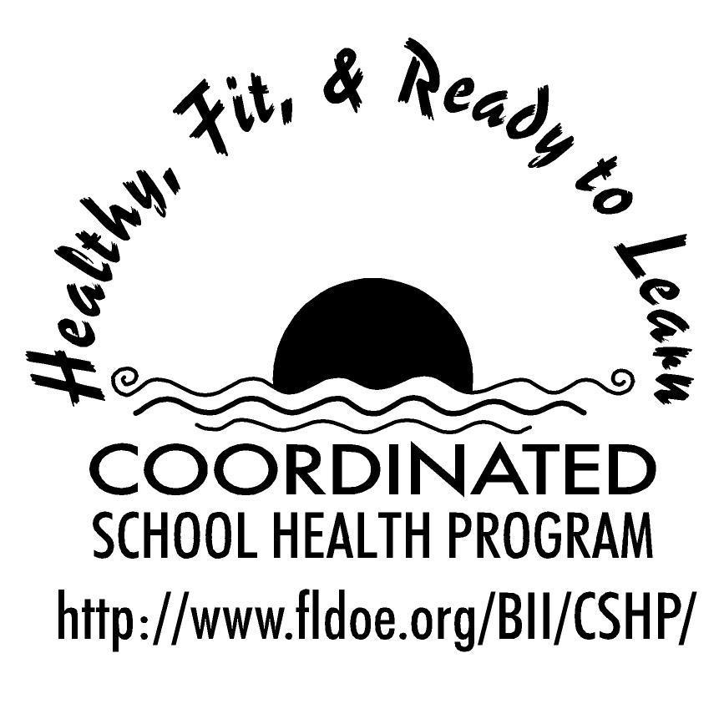

Wellness Wakeup Call

Welcome to the Wellness Wakeup Call! The intention of this initiative is to promote a healthy school environment by providing students with a daily healthy lifestyle message that can be read over the morning announcements each school day. There are 9 categories of health messages that can be used every month of the school year. There are many daily tips to choose from in each category.

The 9 categories are:

- Healthy Eating Tips
- Mental and Emotional Health
- Personal and Consumer Health
- Physical Activity
- Injury Prevention
- Nutrition Fun Facts
- Tobacco Prevention
- Alcohol and Other Drug Use
- Community and Environmental Health

How to use daily healthy lifestyle messages:

- Each day, start the message with: “Good morning, this is your Wellness Wakeup Call!”
- Read message for the day.
- End each message by saying: “Enjoy your day, the healthy way!”

Health messages, references, and additional healthy school tools are available at: www.fldoe.org/BII/CSHP/h-pilot.asp
Wellness Wakeup Call
Month _____________

Nutrition Facts for Grades K-5

- Each day, start the message with: “Good morning, this is your Wellness Wakeup Call!”
- Read message for the day.
- End each message by saying: “Enjoy your day, the healthy way!”

There are handy check-off boxes next to each tip, so you can keep track of which ones
you’ve used!

- An apple a day keeps the doctor away! Apples are packed with Vitamin C and
fiber to help keep you healthy.

- Beans, beans they’re good for your heart. Beans are high in fiber, which help to
keep your heart healthy and help your digestive system healthy, too!

- Antioxidant? What’s that? Antioxidants are found in fruits and vegetables and they help protect the cells in your body. When you eat dark-colored fruits like blueberries and blackberries, you can be sure that you’re getting lots of antioxidants!

- Did you know that eating fish can help your memory? Fish has fatty acids called
Omega-3’s, which help your brain!

- Need a healthy breakfast option? Enjoy a bowl of oatmeal which has tons of
soluble fiber. Try making it with low-fat or skim milk!

- Did you know: You can live up to 8 weeks without food, but only a few days
without water? Water makes up about 60% of our bodies.

- Many people think that fat is bad for us. Actually, certain types of fat, like those from nuts, avocado, and fish are actually good for our bodies!

- Vitamin C-rich foods help us fight off infection. Some great sources of vitamin C
include: oranges, tomatoes, broccoli, spinach, strawberries, potatoes, cabbage, and peppers!

- When you exercise, you sweat. When you sweat, you lose water. Make sure that
you are drinking plenty of water when you’re playing sports or even games like hide-and-go-seek to stay hydrated!
- Vitamin E is important for heart health and for your skin, too! Great sources of
vitamin E include: nuts, seeds, whole grains, green leafy vegetables, and asparagus.

- Did you know that Vitamin A can help your eyes see naturally in the dark?
Vitamin A can be found in veggies like carrots, and sweet potatoes!

- Grow strong bones! Get your daily recommended amount of calcium from dairy
like low-fat or skim milk, and yogurt and cheese.

- The average American eats over 150 pounds of sugar each year! Don’t let those
food labels trick you! Watch out for foods that list sugar, high-fructose corn syrup, cane syrup, sucrose or dextrose.

- Here’s a tasty solution to improve your memory: blueberries, strawberries, dried
plums and fish enhance short-term memory!

- The major health problems in the US are often caused by a poor diet, eating too
much, and not enough exercise. These are three things we can prevent ourselves!

- In 1957, a theater serving of popcorn was 3 cups. Today, it is about 16 cups! Watch those portion sizes!

- Did you know that 1 cup of whole milk has almost as much saturated fat, a fat
that can clog your arteries, as a single-patty cheeseburger? Low-fat or skim milk contains much less saturated fat and is better for you!

- Broccoli contains twice the amount of vitamin C of an orange. Help boost your
immune system by adding broccoli as a side to your meal!

- Did you know that one can of regular soda contains 10 teaspoons of sugar? If you drink 1 can of soda each day, that’s over 35 pounds of sugar a year!

- Did you know that temperature can affect your appetite? A person who is cold is
more likely to eat more food. Stay warm and don’t over eat!

- Not all smoothies are healthy! One McDonald’s fruit smoothie has the same
amount of sugar as four Reese’s Peanut Butter Cups.
- Fun fact: Spicy green chilies have about five times as much Vitamin C as an orange!

- It is easy to overeat when you are not paying attention. Eating while watching TV,
reading, or talking to your friends can make you eat more food than you actually need to.

- Can you guess what fast-food item has the most calories worldwide? A milkshake!

- Yogurt contains probiotics that fight harmful bacteria in your body and boost your immune system. It is also loaded with protein and calcium! Yogurt makes a great
breakfast, snack, or even dessert!

- All beans are good for you, but if you want to get all the benefits of eating beans
and improve brain function, choose black beans.

- Can you guess which fruit contains the most fiber? You might be surprised to know that it’s the pear! A medium pear has about 6 grams of fiber.

- People who eat meat and vegetables are known as omnivores, whereas those who eat only eat fish and vegetables are known as pescatarians. People who do not eat meat or fish are called vegetarians. Those who do not eat any animal products, including eggs, honey, or cheeses are called vegans.

- Fun fact: The minerals that our bodies need to work properly can even be found on the moon and on the planet Mars.

- Did you know? Blueberries are one of the only foods found in nature that are actually blue.

References for these tips cans be found at www.fldoe.org/BII/CSHP/h-pilot.asp

Wellness Wakeup Call
Month _____________

Healthy Eating Tips for Grades K-5
- Each day, start the message with: “Good morning, this is your Wellness Wakeup Call!”
- Read message for the day.
- End each message by saying: “Enjoy your day, the healthy way!”

There are handy check-off boxes next to each tip, so you can keep track of which ones
you’ve used!

- Breakfast is the most important meal of the day. Eat breakfast to give your brain and muscles the energy they need so you can learn and play the best you can today!

- A tip to eat more veggies in the morning: Have an adult help you add some broccoli or spinach and ham to your eggs and you’ve got green eggs and ham! A breakfast that even Dr. Seuss would approve of!

- Fiber helps keep your digestive system healthy, which will help keep your whole body healthy. You can get fiber by eating things like vegetables, whole wheat bread, and whole wheat pasta.

- Have you ever eaten ants on a log? Spread some peanut butter on the inside of celery sticks and add some raisins on top for a delicious, fun treat.

- The 3 B’s of healthy living: Be adventurous by trying new foods. Be flexible by balancing sweets with healthy foods. Be active by including physical activity every day.

- Try to eat foods like potato chips, candy bars or ice cream in small amounts only.

- Give veggies a try! Eating more vegetables at lunch and dinner will help give your immune system the nutrients it needs, and lower your risk of getting sick. The less time you spend being sick, the more time you can spend doing well in school and having fun!

- Instead of drinking fruit juice, try to eat whole or cut fruit so you can get more fiber in your diet for a healthy heart!

- Would you like to have more energy to play with your friends? Fuel your body with healthy foods like fruits and veggies, and don’t forget your protein!

- You will concentrate better if your stomach is full. What foods are best for your brain? Fruits, vegetables and whole grains.

- Instead of reaching for a popsicle, try frozen grapes for a healthy, refreshing treat!

- Rethink your drinks. Try to drink less sodas and more water, to make sure you are staying hydrated the super hero way!

- Are you sometimes cranky in the morning? Eating a healthy breakfast can help put you in a better mood and get you ready for the day!

- Did you know that sandwiches are the most popular food made at home? To make a sandwich healthier, make sure to use whole grain or whole wheat bread!

- Are you nutty about nuts? Eating a handful of nuts is a great way to get healthy fat into your diet!

- What do you think super heroes eat for lunch? Probably whole grains and lots of veggies to help their bodies in tip-top shape!

- Make your breakfast fun by adding fruit to your cereal in the shape of a smiley face!

- Can you name the five food groups? You are correct if you named grains, fruit, vegetables, dairy, and protein. For a balanced diet, choose foods from all five food groups.

- You can make your own trail mix by mixing your favorite nuts, dried fruit, and granola or whole grain cereal for a snack that will give you lots of energy!

- A healthy snack can give you the energy boost you need to get through the day. Try veggies with hummus, yogurt, or a delicious piece of fruit.

- Eat the rainbow! An easy way to make sure you’re getting different nutrients is to fill your plate with colorful vegetables.

- Instead of eating ice cream, you can fill a small ice cream cone with low-fat yogurt and fresh fruit for a healthy, delicious dessert!

- Try not to get confused between being hungry and being bored. Snack only when you are hungry!

- When getting a kid’s meal at a restaurant, try to choose vegetables or fruit instead of fries, for extra nutrients to help you grow big and strong!

- Top your waffle with low-fat or fat-free yogurt and fruit slices instead of syrup for a healthier breakfast!

- Avoid starving yourself! Try to pack a healthy snack like low fat string cheese, whole grain crackers, fruit, or granola bars in your backpack.

- Make it a rule to try a new fruit or veggie each day!

- Ask an adult to help you make a healthier banana split by topping half a banana with frozen yogurt and your favorite whole-grain cereal or granola!

- Choose baked or grilled food instead of fried when you’re eating at a restaurant. Stick with the same rule at home.

- You can make a lean, green smoothie by blending spinach with your favorite fruit! You won’t even taste it!

- Have you ever tried dipping apple slices into peanut butter? You’ll get plenty of vitamins from the apple and protein from the peanut butter!

- Tips for eating at a buffet: Fill up on salads and vegetables first. Take no more than two trips and use a smaller plate that holds less food.

- Make your own mini pizza by putting tomato sauce and low-fat cheese on a whole wheat English muffin!

- If you feel like eating sweets, try eating some fruit to satisfy your sweet tooth!

- Have you ever eaten too much and felt uncomfortable afterwards? Try to eat slowly, chewing your food thoroughly and only eat until you’re full.

References for these tips cans be found at www.fldoe.org/BII/CSHP/h-pilot.asp
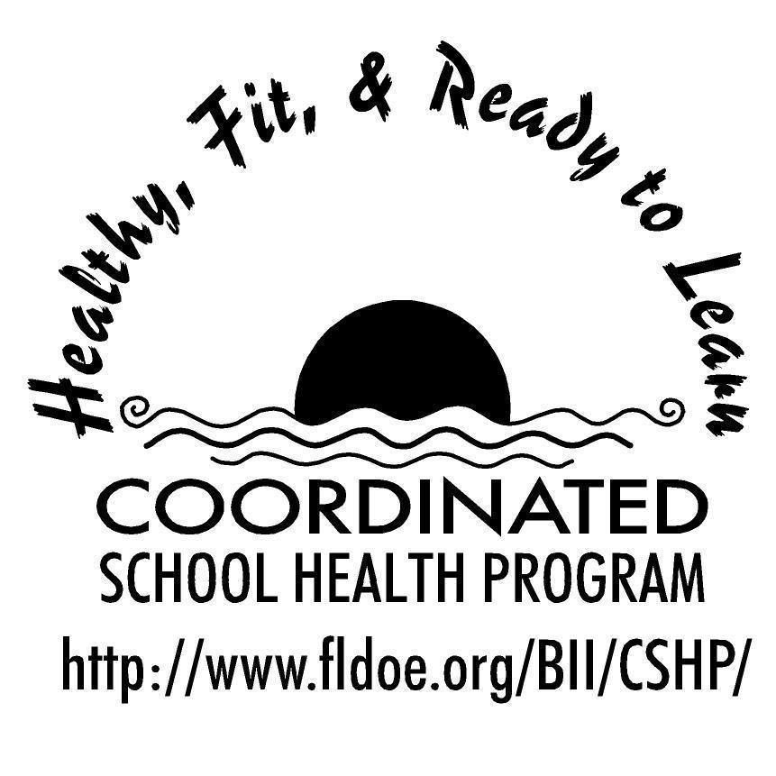
Wellness Wakeup Call

Month _____________

Physical Activity Facts & Tips for Grades K-5
- Each day, start the message with: “Good morning, this is your Wellness Wakeup Call!”
- Read message for the day.
- End each message by saying: “Enjoy your day, the healthy way!”

There are handy check-off boxes next to each tip, so you can keep track of which ones
you’ve used.

- Did you know that less than 50% of Floridians get the recommended amount of exercise? Change that stat! Get out there and move it!

- Stretching can help you stay flexible and help prevent you from getting injured. But did you know that one of the best times to stretch is actually after you exercise?

- What is the best exercise? One you enjoy! So go and run, jump, dance,
play, swim, bike, surf, lift, climb, or paddle your way to a healthier body!

- Did you know that exercise can make you happier? Exercise releases chemicals in your brain called endorphins, which help you stay happy!

- Eating well is just as important as exercise. A healthy diet and regular exercise will help you study better and grow stronger!

- Exercise can save your life! It helps keep your heart healthy and can prevent many types of diseases.

- Did you know that some types of exercise, like jumping, can actually help you build stronger bones?

- Be a team player! Physical activity and sports can help you make friends and have a better relationship with your friends!

- Take five! Warming up for five minutes before you exercise can help you play better in sports and lowers your chances of injury.

- Give yourself a break! If you've been injured, wait until you are completely
healed and your doctor or parent says it’s okay before you start exercising again.

- Try to reach the goal! Growing kids should be physically active for 60 minutes on most days of the week. Don’t worry, if you’re not active for 60 minutes straight, it’s okay to exercise for 10 or 20 minutes at a time to reach your 60 minute goal!

- Try to stretch each time you get up from your desk. Stretching can help wake you up when you’ve been sitting still for too long.

- Remember, drinking water before, during, and after exercise is important
for your health.

- Practice makes perfect in sports, and in life! Don’t get discouraged and keep trying even when you’re frustrated. You will find yourself improving if you keep trying.

- It is important to wear a helmet when you’re riding a bike, scooter, skateboarding, or rollerblading. This helps to protect your head in case of an accident.

- Fun fact: Sports drinks are only more beneficial than water when you are exercising for more than 90 minutes or exercising in really hot weather.

- Sports and games have rules to make things fair and safe for all players. Try to always follow the rules so that everyone can enjoy the game!

- Exercising throughout the day helps you stay fit! Get moving for just ten minutes in the morning, afternoon, and evening and you will feel yourself growing stronger.

- Did you know that there are exercises you can do without equipment? Try jumping jacks, pushups, or even sit-ups.

- A quick and easy tip to keep moving: take the stairs instead of an elevator or an escalator whenever you can.

- A great way to increase your physical activity while watching TV is to do stretches and exercises like running in place.

- Did you know that swimming is a great exercise for your entire body? Doing laps can be fun if you do it with friends!

- Moderate physical activities are ones that will make you breathe harder and your heart beat faster. You should be able to talk while doing moderate activities, but not sing. Some moderate activities are walking quickly, biking, skating, and skateboarding.

- A fun and easy way to get more exercise in during the day is by simply walking the dog!

- Ask your parents if they need help around the house or with washing their car. Doing chores is a great way to stay active.

- Staying healthy and full of energy requires a good night‘s sleep! Make sure you get 8 to 9 hours of sleep every night.

- Feeling too tired to exercise? Did you know that exercising actually gives you more energy and makes you feel happier?

- Don’t exercise on an empty stomach! Food acts as fuel to your body and helps you feel stronger and perform better.

- Try to play outside whenever it is safe and it is okay with an adult. Being outside in the sunshine helps your body get Vitamin D, which helps you stay healthy and helps your bones grow strong!

- Did you know that your heart is a muscle? Aerobic exercises, like running, help keep your heart happy!

- Playing fun games with your friends like hide-and-go-seek, tag, and red-light/green-light count as physical activity too! Exercise doesn’t have to be boring!

- Remember that you need to drink more water when you’re playing outside on a hot day. Becoming dehydrated can make you feel sick, and is no fun!

- Do you want to grow strong muscles? Any kind of physical activity, even playing with your friends helps you grow muscles. Why? Because you’re using your muscles to do it!

References for these tips cans be found at www.fldoe.org/BII/CSHP/h-pilot.asp

