FLORIDA DEPARTMENT OF EDUCATION

2021-2022 Request for Application (RFA Discretionary)

TAPS #22B002

Bureau/Office
Division of Career, Technical, and Adult Education, Farmworker Career Development Office

Program Name
Migrant and Seasonal Farmworkers (MSFW) Program, Workforce Innovation and Opportunity Act (WIOA), Title I, Section 167/Statewide Emergency Assistance

Specific Funding Authority(ies)
Workforce Innovation and Opportunity Act of 2014, Title I, Section 167 (National Farmworker Jobs Program), Migrant and Seasonal Farmworkers) CFDA # 17.264

Funding Purpose/Priorities
To implement and manage a statewide Emergency Assistance Service System throughout the state which strengthens the ability of eligible farmworkers and their families to achieve economic self-sufficiency (Refer to Attachment A).

Funding Priorities
Agencies with experience in providing statewide Emergency Assistance to National Farmworker Jobs Program eligible participants within stated budgetary guidelines in an expedient and effective manner will receive funding priority.

Type of Award
Discretionary Non-Competitive

Program Performance Period
July 1, 2021 to September 30, 2022

Budget Period
July 1, 2021 to September 30, 2022

Total Funding Amount/Approximate Number of Awards
$50,000 (Allocation is contingent on Florida’s 2021 Federal Award)

Note:
  - The Florida Department of Education (FDOE) is conducting this grant allocation before the passage of the United States Department of Labor’s (USDOL) Fiscal Year (FY) 2021-22 appropriation in anticipation of the appropriation of funds for Program Year (PY) 2021-22 Farmworker Career Development Program grants. FDOE will not obligate any funds for PY 2021-22 grants unless and until they are appropriated and Florida Department of Education has received its federal award notification from USDOL. Therefore, the award of funds under this grant is contingent upon the enactment of a PY 2021-22 appropriation for the Workforce Innovation and Opportunity Act.
- Statewide emergency assistance recipients must provide services in non-contiguous counties.
- The allocation posted in the Request for Application is subject to change, based on Florida’s federal award notification.
- The Commissioner may recommend an amount greater or less than the amount requested in the application

Target Population(s)
Eligible Migrant and Seasonal Farmworkers, as outlined in Title I, Section 167 of the Workforce Innovation and Opportunity Act (Refer to Attachment C)

Eligible Applicant(s)
Agriculture and Labor Program, Inc. as indicated on the Allocation Chart (Attachment B).

Requirement for Eligible Applicants
Applicant must have an understanding of the problems of eligible migrant and seasonal farmworkers, including their dependents. The Applicant must have a familiarity with the geographic area to be served and demonstrate the capacity to effectively administer emergency assistance to the target population in support of workforce investment activities and related assistance, as stated in the Workforce Innovation and Opportunity Act, Title I, Section 167(b).

The awarded agency will be required to implement and manage an Emergency Assistance services system that supports all Farmworker Career Development Program providers throughout the state.

Application Due Date
June 25, 2021

For Federal programs, the project effective date will be the date that the application is received within the Office of Grants Management meeting conditions for acceptance, or the budget period specified in the Federal Award Notification, whichever is later.

Where to submit the Grant Application
Grant Applications must be submitted electronically to the Office of Grants Management cloud-based ShareFile system.

Matching Requirement
None

Contact Persons
Program Office Contact Grants Management Contact
James Haugli Paula Starling
813-224-1920 850-245-0711
James.Haugli@fldoe.org Paula.Starling@fldoe.org

Assurances
The Florida Department of Education (FDOE) has developed and implemented a document entitled General Terms, Assurances and Conditions for Participation in Federal and State Programs to comply with:

2 C.F.R. 200, Uniform Grant Guidance (UGG) requiring agencies to submit a common assurance for participation in federal programs funded by the United States Education Department (USED); Applicable regulations of other Federal agencies; and State regulations and laws pertaining to the expenditure of state funds

In order to receive funding, applicants must have on file with the Florida Department of Education, Office of the Comptroller, a signed statement by the agency head certifying applicant adherence to these General Assurances for Participation in State and Federal Programs. The complete text may be found in Section D of the Green Book.

Private Colleges, Community-Based Organizations and Other Agencies
In order to complete requirements for funding, applicants of this type must certify adherence to the General Assurances for Participation in State and Federal Programs by submitting the certification of adherence page, signed by the agency head with each application.

Note: The UGG combines and codifies the requirements of eight Office of Management and Budget (OMB) Circulars: A-89, A-102 (former 34 CFR part 80), A-110 (former 34 CFR part 74), A-21, A-87, A-122, A-133, A-50. For the FDOE this means that the requirements in EDGAR Parts 74 and 80 have also been subsumed under the UGG. The final rule implementing the UGG was published in the Federal Register on December 19, 2014, and became effective for new and continuation awards issued on or after December 26, 2014.

Technical assistance documents and other materials related to the UGG, including frequently asked questions and webinar recordings, are available at The Chief Financial Officers Council web site: https://cfo.gov/cofar.

Risk Analysis
Every agency must complete a Risk Analysis form. The appropriate DOE 610 or DOE 620 form will be required prior to a project award being issued. The Risk Analysis must be submitted with the application. If an agency is submitting applications for multiple programs, only one Risk Analysis is required.

Governmental and Non-Governmental Entities must use the DOE 620 form. The DOE 620 form is required to be submitted each state fiscal year (July 1-June 30) prior to a Project Award being issued for that agency. An amendment is required if significant changes in circumstances in the management and operation of the agency occurs during the state fiscal year after the form has been submitted. The appropriate Risk Analysis form may be found at http://www.fldoe.org/core/fileparse.php/5625/urlt/doe620.xls

Non-public entities are required to take the Grants Fiscal Management Training and Assessment annually. The agency head and/or the agency’s financial manager (CFO) must complete this training within 60 days of the date of execution (Block 12) on the DOE 200, Project Award Notification. Training and assessment can be found using the following link:
https://web01.fldoe.org/TrainingAssessment/SignOn/Home.aspx

Non-participation in the training program may result in termination of payment(s) until training is completed.

Funding Method

Federal Cash Advance (Public Entities only as authorized by the FDOE)
Federal cash advances will be made by state warrant or electronic funds transfer (EFT) to a recipient or subrecipient for disbursements. For federally-funded programs, requests for federal cash advance must be made through FDOE’s Florida Grants System (FLAGS). Supporting documentation for expenditures should be kept on file at the program. Examples of such documentation include, but are not limited to, payroll records, contracts, invoices with check numbers verifying payment and/or bank statements – all or any of these items must be available upon request.

Fiscal Records Requirements and Documentation
Applicants must complete a Budget Narrative form, DOE101S. Budget pages must be completed to provide sufficient information to enable FDOE reviewers to understand the nature and reason for the line item cost.

All accounts, records, and other supporting documentation pertaining to costs incurred shall be maintained by the recipient for five years. Supporting documentation for expenditures is required for all funding methods. Examples of such documentation include but are not limited to: invoices with check numbers verifying payment, and/or bank statements; time and effort logs for staff, salary/benefits schedules for staff. All must be available upon request.

Funded programs and any amendments are subject to the procedures outlined in the FDOE Project Application and Amendment Procedures for Federal and State Programs (Green Book) and the General Assurances for Participation in Federal and State Programs, which may be found at:
http://www.fldoe.org/finance/contracts-grants-procurement/grants-management/project-application-amendment-procedur.stml.

Budgeted items must correlate with the narrative portion of the project application that describes the specific activities, tasks and deliverables to be implemented.

All project recipients must submit a completed DOE 599 form, Final Project Disbursement Report by the dates specified on the DOE 200 form, Project Award Notification.

Financial Consequences
FDOE shall periodically review the progress made on the activities and performance measures approved in this grant application. If the eligible provider fails to meet and comply with the performance measures established in the grant application or make appropriate progress on the performance measures, FDOE may approve a reduced payment or request the eligible provider terminate the grant application agreement.

Failure to meet the performance measures may result in additional performance reporting, submission of a program improvement plan, participation in training, and/or decrease in payment commensurate to an applicable amount approved by FDOE. The contract manager must assess one or more of these consequences based on the severity of the failure to perform and the impact of such failure on the ability of the contractor to meet the timely and desired results. These financial consequences shall not be considered penalties.

Allowable Expenses
Program funds must be used solely for activities that directly support the accomplishment of the program purpose, priorities and expected outcomes during the program period. All expenditures must be consistent with the approved application, as well as applicable state and federal laws, regulations and guidance.

Unallowable Expenses
- Project funds may not be used to supplant existing programs and/or funding.
- Costs for items/services already covered by indirect costs allocation
- Costs not allowable for federal programs per the U.S. Education Department General Administrative Regulations (EDGAR), which may be found at www.ed.gov/policy/fund/reg/edgarReg/edgar.html and the Reference Guide for State Expenditures, which may be found at www.myfloridacfo.com/aadir/reference_guide/.
- Expenditure of funds for purposes other than to directly provide emergency assistance to eligible participants must not exceed 48% of the overall allocation for this grant

Note: This is not an all-inclusive list of unallowable items. Subrecipients are expected to consult the State Office with questions regarding allowable costs.

Equipment Purchases
Any equipment purchased under this program must follow the Uniform Grants Guidance found at http://www.ecfr.gov/cgi-bin/text-idx?tpl=/ecfrbrowse/Title02/2cfr200_main_02.tpl or the Reference Guide for State Expenditures, www.myfloridacfo.com/aadir/reference_guide/.

Any equipment purchases not listed on the original budget approved by the FDOE require an amendment submission and approval prior to purchase by the agency awarded the funding.

Further guidance and instruction on property records, inventory and disposition requirements for property are outlined in the Green Book at:
http://www.fldoe.org/finance/contracts-grants-procurement/grants-management/project-application-amendment-procedur.stml.

Division of Career, Technical, and Adult Education Requirement
To ensure that Florida adequately monitors equipment purchased with federal funds applicants must record ALL equipment with a unit cost of $500 or more on the DOE 101S Budget Narrative Form and on the Projected Equipment Purchases Form (applicant may use this form or another format that contains the information appearing on this form).

All additional equipment purchases with a unit cost of $500 or more not listed on the original budget by the FDOE require an amendment submission and approval by the Florida Department of Education prior to purchase by the agency awarded the funding.

Amendment Procedures
Project amendments may be proposed by the project recipient or by the FCDP State Director. Program and budget amendments to approved project applications for all programs shall be prepared by project recipients on the project amendment request form (DOE 150) and the amendment narrative form (DOE 151) available in the Green Book and on the Division of Career and Adult Education Grants website at: http://www.fldoe.org/academics/career-adult-edu/funding-opportunities/index.stml.

A subrecipient may not begin to expend or obligate federal funds under a project amendment until the latter of the following two dates: (1) the date the Department receives the amendment in substantially approvable form or (2) the date approved by the Department Program Manager.
Program office policy regarding project amendments must be followed including the submission of Projected Equipment Purchases form and revised PY 2021 Staffing Breakout Form (Attachment E) with project amendments if amended object codes impact equipment or personnel related funds on the original approved budget.

Intellectual Property
The awarded agency is subject to following additional provisions:

A. Anything by whatsoever designation it may be known, that is produced by, or developed in connection with, this Grant/Contract shall become the exclusive property of the State of Florida and may be copyrighted, patented, or otherwise restricted as provided by Florida or federal law. Neither the Grantee/Contractor nor any individual employed under this Grant/Contract shall have any proprietary interest in the product.

B. With respect to each Deliverable that constitutes a work of authorship within the subject matter and scope of U.S. Copyright Law, 17 U.S.C. Sections 102-105, such work shall be a "work for hire" as defined in 17 U.S.C. Section 101 and all copyrights subsisting in such work for hire shall be owned exclusively by the Department pursuant to s. 1006.39, F.S., on behalf of the State of Florida.

C. In the event it is determined as a matter of law that any such work is not a "work for hire," grantee shall immediately assign to the Department all copyrights subsisting therein for the consideration set forth in the Grant/Contract and with no additional compensation.

D. The foregoing shall not apply to any pre-existing software, or other work of authorship used by Grantee/Contractor, to create a Deliverable but which exists as a work independent of the Deliverable, unless the pre-existing software or work was developed by Grantee pursuant to a previous Contract/Grant with the Department or a purchase by the Department under a State Term Contract.

E. The Department shall have full and complete ownership of all software developed pursuant to the Grant/Contract including without limitation:
1. The written source code;
2. The source code files;
3. The executable code;
4. The executable code files;
5. The data dictionary;
6. The data flow diagram;
7. The work flow diagram;
8. The entity relationship diagram; and
9. All other documentation needed to enable the Department to support, recreate, revise, repair, or otherwise make use of the software.

Administrative Costs including Indirect Costs
Chapter 1010.06 F.S. Indirect cost limitation.—State funds appropriated by the Legislature to the Division of Public Schools within the Department of Education may not be used to pay indirect costs to a university, Florida College System institution, school district, or any other entity.

Agencies interested in pursuing the Special Rules should access the required form on the Division of Career and Adult Education’s website: http://www.fldoe.org/academics/career-adult-edu/funding-opportunities.

Positions such as project coordinator, accountant, clerical staff, or other positions not directly involved in instructional activities of students are considered administrative. Travel, equipment, and supplies for administrators are also considered administrative costs unless used for the purpose of providing personnel development directly related to assisting eligible Migrant and Seasonal Farmworkers or their dependents.

State of Florida, Executive Order 11-116
The employment of unauthorized aliens by any contractor is considered a violation of section 274A(e) of the Immigration and Nationality Act. If the contractor knowingly employs unauthorized aliens, such violation shall be cause for unilateral cancellation of the contract. In addition, pursuant to Executive Order 11-116, for all contracts providing goods or services to the state in excess of nominal value; (a) the Contractor will utilize the E-verify system established by the U.S. Department of Homeland Security to verify the employment eligibility of all new employees hired by the contractor during the Contract term, (b) require that Contractors include in such subcontracts the requirement that subcontractors performing work or providing services pursuant to the state contract utilize the E-Verify system to verify the employment eligibility of all new employees hired by the subcontractor during the contract term. Executive Order 11-116 may be viewed at http://www.flgov.com/wp-content/uploads/orders/2011/11-116-suspend.pdf.

State of Florida, Executive Order 20-44
In accordance with Executive Order 20-44, each grantee meeting the following criteria: 1) all entities named in statute with which the agency must form a sole source, public private agreement and 2) all entities that, through contract or other agreement with the State, annually receive 50% or more of their budget from the State or from a combination of State and Federal funds shall provide to the department an annual report in the format required by the department. This report shall detail the total compensation for the entities’ executive leadership teams. Total compensation shall include salary, bonuses, cashed in leave, cash equivalents, severance pay, retirement benefits, deferred compensation, real-property gifts, and any other payout. In addition, the grantee shall submit with the annual report the most recent Return of Organization Exempt from Income Tax, Form 990, if applicable, or shall indicate that the grantee is not required to file such Form 990. This report shall be submitted by March 1 of each year. Executive Order 20-44 may be obtained via this link:
https://www.flgov.com/wp-content/uploads/orders/2020/EO_20-44.pdf

Access and Equity
The recipient will comply with all federal statutes relating to nondiscrimination. (These include but are not limited to Title VI of the Civil Rights Act of 1964 [P.L. 88-352], which prohibits discrimination on the basis of race, color, or national origin; Title IX of the Education Amendments of 1972, as amended [20 U.S.C. 1681-1683 and 1685-1686], which prohibits discrimination on the basis of sex; Section 504 of the Rehabilitation Act of 1973, as amended [29 U.S.C. 794], which prohibits discrimination on the basis of handicaps; the Age Discrimination Act of 1975, as amended [42 U.S.C. 6101-6107], which prohibits discrimination on the basis of age; Title II of the Genetic Information Nondiscrimination Act (GINA) of 2008 [P.L. 110-233], 29 CFR 635.10 (c)(1), which prohibits the use of genetic information in making employment decisions, restricts employers and other entities covered by Title II (employment agencies, labor organizations and joint labor-management training and apprenticeship programs - referred to as "covered entities") from requesting, requiring or purchasing genetic information, and strictly limits the disclosure of genetic information.)

National Farmworker Jobs Program Federal Regulations
For complete information regarding NFJP Regulations access the following link: https://www.govinfo.gov/content/pkg/CFR-2018-title20-vol4/xml/CFR-2018-title20-vol4-part685.xml

APPLICATION NARRATIVE SECTION

Instructions for Completing the Narrative Information
Following the instructions within each narrative component, complete the application using the same sequence presented in this narrative section.

- Before inserting any text or information into the Application Narrative Section, forms and charts, save the pages/charts/forms in Word on your computer.

- Use size 12-point font.
- Responses should be brief, clear and concise.
- All required forms have signatures by an authorized entity. The department will accept electronic signatures from the agency head in accordance with section 668.50(2)(h), Florida Statutes.
- An “electronic signature” means an electronic sound, symbol, or process attached to or logically associated with a record and executed or adopted by the person with the intent to sign the record.
- The department will accept as an electronic signature a scanned or PDF copy of a hardcopy signature.
- The department will also accept a typed signature, if the individual signing the document uploads the document.

- Submit the application through the Office of Grant Management ShareFile system with agency head signatures. See Attachment O for instructions.
- Place all application items in the order specified in the Application Checklist (Refer to the last page of this RFA document).

- NARRATIVE SECTIONS (1-8): MAXIMUM PAGE LIMIT IS THIRTY (30) PAGES
This does not include any required forms and/or other specified information.

Narrative Section response format:
a) Font - Arial / Size – 12
b) Margin size - 1” – both sides and top/bottom margins
c) Double spaced (this does not include charts)
d) Single-sided pages
e) Complete the narrative using the same sequence presented in the
Scope of Work/Narrative Components Section.

- Grant Application must be submitted electronically to the Office of Grants Management in the established Department Grants Management ShareFile.

Scope or Work/Narrative

1. Project Abstract or Summary
Provide a brief summary of the proposed project including:
- General purpose
- Specific goals
- Brief program design
- Significance for providing emergency assistance to eligible Farmworker and their families throughout the state.

2. Project Need
Describe the need for the proposed project and provide supporting data as evidence relative to local factors and conditions that may affect a farmworker and his/her family’s ability to achieve economic self-sufficiency, socio-economic and educational barriers.
- Geographic service areas
- Socio-economic needs and problems
- Magnitude or severity of the problem is evident, compelling, and clearly linked to the outcome(s) of the proposed project
- Evident that the proposed project is focused on those with greatest needs
- Gaps or weaknesses in services are explained

3. Project Design and Implementation
a. Objectives and Timelines
Describe the measurable objectives and activities for the proposed project
  - The goals
  - The objectives outcomes of the proposed project
  - The design of the proposed project aligns with, and will successfully address
  - The needs of the target population
  - Other identified needs

b. Assessing Participant Need for Emergency Assistance
Describe the methodology and criteria to be used for:
- Assessing FCDP participant eligibility and
- Need for emergency assistance and the
- Procedures used to develop support for eligible participants.

c. Emergency Assistance Services
Explain the types of emergency assistance services to be provided that will help farmworkers and their families overcome socio-economic and educational barriers and promote self-sufficiency. Include the strategies that will be used to stabilize participants and ensure that all program requirements are met to include either working through a local FCDP provider to provide these services, or where necessary, directly with an eligible participant.

d. Evidence of Capability
Provide evidence of capability to operate WIOA Title I, Section 167, programs. Explain past experiences, successes, and obstacles with the target population and provide supportive data that covers three years of operations for the time period of July 1, 2019, through March 31, 2021.

4. Evaluation
Describe the instruments and method(s) for on-going evaluation of the proposed project. The applicant’s internal evaluation should go beyond the evaluation that is conducted by the Florida Department of Education. It should be comprehensive and include an approach that leads to necessary adjustments that will result in successful outcomes.

Elements for conducting an internal evaluation can include data collection or management tools; reports generated by the Florida Department of Education; monthly activity reports; review of staffing requirements; regularly scheduled staff meetings; and monthly expenditure reports.

Note: In addition to completing this narrative Evaluation section the applicant must complete and submit the Self-Evaluation Form located in the Attachments section. The form is not included in the maximum narrative page count.

5. For Federal Programs - General Education Provisions Act (GEPA)
Provide a one-page concise description of the process to ensure equitable access to, and participation of students, teachers, and other program beneficiaries with special needs. For details refer to URL: http://www.ed.gov/fund/grant/apply/appforms/gepa427.pdf

The GEPA one-page response is not included in the maximum page count for the Narrative Section.

6. Support for Strategic Plan
Describe how the project will incorporate one or more of the Goals included in the State Board of Education’s K-20 Strategic Plan. URL: http://www.fldoe.org/policy/state-board-of-edu/strategic-plan.stml.

7. Dissemination Plan
Describe the methods / strategies to disseminate and share information about FCDP emergency assistance to appropriate populations (migrant and seasonal farmworkers and collaborating agencies). Information should include services to be offered, where and when services can be obtained, and information on eligibility for receipt of services. Dissemination of information should incorporate proactive outreach and recruitment efforts, such as the agriculture community, day labor and health care organizations serving farmworkers and their families, home and school visits, attendance at interagency meetings, the use of radio, television, the internet, and social and print media.

8. Budget
The Budget Narrative Component is in addition to completing the DOE 101S, Budget Narrative Form.
Present a budget that reflects objectives and proposed costs of the project. Demonstrate how project funds
will be used in a cost-effective and cost-efficient manner, alone or in combination with other resources
and that planned expenditures are realistic, reasonable, and support project activities and objectives.

Describe any in-kind contributions that will be made by the applicant and assign a monetary value to the
contributions.

Budget must reflect that at least 52% of the overall allocation has been targeted for the purpose
of directly providing emergency assistance to eligible FCDP participants.
Budget Narrative Form, DOE 101S
When completing the Budget Narrative Form, DOE 101S, under Column (3), Account Title and Narrative, for each line item specify the budgetary expenditures such as salaries, equipment and supplies. Expenditures should focus on performance improvement, as noted in the application.

All FCDP applicants must use the Budget Narrative DOE 101S budget form. All FCDP applications must also include a separate Budget Narrative Form, DOE 101S, for each participating fiscal partner.

Required Forms:
Please visit our Division’s website at http://www.fldoe.org/academics/career-adult-edu/funding-opportunities/index.stml, to access all forms.

The DOE 101S, Budget Narrative Form, is not included in the maximum page count for the Narrative Components section.

2. The DOE 599, Project Disbursement Form, must be submitted with the application, and is not included in the maximum page count for the Narrative Components section.

3. Attachment H, Staffing Breakout Form must be submitted with the application and is not included in the maximum page count for the Narrative Components section. A job position and salary schedule for each staff member must be included.

The totals on all of these forms: DOE 101S, 599 and Attachment E, must match as shown in the example forms below.

DOE 101S, Budget Narrative Form must include an explanation of why the expenditures are necessary as shown in the example 101S Form.

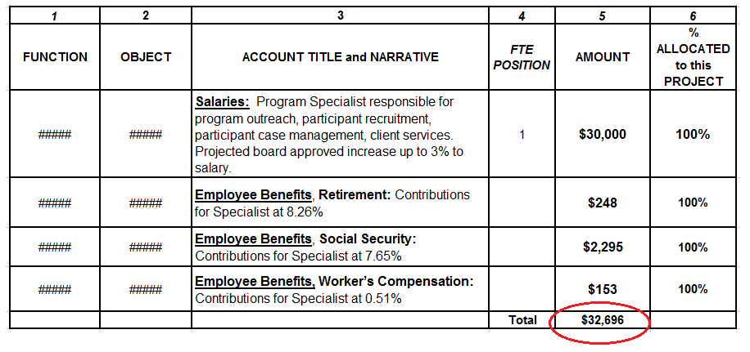
Attachment E, Staffing Breakout Form must list each staff member’s salary and benefits. The totals of each must be equal to the amounts given in the DOE 101S.

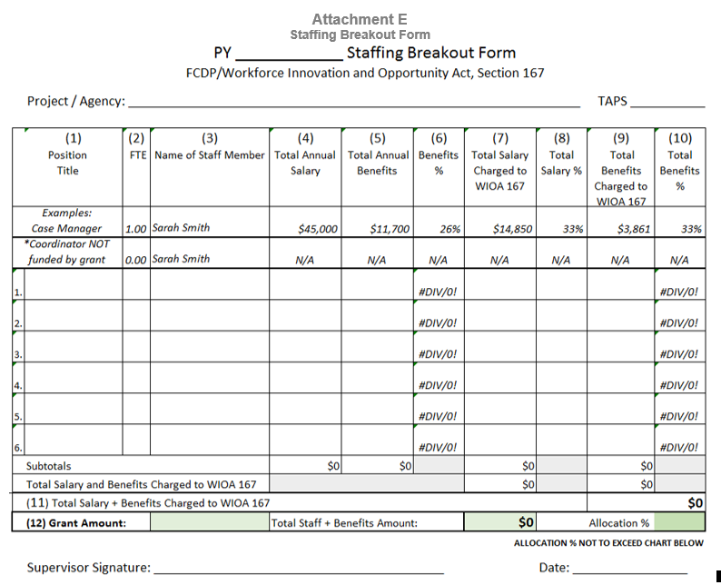

The DOE 599, Project Disbursement Form must be submitted. The budget amount in column 4 must equal the totals in the DOE 101S Form and Attachment E, Staffing Breakout Form:

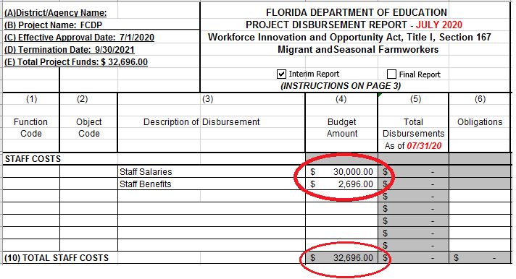
Please visit our Division’s website at http://www.fldoe.org/academics/career-adult-edu/funding-opportunities/index.stml, to access all forms.

Conditions for Acceptance
The requirements listed below should be met for applications to be considered for review:
- Application is received in the Office of Grants Management within the timeframe specified by the RFA
- Application includes required forms: DOE 100A Project Application Form and DOE 101S Budget Narrative Form
- All required forms must have the assigned TAPS Number included on the form
- All required forms have signatures by an authorized entity. The department will accept electronic signatures from the agency head in accordance with section 668.50(2)(h), Florida Statutes.

- NOTE: Applications signed by officials other than the appropriate agency head identified above must have a letter signed by the agency head, or documentation citing action of the governing body delegating authority to the person to sign on behalf of said official. Attach the letter or documentation to the DOE 100A when the application is submitted.
  - An “electronic signature” means an electronic sound, symbol, or process attached to or logically associated with a record and executed or adopted by the person with the intent to sign the record.
  - The department will accept as an electronic signature a scanned or PDF copy of a hardcopy signature.
  - The department will also accept a typed signature, if the document is uploaded by the individual signing the document.

- Application must be submitted electronically to the Office of Grants Management via ShareFile. See Attachment L for instructions.
Subrecipients do not have the authority to report expenditures before or after these specified dates in the Notice of Award.

Project Disbursement Report - DOE 599
All awarded projects must submit a final DOE 599, Project Disbursement Report and Projected Equipment Purchases Form to the Florida Department of Education, Comptroller’s Office by November 21, 2022.

Employ Florida
Subrecipients must use Employ Florida to enter participant data, including but not limited to the following: NFJP eligibility information, case notes, voucher documentation, and program exit date.

Subrecipients must scan all related documents into Employ Florida. This includes all participant information that is needed to validate participation.

The system will include data elements required by the Workforce Innovation and Opportunity Act, Section 167, the U.S. Department of Labor (USDOL) and Social Policy Research Associates, a USDOL contractor. The system will permit automated case management services at the subrecipient project level and tracking of case management services at the State administrative level. Subrecipients will receive training, technical support, system maintenance, and ongoing updates for the database system.

All FCDP staff must be certified to have access to Employ Florida.

Compliance Monitoring
The State will evaluate the effectiveness of project activities based on established and approved performance goals. Department staff will monitor providers’ compliance with program and fiscal requirements according to applicable federal and state laws and regulations specified by: Education Department General Administrative Regulations (EDGAR), Office of Management and Budget (OMB) Circulars, and Florida Department of Financial Services Reference Guide for State Expenditures and guidelines published in the Florida Department of Education’s Green Book. FCDP Monitoring Policies, Procedures and Protocols (2020-21) http://www.fldoe.org/academics/career-adult-edu/farmworker-jobs-edu-program/.

Project Performance Accountability Information, Instructions, and Form

NOTE: The following pages are included in the RFA (DOE 900D) template and are to be completed by the applicant.
The Florida Department of Education has a standardized process for preparing applications for discretionary funds. This section of the RFA, Project Performance Accountability, is to assure proper accountability and compliance with applicable state and federal requirements.
The Department’s project managers will:
- track each project’s performance based on the information provided and the stated criteria for successful performance
- verify the receipt of required deliverables prior to payment
For projects funded via Cash Advance, the Department’s project managers will verify that the project activities/deliverables are progressing in a satisfactory manner, consistent with the Scope of Work/Project Narrative and Performance Expectations, on a quarterly basis.
The Scope of Work/ Project Narrative must include the specific tasks that the grantee is required to perform.
Deliverables must:
- be directly linked to a specific line item/cost item that in turn links to the specific task/activity/service
- identify the minimum level of service to be performed
- be quantifiable, measureable, and verifiable.

The applicant must complete the information related to the required tasks to be performed and timelines/due dates for the respective tasks/deliverables consistent with the provided instructions. Per Chapter 215.971 F.S. financial consequences will be applied if the subrecipient fails to perform the minimum level of services required by the agreement. Unit cost is not necessary for each item but can be used to establish a methodology for reduction in the event minimum performance is not met.

The Division of Career and Adult Education has already populated this form with the required information.
- Simply submit this form with the application as printed.
- See Checklist (last page of this RFA) for proper placement of this form in the application package.

Project Performance Accountability Form

Scope of Work  (see Project Design – Narrative) | Tasks  (see Project Design – Narrative) | Deliverables | Due Date
Total Participants Assisted – To achieve 100% of DOE performance measure set by Department of Labor (DOL).  This will be accomplished by reporting the number of applicants who meet the WIOA, Title I, Section 167 eligibility requirements and received at least one Emergency Assistance Service. | Implement the strategies outlined in the application and process all Emergency Assistance Service request in a timely and efficient manner. | Management Information System of the DOE/FCDP Office.  Monthly Data report must include the amount of assistance provided to each participant that month and:  - Number of participants assisted by County  - Number of participants assisted  by Region  - Number of participants assisted  by FCDP Provider | By the fifth of the month following the month for which activities are reported.

Attachments

- Attachment A – Program Purpose and Overview of Allowable Activities and Services
- Attachment B – FCDP Emergency Assistance Allocation Chart
- Attachment C – Target Population
- Attachment D – Special Conditions for WIOA, Section 167, Project Awards Form
- Attachment E – Staffing Breakout Form
- Attachment F – Self-Evaluation Form
- Attachment G – DOE 101S, Example Budget Narrative Form
- Attachment H – DOE 599, Project Disbursement Form
- Attachment I – DOE 100A, Project Application Form
- Attachment J – Projected Equipment Purchases Form (if applicable)
- Attachment K – Application Checklist
- Attachment L – ShareFile Instructions

The program purpose is to strengthen the ability of eligible migrant and seasonal farmworkers and their families to achieve economic self-sufficiency. The program serves eligible farmworkers and their dependents (Refer to Attachment C) that have the following socio-economic and educational barriers, as identified by the United States Department of Labor for WIOA, Title I, Section 167 funded programs:

- Dropout  - Unemployed  - Limited English proficient  - English reading below grade 9  - Math skill below grade 9  - Migrant  - Seasonal  - Economically disadvantaged  - Food stamps  - Veteran | - Unemployment claimant  - Unemployment exhaustee  - Offender or parolee  - Disability  - Single parent with dependent under 18  - Pregnant / parenting youth  - Long term agriculture employed  - Lacks work history outside agriculture  - Lacks transportation or means to access it  - Homeless

Allowable Program Activities
To meet the education, training and employment needs of farmworkers and their families program funds shall be used to provide individuals with Emergency Assistance Services as described in Section 134, paragraph (d)(2) of the Act.

Emergency Assistance Services
- Emergency assistance / non-training related supportive services to stabilize farmworkers
- Training related emergency supportive services that will enable farmworkers to complete training services (transportation, childcare, medical, etc.)
- Emergency supportive services such as transportation, family care, medical care.

Related Assistance Services – Related assistance may include such services and activities as:
- Workplace safety and farmworker pesticide safety instruction;
- Heat stress prevention;
- Housing development assistance;
- Allowance payments;
- Other supportive services described in the grant plan; and
- English language classes and basic education classes for participants not enrolled in intensive or training services.

The funds cited in the chart below reflect the total allocated dollar amounts for each project being funded in this program year. The Allocation Chart is subject to change based on the final federal allocation. All agencies will be notified regarding their final allocation prior to the issuance of their 2021-2022, DOE 200, Award Notification.
Program Title: National Farmworker Jobs Program
(WIOA Section 167) – Statewide Emergency Assistance
FY 2021-2022
Agency Name | 2021-2022  Project Number | 2021-2022  Projected  Allocation
Agriculture and Labor Program, (ALPI) | TBD | $ 50,000.00
 | Total | $ 50,000.00

To be eligible for participation in the WIOA §685.100 Section 167 NFJP program an individual:
- A MSFW Adult

- OR

- A MSFW Youth (aged 14-24)

- Must be a citizen or national of the United States, a lawfully admitted permanent resident alien, refugee, asylee, or parolee, or other individual legally authorized to work in the United States [WIOA Section 188 (a)(5)] AND;

- Must have not violated Section 3 of the Military Selective Service Act by knowingly and willfully failing to register for the Selective Service registration [20CFR §667.250; WIOA Section 189 (h) AND;

- A low‐income individual who faces multiple barriers to economic self‐sufficiency (WIOA Section 3(36) (A)(B)) TEGL No. 18-16. AND;

- Must have performed labor for wages in occupations and industries within agricultural production and agricultural services for 12 consecutive months out of the 24 months prior to application for the program involved [20 CFR §685.110]. Primarily employed in agricultural or fish farming labor (earns at least 50 percent of his/her total income from farm work or is employed at least 50 percent of his/her total employment time in farm work) TEGL No. 18-16.

- OR

- Is a dependent of an eligible MSFW (A dependent is an individual who was claimed as a dependent on the qualifying farmworker's federal income tax return for the previous year); If not claimed as a dependent for federal income tax purposes, is able to establish a qualifying relationship with the farmworker.

- The individual receives half of his/her total support from the eligible farmworker's family during the eligibility determination period.

General
The subrecipient agrees to fully comply with the requirements of the Workforce Innovation and Opportunity Act (WIOA) and all federal regulations, policies, or procedures that may replace or modify WIOA Title I, Section 167. The subrecipient agrees to fully perform the services prescribed in the Project Application and will comply with the Florida Department of Education (FDOE) Green Book General Assurance, Terms and Conditions for Participation of Federal and State programs, which are required to be signed and submitted to FDOE prior to the issuance of grant award notification. The Department has the option of reducing project funding due to a project’s failure to meet performance goals, meet minimum data accuracy requirements, or comply with the resolution of program, fiscal, or data validation / monitoring findings.

Operational Guidelines and Internal Procedures
Subrecipients must implement project operations as instructed in WIOA, Title I, Section 167, USDOL guidance notices/letters, all FCDP State Office policy related technical assistance papers, memos, and manuals no later than July 31 of the program year. The FCDP State Office requires the use of an online database system to conduct and manage daily business. Employ Florida is used to enter, update, and store participants’ information. In addition, SUNTAX is used to confirm participants’ wages and employer information. Access to Employ Florida requires completion of the Department of Economic Opportunity’s Tier I training and successful completion of a Level 2 Security Background check.

MSFW Eligibility Determination
Subrecipients will be required to have coordinators and all intake/case management staff successfully complete MSFW eligibility certification training provided by the FCDP State Office in order to determine and document participant eligibility for the FCDP program. Instructions on how to maintain source documentation validating eligibility criteria and entering applicable eligibility data into Employ Florida provided for this purpose will be included in this eligibility certification training.

Program Branding
An organization name and logo are the centerpiece of a brand and sets the stage for how an organization is perceived among its key stakeholders. All funded agencies must ensure that the office(s) supported by these funds are named, “Farmworker Career Development Program of Grant Host Agency Name” and that all program promotional materials, web sites, agreements, memoranda of understanding, and contracts use this name (and the associated program logo) to identify and describe program services. In addition, telephone and email forms of communication should include this name as part of the ongoing effort to brand the program statewide as one whose main purpose is to build sustainable and rewarding careers for eligible farmworkers.

Personnel Requirements
- Time and Effort Reporting – The subrecipient agrees that staff whose total annual compensation is derived from WIOA Title I, Sections 167 funds shall contribute 100% of compensated time to completion of approved WIOA Title I, Section 167 project activities. The subrecipient must submit to the State Office the Time and Effort form in September and March of the project year to document the staff work 100% on single cost objective. Time and Efforts forms are to be maintained for a period of five years.

- Personal Activities Report (PAR) – Subrecipient staff positions funded in part by WIOA Title I, Section 167 funds in combination with any other funds will be charged on a proportional basis based on actual activities. The subrecipient must submit to the FCDP office the PAR forms by the 6th of each month. PAR forms are to be maintained for a period of five years. The project recipient must receive prior written authorization from the Department of Education prior to changes to direct personnel costs charged to the budget.

- Position Descriptions and Personnel Selection – The Department will review the position descriptions of all grant funded positions to ensure they document the required knowledge, skills, and abilities for positions supporting the FCDP grant. In addition, the qualifications of individuals hired by subrecipients must be reviewed by the program office to ensure they meet the minimum standards outlined in the applicable position description.

- Personnel Related Changes – Recipients will notify the Director of the Farmworker Career Development Program (FCDP) Office, Florida Department of Education, of any proposed personnel, salary, or FTE changes, in writing using the approved Staffing Form at Attachment E, within ten (10) days of the proposed change and include copies of any new position descriptions for the positions being filled along with the resume of the individual being considered for the vacant position. Any changes to salary or benefits as outlined on the originally approved Staffing Form must be pre-approved by the State Director before any grant funds are encumbered for this purpose.

Collaboration with Local Agency

- Title I Migrant Education Office – Collaboration with the Title I Migrant Education Office(s) serving migrant children in the state is required and should be documented with a signed collaboration agreement. This agreement should identify the specific manner in which the collaboration will take place to include shared outreach efforts, program awareness building, and identification of ways in which program participants may benefit from this collaboration.

Cost Standards
The subrecipient agrees that WIOA Title I, Section 167 funds may only be used for activities allowable under WIOA Title I, Section 167. Costs must be necessary and reasonable for proper and efficient performance and administration of the project. A cost is allocable to a particular project grant if the goods or services involved are chargeable or assigned to such project grant in accordance with relative benefits received. This would include the cost for compensation of employees for the time devoted and identified specifically to the performance of the project, cost of materials acquired, consumed, or expended specifically for the purpose of the project, and equipment and other approved capital expenditures.

Program Costs
The subrecipient agrees that administration expenses for the program year may not exceed five (5%) percent, including indirect cost, of total expenditures on the final report. Total expenditures are defined as the amount reported as Total All Categories (line 13) on the Florida Department of Education's Form DOE-599, Project Disbursement Report. Administration expenses are defined as those expenses reported in the Total Administration (line 9) cost category on the State of Florida, Department of Education's Form DOE-599, and Project Disbursement Report.

Travel Costs
The subrecipient agrees that all staff charging travel costs to WIOA Title I, Section 167 funds must derive their salary from WIOA Title I, Section 167 funds and the travel must relate to WIOA Title I, Section 167 activities.

Travel Approval
Subrecipients must request prior permission in writing from the FCDP State Director for approval to charge out-of-state travel. Approval will be given only if such travel supports goals of WIOA Title I, Section 167. Travel must comply with Section 112.061, Florida Statutes, as outlined in Section H of the Green Book, available at: http://www.fldoe.org/finance/contracts-grants-procurement/grants-management/project-application-amendment-procedur.stml

Fiscal Management
- Project Amendments – Green Book Section B – page B-1 – Requests for realignment of funds between approved budget categories and any requests for additional funds prior to the end of the project year must be submitted to the FCDP State Office for review and approval using the appropriate budget and project amendment forms identified in the Green Book.

- Electronic Budget and Monthly Disbursement Reports – Funded agencies will be required to send the State Office an electronic version (Excel) of the Budget Narrative Form, DOE 101S, at the beginning of the program year and agree to generate the monthly DOE-599, Project Disbursement Report, using the e599 (electronic 599) workbooks provided by the State Office at the beginning of the program year. Final certified copies of the DOE 599 must be submitted monthly to the FDOE Comptroller’s office no later than twenty (20) days following the close of the reporting month indicating the amount of funds expended (by budget category) for this project during the reporting month. A copy of these monthly DOE 599s must be provided to the State Office at the same time the originals are forwarded to FDOE.

- Close-Out – Each project must be closed out promptly after expiration or termination. Final expenditure report is due to the Office of the Comptroller no later than November 20
following the close of the Program Year. One copy must be submitted to the FCDP State Office. In the event that the business operations of the subrecipient agency are suspended, such agency will deliver the most current program records within 30 days of the close of business to the FCDP State Office. The FCDP State Office may terminate the project award for cause. In this event, a written termination notice will be prepared by the FCDP State Office to become effective thirty (30) days after such notice is given. In closing out projects, the following shall be observed: The close out of a project does not affect the retention period for records or access rights by federal or state personnel. If a project is closed out without an audit, FDOE retains the right to disallow an appropriate amount after fully considering any recommended disallowance resulting from a subsequent audit

Program Non-Compliance Policy
The subrecipient agrees that the FDOE may discontinue the project award, not refund the subrecipient, or impose special conditions if the subrecipient has failed to provide services specified herein or in the project award, or failed to achieve goals and performance standards.

Property Standards
The subrecipient may purchase items/property with a value or cost less than $500 without prior written approval from the FCDP State Office. However, all purchases must be necessary for the support of staff and/or participants and considered allowable activities WIOA Title I, Section 167. Subrecipients must request written permission from the Department of Education to purchase items/property with a value or cost of $500 or more. Property is defined as equipment, fixtures, and other tangible personal property of a non-consumable and non-expendable nature, with a value or cost of $500 or more and the normal expected life is one year or more. The subrecipient agrees that items purchased with WIOA Section 167 funds and defined as property with a cost of $500 or more may be inventoried by the FDOE.

Record Retention
The subrecipient agrees to retain all records pertinent to the project award including financial, statistical, property and participant records, and supporting documentation for three years from the final closing date of the project award. If at the end of five years, there is ongoing litigation or an outstanding audit involving those records, the subrecipient shall retain the records until resolution of the litigation or audit.

Audits
Private nonprofit organizations must provide an audit prepared in accordance with U. S. Department of Labor laws and regulations to the Office of the Comptroller and the Farmworker Career Development State Office.
Signature of Authorized Agency Representative |  |  |  | Date

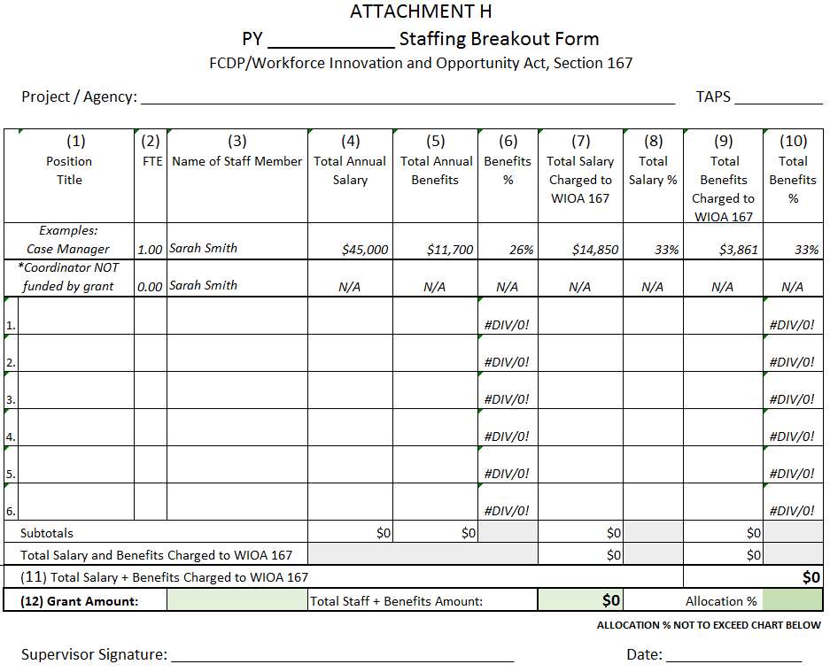

Projects recommended for FY 2021-2022 continuation funding must show successful performance accomplishments during the 2020-2021 project year. Any shortfalls or negative answer(s) must be explained below.

Agency name: _____________________________________ County: _________________ Date prepared: _________________

Project # for 2020-2021:____________________ Form prepared by (name and title):____________________________________

Agency project coordinator (name and title): _________________________________ E-mail: ____________________________

Cells will expand when text is typed.

Evaluation of FY 2020-2021 Project | YES | NO | If NO, recipient must adequately  explain any changes.  Use 12-point font and single spacing.
- Are grant expenditures directly related to and proportionate with performance outcomes achieved in 2020-2021?
- Has most recent available MSFW Emergency Assistance performance data for 2020-2021 been reviewed for compliance with approved performance plans by the grantee’s project coordinator, and corrective action plans developed if necessary?
- The grantee’s project coordinator understands the need to enter participant data and provide ongoing case documentation in the centralized database system; and correctly exits participants from the database system at the appropriate time?
- The centralized database system’s information is used for follow-up retention services at the sub-recipient project level?
- Are all applicable collaboration arrangements still in place (financial and non-financial)?
- Were the services to be provided to the target population for 2020-2021 consistent with the approved 2020-2021 project plan?
- Are performance outcomes achieved in 2020-2021 meeting the minimum performance benchmarks outlined in the PY 2020-2021 FCDP Emergency Assistance Plan?
- Have all projected performances and grant deliverables been satisfied to date as stated in the 2020-2021 approved application?

- What was the total amount of your agency’s FCDP 2020-2021 funding allocation for this project? | $
- How much has been spent to date? | $
- What amount will be spent and/encumbered by September 30, 2021? | $
- If 100% of the total allocation will not be spent and/or encumbered by September 30, 2021, explain why:

Any performance shortfalls must be explained by including corrective measures put into place to prevent future shortfalls.
Please respond here and use as much room as necessary to adequately address:

Do you need technical assistance? Yes _____ No _____

If yes, to facilitate service, please state your need(s) and your program manager will contact you.
Please respond here
EXAMPLE Budget Narrative Form (DOE 101S Form)

Please visit our website at http://www.fldoe.org/academics/career-adult-edu/funding-opportunities/index.stml. Refer to the Program Management Resources section to access the new DOE 101S Budget form and the instructions for completing the form.
(1) | (2) | (3) | (4) | (5) | (6)
FUNCTION | OBJECT | ACCOUNT TITLE and NARRATIVE | FTE POSITION | AMOUNT | % ALLOCATED to this PROJECT
##### | ##### | Salaries: Program Specialist responsible for program outreach, participant recruitment, participant case management, client services. Projected board approved increase up to 3% to salary. | 1 | $30,000
 | 100%
##### | ##### | Employee Benefits, Retirement: Contributions for Specialist at 8.26% |  | $2,478 | 100%
##### | ##### | Employee Benefits, Social Security: Contributions for Specialist at 7.65% |  | $2,295 | 100%
##### | ##### | Employee Benefits, Worker’s Compensation: Contributions for Specialist at 0.51% |  | $150 | 100%
##### | ##### | Computer Hardware: Purchase of 5 computers and monitors for staff to use for input and management of program and participant data. Projected Equipment Purchases Form attached |  | $4,500 | 100%
##### | ##### | Contractual Services: 1 Staff member to utilize office space in One Stop Center as per DOL policy. Contractual Service Agreement attached |  | $500 | 100%
##### | ##### | Travel: 3 Staff Members to attend Annual Farmworker Career Development Program Conference ($550 each) and 1 Staff Member to attend annual AFOP Conference ($1,600) |  | $2,100 | 100%
 |  |  | Total | $42,023
NOTE:
When completing the Budget Narrative Form, located on the website under Column (3), Account Title and Narrative, for each line item specify the budgetary expenditures such as salaries, equipment and supplies. Expenditures should focus on performance improvement, as noted in the application. Place TAPS number 22B002 on the Budget Narrative Form DOE 101S form.

DOE 599, Project Disbursement Form

The DOE 599, Project Disbursement Form must be submitted. The budget amount in column 4 must equal the totals in the DOE 101S Form and Attachment E, Staffing Breakout Form:

Please visit our Division’s website at http://www.fldoe.org/academics/career-adult-edu/funding-opportunities/index.stml, to access all forms.

INSTRUCTIONS FOR DOE 599 PROJECT BUDGET SUMMARY AND DISBURSEMENT REPORT
Workforce Innovation and Opportunity Act, Title I, Section 167, Migrant and Seasonal Farmworkers
Instructions

DISBURSEMENT REPORT
Complete Items (A) through (J)

Mark "X" in the box provided below the title to indicate that this is an interim or a final report (a final report is that which closes out the project).
In the title box to Column (5), enter the month, day and year (e.g. 07/31/12 that represents the ending date for the month of disbursement being reported).

Submit two copies by the 20th of each month following the month of disbursement to:
(Copy one)

Comptroller's Office, Florida Department of Education, Turlington Building, Room 914, 325 West Gaines Street, Tallahassee, Florida 32399-0400, (850) 245-0401

(Copy two)
Farmworker Career Development Program, 1313 N. Tampa Street, Suite 103, Tampa, Florida 33602, (813)224-1920.

COLUMNS
- SCHOOL DISTRICTS ONLY:
FUNCTION Use the four digit function codes as required in the Financial and Program Cost Accounting and Reporting for Florida Schools Manual.

- SCHOOL DISTRICTS:
OBJECT Use the three digit codes as required in the Financial and Program Cost Accounting and Reporting for Florida Schools Manual.

COMMUNITY COLLEGES:
Use the five digit object codes as required in the Accounting Manual for Florida’s Public Community Colleges.

UNIVERSITIES AND STATE AGENCIES
Use the six digit object codes as required in the Florida Accounting Information Resource Manual.

OTHER AGENCIES
Use the object code as required in the agency’s expenditure chart of accounts.

(3) ALL APPLICANTS:
DESCRIPTION Provide a specific description of the type of expenditures.

(4) AMOUNT: For each function and object code indicate the budget amount requested. (Cells on the spreadsheet that are highlighted in gray do not require entries, as explained below).

(5) Complete by reporting total project disbursements as of the date indicated at the top of the column (do not include obligations).

- Enter total of encumbered obligations at the end of reporting month, (do not include salaries and fringe benefits).

- Column (7), the Unobligated Balance, automatically calculates when entries are made for Columns (4) through (6). No entries are required. [Column (7) = Col. (4), the Budget Amount, minus Col. (5), the Total Disbursements, minus Col. (6), the Obligations

- Complete by reporting all current disbursements for both cost categories. Enter the difference between the amount shown in Column (5) on the previous disbursement report and Column (5) of this report.
LINES
(9)- (12) The Totals for Columns (4)–(8) automatically sum on Lines (9)–(12) as values are entered in columns (4) through (8). No entries are required.

- The Totals in the cells for line (13) automatically sun Lines (9) through (12) to represent the complete project status. No entries are required.

- FEDERAL PROGRAM INCOME is not applicable for this program.
(15) FEDERAL PROGRAM INCOME comments are not applicable for this program

ITEM
(16) The Finance Officer or authorized representative must sign and date the project disbursement report on the last page. Enter the Disbursement Report Number and page information in the lower left hand corner of the last page.

Florida Department of Education

Project Application

Please return to:  Florida Department of Education  Office of Grants Management  ShareFile System  Telephone: (850) 245-0496 | A) Program Name:  National Farmworker Jobs Program  WIOA Section 167  Statewide Emergency Assistance  Discretionary, Continuation  Fiscal Year 2021-2022  TAPS NUMBER: 22B002 |  | FDOE USE ONLY  Date Received
B) Name and Address of Eligible Applicant:

 |  |  | Project Number (FDOE Assigned)
C) Total Funds Requested:  $  DOE USE ONLY  Total Approved Project:  $ |  | D)  Applicant Contact & Business Information
 |  | Contact Name:  Fiscal Contact Name: |  | Telephone Numbers:
 |  | Mailing Address: |  | E-mail Addresses:
 |  | Physical/Facility Address: |  | DUNS number:  FEIN number:

CERTIFICATION
I, ______________________________________________, (Please Type Name) as the official who is authorized to legally bind the agency/organization, do hereby certify to the best of my knowledge and belief that all the information and attachments submitted in this application are true, complete and accurate, for the purposes, and objectives, set forth in the RFA or RFA and are consistent with the statement of general assurances and specific programmatic assurances for this project. I am aware that any false, fictitious or fraudulent information or the omission of any material fact may subject me to criminal, or administrative penalties for the false statement, false claims or otherwise. Furthermore, all applicable statutes, regulations, and procedures; administrative and programmatic requirements; and procedures for fiscal control and maintenance of records will be implemented to ensure proper accountability for the expenditure of funds on this project. All records necessary to substantiate these requirements will be available for review by appropriate state and federal staff. I further certify that all expenditures will be obligated on or after the effective date and prior to the termination date of the project. Disbursements will be reported only as appropriate to this project, and will not be used for matching funds on this or any special project, where prohibited.

Further, I understand that it is the responsibility of the agency head to obtain from its governing body the authorization for the submission of this application.

E) ________________________________________________ _________________________________ ________
Signature of Agency Head Title Date

DOE 100A
Revised July 2020 Page 1 of 2 Richard Corcoran, Commissioner
Instructions for Completion of DOE 100A

- If not pre-populated, enter name and TAPS number of the program for which funds are requested.

- Enter name and mailing address of eligible applicant. The applicant is the public or non-public entity receiving funds to carry out the purpose of the project.

- Enter the total amount of funds requested for this project.

- Enter requested information for the applicant’s program and fiscal contact person(s). These individuals are the people responsible for responding to all questions, programmatic or budgetary regarding information included in this application. The Data Universal Numbering System (DUNS), or unique agency identifier number, requirements are explained on page A-2 of the Green Book. The Applicant name must match the name associated with their DUNS registration. The Physical/Facility address and Federal Employer Identification Number/Tax Identification Number (FEIN/FEID or TIN) (also known as) Employer Identification Number (EIN) are collected for department reporting.

- The original signature of the appropriate agency head is required. The agency head is the school district superintendent, university or community college president, State agency commissioner or secretary, or the chairperson of the Board for other eligible applicants.

- Note: Applications signed by officials other than the appropriate agency head identified above must have a letter signed by the agency head, or documentation citing action of the governing body delegating authority to the person to sign on behalf of said official. Attach the letter or documentation to the DOE 100A when the application is submitted.

DOE 100A
Revised July 2020 Page 1 of 2 Richard Corcoran, Commissioner

Florida Department of Education, Division of Career and Adult Education

PROJECTED EQUIPMENT PURCHASES FORM

Equipment projected to be purchased from this grant must be submitted on this form or in a format that contains the information appearing on this form.

A) ___________________________________________________
TAPS Number
22B002

Name of Eligible Recipient

B) ___________________________________________________
Project Number (DOE USE ONLY)
Agencies are accountable for all equipment purchased using grant funds including those below the agencies
threshold.

PROJECTED EQUIPMENT PURCHASES

(Cells will expand when text is typed.)
ITEM  # | FUNCTION CODE | OBJECT CODE | ACCOUNT TITLE | DESCRIPTION | SCHOOL /  PROGRAM | NUMBER OF ITEMS | ITEM COST  ($) | TOTAL AMOUNT  ($)
 | A | B | C | D | E | F | G | H
1
2
3
4
5
6
7
8
9
10

Inventory Guidelines

The following elements are required on the inventory of all equipment purchased.

2 C.F.R. 200, Uniform Guidance sections: 200.313 Equipment: Property records must be maintained that include a description of the property, a serial number or other identification number, the source of property, who holds title, the acquisition date, and cost of the property, percentage of Federal participation in the cost of the property, the location, use and condition of the property, and any ultimate disposition data including the date of disposal and sale price of the property.

State Requirements for inventory elements are located in Rule 69I-72.003, Florida Administrative Code, Recording of Property.

Does the agency’s inventory system contain all required federal and state elements listed above?
YES NO
Florida Department of Education Division of Career and Adult Education

PROJECTED EQUIPMENT PURCHASES FORM

Instructions for Completion
This form should be completed based on the instructions outlined below, unless instructed otherwise in the Request for Proposal (RFP) or Request for Application (RFA). Use multiple forms as needed.

- Enter Name of Eligible Recipient.
- Project Number (DOE USE ONLY)

COLUMN A - FUNCTION CODE: | SCHOOL DISTRICTS ONLY: Use the four digit function codes as required in the Financial and Program Cost Accounting and Reporting for Florida Schools Manual.
COLUMN B - OBJECT CODE: | SCHOOL DISTRICTS: Use the three digit object codes as required in the Financial and Program Cost Accounting and Reporting for Florida Schools Manual.  STATE COLLEGES:  Use the first three digits of the object codes listed in the Accounting Manual for Florida’s Public State Colleges.  UNIVERSITIES AND STATE AGENCIES:  Use the first three digits of the object codes listed in the Florida Accounting Information Resource Manual.  OTHER AGENCIES: Use the object codes as required in the agency’s expenditure chart of accounts.
COLUMN C – ACCOUNT TITLE: | Use the account title that applies to the object code listed in the accordance with the agency’s accounting system.
COLUMN D – DESCRIPTION: | Provide detailed descriptions/specifications of all equipment items to be purchased that have a projected unit value of $500 – specific to MFSW (State’s threshold) or more with a useful life of one year or more.  Note: If the agency has a threshold of less than $500 – specific to MFSW the lower amount is the guiding threshold.
COLUMN E – SCHOOL/PROGRAM: | Provide the name of the school and the name of the program for which the equipment is being purchased.
COLUMN F – NUMBER OF ITEMS: | Provide the total number purchased of this item.
COLUMN G – ITEM COST: | Provide the projected cost for each item.
COLUMN H – TOTAL COST: | Provide the total projected cost of all items.

Workforce Innovation and Opportunity Act, Section 167
Migrant and Seasonal Farmworker Program
Program Year 2021-2022
TAPS#22B002

APPLICATION REVIEW CRITERIA AND CHECKLIST

- Include this form in the application package. (Do not include Instructions pages).
- Place all items requested in the order indicated below.
- Include only the items requested.
- Place page numbers on every page consecutively, at the bottom, beginning with the DOE 100A as page one of the application package. Page numbers written by hand are permissible if electronic numbering is a problem.

PLACEMENT ORDER | ITEM | APPLICANT | DOE STAFF  - Check appropriate box below
 |  | Indicate Page Numbers Below | Complete | Incomplete
1 | DOE 100A, Project Application – with original signature
2 | DOE 101S, Budget Narrative Form
3 | DOE 599, Project Disbursement Form
 | Narrative Components
4 | 1. Project Abstract or Summary
 | 2. Project Need
 | 3. Project Design and Implementation (a-d)
 | 4. Evaluation
 | 5. General Education Provisions Act (GEPA) – one page
 | 6. Support Strategic Plan
 | 7. Dissemination Plan
 | 8. Budget Narrative
 | Attachments
5 | Project Performance and Accountability Form (include as is)
6 | Program Purpose and Overview of allowable Activities and Services
7 | Target Population
8 | Special Conditions for WIOA, Section 167, Project Awards Form
9 | Staffing Breakout Form
10 | Self-Evaluation Form
11 | Projected Equipment Purchases Form - if applicable
12 | Contractual Service Agreements – if applicable
13 | DOE 610 or 620 Risk Analysis Form – if applicable
14 | Application Review Criteria and Checklist Form

Purpose

The purpose for the Office of Grants Management ShareFile Instructions is to provide recipients and subrecipients with directions on how to access ShareFile, reset the passwords, naming conventions for documents, how to upload documents, and retrieve the award notifications from Office of Grants Management’s (OGMs) cloud‐based “ShareFile.”

Instructions

For optimal performance users should access ShareFile using Google Chrome. To download a free version of this browser, go to https://www.google.com/chrome/.

The Universal Resource Locator (URL) to the Office of Grants Management ShareFile is https://fldoe.sharefile.com/Authentication/Login. Only contacts identified by Florida Department of Education (FDOE) will have access to “ShareFile.” Agency heads may send an email to OGM@fldoe.org to add users by providing the program name, TAPS number, the contacts first name, last name, and email address. The same information should be provided if the agency head requests to remove a user.

If the user agency has deployed a network firewall the agency will need to whitelist the IP addresses at https://support.citrix.com/article/CTX234446 in order to avoid service interruptions. If customers do not have a firewall, no action is required.

To ensure the user is receiving alerts from ShareFile the user can whitelist the following email domains:

- sf-notifications.com
- noreply@sf-notifications.com
- mail@sf-notifications.com
- *.sf-notifications.com

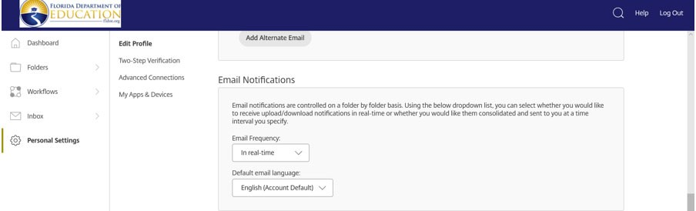
ShareFile Alerts

To control the alerts from ShareFile the user can access their profile settings and update the frequency of alerts. After logging into ShareFile look at the left side of the screen and Select Personal Settings.

This will bring up the users Profile settings. Select the edit Profile button.

Then scroll down till you see the Email Notifications field.

The settings for the Email Frequency field should be set to “In real‐time.” It is recommended that users change this setting to “In real‐time” to receive static notifications as uploads occur in ShareFile.

Initial Log into “ShareFile”

An initial user setup notice will come from the Florida Department of Educations’ program offices when programs become available for submission. If you are a new user or have not logged into ShareFile in the past 30 days. Users must select the “Forgot Password” button to reset their password.

Resetting your Password in “ShareFile”

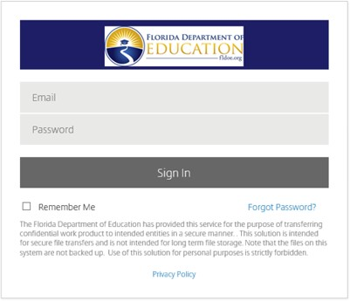
Select “Forgot Password” on the ShareFile log in page at https://fldoe.sharefile.com/Authentication/Login. The Forgot Password Button is located under the sign in button.

By selecting the Forgot Password button users will be taken to the email verification page. Users will enter their business email address, verify that users are not a robot and select the send button.

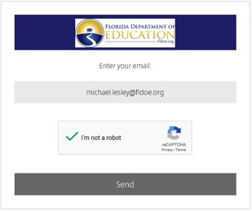

Users will then receive a message that states an email has been sent to the email address to reset your password.
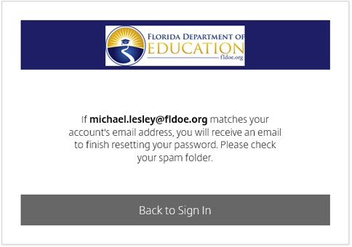

Users will click the link in the email to reset your password and then follow the ShareFile prompts to reset your password.
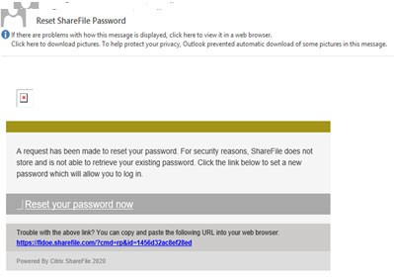

ShareFile prompts
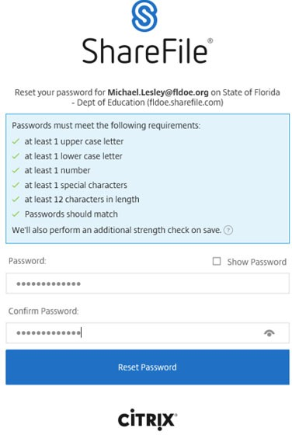

“ShareFile” Document Naming Convention

The standard naming convention for Projects is the Agency Number followed by the Fund Source ended by the Project Code. This is known as the Project Number.

When uploading documents into ShareFile users will utilize this method with the following difference. At the end of the Project Number for amendments use an “A” – Amendments and follow with the Amendment request number “1, 2, or 3”.

For example, if requesting amendment one for Alachua County’s Title I, Part A 2019‐2020 fiscal year project. The naming convention should be 010‐2120B‐0CB01‐A1.

Uploading a file into “ShareFile”

When uploading documents into “ShareFile” it is important to verify that you are submitting into the correct program folder. Once a document is uploaded into “ShareFile” it cannot be deleted.

There are two options for users to upload submissions in “ShareFile:”

1) Drag and Drop
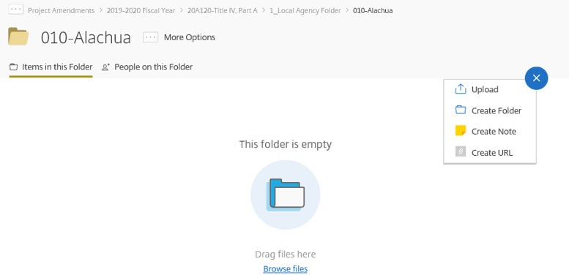
2a) Manual Upload ‐ hover the mouse over the plus symbol on the upper right side of the screen and select the Upload button.

(2b) Then select the Browse files button.

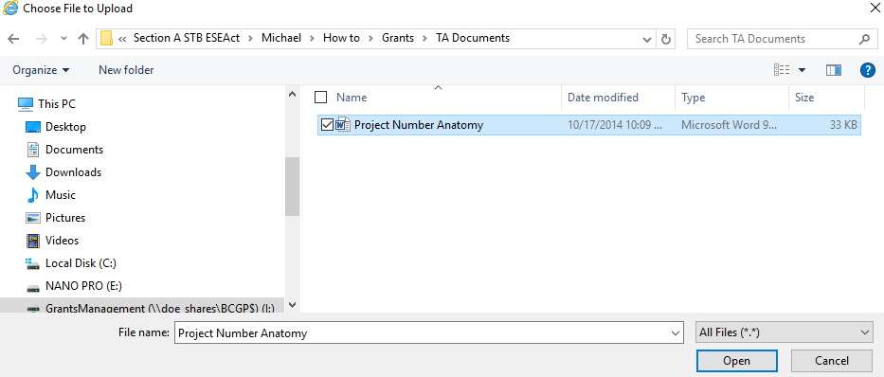
This will open up a document browser which will allow users to select the document to upload. (2c) Select the document to be uploaded to “ShareFile” and

(2d) Select the Open button.

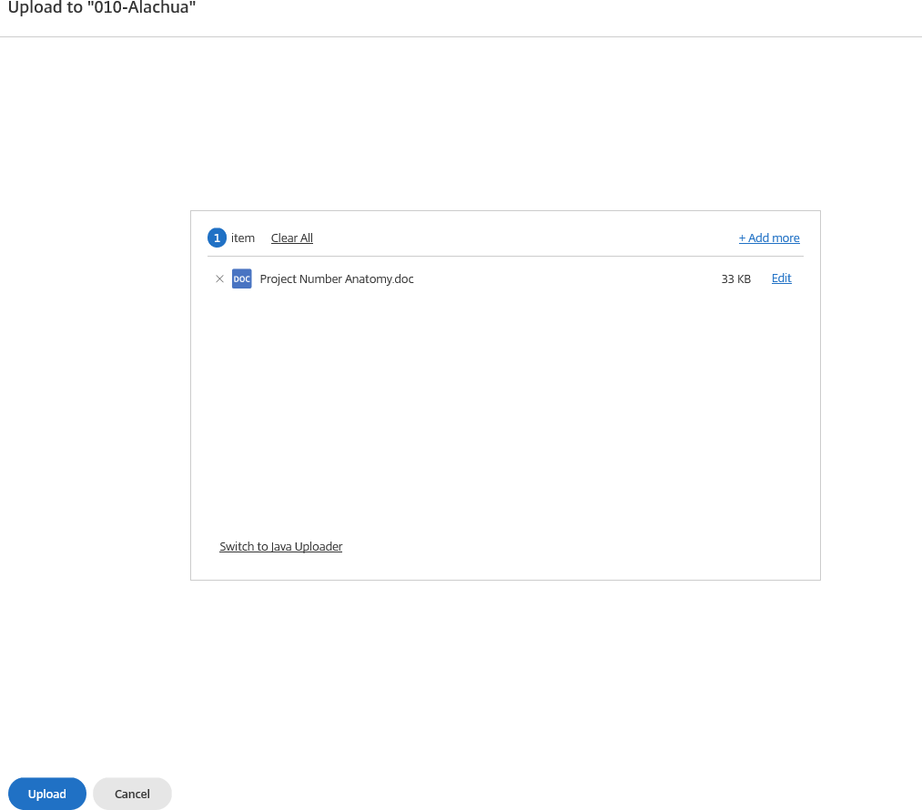
This will cause “ShareFile” to prompt user to verify the document to be uploaded.

If users want to upload more than one document at a time, select the Add more button and repeat steps
(2c‐2d).

(2e) Verify the document(s) to be submitted and then select the Upload button.

This will upload the selected document(s) into the agency “ShareFile” folder. Users should verify that the document(s) loaded are correct. If documents uploaded into “ShareFile” are incorrect notify the Office of Grants Management at OGM@FLDOE.ORG.
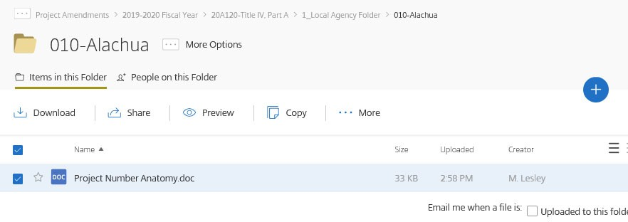

Retrieving your award notification from ShareFile.

All recipients and sub‐recipients will receive an email from “ShareFile” when awards are authorized. Users may select the link provided in the email from “ShareFile” to retrieve the award document or log into “ShareFile” and access the award in the program notification folder. Users must download the award notification and save it on your own storage system as “ShareFile” is not a permanent storage system.

Awards approved in ShareFile are the official documents from the FDOE. Hard copies will no longer be mailed to recipients and subrecipients.

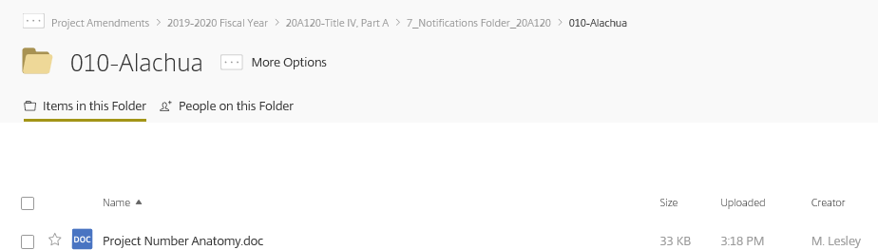
To download the award notification, select the file to download.

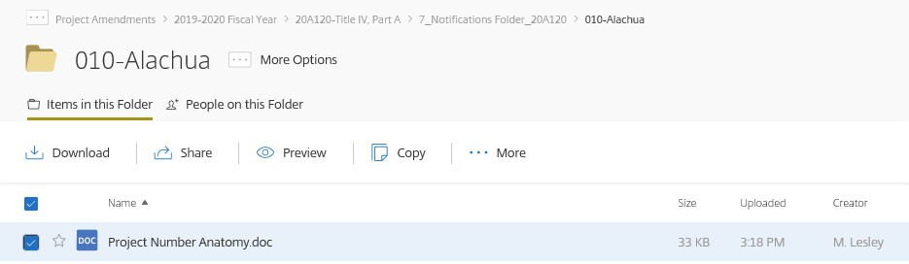
Then select the download button.

“ShareFile” will ask users to either open or save the selected file. Select the arrow next to the save button.
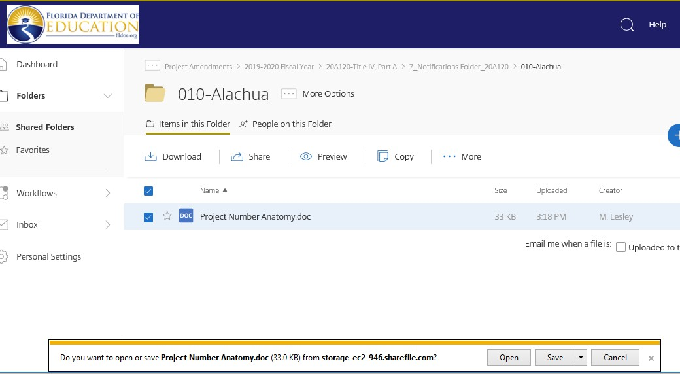

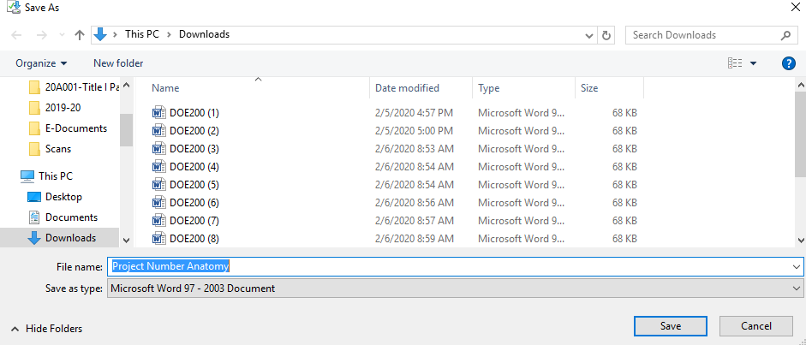
Users will have the option to save, save as, or save as and open. Select the save as button. This will bring up a browser window. It is advised that users maintain the naming convention already established, select the location you prefer the document to be saved and select the save button.

For additional information, contact the Office of Grants Management at OGM@fldoe.org.

