Online Title Grants Manual

This technical assistance manual provides local educational agencies (LEAs) with a systematic process about the general concepts of the Request for Applications (online title grants).

Florida Department of Education


Table of Contents
Online Title Grant Manual 2
Important Uniform Resource Locators (URLs) 3
Online Title Grant Listserv 3
Browser Downloads and Features 3
Downloading Project Applications 3
Required Browser Cookies 4
Caution! 4
Need Assistance? 4
New User Registration 4
Returning User Login 6
Forgot Password? 7
Front End Navigation 8
Login Name and Passwords 9
View Registered Roles for this Agency 9
Edit My Profile 10
Online Grant Applications 11
Navigation 12
Entering and Editing Information in the Application 12
Trouble Shooting 15
Server Error 15
Clearing your Cache 15
Printing the Application 17
Instructions for Completing the Online DOE 100A 18
Uploading Files 19
Identifying Replaced Data Files 20
Budget Page (DOE 101) 20
Print or View Budget Data 22
Export to Excel for Your Records 22
Reformatting Budget Pages for Printing 22
Budget Page Upload 23
Agency Codes and Passwords 24
FDOE Can Help You! 26

Online Title Grant Manual
This manual provides local educational agencies (LEAs) with a systematic process about the general technical concepts of the Request for Applications (online title grants). Please save this document to your desktop, or print it and keep it next to your computer to use as a quick reference.

As a safeguard and best practice, please use the Word version of the Request for Applications (RFAs) as your workspace, and then cut and paste information into the online system. You may access them at http://www.fldoe.org/NCLB/2008nclbta_site.asp or by contacting program staff listed on page 26.

The Online Title Grants Manual is on the Online Grant Applications menu for convenience under each program.
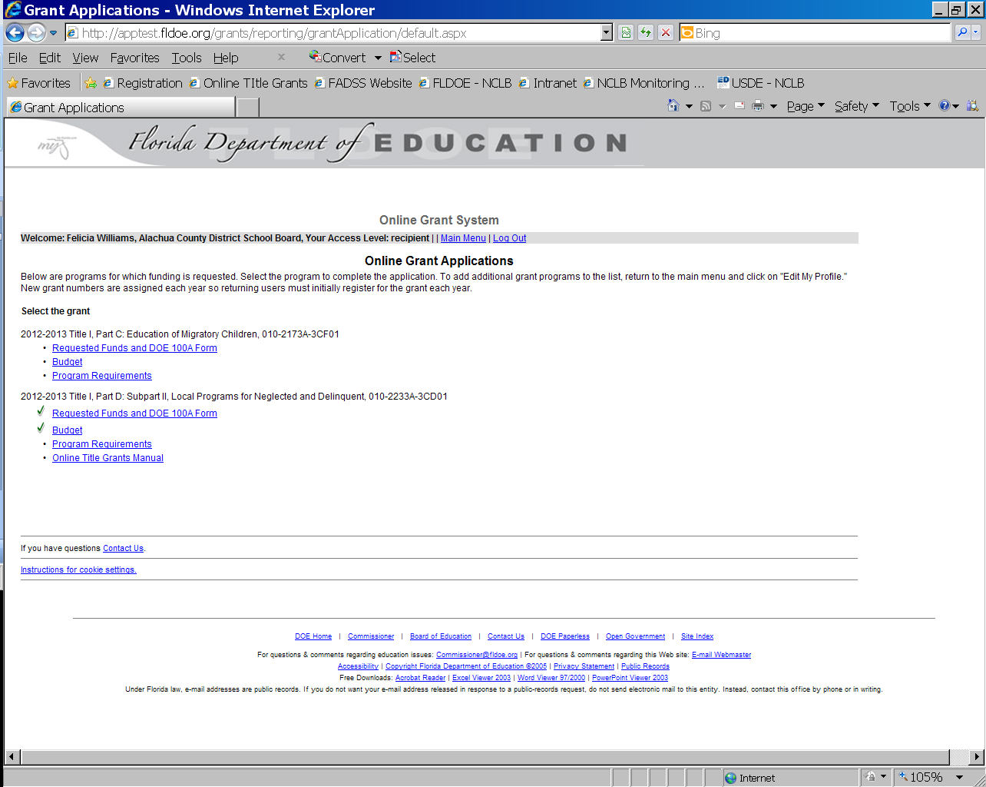

Important Uniform Resource Locators (URLs)
2013-2014 RFAs for Selected NCLB Programs – https://app1.fldoe.org/grants/reporting/
2012-2013 Read only project applications –
2011-2012 Read only project applications – http://data.fldoe.org/titlegrants1112/
2010-2011 Read only project applications – http://data.fldoe.org/titlegrants1011/
2009-2010 Read only project applications – http://data.fldoe.org/titlegrants0910/
2008-2009 Read only project applications – http://data.fldoe.org/titlegrants0809/
2007-2008 Read only project applications – http://data.fldoe.org/titlegrants0708/
2006-2007 Read only project applications – http://data.fldoe.org/titlegrants0607/
Online Title Grant Listserv
The Florida Department of Education (FDOE) provides technical assistance to LEA administrators via listserv for a variety of online Request for Applications, also known as online title grants (OTGs). By subscribing to this listserv, LEA staff will receive technical updates for the entitlement programs listed below.

This listserv will not allow spam and will only disseminate technical information about the specified entitlement program(s). Please only subscribe to this listserv if you are LEA personnel working at least one of these programs.

Join Now - http://data.fldoe.org/listserv/otg/
Browser Downloads and Features
Internet Explorer (I.E.) is the only browser for which FDOE can offer technical assistance. The I.E. does not allow users to expand text fields or spell check; however, there are web browsers such as Safari (http://www.apple.com/safari/ download/) and Mozilla Firefox (http://www.mozilla.com/en-US/) that have features such as these. References to other browsers are strictly to provide tools that may assist users with completing applications in the online reporting system.

Users interested in these features may download Safari or Mozilla Firefox, which requires an additional add-on download (https://addons.mozilla.org/en-US/firefox/addon/3818). If you need assistance with downloading browsers, please contact your Information Technology administrator.

Neither I.E. or the online reporting system has a spell checker; however, both the Safari and Mozilla Firefox browsers do. In Mozilla, with your cursor in the text box, right click to show the menu. Select check spelling to turn the feature on (you will see a check mark if it is already turned on). A red line should appear under any misspelled words. It does not check for grammar or punctuation. Following the same directions in Safari will produce similar results; additionally, the Safari browser has the ability to check basic grammar.
Downloading Project Applications
The OTGs are not available to download in Word or save as a Rich Text File in the online system. Users will not be able to print the entire application (using the application menu’s printer friendly option) unless information/data saved in a section. Users can use the Word versions of the OTGs as working documents; documents are found at http://www.fldoe.org/NCLB/2008nclbta_site.asp.
Required Browser Cookies
You must enable a browser cookie for fldoe.org in order to access the OTG. It might be easier to complete this step prior to logging in for the first time. Links for commonly used browsers are below to assist users with enabling browser cookies. Reminder: FDOE only offers support I.E.

If asked for a website address, enter fldoe.org.
- Internet Explorer: http://windows.microsoft.com/en-US/windows7/Block-enable-or-allow-cookies
- Mozilla Firefox: http://support.mozilla.com/en-US/kb/Enabling+and+disabling+cookies?bl=n&s=Enable%20Cookies
- Safari: http://docs.info.apple.com/article.html?path=Safari/3.0/en/9277.html
- Chrome: http://www.google.com/support/chrome/bin/answer.py?hl=en&answer=95647
Once you have successfully enabled the required cookie, please refresh your browser.
Caution!
The online reporting system times out after two hours of inactivity; please save regularly. Should the system time out, browser cookies previously established may reset and require the user to reauthorize cookies for fldoe.org. Users will know if this happens, as they will not be able to access the OTGs.
Need Assistance?
Please send an email to the FDOE at ofp@fldoe.org, or call 850-245-0657 if you experience technical difficulties. Staff identified on page 26 will be able to provide you with program specific and budgetary assistance.

Please add ofp@fldoe.org to your safe senders list to insure response delivery.
New User Registration
Returning Users! Please select Edit My Profile to assign the new year’s OTGs to your role(s)! Go to page 10 of this manual for more information.

New Users! To get started, ascertain the Agency Code and default Password (e.g., 010 is Alachua’s Agency Code, and the Password is agency010). Agency Codes are three-digit codes and they can be found on pages 24-25 of this manual.

When you are equipped with the agency code and default password, enter the requested information on the New User Registration main page. Select Continue. From there, follow the rest of the instructions. You will need to scroll down for each new step; previous steps will appear in gray font. Once complete, this process will no longer be necessary when you return to the online reporting system, even in future school years.

Please send an email to ofp@fldoe.org if this process does not assist you with retrieving login information.

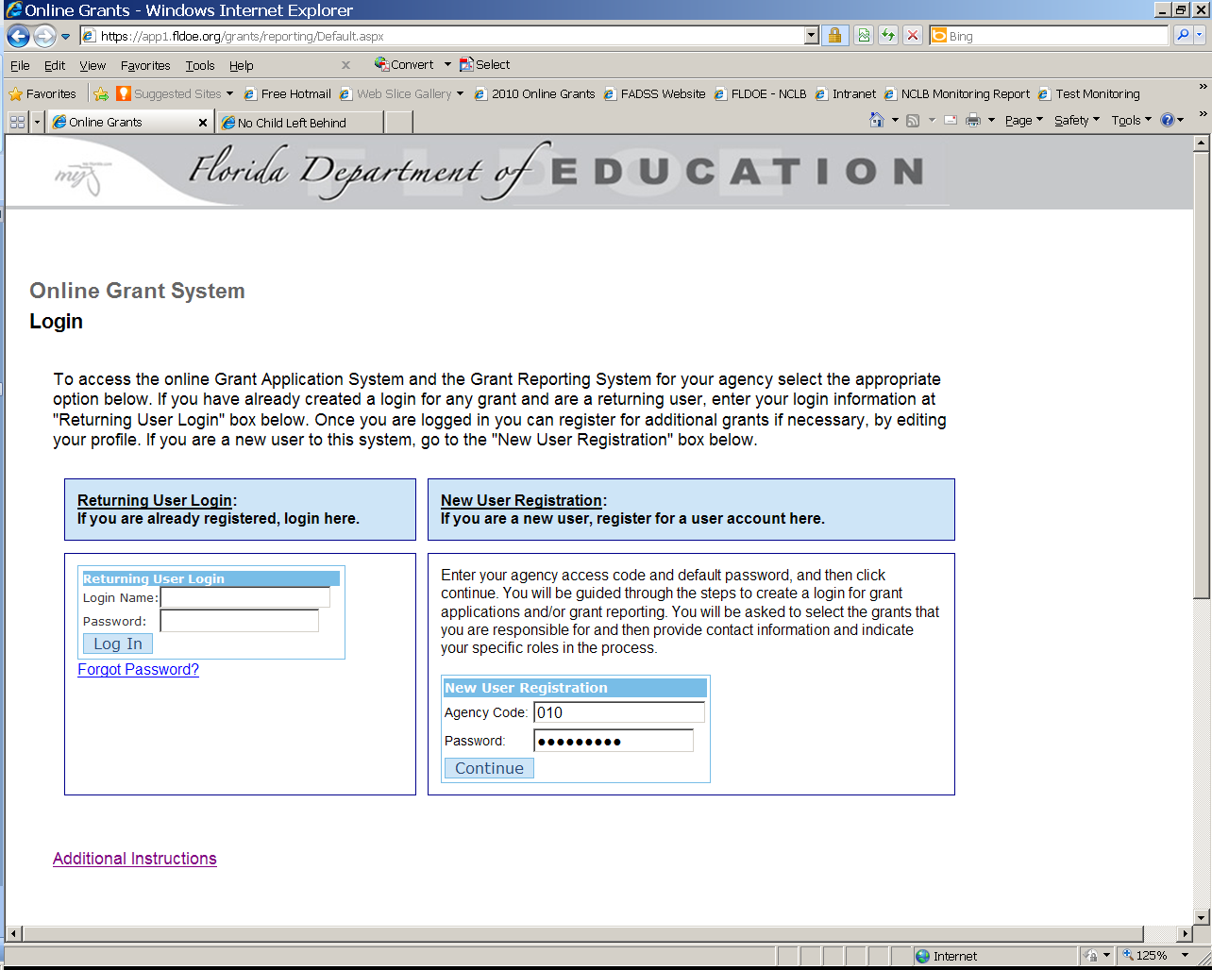
REMEMBER!
You are only a New User once.
NOTE: Save your Login Name and Password in a location where it is easily obtainable. The FDOE does not have access to passwords for security reasons.

Returning User Login
Please enter the Login Name and Password established when you registered, and follow the instructions provided for Edit My Profile on page 10.

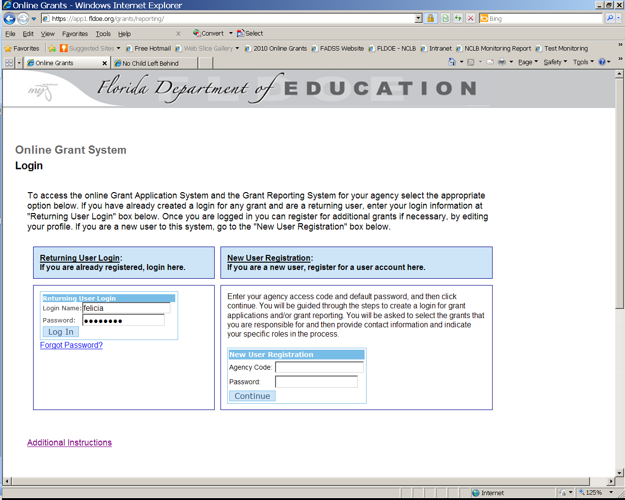
Returning User
Go here to add new projects; you are no longer a new user.
NOTE: Returning users needing to add annual OTGs should update their profile by selecting Edit My Profile to register for grant(s).
Forgot Password?
By selecting “Forgot Password?” users can retrieve their Login Name and Password by providing the information requested in the online grant system. An email will be sent to the address used to register shortly after selecting “go” and will provide the requested information.

Please send an email to ofp@fldoe.org if this process does not assist you with retrieving login information.

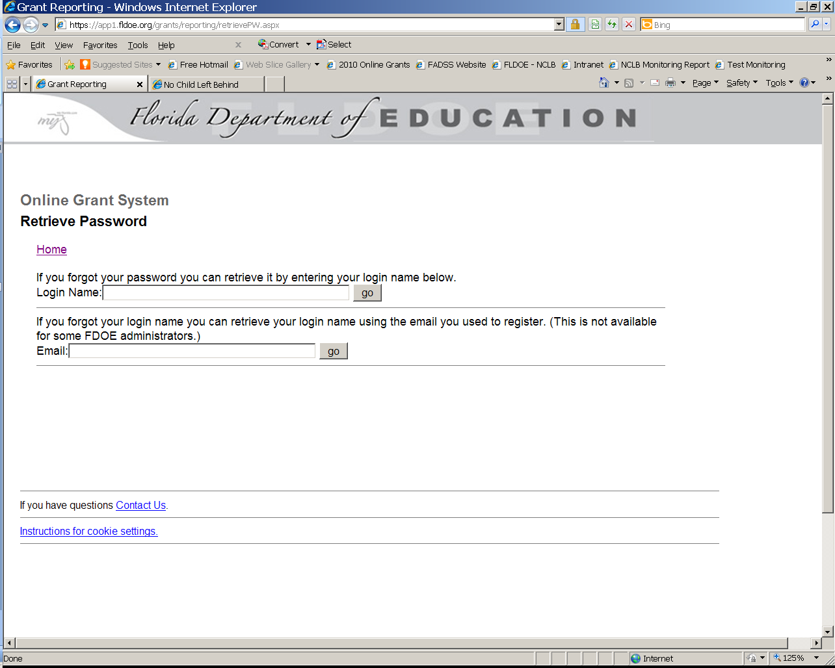
NOTE: An email should arrive in your inbox providing the Login Name or Password. Please check your junk mail or quarantine folder if you do not receive this information within five minutes of your request.

Front End Navigation
Once successfully registered, users may access the Online Grant System Main Menu, which is the segue to the online grant application(s) and budget(s) based on profile settings.

Users may view registered user roles for their entire agency. This feature provides the name, phone number, and email of the person(s) assigned to OTGs and other roles affiliated with the online reporting system. If you cannot access your specific role because another person has been assigned to the OTG, please View Registered User Roles for this Agency, locate the individual’s contact information, and request they change their profile so you may add the grant(s) in question to your profile. (See page 10)

Contact the FDOE at ofp@fldoe.org if this process does not assist you with accessing your specific roles.

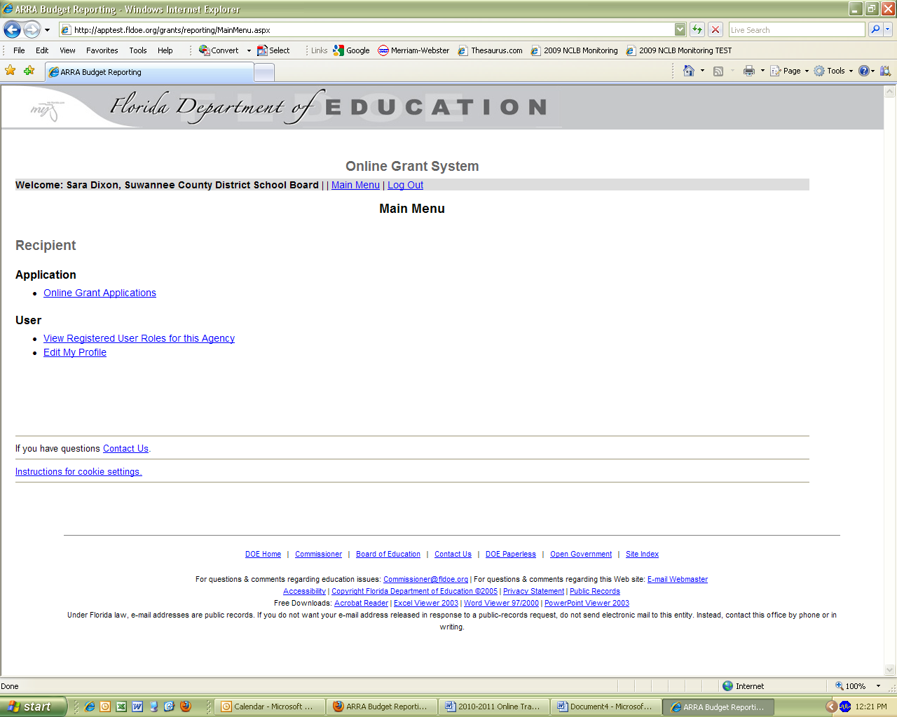
NOTE: The FDOE can assist districts in need of removing access to employees that are no longer responsible for OTGs. An email from the superintendent (or designee) requesting the disabling of a profile of an individual gives FDOE authorization to honor the request effective immediately.

Login Name and Passwords
In order to allow multiple users access to a project application, the primary grant contact will need to share the username and password. The FDOE does not have access to passwords and will not be able to give the password to any user. If the primary grant contact has forgotten the password, that user can go to the Go to User Login screen and select the link Forgot Password? (see page 7). The user must to enter the Login Name or Email associated with a profile to retrieve this information via email from no-reply@fldoe.org.

Please add no-reply@fldoe.org to your safe senders list to ensure response delivery.
View Registered Roles for this Agency
Users can view registrants for each of the selected title grant budgets and applications for their agency. Each person is listed by the grant and role with an email and phone number. Selecting any of the hyperlinked headings will sort the list according to that column. The information on this page should help promote communication between offices. If users need to edit any of the information on this screen, they can go back to the main menu, select Edit My Profile, and follow the prompts to update their profile (see page 10).

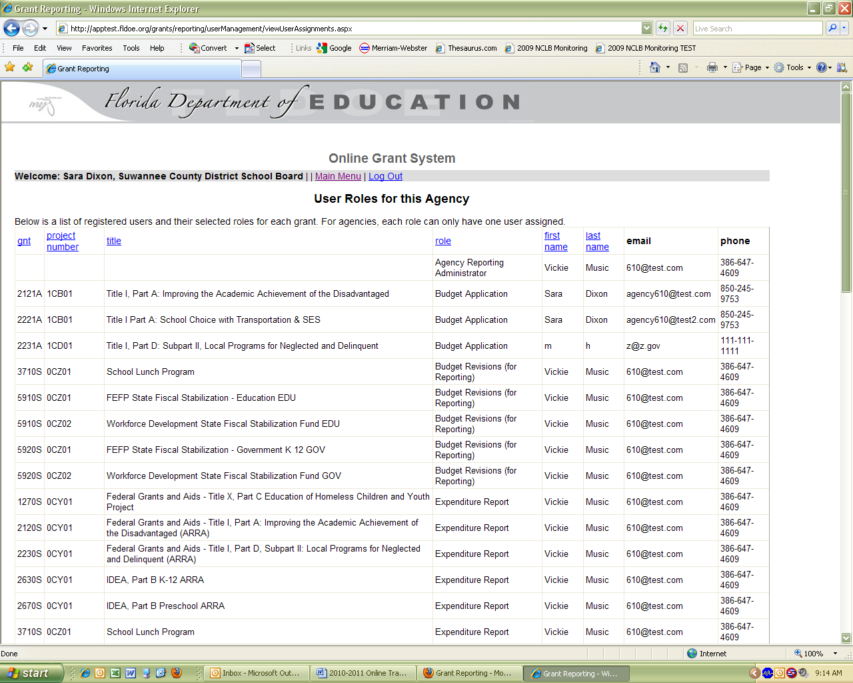

Edit My Profile
Selecting Edit My Profile from the Main Menu will lead users through a series of prompts identical to the initial registration process. Edit the information that needs to be updated and select continue. If there are no changes to be made within a subsection of the registration process, select Continue to go to the next subsection. This process should be used to add or remove roles.

LEAs are required to add project applications on an annual basis. For example, if you want to access the 2013-14 Title I, Part A – Improving the Academic Achievement of the Disadvantaged follow the prompts below:

Returning Users:
- Enter your Login Name and Password (left hand side of the online grant system).
- Select Edit My Profile under “User.”
- Make sure the checkbox for “I am registering for the Grant Application System” is checked.
- Select Continue.
- Scroll down to Application and then select the grant(s) you are responsible for administering.
- Select Continue.
- Scroll down past your contact information and select whether you are responsible for either the Online Grant Applications or Submit Budget Data for Application or both.
- Select Save.

You should be able to access the project applications selected by selecting the online grant applications link.

NOTE: The password fields will be blank each time users access a profile for security purposes; even though they are not visible, the online grant system will maintain your original Login Name and Password.
Online Grant Applications
From the Main Menu, choose Online Grant Applications. This brings you to the screen below. To navigate to this menu from any of the following pages, choose Grant Application Menu. If a program has the option to roll funds forward, select Requested Funds and DOE 100A Form to input the amount. Users should also follow this link to print the DOE 100A form from the Grant Application Menu. If a user has access to the budget of a particular program, the budget page can be accessed from this menu by selecting the Budget link.

Select Program Requirements to begin the application process. When the DOE 100A Form and the Budget are complete, a green checkmark will appear in place of the bullet. However, a green check will not appear next to Program Requirements on this page after completion. Users can track progress while completing the requirements for each program by looking for green checkmarks on the Program Main Menu (See page 17).

Example of checks for the Budget and Requested Funds and DOE 100A Form
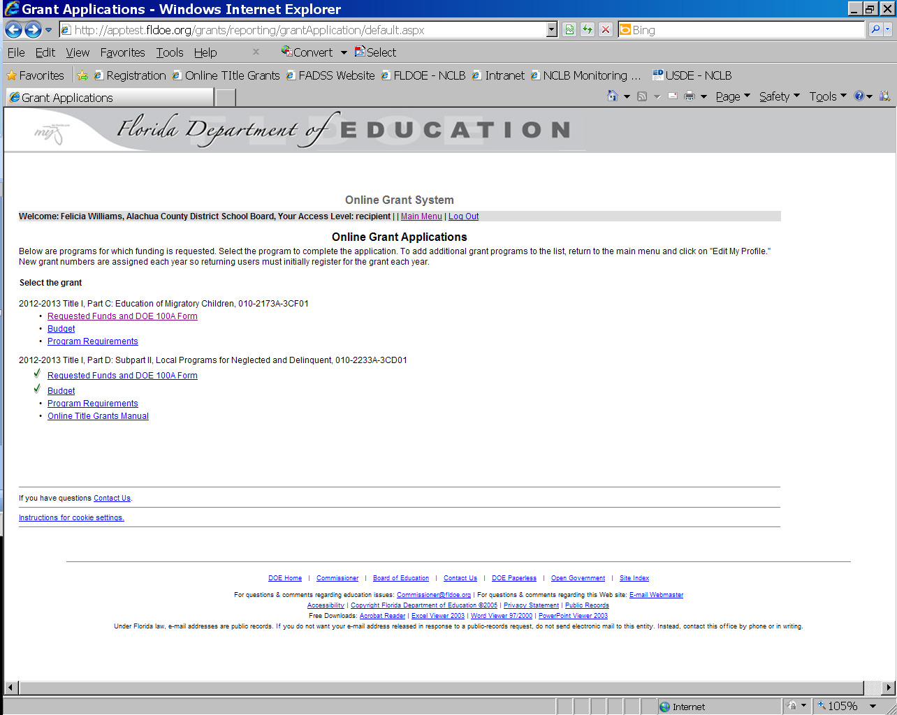
Navigation
The menu links, Logout link, and Save and Back Browser buttons are your navigation tools.

- To return to the home page of the Online Grant System, select the hyperlink Main Menu.
- To return to the main page of the Online Grant Applications, select the hyperlink Grant Application Menu. On this page, users can access the links for Budget, Program Requirements, and the DOE 100A form.
- To return to the main page of a program specific OTG, select the hyperlink Program Main Menu.
- Users should avoid using the Back browser button unless instructed to do so by the system. This can have undesirable consequences on your data entry, which may require total reentry of all the data.
- To logout of the application, select the hyperlink Log Out (located at the top of each page). While in the Program Requirements, there is a logout button located at the top right of each page.
- To save a page, select the Save button (located at the bottom left hand corner of each page). Please note: most pages in the application require entry into each field before saving.

NOTE: On the Program Main Menu, checkmarks will appear after a section of the application is completed. Once they are all complete, a link will appear for the LEA to submit the entire application to the FDOE (see page 17). The FDOE program staff will receive an alert notifying them of the submission. Users may continue to access applications until FDOE closes them for review and approval purposes.
Entering and Editing Information in the Application
Multiple users can access the program application simultaneously, as long as the primary application contact shares the password. However, it is not recommended that users work on the same section at the same time. This will cause entries to be overwritten. Once saved, the database is updated and previous information is permanently removed.

It is also important to note, when utilizing more than one browser tab or window for forms that communicate with each other, users will need to refresh their windows for the data to appear correctly. For example, in Title I, Part A, the Public School Eligibility Survey and the Support for Eligible Students in Private Schools are forms that are dependent on each other’s data; so if both are open and one is updated, the other will need to be refreshed to capture the changes.

Most fields are required and identified with red asterisks. Error checks will assist users with completing required components. Users should follow the directions found in error checks, which are usually specific and helpful.

Data entered in the project applications will be stored on the FDOE server by selecting the Save button located at the bottom of each page of a project application. If users have not completed a section of the application and need to save the information entered, they should enter a note in the areas not finished (e.g., please answer later) and select save. If this process is not followed, no data will be saved. The exception is the DOE 101.

Edits to a project application submitted to FDOE may continue until the program office approves and closes it. Show History is provided for various text fields in the online system to assist LEA and FDOE program staff with tracking previous entries (see the next two screen shots below). The hyperlink for Show History will appear when the user saves, and then returns to the page. This feature is only applicable to Title I, Part A – Improving the Academic Achievement of the Disadvantaged.

Example of Show History Hyperlink
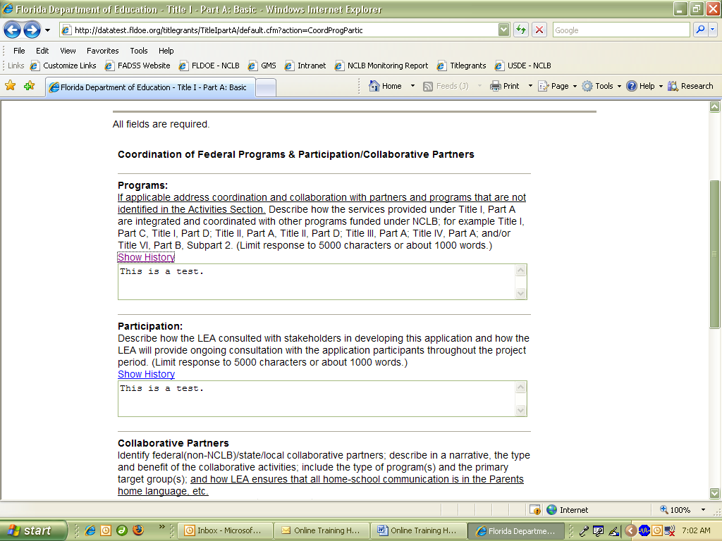
Example of Tracking Previous Entries through Show History
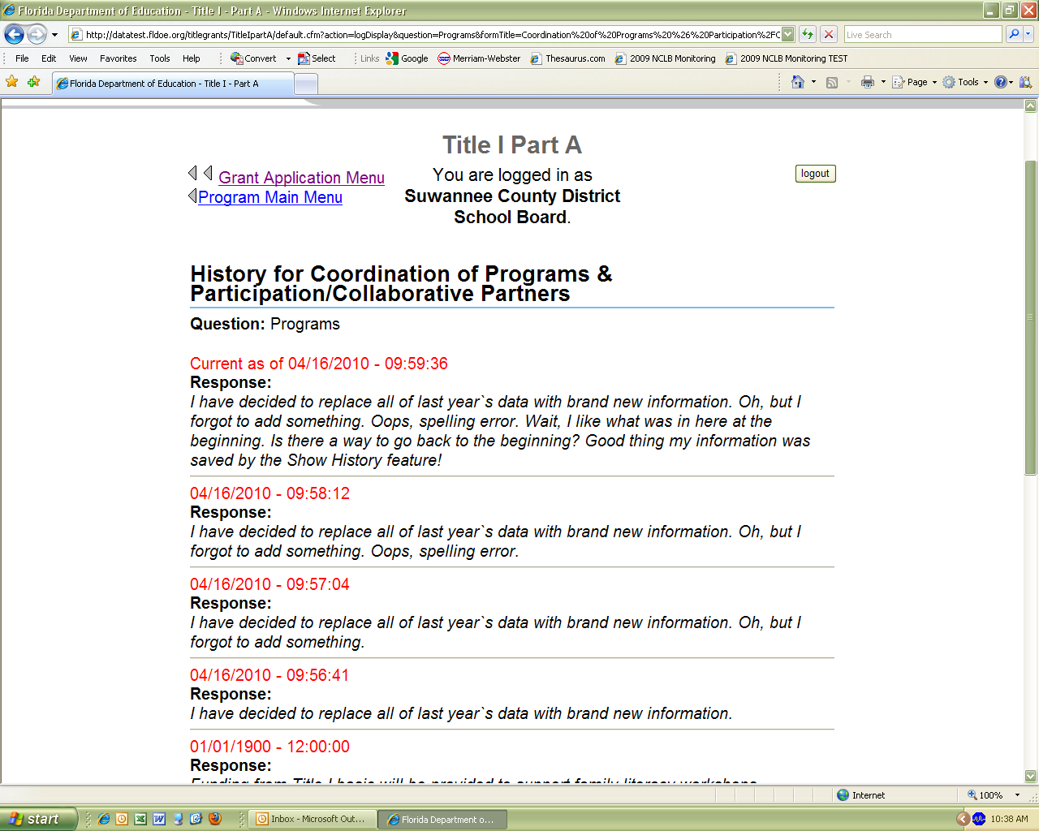
Trouble Shooting

Server Error
If you receive a 500 Error or Internal Server Error, the FDOE server is down. Please send an email to ofp@fldoe.org immediately to inform us about the error to expedite a resolution and proper communication will be sent to LEA and FDOE staff about the status via the listserv. Data will be lost if you were working in a project application when the server failed. Users are encouraged to use the Word version RFA as a working document, from which they can cut and paste data into the online system.

Clearing your Cache
If you have made changes to your application, but cannot see the changes reflected on your screen, your computer may be caching. If attempts to save/submit a page are not successful, this may also be a result of caching. Please follow the instructions below (and see the screen shot on the following page) for Internet Explorer to clear your cache. Instructions for browsers such as Safari and Mozilla Firefox may vary, but are similar:

Step 1 - Logout of the application and keep the browser open.
Step 2 - Select Tools in the tool bar.
Step 3 - Select Delete Browsing History.
Step 4 - Delete files, history, and forms (categorically). Do not delete cookies or select Delete All.
Step 5 - Login and access the application again. If the problem persists, please send an email to ofp@fldoe.org; there may be a problem with the server/application(s). If a conclusion is made that it is not a problem with the server/application(s), users should contact their Information Technology Administrator.

Screen Shot of How to Delete Files, History, and Forms
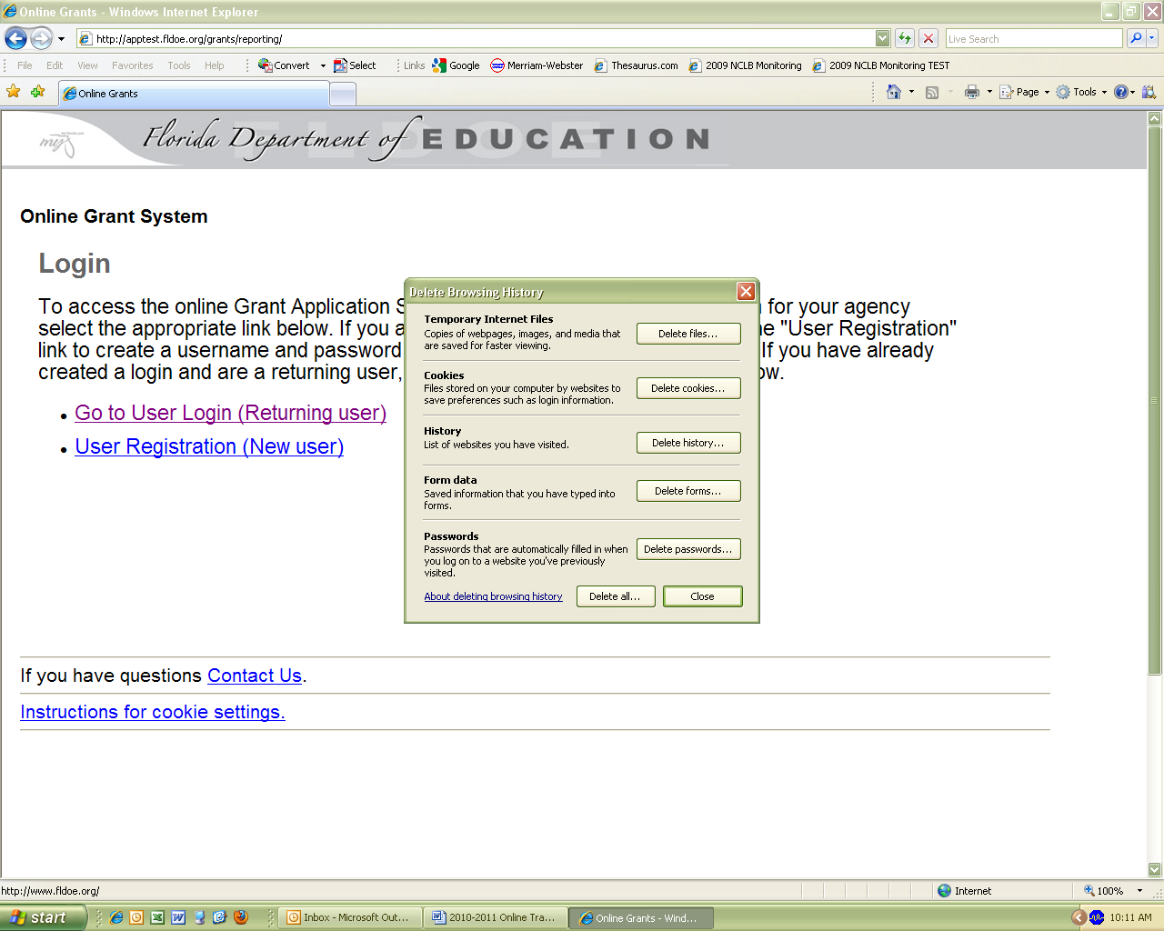
NOTE: Do not delete cookies. The system requires a cookie for fldoe.org; if deleted, users will need to follow the links on page 4 for directions on how to reauthorize the cookie.

Printing the Application
Users can print OTGs any time during the process, though there must be data in the fields in order for a section to print. Once all sections are complete, users should retain a copy of the entire application for their records. Users can print the entire application, print the budget, and print the DOE 100 Form from the Program Main Menu. In the screen shot below, the last three links pertain to printing; other programs may have additional printing options.

- Title I, Part A – Improving the Academic Achievement of the Disadvantaged, allows users to print the entire application without the Public School Eligibility Survey.

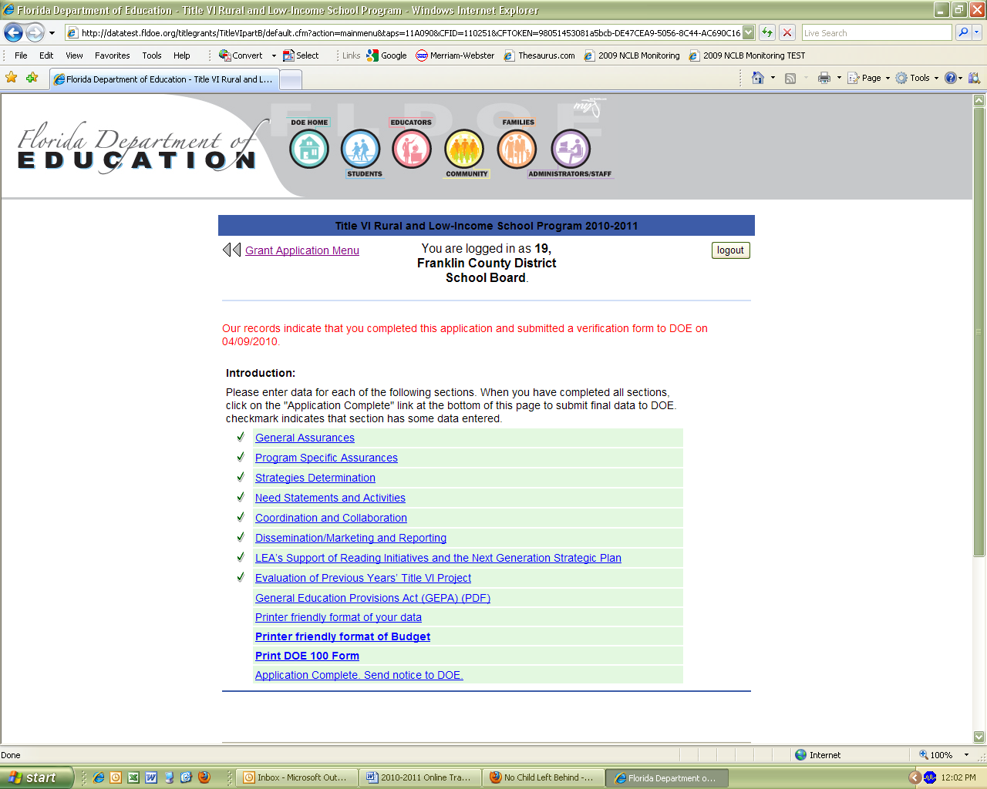

Instructions for Completing the Online DOE 100A
From the Grant Application Menu, select Requested Funds and DOE 100A Form and enter the estimated roll forward. Select the Save button. The DOE 100A will not include an estimated roll forward field if it is not allowable by the program during the application process. Once saved, select Print 100A Form for this Grant. The Agency Head (superintendent or designee) must sign the DOE 100A Form; users are required to enter the name in the online system for it to appear on the DOE 100A certification. Once the form is complete, select the Generate Printable Form button, print, have it signed, and mail the original signature to the Office of Grants Management. On the browser’s toolbar, choose File → Print.

Printable DOE 100A
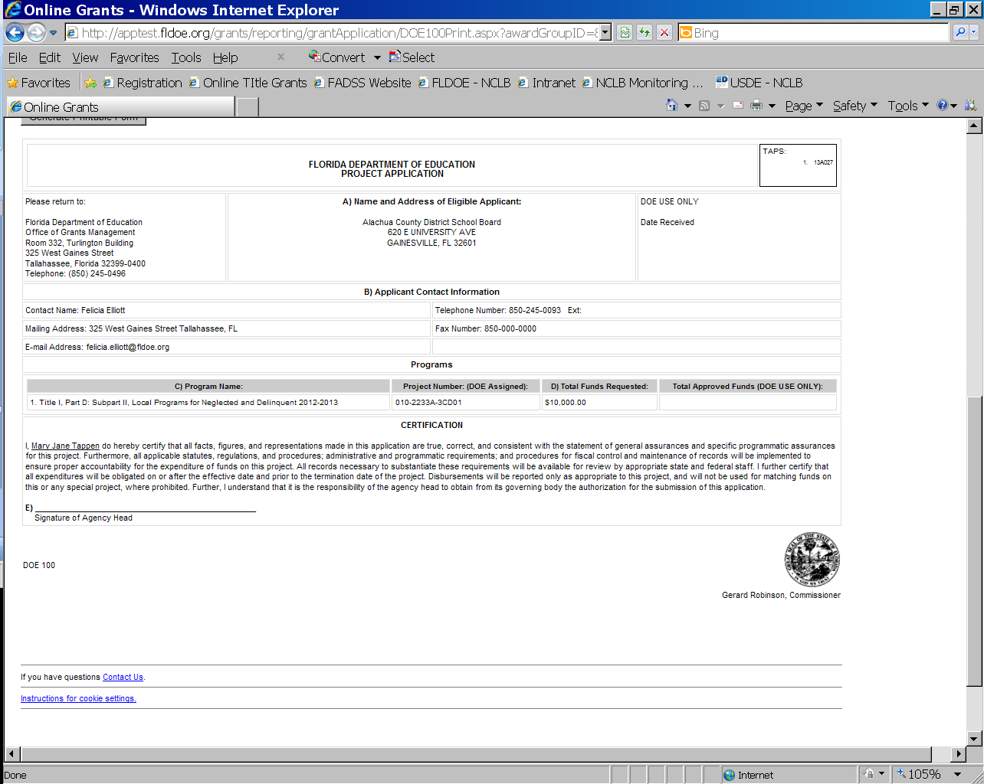
NOTE: The FDOE receipt of the DOE 100A (hard copy) and the application (electronically) begins the grant application process. The date the Grants Management Section receives both documents in substantially approvable form will be the date certain. Remember to mail the signed, original DOE 100A to the address in the “Please return to:” field on this form.
Uploading Files
Follow the instructions below to upload files successfully using I.E. Instructions for browsers such as Safari and Mozilla Firefox may vary, but are similar. Pay attention to the type of files that are allowable to upload in the online system (.doc, .docx, .xls, .xlsx, .pdf, or .txt)
- Select the Browse button next to the field earmarked for the path of the document.
- Find the location of the document you are uploading on your hard/network drive, disk, CD, etc. and select the file.
- Select Open. You should see the path to the selected file.
- Select the Upload button.
- Save the page and your file will upload to the FDOE server.

Browsing for Location of File to be Uploaded to the FDOE server
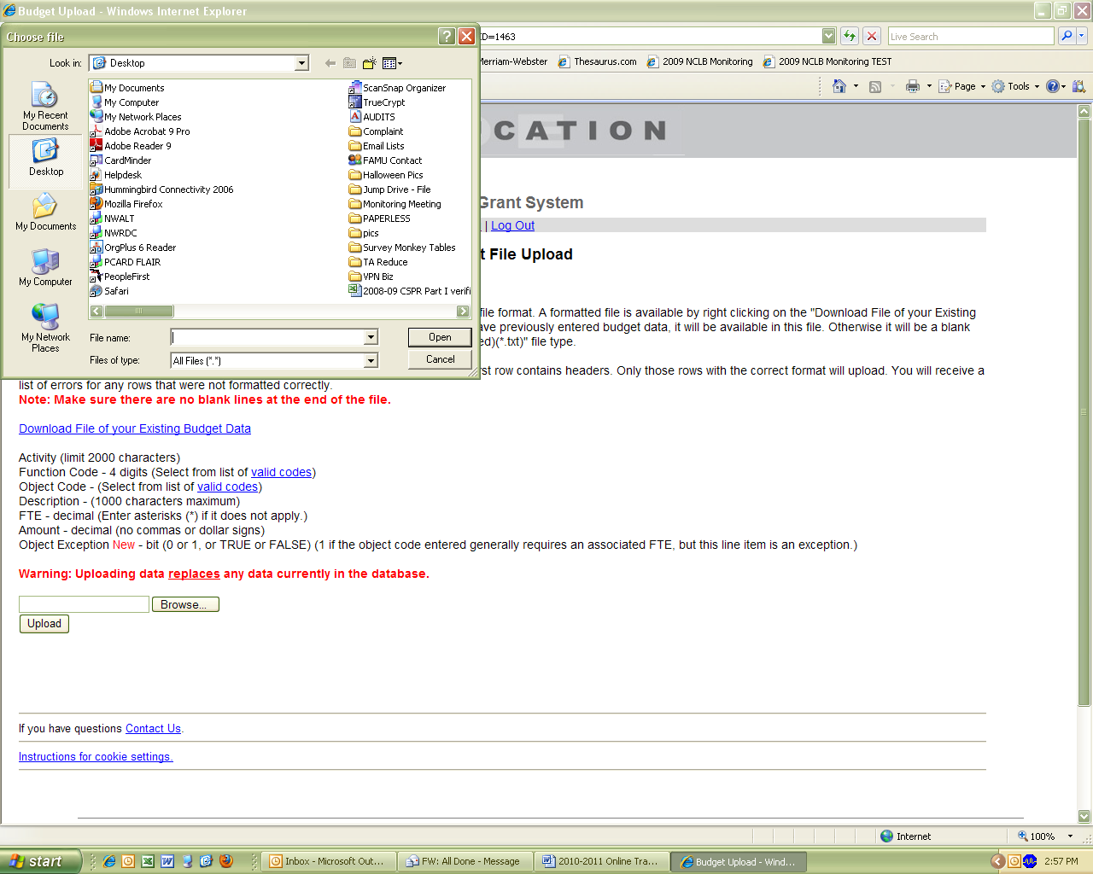
NOTE: Users can verify a successful upload by selecting the link that appears next to the field for the upload and viewing the file.

To delete and replace an uploaded file, select delete and follow the process for uploading a document again.

Identifying Replaced Data Files
Users can confirm replaced data files such as the DOE 101, Public School Eligibility Survey, and Support for Eligible Students in Private Schools by accessing the section and viewing the information on screen. However, identification of replaced files, such as .pdf, .doc, or .txt, may not be as obvious as files that deal with numeric (.xls and .xlsx) data. For example, if asked to replace a letter, it is hard to identify if the document is similar to the original. Users may add a cover page with the date and version of the document if FDOE program staff request changes; this will make it easier to identify the most recent upload.
Budget Page (DOE 101)
The person responsible for the budget should register for the budget role for a given program. Additional instructions for the budget are in the Green Book and Red Book; links to these books are above the total funding amount on the budget page.

The text fields may look small, but they can hold up to 4000 characters and spaces for Activity and 3500 for Account Title and Description fields. Mozilla Firefox and Safari have features that allow users to expand these fields so that more of the narrative is visible at a given time (see page 3).

The DOE 101 will save multiple instances of function and object codes. If FTE is left blank, the system will recognize it as 0.00. The Grants Management Section (OGs) establishes the online budget rules for Function and Object Codes. Please contact OGS at http://www.fldoe.org/grants/gm/ or call 850-245-0496 if there is a discrepancy.

Users may see all records with totals after a complete budget page has been saved (at least one line item is required to save this page). The Print or View Budget Data link is next to the Grant Application Menu link at the top left of the screen. This will assist users with easily viewing all their records at one time, in a printable format. If there are more than 75 characters in the Activity of Account Title and Description fields, the system will automatically abbreviate the content when viewing and printing. Click on Show, found in the Note at the top of the screen. Alternatively, if you want the abbreviated version of the table again, click on Hide. When viewed and/or printed the Function and Object codes will be in numeric order.

The budget page saves line items in increments of 10. Users may add additional line items by saving each entry of 10 until the budget is complete. The budget must equal the summation of the allocation and estimated roll forward (if applicable) on the DOE 100A.

Users should update budget pages when notified that the final allocations are available in the OTGs.

DOE 101
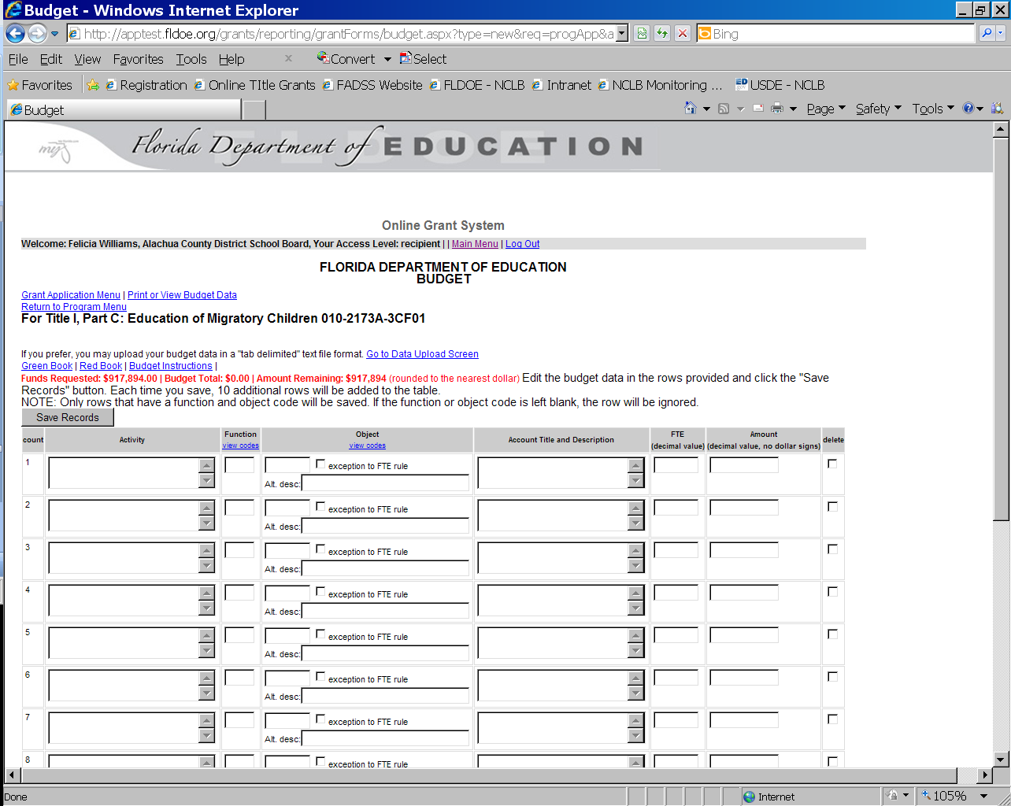

Print or View Budget Data
By selecting the Print or View Budget Data, the online grant system will reflect all entries in the DOE 101. To show full text, please select the Show link on this page.

Export to Excel for Your Records
Important! LEAs may export the DOE 101 in Excel for their records.

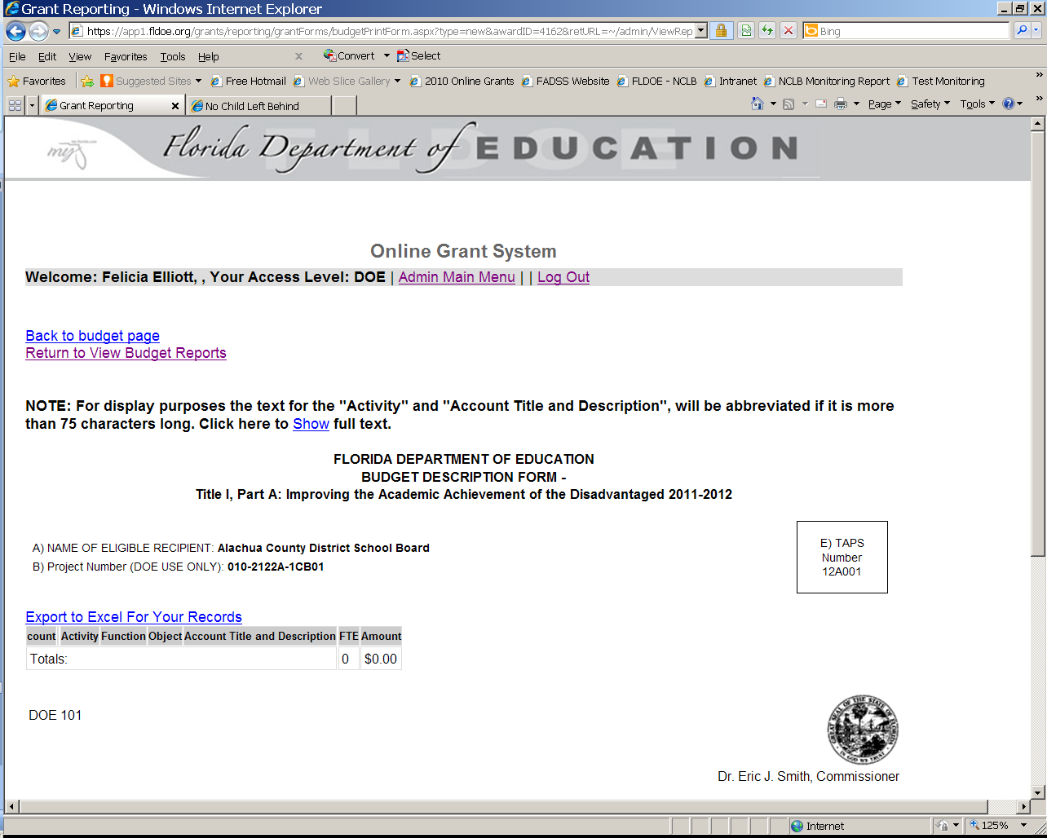

Reformatting Budget Pages for Printing
Users can reformat the budget page to make viewing easier for printing purposes. Select File in the web browser and go down to print preview. Select page setup to print as portrait or landscape, letter or legal size. You may also adjust the margins.

Budget File Upload
Instructions and required formats are set up in the sample file for the budget.

WARNING!
Do not add headers, footers, or totals to the file; it must be in the same format as the sample provided.

Please refer to Budget File Upload page for instructions.

Each time a file is uploaded to the server, the previous file is overwritten.

Users will receive a screen similar to the one below when saving the budget upload file. Users must select “Yes” to save the format and preserve all features of the file.
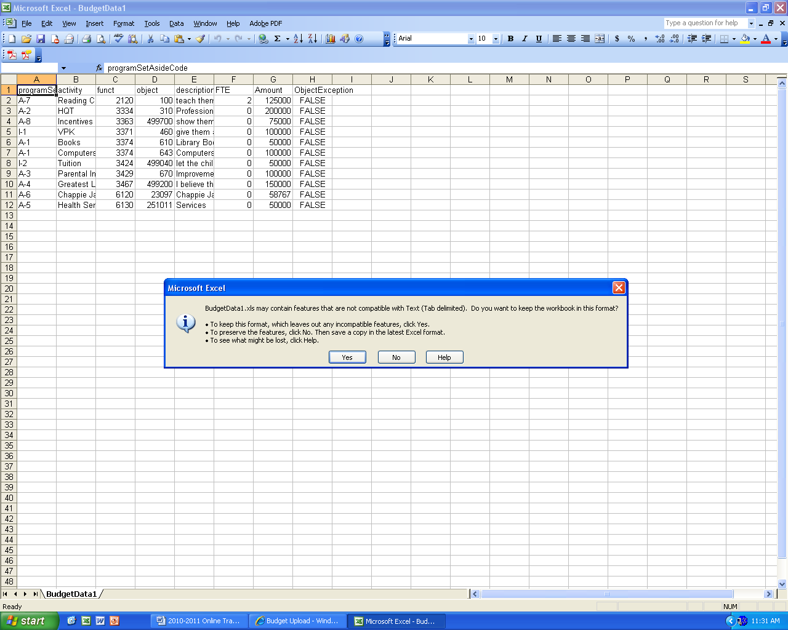

Agency Codes and Passwords
These codes are for new registrants responsible for the grants listed on page 26 of this document. If you have accessed the OTGs in the past and do not remember your Login Name or Password, please follow the instructions located on page 7 to retrieve this information.

Please contact the FDOE at 850-245-0657 or ofp@fldoe.org if you need assistance.

Agency Code | Local Educational Agency | Password
010 | ALACHUA | agency010
020 | BAKER | agency020
030 | BAY | agency030
040 | BRADFORD | agency040
050 | BREVARD | agency050
060 | BROWARD | agency060
070 | CALHOUN | agency070
080 | CHARLOTTE | agency080
090 | CITRUS | agency090
100 | CLAY | agency100
110 | COLLIER | agency110
120 | COLUMBIA | agency120
130 | MIAMI-DADE | agency130
140 | DeSOTO | agency140
150 | DIXIE | agency150
160 | DUVAL | agency160
170 | ESCAMBIA | agency170
180 | FLAGLER | agency180
190 | FRANKLIN | agency190
200 | GADSDEN | agency200
210 | GILCHRIST | agency210
220 | GLADES | agency220
230 | GULF | agency230
240 | HAMILTON | agency240
250 | HARDEE | agency250
260 | HENDRY | agency260
270 | HERNAND | agency270
280 | HIGHLANDS | agency280
290 | HILLSBOROUGH | agency290
300 | HOLMES | agency300
310 | INDIAN RIVER | agency310
320 | JACKSON | agency320
330 | JEFFERSON | agency330
340 | LAFAYETTE | agency340
350 | LAKE | agency350
360 | LEE | agency360
370 | LEON | agency370
380 | LEVY | agency380
390 | LIBERTY | agency390
400 | MADISON | agency400
410 | MANATEE | agency410
420 | MARION | agency420
430 | MARTIN | agency430
440 | MONROE | agency440
450 | NASSAU | agency450
460 | OKALOOSA | agency460
470 | OKEECHOBEE | agency470
480 | ORANGE | agency480
490 | OSCEOLA | agency490
500 | PALM BEACH | agency500
510 | PASCO | agency510
520 | PINELLAS | agency520
530 | POLK | agency530
540 | PUTNAM | agency540
550 | ST. JOHNS | agency550
560 | ST. LUCIE | agency560
570 | SANTA ROSA | agency570
580 | SARASOTA | agency580
590 | SEMINOLE | agency590
600 | SUMTER | agency600
610 | SUWANNEE | agency610
620 | TAYLOR | agency620
630 | UNION | agency630
640 | VOLUSIA | agency640
650 | WAKULLA | agency650
660 | WALTON | agency660
670 | WASHINGTON | agency670
670 | Okeechobee Boys School | agency670
557 | FSDB | agency557
687 | A.D. HENDERSON | agency687
686 | FSU | agency686
685 | FAMU | agency685
015 | P.K. YONGE | agency015
708 | Department of Corrections | agency708
53D | Lake Wales Charter System | agency53D
48C | Florida Virtual Schools | agency48C

FDOE Can Help You!

Please use the information below to contact program offices, and technical support staff.

Title I, Part A – Improving the Academic Achievement of the Disadvantaged
Please visit - http://www.fldoe.org/bsa/title1/title1reg_contacts.asp to locate your Program Specialist, call 850-245-0414 or send an email to bfep@fldoe.org.

Title I, Part C – Migrant Education Program
Carol Gagliano – Carol.Gagliano@fldoe.org; 850-245-0709; bfep@fldoe.org

Title I, Part D Subpart I – State Neglected and Delinquent
Melvin Herring – Melvin.Herring@fldoe.org; 850-245-0684; bfep@fldoe.org
Title I, Part D Subpart II – Local Neglected and Delinquent
Melvin Herring – Melvin.Herring@fldoe.org; 850-245-0684; bfep@fldoe.org
Title II, Part A – Teacher and Principal Training and Recruiting Fund*
Peggy Primicerio – Peggy.Primicerio@fldoe.org or 850-245-0734

Title III, Part A – English Language Acquisition
Please visit http://www.fldoe.org/aala/omsstaff.asp to locate your Program Specialist; 850-245-0417 or send an email to sala@fldoe.org

Title VI, Part B, Subpart II – Rural and Low Income
Jessie Simmons – Jessie.Simmons@fldoe.org; 850-245-0682; bfep@fldoe.org

Grants Management Section
Please review individual Request for Applications to identify your budget officer.

Gwendolyn Jackson – Gwendolyn.Jackson@fldoe.org; 850-245-0653
Kinisha Murphy – Kinisha.Murphy@fldoe.org; 850-245-0731
*Matthew Caldwell – Matthew.Caldwell@fldoe.org; 850-245-0717

Online Technical Assistance
Please send an email to ofp@fldoe.org or call 850-245-0657 if you need technical assistance. Technical support staff:

Felicia A. Williams – Felicia.Williams@fldoe.org; 850-245-0093



Thank You for Your Dedication and Service!

