CAREER CRUISER | Exploring Careers

Step 2 | Explore careers.
Driving Question | What are my options after high school?
Goal | Prioritize three careers for further investigation.
Standard | Describe occupations and industries in their region. (CR.1.2)

FOR TEACHERS

Timeframe | 1 to 2 roughly hour-long lessons.
Materials | Internet and digital device access.
Xello | Xello, Florida’s official K-12 public school career planning and work-based learning coordination system, has tools you can use on this topic! Within the system, navigate to ‘Explore’ tab and then click on ‘Careers’ to explore. Under ‘Home’ and ‘View All Lessons,’ consider having students complete the 'Explore Career Factors,’ ‘Explore Career Matches,’ and ‘Discover Learning Pathways’ lessons.
Overview | Beginning  - Set the context for this lesson explaining to students that getting started on a career path will involve a series of questions: After high school, do I want start enrollment, enlistment, employment or entrepreneurship? Have the students help you define each of those terms. Then, discuss the different options available within each of those categories. Emphasize that choosing a career starts with large, broad questions and then progressively narrows in its scope.  Middle  - Students will review career information and record their understanding of the pros, cons and education for three top career choices.  End  - Have students discuss in pairs what they learned about their top career choice – what they liked, what they did not like, and one thing the student would like to learn next about the career.  Extension  - Have students research a business related to the student’s top career choice. Have the student search online for the name of the employer plus the word “reviews.” Then, find a website where past or current employees can post their reviews of working at the business. Then, have the student write a summary of the positive and negative reviews.  - Other sources of information on careers:  - Detailed Occupation Profiles  - U.S. Bureau of Labor Statistic’s Occupational Outlook Handbook allows individuals to browse by occupation group, salary, required educational level, on-the-job training, projected number of new jobs and projected growth rate. The occupation profiles within the system are rich with information and video profiles.  - CareerInfo Phone App  - U.S. Department of Labor’s CareerInfo App is a free phone app available on the Apple App Store and Google Play. In the app, students will be able to browse based on occupation groups and labor market data as well as search for key words.  - U.S. Department of Labor’s Career Videos  - The U.S. Department of Labor has hundreds of career videos available for streaming organized by Career Cluster. These videos are often embedded in other U.S. government sites, such as GetMyFuture, the Occupational Outlook Handbook, etc. Videos overviewing Career Clusters and skills and abilities are also available.  - Khan Academy Career Videos  - Khan Academy has dozens of career profiles on video, many of which share tasks, income, how to get a job in that field, and advice on budgeting and planning.

FOR STUDENTS

Learn
Learning More About Careers
This lesson’s activity will focus on reading and watching videos about careers to learn more about what those careers might be like. Typical career profiles cover:
- Tasks – the typical responsibilities and activities of a career. As you are reviewing these, consider how these activities do or do not align with your interests, skills, and values.
- Training requirements – how much and what type of training is typically required of the occupation.
Training Options After High School
After high school, there are essentially four main options – start a training program (enrollment), start working (employment), start your own business (entrepreneurship), or join the military or Ameri Corps (enlistment). For the purposes of this activity, we will be focusing on enrollment, as people with postsecondary training are more likely to find and keep a job as well as make more money, and because you can always return to a training plan later on even if you decide to go straight into employment, entrepreneurship, or enlistment.

Each of your training options has different costs (time, financial, etc.) and benefits (starting salary, ease of getting a job, etc.) that will vary by program and institution offering the program.
Postsecondary Training Option | Credentials Offered | How Long It Often Takes
Apprenticeship | Certificate of Completion of an Apprenticeship | 1-6 years
Technical College | Career Certificate | Less than 2 years
State or Community College | Career Certificate, Associate’s Degree, Bachelor’s Degree | Associate’s degrees typically take 2 years
University | Bachelor’s Degree | 4 years

Do
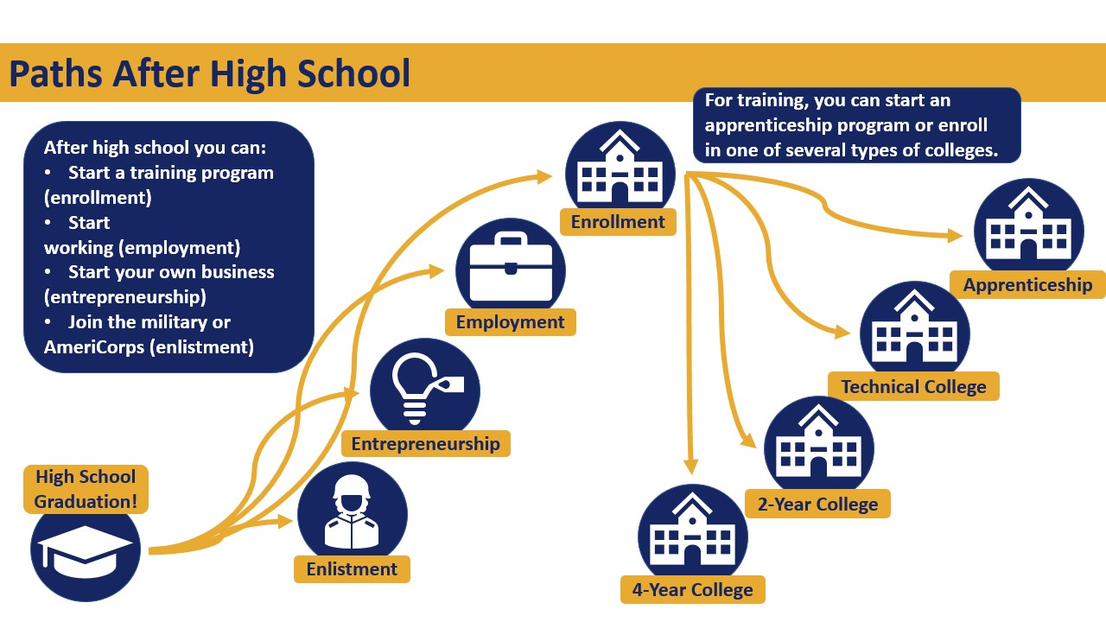
Explore Career Profiles
Follow these steps:
- Navigate to the GetMyFuture Occupational Profile website: https://www.careeronestop.org/GetMyFuture/Toolkit/Occupation-Profile.aspx.
- Click on ‘List of Occupations’ in roughly the middle of the page and select an industry and then an occupation. It is recommended you base your selection on your career assessment results.
- Then, put in your zip code or city and state. Then, press ‘Search.’
- Read the entire page and watch the video (if available).
- Click ‘Find Job Openings’ and review.
- Click ‘Find Local Training’ and review.
- Repeat the entire process for at least two other careers you are interested in and complete the below table.

Reflect
For your top three career choices, fill in the below data chart based on information from the U.S. Department of Labor’s GetMyFuture or another information source.
Career | Like: What did you like about the career you reviewed? | Dislike: What did you NOT like about the career you reviewed? | Education Requirements: How much education does the occupation typically require?

