For problems 1-14, use the information below to find the volume of the given shapes.

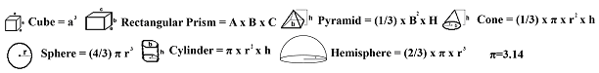

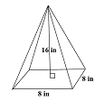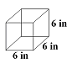

1.
- 128.0 in³
- 64.0 in³
- 341.33 in³
- 1024 in³

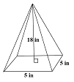
2.
- 25 in³
- 150 in³
- 90 in³
- 450 in³

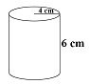3.
- 75.4 cm³
- 113.1 cm³
- 24 cm³
- 301.4 cm³

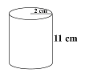
4.
- 138.2 cm³
- 22.4 cm³
- 121.4 cm³
- 242.8 cm³

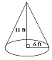
5.
- 414.5 ft³
- 66.0 ft³
- 380.10 ft³
- 207.3 ft³

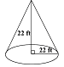6.
- 2787.64 ft³
- 23457.7 ft³
- 1520.53 ft³
- 11144.9 ft³

7.
- 216 in³
- 36 in³
- 108 in³
- 648 in³

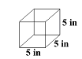8.
- 42 in³
- 25 in³
- 125 in³
- 35 in³

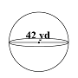9.
- 38772.7 yd³
- 4849.0 yd³
- 87.96 yd³
- 12348.0 yd³

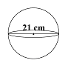10.
A. 4846.6 cm³
B. 1543.5 cm³
C. 461.8 cm³
D. 44 cm³

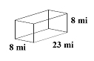11.
A. 128 mi³
B. 1472 mi³
C. 552 mi³
D. 1024 mi³

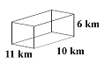
12.
- 726 km³
- 600 km³
- 660 km³
- 659 km³

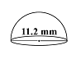13.
- 367.6 mm³
- 117.1 mm³
- 183.9 mm³
- 551.7 mm³

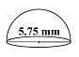14.
- 99.54 mm³
- 15.84 mm³
- 74.66 mm³
- 49.74 mm³

Choose the best answer to questions 15 through 18.

15. Find the volume remaining in the rectangular prism after the cylinder is inserted.
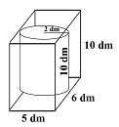
- 7.85 dm³
- 280.0 dm³
- 165.81 dm³
- 174.4 dm³

16. Find the volume remaining in the cylinder after the sphere is inserted.
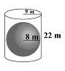
- 5598.32 m³
- 2144.66 m³
- 3451.91 m³
- 1999.82 m³

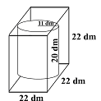17. Find the volume remaining in the cube after a cylinder is inserted.

- 3175.0 dm³
- 10648 dm³
- 3049.2 dm³
- 7602.65 dm³

18. Find the volume remaining in the cylinder after the sphere is inserted.
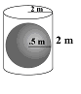
- 24.6 m³
- 0.52 m³
- 25.13 m³
- 4 m³

Answer Key

- B
- C
- D
- B
- D
- B
- A
- A
- D
- C
- A
- B
- B
- B
- D
- B
- C
- A

