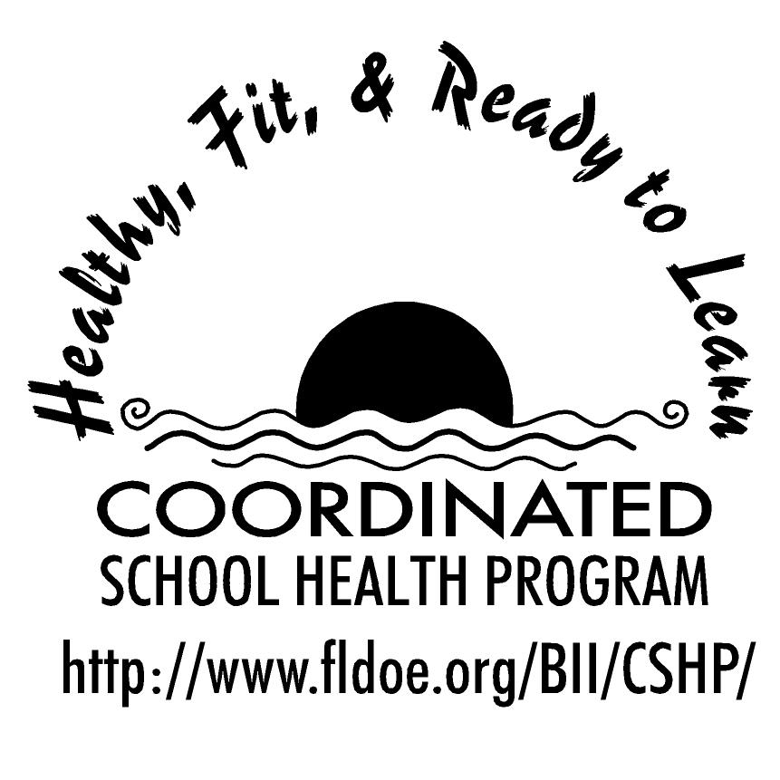
Wellness Wakeup Call Mental and Emotional Health
Month _______________

Each day, start the message with: “Good morning, this is your Wellness Wakeup Call!”
Read message for the day. End each message with “Enjoy your day, the healthy way!”

By focusing on the positive aspects of your life you can feel more positive about yourself! Don't forget to give yourself compliments too! When the day is done consider saying out loud, "Today I played my best in our soccer game," or "My friends really liked the jokes I told them."

Tips for reducing stress: learn to manage your time better, seek out social support and eat healthy well-balanced meals. A healthy meal will give you an energy bank to draw on whenever you experience stress.

Body image is generally the mental picture you have of your physical appearance and the attitudes and feelings you have toward it. So be sure to see your true self!

No fret with pets! Research has shown that when dog or cat owners were asked to perform a stressful math problem, they showed less stress in the company of their pets.

Friendship is like standing on wet cement. The longer you stay, the harder it is to leave, and you can never go without leaving your footprints behind.

Two tips to resolve a conflict: Tip 1- List all options without judgment or feelings that they must be carried out. Tip 2- Try to think of solutions where everyone gains something.

Did you know that teens need 8 to 9 hours of sleep a night? Yet research shows that teens get about 7 hours a night. If you don’t get enough sleep, you may have problems paying attention in class or doing your homework. So catch those ZZZ’s!

Tips for being a good friend: Mean what you say and say what you mean. Openness and honesty with each other is a must.

Solve problems the healthy way! Decide on your options for handling the problem, such as talking the problem out calmly, staying away from certain people or getting help from others like your teacher or counselor.

Protect your heart from anger! Feelings of anger produce changes in the body such as increased heart rate, blood pressure and adrenaline; all which negatively affect your heart.

Look on the plus side of life! People with a positive view of the events in their lives have better physical health and live longer than people with a negative view.

Is stress always a bad thing? No! A little bit of stress can work in a positive way.
For example, being stressed because your homework is due may help you get it done on time.

To be a good friend, remember, you don’t have the power to change someone. Instead try to understand each others strengths and weaknesses.

Remember, it is normal to become angry. It’s what you do with your anger that counts.

A few tips about resolving conflict: Tip1- Listen up! Let each person describe their point of view without interruption to help you understand what a person wants and why they want it. Tip 2- Find something in common to establish facts and issues that everyone can agree on.

See the beauty and fitness on TV and in magazines for what they are. Know that one of their goals is to make you feel bad about yourself so that you will buy their products. Instead, look to yourself for inner beauty and strength.

Truly great friends are hard to find, difficult to leave, and impossible to forget.

Tips for reducing stress: keep a positive attitude, accept that there are events you cannot control and exercise regularly. Your body can fight stress better when it is fit.

Scales belong on a fish. Try to get yourself off of the scales; they do not define who you are.

If you become angry, first relax by breathing deeply from your belly and slowly repeat a calming word or phrase like "take it easy." Also think of relaxing images like sitting on a beach or walking through a forest.

A true friend is someone that shows their loyalty, honesty, trustworthiness or willingness to make a sacrifice when you need help.

Did you know that a decrease in sleep causes an increase in the release of stress hormones? So, to lessen stress, get enough sleep and rest!

To lessen your chances of developing a negative body image, keep the following strategies in mind: surround yourself with supportive people, eat a balanced diet and choose physical activities you enjoy. Your worth as a human being is not dependent on how you look.

References for these tips cans be found at www.fldoe.org/BII/CSHP/h-pilot.asp

